**International Committee for Future Accelerators (ICFA)**

**Standing Committee on Inter-Regional Connectivity (SCIC)**

**Chairperson: Professor Harvey Newman, Caltech**

**ICFA SCIC Network Monitoring Report**

Prepared by the ICFA SCIC Monitoring Working Group

On behalf of the Working Group:   
Shawn McKee [smckee@umich.edu](mailto:cottrell@slac.stanford.edu)

Marian Babik Marian.Babik@cern.ch



2015 - 2016 Report of the ICFA-SCIC Monitoring Working Group

Edited by Shawn McKee, Marian Babik On behalf of the [ICFA-SCIC Monitoring WG](mailto:icfa-ntf-wg-monitoring@listbox.cern.ch)

Contributions from Les Cottrell, Brian Tierney, Soichi Hayashi,

Created January 18, 2016, Finished January 31, 2016

[ICFA-SCIC Home Page](http://icfa-scic.web.cern.ch/ICFA-SCIC/) | [Monitoring WG Home Page](http://icfa-scic.web.cern.ch/ICFA-SCIC/Committees/monitoring.htm)

This report is available from:

Table of Contents

[Figures 4](#_Toc441322415)

[Executive Overview 4](#_Toc441322416)

[Introduction 6](#_Toc441322417)

[Methodology 7](#_Toc441322418)

[PingER Status 7](#_Toc441322419)

[Deployment 7](#_Toc441322420)

[Historical Growth of PingER Coverage Since 1998 8](#_Toc441322421)

[Metrics 9](#_Toc441322422)

[Yearly Throughput Trends 9](#_Toc441322423)

[High Performance Network Monitoring 12](#_Toc441322424)

[Introduction 12](#_Toc441322425)

[Open Science Grid 12](#_Toc441322426)

[WLCG Network and Transfer Metrics Working Group 12](#_Toc441322427)

[The perfSONAR Project 12](#_Toc441322428)

[Recent Changes to perfSONAR 13](#_Toc441322429)

[perfSONAR next steps 13](#_Toc441322430)

[New and Ongoing Monitoring and Diagnostic Efforts in HEP 14](#_Toc441322431)

[Using and Managing perfSONAR 16](#_Toc441322432)

[Network Datastore 19](#_Toc441322433)

**[Complementary End-to-End Monitoring](#_Toc441322434)** [22](#_Toc441322434)

**[Summary: Progress in HEP Network Monitoring for 2015](#_Toc441322435)** [22](#_Toc441322435)

*[Related HEP Network Research](#_Toc441322436)* [23](#_Toc441322436)

[Comparison with HEP Needs 24](#_Toc441322437)

[Recommendations 24](#_Toc441322438)

[Future Support 25](#_Toc441322439)

[Acknowledgements 25](#_Toc441322440)

[Appendices 26](#_Toc441322441)

[Appendix A: PingER Presentations etc. in 2015. 26](#_Toc441322442)

[Publications and White papers (most recent first) 26](#_Toc441322443)

[Talks (most recent first) 26](#_Toc441322444)

[Appendix B: PingER Project History in 2015 27](#_Toc441322445)

[Appendix C: ICFA/SCIC Network Monitoring Working Group 28](#_Toc441322446)

[Goals of the Working Group 29](#_Toc441322447)

# Figures

*Please note that for all yearly graphs the data point is for the end of the year.*

[Figure 1: Locations of PingER monitoring and remote sites as of January 2016. Red sites are monitoring sites, blue sites are beacons that are monitored by most monitoring sites, and green sites are remote sites that are monitored by one or more monitoring sites. 8](#_Toc441322477)

[Figure 2: The growth in PingER monitoring hosts, remote hosts monitored, countries monitored & monitor-remote site pairs 9](#_Toc441322478)

[Figure 3: Derived Throughput kbits/sec from SLAC to the World (since the throughputs in this graph are not normalized we have not shown N. America) until Dec 2015 9](#_Toc441322479)

[Figure 4: Derived Throughput kbits/sec from SLAC to the World until Dec 2015 shown as the exponential trendlines. The yellow line is to help show the rate of change 10](#_Toc441322480)

[Figure 5: Extrapolations on the throughput data with a focus on Africa. 11](#_Toc441322481)

[Figure 6: Derived annual throughputs seen from SLAC to African regions together with exponential trendlines 12](#_Toc441322482)

[Figure 7: Example of OSG's mesh-management tool interface 18](#_Toc441322483)

[Figure 8 The OSG network datastore architecture used to gather, organize and archive network metrics from the global OSG and WLCG perfSONAR deployment and make those measurements available for visualization or higher-level services. 20](#_Toc441322484)

[Figure 9: Example of MaDDash dashboard in prototype instance at AGLT2 showing the USATLAS meshes for bandwidth and latency. 21](#_Toc441322485)

[Figure 10: OMD Check\_MK screenshot showing some of the monitored perfSONAR hosts in WLCG. 22](#_Toc441322486)

# Executive Overview

This year’s report has a truncated PingER contribution because of insufficient support for that effort. Much of the focus will be on monitoring and network management activities in High-Energy Physics (HEP).

Internet performance is improving each year with throughputs typically improving by 15% (for developed regions)-20% (for some developing regions such as Russia, South and Central Asia) per year and losses by up to 25% per year. Most countries have converted from using Geostationary Satellite (GEOS) connections to terrestrial links. This has improved performance in particular for Round Trip Time (RTT) and throughput. GEOS links are still important to countries with poor telecommunications infrastructure, landlocked developing countries, remote islands, and for outlying areas. In some cases they are also used as backup links. In future, developing techniques such as weather balloons, solar powered drones, and low and medium earth satellites may assist in providing much reduced latencies and hence performance to remote areas[[1]](#footnote-4).

In general, throughput measured from within a region is much higher than when measured from outside. Links between the more developed regions including N. America[[2]](#footnote-5), E. Asia (in particular Japan, South Korea and Taiwan) and Europe are much better than elsewhere (2 - 10 times more throughput achievable). Regions such as S.E. Asia, S.E. Europe and Latin America are 5-9 years behind. However, in 2009, Africa was ~18 years behind Europe, also Africa’s throughput was 12-14 times worse than Europe and extrapolating the data indicated that it would further degrade to almost 60 times worse by 2040. Since 2009, due in large part to the installation of multiple submarine fibre optic cables to sub-Saharan Africa, there has been a significant improvement in Africa’s performance. It now appears to be catching up, such that if the present improvements are maintained, it could catch Europe by around 2040. However, since the initial bump in performance in 2010 and 2011, the growth rate has dropped. Hopefully future cable deployments[[3]](#footnote-6) will assist in accelerating the performance once again, especially for East Africa.

Africa and South Asia are two regions where the Internet has seen phenomenal growth, especially in terms of usage. However, it appears that network capacity is not keeping up with demand in these regions. In fact many sites in Africa and India appear to have throughputs less than that of a well-connected (cable, DSL, etc.) home in Europe, North America, Japan or Australia. Further the end-to-end networking is often very fragile both due to last mile effects and poor infrastructure (e.g. power) at the end sites, and also due to lack of adequate network backup routes. Africa is a big target of opportunity with over a billion people of which in 2012 only 15.6% were Internet users. This grew to 26.5% in 2014[[4]](#footnote-7). It also had a 3,607% (compared to 566% for the world) growth in number of Internet users from 2000-2012[[5]](#footnote-8). However, there are many challenges including lack of power, import duties, lack of skills, disease, corruption, and protectionist policies. In almost all measurements, Africa stands out as having the poorest performance. Further Africa is a vast region and there are great differences in performance between different countries and regions within Africa.

There is a moderate to strong positive correlation between the Internet performance metrics and economic and development indices available from the UN and International Telecommunications Union (ITU). Given the difficulty of developing the human and technical indicators (at best they are updated once a year and usually much less frequently); having non-subjective indicators such as PingER that are constantly and automatically updated is a very valuable complement.

For modern HEP collaborations and Grids there is an increasing need for high-performance monitoring to set expectations, provide planning and trouble-shooting information, and to provide steering for applications. As link performance continues to improve, the losses between developed regions are decreasing to levels that are not measureable by PingER. Though the measurements for RTT, jitter, and unreachability[[6]](#footnote-9) are still correct, as the measured losses go to zero this also makes the throughput derivation unreliable. Alternative solutions to measuring the throughput are available, however they can be harder to install and absorb more network bandwidth. Examples of other measurement projects using the more intense methods are the MonALISA[[7]](#footnote-10) project that uses the pathload[[8]](#footnote-11) packet pair technique as well as file transfers, and perfSONAR[[9]](#footnote-12) that uses the iperf[[10]](#footnote-13) (and more recently iperf3[[11]](#footnote-14)) TCP transport mechanism.

In the last year there have been the following changes:

* Case study of Networking within Malaysia and S. E. Asia[[12]](#footnote-15).
* Thiago Barbosa, a student from Brazil spent 3 months at SLAC successfully developing a PingER big data data warehouse using a 4 node cluster with the Hadoop18 File System, MapReduce, and Cloudera Impala. This demonstrated the utility of near real time flexible queries of the PingER database. Unfortunately due to insufficient development time, access is currently limited to SLAC only. We plan to continue this activity in the coming year with another student from Brazil.
* There was a project to evaluate PingER monitoring using a Raspberry Pi[[13]](#footnote-16). It successfully demonstrated that the results were statistically the same as for a regular PingER host at the same location, and the robustness was similar. The idea was to provide a fully loaded server, to be powered by solar for remote sites such as Bario in the Kelabit Highlands of Borneo.

To quantify and help bridge the Digital Divide, enable world-wide collaborations, remote workforces, and workforce globalization in particular each-out to scientists world-wide, it is imperative to continue the PingER monitoring coverage to all countries with HEP programs and significant scientific enterprises. However, the funding for PingER is currently a major challenge.

# Introduction

This report may be regarded as a follow up to the previous ICFA Standing Committee on Inter-regional Connectivity (SCIC) Monitoring working group’s Network reports[[14]](#footnote-17) dating back to 1997.

The current report updates the January 2015 report.  **As noted there PingER activities will only be briefly summarized because of a lack of funding for this effort**. We will be including some new areas related to network monitoring in HEP including updates and status on the perfSONAR efforts globally as well as the WLCG Network and Transfer Metrics Working Group activities.

# Methodology

There are two complementary types of Internet monitoring reported on in this report.

1. In the first we use [PingER[[15]](#footnote-18)](http://www-iepm.slac.stanford.edu/pinger/) which uses the ubiquitous "ping" utility available standard on most modern hosts. Details of the PingER methodology can be found in the [Tutorial on Internet Monitoring & PingER at SLAC[[16]](#footnote-19)](http://www.slac.stanford.edu/comp/net/wan-mon/tutorial.html#loss). PingER provides low intrusiveness (~ 100bits/s per host pair monitored[[17]](#footnote-20)) RTT, loss, jitter, and reachability (if a host does not respond to a set of 30 pings it is presumed to be non-reachable). The low intrusiveness enables the method to be very effective for measuring regions and hosts with poor connectivity. Since the ping server is pre-installed on all remote hosts of interest, minimal support is needed for the remote host (no software to install, no account needed etc.)
2. The second method (perfSONAR[[18]](#footnote-21) etc.) is for measuring high network and application throughput between hosts with excellent connections. Examples of such hosts are to be found at HEP accelerator sites and the Large Hadron Collider (LHC) tier 1 and 2 sites, major Grid sites, and major academic and research sites in N. America, Japan and Europe. The method can be quite intrusive (for each remote host being monitored from a monitoring host, it can utilize hundreds of Mbits/s or more for ten seconds to a minute, each hour). To minimize intrusion, the WLCG scheduling utilizes 30 second tests every 64 hours rather than every hour. It also requires more support from the remote host. In particular either various services must be installed and run by the local administrator or an account is required, software (servers) must be installed, disk space, compute cycles etc. are consumed, and there are security issues[[19]](#footnote-22). The method provides expectations of throughput achievable at the network and application levels, as well as information on how to achieve it, and trouble-shooting information.

# PingER Status

Deployment

Details on the deployment of PingER can be found in the 2015 ICFA/SCIC Networking 2015 Annual Report[[20]](#footnote-23). The current January 2016 deployment of PingER can be seen in Figure 1 below.

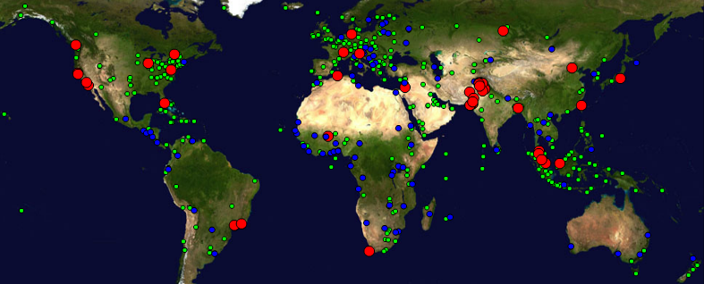

Figure : Locations of PingER monitoring and remote sites as of January 2016. Red sites are monitoring sites, blue sites are beacons that are monitored by most monitoring sites, and green sites are remote sites that are monitored by one or more monitoring sites.

## Historical Growth of PingER Coverage Since 1998

Figure 2 shows the growth in the number of PingER monitoring sites, countries monitored, active remote sites monitored by PingER from SLAC and monitor-remote host pairs since 1998. Initially the main regions monitored were North America, Europe, East Asia, and Russia. These were the regions with the main HEP interest. Starting in 2003-2004, we increased the number of hosts monitored in developing regions such as Africa, Latin America, Middle East and South Asia. Starting in 2007 the number of countries monitored plateaued at 160-170, and in 2011 the number of monitor-remote site pairs plateaued fluctuating between 700 and 850. Also less apparent but more important the number of monitoring sites (Monitors) dropped from 97 in 2011 to just over 70 in 2015. This was driven by the reduced support from the Higher Education Commission in Pakistan and somewhat masked by the addition of support from Malaysian Universities. We expect a further drop in number of monitors in 2016 as we disable more non –responding monitors in Pakistan.

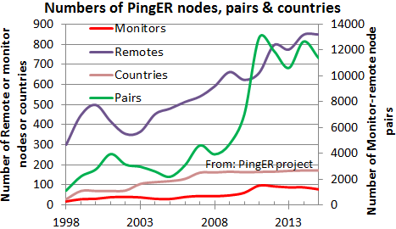

Figure : The growth in PingER monitoring hosts, remote hosts monitored, countries monitored & monitor-remote site pairs

## Metrics

See 25 for details on the use of the various PingER metrics and the measurements between 1998 and 2014. Here we only report on what is probably the most used metric, i.e. the thoughput.

### Yearly Throughput Trends

shows the annual throughput measured from SLAC using the Mathis formula[[21]](#footnote-24) to derive the throughput from PingER measured RTT and loss. Since the throughput derivation depends critically on the inverse RTT we have not shown SLAC to N. America since the small RTTs would distort the results.

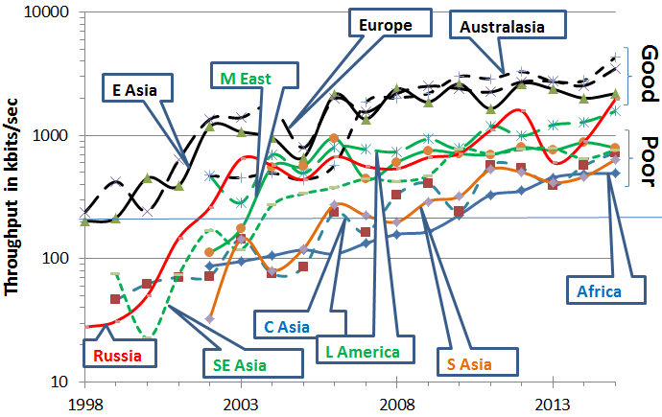

Figure : Derived Throughput kbits/sec from SLAC to the World (since the throughputs in this graph are not normalized we have not shown N. America) until Dec 2015

It is seen that throughput performance for the world divides roughly into two with Europe, Australia, East Asia and North America leading, and the Middle East, Central Asia, South Asia and Africa bringing up the rear. Latin America and Russia are hovering on joining the leaders.

Parts of Latin America moved from satellite to fibre in 2000, and E. Asia in 1999. Also note the impact of moving the ESnet routing from E. Asia (in particular Japanese academic and research networks) to the US via New York in 2001 to a more direct route via the West Coast of the US. Also note that there is almost a 10 times difference in throughput between Africa and N. America, Europe and Oceania. Africa is the worst off region and had the slowest rate of improvement until 2008.

To make the overall changes stand out more clearly, Figure 4 shows just the exponential trendline fits to monthly averages of the derived throughput on a log-linear scale (exponentials show up as straight lines).

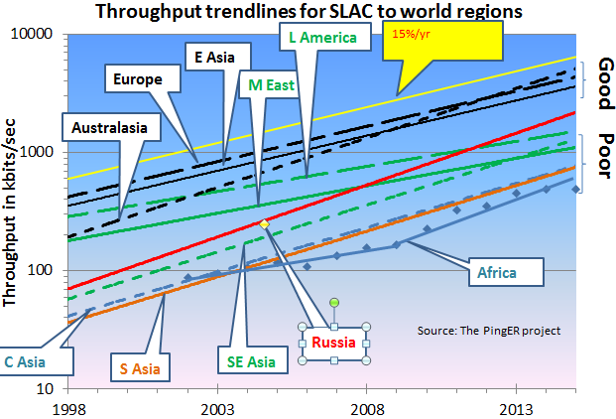

Figure : Derived Throughput kbits/sec from SLAC to the World until Dec 2015 shown as the exponential trendlines. The yellow line is to help show the rate of change

partially The slow increase for Europe in Figure 4 is partially an artifact of the difficulty of accurately measuring loss with a relatively small number of pings (14,400 pings/month at 10 pings/30 minute interval, i.e. a loss of one packet ~ 1/10,000 loss rate). We looked at using a method[[22]](#footnote-25) that allows for zero packet loss, however it requires one to know the maximum congestion window size. Unfortunately this varies from host to host and can easily be changed, so we did not pursue it.

Looking at the data points one can see:

* East Asia and Oceania are catching Europe;
* Russia is 6 years behind Europe and catching up;
* Latin America and the Middle East are 8 years behind and falling further behind;
* S. E. Asia is also 8 years behind but is catching up;
* S. Asia and Central Asia are 13 years behind and keeping up;
* We deal with Africa in the next section.

###### Africa

Africa is 14 years behind Europe. See Figure 5 where it is seen:

* In 2008-2009 Africa was 12-14 years behind Europe and even worse was falling further behind such that in 2030 it would have been 60 times worse off or almost 28 years behind.
* Prior to 2008 the rate of improvement was a factor of 2 in 7 years
* Since 2008 the improvement is a factor of 3 in 5years and at the current rate it could catch up with Europe by around 2040.
* This remarkable improvement is largely a reflection of the impact of the multiple terrestrial links installed since 2008[[23]](#footnote-26), initially driven by the soccer world cup.
* However, there is evidence that the rate of catch up has fallen off in 2013, 2014 and 2015.

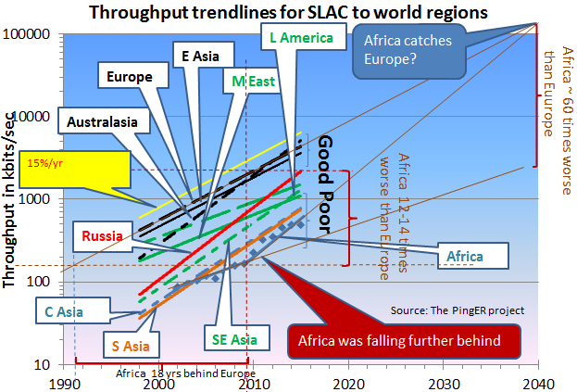

Figure : Extrapolations on the throughput data with a focus on Africa.

More detail on the derived throughput seen from SLAC for the various African sub-regions is seen in Figure 6.

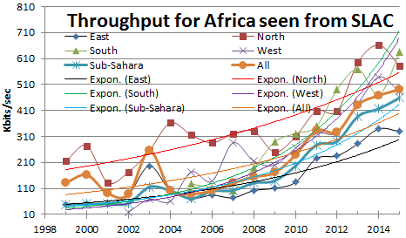

Figure : Derived annual throughputs seen from SLAC to African regions together with exponential trendlines

It is seen that:

* North Africa, for long the leader is being caught up to by Southern and West African countries,
* Sub-Sahara tracking all Africa but about 10% lower.
* East Africa and West Africa saw big improvement in 2010. It is still improving but much more slowly, possibly more linearly rather than exponentially.
* The East African region appears to have the worst performance

There are reports5 that a new subsea cable, is to be laid off Africa's eastern coastline by Liquid Sea, a literally offshore subsidiary of Liquid Telecom, which already runs a pan-African network based on terrestrial fiber-optic cable supplemented by satellite links for rural and remote areas. “It will offer speeds of 20-30Tbps, up to 10 times the capacity of existing submarine cables in the region. enabling a reliable and affordable international connectivity service to both coastal and landlocked countries in Eastern, Central and Southern Africa.” Hopefully this will measurably assist in dramatically improving access in East Africa.

# High Performance Network Monitoring

## Introduction

## Open Science Grid

## WLCG Network and Transfer Metrics Working Group

## The perfSONAR Project

perfSONAR is an open source software project that enables seamless deployment of a network monitoring infrastructure. perfSONAR is currently a successful medium size open source project with ~1,600 known public deployed instances, and likely an equal number of private deployments.

The global Research & Education (R&E) network ecosystem is comprised of hundreds of international, national, regional and local-scale networks. While these networks all interconnect, each network is owned and operated by separate organizations (called “domains”) with different policies, customers, funding models, hardware, bandwidth and configurations. This complex, heterogeneous set of networks must operate seamlessly from “end to end” to support science and research collaborations that are distributed globally.

The perfSONAR collaboration is an Open Source project lead by ESnet, Internet2, Indiana University, and GEANT. Each organization has committed 1.5 FTE effort to the project. The project also gets additional help from many others in the community, such as OSG, RNP, SLAC, and others.

The perfSONAR Roadmap is influence by the following: requests on the project issue tracker; annual user surveys sent to everyone on the user list; regular meetings with Virtual Organizations using perfSONAR such as the WLCG and OSG; and discussions at various perfSONAR related workshops.

### Recent Changes to perfSONAR

perfSONAR has historically been packaged as the **perfSONAR Toolkit**: an ISO containing a custom distribution of the CentOS operating system with all of the perfSONAR tools and services. Starting with perfSONAR 3.5, there are several other installation options as well for certain versions of both **CentOS** and **Debian/Ubuntu**:

1. **perfSONAR-Tools:** This bundle includes all tools used by perfSONAR. These tools are useful for network testing and troubleshooting in general, and we recommend you install these tools on any host where you need to maximize network performance, such as a [Data Transfer Node](http://fasterdata.es.net/science-dmz/DTN/).
2. **perfSONAR-TestPoint:** This bundle is targeted at organizations that run a centrally managed test mesh and use a central measurement archive. It contains all perfSONAR tools, including those to publish the location of these services to the perfSONAR-PS Simple Lookup Service and to run scheduled measurements. This is also the bundle to use on [low-end hardware](http://docs.perfsonar.net/low_cost_nodes.html).
3. **perfSONAR-Core:** The perfSONAR-Core install includes everything in the perfSONAR-TestPoint install plus the measurement archive.
4. **perfSONAR-Complete:** This is the full set of perfSONAR packages Toolkit distribution. It includes everything in perfSONAR-Core and also contains web interfaces and Toolkit configuration. This provides an option for installing these packages without using the Toolkit ISO.
5. **perfSONAR-CentralManagement:** The perfSONAR-CentralManagement Bundle installs the [*central mesh config*](http://docs.perfsonar.net/multi_overview.html), Maddash, centralized config service and the autoconfig.

### perfSONAR next steps

The current perfSONAR release is version 3.5. The theme for the 3.6 release is *control* and *scalability*, and release is currently scheduled for September, 2016.

In the 3.6 release, there will be a noticeable impact to both users and perfSONAR developers, and to also lay the groundwork for future releases.

**What the users get:**

* A test scheduler:
  + Shared by all tests and aware of the resources each uses
  + Containing finer grained controls about who can run tests and what tests they are allowed to run.
  + Increased visibility and control as to when tests will be run
* New graphs that allow for easier comparison of multiple metrics
* A web interface for creating test meshes
* Easier selection of endpoints based on topology location, geographic location, accessibility and/or custom searches
* Dashboards that support alerting based on patterns across an entire mesh
* Debian 8 support
* CentOS 7 versions of the tools, testpoint, core, and central management bundles
* The ability to publish summarized results about private deployments
* Ability to easily view perfSONAR logs in Kibana using logstash (https://www.elastic.co/)

**What developers (both internal and external to the core team) get:**

* Additional metadata about deployed hosts
* A test scheduler with a public rest API they can integrate into their applications, such as SDN-like applications
* A framework for integrating new tools with the perfSONAR test scheduler, without changing the scheduler code.
* A new LS cache that only requires a query to one location and includes a richer search API
* An alerting API from MaDDash that allows easier diagnosis of network or measurement infrastructure issues
* APIs to determine the closest measurement node
* APIs to determine if a test can be run to a node

**What is setup for future versions:**

* A new test scheduling platform that allows for easier integration of new tools and addition of new control in the future
* The start of a CentOS 7 transition for the full toolkit.
* Pieces needed for a true test setup wizard where the user provides little to no criteria and the tools come up with a reasonable mesh.
* Additional experience with users running large deployments

## New and Ongoing Monitoring and Diagnostic Efforts in HEP

PingER is an excellent system for monitoring the general health and capability of the existing networks used worldwide in HEP. However, we need additional end-to-end tools to provide high—performancde sites with the capability to quantify their network connectivity along specific paths in the network, quickly isolate and diagnose network issues and inform developing tools and applications that need network information to be optimize their tasks. These are needed both to ascertain the siter's current network capability as well as to identify limitations which may be impeding the user’s ultimate (expected) network performance. The perfSONAR project has grown to fill this need and we will show later how it is being leveraged to address the needs of the worldwide LHC community.

Most HEP users are not "network wizards" and don't wish to become one. In fact as pointed out by Mathis, the gap in throughput between what a network wizard and a typical user can achieve was growing significantly from the late 1980’s to the late 1990’s.

Within the last 15 years, because of improvements in default OS TCP stack settings, new protocols, hardware, firmware and software, this gap has decreased but still remains in 2014. Because of HEP's critical dependence upon networks to enable their global collaborations and grid computing environments, it is extremely important that more end-user focused tools be developed to support these physicists and continue to decrease the gap between what an expert can achieve and what a typical user can get “out of the box”.

Efforts continue in the HEP community to develop and deploy a network measurement and diagnostic infrastructure which includes end hosts as test points along end-to-end paths in the network. This is critical for isolating problems, identifying bottlenecks and understanding infrastructure limitations that may be impacting HEP’s ability to fully utilize their existing networks. The history of the effort was documented in last year’s report and we won’t repeat it here, instead highlighting updates during the last year in the following sections.

**perfSONAR for HEP**

High-energy physics grid sites rely upon the network to provide access to their computing and storage. The network provides the basis for users to access those resources and for virtual organizations to organize the sharing and use of their member's resources. When there are problems in the network, it can significantly degrade or even disable users and VOs ability to do their science.

Networking problems can be difficult to identify and isolate for numerous reasons:

* Network paths typically span multiple administrative domains with no single entity having complete access to the end-to-end infrastructure components
* Applications that work well on a Local Area Network (LAN) may behave significantly differently when run on a Wide Area Network (WAN) due to the impact of latency on the network communication involved
* End-host or LAN issues may be the actual source of problems and differentiating HOST vs LAN vs WAN problems can be difficult without sufficient expertise
* Problems that actually exist on a host or in the LAN may not be "visible" in local use and only show up when the application is used in the WAN. The tendency is to believe the WAN is the problem even though it many cases it isn't
* Real WAN problems are hard to localize and it is not practical or effective to contact every entity managing a portion of the network path on which you see a problem.

For high-performance, data intensive sites, PingER is insufficient to address these issues. Our goal is to help users, VOs and site administrators better understand their network infrastructure and enable them to more effectively find problems and isolate their root cause. To do this WLCG is mandating its Tier-0/Tier-1/Tier-2 sites deploy [perfSONAR Toolkit](http://docs.perfsonar.net/" \l "installation" \t "_top) instances in their infrastructure. A brief overview of the recent history behind this follows.

In June of 2012, the Open Science Grid (OSG) began a new effort in networking to enable OSG to become the networking information provider for its constituents. A primary goal was to work with the perfSONAR developers and the various Virtual Organizations (VOs) supported by OSG to enable pervasive network monitoring, regularly collecting network measurements, visualizing them and making them available for users and higher level services.

At nearly the same time (fall of 2012) the Worldwide LHC Computing Grid (WLCG) formed a deployment task force to guide the deployment and configuration of the perfSONAR Toolkit at all WLCG Tier-1 and Tier-2 sites worldwide. This decision was made in great part based upon both the success in using perfSONAR in the US and within the LHCOPN as well as the increasing need to better integrate networks within our HEP global cyberinfrastructure. This deployment task-force finished its work in spring 2014, having gotten 220 perfSONAR toolkits fully deployed (with 6 additional deployment’s “planned”) by May 30, 2014. WLCG then created a follow-on working group (the WLCG Network and Transfer Metrics Working Group[[24]](#footnote-27)) to maintain the perfSONAR deployments as well as to ensure all needed metrics from the network and transfer tools were being captured and made available to WLCG. This working group has actively supported new sites to install and configure perfSONAR, as well as documenting installation/upgrade procedures and coordinating and maintaining the systems already deployed. The working group tracks status (updated daily) at <http://grid-monitoring.cern.ch/perfsonar_coverage.txt>

### Using and Managing perfSONAR

The perfSONAR systems in WLCG (and OSG) are intended to serve a number of purposes. First we intend these systems to run regularly scheduled tests with other WLCG sites to track network behavior, verify proper network operation and find any problems as early as possible. There are three types of tests that are run: 1) traceroute (to monitor the network path between sites), 2) latency (to monitor one-way latency AND packet loss along the path) and 3) bandwidth (to provide a measure of available bandwidth between sites). The frequency of tests, the testing partners and the test parameters all need to be adjusted depending upon which set of sites are involved. WLCG has chosen to organize testing by Tier-1 cloud meshes, sometimes VO specific. For example, we have a USATLAS mesh (comprising the USATLAS Tier-1 and Tier-2 sites) as well as a USCMS mesh (comprising the USCMS Tier-1 and Tier-2 sites) but in the UK we have a single UK mesh (happens to be mostly ATLAS). There will be more on the meshes and how they are organized below. Another purpose for the perfSONAR instances is to provide a site “beacon” that can respond to on-demand tests. The perfSONAR developers have provided command line tools to run bandwidth or latency tests as required (if a problem is suspected). In addition the toolkit instances have some additional on-demand tests that try to identify common problems along a network path. Though not updated recently, NPAD and NDT are still useful to allow users to run a quick diagnostic via a web browser to the perfSONAR instances of their choice.

One of the challenges for a large scale deployment of perfSONAR is managing the tests amongst the participating sites. When USATLAS began deploying perfSONAR in 2008, all configuration for each site was controlled by “emails” to the perfSONAR administrators. Every change (addition or deletion) required every administrator to update their configuration. The perfSONAR developers provided a solution with the so called “mesh-configuration”. The perfSONAR toolkit was updated to provide a mesh agent that could get its configuration from URL. A web server could provide the JSON configuration for a whole mesh and changes could be made centrally. The perfSONAR administrators just needed to configure their agent to read from the specified URL for each mesh they participate in.

In 2014, OSG improved upon this system by providing a secured GUI in MyOSG (see Figure 24) that could construct meshes based upon the perfSONAR registration information required by OSG and WLCG. All perfSONAR instances in OSG are required to be registered in OIM while all such instances in WLCG (not in OSG) are required to be registered in GOCDB. This allows OSG to centrally gather all needed information to create meshes for use by perfSONAR instances all over the world. Once created the meshes automatically update as registration information is updated.

One further interesting capability was enabled by OSG because of their mesh-management system: since OSG knows which perfSONAR hosts are participating in which meshes it is possible to have each perfSONAR instance configure a single URL (even if they participate in multiple meshes). We call this new URL the “auto-mesh” URL and is identical for all perfSONAR hosts except for the last part, which is the perfSONAR host’s fully qualified domain name, e.g., [https://myosg.grid.iu.edu/pfmesh/mine/hostname/<FQDN](https://myosg.grid.iu.edu/pfmesh/mine/hostname/%3cFQDN)>. This is very powerful in that now perfSONAR admins no longer need to update their configuration if meshes are added or changed.

Using the mesh management system from OSG, we can now easily manage how, where and when tests are run. We need to walk a careful line of testing only enough to meet our needs. We have a tension between those who would like better test coverage vs those concerned about using available bandwidth to test.

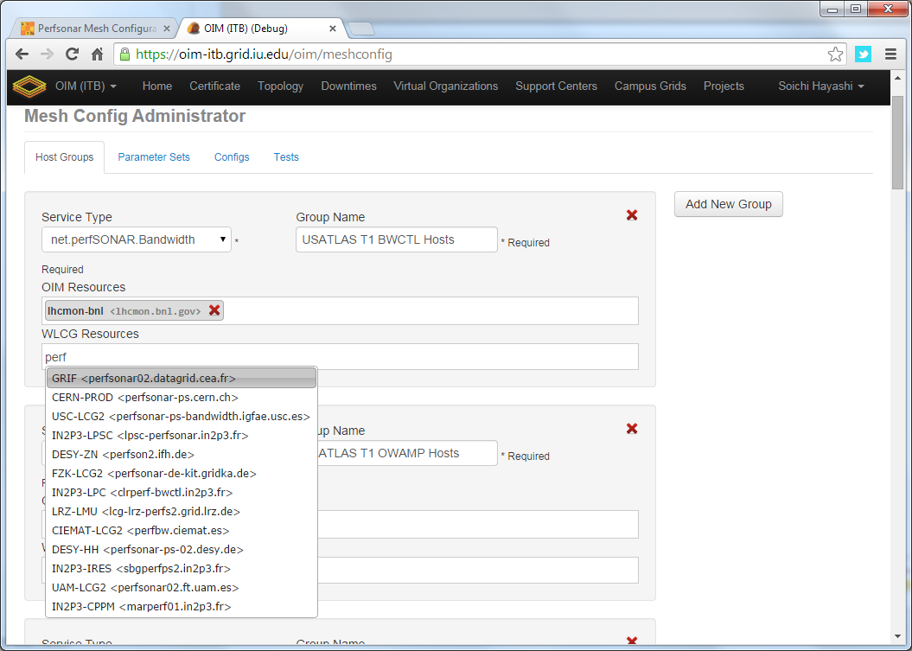

Figure 7: Example of OSG's mesh-management tool interface

The latency test we have configured are managed by OWAMP and measures one-way delays between the latency node and its test partner at another site. We send 10Hz of small UDP packets to each test partner continuously (600 packets/minute). Since absolute time accuracy is critical for this test, part of a latency node configuration includes setting up a reliable time service (ntpd) configuration to ensure the node keeps accurate time. From this measurement we get the one-way delay to the partner site as well as information on any packet losses for each 1 minute interval (how many of the 600 packets were lost?). It is the packet loss measurement that is very sensitive to problems along the network path.

The second type of test measures throughput using Iperf. Within a Tier-1 cloud mesh we schedule a 30 second throughput test each direction (source to destination and destination to source) every 6 hours. In addition EACH end schedules it (both ways) so we end up with two 30 second tests each direction each 6 hours. We additionally are trying to sample ALL network paths but at a much lower cadence. To do this we have setup a WLCG-wide mesh which tries to run a 30 second throughput test each direction, once per week. Until we can determine the impact of this, we have limited the WLCG mesh to be the largest 50 sites (according to their published disk storage numbers).

The last type of test is a critical one: traceroute. The traceroute test tracks the network path between the host and any destination and is run every 20 minutes to EACH destination which is being tested. If the route changes, we record the new route in the perfSONAR measurement archive. This is required to understand the topology we are measuring and can alert us to routing changes that may be correlated with observed network problems.

Details about how to setup and configure perfSONAR for OSG/WLCG are maintained at <https://twiki.opensciencegrid.org/bin/view/Documentation/DeployperfSONAR>

### Network Datastore

OSG and WLCG have worked closely together on perfSONAR for high-energy physics (and others). OSG, as a member of WLCG, has agreed to become the control hub for the global perfSONAR deployment and has developed a Network Datastore, based upon the Esmond datastore in perfSONAR v3.4, to host all the perfSONAR metrics. This datastore collects in near real time all perfSONAR test results from OSG/WLCG perfSONAR instances and allows users to query the test results from a single Esmond instance. The datastore also publishes the test results through ActiveMQ server hosted by WLCG that users can subscribe to. Figure 25 provides an architecture diagram of the OSG network datastore, showing the use of a back-end Cassandra database easily scaled by adding additional instances. This datastore is intended to become the source of network metrics for OSG and WLCG and went production in November 2015.

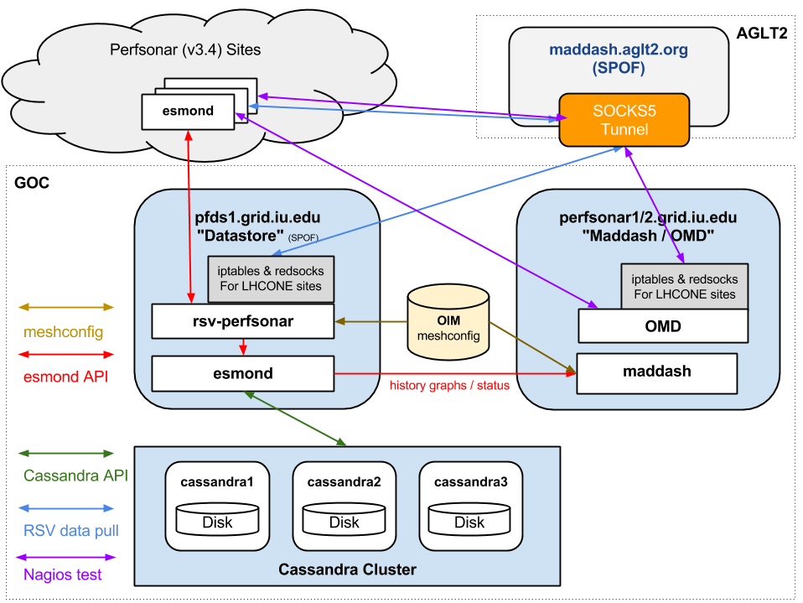

Figure 8 The OSG network datastore architecture used to gather, organize and archive network metrics from the global OSG and WLCG perfSONAR deployment and make those measurements available for visualization or higher-level services.

**perfSONAR Metric Visualization**

While perfSONAR provides a convenient way to gather standardized network metrics via deploying a toolkit instance, it can still be cumbersome to try to gather, check and interpret this data. As USATLAS began deploying perfSONAR instances we realized that a critical missing component was a means of centrally monitoring and displaying the information we were collecting. ESnet had some initial efforts in this direction by creating [Nagios](http://www.nagios.org/) “plugins” that could query individual perfSONAR instances and check to see if the data returned was within bounds.

Originally we started a project to provide a visualization and management dashboard, call the Modular Dashboard project. However the developer left BNL (where the project was hosted) in 2013 and we replaced it with MaDDash, a project created and supported by ESnet. We now use MaDDash to monitor all our WLCG and OSG metrics. The prototype instance can be seen at <http://maddash.aglt2.org/maddash-webui/> (and in Figure 26). Colors indicate whether the metrics tracked are OK (green), WARNING (yellow), CRITICAL (red) or UNAVAILABLE (orange). MaDDash also supports “drilling-down” by clicking on the cell which will take the user to an interface with historical data, graphs and details of the test results.

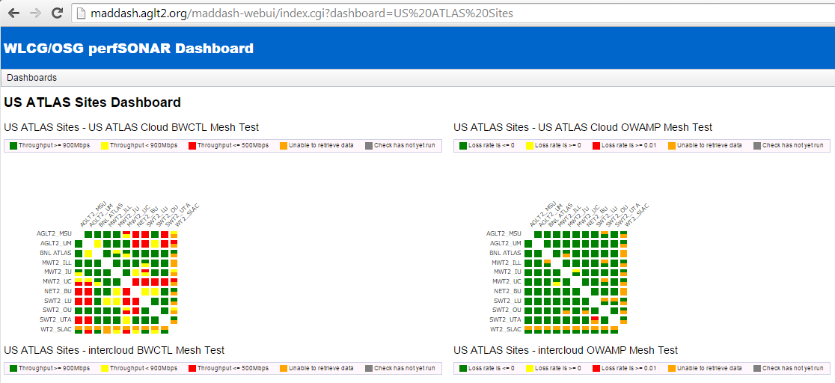

Figure : Example of MaDDash dashboard in prototype instance at AGLT2 showing the USATLAS meshes for bandwidth and latency.

OSG hosts the production instance at <https://perfsonar2.grid.iu.edu/maddash-webui/>

**Infrastructure and Service Monitoring**

In addition to metric visualization, the global perfSONAR deployment has another challenge. We need to be able to quickly find problems in the measurement infrastructure itself. While perfSONAR has evolved to be more robust over time, there are still cases where it has problems and fails to gather the needed metrics. To address this we have created a simple-to-deploy infrastructure monitoring system based upon OMD (Open Monitoring Distribution; <http://omdistro.org/> ) which is a single RPM install of Nagios and many integrated applications. This has allowed us to quickly find infrastructure issues and better support end-sites when they have problems. We have created service checks for all perfSONAR services (by host type) as well as checks on registration information like admin name and email, latitude and longitude and program version. See Figure 27 for a view of OMD summarizing the WLCG perfSONAR host status.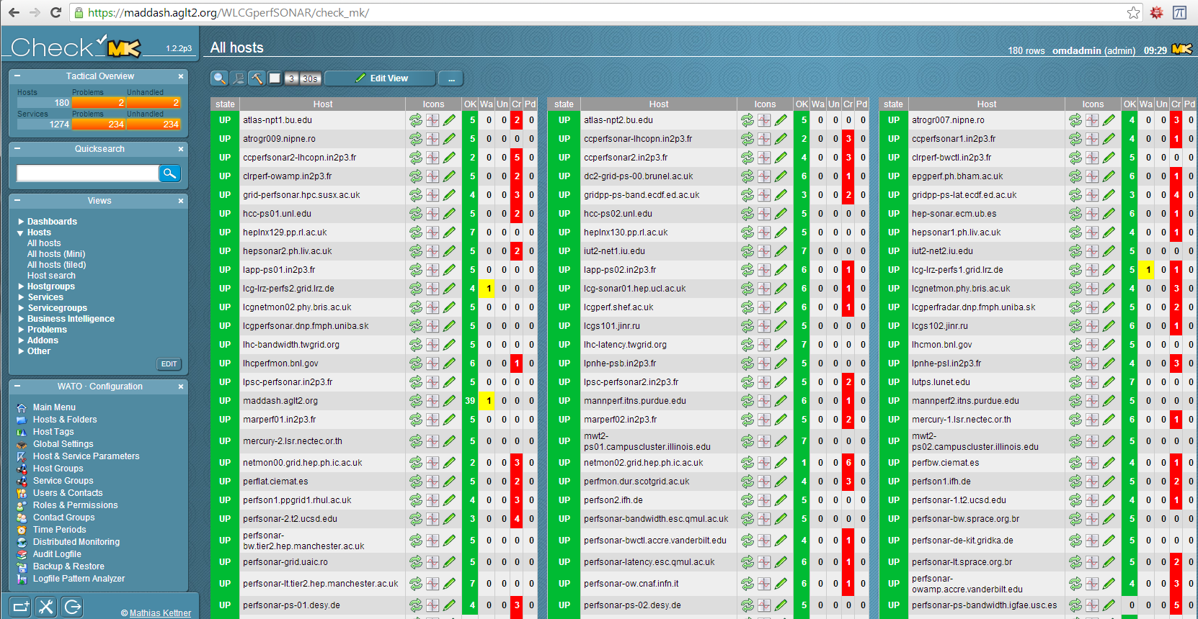

Figure : OMD Check\_MK screenshot showing some of the monitored perfSONAR hosts in WLCG.

OSG hosts the production version@ <https://perfsonar2.grid.iu.edu/WLCGperfSONAR/check_mk>

**Complementary End-to-End Monitoring**

The WLCG network and transfer metrics working group is trying to identify additional metrics related to ongoing data-transfers that can also provide insight into both the networks WLCG uses and well as the end-to-end data transfers continually underway. Both ATLAS and CMS rely upon FTS (and now FTS3) to handle transfers of files between sites and the transfer details (file size, source, destination, time, transfer rate) are tracked centrally. In addition the LHC experiments are also using the xrootd protocol to provide WAN access to data files directly, rather than copying the files first. To check the xrootd behavior regular xrootd file transfers are regularly scheduled between various sites and the results are stored in a central database at CERN.

The combination of file transfer metrics end-to-end along with the set of network metrics provided by perfSONAR will allow us to quickly differentiate between end-site issues and network issues.

**Summary: Progress in HEP Network Monitoring for 2015**

As noted above, efforts to ensure commonality in both monitoring and provisioning of networks have seen a significant increase in activity in HEP during 2015. Originally, the [GLIF](http://www.glif.is/)[[25]](#footnote-28) and [DICE](http://www.geant2.net/server/show/conWebDoc.1308)[[26]](#footnote-29) communities were both working toward implementing “managed” network services and the corresponding monitoring that will be needed to support their efforts. During 2015 there were a number of new or expanded initiatives within global HEP:

* The WLCG community completed deploying perfSONAR toolkits at sites to provide needed network visibility for users, site-admins and eventually higher-level services.
* The Open Science Grid (OSG) focused on provisioning network monitoring within OSG to become the definitive source of networking information for OSG sites as part of their year-2 planning for networking.
* Previous ATLAS-initiated perfSONAR deployments within national regions in the US, Italy and Canada, were augmented by new national deployments in France, Germany, Spain, Taiwan, Russia and the UK and now include all four LHC experiments.
* The Worldwide LHC Computing Grid (WLCG) continued work on network issues via the networking committee chaired by Michael Ernst.

To summarize, 2015 has seen a convergence to a standard network monitoring infrastructure based upon perfSONAR. The goal is to have a single system to provide network related metrics for HEP. This is feasible because HEP’s use of the network is qualitatively the same between HEP collaborations. It is desirable because network providers and users don’t want to have multiple “network measurement infrastructures” making redundant (and possibly interfering) measurements nor do they wish to have to develop, deploy and support many such instances when one will do.

***Related HEP Network Resear****ch*

There has been a significant amount of research around managed networks for HEP that we should note. <Mention ANSE, BigPANDA, PuNDIT, various Caltech projects, BNL work, perfSONAR efforts, etc.>. Some of the existing monitoring discussed in previous sections either came out of these efforts or is being further developed by them.

In summer 2010 a new NSF MRI project was funded called [DYNES](http://www.internet2.edu/ion/dynes.html)[[27]](#footnote-30). The DYNES collaboration (Internet2, Caltech, Michigan and Vanderbilt) intends to create a virtual distributed instrument capable of creating dynamic virtual circuits on-demand between the participating member sites. The LHC community and its data access and transport requirements are the primary “users” targeted by this new infrastructure. Funding was provided to initially deploy DYNES at 40 institutions and 14 regional networks within the United States. DYNES leverages prior work related to virtual circuit construction, QoS and perfSONAR to enable the required capabilities. Instrument deployment began in spring 2011. The DYNES project was completed in July 2013 but work is continuing on a best effort basis to improve the ability of DYNES sites to utilize end-to-end circuits.

During 2012, with the LHC Long Shutdown 1 (LS1) approaching in 2013 through the spring of 2015, many people realized we have an opportunity to better integrate networking within our various LHC computing and software infrastructure. Two specific proposals targeting this area were funded in 2012 and have been active in 2013:

* Advanced Network Services for Experiments (ANSE), NSF funded (Caltech, Michigan, Vanderbilt and U Texas Arlington)
* Next Generation Workload Management and Analysis System for Big Data, PANDA integration with networking, DOE ASCR funded (BNL, U Texas Arlington)

ANSE is focusing on the integration of advanced network services into the software stacks of ATLAS and CMS with a goal of transparently integrating new networking capabilities to increase the overall efficiency and effectiveness of their globally distributed computing and storage resources. The ATLAS PANDA proposal has a similar focus and is trying to update the PANDA infrastructure with network “awareness” and the ability to interact with network services to prioritize and manage its workload.

## Comparison with HEP Needs

Previous studies of HEP needs, for example the TAN Report (<http://gate.hep.anl.gov/lprice/TAN/Report/TAN-report-final.doc>) have focused on communications between developed regions such as Europe and North America.  In such reports packet loss less than 1%, vital for unimpeded interactive log-in, is assumed and attention is focused on bandwidth needs and the impact of low, but non-zero, packet loss on the ability to exploit high-bandwidth links.  The PingER results show clearly that much of the world suffers packet loss impeding even very basic participation in HEP experiments and points to the need for urgent action.

The PingER throughput predictions based on the Mathis formula assume that throughput is mainly limited by packet loss.  The 15% per year growth curve in Figure 10 is somewhat lower than the 79% per year growth in future needs that can be inferred from the tables in the TAN Report. True throughput measurements have not been in place for long enough to measure a growth trend.  Nevertheless, the throughput measurements, and the trends in predicted throughput, indicate that current attention to HEP needs between developed regions could result in needs being met.  In contrast, the measurements indicate that the throughput to less developed regions is likely to continue to be well below that needed for full participation in future experiments.

# Recommendations

There is interest from ICFA, ICTP, IHY and others to extend the monitoring further to countries with no formal HEP programs, but where there are needs to understand the Internet connectivity performance in order to aid the development of science. Africa is a region with many such countries. The idea is to provide performance within developing regions, between developing regions and between developing regions and developed regions.

We should strive for >=2 remote sites monitored in each major Developing Country. All results should continue to be made available publicly via the web, and publicized to the HEP community and others. Typically HEP leads other sciences in its needs and developing an understanding and solutions. The outreach from HEP to other sciences is to be encouraged. The results should continue to be publicized widely.

We need assistance from ICFA and others to find sites to monitor and contacts in the developing and the rest of the world, especially where we have <= 1 site/country. A current list of countries with active nodes can be found at <http://www-iepm.slac.stanford.edu/pinger/sites-per-country.html>.

# Future Support for PingER

The PingER project with members in: Pakistan at NUST Islamabad and the University of Agriculture Faisalabad; the Malaysian Universities of UNIMAS, UM, and UUM; and SLAC continues to meet monthly by Skype. In addition there are collaborators at the Federal University of Rio de Janeiro, and the Federal Rural University of Rio de Janeiro.

The funding we had at SLAC is now exhausted as is the Pakistani Higher Education Commission (HEC) funding for PingER at NUST. As a result the resources available to PingER in Pakistan dropped and the number of working monitoring hosts in Pakistan has dropped by about 50% (~20).

Hassaan Khaliq of NUST has submitted a proposal to HEC and is optimistic that if the proposal is accepted then we can easily have a full time RA for the project. However it may take a while to get acceptance and funding. In the meantime NUST has also added another student on this project who will be working to improve the monitors in Pakistan. In addition the father/mentor of PingER in Pakistan Dr. Arshad Ali has now left NUST and is now the executive director of HEC. This post is the second highest in HEC, right after the chairman.

In the last year, there has been considerable interest and effort to use big data/analysis techniques with cluster computing/Hadoop/Cloudera to mine the PingER data and we (NUST, Malaysian and Brazilian universities) published four papers on this work. To assist in this we have carefully gathered together the PingER raw measurements and the analyzed data and made data, going back to 1998, available via anonymous FTP.

In the coming year:

* There is still interest in Africa as seen in the recent Huffington Post Article6 so we will be ensuring that we continue to track Africa’s Internet performance;
* We look forward to a successful resolution of NUSTs proposal to HEC;
* This summer, we plan to host a student from Brazil for 3 months at SLAC to continue the work on the PingER data warehouse;
* We are working with a team including 9 students at Amity University in Delhi India who are working on analyzing PingER data. Once the students have their degree we plan to invite them to SLAC.

# Acknowledgements

We gratefully acknowledge the following: the assistance from NUST SEECS in improving the PingER toolkit and management has been critical to keeping the project running, with respect to this we particularly acknowledge the support of their leader Arshad Ali; and the students and lecturers who have assisted including recently: Umar Kalim, Anjum Navid, Raja Asad Khan of NUST SEECS who helped in updating some of the graphs, the case studies on Africa and Pakistan and implementation of PingER tools such as TULIP. Mike Jensen provided much useful information on the status of networking in Africa[[28]](#footnote-31). Alberto Santoro of UERJ provided very useful information on Latin America. Sergio Novaes of UNESP and Julio Ibarra of Florida International University provided useful contacts in Latin America. We received much encouragement from Marco Zennaro and Enrique Canessa of ICTP and from the ICFA/SCIC in particular from Harvey Newman the chairman. We must also not forget the help and support from the administrators of the PingER monitoring sites worldwide as well as all the perfSONAR site managers and the WLCG working group members.

.

# Appendices

## Appendix A: PingER Presentations etc. in 2015.

### Publications and White papers (most recent first)

* Survey on Big Data Indexing strategies, Fatima Bintu Adama, Adib Habbal, Suhaidi Hassan, R. Les Cottrell. Bebo White, Ibrahim Abdullahi, presented at NETAPPS 2015[[29]](#footnote-32).
* Worldwide Internet Performance Measurements Using Lightweight Measurement Platforms  
  R. Les Cottrell, Thiago Barbosa, Bebo White, Johari Abdullah and Topher White, SLAC-PUB-16343, presented at NETAPPS 201534.
* Applying Data Warehousing and Big Data Techniques to Analyze Internet Performance, T. M. S. Barbosa, R. F. Souza, S. M. S. Cruz, M. L. Campos and R. Les Cottrell. SLAC PUB, presented at NETAPPS2015 34.
* PingER Malaysia-Internet Performance Measuring Project: A Case Study, Saqib Khan, R. Les A Cottrell, Anjum Naveed, SLAC-PUB-16359, presented at NETAPPS 201534.
* Adaptive Geolocation of Internet Hosts, Raja A.A. Khan, R. Les. Cottrell, Anjum Naveed, SLAC-PUB-16360, presented at NETAPPS 201534.
* International Committee for Future Accelerators - Standing Committee on Inter-Regional Connectivity (ICFA-SCIC) 2015 [Report on Networking](https://confluence.slac.stanford.edu/download/attachments/123309267/report-jan15.docx?version=1&modificationDate=1425072461000&api=v2)[,  compiled by Les Cottrell and Shawn McKee on behalf of the working group, January 201](http://www.slac.stanford.edu/xorg/icfa/icfa-net-paper-jan14/report-jan14.docx)5.

### Talks (most recent first)

* [PingER Malaysia-Internet Performance Measuring Project: A Case Study](https://confluence.slac.stanford.edu/download/attachments/123309267/saqib-pres.pptx?version=1&modificationDate=1448936529000&api=v2), Saqib Ali, R. Les Cottrell, Anjum Naveed, presented at NetApps2015, Dec 2015
* [Applying Data Warehousing and Big Data Techniques to Analyze Internet Performance](https://confluence.slac.stanford.edu/download/attachments/123309267/NETAPPS_PRESENTATIONrevLuiza.pptx?version=1&modificationDate=1448936351000&api=v2), Thiago Barbosa, Renan Souza, Sergio Serra, R. Les Cottrell presented at NetApps2015, Dec 2015
* [Worldwide Internet performance measurements using a Raspberry P](https://confluence.slac.stanford.edu/download/attachments/123309267/netapps-rpi.pptx?version=2&modificationDate=1448935554000&api=v2)i, presented at NetApps2015, Dec 2015.  Also a [video](ftp://ftp.slac.stanford.edu/users/cottrell/IMG_2706.MOV).
* [Adaptive Geolocation of Internet Hosts,](https://confluence.slac.stanford.edu/download/attachments/123309267/NetAppsFinal.pdf?version=1&modificationDate=1448936923000&api=v2) Raja A. A. Khan, Anjum Naveed, R. Les Cottrell presented at NetApps2015, Dec 2015
* [Monitoring the World's Networks](https://confluence.slac.stanford.edu/download/attachments/123309267/icfa-2015-presentation.pptx?version=1&modificationDate=1425072108000&api=v2)[, Les Cottrell et. al., presented by Prof Harvey Newman at the](http://www.slac.stanford.edu/xorg/icfa/icfa-net-paper-jan14/ICFASCICPresentation_MonitoringGroupSlides20140205.pptx)[ICFA meeting](http://icfa-scic.web.cern.ch/icfa-scic/meetings.html)[CERN February 2015.](http://www.slac.stanford.edu/xorg/icfa/icfa-net-paper-jan14/ICFASCICPresentation_MonitoringGroupSlides20140205.pptx)

## Appendix B: PingER Project History in 2015

There is a complete history of the PingER project this millennium[[30]](#footnote-33). Here we only report on 2015.

We extended the collaboration with the University of Malaysia in Sarawak (UNIMAS), the University of Malaya (UM) in Kuala Lumpur and Universiti Tehcnologi Malaysia (UTM) in Johor Bahru to add Universiti Utara in Northern mainland Malaysia (UUM) and the Malaysia Research and Education Network (MYREN) Internet Service Provider. We held 12 (monthly) Skype meetings[[31]](#footnote-34) with NUST, UM, UTM, UUM, UNIMAS and MTREN.

Worked with the Rector of NUST and the new Director of SEECS to ensure continuity of the PingER project at NUST, following Dr Arshad Ali’s move from the Director of SEECS to the executive director of the Pakistani Higher Education Commission (HEC). This post is the second highest in HEC, right after the chairman.

We met with Colombia RENATA NREN leaders and the Colombia minister of IT to discuss the use of PingER in Colombia. To assist we put together a short case study on Colombia[[32]](#footnote-35). However after several months this collaboration did not go anywhere.

To support multiple Big Data Analysis of PingER data projects at UM, UUM, UFRJ, and Amity University in New Delhi we gathered both the raw (as measured) data and the hourly analyzed data from 1998 to the present and made it available[[33]](#footnote-36) via anonymous FTP. We also provided information on retrieving the data[[34]](#footnote-37).

To support the porting of PingER to an Android smartphone we made the PingER measurement Agent available via Github[[35]](#footnote-38).

Utilizing a SLAC 4 host cloud with~16Gbytes each, plus access to 220Gbytes each, with Hadoop, Cloudera and Impala, Thiago Barbosa put together a warehouse of hourly PingER data going back to 1998. It successfully provided database queries to access the full set of PingER data with response times of several seconds. Unfortunately due to lack of time at SLAC, we were unable to make the access available outside of SLAC.

We put together a report on Duplicate ping responses[[36]](#footnote-39).

Successfully ported PingER to a Raspberry Pi version 1[[37]](#footnote-40).

We put together a case study on the impact of demonstrations against the government in Malaysia (August28-31st 2015) on various Malaysian hosts[[38]](#footnote-41).

We prepared and presented five papers at the 4th International Conference on Internet Applications, Protocols and Services (NETAPP2015) Cyberjaya, Malaysia, 1-3 December 2015[[39]](#footnote-43).

Bebo White made a keynote presentation at the CITA 9th International Conference on IT in Asia[[40]](#footnote-44) on Transforming Big Data into Knowledge. Bebo used PingER as a case study on what you can do with PingER and how to access the data.

## Appendix C: ICFA/SCIC Network Monitoring Working Group

The formation of this working group was requested at the [ICFA/SCIC meeting at CERN in March 2002[[41]](#footnote-46)](http://www.slac.stanford.edu/grp/scs/trip/cottrell-icfa-mar02.html). The mission is to: *Provide a quantitative/technical view of inter-regional network performance to enable understanding the current situation and making recommendations for improved inter-regional connectivity.*

The lead person for the monitoring working group was identified as Les Cottrell. The lead person was requested to gather a team of people to assist in preparing the report and to prepare the current ICFA report for the end of 2002. The team membership used to consist of:

Table : Members of the ICFA/SCIC Network Monitoring team

|  |  |  |  |
| --- | --- | --- | --- |
| *Les Cottrell\** | SLAC | US | [cottrell@slac.stanford.edu](mailto:cottrell@slac.stanford.edu) |
| Richard Hughes-Jones | University of Manchester | UK and DANTE | Richard Hughes-Jones (Richard.Hughes-Jones@dante.net) |
| Sergei Berezhnev | RUHEP, Moscow State.Univ. | Russia | sfb@radio-msu.net |
| Sergio F. Novaes | FNAL | S. America | novaes@fnal.gov |
| Fukuko Yuasa | KEK | Japan and E. Asia | fukuko.yuasa@kek.jp |
| Shawn McKee\* | Michigan | I2 HEP Net Mon WG, USATLAS | [smckee@umich.edu](mailto:smckee@umich.edu) |

\*Still active.

### Goals of the Working Group

* Obtain as uniform picture as possible of the present performance of the connectivity used by the ICFA community
* Prepare reports on the performance of HEP connectivity, including, where possible, the identification of any key bottlenecks or problem areas

1. Providing Internet access for hard to reach places, see <https://confluence.slac.stanford.edu/display/IEPM/Providing+Internet+Access+for+hard+to+reach+places>. [↑](#footnote-ref-4)
2. Since North America officially includes Mexico, the Encyclopedia Britannica recommendation is to use the terminology Anglo America (US + Canada). However, in this document North America is taken to mean the U.S. and Canada. [↑](#footnote-ref-5)
3. A Giant Leap 2016? Africa is narrowing its Techno-gap, see <http://www.huffingtonpost.com/david-tereshchuk/a-giant-leap-in-2016-africa_b_8901556.html> [↑](#footnote-ref-6)
4. See http://www.internetworldstats.com/stats1.htm [↑](#footnote-ref-7)
5. Internet World Statistics available at <http://www.internetworldstats.com/stats1.htm> [↑](#footnote-ref-8)
6. A host is considered unreachable when none of the pings sent to it there is no response to any of the pings sent to it. [↑](#footnote-ref-9)
7. MonALISA, see http:// monalisa.caltech.edu [↑](#footnote-ref-10)
8. Pathload, see <http://www.cc.gatech.edu/fac/Constantinos.Dovrolis/bw-est/pathload.html> [↑](#footnote-ref-11)
9. What is perfSONAR available at http://www.perfsonar.net/ [↑](#footnote-ref-12)
10. Iperf home page is available at http://dast.nlanr.net/Projects/Iperf/ [↑](#footnote-ref-13)
11. Iperf3 at ESnet is available at http://software.es.net/iperf/ [↑](#footnote-ref-14)
12. PingER Malaysia-Internet Performance Measuring Project: A Case Study, Saqib Ali, , R. Les Cottrell and Anjum Naveed, presented at NETAPPS2015, see <https://confluence.slac.stanford.edu/download/attachments/123309267/saqib-pres.pptx> [↑](#footnote-ref-15)
13. R. Les Cottrell, Thiago Barbosa, Bebo White, Johari Abdullah and Topher White, Worldwide Internet Performance Measurements using a Raspberry Pi, presented at NETAPPS2015, see <https://confluence.slac.stanford.edu/download/attachments/123309267/netapps-rpi.pptx> [↑](#footnote-ref-16)
14. ICFA/SCIC Monitoring Working Group’s Annual Reports, see <http://www.slac.stanford.edu/xorg/icfa/scic-netmon/#annual> [↑](#footnote-ref-17)
15. "PingER". Available <http://www-iepm.slac.stanford.edu/pinger/>; W. Matthews and R. L. Cottrell, "The PingER Project: Active Internet Performance Monitoring for the HEP Community", IEEE Communications Magazine Vol. 38 No. 5 pp 130-136, May 2002. [↑](#footnote-ref-18)
16. R. L. Cottrell, "Tutorial on Internet Monitoring & PingER at SLAC". See <http://www.slac.stanford.edu/comp/net/wan-mon/tutorial.html> [↑](#footnote-ref-19)
17. In special cases, there is an option to reduce the network impact to ~ 10bits/s per monitor-remote host pair. [↑](#footnote-ref-20)
18. PERFormance Service Oriented Network monitoring Architecture , see <http://www.perfsonar.net/> [↑](#footnote-ref-21)
19. WLCG/OSG perfSONAR details: <https://twiki.opensciencegrid.org/bin/view/Documentation/DeployperfSONAR> [↑](#footnote-ref-22)
20. International Committee for Future Accelerators - Standing Committee on Inter-Regional Connectivity (ICFA-SCIC) 2015 [Report on Networking](https://confluence.slac.stanford.edu/download/attachments/123309267/report-jan15.docx?version=1&modificationDate=1425072461000&api=v2)[,  compiled by Les Cottrell and Shawn McKee on behalf of the working group, January 201](http://www.slac.stanford.edu/xorg/icfa/icfa-net-paper-jan14/report-jan14.docx)5. [↑](#footnote-ref-23)
21. M. Mathis, J. Semke, J. Mahdavi, T. Ott, ["The Macroscopic Behavior of the TCP Congestion Avoidance Algorithm"](http://www.psc.edu/networking/papers/model_ccr97.ps),*Computer Communication Review*, volume 27, number 3, pp. 67-82, July 1997 [↑](#footnote-ref-24)
22. “[Modeling TCP throughput: A simple model and its empirical validation](http://conferences.sigcomm.org/sigcomm/1998/tp/paper25.pdf)” by J. Padhye, V. Firoiu, D. Townsley and J. Kurose, in *Proc. SIGCOMM Symp. Communications Architectures and Protocols* Aug. 1998, pp. 304-314. [↑](#footnote-ref-25)
23. African Undersea Cables, see <http://manypossibilities.net/african-undersea-cables/> [↑](#footnote-ref-26)
24. Working group wiki at https://twiki.cern.ch/twiki/bin/view/LCG/NetworkTransferMetrics [↑](#footnote-ref-27)
25. “Global Lambda Integrated Facility”, see <http://www.glif.is/> [↑](#footnote-ref-28)
26. “DANTE-Internet2-CANARIE-ESnet collaboration, see <http://www.geant2.net/server/show/conWebDoc.1308> [↑](#footnote-ref-29)
27. “Development of Dynamic Network System”, Internet2, see <http://www.internet2.edu/ion/dynes.html> [↑](#footnote-ref-30)
28. Mike Jensen, ["Connectivity Mapping in Africa"](http://www.ictp.trieste.it/~ejds/seminars2002/Mike_Jensen/jensen-full.ppt), presentation at the ICTP Round Table on Developing Country Access to On-Line Scientific Publishing: Sustainable Alternatives at ITCP, Trieste, October 2002. Available http://www.ictp.trieste.it/~ejds/seminars2002/Mike\_Jensen/jensen-full.ppt [↑](#footnote-ref-31)
29. 4th International Conference on Internet Applications, Protocols and Services [NETAPPS2015] Cyberjaya, Malaysia, 1-3 December 2015, see http://netapps2015.internetworks.my/v2/ [↑](#footnote-ref-32)
30. History of PingER this Millenium, see <https://confluence.slac.stanford.edu/display/IEPM/History+of+growth+in+PingER+hosts+this+millenium> [↑](#footnote-ref-33)
31. 2015 PingER Meetings, see <https://confluence.slac.stanford.edu/display/IEPM/2015+PingER+meetings>. [↑](#footnote-ref-34)
32. Colombia, see <https://confluence.slac.stanford.edu/display/IEPM/Colombia>. [↑](#footnote-ref-35)
33. Archiving PingER data by tar for retrieval by anonymous FTP, see <https://confluence.slac.stanford.edu/display/IEPM/Archiving+PingER+data+by+tar+for+retrieval+by+anonymous+ftp>. [↑](#footnote-ref-36)
34. Retrieving Archived PingER data from Anonymous FTP, see <https://confluence.slac.stanford.edu/display/IEPM/Retrieving+Archived+PingER+data+from+Anonymous+FTP>. [↑](#footnote-ref-37)
35. Official pinger2 network monitoring, see <https://github.com/iepm/>. [↑](#footnote-ref-38)
36. Duplicate packets, see <https://confluence.slac.stanford.edu/display/IEPM/Duplicate+packets>. [↑](#footnote-ref-39)
37. ePingER Project at SLAC, see <https://confluence.slac.stanford.edu/display/IEPM/ePinger+Project+at+SLAC>. [↑](#footnote-ref-40)
38. Malayisan unrest Aug-Sep 2015, see <https://confluence.slac.stanford.edu/display/IEPM/Malaysian+unrest+Aug-Sep+2015>. [↑](#footnote-ref-41)
39. 4th International Conference on Internet Applications, Protocols and Services (NETAPP2015) Cyberjaya, Malaysia, 1-3 December 2015, see <http://netapps2015.internetworks.my/v2/>. [↑](#footnote-ref-43)
40. CITA 9th International Conference on IT in Asia, see <http://www.cita.my/cita2015/>. [↑](#footnote-ref-44)
41. "ICFA/SCIC meeting at CERN in March 2002". Available <http://www.slac.stanford.edu/grp/scs/trip/cottrell-icfa-mar02.html> [↑](#footnote-ref-46)