International Committee for Future Accelerators (ICFA)
Standing Committee on Inter-Regional Connectivity (SCIC)
Chairperson: Professor Harvey Newman, Caltech

ICFA SCIC Network Monitoring Report

Prepared by the ICFA SCIC Monitoring Working Group
On behalf of the Working Group:
Les Cottrell cottrell@slac.stanford.edu



2009 - 2010 Report of the ICFA-SCIC Monitoring Working Group
Edited by R. Les Cottrell, Fahad Satti, Shawn McKee____________
on behalf of the ICFA-SCIC Monitoring WG
Created January 07, 2010, Finished Jan __, ____
ICFA-SCIC Home Page | Monitoring WG Home Page
This report is available from _______________________________

Executive Overview 5
Introduction 6
ICFA/SCIC Network Monitoring Working Group 7
Goals of the Working Group 7
Methodology 7
PingER Results 8
Deployment 8
Historical Growth of PingER Coverage Since 1998 11
Metric Meanings 13
Yearly Throughput Trends 14
View from Europe 15
Variability of performance between and within regions 16
Comparisons with Economic and Development Indicators 19
Human Development Index (HDI) 19
The Digital Opportunity Index (DOI) 21
Case Studies 22
High Performance Network Monitoring 22
New and Ongoing Monitoring and Diagnostic Efforts in HEP 22
LHC-OPN Monitoring 28
Related HEP Network Research 29
Comparison with HEP Needs 29
Accomplishments since last report 30
PingERExtensions 31
Porting PingER Archive/Anlaysis Toolkit to SEECS 31
SmokePing Graphs 31
2009 Digital Divide Publications/Presentations: 32
Publications 32
Talks 32
Recommendations 33
Future Support 34
Acknowledgements 35
References 35
Appendices: Case Studies 39
Appendix A: New East Coast of Africa Fibre 39
Introduction 39
Submarine Fibre Cables for E.Africa 40
Current State of the African Internet 42
Emergence of National Research and Education Networks (NRENs) & Routing 45
Initial Results on First Day 48
Adding Extra Hosts 52
Later Results Illustrating Impact of Changes 53
Seen from ITCP Trieste Italy 57
Other nearby Countries 58
Fractional Conversion 60
Other Regions in Sub-Saharan Africa 61
Further Reading 61
Appendix B: Effects of Mediterranean Fibre Cuts December 2008 63
Losses 63
Unreachability 63
Round Trip Times 64
Jitter 67
Minimum RTT 68
Traceroutes from SLAC to Egypt 69
TCP Throughput 69
Appendix C: SEECS-NUST, Pakistan Case Study 72
International Connectivity to Pakistan 73
Routing within Pakistan 74
Performance as seen from North America, SLAC 75
Performance within Pakistan as seen from SEECS-NUST and NCP-QAU 79
Appendix D: Tools we Use 84
PingER Validation Toolkit 84
PingER Metrics Motion Charts 84

Executive Overview
Internet performance is improving each year with throughputs typically improving by 25-40% per year and losses by up to 25% per year, and for some regions such as S. E. Europe, even more. Geosynchronous satellite connections are still important to countries with poor telecommunications infrastructure, landlocked developing countries, and for outlying areas. However, the number of countries with fiber connectivity has and continues to increase and in most cases, satellite links are used as backup or redundant links. In general for HEP countries satellite links are being replaced with land-line links with improved performance in particular for Round Trip Time (RTT). On the other side of the coin Internet usage is increasing (see http://www.internetworldstats.com/stats.htm), the application demands (see for example [bcr]) are growing and the expected reliability is increasing, so we cannot be complacent.
In general, throughput measured from within a region is much higher than when measured from outside. Links between the more developed regions including N. America, E. Asia (in particular Japan, South Korea and Taiwan) and Europe are much better than elsewhere (3 - 10 times more throughput achievable). Regions such as Russia, S.E. Asia, S.E. Europe and Latin America are 3-6 years behind. Russia and S.E. Asia are catching up slowly. However, Africa is 13 years behind E. Asia and even worse Africa and C. Asia appear to be falling further behind. Looking forward ten years to 2020, if the current rates of progress continue, then performance from N. America to Africa will be 75 times worse than to E. Asia.
Africa and South Asia are two regions where the Internet has seen phenomenal growth, especially in terms of usage. However, it appears that network capacity is not keeping up with demand in these regions. In fact many sites in Africa and India appear to have throughputs less than that of a well connected (cable, DSL or ISDN) home in Europe, Anglo America, Japan or Australia. Further the end-to-end networking is often very fragile both due to last mile effects and poor infrastructure (e.g. power) at the end sites, and also due to lack of adequate network backup routes. Africa is a big target of opportunity with close to a billion people and a 625% growth in number of Internet users from 2000-2006. However, there are many challenges including lack of power, import duties, lack of skills, disease, corruption, and protectionist policies. In almost all measurements Africa stands out as having the poorest performance and even worse is falling behind much faster than any other region. Further Africa is a vast region and there are great differences in performance between different countries and regions within Africa. Despite Africa’s dreadful performance exemplified by almost all network measurements, recent observations of performance (see Appendix A: New East Coast of Africa Fibre) to many Sub-Saharan sites give reasons for hope. This is driven by the installation of terrestrial (submarine) fibre optic cables, along both the East and West coasts of Africa, to provide connectivity for the 2010 World Soccer Cup in South Africa. Prior to the lighting of the first East African cable, in July of 2009, hosts were connected to other regions via geostationary satellite links, with a minimum of 450ms RTTs to anywhere. As hosts had their connections moved to the fibre optic cable, RTTs improved by factors of 2 to 3 and with the extra capacity losses and jitter were also reduced. All this resulted in site throughput improvements of factors of 2 to 4 within a period of a couple of weeks (while the new links and hosts were configured). Furthermore, these improvements were not just to coastal countries such as Kenya, but were quickly extended to landlocked countries such as Uganda and Rwanda. For the longer term, the provision of multiple cables from different companies is resulting in competition and significant price reductions.
There is a moderate to strong positive correlation between the Internet performance metrics and various economic and development indices available from the UN and International Telecommunications Union (ITU). Besides being useful in their own right these correlations are an excellent way to illustrate anomalies and for pointing out measurement/analysis problems. The large variations between sites within a given country illustrate the need for careful checking of the results and the need for multiple sites/country to identify anomalies. Also given the difficulty of developing the human and technical indicators (at best they are updated once a year and usually much less frequently); having indicators such as PingER that are constantly and automatically updated is a very useful complement.
For modern HEP collaborations and Grids there is an increasing need for high-performance monitoring to set expectations, provide planning and trouble-shooting information, and to provide steering for applications.
To quantify and help bridge the Digital Divide, enable world-wide collaborations, and reach-out to scientists world-wide, it is imperative to continue and extend the PingER monitoring coverage to all countries with HEP programs and significant scientific enterprises.

Introduction
This report may be regarded as a follow on to the May 1998 Report of the ICFA-NTF Monitoring Working Group [icfa-98], the January 2003 Report of the ICFA-SCIC Monitoring Working Group [icfa-03], the January 2004 Report of the ICFA-SCIC Monitoring Working Group [icfa-04], the January 2005 Report of the ICFA-SCIC Monitoring Working Group [icfa-05], the January 2006 Report of the ICFA-SCIC Monitoring Working Group [icfa-06], the January 2007 Report of the ICFA-SCIC Monitoring Working Group [icfa-07], the January 2008 Report of the ICFA-SCIC Monitoring Working Group [icfa-08] and January 2009 Report of the ICF-SCIC Monitoring Working Group [icfa-09].
The current report updates the January 2009 report, but is complete in its own right in that it includes the tutorial information and other relevant sections from the previous report. The main changes in this year’s reports are:
- The addition of a case study of the impact of the first terrestrial (sub-marine) fibres coming into production on the East Coast of Africa (see Appendix B: Effects of Mediterranean Fibre Cuts December 2008 ).
- The addition of a new case study on Pakistan (see Appendix C: SEECS-NUST, Pakistan Case Study).
- Updating of the major figures and tables.
- The addition of a new graphing facility (see SmokePing Graphs)
- Mention of a publication, 4 lectures and 9 presentations (see 2009 Digital Divide Publications/Presentations:)
- Mention of porting of the PingER archive/analysis/presentation toolkit to a host in Pakistan.

ICFA/SCIC Network Monitoring Working Group
The formation of this working group was requested at the ICFA/SCIC meeting at CERN in March 2002 [icfa-mar02]. The mission is to: Provide a quantitative/technical view of inter-regional network performance to enable understanding the current situation and making recommendations for improved inter-regional connectivity.
The lead person for the monitoring working group was identified as Les Cottrell. The lead person was requested to gather a team of people to assist in preparing the report and to prepare the current ICFA report for the end of 2002. The team membership consists of:

Table 1: Members of the ICFA/SCIC Network Monitoring team
Les Cottrell | SLAC | US | cottrell@slac.stanford.edu
Richard Hughes-Jones | University of Manchester | UK | rich@a3.ph.man.ac.uk
Sergei Berezhnev | RUHEP, Moscow State.Univ. | Russia | sfb@radio-msu.net
Sergio F. Novaes | FNAL | S. America | novaes@fnal.gov
Fukuko Yuasa | KEK | Japan and E. Asia | fukuko.yuasa@kek.jp
Shawn McKee | Michigan | I2 HEP Net Mon WG | smckee@umich.edu

Goals of the Working Group
- Obtain as uniform picture as possible of the present performance of the connectivity used by the ICFA community
- Prepare reports on the performance of HEP connectivity, including, where possible, the identification of any key bottlenecks or problem areas.

Methodology
There are two complementary types of Internet monitoring reported on in this report.
- In the first we use PingER [pinger] which uses the ubiquitous "ping" utility available standard on most modern hosts. Details of the PingER methodology can be found in the Tutorial on Internet Monitoring & PingER at SLAC [tutorial], ]. PingER provides low intrusiveness (~ 100bits/s per host pair monitored) RTT, loss, jitter, and reachability (if a host does not respond to a set of 21 pings it is presumed to be non-reachable). The low intrusiveness enables the method to be very effective for measuring regions and hosts with poor connectivity. Since the ping server is pre-installed on all remote hosts of interest, minimal support is needed for the remote host (no software to install, no account needed etc.)
- The second method (perfSONAR [perfSONAR] etc.) is for measuring high network and application throughput between hosts with excellent connections. Examples of such hosts are to be found at HEP accelerator sites and tier 1 and 2 sites, major Grid sites, and major academic and research sites in N. America², Japan and Europe. The method can be quite intrusive (for each remote host being monitored from a monitoring host, it can utilize hundreds of Mbits/s or more for ten seconds to a minute, each hour). It also requires more support from the remote host. In particular either various services must be installed and run by the local administrator or an account is required, software (servers) must be installed, disk space, compute cycles etc. are consumed, and there are security issues. The method provides expectations of throughput achievable at the network and application levels, as well as information on how to achieve it, and trouble-shooting information.

PingER Results

Deployment
The PingER data and results extend back to the start of 1995. They thus provide a valuable history of Internet performance. PingER has over 45 monitoring nodes in 22 countries, that monitor over 900 remote nodes at over 750 sites in over 165 countries (see PingER Deployment [pinger-deploy]). These countries contain over 98% of the world's population (see Table 2) and over 99% of the online users of the Internet. Most of the hosts monitored are at educational or research sites. We try and get at least 2 hosts per country to help identify and avoid anomalies at a single host, although we are making efforts to increase the number of monitoring hosts to as many as we can. The requirements for the remote host can be found in [host-req]. Figure 1 below shows the locations of the monitoring and remote (monitored sites).

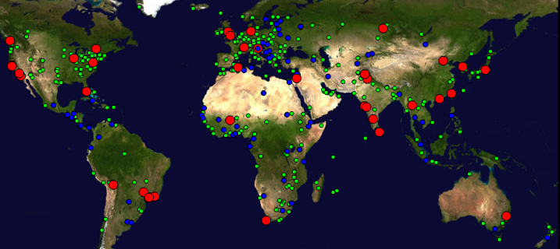
Figure 1 : Locations of PingER monitoring and remote sites as of Jan 2010. Red sites are monitoring sites, blue sites are beacons that are monitored by most monitoring sites, and green sites are remote sites that are monitored by one or more monitoring sites
There are about eighteen hundred monitoring/monitored-remote-host pairs, so it is important to provide aggregation of data by hosts from a variety of "affinity groups". PingER provides aggregation by affinity groups such as HEP experiment collaborator sites, country, Top Level Domain (TLD), Internet Service Provider (ISP), or by world region etc. The world regions, as defined for PingER, and countries monitored are shown below in Figure 2. The regions are chosen starting from the U.N. definitions [UN]. We modify the region definitions to take into account which countries have HEP interests and to try and ensure the countries in a region have similar performance.
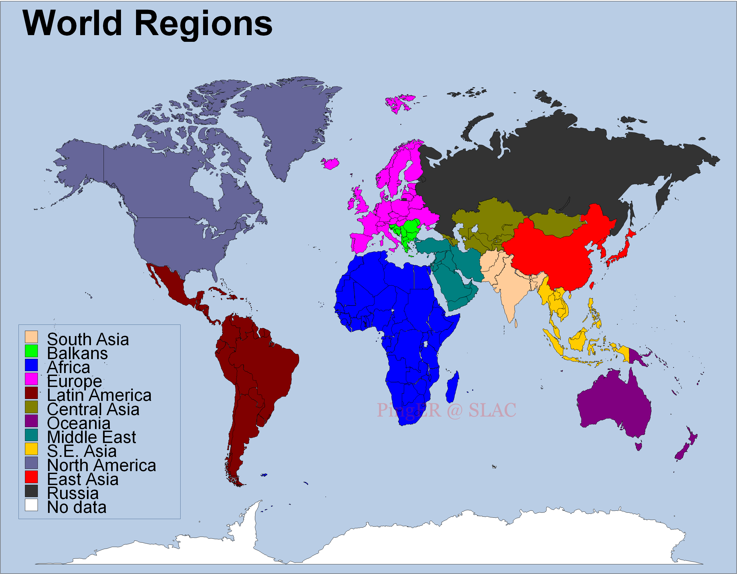
Figure 2 Major regions of the world for PingER aggregation by regions, countries in white are not monitored
More details on the regions are provided in Table 2 that highlights the number of countries monitored in each of these regions, and the distribution of population in these regions.

Table 2: PingER Monitored Countries and populations by region Dec 2010
Regions | # of Countries | Population of the Region | % of World Population
Africa | 50 | 987805976 | 14.57%
Balkans | 10 | 69238964 | 1.02%
Central Asia | 9 | 80017292 | 1.18%
East Asia | 4 | 1534132345 | 22.62%
Europe | 31 | 526534194 | 7.76%
Latin America | 21 | 556994135 | 8.21%
Middle East | 13 | 225596597 | 3.33%
North America | 3 | 342360000 | 5.05%
Oceania | 4 | 33192700 | 0.49%
Russia | 1 | 141915979 | 2.09%
S.E. Asia | 11 | 577614703 | 8.52%
South Asia | 8 | 1584797000 | 23.37%
Total | 165 | 6660199885 | 98.21%

Historical Growth of PingER Coverage Since 1998
Figure 3 shows the growth in the number of hosts monitored by PingER from SLAC for each region since 1988. As can be seen, initially the main regions monitored were North America, Europe, East Asia, and Russia. These were the regions with the main HEP interest. More recently the increased number of hosts monitored in developing regions such as Africa, Latin America, Middle East and South Asia is very apparent.
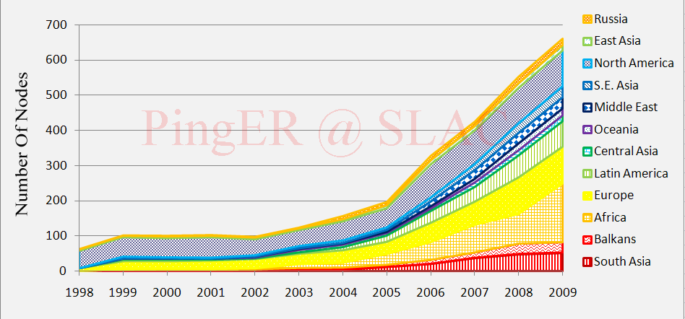
Figure 3 : Number of hosts monitored from SLAC by region ( 1998 – 2009)
Towards the end of 2001 the number of sites monitored started dropping as sites blocked pings due to security concerns. The rate of blocking was such that, for example, out of 214 hosts that were pingable in July 2003, 33 (~15%) were no longer pingable in December 2003 even though they were still up and running (as measured by responding to TCP probes).
The increases in monitored sites towards the end of 2002 and early 2003 was due to help from the Abdus Salam Institute of Theoretical Physics (ICTP). The ICTP held a Round Table meeting on Developing Country Access to On-Line Scientific Publishing: Sustainable Alternatives [ictp] in Trieste in November 2002 that included a Proposal for Real time monitoring in Africa [africa-rtmon]. Following the meeting a formal declaration was made on RECOMMDENDATIONS OF the Round Table held in Trieste to help bridge the digital divide [icfa-rec]. The PingER project started collaborating closely with the ICTP to develop a monitoring project aimed at better understanding and quantifying the Digital Divide. On December 4th, 2002 the ICTP electronic Journal Distribution Service (eJDS) sent an email entitled Internet Monitoring of Universities and Research Centers in Developing Countries [ejds-email] to their collaborators informing them of the launch of the monitoring project and requesting participation. By January 14th 2003, with the help of ICTP, we added about 23 hosts in about 17 countries including: Bangladesh, Brazil, China, Columbia, Ghana, Guatemala, India (Hyderabad and Kerala), Indonesia, Iran, Jordan, Korea, Mexico, Moldova, Nigeria, Pakistan, Slovakia and the Ukraine. The increase towards the end of 2003 was spurred by preparations for the second Open Round Table on Developing Countries Access to Scientific Knowledge: Quantifying the Digital Divide 23-24 November Trieste, Italy and the WSIS conference and associated activities in Geneva December 2003.
The increases in 2004 were due to adding new sites especially in Africa, S. America, Russia and several outlying islands.
In 2005, the Pakistan Ministry Of Science and Technology (MOST) and the US State Department funded SLAC and the National University of Sciences and Technology’s (NUST), School of Electrical Engineering and Computer Sciences (SEECS, formerly known as NUST Institute of Information Technology (NIIT)) to collaborate on a project to improve and extend PingER. As part of this project and the increased interest from Internet2 in the “Hard to Reach Network Places” Special Interest Group, many new sites in the South Asia and Africa were added to increase the coverage in these regions and also to replace sites that were blocking pings. For instance we were unable to find pingable sites in Angola prior to December 2005. Also as part of this project we started to integrate PingER with the NLANR/AMP project and as a result a number of the AMP nodes were added as PingER remote hosts in the developing regions. With help of Duncan Martin and the South Africa Tertiary Education Network (TENET) (http://www.tenet.ac.za), we successfully set up a monitoring node in South Africa, which became a great help in viewing the Digital Divide from within the Divide. With the help of SEECS, NUST (www.niit.edu.pk), a monitoring node was set up at NUST and in Nov. 2005, another node was added at NTC (National Telecommunication Corporation www.ntc.net.pk), which is the service provider for the PERN (Pakistan Educational and Research Network www.pern.edu.pk).
Again in 2006 in preparation for a conference on Sharing Knowledge across the Mediterranean at ICTP Trieste Nov 6-8, 2006, we added many new sites especially in Africa. Additionally, new monitoring nodes were setup in Pakistan (National Center for Physics (NCP)), Australia (University of New South Wales) and South Korea (Kyung Hee University).
In 2007, an effort was made to find new monitored nodes in countries not previously being observed. This was:
- To improve comparisons with human and economic development indices from the ITU, the UNDP, the World Bank, the CIA and also measures of International bandwidth capacity/country.
- To better enable validation of PingER derived throughputs versus throughput measures from Ookla Speedtest.net and ZDnet speedtest.
- To prepare for case studies on South Asia [casesasia] and Sub-Saharan Africa [caseafrica].
- To prepare for invited talks given at the American Physical Society (APS) meeting in Jacksonville Florida [aps07], the IHY in Addis Ababa, Ethiopia [ihy07], and the Sharing Knowledge Foundation in Montpellier, France [skf07]. In addition a talk was given at the Internet2 Spring Members meeting [i207].
- To prepare for a visit to NUST in Pakistan and talks to be given there.
- As a result of the collaboration with James Whitlock of the Bethlehem Alliance resulting in two monitoring hosts in Palestine (Jerusalem and the Gaza Strip).
As a result, in 2007, the total number of hosts monitored from SLAC went up from 334 to 442, the main increases being in Africa which went from 58 to 95 hosts, South Asia from 20 to 37 hosts, Middle East 15 to 26 hosts, and South East Asia from 12 to 22 hosts. We added over a hundred new hosts from Ookla servers which cover over 50 countries.

In 2008 due to US Science budget cuts in particular in HEP, there were layoffs at SLAC and a redirection of goals that led to a much reduced support for PingER. This is discussed in the section “Outlook: cloudy” in http://www.symmetrymagazine.org/cms/?pid=1000639. Despite this, with some remaining funding from past, three graduate students from SEEC Pakistan and donated time it has successfully continued running.

In 2009 the support for PingER continued at a similar level to that in 2008. We were fortunate to have continued support from Pakistan, including 2-3 graduate students and a lecturer, at SLAC for a year. The increase in number of hosts in Africa was enabled by invited talks in Ethiopia and Zambia, a paper at a conference in Namibia, a series of four lectures to African computing and networking people at a meeting at the ICTP in Trieste, and a talk on African Internet performance at the European Geophysical Union in Vienna.

Metric Meanings
To assist in interpreting the results in terms of their impact on well-known applications, we categorize the losses into quality ranges. These are shown below in Table 3.
Table 3: Quality ranges used for loss
 | Excellent | Good | Acceptable | Poor | Very Poor | Bad
Loss | <0.1% | >=0.1% &  < 1% | > =1%  & < 2.5% | >= 2.5%  & < 5% | >= 5%  & < 12% | >= 12%
More on the effects of packet loss and RTT can be found in the Tutorial on Internet Monitoring & PingER at SLAC [tutorial], briefly:
- At losses of 4-6% or more video-conferencing becomes irritating and non-native language speakers are unable to communicate effectively. The occurrence of long delays of 4 seconds (such as may be caused by timeouts in recovering from packet loss) or more at a frequency of 4-5% or more is also irritating for interactive activities such as telnet and X windows. Conventional wisdom among TCP researchers holds that a loss rate of 5% has a significant adverse effect on TCP performance, because it will greatly limit the size of the congestion window and hence the transfer rate, while 3% is often substantially less serious, Vern Paxson. A random loss of 2.5% will result in Voice Over Internet Protocols (VOIP) becoming slightly annoying every 30 seconds or so. A more realistic burst loss pattern will result in VOIP distortion going from not annoying to slightly annoying when the loss goes from 0 to 1%. Since TCP throughput for the standard (Reno based) TCP stack goes as 1/(sqrt(loss) [mathis]) (see M. Mathis, J. Semke, J. Mahdavi, T. Ott, "The Macroscopic Behavior of the TCP Congestion Avoidance Algorithm", Computer Communication Review, volume 27, number 3, pp. 67-82, July 1997), it is important to keep losses low for achieving high throughput.
- For RTTs, studies in the late 1970s and early 1980s showed that one needs < 400ms for high productivity interactive use. VOIP requires a RTT of < 250ms or it is hard for the listener to know when to speak.
It must be understood that these quality designations apply to normal Internet use. For high performance, and thus access to data samples and effective partnership in distributed data analysis, much lower packet loss rates may be required.

Yearly Throughput Trends
To visualize major changes in network performance, that typically happen in a stepwise fashion we present Figure 5 showing data averaged into yearly intervals. We have also reduced the effect of the 1/RTT in the Mathis formula for derived throughput by normalizing the throughputs using:
norm_throughput = throughput * min_RTT(remote region) / min_rtt(monitoring_region)

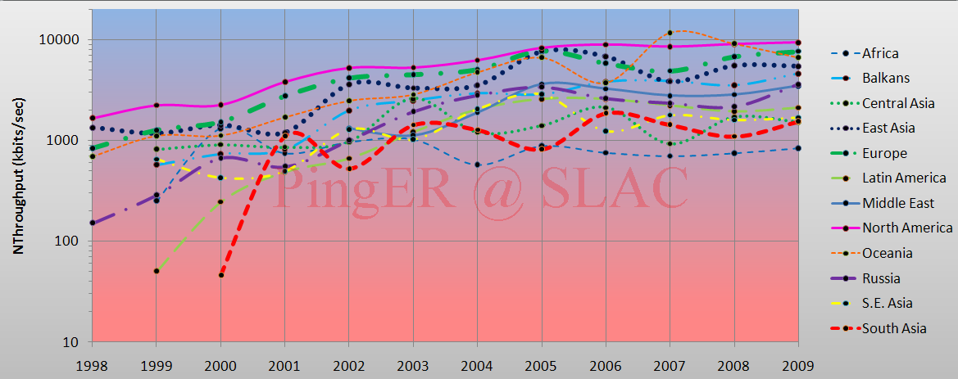
Figure 4 : Yearly averaged normalized derived TCP throughputs from the SLAC to various regions of the world.

In particular note the improved performance as parts of Latin America moved from satellite to fibre in 2000, and the impact of moving the ESnet routing from E. Asia (in particular Japanese academic and research networks) to the US via New York in 2001 to a more direct route via the West Coast of the US. Also note the factor of ~10 difference in throughput between Africa and N. America, Europe and Ociania. Finally note that Africa has been caught up and passed by S. Asia, Latin America,and Russia and is now the worst off region and has the slowest rate of improvement.

To make the overall changes stand out more clearly Figure 5 shows just exponential trendline fits to monthly averages of the derived throughput on a log-linear scale (exponentials show up as straight lines). These trendlines are useful to see in general how, a particular region is doing against others and over a period of time, against its past. For guidance, the top red line show what a 25% improvement per year would look like, this corresponds to roughly a factor of 10 in ten years.

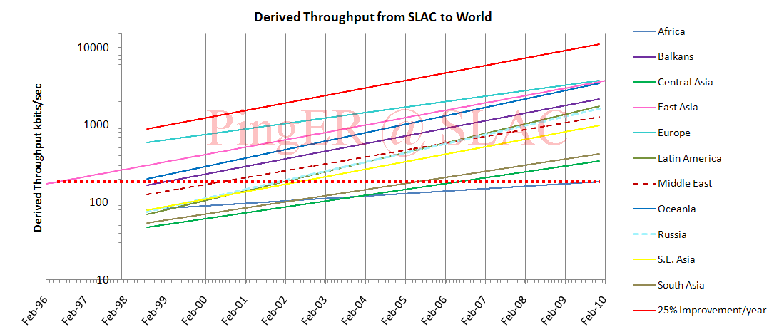
Figure 5: Derived Throughput kbits/sec from SLAC to AFRICA (since the throughputs in this graph are not normalized we have have not shown N. America). The red dotted line is to help extrapolate Africa’s performance today back to 1996 and show where it intercepts East Asia’s performance 1996 (i.e. the flat dotted line intercepts the extended trendline for E. Asia).
The slow increases for North America and Europe are partially an artifact of the difficulty of accurately measuring loss with a relatively small number of pings (14,400 pings/month at 10 pings/30 minute interval, i.e. a loss of one packet ~ 1/10,000 loss rate). Looking at the data points one can see that the East Asian trend crossing Europe and North America is mainly a result of East Asia starting from a lower throughput, which gives a steeper slope to its trendline. Looking at the data points they are seen to overlap for the last two years. Russia, S. E. Europe (Balkans) and Oceania are catching up with Europe, East Asia and North America; the Middle East, Central Asia, Latin America and S. E. Asia are falling behind. Africa on the other hand is falling behind.
Taking Africa as an example the dotted red line indicates that by Dec 2009, the African Region had a throughput comparable to East Asia in July, i.e. it is roughly 14 years behind East Asia at the end of 2009. Also after 10 more years at the current rates of improvement, East Asian sites would typically have 75 times more throughput than African sites.

View from Europe
To assist in developing a less N. American view of the Digital Divide; we added many more hosts in developing countries to the list of hosts monitored from CERN in Geneva Switzerland. We now have data going back for eight years that enables us to make some statements about performance as seen from Europe. Figure 6 shows the normalized throughput data from CERN to the rest of the world.
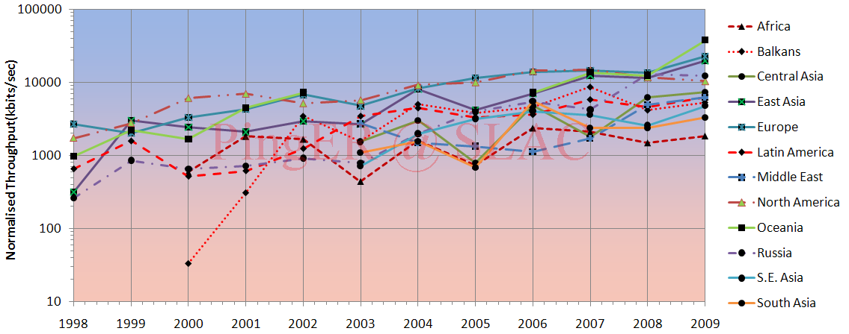
Figure 6: Normalized throughputs to various regions as seen from CERN.
As can be seen by comparing Figures 4 and 6 the general performance changes are very similar in both cases.

Variability of performance between and within regions
The throughput results, so far presented in this report, have been measured from North America and to a lesser extent from Europe. This is since there is more data for a longer period available for the North America monitoring hosts. Table 4 shows the throughputs seen between monitoring and remote/monitored hosts in the major regions of the world. Each column is for monitoring hosts in a given region, each row is for monitored hosts in a given region. The cells are colored according to the median throughput quality for the monitoring region/monitored region pair. White is for derived throughputs > 10,000 kbits/s (good), green for <= 10,000 kbits/s and >5,000kbits/s (acceptable), yellow for <= 5,000kbits/s and > 1,000 kbits/s, pink for <= 1000kbits/s and > 100kbits/s red for <= 100kbits/s (very poor to bad) and > 1 kbits/s, and grey for no measurements. The Monitoring countries are identified by the Internet two-character Top Level Domain (TLD). Just for the record CA=Canada, US=NET=GOV=United States, CH=Switzerland, DE=Denmark, UK=United Kingdom, AU=Australia, CN=China, HK=Hong Kong, KR=South Korea, TW=Taiwan, BO=Bolivia, MX=Mexico, IN=India, LK=SriLanka, PK=Pakistan, SU=Russia, DZ=Algeria, ZA=South Africa and BF=Burkina Faso. S. Asia is the Indian sub-continent; S.E. Asia is composed of measurements to Indonesia, Malaysia, Singapore, Thailand and Vietnam.
Table 4: Derived throughputs in kbits/s from monitoring hosts to monitored hosts by region of the world for December 2009.
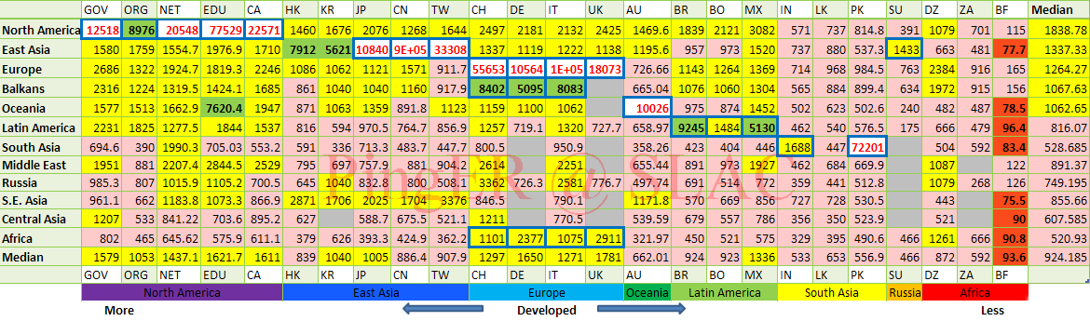
As expected it can be seen that for most TLDs (represented in columns) the best possible throughput values represented by the outlined boxes, usually exist within a region. For example for regions with better Internet connectivity, such as Europe, higher throughput is seen from European monitoring sites to TLDs (CH, DE, IT and UK) that lie within Europe. However, if the regions are close enough in terms of connectivity, throughput values are relatively higher. For example performance is better between closely located regions such as: the Balkans and European countries; Russia and E. Asia (the Russian monitoring site is in Novosibirsk); Mexico and N. America (is better than Mexico and Latin American countries). This shows that network performance is not completely dependent on geographic proximity, but rather on how close the regions are on the map of Internet connectivity and performance. Also take for example Africa: higher throughput values are evident between Africa and the TLDs DE, IT, UK and then DZ rather than between African sites. This serves to illustrate the poor intra regional connectivity within Africa.
This table also shows that throughput values show large variability within regions (e.g. an order of magnitude between Burkina Faso and Algeria). To provide further insight into the variability in performance for various regions of the world seen from SLAC, 8 and 9 show various statistical measures of the losses and derived throughputs. The regions are sorted by the median of the measurement type displayed. Note the throughput graph uses a log y-scale to enable one to see the regions with poor throughput. Also North America is not represented by the throughput graph, since throughput from North America was not normalized, in difference to, other regions. The countries comprising a region can be seen in Figure 2.

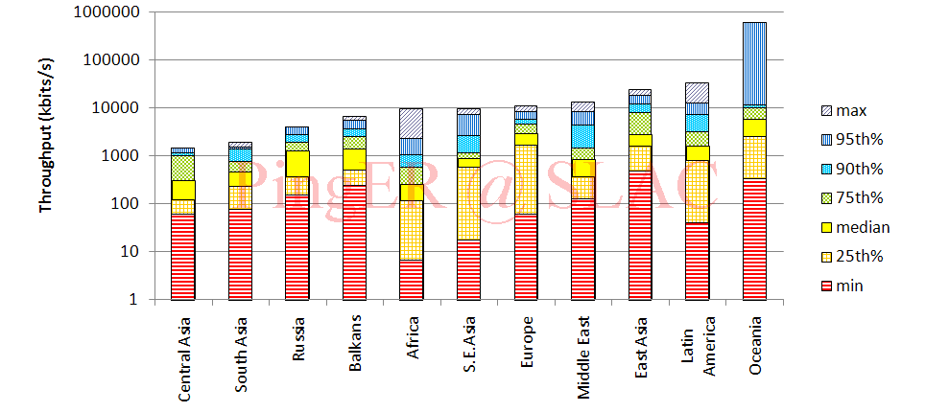
Figure 7 : 25 percentile, median and 75 percentile derived throughputs of various regions measured from SLAC for Dec 2009

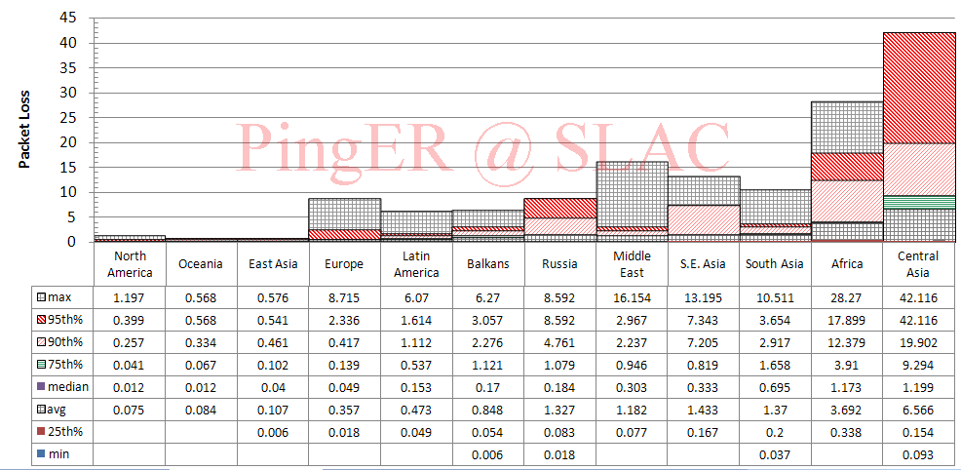
Figure 8: percentiles for packet loss measured for various regions from SLAC in Dec 2009

The most uniform region (in terms of Inter-Quartile-Range/median for both derived throughput and loss) is Central Asia, probably since most of the paths use a geo-stationary satellite. The most diverse is Europe. For Europe, Belorussia stands out with poor performance. It was hoped that the Porta-Optica project (http://www.porta-optica.org) would improve this situation.

Comparisons with Economic and Development Indicators
The UN, the International Telecommunication Union (ITU) and various other task forces are independent expert bodies which aim to provide policy advice, based on various economic factors, to governments, funding sources, and international organization for the purpose of bridging the Digital Divide. See the table below for details.
In reality, it is difficult to classify countries according to their development. The main challenges lie in determining what factors to consider, how to measure them, how useful and pervasive they are, how well defined they are, and whether they are uniformly measured for every country. Various organizations such as the ITU, UNDP, CIA, World Bank etc. have come up with Indices based on measured items such as life expectancy, GDP, literacy, phone lines, Internet penetration etc. Although many of the above challenges are not insurmountable they can require a lot of cost and time. Thus, many of these measurements are outdated and may not depict the current state of the country.
One of the most important factors determining the economic development of a country in today’s information age is its Internet connectivity. Thus we may expect moderate to strong correlations between the economy and development of a country with its Internet performance measurement. The significance of also using PingER’s Internet measurements to characterize a country’s development is due to the fact that PingER’s data is current (up-to date) and covers most of the countries of the world. The following table shows the most commonly used indices categorized by organizations which produce them, the number of countries covered and date of the latest data.
Table 5: Economic and development indicators
Abv. | Name | Organization | No of countries | Date of Data
GDP | Gross Domestic Product per capita | CIA | 229 | 2001-2008
HDI | Human Development Index | UNDP | 182 | 2007/2008
DAI | Digital Access Index | ITU | 180 | 1995-2003
NRI | Network Readiness Index | World Economic Forum | 134 | 2008/2009
TAI | Technology Achievement Index | UNDP | 72 | 1995-2000
DOI | Digital Opportunity Index | ITU | 180 | 2004-2005
OI | Opportunity Index | ITU | 139 | 1996-2003
CPI | Corruption Perception Index | Transparency Organization | 180 | 2009
From this list of indices we selected the HDI and DOI for further analysis and comparisons with PingER measurements because they are enriched with most of the important factors, cover a large number of countries and are reasonably up-to-date.

Human Development Index (HDI)
The UNDP Human Development Indicator (HDI) (see http://hdr.undp.org/reports/global/2002/en/) measures the average achievements in a country in three basic dimensions of human development:
- A long and healthy life, as measured by life expectancy at birth
- Knowledge, as measured by the adult literacy rate (with two-thirds weight) and the combined primary, secondary and tertiary education gross enrollment ratio (with one-third weight)
- A decent standard of living, as measured by GDP per capita (or Purchasing Power Parity (PPP) in US$).
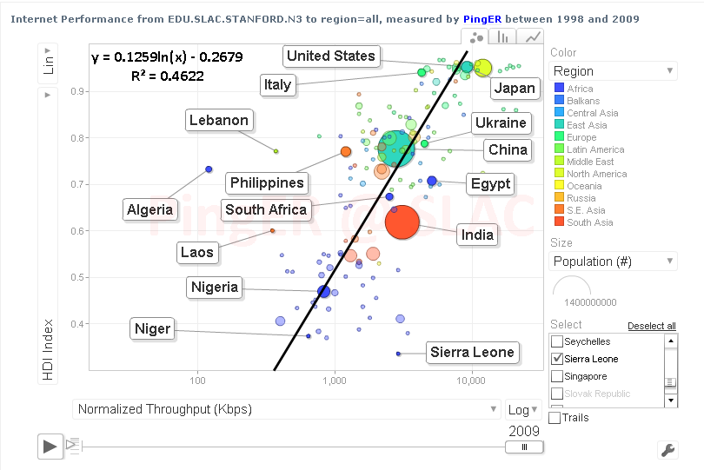
Figure 9: Comparison of PingER derived throughputs seen from N. America to various countries and regions versus the U.N. Development Program (UNDP) Human Development Indicator (HDI).
Error: Reference source not found0 shows a scatter plot/bubble chart - created using PingER motion chart application [http://www-iepm.slac.stanford.edu/pinger/pinger-metrics-motion-chart.html] - of the HDI versus the PingER Normalized Derived Throughput for 2009. Each point (bubble) is colored according to the country’s region. The size of each bubble is based on the population of the region. A logarithmic fit is also shown. Logarithmic is probably appropriate since Internet performance is increasing exponentially with time and the differences between the countries can be related to number of years they are behind the developing countries, while human development is more linear. It is seen that there is agmoderately positive correlation , see [an96]) between the HDI and throughput. As expected countries in Africa generally occupy the lower values in x and y, and European countries together with Australia, New Zealand, Korea and Japan occupy the higher values of x and y.
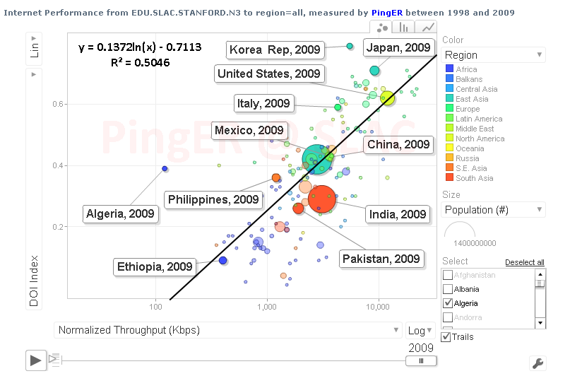
Figure 10: Normalized throughput vs. Digital Opportunity Index

The Digital Opportunity Index (DOI)
The Digital Opportunity Index is a comprehensive metric made up of a composite of 11 core indicators that aims to track progress made in infrastructure, opportunity and utilization. If we correlate the PingER performance measurements (jitter, loss and throughput) with ITU’s indices we get moderate to strong correlations. Moderate to strong correlations are obtained with the DOI and other development indices (not shown here) that are more technology or Internet related. The Following table summarizes the R² values which are for the correlations of pingER measurements with DOI and GDP/cap.
Table 6: R² values on correlations between PingER data vs. DOI and GDP/cap
 | Jitter (ms) | Loss (%) | Derived TCP Throughput | Unreachability
DOI | 0.58 | 0.64 | 0.67 | 0.37
GDP/capita | 0.61 | 0.53 | 0.59 | 0.35
The scatter-plot [motion-chart] in the Figure 10 shows the correlation of PingER normalized derived throughput for 2008 versus DOI.

Case Studies
For the sake of continuity we discuss the case studies at length as an annexure to this document. The case studies include a review of:
- New East Coast of Africa Fiber(New)
- The effects of the fibre cut in the Mediterranean – December 2008(Updated)
- Internet connectivity and its performance in Pakistan(Updated)

High Performance Network Monitoring

New and Ongoing Monitoring and Diagnostic Efforts in HEP
PingER and the now discontinued IEPM-BW are excellent systems for monitoring the general health and capability of the existing networks used worldwide in HEP. However, we need additional end-to-end tools to provide individuals with the capability to quantify their network connectivity along specific paths in the network and also easier to use top level navigation/drill-down tools. The former are needed both to ascertain the user's current network capability as well as to identify limitations which may be impeding the user’s ultimate (expected) network performance. The latter are needed to simplify finding the relevant data.
Most HEP users are not "network wizards" and don't wish to become one. In fact as pointed out by Mathis and illustrated in Figure 12, the gap in throughput between what a network wizard and a typical user can achieve is growing.
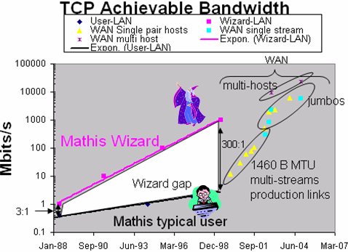
Figure 11: Bandwidth achievable by a network wizard and a typical user as a function of time. Also shown are some recent network throughput achievements in the HEP community.

Because of HEP's critical dependence upon networks to enable their global collaborations and grid computing environments, it is extremely important that more user specific tools be developed to support these physicists.
Efforts are underway in the HEP community, in conjunction with the Internet2 End-to-End (E2E) Performance Initiative [E2Epi], to develop and deploy a network measurement and diagnostic infrastructure which includes end hosts as test points along end-to-end paths in the network. The E2E piPEs project [PiPES], the NLANR/DAST Advisor project [Advisor] and the LISA (Localhost Information Service Agent) [LISA] are continuing to work together to develop an infrastructure capable of making on demand or scheduled measurements along specific network paths and storing test results and host details for future reference in a common data architecture. The perfSONAR project has become the organizing entity for these efforts during the last two years (2008-9) and is broadly supported (see below). The perfSONAR effort is utilizing the GGF NMWG [NMWG] schema to provide portability for the results. This information could be immediately used to identify common problems and provide solutions as well as to acquire a body of results useful for baselining various combinations of hardware, firmware and software to define expectations for end users. In addition perfSONAR includes many of the tools (PingER, NDT, Advisor, Iperf, traceroute server etc) which are the recognized standards in network testing and diagnosis
Efforts to insure commonality in both monitoring and provisioning of networks are continuing The GLIF and DICE communities are both working toward implementing “managed” network services and the corresponding monitoring that will be needed to support their efforts. HEP (US LHCnet, the various HEP network research projects and the national labs) is working closely within these groups to insure our needs are being addressed.
A primary goal is to provide as "lightweight" a client component as possible to enable widespread deployment of such a system. The LISA Java Web Start client is one example of such a client, and another is the Network Diagnostic Tester (NDT) tool [NDT]. By using Java and Java Web Start, the most current testing client can be provided to end users as easily as opening a web page. The current NDT version supports both Linux and Windows clients and is being maintained by Rich Carlson (formerly Internet2, now DOE). In addition to inclusion in perfSONAR, the typical network client tools (NDT and NPAD) are now included in the Open Science Grid (OSG) software distributions since v2.0.0. This allows easy access to these diagnostic tools wherever OSG is deployed.
The goal of easier-to-use top-level drill down navigation to the measurement data is being tackled by MonALISA [MonALISA] in collaboration with the perfSONAR project.
The US ATLAS collaboration has made an extensive effort to improve the throughput of their Tier-1 and Tier-2 centers and has coupled this with active testing and monitoring to track performance over time. Bi-weekly meetings focusing on throughput and network measurement are being held. This group is working in two primary areas: 1) automated transfer throughput testing using ATLAS production systems and 2) deployment and integration of perfSONAR at all USATLAS Tier-2 sites and the Tier-1 site at Brookhaven. We will discuss perfSONAR deployment and experience in USATLAS in the next section and will focus on the automated (and manual) throughput testing USATLAS is using here.
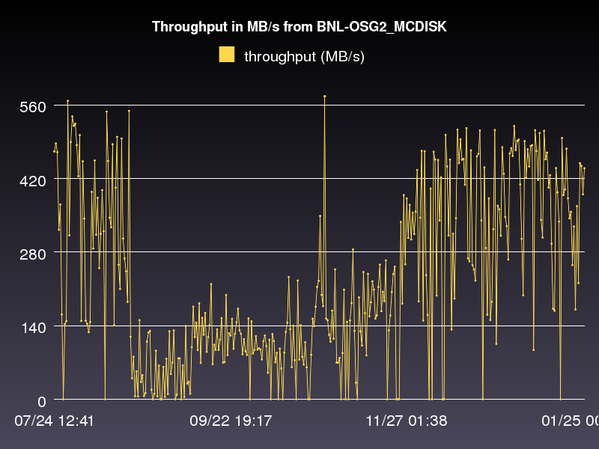
Figure 12 Example automated throughput graph for USATLAS showing transfer results from BNL (USATLAS Tier-1) to AGLT2 (USATLAS Tier-2)
The perfSONAR infrastructure is intended to measure the network (LAN,WAN) between perfSONAR test nodes but this is not sufficient to characterize the “end-to-end” behavior of the distributed systems in use in HEP. The USATLAS throughput group has developed some additional automated (and manual) tests to accurately measure their system capabilities and limits. Hiro Ito (BNL) has developed an automated data transfer service which sends a fixed number of files between sites using the standard ATLAS production system and records the results. Results of these tests are available at http://www.usatlas.bnl.gov/dq2/throughput where you can find details on the number of successful transfers, their throughput and timing. One example graph is shown in Figure 13. During 2009 the system was extended to include Tier-2 to Tier-3 tests (in addition to the standard Tier-1 to Tier-2 tests originally defined). These results, in combination with perfSONAR results, are used to identify problems in the overall system and isolate their likely location.
In addition to automated testing USATLAS has setup manual “Load Tests” designed to characterize the maximum transfer capability between sites. A “Load Test” TWiki page at http://www.usatlas.bnl.gov/twiki/bin/view/Admins/LoadTests has further details on some initial tests. One of the milestones of the USATLAS throughput group was achieving 1 GigaByte/sec from the Tier-1 to a set of Tier-2’s. This was demonstrated in October 2009 and is shown in Figure 14.
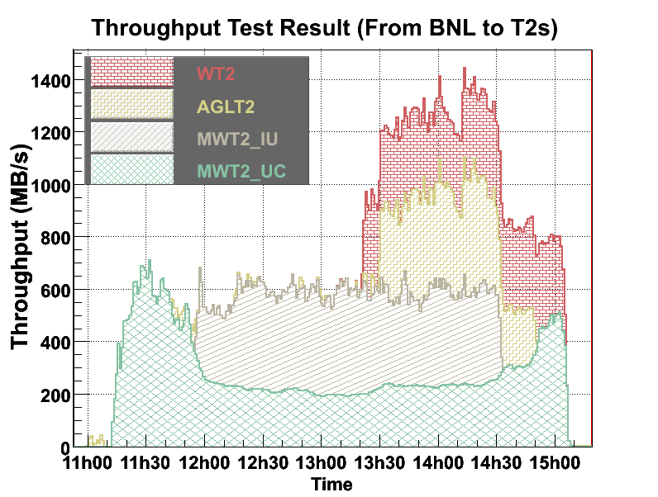
Figure 13: USATLAS Throughput milestone (1GB/sec for 1 hour)
perfSONAR in USATLASAs mentioned above, most HEP users are not interested in becoming network wizards nor do they have the expertise to diagnose network related problems. Within USATLAS a significant effort has been made to deploy and integrate perfSONAR at all Tier-1/Tier-2 sites in the US to provide a standardized set of tools and corresponding network measurements to aid in problem isolation and diagnosis as well as for baseline monitoring. The plan for USATLAS has been to deploy two perfSONAR instances (each on their own, identical hardware) at each distinct Tier-2 site (as well as the Tier-1 at BNL).
Since many USATLAS Tier-2’s are physically distributed at more than one location, more than 2 systems per Tier-2 are deployed. It was important that all sites deploy identical hardware to remove hardware variations that might impact measurements. An inexpensive system with 2 1GE onboard NICs (~$635) from KOI computing was identified in Fall 2008 and has been deployed at 8 Tier-2 sites and BNL. Two systems per site are required to allow both throughput and latency tests to be undertaken which would interfere with each other if they ran on the same system. Since these systems were purchased some issues with the particular 1 GE NIC and hard-disk controller have been identified and Internet2 has new recommendations for future perfSONAR purchases. While all sites have systems deployed, the Western Tier-2 (WT2) at SLAC has just received security clearance to enable their system and it should be operational in February of 2010.
The perfSONAR systems in USATLAS are intended to run full-mesh tests for both throughput and latency with all other USATLAS Tier-2’s and the Tier-1. The latency role is assigned to the first node (typically designated with a ‘1’ in the DNS name) by convention while the throughput role is assigned to the second node. Installation is made straightforward by simply booting a recent ISO image provided by Internet2 and doing a one-time configuration of the node. Configuration results as well as measurements are persisted onto the local hard-disk of the system being configured.
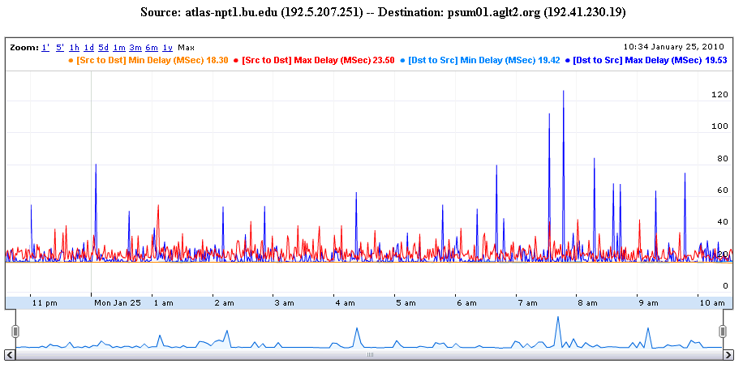
Figure 14 Example OWAMP test between two USATLAS Tier-2's (bi-directional testing is enabled)

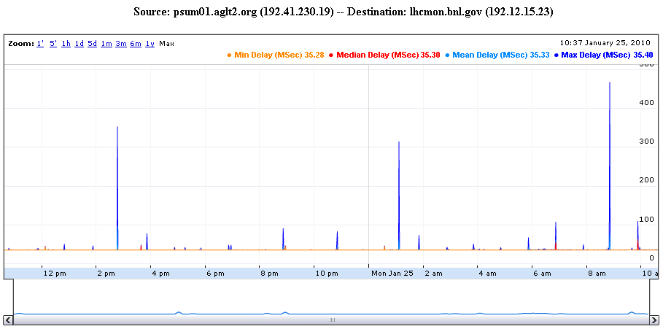
Figure 15 Example PingER graph between the Tier-1 and a Tier-2

The latency tests have two variations. The first is managed by OWAMP and measures one-way delays between the latency node and its test partner at another site. Since absolute time accuracy is critical for this test, part of a latency node configuration includes setting up a reliable time service (ntpd) configuration to insure the node keeps accurate time. The second type of latency test is provided by PingER which is configured by default to send 600 ping packets between the latency node and its target and track the results. Examples of both types of tests are shown in Figure 15 and Figure 16.

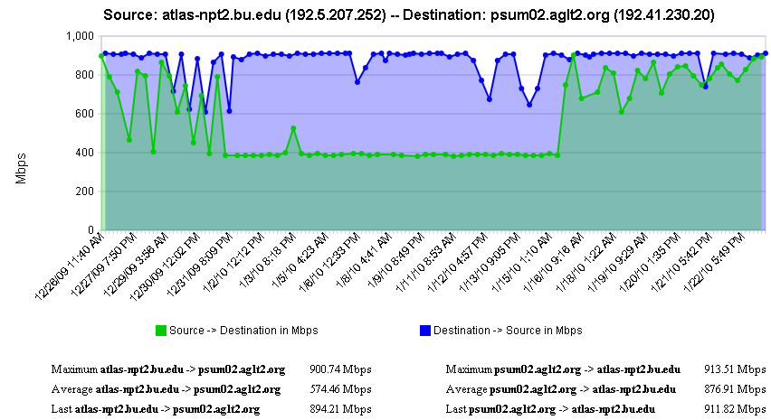
Figure 16 Example bi-directional throughput test in perfSONAR between two Tier-2s

The second perfSONAR node measures throughput using Iperf. Typical results are shown in Figure 17.
Incorporating perfSONAR into USATLAS “operations” is under evaluation. The USATLAS group has provided important feedback to the perfSONAR distribution developers and have identified a number of bugs which impact the reliability and usability of the distribution. Once a sufficiently robust distribution is identified USATLAS plans to recommend broader perfSONAR deployment to include Tier-3 sites. Having a perfSONAR instance at Tier-3’s can help compensate for the lack of manpower and expertise at these sites and allow remote experts access to necessary information for diagnosing network or end-site issues.
It should also be noted that having perfSONAR services running co-located with important resources provides the ability to run “on-demand” tests using the broadly deployed NDT and NPAD tools. These tools can be run from any remote location, testing to any perfSONAR instance. This is a very important additional capability that can be vital in network diagnosis.
perfSONAR is already broadly deployed in Research and Education network PoPs (Internet2, GEANT2, ESnet) and it is hoped that more collaborations within HEP will deploy perfSONAR instances co-located with their computing and storage resources. Having a more extensive deployment significantly improves the value and applicability of the overall perfSONAR infrastructure for HEP.

LHC-OPN Monitoring
During the last two years there has been a concerted effort to deploy and monitor the central data distribution network for the Large Hadron Collider (LHC). This network, dubbed the LHC-OPN (Optical Private Network), has been created to primarily support data distribution from the CERN Tier-0 to the various Tier-1’s worldwide. In addition, traffic between Tier-1 sites is also allowed to traverse the OPN.
Given the central role this network will play in the distribution of data it is critical that this network and its performance be well monitored. A working group was convened in Fall of 2005 to study what type of monitoring might be appropriate for this network. A number of possible solutions were examined including MonALISA, IEPM-BW/Pinger, various EGEE working group efforts and perfSONAR.
By Spring of 2006 there was a consensus that LHC-OPN monitoring should build upon the perfSONAR effort which was already being deployed in some of the most important research networks. perfSONAR is a standardized framework for capturing and sharing monitoring information, other monitoring systems can be plugged into it with some interface “glue”.
During 2007 a newly created organization named the E2ECU (End to End Coordination Unit), operated by the GEANT2 NOC, started using perfSONAR tools to monitor the status of almost all the circuits in the LHCOPN.
DANTE has proposed a no-cost managed network measurement service to the LHCOPN community to perform significantly more robust measurement of the LHCOPN, including active latency & bandwidth tests, link utilization, etc all based on perfSONAR tools & protocols. This is still in the discussion stage as of this report.

Related HEP Network Research
There has been a significant amount of research around managed networks for HEP that we should note. There are efforts funded by the National Science Foundation (UltraLight (finished Aug 2009), PLaNetS) and Department of Energy (Terapaths (finished Dec 2009), LambdaStation (finished 2009), OSCARS, and the associated follow-on projects StorNet and ESCPS projects) which are strongly based in HEP. These projects are not primarily focused upon monitoring but all have aspects of their efforts that do provide network information applications. Some of the existing monitoring discussed in previous sections are either came out of these efforts or are being further developed by them.

Comparison with HEP Needs
Previous studies of HEP needs, for example the TAN Report (http://gate.hep.anl.gov/lprice/TAN/Report/TAN-report-final.doc) have focused on communications between developed regions such as Europe and North America. In such reports packet loss less than 1%, vital for unimpeded interactive log-in, is assumed and attention is focused on bandwidth needs and the impact of low, but non-zero, packet loss on the ability to exploit high-bandwidth links. The PingER results show clearly that much of the world suffers packet loss impeding even very basic participation in HEP experiments and points to the need for urgent action.
The PingER throughput predictions based on the Mathis formula assume that throughput is mainly limited by packet loss. The 25% per year growth curve in Error: Reference source not found is somewhat lower than the 79% per year growth in future needs that can be inferred from the tables in the TAN Report. True throughput measurements have not been in place for long enough to measure a growth trend. Nevertheless, the throughput measurements, and the trends in predicted throughput, indicate that current attention to HEP needs between developed regions could result in needs being met. In contrast, the measurements indicate that the throughput to less developed regions is likely to continue to be well below that needed for full participation in future experiments.

Accomplishments since last report
During 2009, we have been working hard to improve our monitoring systems to ensure high quality and justifiable quantity of Network Performance Metrics for 97% of the Internet. Some of our major Accomplishments, between Jan 2009 – Jan 2010 are listed below:
  - We have added 108 new nodes in PingER, to increase its coverage.
  - In order to keep track of PingER sites, we now have a quick look interface.
  - We created smokeping graphs, to provide a better look, at ill performing Sites, as well as to catch any anomalies, which would be hard to identify otherwise.
  - Utilising perfSONAR_PS sites 7 new hosts were added, thus bringing the count of non-planetlab TULIP nodes to 72.
  - Several changes were made to increase the accuracy of Tulip nodes. 90% of our 72 non-planetlab nodes have accurate geo coordinates up to a few meters.
  - Several techniques are understudy to change the core algorithm of TULIP from Triliteration to Appolonius or any other, which can provide better results.
  - The perfSONAR_PS team schedules quarterly perfSONAR releases (or shorter release periods in response to identified security problems), leveraging strong community support from USATLAS and other virtual organizations who provide testing and feedback.
  - Many sites have deployed the new perfSONAR toolkit (including components like OWAMP, BWCTL, PingER, NDT and NPAD) during 2009 including 9 USATLAS Tier-2 sites, the USATLAS Tier-2 and the Australian Tier-2 in Melbourne. In addition a number of Tier-3 sites have also deployed perfSONAR, including Illinois, SMU, LBL, Duke, Penn, Wisconsin and USTC in Hefei, China bringing the total installations up to 18.

We have extended the measurements to cover more developing countries and to increase the number of hosts monitored in each developing country. We have carefully evaluated the routes and minimum ping RTTs to verify that hosts are where they are identified to be in our database. As a result we have worked with contacts in relevant countries and sites to find alternatives, and about 20-30 hosts have been replaced by more appropriate hosts. In addition (see Table 6) since December of 2006, we have added a net of over 230 new remote hosts, and added 51 countries (Africa: BF, CD, CV, CI, DJ, GA, GM, GH, GW, LR, LY, MU, NA, SC, SL, SZ, TG, ZM; Balkans/S.E. Europe: BA, LV, MD; Central Asia: TM, Europe: AD, AT, BE, BG, CZ, FO, GI, LI, LU, SM, SE; Latin America: AN, BS, CO, CU, DO, NI; Middle East: AE, BH, OM, QA, SA; South East Asia: KH, LA, PH, TH; South Asia: AF, BT, MV). While ping blocking is still a big problem as many hosts start blocking over time, no countries were lost this year.
The collaboration between SLAC and the NUST, SEECS (formerly NIIT) in Rawalpindi Pakistan was funded by the Pakistan Ministry of Science and Technology and the US Department of State for one year starting September 2004. The funding is for travel only. The collaboration has successfully developed and populated a new PingER configuration database to keep track of location (city, country, region, latitude/longitude), contacts, site name, affinity groups etc. This data is already being used to provide online maps such as Figure 1. Work has also been completed on automating the process of generating graphs of performance aggregated by region
We still spend much time working with contacts to unblock pings to their sites (for example ~15% of hosts pingable in July 2003 were no longer pingable in December 2003), to identify the locations of hosts and to find new hosts/sites to monitor. It is unclear how cost-effective this activity is. It can take many emails to explain the situation, sometimes requiring restarting when the problem is passed to a more technically knowledgeable person. Even then there are several unsuccessful cases where even after many months of emails and the best of intentions the pings remain blocked. One specific case was for all university sites in Vietnam were blocked for ping.
Even finding knowledgeable contacts, explaining what is needed and following up to see if the recommended hosts are pingable, is quite labor intensive. To assist with this we have created a brochure for PingER describing its purposes, goals and requirements. More recently we have had some success by using Google to search for university web sites in specific TLDs and this year have automated this. The downside is that this way we do not have any contacts with specific people with whom we can deal in case of problems.

PingERExtensions
This year there have been two major extensions.

Porting PingER Archive/Anlaysis Toolkit to SEECS
Major portions of PingER’s data gathering, archiving, data aggregation visualization and reporting function were ported from SLAC to SEECS.

SmokePing Graphs
Identifying a change in performance of a network link is of utmost importance. As network performance Analyst working on the forefront of Internet, we recognize the need for applications and tools, which can help us, identify and analyze any anomaly. SmokePing Graphs are an endeavor towards the same goal.
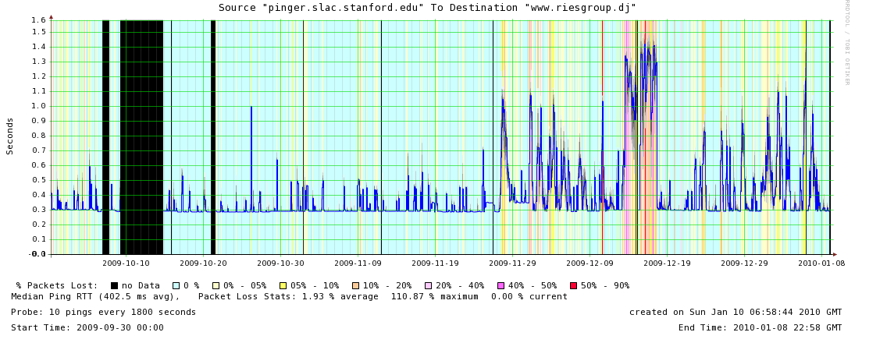
These graphs provide a quick look, at the performance of a link, over a period of 120 days, 30 days, 10 days, 7 days, 3 days and 1 day. A change in latency is identified, by multi layers of gray shade above and below a metric value at a point in time. The background color, at that time, represents percentage of packet loss.
These graphs are plotted using RRDs generated, periodically. One of the problems, with this model is that, the data being plotted is a day old upto a period of 120 days.
The graphs, offer a wide variety of customizable options, for the user to manipulate the output, in a way that he or she thinks is better.
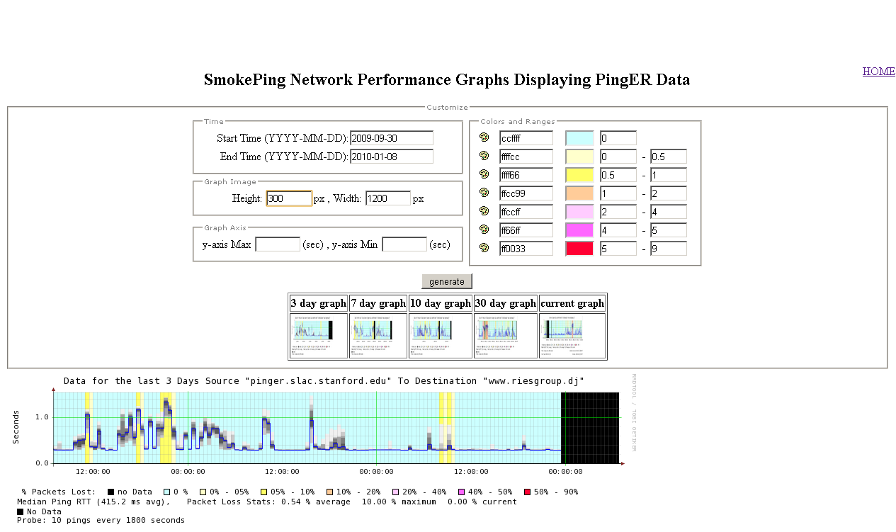
The graph for any node can be viewed, by click the monitoring host link from “pingtable”, against any monitored node or a beacon site.

2009 Digital Divide Publications/Presentations:

Publications
- eGy-Africa: Addressing the digital divide for science in Africa, C. E. Barton, C. Amory-Mazaudier, B. Barry, V. Chukwuma, R. L. Cottrell, U. Kalim, A. Mebrahtu, M. Petitdidier, R. Rabiu and C. Reeves, Russian Journal of Earth Sciences, Vol 11, ES1003, Doi: 10.2205/2009ES000377, 2009, published 24, November 2009. Also SLAC-PUB 13852.

Talks
- How does the Internet Work by Les Cottrell, Lecture 1 presented at the Workshop on Scientific Information in the Digital Age: Access and Dissemination ICTP, Trieste, Italy October, 2009.
- How is the Internet Performing by Les Cottrell, Lecture 2 presented at the Workshop on Scientific Information in the Digital Age: Access and Dissemination ICTP, Trieste, Italy October, 2009.
- Network Measurements by Les Cottrell, Lecture 3 presented at the Workshop on Scientific Information in the Digital Age: Access and Dissemination ICTP, Trieste, Italy October, 2009.
- Measuring the Digital Divide by Les Cottrell, Lecture 4 presented at the Workshop on Scientific Information in the Digital Age: Access and Dissemination ICTP, Trieste, Italy October, 2009.
- African Internet Performance, Fibre and the Soccer World Cup by Les Cottrell & Umar Kalim, Internet2 Africa Regional Interest Group meeting, Monday 5th October 2009, San Antonio, Texas..
- New E. Coast of Africa Fibre by Les Cottrell and Umar Kalim, presentation to the International Committee on Future Accelerators, August 2009.
- eGY-Africa: addressing the digital divide for science in Africa presented Charles Barton, Monique Petitdidier and Les Cottrell, presented in Moscow, June 1009.
- African Internet Performance. How Bad is it? What Can be done? Presented by Les Cottrell at the IHY Africa/SCINDA 2009 Conference, Livingstone, Zambia, 7-12 June 2009.
- Digital Divide Afria, eGY and the way Forward by V. Chukwuma, B Rabiu, M Petitdidier, L Cottrell, C. Barton, presented at IHY Africa 2009, Livingstone, Zambia June 2009.
- Internet Performance to Africa and the Rest of the World (long version), presented by Les Cottrell at the International Center for Theoretical Physics, Trieste April 24th , 2009,
- Internet Performance to Africa and the Rest of the World, presented by Les Cottrell at the European Geosciences Union General Assembly session on African Cyberinfrastructures, Vienna, Austria April 22, 2009.
- eGY-Africa: addressing the digital divide for science in Africa, Charles Barton, Australian National University, Monique Petitdidier, CETP/CNRS, France, Les Cottrell, Stanford Linear Accelerator Center, USA, Peter Fox, RPI, Troy, USA, presented at the European Geosciences Union General Assembly session on African Cyberinfrastructures, Vienna, Austria April 22, 2009.
- Significance of the PingER project and its application to Pakistan Education Research Network (PERN), presented by Umar Kalim to PERN - Special Interests Group on Network Monitoring, 8th April, 2009, Higher Education Commission of Pakistan, Islamabad.

Recommendations
There is interest from ICFA, ICTP, IHY and others to extend the monitoring further to countries with no formal HEP programs, but where there are needs to understand the Internet connectivity performance in order to aid the development of science. Africa is a region with many such countries. The idea is to provide performance within developing regions, between developing regions and between developing regions and developed regions.
We should ensure there are >=2 remote sites monitored in each Developing Country. All results should continue to be made available publicly via the web, and publicized to the HEP community and others. Typically HEP leads other sciences in its needs and developing an understanding and solutions. The outreach from HEP to other sciences is to be encouraged. The results should continue to be publicized widely.
We need assistance from ICFA and others to find sites to monitor and contacts in the developing and the rest of the world, especially where we have <= 1 site/country. A current list of countries with active nodes can be found at http://www-iepm.slac.stanford.edu/pinger/sites-per-country.html.

Future Support
Although not a recommendation per se, it would be disingenuous to finish without noting the following. SLAC, SEECS, NUST & FNAL are the leaders in the PingER project. The funding for the PingER effort came from the DoE MICS office since 1997, however it terminated at the end of the September 2003, since it was being funded as research and the development is no longer regarded as a research project. From 2004 onwards, development was continued with funding from the Pakistani Higher Education Commission (HEC) and the US State Department. The funding for this has recently been renewed for a further three years. The development consists of extending and enhancing the project, fixing known non-critical bugs, improving visualization, automating reports generated by hand today, finding new country site contacts, adding route histories and visualization, automate alarms, updating the web site for better navigation, adding more Developing Country monitoring sites/countries, improve code portability. The daily management, operation and supervising/leading the development has been continued with discretionary funding from the SLAC and FNAL HEP programs. The management and operation includes maintaining data collection and archiving, explaining needs, identifying and reopening broken connections, identifying and opening firewall blocks, finding replacement hosts, making limited special analyses and case studies, preparing and making presentations, responding to questions. The equipment performing this is currently in place at both SLAC and FNAL. Management, operation and supervision requires central funding at a level of about 20% of a Full Time Equivalent (FTE) person, plus travel. This has been provided by discretionary funding from the HEP budgets of SLAC and FNAL. The recent cuts in the US science budget, the impact on the Department of Energy, HEP and SLAC (see http://www.science.doe.gov/News_Information/speeches/speeches/08/SC08.htm?ReleaseNumber=mr20080124-00) have meant that SLAC no longer has discretionary funding and has thus cut continued Digital Divide activities. Without funding, for the operational side, the future of PingER and reports such as this one is unclear, and the level of effort sustained in previous years will not be possible. Many agencies/organizations have expressed interest (e.g DoE, ESnet, NSF, ICFA, ICTP, IDRC, UNESCO, IHY) in this work but none have so far stepped up to funding the management and operation.

Acknowledgements
We gratefully acknowledge the following: the assistance from NUST/SEECS in improving the PingER toolkit and management has been critical to keeping the project running, with respect to this we particularly acknowledge the support of their leader Arshad Ali; Akbar Mehdi, Shahryar Khan and Qasim Lone of SEECS who helped in updating some of the graphs and the case study on Africa and implementation of PingER tools such as TULIP; Shawn McKee of the University of Michigan kindly provided the sections on LHC-OPN Monitoring and Related Network Research; Mike Jensen provided much useful information on the status of networking in Africa, Alberto Santoro of UERJ provided very useful information on Latin America; Sergio Novaes of UNESP and Julio Ibarra of Florida International University provided useful contacts in Latin America. We received much encouragement from Marco Zennaro and Enrique Canessa of ICTP and from the ICFA/SCIC in particular from Harvey Newman the chairman. We must also not forget the help and support from the administrators of the PingER monitoring sites worldwide [participants].

References
[Advisor] http://dast.nlanr.net/Projects/Advisor/
[africa] Mike Jensen, "African Internet Connectivity". Available http://www3.sn.apc.org/africa/afrmain.htm
[africa-rtm] Enrique Canessa, "Real time network monitoring in Africa - A proposal - (Quantifying the Digital; Divide)". Available http://www.ictp.trieste.it/~ejds/seminars2002/Enrique_Canessa/index.html
[AMPATH] “International Exchange Point in Miami”, see http://www.ampath.fiu.edu/.
[aps07] “Quantitative Measurement of the Digital Divide”, Les Cottrell, Shahryar Khan, presented at the April APS meeting, Jacksonville Florida April 15, 2007
[bbcp] Andrew Hanushevsky, Artem Trunov, and Les Cottrell, "P2P Data Copy Program bbcp", CHEP01, Beijing 2002. Available at http://www.slac.stanford.edu/~abh/CHEP2001/p2p_bbcp.htm
[bbftp] "Bbftp". Available http://doc.in2p3.fr/bbftp/.
[bcr] “Application Demands Outrun Internet Improvements”, P. Sevcik, Business Communications Review, January 2006.
[bullot] "TCP Stacks Testbed", Hadrien Bullot and R. Les Cottrell. Avialble at http://www-iepm.slac.stanford.edu/bw/tcp-eval/
[caseafrica] “Sub-Sahara case Study”, Les Cottrell, available at: https://confluence.slac.stanford.edu/display/IEPM/Sub-Sahara+Case+Study
[casesasia] “South Asia case Study”, Les Cottrell, available at: https://confluence.slac.stanford.edu/display/IEPM/South+Asia+Case+Study
[cia-pop-figures] Available at: http://www.cia.gov/cia/publications/factbook/fields/2119.html
[coccetti] "TCP STacks on Production Links", Fabrizzio Coccetti and R. Les Cottrell. Available at http://www-iepm.slac.stanford.edu/monitoring/bulk/tcpstacks/
[E2Epi] http://e2epi.internet2.edu/
[eassy] The East African Submarine System http://eassy.org/
[ejds-email] Hilda Cerdeira and the eJDS Team, ICTP/TWAS Donation Programme, "Internet Monitoring of Universities and Research Centers in Developing Countries". Available http://www.slac.stanford.edu/xorg/icfa/icfa-net-paper-dec02/ejds-email.txt
[ejds-africa] "Internet Performance to Africa" R. Les Cottrell and Enrique Canessa, Developing Countries Access to Scientific Knowledge: Quantifying the Digital Divide, ICTP Trieste, October 2003; also SLAC-PUB-10188. Available http://www.ejds.org/meeting2003/ictp/papers/Cottrell-Canessa.pdf
[ejds-pinger] "PingER History and Methodology", R. Les Cottrell, Connie Logg and Jerrod Williams. Developing Countries Access to Scientific Knowledge: Quantifying the Digital Divide, ICTP Trieste, October 2003; also SLAC-PUB-10187. Available http://www.ejds.org/meeting2003/ictp/papers/Cottrell-Logg.pdf
[EMA] http://monalisa.cern.ch/EMA/
[floyd] S. Floyd, "HighSpeed TCP for Large Congestion Windows", Internet draft draft-floyd-tcp-highspeed-01.txt, work in progress, 2002. Available http://www.icir.org/floyd/hstcp.html
[gridftp] "The GridFTP Protocol Protocol and Software". Available http://www.globus.org/datagrid/gridftp.html
[host-req] "Requirements for WAN Hosts being Monitored", Les Cottrell and Tom Glanzman. Available at http://www.slac.stanford.edu/comp/net/wan-req.html
[icfa-98] "May 1998 Report of the ICFA NTF Monitoring Working Group". Available http://www.slac.stanford.edu/xorg/icfa/ntf/
[icfa-mar02] "ICFA/SCIC meeting at CERN in March 2002". Available http://www.slac.stanford.edu/grp/scs/trip/cottrell-icfa-mar02.html
[icfa-jan03] "January 2003 Report of the ICFA-SCIC Monitoring Working Group". Available http://www.slac.stanford.edu/xorg/icfa/icfa-net-paper-dec02/
[icfa-jan04] "January 2004 Report of the ICFA-SCIC Monitoring Working Group". Available http://www.slac.stanford.edu/xorg/icfa/icfa-net-paper-jan04/
[icfa-jan05] "January 2005 Report of the ICFA-SCIC Monitoring Working Group". Available http://www.slac.stanford.edu/xorg/icfa/icfa-net-paper-jan05/
[icfa-jan06] "January 2006 Report of the ICFA-SCIC Monitoring Working Group". Available http://www.slac.stanford.edu/xorg/icfa/icfa-net-paper-jan06/
[icfa-jan07] "January 2007 Report of the ICFA-SCIC Monitoring Working Group". Available http://www.slac.stanford.edu/xorg/icfa/icfa-net-paper-jan07/
[icfa-jan08] "January 2008 Report of the ICFA-SCIC Monitoring Working Group". Available http://www.slac.stanford.edu/xorg/icfa/icfa-net-paper-jan08/
[icfa-jan09] "January 2009 Report of the ICFA-SCIC Monitoring Working Group". Available http://www.slac.stanford.edu/xorg/icfa/icfa-net-paper-jan09/
[icfa-jan10] "January 2010 Report of the ICFA-SCIC Monitoring Working Group". Available http://www.slac.stanford.edu/xorg/icfa/icfa-net-paper-jan10/
[iepm] "Internet End-to-end Performance Monitoring - Bandwidth to the World Project". Available http://www-iepm.slac.stanford.edu/bw
[ictp] Developing Country Access to On-Line Scientific Publishing: Sustainable Alternatives, Round Table meeting held at ICTP Trieste, Oct 2002. Available http://www.ictp.trieste.it/~ejds/seminars2002/program.html
[ictp-jensen] Mike Jensen, "Connectivity Mapping in Africa", presentation at the ICTP Round Table on Developing Country Access to On-Line Scientific Publishing: Sustainable Alternatives at ITCP, Trieste, October 2002. Available http://www.ictp.trieste.it/~ejds/seminars2002/Mike_Jensen/jensen-full.ppt
[ictp-rec] RECOMMDENDATIONS OF the Round Table held in Trieste to help bridge the digital divide. Available http://www.ictp.trieste.it/ejournals/meeting2002/Recommen_Trieste.pdf
[ihy07] “Internet View of the Digital Divide, Especially for Sub-Saharan Africa,” presented by Les Cottrell at the IHY Africa Workshop 11-16 November 2007, Addis Ababa, Ethiopia
[kuzmanovic] "HSTCP-LP: A Protocol for Low-Priority Bulk Data Transfer in High-Speed High-RTT Networks", Alexander Kuzmanovic, Edward Knightly and R. Les Cottrell. Available at http://dsd.lbl.gov/DIDC/PFLDnet2004/papers/Kuzmanovic.pdf
[LISA] http://monalisa.cern.ch/monalisa__Interactive_Clients__LISA.html
[low] S. Low, "Duality model of TCP/AQM + Stabilized Vegas". Available http://netlab.caltech.edu/FAST/meetings/2002july/fast020702.ppt
[mathis] M. Mathis, J. Semke, J. Mahdavi, T. Ott, "The Macroscopic Behavior of the TCP Congestion Avoidance Algorithm",Computer Communication Review, volume 27, number 3, pp. 67-82, July 1997
[MonALISA] http://monalisa.cacr.caltech.edu/
[NDT] http://miranda.ctd.anl.gov:7123/
[NMWG] http://www-didc.lbl.gov/NMWG/
[normal] “Deriving TCP throughput from ping measurements” available at http://www.slac.stanford.edu/comp/net/wan-mon/tutorial.html#derive.
[nua] NUA Internet Surveys, "How many Online". Available http://www.nua.ie/surveys/how_many_online/
[os] "TCP Tuning Guide". Available http://www-didc.lbl.gov/TCP-tuning/
[pak-develop-news] News Article entitled “PM launches Seamewe-4 submarine cable” Available at http://www.jang.com.pk/thenews/jan2006-daily/03-01-2006/main/main5.htm
[pak-fibre] “Fiber Outage in Pakistan June 27th 2005 to July 8th 2005”, R. L. Cottrell, A. Rehmatullah, available at http://www.slac.stanford.edu/grp/scs/net/case/pakjul05/
[pinger] "PingER". Available http://www-iepm.slac.stanford.edu/pinger/; W. Matthews and R. L. Cottrell, "The PingER Project: Active Internet Performance Monitoring for the HEP Community", IEEE Communications Magazine Vol. 38 No. 5 pp 130-136, May 2002.
[perfSONAR] PERFormance Service Oriented Network monitoring Architecture , see http://www.perfsonar.net/
[Pernprop] PC-1 Documents: 1) “Last Mile Pakistan Education and Research Network Connectivity Model PC-1” and 2 ) “Conversion of last mile Pakistan Education and Research Network Connectivity to Fiber Optics Model” PC-1 Available at: http://www.pern.edu.pk/PC-1doc/pc-1doc.html
[pinger-deploy] "PingER Deployment". Available http://www.slac.stanford.edu/comp/net/wan-mon/deploy.html
[PiPES] http://e2epi.internet2.edu/
[qbss] "SLAC QBSS Measurements". Available http://www-iepm.slac.stanford.edu/monitoring/qbss/measure.html
[ravot] J. P. Martin-Flatin and S. Ravot, "TCP Congestion Control in Fast Long-Distance Networks", Technical Report CALT-68-2398, California Institute of Technology, July 2002. Available http://netlab.caltech.edu/FAST/publications/caltech-tr-68-2398.pdf
[RedCLARA] “Latin American Cooperation of Advanced Networks”, see http://www.redclara.net/en/03.htm
[SEACOM] “SEACOM”, see http://www6.lexisnexis.com/publisher/EndUser?Action=UserDisplayFullDocument&orgId=1614&topicId=21924&docId=l:724211277
[Silk]”Virtualk Silk Highway”, see http://www.silkproject.org/.
[skf07] “Internet Connectivity in Africa” , presented by Les Cottrell at the Internet and Grids in Africa: An Asset for African Scientists for the Benefit of African Society, 10-12 December 2007, Montpellier France.
{TEAMS] “East Africa Marine System”, see http://allafrica.com/stories/200801100785.html
[traceroute] “Traceroute Servers for HENP & Esnet”, available at http://www.slac.stanford.edu/comp/net/wan-mon/traceroute-srv.html
[tsunami] "Tsunami". Available http://ncne.nlanr.net/training/techs/2002/0728/presentations/pptfiles/200207-wallace1.ppt
[tutorial] R. L. Cottrell, "Tutorial on Internet Monitoring & PingER at SLAC". Available http://www.slac.stanford.edu/comp/net/wan-mon/tutorial.html
[udt] Y Gu, R. L Grossman, “UDT: An Application Level Transport Protocol for Grid Computing”, submitted to the Second International Workshop on Protocols for Fast Long-Distance Networks.
[un] "United Nations Population Division World Population Prospects Population database". Available http://esa.un.org/unpp/definition.html
[an96] T.W Anderson Jeremy D.Finn, “The New Statistical Analysis of Data”, 1996
[wis] http://www.internetworldstats.com/stats.htm
[mos] http://www.slac.stanford.edu/comp/net/wan-mon/tutorial.html#mos
[fibre-cut-2008] https://confluence.slac.stanford.edu/display/IEPM/Effects+of +Mediterranean+ Fibre+Cuts+December+2008
[casestudy-pak04] http://www.slac.stanford.edu/grp/scs/net/talk03/niit-jan04.ppt
[casestudy-pak05] http://www.slac.stanford.edu/grp/scs/net/case/pakjul05/
[internet-stats] http://internetworldstats.com/stats.htm
[pinger-casestudies] https://confluence.slac.stanford.edu/display/IEPM/PingER
[ixp-pak-rec] http://www.slac.stanford.edu/xorg/icfa/icfa-net-paper-jan07/#_Toc157325928
[participants] http://pinger.fnal.gov/participants.html
[motion-chart] http://www-iepm.slac.stanford.edu/pinger/pinger-metrics-motion-chart.html
[afr-undersea-links] http://manypossibilities.net/african-undersea-cables/
h. These countries appear in the Particle Data Group diary and so would appear to have HEP programs.

Appendices: Case Studies
PingER can help in establishing comprehensive analysis of poor internet connection at any region./country which can help to eliminate/pin point problems and hence can lead to improving bandwidth in that region. Some of our recent work is shown below in different case studies. The detailed reports are available online [pinger-casestudies].

Appendix A: New East Coast of Africa Fibre

Introduction
This case study is an extension to an older one titled “Case Study of Sub Saharan Africa” [see-https://confluence.slac.stanford.edu/display/IEPM/Sub-Sahara+Case+Study]. In general this case study studies and analyzes the effect of new Fibre around East Coast of Africa.
With the 2010 Soccer World Cup fast approaching the Seacom undersea fibre optic cable, plugging East Africa (Network Schematic) into high speed Internet , went live on Thursday July 23, 2009 - as reported by the BBC and CNN. Such a cable should dramatically reduce the cost of bandwidth measured in $/Mbps and the Round Trip Times (RTT) from >~ 480 ms for a geostationary satellite, down to 200-350ms (seen from N. America) by using shorter distance terrestrial routes. Also by increasing the capacity this new fibre optic cable reduces the congestion and thus the losses and jitter.
In this case study we look at the current state of Internet access for Africa as measured by the PingER project and also at the effect of the new submarine cable connections on the RTTs to countries of Africa as seen from the SLAC National Accelerator Center near San Francisco and from the International Centre for Theoretical Physics (ICTP) near Trieste Italy. The main effects seen so far are on the RTTs for selected sites that have converted to using the terrestrial links. As the new routes stabilize and more and more customers, e.g academia and commercial organizations, subscribe to the service, we can expect to also see lower losses and jitter and higher through-puts together with a wider impact on deployment.
PingER monitors over 165 sites in 50 African countries that contain about 99% of Africa's population. The African countries that are not currently monitored are Chad, Comoros, Equatorial Guinea, Sao Tome & Principe and Western Sahara. The results from PingER are used heavily in this study. Below is seen a map of the PingER sites in Africa. The red dots indicate PinGER monitoring sites, the blue are beacon sites that are monitored by most of the over 40 PingER monitoring sites around the world, and the green are other sites monitored by at least one monitoring site.
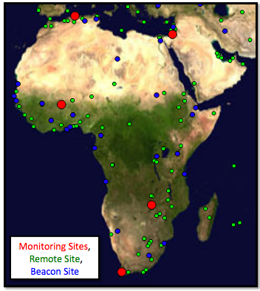
Figure 17: PingER nodes in Africa

This study first outlines the new submarine fibres coming into place for E. Africa. It goes on to summarize the current state and trends of Internet performance for Africa and the costs particularly for Sub_Saharan and E. Africa. Following this we discuss the role of the emerging National Research and Education Networks (NRENs) and traffic routing. Then we look at the RTTs of hosts in Kenya and Tanzania on the day following the start of operation of the Seacom cable, the identification of further hosts of interest, followed by the changes in RTTs as hosts later moved their routing from satellite to terrestrial routes.

Submarine Fibre Cables for E.Africa
At the moment the SAT-3/WASC/SAFE fibre has been in place for some time and connects up several countries on the W. Coast of Africa. Up until now however, there have been no fibres on the East Coast of Africa. The Seacom line is not the only fiber-optic cable project on Africa's East coast — others include the Eastern Africa Submarine Cable Systems (EASSY), The East African Marine System (TEAMS)and Lion — but it will be the longest and have highest capacity (1.28 terabytes per second). The EASSY and TEAMS are designed to build out African telecommunications networking, but Seacom is the only line that directly will connect east coast urban areas in Kenya, Madagascar, Mozambique, South Africa and Tanzania to France and India. TEAMS landed in Mombasa early June 2009 and is currently undergoing testing while EASSY and Lion are expected to be operational by mid-2010. Maps of the various fibres is shown below, more details are available here. Also shown is network schematic of the Seacom link.

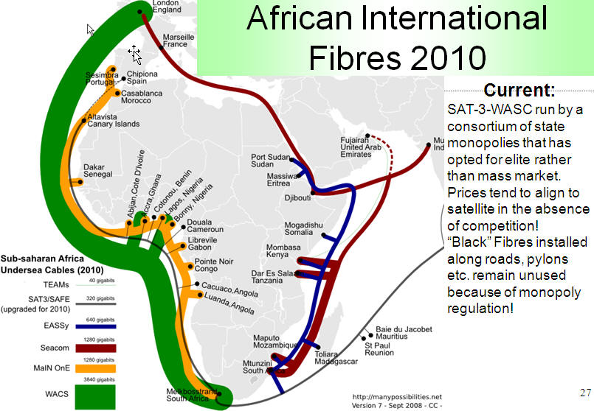
Figure 18: African International Fibres 2010

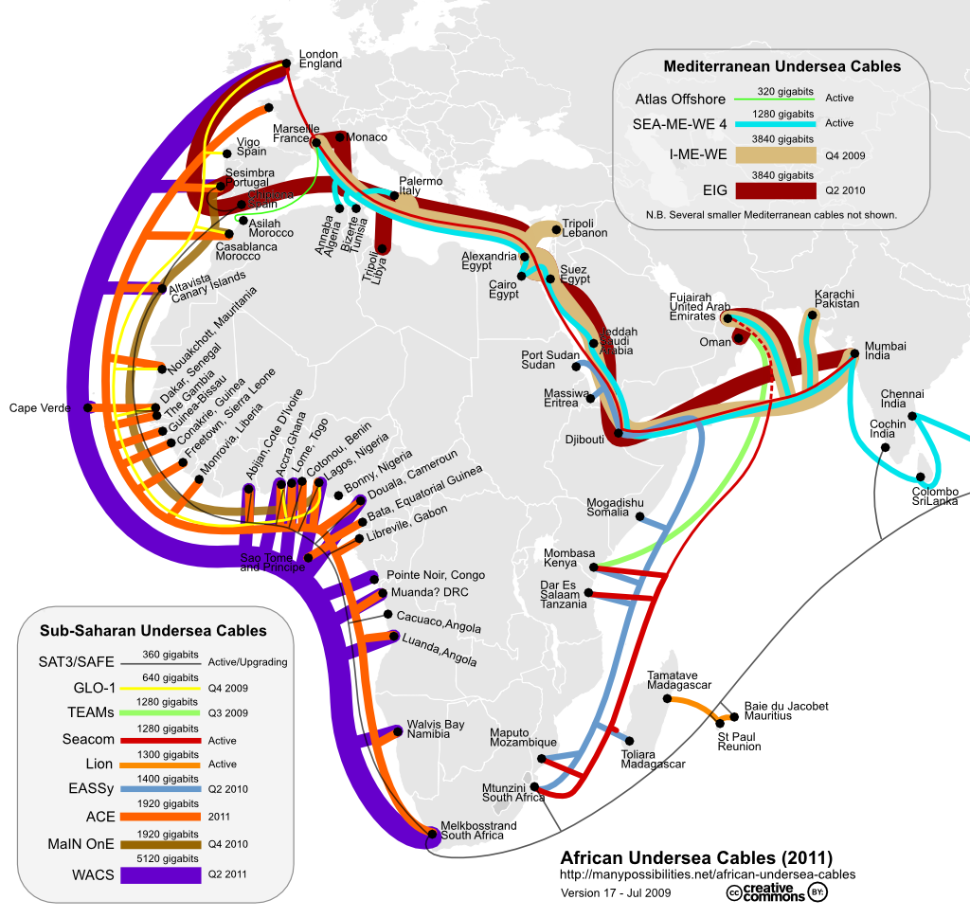
Figure 19: African under sea cables

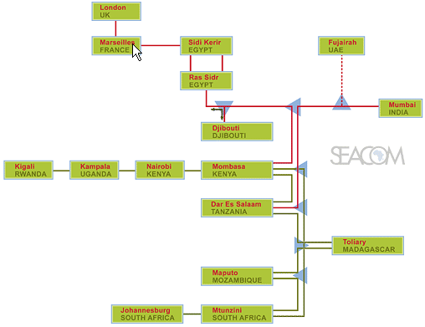
Figure 20: Seacom Network Semantics

Current State of the African Internet
The derived throughputs measured to Africa from N. America for the last decade are shown below in the left hand figure. It is seen that not only do African sites lag the rest of the world in throughput, being roughly in the state that European sites were over a decade and a half ago, but also they are falling further behind with time. Further, bear in mind that for Africa, Mediterranean countries and South Africa have the better perfomance and E. Africa is the worst off (see the the middle map below). Thus the arrival of a terrestrial submarine fibre cable link to the rest of the world for E. Africa is a very significant development.
The minimum RTTs measured from SLAC to African countries in August 2009 are seen in the map below:

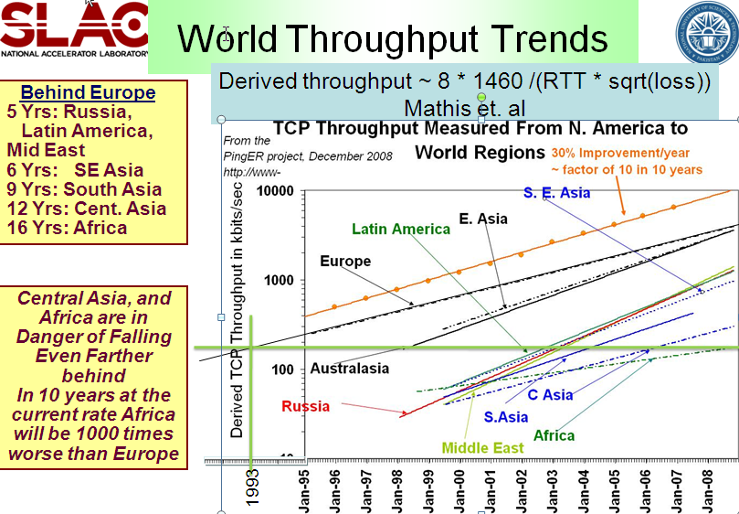
Figure 21: Throughput from SLAC to Regions of the World

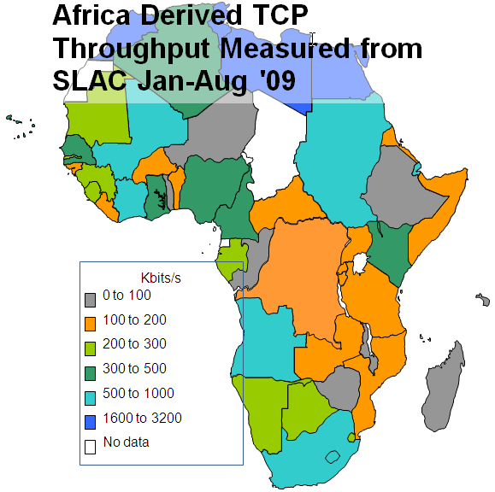  Figure 22: Derived Throughput from SLAC to Africa Jan-Aug 09 | 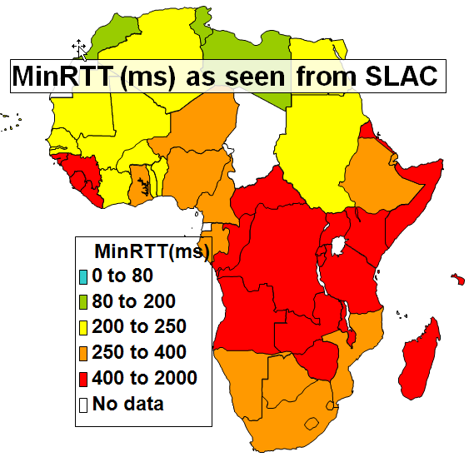  Figure 23: MinRTT(ms) as seen from SLAC

The striking number of countries in Eastern and Central Africa with minimum RTTs of >400ms is indicative that they were using GEO-Stationary (GEOS) satellite links.
Another way of illustrating which countries are using satellites is to look at a bar chart of the PingER measured minimum RTT in the fuirst half of 2009 for each country sorted by the minimum RTT. Such a chart is shown below on the left. It is seen that there is a steep rise around 400ms as one moves to GEOS satellite connection. The predominance of African countries (blue) with large minimum RTT is also apparent. If one creates the same type of bar chart but only using African countries then the result is seen on the right below where the countries with a minimum RTT > 450ms are labeled.

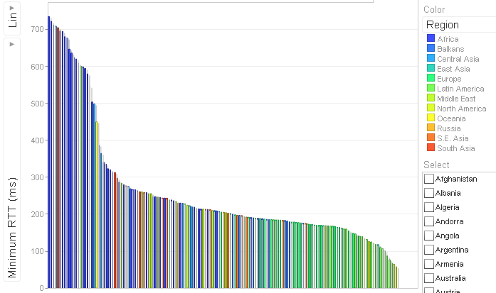
Figure 24: PingER minimum RTT for countries of the World in the first half of 2009

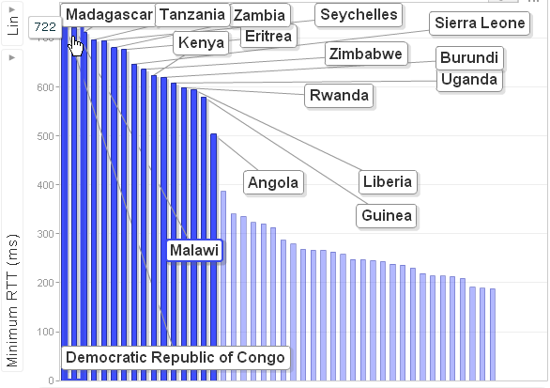
Figure 25: PingER minimum RTT for African Countries in Africa first half of 2009

East Africa contains 300M people, yet less than 3% are Internet users. Bandwidth in Africa is very expensive. See for example the left hand figure below where it is seen that bandwidth costs for broadband in Sub-Saharan Africa are 30-40 times that in the US. Taken together with the earnings differences, what takes say 15% of a US Gross National Income (GNI) per capita will take over 800% of a Sub-Saharan GNI per capita.

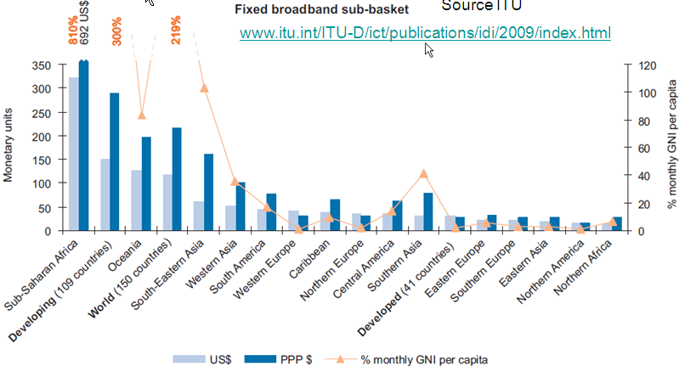
Figure 26: Costs of Broadband Internet Access in Countries of the World

Emergence of National Research and Education Networks (NRENs) & Routing
In the past the area has had poor Internet connectivity with heavy use of expensive (in terms of $/Mbps) geostationary satellite connections to the outside world. (see above) In addition most of the traffic between countries made use of expensive international links via Europe and the U.S. rather than more direct connections. There are active movements to create National Research and Education Networks (NRENs) in the area, see for example "Sub-Saharan Africa: An update" by Boubaker Barry. This, together with direct connections between countries will enable more direct peering. These NRENs in turn are peering with the GEANT network in Europe through the Ubuntunet Alliance. The map on the left below shows the state of African NRENs in 2008, the map in the middle shows the Founding Ubuntunet Alliance members and those who have joined since the founding, the figure on the right shows the prediction (in October 2008) for the state of Ubuntunet connections at the end of 2009.
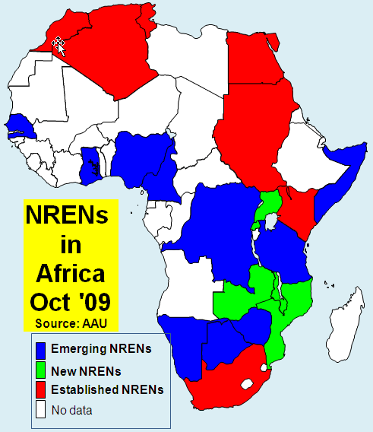  Figure 27: NRENs in Africa OCT 2009 | 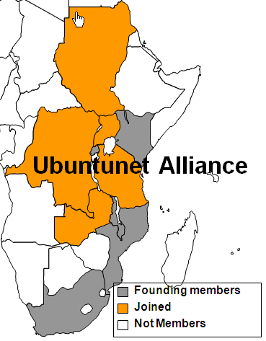  Figure 28: Ubuntunet Alliance

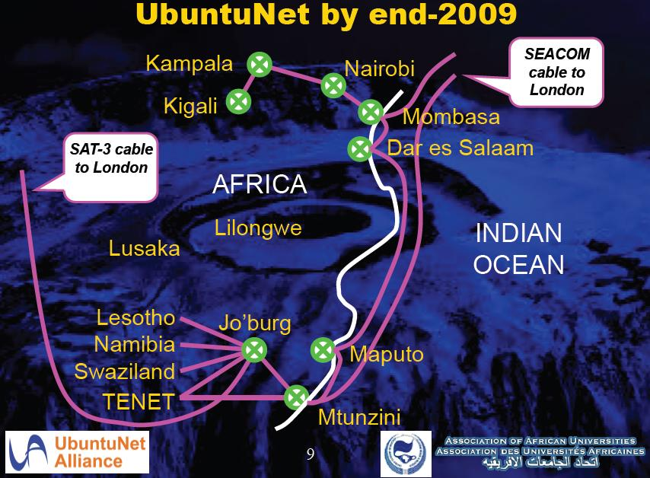
Figure 29: Ubuntunet End 2009, from Duncan Martin

It can be seen that NRENs are being created.

To understand the importance of NRENs and IXPs to reduce the use of intercontinental providers to get between African countries, we can look at the state of direct connections between African countries by measuring the traceroutes within Africa. Below on the left and in the middle are the routes taken from South Africa to other African countries in September 2005 and August 2009 and on the right the routes from Burkina Faso to other African countries in August 2009. In the middle map countries which were only accessible by satellite have horizontal shading lines.

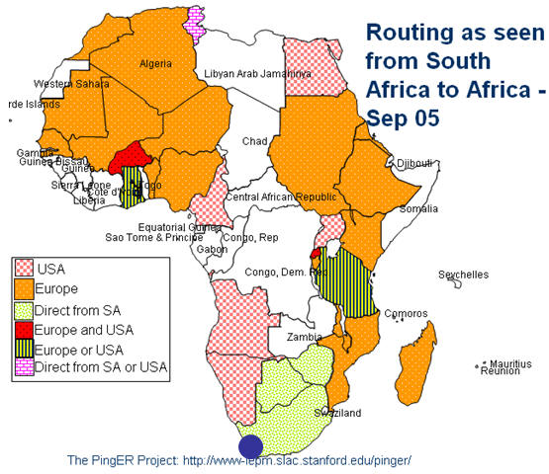
Figure 30: Routing from South Africa to Africa Sep 2005

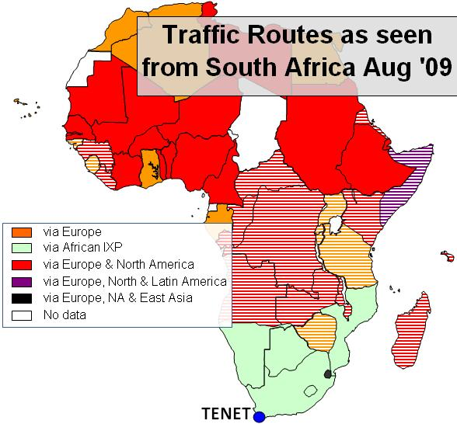
Figure 31: Routing from South Africa to Africa Aug 2009

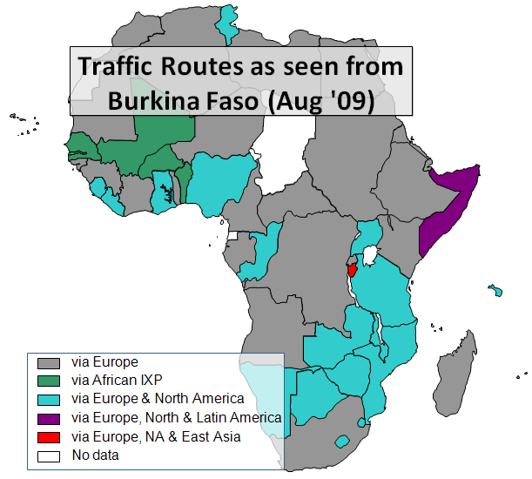
Figure 32: Traffic Routes as seen from Burkina Faso (Aug 2009)

In September 2005 most traffic from South Africa to the rest of Africa took costly international links, only Botswana and Zimbabwe had direct routes. The situation has improved recently as direct routes from South Africa to Namibia and Botswana were added. More details on the routes to African countries from several measurement points around the world measured in Spring 2009 can be seen in a spreadsheet of African routing and inferences.
Connections from Burkina Faso in August 2009 were direct to only Senegal, Mali, and Benin (in green). Most other countries in grey were reached by intercontintal connections via Europe, followed by many in teal that go via Europe and N. America. Somalia was reached via Europe, N. and S. America. Burundi was reached via Europe, N. America and E. Asia.

Initial Results on First Day
One would expect with the use of a terrestial fibre rather than a geo-stationary satellite that the minimum RTT woud be reduced from >=400ms to 200-300ms as seen from the US. Also the reduced congestion enabled by the higher speed links should make the average RTT more stable and reduce the packet loss. Below are shown the average RTTs and losses from SLAC on the West Coast of the US to various hosts on the East Coast of Africa. These are all measured using the PingER project's data.

Kenya
acheraarchitects.co.ke | 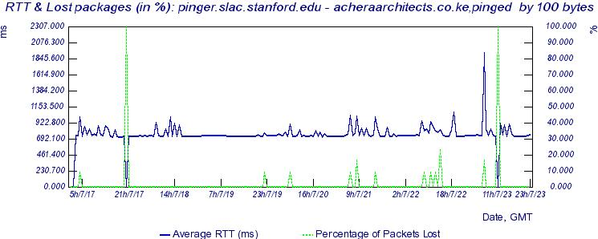
loans.co.ke | 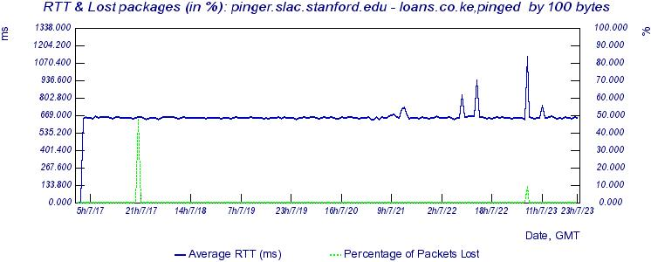
elearning.braeburn.ac.ke | 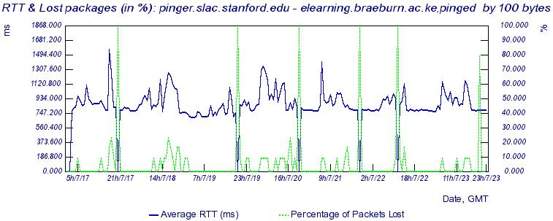

Mozambique
www.micti.co.mz | 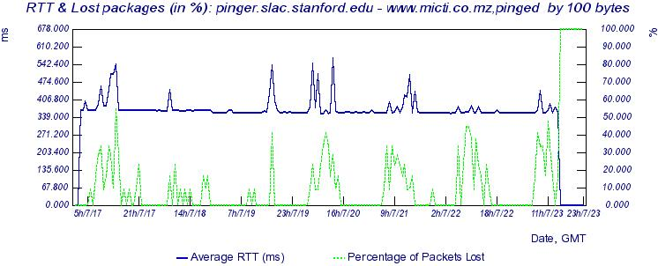
www.uem.mz | 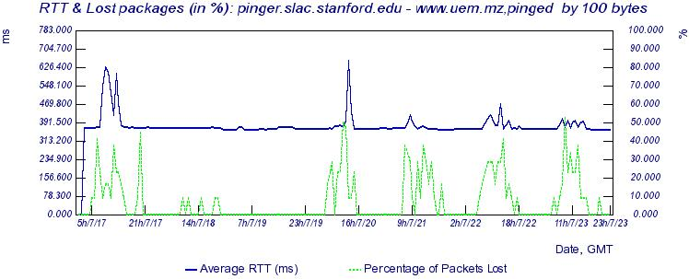

Tanzania
www.muchs.ac.tc | 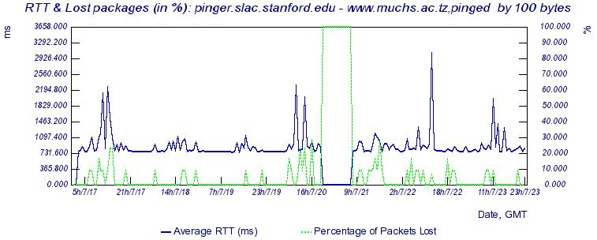
www.6telecoms.co.tz | 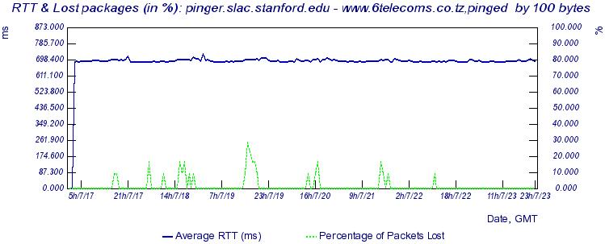
www.acet.or.tz | 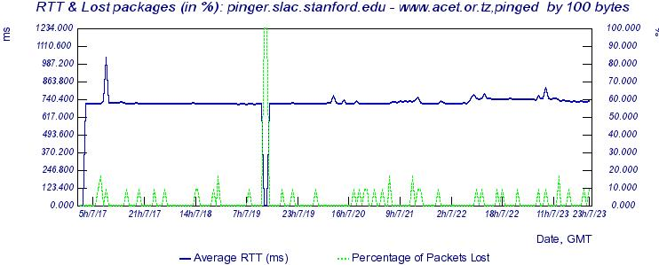

It is apparent we do not observe any dramatic reduction in RTT on July 23rd. We also looked at the PingER recorded RTT from ICTP Trieste, Italy to a host in Tanzania in case the routes from SLAC were still using satellite while those from Italy were not. We also looked at the RTT seen from a TENET host in cape Town South Africa to a host in Mozambique. In this case (see below) the RTTs have long been << 400ms so they already were not using geostationary satellite to connect the sites.

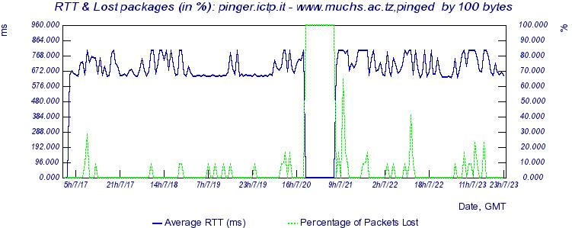
Figure 33: www.muchs.ac.tz from Trieste

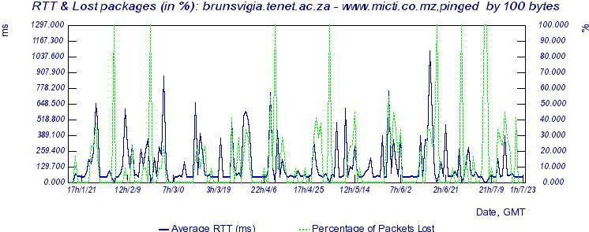
Figure 34: www.micti.co.mz from Cape Town

Again there is no dramatic reduction. Looking at the TENET to www.micti.co.mz RTTs it is apparent that there is a direct (non geo-stationary) satellite connection between the two sites since the RTT << 400ms.
According to the BBC report five institutions are already benefiting from the faster speeds - national electricity company Tanesco, communications company TTCL, Tanzania Railways and the Universities of Dar es Salaam and Dodoma. We also heard from Alem who was visiting Kenyata University from Ethiopia for a one day conference that "You can get connected and download data like what you can do in Europe."
From SLAC, we pinged hosts at each of these organizations; the Round Trip Time (RTT) results in msec. are shown below: For the # pings with an asterisk the host did not respond to pings so we used synack to probe the web server:
Country | Organization | Host | # pings | Min RTT | Avg RTT | Max RTT | Std dev | Loss
Tanzania | Tanzania railways | www.trctz.com | 100 | 764 | 790 | 893 | 19.5 | 0%
Tanzania | Tanzania Telecommunications Company | www.ttcl.co.tz | 100* | 714 | 721 | 730 | 4.3 | 1%
Tanzania | University of Dar Es Salaam | www.udsm.ac.tz | 151 | 696 | 711 | 1130 | 45 | 0%
Tanzania | University of Dodoma | www.udom.ac.tz | 100* | 753 | 783 | 845 | 18 | 0%
Tanzania | Tanesco National Electric Company | www.tanesco.com | 49 | 12.6 | 12.997 | 13.53 | 0.251 | 0%
Kenya | Kenyatta University | www.ku.ac.ke | 138 | 650.138 | 652.36 | 668.44 | 1.97 | 2%
The host www.tanesco.com is probably a proxy located somewhere in the Western US. The other hosts all have minimum RTTs of well over 400ms which indicates they are probably still using a geo-stationary satellite.
When looking at the lack of effects seen initially, following the fibre install, it is important to understand the caveats.
To enable easier selection and looking for changes for these East African Coastal countries, we added a PingER affinity group (E.AFRICA_COAST) for hosts monitored in Kenya, Mozambique and Kenya. The minimum RTT should be very sensitive to a change in the route from a geo-stationary satellite to a terrestrial fibre link. An example of selecting data sensitive to the E. African fibre connection can be seen in the table of PingER daily minimum RTT data for the group E.AFRICA_COAST. This data is updated daily.

Adding Extra Hosts
We received suggestions from Don Riley of UMD:
I would be watching kdn.co.ke, kenet.or.ke in Kenya. maybe also Univ. of Nairobi.
KDN should change soon, since they're connecting directly to SEACOM and lighting fiber to Uganda and Rwanda. KENET should be first on the university side, I think. and Univ. of Nairobi - typical for lead univ. in capitol to come up first. Similar in TZ and MZ, but looks like you've got the right lead univ's there. Would probably track MORENET and TERNET there.
We have been monitoring kdn.co.ke so we will have a nice history and see the change.
Kenet.or.ke does not respond to pings, using synack the response time to its web server (kenet.or.ke:80) on 7/25/09 was about 667ms.
For the University of Nairobi I Googled it and got www.uonbi.ac.ke however it has an RTT of 78ms from SLAC and appears to be in Virginia USA. Instead I added library.uonbi.ac.ke that is a University of Nairobi host that appears to be in Nairobi. On 7/25/09 it had an RTT of ~ 658ms.
I googled MORENET Mozambique and came up with morenet.mct.gov.mz. However it does not respond to pings. It does respond to synack on port 80 (www) and the response time to a trivial request is ~368ms so it may have already moved over. However GeoIPTool (see http://www.geoiptool.com/en/?IP=morenet.mct.gov.mz) says it's in Buenos Aires which I do not believe. Visualroute's (at http://visualroute.visualware.com/) tests fail. Looking at the traceroute from SLAC and using GeoIPTool to locate the nodes , it appears that on leaving the US the route goes directly from the West Coast of the US (Sunnyvale) through Buenos Aires (node telkomsa.ge9-16.br02.ldn01.pccwbtn.net 152ms) then to Pretoria (rrba-ip-lir-1-pos-1-0-4.telkom-ipnet.co.za 352 ms) and then to Mozambique. This it is not currently using the new fibreoptic cable running south, down the E. African coast.

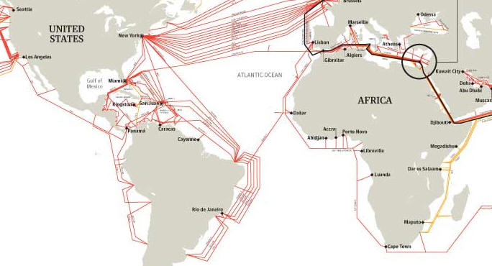
Figure 35: World Undersea Fibre Cables in African Region
Steve Song pointed out that a good PingER point would be the Durban University of Technology. They are the only university in South Africa to be currently connected to Seacom. This was confirmed by Duncan Martin of TENET in an email. All the rest are waiting for the development of the national SANREN backbone, later this year. I added www.dut.ac.za to the list of hosts monitored by PingER on 8/6/09. We will look to see whether we can see differences between it and other hosts monitored in South Africa.

Later Results Illustrating Impact of Changes
To assist in the selection of hosts in this region from the pingtable results, we created an affinity group that contains all hosts in Kenya, Mozambique and Tanzania. This makes it much simpler to look at the minimum RTT for just such hosts for the last few days
Uganda should be connected soon. KDN was building the fiber to Uganda and Rwanda. We therefore also set up a group for countries in the UN definition of Eastern Africa to simplify reviewing minimum RTT for all East Africa.

Kenya
On Aug 2, 2009 following an email from Don Riley who had detected that kdn.co.ke had dropped to 370ms. We were unfortunately not monitoring kdn.co.ke. However on further investigation we found the RTT from SLAC to acheraarchitects.co.ke (see below) had changed between 14:00 and 17:00 hours 6/1/09 GMT from a steady 716 ms to a steady 325ms. This is exactly what one would expect as the route moves from a GEOS to a terrestrial line. The traceroute from SLAC to Kenya went via ESnet to Sunyvale, then via Level3 to New York and London and thence to Kenya. The RTT between London and Kenya was about 200ms.
On August 3, 15:00 hours www.ku.ac.ke dropped to about 370ms (see below), the earlier step change from 650ms to 550ms may have been since only one direction of the route was using the terrestrial line. The large difference by time of day indicate that there is probably still congestion somewhere in the route. A traceroute after the changeover shows the route going via ESnet to New York and via Level3 onto London, there it is transferred to InterRoute and is carried to Kenya by Seacom and thence to Nairobinet. According tohttp://www.interoute.com/news_and_events/news/1278 Seacom partners with Interoute.
On August 3, around 19:00 hours elearning.braeburn.ac.ke dropped from about 750ms to about 400ms (see below). The traceroute from SLAC to Braeburn is different from that to www.ku.ac.ke. It goes from SLAC via Esnet to Sunnyvale, crosses to Teleglobe and then to AS6453 to get to London. AS6453 is GLOBEINTERNET TATA Communications. In Kenya one of the nodes is Access Kenya which according to http://www.accesskenya.com/ "Access KenyaNews: ACCESSKENYA SETS AMBITIOUS TARGET OF 1MB GUARANTEED SPEED FOR THE AVERAGE CUSTOMER. ACCESSKENYA UPGRADES CORE NETWORK IN PREPARATION OF SEACOM AND TEAMS CAPACITY" (their capitalization.
More details on the Kenyatta University (www.ku.ac.ke) and Braeburn (elearning.braeburn.ac.ke) links can be found in an email from Kevin Chege of KENET.

Rwanda
Between the 22nd and 25th of September the RTT from SLAC to The Kigali Institute of Education host www.kie.ac.rw in Kigala, Rwanda dropped by a factor of 2 from 720msec to 320msec (see below). The connection was through Kampala Uganda to Kenya. The traceroute appears to go via Austria.

Tanzania
On the 26th September 2009 the RTT from SLAC to www.acet.or.tz in Dar Es Salam Tanzania dropped from about 720msec to about 310msec (see below).

Uganda
By August 3rd, the average RTT from SLAC to mail2.starcom.co.ug in Kampala Uganda reduced from about 780ms to about 540ms. On August the average RTT dropped further to about 380ms. Possibly in the intermediate state (540ms) only one direction was using the fibre. The traceroute measured on 8/15/09shows the route going via ESnet to Sunnyvale then onto San Jose and Level3 that carries it to New York and London, the next hop is in Nairobi an Intersat Africa node. Hop 18 is also in Nairobi and hop 19 in Kampala. Looking at the time series of the average RTT below it is not clear the route has fully stabilized yet.
In some cases such as Uganda Telecom (81.199.21.194) the losses and fluctuations in RTT went up dramatically after the changeover. In others such as library.uonbi.ac.ke andacherarchitects.co.ke the losses and stability appeared to improve.

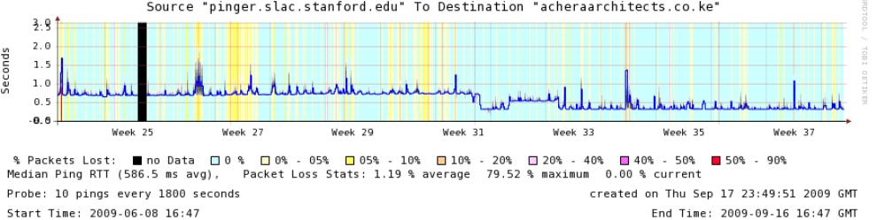
Figure 36: acheraarchitects.co.ke

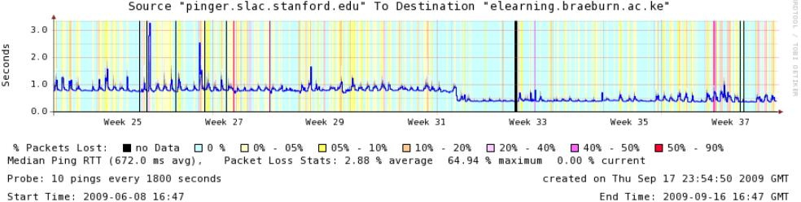
Figure 37: ealearning.braeburn.ac.ke

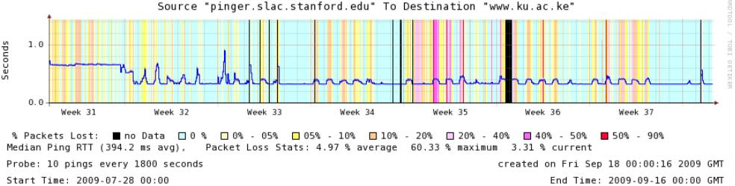
Figure 38: www.ku.ac.ke from SLAC

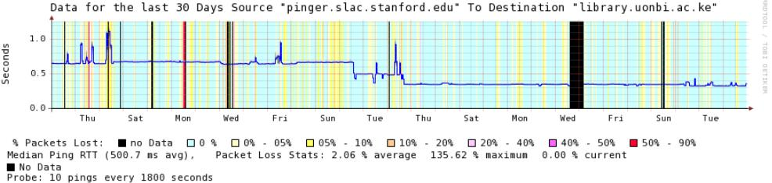
Figure 39: library.uonbi.ac.ke (03 Aug 09- 09 Sep 09)

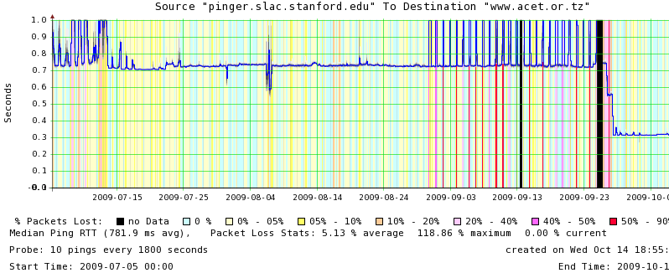
Figure 40: www.acet.or.tz

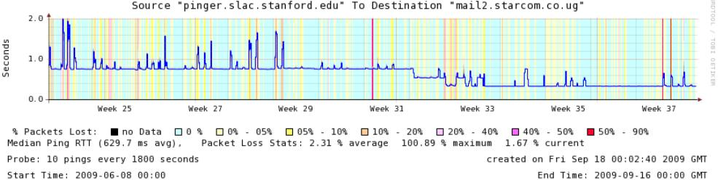
Figure 41: mail2.starcom.co.ug from SLAC
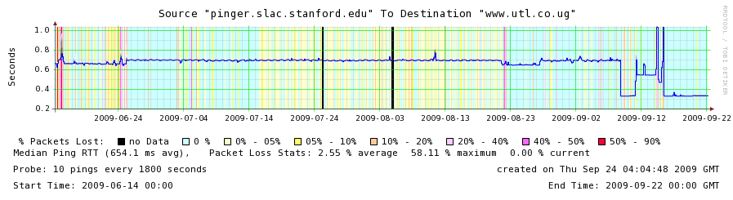
Figure 42: www.utl.co.ug from SLAC

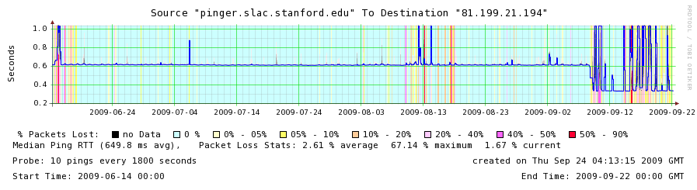
Figure 43: Ugandatelecom.ug from SLAC

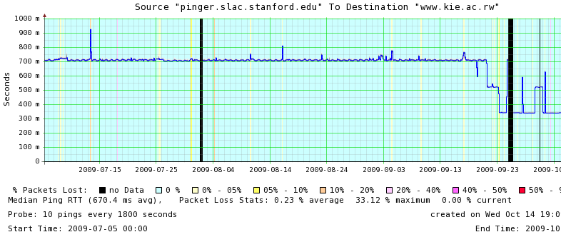
Figure 44: www.kie.ac.rw from SLAC

Seen from ITCP Trieste Italy
If one compares the RTTs seen from SLAC to East Africa with those seen from ICTP in Trieste Italy which is much closer, then:
- for www.ku.ac.ke from ICTP the change is from 800ms to ~200ms (a factor of ~4 improvement) while from SLAC it is 650ms to ~350ms (or less than a factor of 2 improvement)
- for mail2.starcom.co.ug from ICTP the change is from ~ 600ms to 200ms (or a factor of 3 times) while from SLAC it is 800ms to 350ms (or just over a factor of 2 improvement)

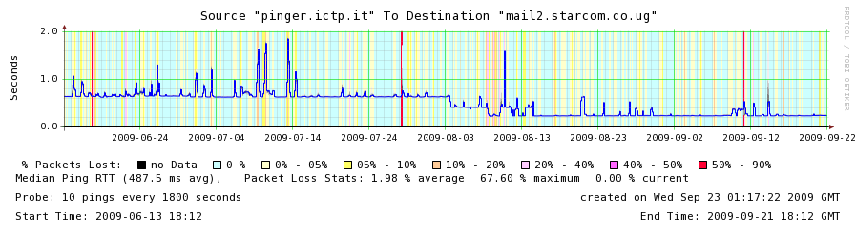
Figure 45: mail2.starcom.co.ug from ICTP

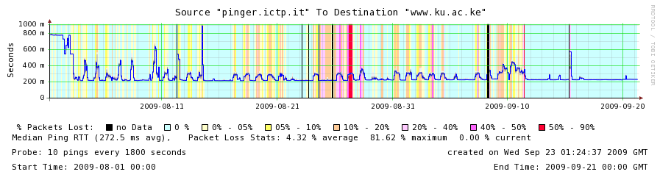
Figure 46: www.ku.ac.ke from ICTP

Though we show several time series of median RTT for hosts in various countries which have converted from GEOS to landlines, in all the countries above there are still hosts that are connected via GEOS.

Other nearby Countries
Similar effects (dramatic reduction in RTTs) have also been observed for other sites in south and eastern African countries.

Angola
For example on May 19th 2009, www.novagest.co.ao one of 4 sites PinGER monitors in Angola reduced the average RTT from about 750ms to 450ms and became much more stable (less jitter) in the process (see the time series in the figure below). The traceroute goes via Globenet TATA Communications and then to the Angola Telecom IP backbone.

Ethiopia
The RTT from SLAC to www.haramaya.edu.et at the University of Addis Ababa in Dire Dawa, Ethiopia's second largest city (about 300km as the crow flies from the coast) on the railway line between Djibouti and Addis Ababa, dropped from about 580ms to 300ms on June 9th 2009 (see below).

Malawi
Malawi currently (10/13/09) has only GEOS access. The most likely terrestrial path will be via Mozambique to Maputo (the landing point for both Seacom and TEAMS) see the email from Bjorn Pehrson and the article by Telegeography.

Mozambique
Similarly the average RTTs of both hosts that PingER monitors in Mozambique (www.uem.mz and www.micti.co.mz) dropped from 780ms to about 360 ms in May 2007.

Namibia
On the other hand hosts in Namibia (such as www.adsl.com.na seen below) seem to be switching between using a long RTT path from SLAC and a shorter one.

Zambia
One host (www.aisha.ac.zm) of the 6 monitored in Zambia improved its RTT from about 720ms to 550ms on August 20, 2009 (see below). They then spent many days moving the link over to the terrestrial lines. During this time the performance was very unstable (high losses) and there were big changes in RTT. It is probable the link in one direction was using a GEOS while the other was an all terrestrial link and the large dips to 400ms were when both legs were using terrestrial links. We believe the terrestrial path goes via Botswana and Namibia. The traceroute from SLAC on 9/9/09 appeared to use a satellite link in at least one direction. The final cutover to terrestrial link is in both directions appears to have been made on October 23rd when the RTT dropped to ~350ms and the link appeared more stable. On October 2, 2009 Mike Jensen reported that the traceroute from Rome to www.aisha.ac.zm was well below 450ms and thus appears to be a terrestrial link. However the tracreoute from SLAC was still taking over 550ms. Also the traceroute from TENET/Cape Town South Africa to www.aisha.ac.zm took over 650ms. The traceroute from NUST, Islamabad, Pakistan to mail.unza.zm takes less than 450ms and appears to be a terrestrial path going via Namibia. On October 7th 2009 the traceroute from SLAC to mail.unza.zm appeared to be terrestrial and went via Namibia.

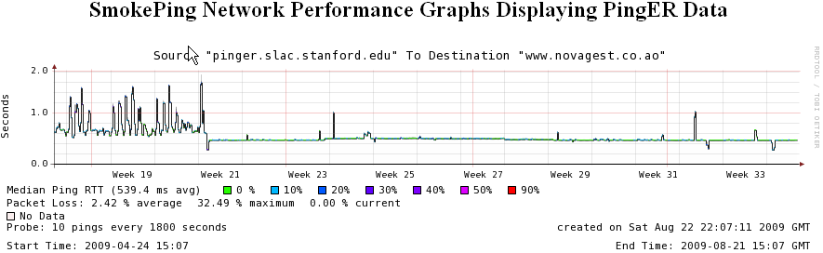
Figure 47: Angola: www.novagest.co.ao

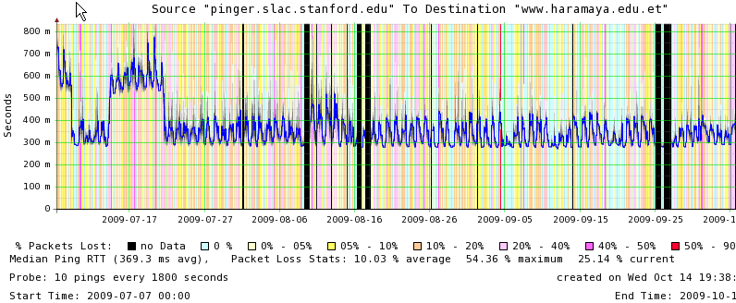
Figure 48: Ethiopia: www.haramaya.edu.et

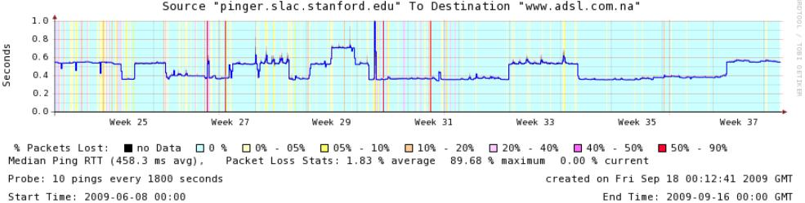
Figure 49: Namibia: www.adsl.com.na

Figure 50: Zambia: www.aisha.ac.zm

Fractional Conversion
The table below shows the number of hosts monitored from SLAC in the country and the number of those that used a terrestrial path as of a particular date.

 |  |  | Monitored | Terresrial
 | Oldest Measured Data | 1st observed conversion | 10/17/09 | 10/17/09
Angola | Oct 2006 | May 19, 2009 | 3 | 1
Botswana | Apr 2009 | None | 3 | 2
Ethiopia | Nov 2008 | June 9, 2009 | 7 | 1
Kenya | Feb 2005 | Aug 2, 2009 | 6 | 5
Lesotha | Feb 2005 | None | 2 | 2
Madagascar | Dec 2003 | None | 2 | 0
Malawi | Mar 2005 | None | 3 | 0
Mozambique | Dec 2003 | May 2007 | 2 | 0
Namibia | Feb 2007 | ? | 2 | 1
Rwanda | Mar 2005 | Oct 17, 2009 | 3 | 1
South Africa | Feb 2005 | None | 14 | 12
Swaziland | Oct 2007 | Feb 2009 | 3 | 1
Tanzania | Dec 2003 | Sep 26, 2009 | 5 | 1
Uganda | Nov 2003 | Aug 3, 2009 | 3 | 2
Zambia | Feb 2009 | Aug 20, 2009 | 6 | 1
Zimbabwe | Feb 2007 | None | 5 | 0

Other Regions in Sub-Saharan Africa
On September 6th, 2009 it was reported that the Glo-1 Submarine cable landed in Lagos, Nigeria. The 9800km cable is coming from Bude in the UK and connects Nigeria to the rest of West Africa and the UK. It has landing points in Nigeria, London and Lisbon in Portugal. It is deploying 16 branching units to connect countries in West Africa. It is a project jointly executed by Globacom and its partners, Alcatel Lucent. this brings competition to the SAT3/WASC/ cable consortium. In May 2010 the Main One cable will be landing on the West Coast of Africa.

Further Reading
- Africa Undersea Cables
- The Cable Guy: How to Network a Continent is a great Wired UK article that tells a compelling story illustrating the physical dimension and the challenges of deploying broadband in Africa.
- How to Cross the Digital Divide, Rwanda-Style provides an interesting case study of how Rwanda has been able to somewhat bridge the digital divide in a methodological manner.
- Internet prices to fall with surge in clients
- Linking Tunisia with Italy
- MANGO-NET (Made in Africa NGO NET work)

Appendix B: Effects of Mediterranean Fibre Cuts December 2008
The purpose of this study was to examine the effects of fibre cuts in the Mediterranean in December 2008. The fibre cuts were reported by many sources including the BBC, Blomberg News, Al Jazeera, Orange and Wired on December 19th 2008, also see the article in Wikipedia. We decided to have a look at the impact on ping performance using the PingER data. For performance issues following the previous Mediterranean fibre cut in January 2008, see:
https://confluence.slac.stanford.edu/display/IEPM/Effects+of+Fibre+Outage+through+Mediterranean.
On December 19, Orange reported that France Telecom observed 3 major underwater cables were cuts: "Sea Me We 4" at 7:28am, "Sea Me We3" at 7:33am and FLAG at 8:06am. A Telegeography map of the cable routes in the Mediterranean is seen below in Figure 51.

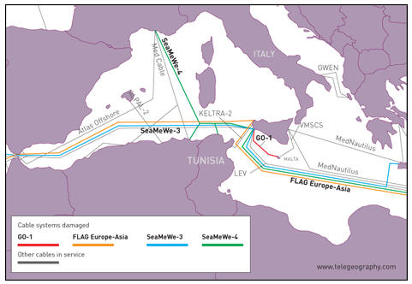
Figure 51 Map of undersea cable routes through the Mediterranean

Losses
The measured effects on the losses seen from N. America (SLAC in California) to hosts in N. Africa (Egypt, Sudan); Middle East (Bahrain, Palestine, UAE, Oman, Jordan, Lebanon, Saudia Arabia); S. Asia (Sri Lanka, Maldives, Pakistan) are huge. As seen from PingER daily loss data measured from SLAC, comparing the losses on Friday Dec 19 with those on Mon-Thu (15-18 Dec) the losses have increased by a factor of 5 to 30 times for most of the hosts monitored in the above countries.

Unreachability
Unreachability is defined in PingER terms as when none of the 10 pings sent each 30 mins gets a response. Looking at the PingER data despite the magnitude of these cuts and the large impact on losses there is no indication of unreachability (100%) losses to any of the hosts measured in the affected regions. This does not mean that applications that require higher bandwidth than pings (1000bits/sec for a short period (~10secs)), low loss or jitter or Round Trip Time (RTT) will not be badly impacted causing them to fail or to be effectively useless. On the other hand it does show that Internet connectivity was successfully maintained due to the use of redundant paths etc.

Round Trip Times
Examples of the increase in RTT can be seen below in the plot of RTT seen from SLAC to two hosts in Egypt, a host at the Lahore School of Economics Pakistan and a host at the NCP provider in Pakistan, a host in Bahrain, one in Oman, one in Bangladesh (www.brauniversity.net), one in Jordan and one in Saudi Arabia. All show an increase in RTT around 9-10 am on Friday Dec 19th 2009 (UDT). In the case of the www.tanta.edu.eg host in Egypt no loss of connectivity was observed at the time of the cut. However for the frcu.edun.eg besides the increase in RTT frequent losses of connectivity are observed and the link appears to be restored on December 23rd (www.frcu.edu.eg recovered at about the same time). In the case of Lahore there was a short period of no connectivity and over the days of the outage the RTT varied dramatically dropping back to normal and full recovery did not appear to be complete by December 27th. NCP had a small increase in RTT and a long period of no connectivity later on Friday stretching into Saturday. The Bahrain host experienced large changes in RTT between daytime (busy times, more congested, more queuing and longer RTTs) and night-times. The increases in RTT during the daytime for Oman were extremely large (~ 5 seconds), however the problem appears by-passed/fixed by December 23rd. The Bangladesh host follows a very reproducible pattern switching between 250ms at night and 300ms RTT for the rest of the time and the effect continues to at least the end of December 30th. The Jordan host is less regular in its behavior and there is little effect on the weekend (December 20th & 21st) following the start of the outage. The Saudi Arabia host RTT increases and even at nights and weekends the minimum RTT is greater than before the cuts. These graphs illustrate the variability of the impact even within a country.

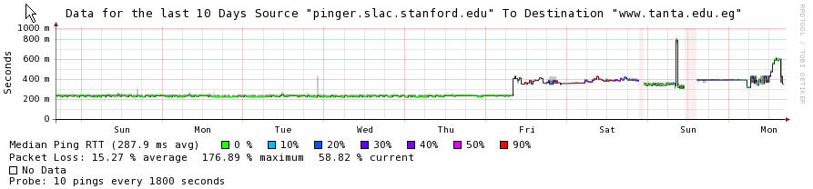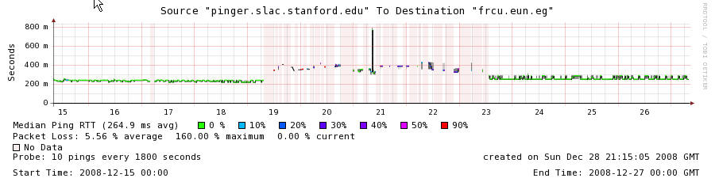
Figure 52 RTT and Losses for Egypt as seen from SLAC
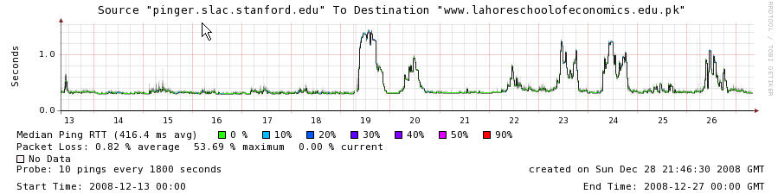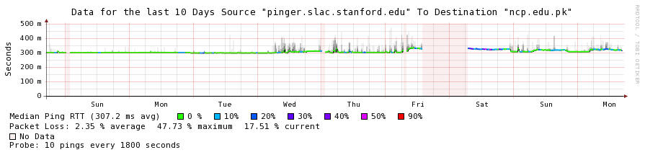
Figure 53 RTT and Losses for Pakistan as seen from SLAC
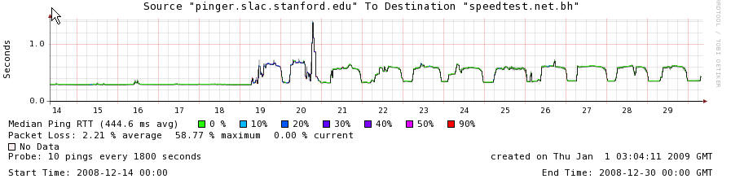
Figure 54 RTT and Losses for Bahrain as seen from SLAC
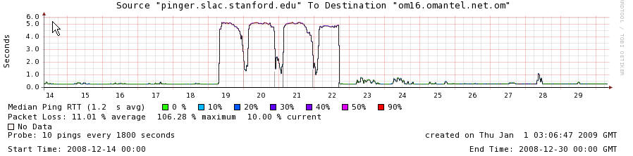
Figure 55 RTT and Losses for Oman as seen from SLAC
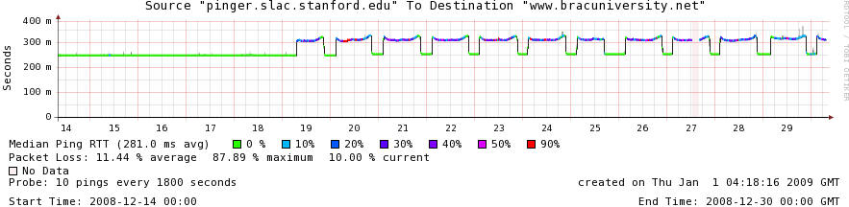
Figure 56 RTT and Losses for Bangladesh as seen from SLAC
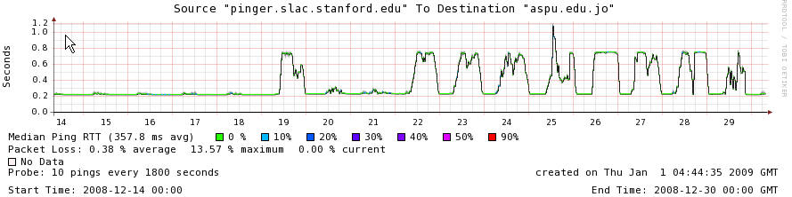
Figure 57 RTT and Losses for Jordon as seen from SLAC
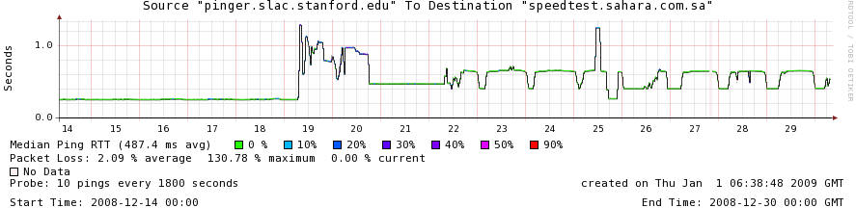
Figure 58 RTT and Losses for Saudi Arabia as seen from SLAC

Another view of the effect of the RTT increases is seen in the plot below in Figure 59 of the median RTTs measured (the error bars is the standard error) from 3 monitoring hosts in Pakistan (NUST, COMSATS and NCP) to FNAL, SLAC and CARLETON (i.e. 9 pairs of monitor/remote hosts) for the duration of 1st December 2008 to 27th January 2009.
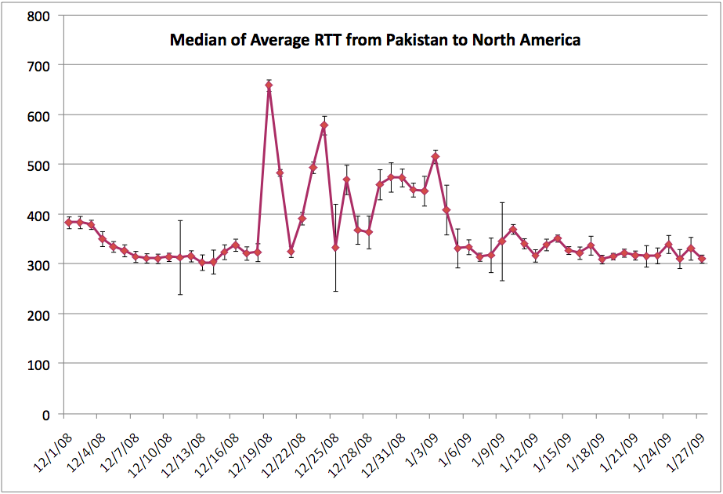
Figure 59 Median of AvgRTT from Pakistan to North America

Jitter
We measure the jitter as the Inter Packet Delay Variability (IPDV). The plots below show the RTT and Loss plus the IPDV and maximum and minimum (of 10 pings) measured for a host (Sudan University of Science and Technology (SUSTECH)) in the Sudan. The dramatic increases in jitter (Figure 97), RTT and losses (Figure 98) are clearly seen following the December 19th cable cuts. Figure 99shows the drop in throughput derived from the average RTTs and losses.

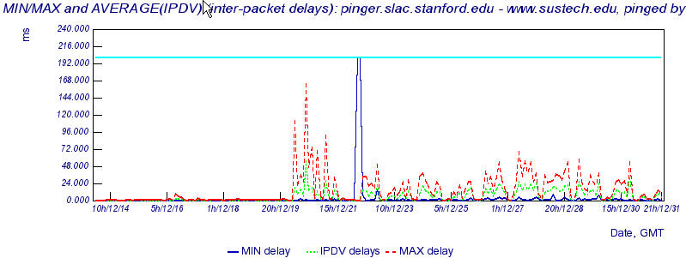
Figure 60 Jitter for SUSTECH as seen from SLAC

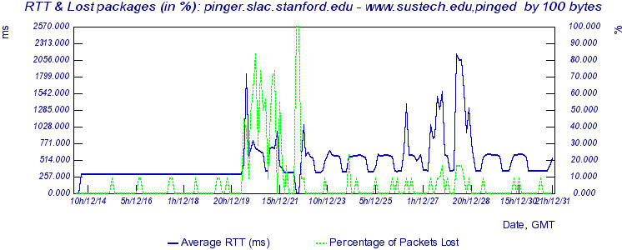
Figure 61 RTT and Losses for SUSTECH as seen from SLAC

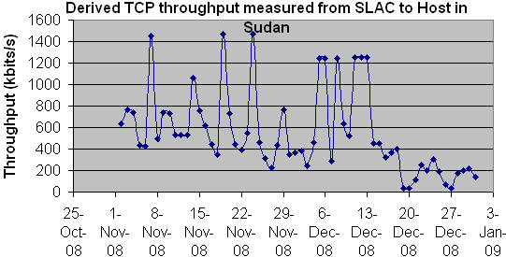
Figure 62 TCP throughput to Sudan as seen from SLAC

Minimum RTT
The minimum (of 10 pings) seen from SLAC to selected hosts in various affected countries is seen below in Figure 100. The Top Level Domain of each host appears at the start of the host name (EG = Egypt, IN = India, LK = Sri Lanka, OM = Oman, PK = Pakistan, SD = Sudan). Not all hosts in each country were similarly affected, due to the use of different carriers. The sudden changes in minimum RTT are presumably due the choice of different routes to carry the traffic. It is seen that steps in minimum RTT occur after the initial cut as carriers changed the routing. Note that just because the minimum RTT may return to its previous fibre cut values does not mean the performance has been restored, the route though being short may have insufficient capacity and still be heavily congested.

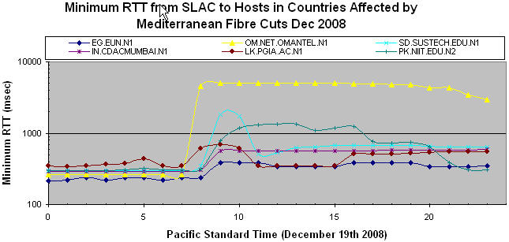
Figure 63 Minimum RTT to affected Regions as seen from SLAC

Traceroutes from SLAC to Egypt
Following the outage the routes changed dramatically and pretty often as the carriers found alternate routes. Before the cut the routes went Eastwards across the US via ESnet, then via GEANT (including routers at Vienna and Italy) to Egypt. Immediately following the cut starting at 23:43 Dec 18th (PST), traffic still went Eastwards but via NTT and London and FLAG across Europe to Alexandria. At 15:32 on Dec 19th the route switched to going Westwards via Singapore using TATA as the carrier beyond the US. Later it went Westwards from Palo Alto in California to Tokyo and Hong Kong using FLAG (until ~13:35 Dec 20th). At 14:52 Dec 20th, it switched to TeleGlobe and TATA going westwards via Singapore. Then on Dec 21st at 03:15 it switched to using Cogent and went eastwards via Boston, London and Paris.

TCP Throughput
We derive the throughput from the loss and RTT measurements as described elsewhere. We then calculate the Residual_Bandwidth_Fraction as
median(derived_throughput for Dec 19-20) / median(derived_throughput for Dec 1-18)

These results were sorted by Residual_Bandwidth_Fraction to create the following Table 7 of the worst affected countries:
Table 7: Worst affected countries by the Mediterranean cut in December 2008
Country | Residual_Bandwidth_Fraction | Internet Users  (from Internet World Stats)
Oman | 1.89% | 0.2M
Sudan | 2.79% | 1.5M
Cape Verde | 3.26% | 0.025M
Egypt | 3.72% | 8.6M
Jordan | 4.06% | 0.6M
Bahrain | 8.24% | 0.2M
Sri Lanka | 19.41% | 0.280M
Ethiopia | 24.03% | 0.113M
Pakistan | 24.32% | 12M
Reunion-French Colony | 26.21% | 0.2M
Libya Arab Jamahiriya | 28.72% | 0.205M
Bangladesh | 28.89% | 0.300M
United Arab Emirates | 31.04% | 1.7M
Malta | 31.28%

The derived throughputs as for the above countries are shown below in a contour plot as Figure 101. The drastic reduction occurring December 19-20 2008 is quickly seen to the left.
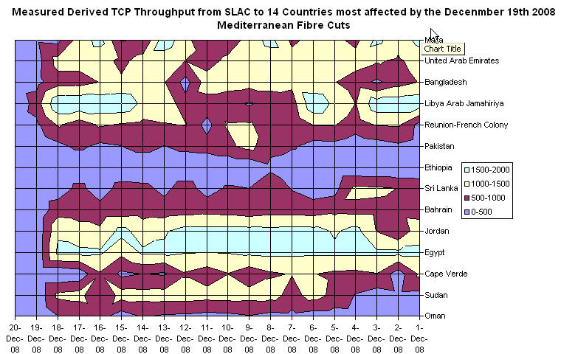
Figure 64 Derived TCP Throughput from SLAC to 14 countries most affected by the December 19th 2008 Mediterranean Fibre Cuts
Another contour plot of the RBF but for a longer period and using:
Residual_Bandwidth_Fraction =
median(derived_throughput for Dec 19-27) / median(derived_throughput for Dec 1-18)

is shown in the Figure 102 with the RBF per country. It is seen that hosts in some countries such as UAE and Egypt seem to have recovered by December 23rd, others such as Sudan, Cape Verde, Bangladesh (one of two hosts) and Libya are still badly affected. Others such as Saudi Arabia and Jordan are partially recovered. Also note the discrepancies in the recovery of the Pakistani hosts. Figure 103 shows the impact in terms of the Reduced Bandwidth Fraction for the various hosts. The inclusion of Russia is probably a statistical anomaly given the variability of the Derived TCP throughputs (Inter Quartile Range ~ 990 kbits/sec) measured to the Russian host, the same can be said for Zimbabwe.

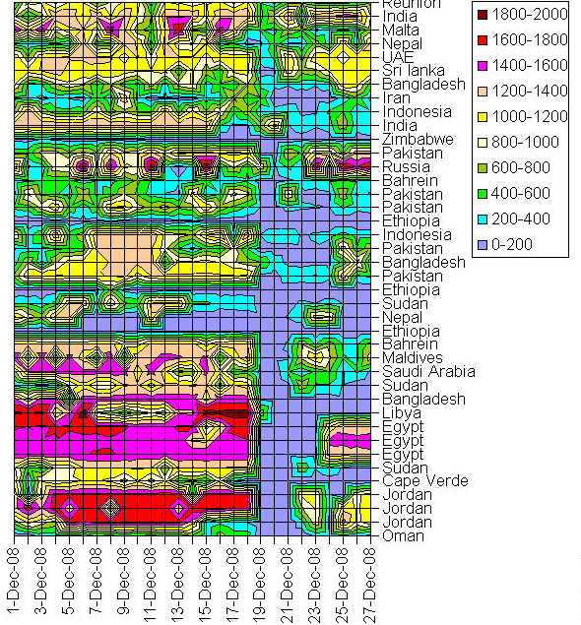
Figure 65 Derived TCP Throughput as seen from SLAC to affected countries

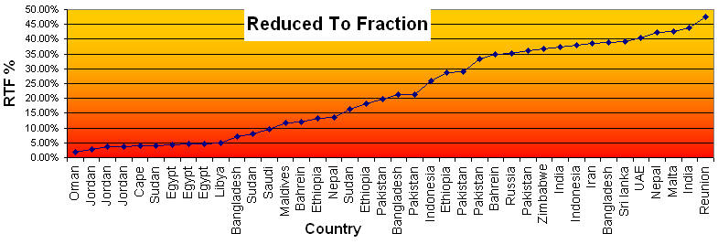
Figure 66 Reduced to Fraction (effects of the fibre cut)

Appendix C: SEECS-NUST, Pakistan Case Study
This case studies, explores Network Performance monitoring in Pakistan, as an extension to “South Asia Case Study” which can be further reviewed in ICFA 2009.
The School of Electrical Engineering and Computer Sciences (SEECS) is a constituent college of National University of Sciences and Technology (NUST), Pakistan - SEECS was formerly known as NIIT (NUST Institute of Information Technology). Since SEECS has been an important collaborator with SLAC, CERN and Caltech, we prepared a case study presenting an overview of the issues faced by SEECS in particular and Pakistan in general.
Table 7 – Monitoring nodes in Pakistan
Location | No. of monitoring nodes
SEECS, NUST | 4
NCP, Quaid-e-Azam University | 1
COMSATS University | 1
Pakistan Education Research Network (PERN) | 1
Micronet/Nayatel Pakistan | 1
Currently the PingER project maintains eight (8) monitoring nodes in Pakistan, measuring the performance of sites listed in the table - monitored nodes - below. The measurements date back to 2003. Since then there has been a gradual increase in the number of monitoring nodes which helps in making reliable inferences. These monitoring sites are deployed in Islamabad at the locations shown in Table 7. The remote/monitored nodes are listed in Table 8.
Table 8 – Remote/Monitored nodes in Pakistan
Remote Node | University/ Organization  Location | Service Provider | Available  Bandwidth | End Host Location
LSE (lahoreschoolofeconomics.edu.pk) | Lahore |  |  | Lahore
COMSATS (comsats.edu.pk) | Islamabad | PERN |  | Islamabad
BUITMS (buitms.edu.pk) | Quetta | PERN* |  | Quetta
SSUET (ssuet.edu.pk) | Karachi | PERN |  | Karachi
UPESH (www.upesh.edu.pk) | Peshawar | PERN* |  | Islamabad
PIEAS (www.pieas.edu.pk) | Nilore | PERN* |  | Islamabad
NUST (www.niit.edu.pk) | Rawalpindi | Micronet/ Nayatel (dsl.net.pk) | 1 - 1.5 Mbps | Rawalpindi
GIKI (www.giki.edu.pk) | Topi | PERN* |  | Topi
UET (uet.edu.pk) | Lahore | PERN |  | Lahore
HU (hu.edu.pk) | Hazara | PERN |  | Hazara
PERN (www.pern.edu.pk) | Islamabad | PERN |  | Islamabad
DSL.NET (dsl.net.pk) | Islamabad | Micronet/ Nayatel (dsl.net.pk) |  | Islamabad
NAYATEL (nayatel.com) | Islamabad | Micronet/ Nayatel (dsl.net.pk) |  | Islamabad
SDNPK (wb.sdnpk.org) | Islamabad | Cyber NET (cyber.net.pk) |  | Islamabad
*These are assumptions and have not been verified by the respective organizations.
In Table-8 the rows labeled green are universities, the row labeled yellow maintains Pakistan’s Education and Research Network, the rows labeled blue are commercial ISPs where as those labeled white are private organizations. National Center for Physics (NCP) Quaid-e-Azam University, PERN, NUST, PIEAS, COMSATS are directly or indirectly associated with HEP projects.
Note that Pakistan Education and Research Network (PERN) "is a nationwide educational intranet connecting premiere educational and research institutions of the country. PERN focuses on collaborative research, knowledge sharing, resource sharing, and distance learning by connecting people through the use of Intranet and Internet resources". PERN uses the services of NTC (National Telecommunication Corporation), which is the national telecommunication carrier for all official/government services in Pakistan, for the provision of infrastructure and bandwidth to the universities in Pakistan.

International Connectivity to Pakistan
Below (Figure 60 to Figure 70) are the routing results we compiled using (the Route Visualizer and) the monitoring sites in North America, Australia, Europe and East Asia. These results enable us to draw the conclusions listed below:
- Pakistan maintains multiple routes to the world. These routes usually transit the United States, United Kingdom, Singapore and China.
  - Multiple routes provide reliability as we observed recently [fibre-cut-2008]. Unlike in the past [casestudy-pak05], Pakistan did not face a blackout due to the redundant links.
- Having direct connections with United States, United Kingdom and China, provides shortest possible paths to roughly 90% [internet-stats] of the world Internet users and resources.
- Since Pakistan is directly connected to the United States and the United Kingdom which should have a significant impact on the Round Trip Times for most of the Internet traffic. We shall see so in the statistics presented below.

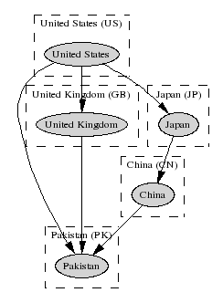  Figure 67 Connectivity to Pakistan as seen from North America – USA, SLAC | 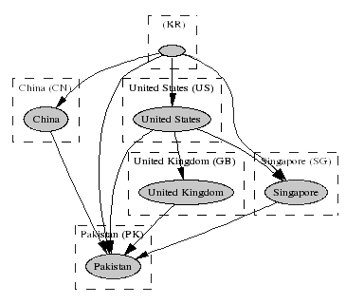  Figure 68 Connectivity to Pakistan as seen from East Asia –South Korea, KHU
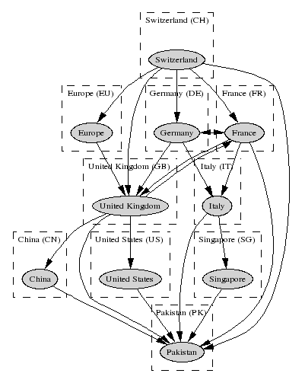  Figure 69 Connectivity to Pakistan as seen from Europe - Switzerland, CERN |  | 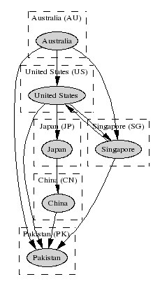  Figure 70 Connectivity to Pakistan as seen from Australia - UNSW

Routing within Pakistan
The routing results compiled using monitoring nodes within Pakistan showed that the traffic stayed within Pakistan. The Internet Exchange Points appear to be operating as expected. This is also confirmed by the Round Trip Times discussed below. Anomalies what so ever, were not observed. The fact that the IXPs are operating as expected is a pleasant observation as compared to the past (2004 [casestudy-pak04]) when traffic originating within Pakistan and destined for a host inside Pakistan would exit the country and transit an international carrier before reaching its destination.

Performance as seen from North America, SLAC
As seen in Figure 71 the average RTT shows that the estimates have dropped gradually from poor (about 600 ms) to acceptable (about 350 ms). While the internet penetration was increasing in 2005, a significant increase was observed around September 2005 when the undersea cables were severed. The average RTT remained steady around 450ms untill 2006 when Pakistan acquired additional international bandwidth by via three undersea fibre links due to which we observe a drop in July 2006. Pakistan has been gradually acquiring additional bandwidth as the demand increases. As also confirmed from the routing results, Pakistan maintains at least four different routes to the world.
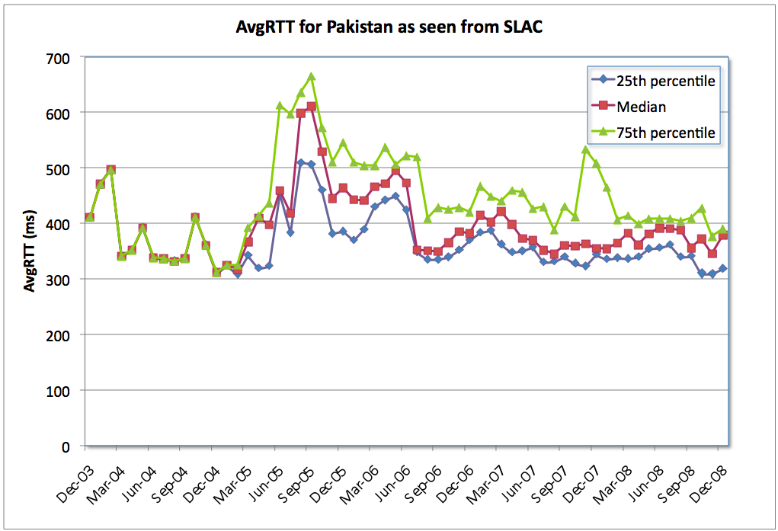
Figure 71 Average RTT for Pakistan as seen from SLAC
Studying the measurements to individual universities and commercial organizations within Pakistan as shown in Figure 72, we see that nearly all the institutions have either maintained their performance i.e. measurements of less than 400ms or have improved relatively over time. Except for GIKI, which has been performing poorly since early 2008.
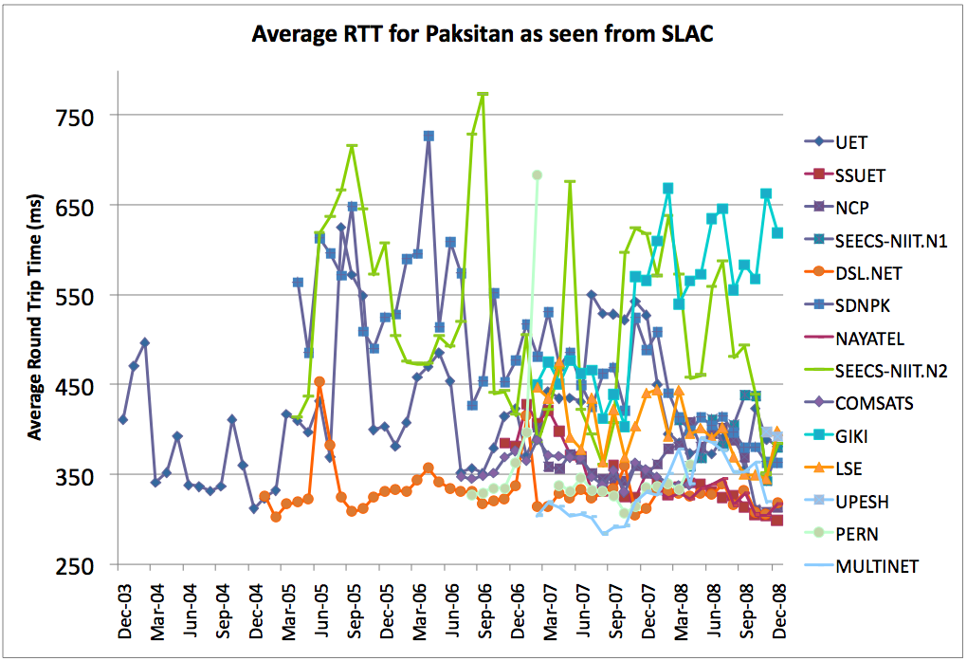
Figure 72 Detailed average RTT for Pakistan as seen from SLAC

The round trip times to Pakistan have generally improved due to change of international routes, however, the connectivity to the institutions has not improved in similar proportions. This is evident from the last mile effects observed in Figure 73. The increase in RTT as well as Packet Loss during the day - when people use Internet resources - is evident for all institutions except NAYATEL which is an Internet Service Provider. We identified these effects in 2006 [ixp-pak-rec], and informal recommendations were forwarded to the concerned institutions as well as the Higher Education Commission of Pakistan. We see that SEECS-NUST has significantly improved its performance over the years; however, it still faces issues of congestion due to the last-mile effect (in other words, insufficient available bandwidth per person considering the usage at a university).
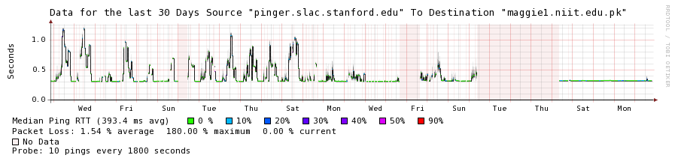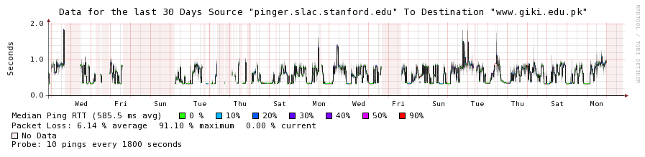
Figure 73 Packet Loss and RTT for SEECS, NUST and GIKI as seen from SLAC, Dec 20, 2008 - Jan 21, 2009
In a similar pattern, we see improvements in Packet Loss estimates as shown in Figure 74. As discussed earlier regarding Figure 72, we see improvements in Packet Loss estimates for nearly all the institutions except GIKI which shows increased losses. However we see in Figure 75 that despite the improvements the packet loss estimates are not at par with international quality standards.
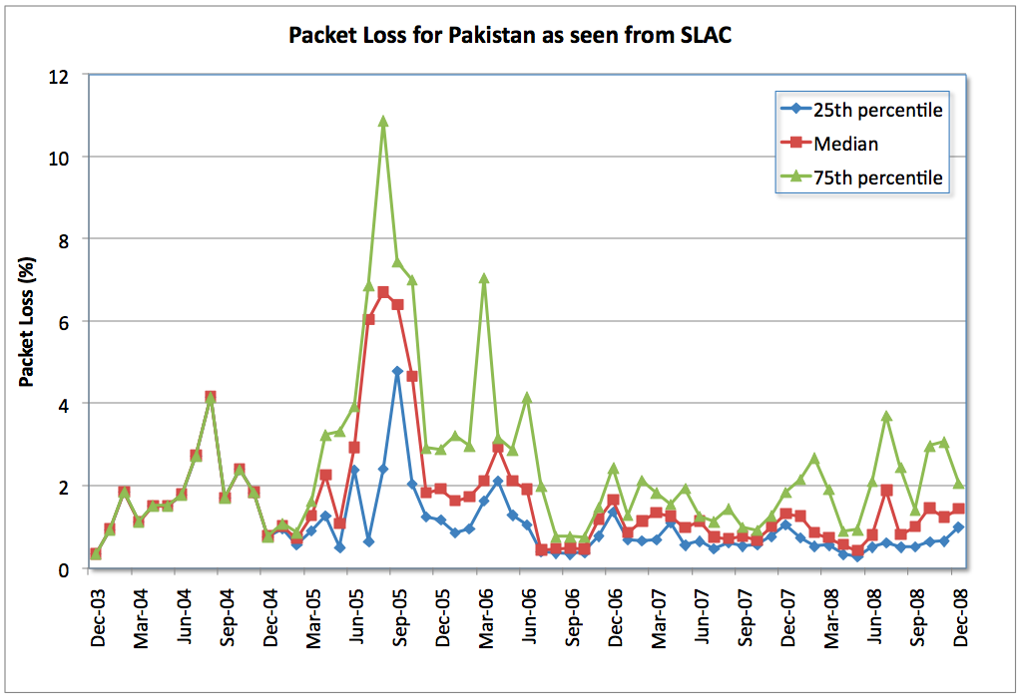
Figure 74 Packet Loss for Pakistan as seen from SLAC
As shown in Figure 75 except for SEECS-NUST, NCP-Quaid-e-Azam University, Micronet/Nayatel and PERN, all the other institutions show packet loss levels greater than 1%. The high unreachability levels of COMSATS and PERN are due to power outages experienced at the monitored nodes. The rest of the institutes show poor unreachability levels when compared to international standards, however, the estimates can be understood in light of the power outages faced by Pakistan during the year.
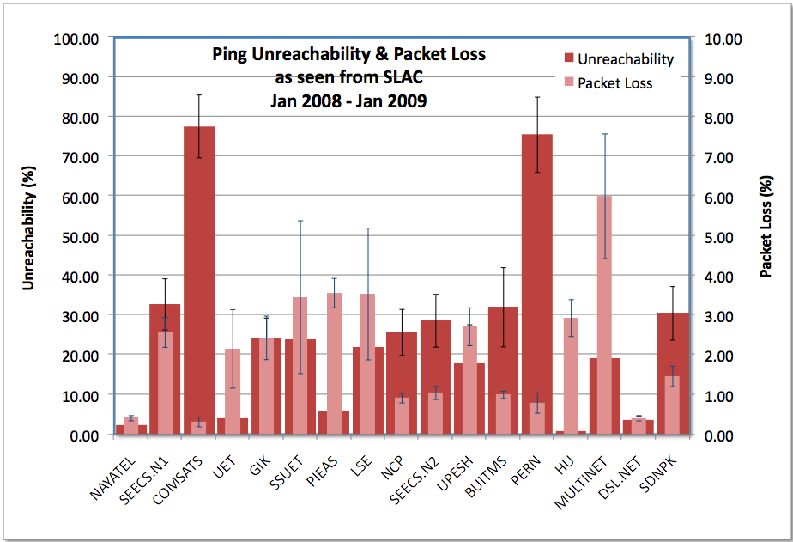
Figure 75 Ping Unreachability and Packet Loss as seen from SLAC Jan 2008 - Jan 2009

Performance within Pakistan as seen from SEECS-NUST and NCP-QAU
Figure 76 and Figure 77 exemplify the fact we discussed earlier that even though the national backbone is well provisioned, the Internet connections to the institutions suffer from the last-mile effects. Though the AvgRTT to different institutions from NUST (Figure 76) has decreased over the years (except for GIKI and PIEAS), yet they are not within acceptable levels (i.e less than 70ms). Table 8, listing the locations of the institutes also helps in evaluating the AvgRTT results in Figure 76.
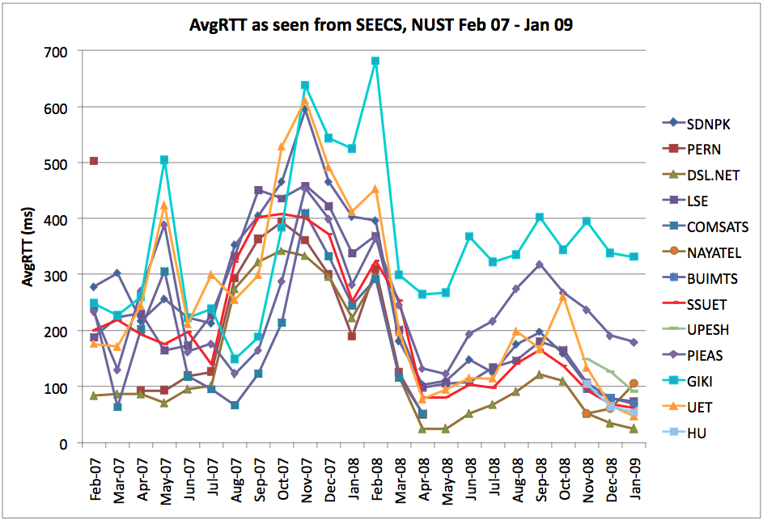
Figure 76 Average RTT for Pakistan as seen from NUST Feb 07 - Jan 09
So is the case of the packet loss results. Except for Micronet/Nayatel (whose loses are due to congestion at SEECS-NUST) all institutes either show poor levels of packet losses (greater than 3%) or show huge fluctuations (such as 2% to 15% or higher). Referring back to Figure 73, these losses are primarily due to the congestion caused by the last-mile effect.
Consequently in Figure 78 we see that most of the sites experience relatively unacceptable levels of TCP throughput. Measurements from NCP to BUITMS and SSUET show good results since NCP enjoys Gigabit connectivity via Nayatel and traceroute results suggest that both BUITMS and SSUET are connected via PERN which has direct connectivity to Nayatel.
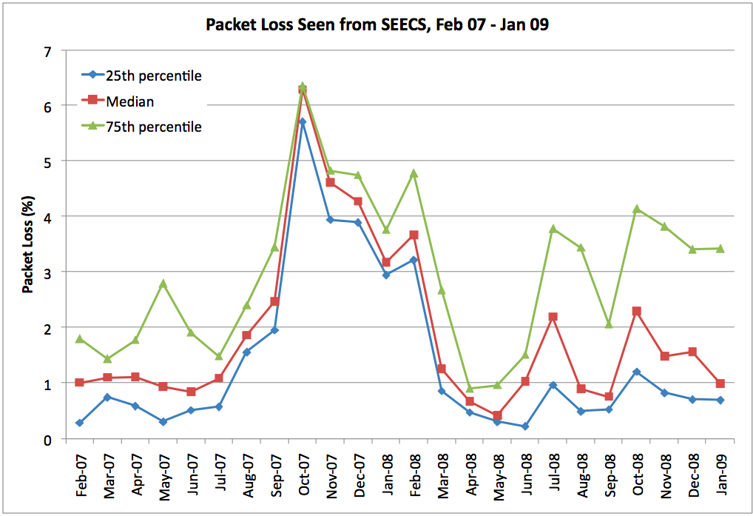
Figure 77 Packet Loss for Pakistan as seen from NUST, Feb 07 - Jan 09
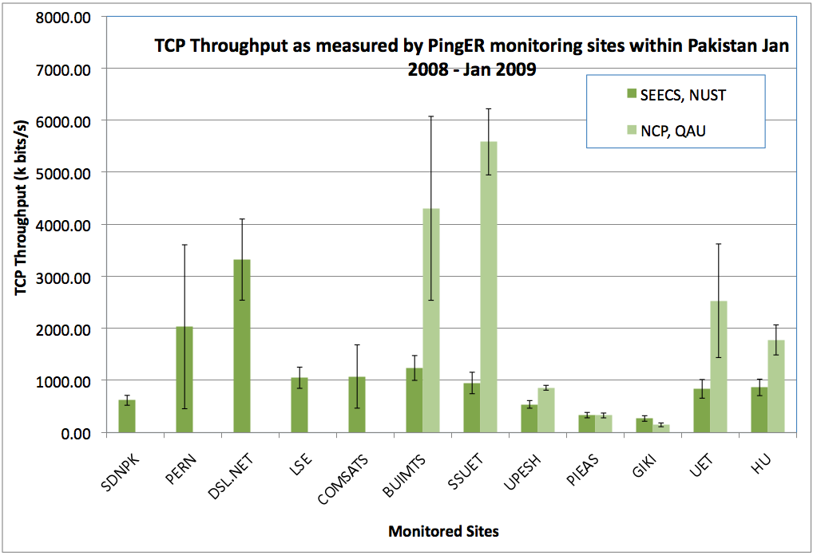
Figure 78 TCP throughput for Pakistan as seen from NUST ant NCP Jan 2008 - Jan 2009
Thus the crux of the matter is that though the national backbone is well provisioned, yet the institutions do not reflect the expected levels of performance. The primary reason for this is the high user to available bandwidth ratio. Also, the power shortage in Pakistan does not help with unreachability levels. With direct connectivity to United States and United Kingdom, the RTTs have reduced significantly. Lastly availability of multiple international links has proved to be effective in providing reliable connectivity.

Appendix D: Tools we Use

PingER Validation Toolkit
Since its inception, the size of the PingER project has grown to where it is now monitoring hosts in over 155 countries from about 42 monitoring hosts in 21 countries. With growth in the number of monitoring as well as monitored (remote) nodes, it was perceived that automated mechanisms need to be developed for managing this project. We therefore developed a tool that runs daily and reports on the following:
- Database errors such as invalid or missing IP addresses, all hosts have an associated region, each host only appears once in the database, all hosts have a latitude and longitude, the names of the monitoring hosts match the labeling of the data gathered from the monitoring host, each host has a unique IP address.
- The list of beacons are now generated from the database, as is the list of sites to be monitored
- We ping all hosts, those not responding are tested to see if they exist (i.e. they do not respond to a name service request), whether they respond to any of the common TCP ports, if so they are marked as blocking pings. If they do not ping with the IP address we try the name in case the IP address has changed.
- We track how long a host pair (monitor host/remote host) has not successfully pinged and whether the remote host is blocked.
- We keep track of how long we have been unable to gather data from each monitoring host.
- We also compare the minimum RTT for sites within a region with one another and look to see whether any are outside 3-4 standard deviations. This is designed to help find hosts that are not really located in a region (e.g. a web site proxied elsewhere).

PingER Metrics Motion Charts
The PingER metrics motion charts are primarily used to visualize the trends in the Internet end-to-end performance statistics measured to about 165 countries from the 40+ PingER monitoring nodes spread worldwide. Having gathered data since 1998, the charts enable the users to study the trends, step changes, significant improvements/degradations with the help of these 5-dimensional charts. The different sets of charts (w.r.t. regions) enables the users to study the progress made by countries in comparison to their neighbours as well as the world in general. Also, the charts help in spotting unusual performance estimates.
The charts were developed using Google’s motion chart widget and can be accessed online [http://www-iepm.slac.stanford.edu/pinger/pinger-metrics-motion-chart.html] in any flash enabled browser.
The tool presents PingER data since 1998 and has the following features:
- Study the trends while choosing either of the metrics listed below for any of the 4 axis (x-axis, y-axis, size of the bubble, colour of the bubble from a defined gradient).
  - Minimum Round Trip Time
  - Average Round Trip Time
  - Normalized Derived Throughput
  - Packet Loss
  - Jitter
  - Ping Unreachability
  - Country Population
  - Corruption Perception Index (CPI)
  - Human Development Index (HDI)
  - Digital Opportunity Index (DOI)
  - Number of Internet users in the country
  - Percentage of Internet Penetration
- The fifth axis is time. The relationship of these metrics with respect to time can be observed by playing back the motion charts.
- Since the metrics presented are gathered by PingER at intervals of 30 mins, their relationships can be studied at different granularity levels, i.e. last21days, monthly, yearly.
- Also, the vantage point or monitoring site can be selected from the following available options:

  - United States (SLAC)
  - Switzerland (CERN)
  - Italy (ICTP)
  - Africa
  - Brazil
  - East Asia
  - India
  - Pakistan (SEECS, NUST)
  - Russia

- Similarly the monitored regions may be selected from the following options:

  - Africa
  - Balkans
  - Central Asia
  - East Asia
  - Europe
  - Latin America
  - Middle East
  - North America
  - Oceania
  - South East Asia
  - South Asia

Figure 79 shows a screen snapshot of motion charts as presenting performance metrics as measured from SLAC to the world.

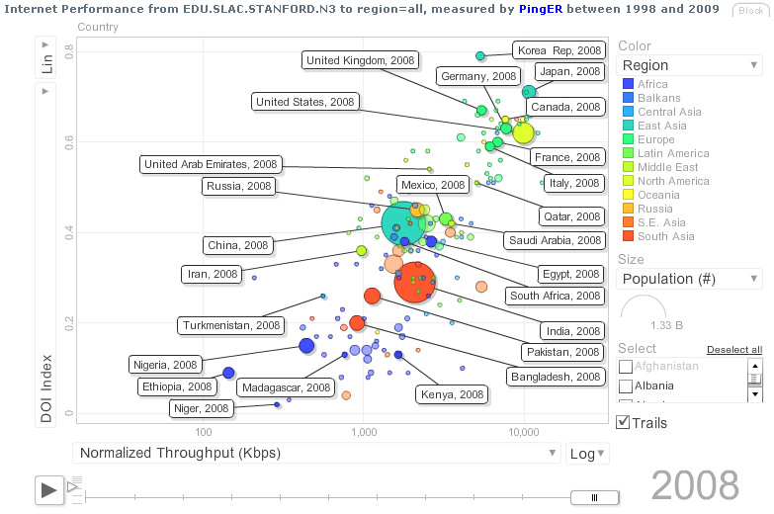
Figure 79: PingER Performance Metrics Charts

Since North America officially includes Mexico, the Encyclopedia Britannica recommendation is to use the terminology Anglo America (US + Canada). However, in this document North America is taken to mean the U.S. and Canada.
In special cases, there is an option to reduce the network impact to ~ 10bits/s per monitor-remote host pair.
A notable effect on derived throughput is that for measurements made from say a N. American site, such as SLAC, to other N. American sites, 1/RTT is large and so throughputs are artificially enhanced compared to measurements to more distant regions with longer RTTs.
The application is discussed at length in the section ‘Efforts to improve PingER management’.
The interpretation of correlations by statisticians is explained as 0 relates to “no correlation”; a correlation between 0 and 0.3 as “weak”; a correlation between 0.3 and 0.6 as “moderate”; a correlation between 0.6 and 1.0 as “strong”; and a correlation of 1 as “perfect”[an06].
Check Remote Site Status (http://www.slac.stanford.edu/cgi-wrap/checkremote.cgi)
Internet Usage in Africa ( http://www.internetworldstats.com/stats.htm )
South Asia Case Study (https://confluence.slac.stanford.edu/display/IEPM/South+Asia+Case+Study)

