Solutions for Internet access for hard to reach areas

Balloons
The balloons fly at 12 miles in the stratosphere. Beneath each lighter-than-air balloon are hung: two radio transceivers to receive and send data streams, plus a third back-up radio; a flight computer and GPS location tracker; an altitude control system, which is used to move the balloon up and down to find winds that will take it in the desired direction; solar panels to power all the gear. They are moved up and down to find the right winds to direct them into position usually travelling along an easterly or westerly latitude. Balloons regularly stay aloft for 150 days. Cover a circular area spanning 50 miles diameter. Balloons transmit using radio frequency and can also transmit to each other (up to 100km apart transferring data at ~500Mbps) to extend the Internet where there is no base station nearby. Can now supply connected devices with about 10 megabits a second to connected devices via antennae on the ground. Mike Cassidy, who heads project Loon, believes the total cost for Internet from balloons could be 10% or even 1% of Internet from satellites. He anticipates paying customers to be connecting to its web of balloons by 2016. See http://www.wsj.com/articles/the-internets-future-lies-up-in-the-skies-1418603566. Google's balloons are already active. Indeed, the firm hopes to start providing connections to early adopters in Indonesia and Sri Lanka soon."We put transponders on all our balloons, which is not required," says Mr Cassidy, "so, just like an aeroplane, air traffic control can always see where the balloons are." http://www.bbc.com/news/technology-34780127. "[We need] about 300 balloons or so to make a continuous string around the world." Google believes it is on course to have enough internet-beaming balloons in the stratosphere to form a ring over part of the world next year. The declaration coincides with the announcement that three of Indonesia's mobile networks intend to start testing Project Loon's transmissions next year. Sri Lanka previously signed a separate agreement signaling its wish to be another participant in the giant helium balloon-based scheme. See http://www.bbc.com/news/technology-34660205
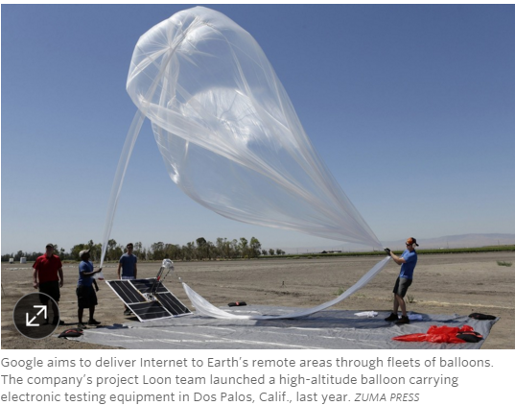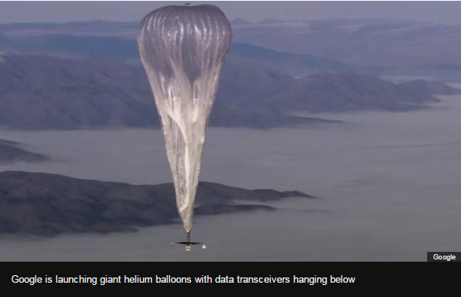

Drones
In April 2014 Google bought solar-powered drone make Titan Aeropspace
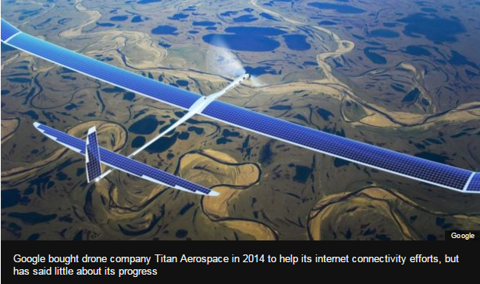
Facebook aims to build a network of laser-beaming drones that will tightly circle known black-spots. Facebook drones (Aquila) fly for 3 months, operate 60Kft – 90Kft (above planes), launched by helium balloons (drone weighs 880lbs), circle a 2 mile radius. "The whole structure is 142ft (43m) wide but weighs less than a Toyota Prius," Mr Parikh explains. The aim is to build a fleet of the drones with radio transmitters fitted underneath to beam data across a 100 mile (160km) diameter zone below. (see http://www.bbc.com/news/technology-34780127). Drones communicate with ground and one another via lasers that use little power and are high speed. The drones can be up to 11km apart so the accuracy requires hitting a dime (18mm diameter) at 11 miles with both source and destination moving and temperature changes of nearly 200 degrees at 27km above the earth.
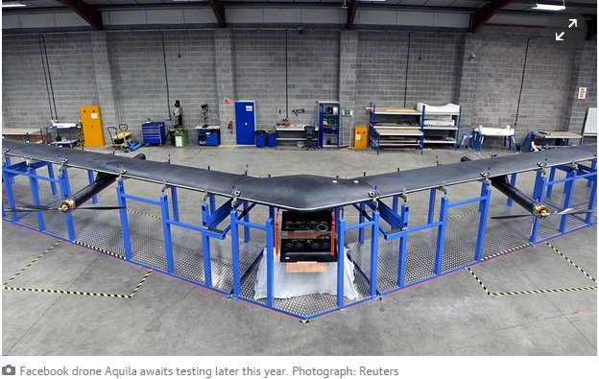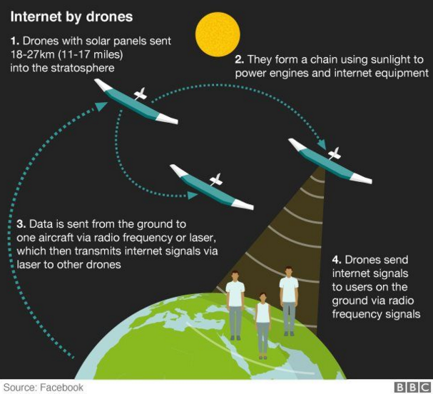
Internet.org a Facebook-led initiative reaches 2/3 of world without reliable internet connection. The team is exploring a variety of technologies, including high-altitude long-endurance planes, satellites and lasers. Criticised by activists in both the developed and developing world for only linking users to a walled-garden version of the internet. Internet.org customers can access, for free, selected services such as Facebook, Wikipedia, weather, job listings and government info. But they cannot access the open web through the same service.

Satellites
Medium Earth Orbit Satellites like O3b Networks, which orbit 5,000 miles above Earth. These satellites are large and powerful like their geostationary counterparts, but aren’t plagued with the issues of latency.
Hedging its bets, perhaps, Google has plans to invest more than $1 billion in satellites for Internet access. Google is planning to launch a fleet of 180 satellites to provide web access for the 4.8 billion people not yet online, according to sources close to the company. Google's venture is being led by Greg Wyler, founder of satellite-communications start-up O3b Networks, and depending on the network's final design, the group may double the number of proposed satellites. http://www.dailymail.co.uk/sciencetech/article-2646039/Googles-plans-world-domination-Search-giant-launch-180-satellites-bring-internet-access-ENTIRE-planet.html#ixzz3xiYaUjJq
The former CEO of 03b, Greg Wyler, who was briefly at Google, is now collaborating with Elon Musk’s SpaceX to create a network of hundreds of low-Earth orbit satellites.
http://oneweb.world/ announced an ambitious constellation of over 600 Low Earth Orbiting Satellites that can communicate with remote place, disasters, 30K feet flying planes etc. 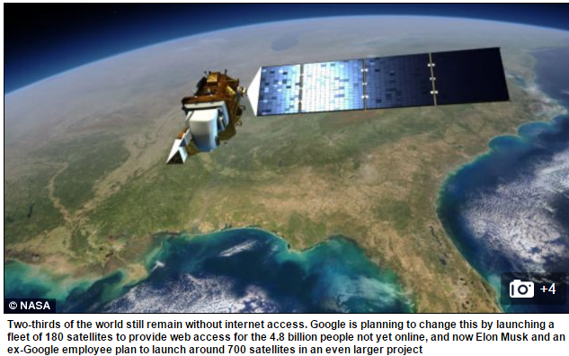
Both Iridium and Globalstar, pioneers in networks of low-Earth orbit satellite networks, have spent time in bankruptcy.
Already, traditional players like Intelsat, the world’s largest satellite company by market capitalization, is using the capabilities of its next-generation geostationary satellites to deliver Internet connectivity to airplanes, cruise ships, the world’s merchant marine fleet, all markets that “basically didn’t exist five to seven years ago,” says David McGlade, CEO of Intelsat.

Overall
Satellites can last decades, but balloons and drones must be constantly replenished, and many more are needed to cover the Earth.
But the brains behind Facebook and Google efforts told the BBC they are convinced they have a real shot at connecting the 57% of the world's population still offline.
It’s likely we’ll end up in an “all of the above” world, in which distant, powerful satellites provide for streaming media while an assortment of balloons, drones and close-in satellites will provide more responsive Internet. http://www.wsj.com/articles/the-internets-future-lies-up-in-the-skies-1418603566
http://www.bbc.com/news/technology-34780127 balloons (Google) vs drones (Facebook, Google)
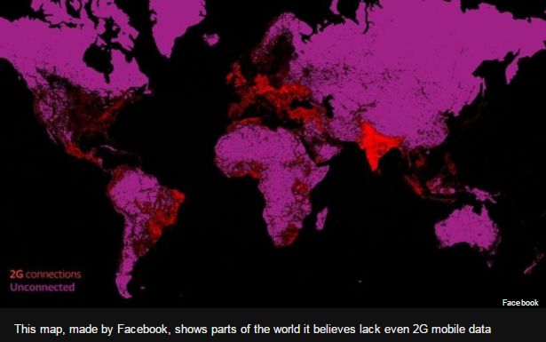

Malaysia case studies by Saqib and Les
Updated Executive Overview
Brief Update of PingER
Future Support of PingER
PingER publications and talks
Malaysia case study
Increased interest in providing better access to PingER data (Big Data, Data Warehouse, easier to ue front ends, database), Thiago
Raspberry Pi, Android
Complementarity with perfSONAR
- perfSONAR
  - perfSONAR actively growing base of monitoring hosts 1300 deployments as of Feb. 2015.
  - well supported. perfSONAR development and support is led by an international collaboration that includes Internet2, ESnet, Indiana University, and the EU funded GN2 JRA1 project.
  - full mesh for throughput, one way delay, ping, traceroute
  - mainly between high performance sites universities, research centers, typically in Europe, North America and East Asia
  - sites have to install perfSONAR software toolkit
  - valuable for ensuring high performance between monitoring hosts
- PingER
  - Base of monitoring hosts peaked at 97, down to 78 in 2015 and now down to 63 but relatively stable
  - Predecessor to perfSONAR hence a long history of data going back 19 years
  - Focused on ping, very simple no software needs loading for the monitored hosts, so remote hosts are passive
  - Limited support, mainly from SLAC
  - Monitored sites are more widely distributed, especially in the developing world than perfSONAR
  - Valuable for setting expectations for workforce globalization and remote workforces
Africa
- Extrapolation of African performance
  - Future and Huffington post and new cable for Africa, new techniques (weather balloons, drones, LEOS)
- Monitoring seen from Ouagadougou Burkina Faso to Africa
- Transition from satellite to terrestrial
NetApps 2015 Kuala Lumpur (Dec 2015)
Characterizing & Exporting data for Amity for big data/big analytics studies
Missing countries & current state, 4 countries with > 1M people not monitored,
Countries monitored contain 99.14% of world’s population
History of monitors, nodes, pairs
- Pakistan, HEC funding/Seecs exhausted
  - Loss of many monitoring hosts mainly Pakistan 48=>18 (-30)
  - Submitted new proposal, await funding
  - Arshad moved from SEECS to rector of Pakistan U, then Dr. Arshad has become executive director of HEC. This post is the second highest in HEC, right after chairman.
- Disabling Pakistani monitoring hosts that we (pinger.slac.stanford.edu) have been unable to gather data from for 6 months or more. This includes:
  - Airuniversity: airuniversity.seecs.edu.pk
  - GIKI: pinger.giki.edu.pk
  - LCWU: pinger.lcwu.edu.pk
  - NU: pinger.lhr.nu.edu.pk
  - NUISB: nuisb.seecs.edu.pk
  - PERNFSBDPOP: pingerfsbd.pern.edu.pk
  - PINGERKHI-CPSP.PERN.EDU: pingerkhi-cpsp.pern.edu.pk
  - SAU.SEECS: sau.seecs.edu.pk
- Disabled the following (not responding to ping and no data for 12 months)
  - > ns3.pieas.edu.pk(PK.PIEAS.EDU.N2)
  - > pinger.cemb.edu.pk(PK.CEMB.EDU.N2)
  - > pinger.nca.edu.pk(PK.NCA.EDU.N2)
  - > pinger.pern.edu.pk(PK.PERN.EDU.N1)
  - > pingerisl-fjwu.pern.edu.pk(PK.PINGERISL-FJWU.PERN.EDU)
  - > pingerlhr.pern.edu.pk(PK.PERNLHRPOP.EDU.N1)
- Hosts monitored, monitoring hosts and pairs
  - Monitors dropped 88 (Feb 2015) =>63
- SLAC funding exhausted
- Ran out of disk space after 18 years. Reclaimed some no longer relevant copies and recovered.
- Increased focus on Cybersecurity, IT operations
- 5 papers to NetApps2015
  - RPi
  - GeoLocation
  - Data Warehouse
  - GeoLocation
  - Adama
- Amity students
  - 3 papers
- Thiago warehouse progress with local cloud

