**International Committee for Future Accelerators (ICFA)**

**Standing Committee on Inter-Regional Connectivity (SCIC)**

**Chairperson: Professor Harvey Newman, Caltech**

**ICFA SCIC Network Monitoring Report**

Prepared by the ICFA SCIC Monitoring Working Group

On behalf of the Working Group:   
Les Cottrell [cottrell@slac.stanford.edu](mailto:cottrell@slac.stanford.edu)



2014 - 2015 Report of the ICFA-SCIC Monitoring Working Group

Edited by [R. Les Cottrell](mailto:cottrell@slac.stanford.edu), Shawn McKee On behalf of the [ICFA-SCIC Monitoring WG](mailto:icfa-ntf-wg-monitoring@listbox.cern.ch)

Created January 3rd, 2015, Finished January 29, 2015

[ICFA-SCIC Home Page](http://icfa-scic.web.cern.ch/ICFA-SCIC/) | [Monitoring WG Home Page](http://icfa-scic.web.cern.ch/ICFA-SCIC/Committees/monitoring.htm)

This report is available from:

<http://www.slac.stanford.edu/xorg/icfa/icfa-net-paper-jan15/report-jan15.doc>

Table of Contents

[Figures 5](#_Toc410553695)

[Executive Overview 6](#_Toc410553696)

[Introduction 8](#_Toc410553697)

[Methodology 9](#_Toc410553698)

[PingER Results 9](#_Toc410553699)

[Deployment 9](#_Toc410553700)

[Historical Growth of PingER Coverage Since 1998 11](#_Toc410553701)

[Metrics 12](#_Toc410553702)

[Yearly loss trends: 13](#_Toc410553703)

[Yearly minimum RTT 14](#_Toc410553704)

[Yearly Jitter trends 17](#_Toc410553705)

[Yearly Throughput Trends 18](#_Toc410553706)

[View from Europe 20](#_Toc410553707)

[Variability of performance between and within regions 21](#_Toc410553708)

[Yearly Mean Opinion Score (MOS) trends 23](#_Toc410553709)

[Directivity 24](#_Toc410553710)

[Comparisons with Economic and Development Indicators 26](#_Toc410553711)

[PingER Case Studies & Projects 27](#_Toc410553712)

[Bangladesh 27](#_Toc410553713)

[Afghanistan 28](#_Toc410553714)

[Cuba switch from Satellite to Terrestrial link 28](#_Toc410553715)

[AAG Cable cut off Hong Kong Sep 15, 2014 29](#_Toc410553716)

[Malaysia 29](#_Toc410553717)

[Duplicate ping responses 30](#_Toc410553718)

[Porting PingER to a Raspberry Pi 31](#_Toc410553719)

[Big Data/Analysis 31](#_Toc410553720)

[Visual Traceroute (VTrace) 31](#_Toc410553721)

[High Performance Network Monitoring 34](#_Toc410553722)

[*New and Ongoing Monitoring and Diagnostic Efforts in HEP* 34](#_Toc410553723)

[Using and Managing perfSONAR 35](#_Toc410553724)

[Network Datastore 38](#_Toc410553725)

[**Complementary End-to-End Monitoring** 40](#_Toc410553726)

[**Summary: Progress in HEP Network Monitoring for 2014** 40](#_Toc410553727)

[*Related HEP Network Research* 41](#_Toc410553728)

[Comparison with HEP Needs 42](#_Toc410553729)

[Other Scientific Research Interests in Africa 43](#_Toc410553730)

[Recommendations 44](#_Toc410553731)

[Future Support 44](#_Toc410553732)

[Acknowledgements 45](#_Toc410553733)

[Appendices 46](#_Toc410553734)

[Appendix A: PingER Presentations etc. in 2014. 46](#_Toc410553735)

[Publications etc. 46](#_Toc410553736)

[Talks 46](#_Toc410553737)

[Appendix C: PingER Project History in 2014 47](#_Toc410553738)

[Appendix D: ICFA/SCIC Network Monitoring Working Group 47](#_Toc410553739)

[Goals of the Working Group 48](#_Toc410553740)

# Figures

*Please note that for all yearly graphs the data point is for the end of the year.*

[Figure 1 : Locations of PingER monitoring and remote sites as of December 2013. Red sites are monitoring sites, blue sites are beacons that are monitored by most monitoring sites, and green sites are remote sites that are monitored by one or more monitoring sites 10](#_Toc409977938)

[Figure 2 Major regions of the world for PingER aggregation by regions, regions in white are not monitored. 11](#_Toc409977939)

[Figure 3 : On left - Number of sites monitored from SLAC by region at the end of each year 1998 – 2014. On right the growth in PingER monitoring hosts, remote hosts monitored, countries monitored & monitor-remote site pairs 12](#_Toc409977940)

[Figure 4: Packet Loss measured for various regions from SLAC till Dec 2014 13](#_Toc409977941)

[Figure 5: Minimum RTTs measured from SLAC to world countries, in Dec 2008 and Dec 2013. Different regions have different colors. 14](#_Toc409977942)

[Figure 6: Maps of minimum RTTs from SLAC to the world in 2008 and 2013. 15](#_Toc409977943)

[Figure 7: Time series of minimum RTT measured from SLAC to various countries since 1998 16](#_Toc409977944)

[Figure 8: Minimum RTTs measured to African countries from SLAC and the University of Ouadouga in Burkina Faso 17](#_Toc409977945)

[Figure 9: Jitter from SLAC to regions of the world until Dec 2014. 17](#_Toc409977946)

[Figure 10: Yearly averaged normalized derived TCP throughputs from the SLAC to various regions of the world until Dec 2013. 18](#_Toc409977947)

[Figure 11: Derived Throughput kbits/sec from SLAC to the World (since the throughputs in this graph are not normalized we have not shown N. America) until Dec 2013. The yellow line is to help show the rate of change. If one extrapolates Europe’s performance backwards to February 1992, it intercepts Africa’s performance today. 19](#_Toc409977948)

[Figure 12: Extrapolations on the throughput data. 20](#_Toc409977949)

[Figure 13: Normalized throughputs to various regions as seen from CERN until Dec 2013. 21](#_Toc409977950)

[Figure 14: maximum, 95, 90, 75 percentile, median, 25 percentile and minimum derived throughputs of various regions measured from SLAC for Nov 2013 and ordered by median throughput. 23](#_Toc409977951)

[Figure 15: Derived throughput from SLAC to S.E. Asia countries until Dec 2013. 23](#_Toc409977952)

[Figure 16: Mean Opinion Scores derived from PingER measurements from SLAC to regions of the world until Dec 2013. 24](#_Toc409977953)

[Figure 17: Directivity measured from SLAC to regions of the world until Dec 2014. 25](#_Toc409977954)

[Figure 18: Pinger Derived Throughput vs. the ICT Development index. The bubble size is proportional to the country's population. 27](#_Toc409977955)

[Figure 19: RTTs measured from SLAC to Afghanistan hosts. 28](#_Toc409977956)

[Figure 20: On the left - Minimum RTT seen from SLAC to www.egrem.com.cu in Cuba; on the right the 29](#_Toc409977957)

[Figure 21: Ping RTT's measured from SLAC toCuban host. 29](#_Toc409977958)

[Figure 22: Visual traceroute from SLAC to NUST in Islamabad, Pakistan 32](#_Toc409977959)

[Figure 23: Traceroute displayed by VTrace. 33](#_Toc409977960)

[Figure 24: Example of OSG's mesh-management tool interface 37](#_Toc409977961)

[Figure 25 The OSG network datastore architecture used to gather, organize and archive network metrics from the global OSG and WLCG perfSONAR deployment and make those measurements available for visualization or higher-level services. 38](#_Toc409977962)

[Figure 26: Example of MaDDash dashboard in prototype instance at AGLT2 showing the USATLAS meshes for bandwidth and latency. 39](#_Toc409977963)

[Figure 27: OMD Check\_MK screenshot showing some of the monitored perfSONAR hosts in WLCG. 40](#_Toc409977964)

# Executive Overview

Internet performance is improving each year with throughputs typically improving by 20% per year and losses by up to 25% per year. Most countries have converted from using Geostationary Satellite (GEOS) connections to terrestrial links. This has improved performance in particular for Round Trip Time (RTT) and throughput. GEOS links are still important to countries with poor telecommunications infrastructure, landlocked developing countries, remote islands, and for outlying areas. In some cases they are also used as backup links. In future, developing techniques such as weather balloons[[1]](#footnote-1) and solar powered drones[[2]](#footnote-2) etc.[[3]](#footnote-3) may assist in in providing much reduced latencies and hence performance to remote areas.

In general, throughput measured from within a region is much higher than when measured from outside. Links between the more developed regions including N. America[[4]](#footnote-4), E. Asia (in particular Japan, South Korea and Taiwan) and Europe are much better than elsewhere (3 - 10 times more throughput achievable). Regions such as S.E. Asia, S.E. Europe and Latin America are 5-9 years behind. However, in 2009, Africa was ~15 years behind Europe, also Africa’s throughput was 12-14 times worse than Europe and extrapolating the data indicated that it would further degrade to almost 60 times worse by 2026. Since 2009, due in large part to the installation of multiple submarine fibre optic cables to sub-Saharan Africa, there has been a significant improvement in Africa’s performance. It now appears to be catching up, such that if the present improvements are maintained, it could catch Europe by around 2040.

Africa and South Asia are two regions where the Internet has seen phenomenal growth, especially in terms of usage. However, it appears that network capacity is not keeping up with demand in these regions. In fact many sites in Africa and India appear to have throughputs less than that of a well-connected (cable, DSL, etc.) home in Europe, North America, Japan or Australia. Further the end-to-end networking is often very fragile both due to last mile effects and poor infrastructure (e.g. power) at the end sites, and also due to lack of adequate network backup routes. Africa is a big target of opportunity with over a billion people of which in 2012 only 15.6% were Internet users. This grew to 26.5% in 2014[[5]](#footnote-5). It also had a 3,607% (compared to 566% for the world) growth in number of Internet users from 2000-2012[[6]](#footnote-6). However, there are many challenges including lack of power, import duties, lack of skills, disease, corruption, and protectionist policies. In almost all measurements, Africa stands out as having the poorest performance. Further Africa is a vast region and there are great differences in performance between different countries and regions within Africa.

There is a moderate to strong positive correlation between the Internet performance metrics and economic and development indices available from the UN and International Telecommunications Union (ITU). Given the difficulty of developing the human and technical indicators (at best they are updated once a year and usually much less frequently); having non-subjective indicators such as PingER that are constantly and automatically updated is a very valuable complement. Besides being useful in their own right these correlations are an excellent way to illustrate anomalies and for pointing out measurement/analysis problems. The large variations between sites within a given country illustrate the need for careful checking of the results and the need for multiple sites/country to identify anomalies.

For modern HEP collaborations and Grids there is an increasing need for high-performance monitoring to set expectations, provide planning and trouble-shooting information, and to provide steering for applications. As link performance continues to improve, the losses between developed regions are decreasing to levels that are not measureable by PingER. Though the measurements for RTT, jitter, and unreachability[[7]](#footnote-7) are still correct, as the measured losses go to zero this also makes the throughput derivation unreliable. Alternative solutions to measuring the throughput are available, however they can be harder to install and absorb more network bandwidth. Examples of other measurement projects using the more intense methods are the MonALISA[[8]](#footnote-8) project that uses the pathload[[9]](#footnote-9) packet pair technique as well as file transfers, and perfSONAR[[10]](#footnote-10) that uses the iperf[[11]](#footnote-11) (and more recently iperf3[[12]](#footnote-12)) TCP transport mechanism. There is also a project in place at SLAC and LBNL under the perfSONAR umbrella to analyze and present data from production gridFTP[[13]](#footnote-13) transfers that are heavily used in the HEP community. These projects are becoming increasingly important for links between well-developed sites.

In the last year there have been the following changes:

* The network monitoring collaboration between SLAC, the University of Malaysia in Sarawak (UNIMAS), the University of Malaya (UM) in Kuala Lumpur and the Universiti Technologi in Johor Bahru was extended to the University Utara Malaysia in Northern Malaysia and to two MYREN hosts one in Kuching and the other in Kuala Lumpur.
* Following last year’s visit of a student from the Federal University in Rio de Janeiro (UFRJ), the PingER collaboration has been extended to UFRJ.
* Case studies of:
  + The round trip times to Cuba from the US following the lighting of a fibre optic cable from Venezuela to Cuba, and potentially the reduction of tension between the US and Cuba.
  + Networking within Malaysia and S. E. Asia[[14]](#footnote-14).
  + Bangladesh[[15]](#footnote-15). This was put together for a meeting of 17 Bangladesh Universities where there appeared to be great interest in PingER.
* Again following last year’s visit by the UFRJ student and interest from UM, there are several projects to use Big/data/analysis techniques to PingER data. This includes the use of Linked Open Data, the Resource Description Framework (RDF)[[16]](#footnote-16), and similar tools. As part of this we made a subset of the PingER data available by anonymous FTP and carefully characterized the data. There is also a project at UM to look at using Hadoop[[17]](#footnote-17) and RDF to look at this data. These are being pursued in Brazil (UFRJ) and Malaysia (UM).
* We now monitor all countries with populations over 1,000,000 except the Central African Republic, Chad, Guinea-Bissau, and North Korea,
* We extended the Geolocation of Internet hosts using trilateration (TULIP) to a visual traceroute tool[[18]](#footnote-18).
* There is a project to evaluate PingER monitoring using a Raspberry Pi. The requirements are that the results should be statistically the same as for a regular PingER host at the same location, and the robustness. The idea is to provide a fully loaded server, to be powered by solar for remote sites such as Bario in the Kalabit Highlands of Borneo.

To quantify and help bridge the Digital Divide, enable world-wide collaborations, and reach-out to scientists world-wide, it is imperative to continue the PingER monitoring coverage to all countries with HEP programs and significant scientific enterprises. However, the funding for PingER is currently a major challenge.  We discussed this need with Dave Macfarlane of SLAC and although he supports the effort no funding is forthcoming. Further we currently have no self-funded students/researchers at SLAC to continue this critical work.

# Introduction

This report may be regarded as a follow up to the previous ICFA Standing Committee on Inter-regional Connectivity (SCIC) Monitoring working group’s Network reports[[19]](#footnote-19) dating back to 1997.

The current report updates the January 2014 report, but is complete in its own right in that it includes the tutorial information and other relevant sections from the previous report.  The main changes in this year’s reports are given in the previous Executive section. Since many of the PingER measurements have not changed abnormally we have not up dated several of the PingER metric graphs.

# Methodology

There are two complementary types of Internet monitoring reported on in this report.

1. In the first we use [PingER[[20]](#footnote-20)](http://www-iepm.slac.stanford.edu/pinger/) which uses the ubiquitous "ping" utility available standard on most modern hosts. Details of the PingER methodology can be found in the [Tutorial on Internet Monitoring & PingER at SLAC[[21]](#footnote-21)](http://www.slac.stanford.edu/comp/net/wan-mon/tutorial.html#loss). PingER provides low intrusiveness (~ 100bits/s per host pair monitored[[22]](#footnote-22)) RTT, loss, jitter, and reachability (if a host does not respond to a set of 10 pings it is presumed to be non-reachable). The low intrusiveness enables the method to be very effective for measuring regions and hosts with poor connectivity. Since the ping server is pre-installed on all remote hosts of interest, minimal support is needed for the remote host (no software to install, no account needed etc.)
2. The second method (perfSONAR[[23]](#footnote-23) etc.) is for measuring high network and application throughput between hosts with excellent connections. Examples of such hosts are to be found at HEP accelerator sites and the Large Hadron Collider (LHC) tier 1 and 2 sites, major Grid sites, and major academic and research sites in N. America, Japan and Europe. The method can be quite intrusive (for each remote host being monitored from a monitoring host, it can utilize hundreds of Mbits/s or more for ten seconds to a minute, each hour). To minimize intrusion, the WLCG scheduling utilizes 30 second tests every 64 hours rather than every hour. It also requires more support from the remote host. In particular either various services must be installed and run by the local administrator or an account is required, software (servers) must be installed, disk space, compute cycles etc. are consumed, and there are security issues[[24]](#footnote-24). The method provides expectations of throughput achievable at the network and application levels, as well as information on how to achieve it, and trouble-shooting information.

# PingER Results

## Deployment

The PingER data and results extend back to the start of 1995 with online data publicly available from the start of 1998. They thus provide a valuable history of Internet performance. PingER now has over 80 active monitoring nodes in 20 countries. PingER monitors over 800 remote (monitored) nodes. This corresponds to a total of over 10,000 monitor node – remote node pairs. The remote hosts are located in over 170 of the world’s 227 countries[[25]](#footnote-25). The only countries with more than 1 Million population that are not currently (Dec 2014) monitored are the Central African Republic, Chad, Guinea-Bissau, and North Korea. The monitored countries contain over 99% of the world's population (see Table 1) and over 99.5% of the online users of the Internet. Most of the hosts monitored are at educational or research sites and are usually web sites. We try and get at least 2 hosts per country to help identify and avoid anomalies at a single host. The [requirements for the remote host](http://www.slac.stanford.edu/comp/net/wan-req.html) are documented[[26]](#footnote-26). below shows the locations of the monitoring and remote (monitored sites).

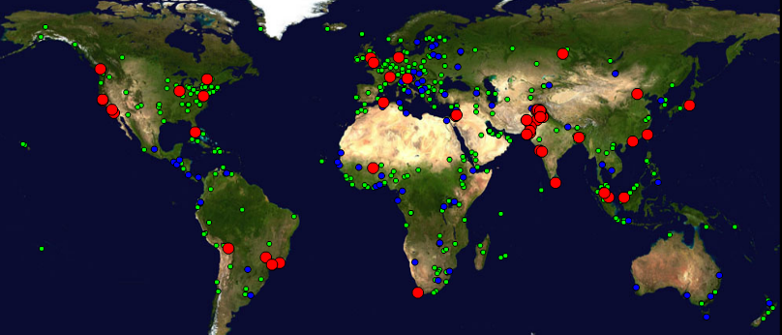

Figure 1 : Locations of PingER monitoring and remote sites as of December 2013. Red sites are monitoring sites, blue sites are beacons that are monitored by most monitoring sites, and green sites are remote sites that are monitored by one or more monitoring sites

There are many thousands monitoring/monitored-remote-host pairs, so it is important to provide aggregation of data by hosts from a variety of "affinity groups". PingER provides aggregation by affinity groups such as HEP experiment collaborator sites, region, country, Top Level Domain (TLD), or by world region etc. The world regions, as defined for PingER, and countries monitored are shown below in . The regions are chosen starting from the [U.N. definitions[[27]](#footnote-27).](http://esa.un.org/unpp/definition.html) We modify the region definitions to take into account which countries have HEP interests and to try and ensure the countries in a region have similar performance.

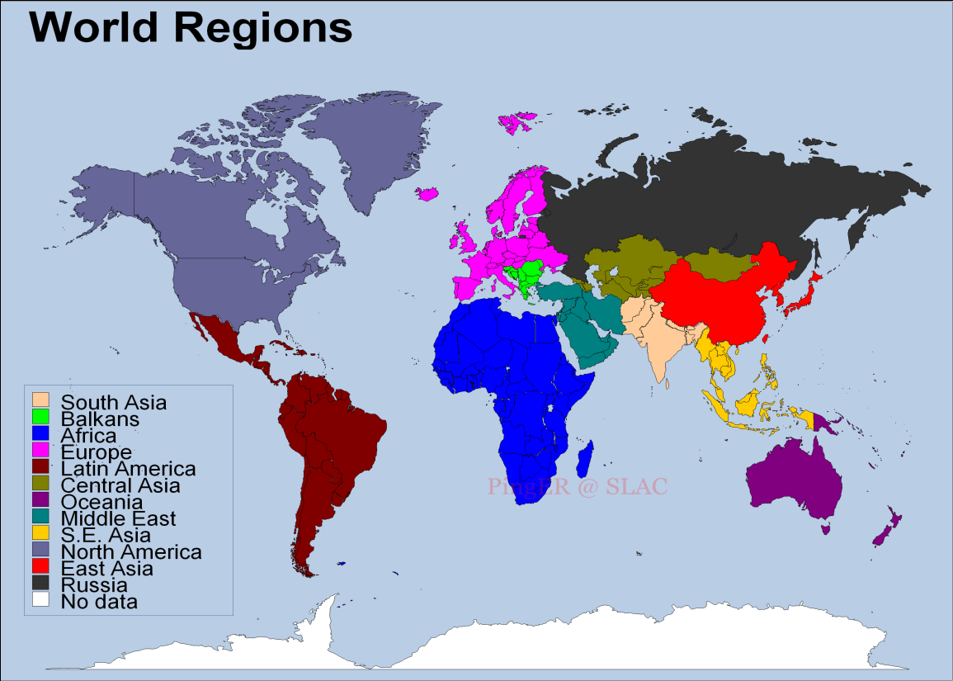

Figure 2 Major regions of the world for PingER aggregation by regions, regions in white are not monitored.

More details on the regions are provided in Table 1 that highlights the number of countries monitored in each of these regions, and the distribution of population in these regions.

Table 1: PingER Monitored Countries and populations by region Dec 2014

|  |  |  |  |
| --- | --- | --- | --- |
| **Regions** | **# of Countries** | **Population of the Region (Millions)** | **% of World Population** |
| Africa | 47 | 1110 | 15% |
| Balkans | 10 | 69 | 1% |
| Central Asia | 9 | 78 | 1% |
| East Asia | 4 | 1618 | 23% |
| Europe | 31 | 673 | 8% |
| Latin America | 25 | 616 | 8% |
| Middle East | 16 | 309 | 4% |
| North America | 3 | 347 | 5% |
| Oceania | 5 | 38 | 1% |
| Russia | 1 | 142 | 2% |
| S.E. Asia | 11 | 618 | 9% |
| South Asia | 8 | 1616 | 23% |
| **Total** | 171 | 7162 | 99.17% |

## Historical Growth of PingER Coverage Since 1998

Figure 3 shows the growth in the number of PingER monitoring sites, countries monitored, active[[28]](#footnote-28) remote sites monitored by PingER from SLAC and monitor-remote host pairs since 1998. Initially the main regions monitored were North America, Europe, East Asia, and Russia. These were the regions with the main HEP interest. Starting in 2003-2004, the increased number of hosts monitored in developing regions such as Africa, Latin America, Middle East and South Asia is very apparent. In the last year (2014), the number of hosts monitored by SLAC has increased from 717 to 794 mainly driven by the collaboration with Malaysia, and an increase in the hosts in S. E. Asia including Malaysia.

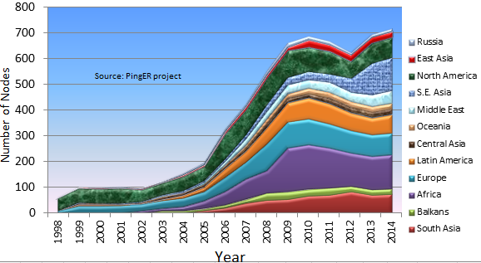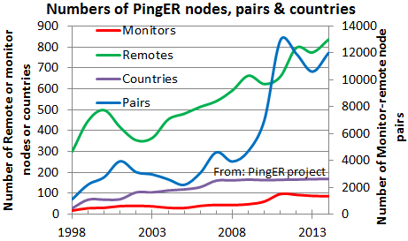

Figure 3 : On left - Number of sites monitored from SLAC by region at the end of each year 1998 – 2014. On right the growth in PingER monitoring hosts, remote hosts monitored, countries monitored & monitor-remote site pairs

## Metrics

To assist in interpreting the losses in terms of their impact on well-known applications, we categorize the losses into quality ranges.  These are shown below in Table 2.

Table 2: Quality ranges used for loss

|  |  |  |  |  |  |  |
| --- | --- | --- | --- | --- | --- | --- |
|  | **Excellent** | **Good** | **Acceptable** | **Poor** | **Very Poor** | **Bad** |
| Loss | <0.1% | >=0.1% &  < 1% | > =1%  & < 2.5% | >= 2.5%  & < 5% | >= 5%  & < 12% | >= 12% |

The major effects of packet loss and RTT can be found in the [Tutorial on Internet Monitoring & PingER at SLAC[[29]](#footnote-29)](http://www.slac.stanford.edu/comp/net/wan-mon/tutorial.html#loss), briefly:

* At losses of 4-6% or more video-conferencing becomes irritating and non-native language speakers are unable to communicate effectively. The occurrence of long delays of 4 seconds or more (such as timeouts in recovering from packet loss) at a frequency of 4-5% or more is also irritating for interactive activities such as telnet and X windows. *Conventional wisdom among TCP researchers holds that a loss rate of 5% has a significant adverse effect on TCP performance, because it will greatly limit the size of the congestion window and hence the transfer rate, while 3% is often substantially less serious,* Vern Paxson. A random loss of 2.5% will result in Voice over Internet Protocols (VoIP) becoming slightly annoying every 30 seconds or so. A more realistic burst loss pattern will result in VoIP distortion going from not annoying to slightly annoying when the loss goes from 0 to 1%. Since TCP throughput for the standard (Reno based) TCP stack according to Mathis et. al. goes as *1460\*8bits/(RTT\*sqrt(loss))*[[30]](#footnote-30) it is also important to keep losses low for achieving high throughput. How well this formula works in practice and dealing with zero packet loss is discussed elsewhere[[31]](#footnote-31)
* For RTTs, studies in the late 1970s and early 1980s showed that one needs < 400ms for high productivity interactive use. VoIP requires an RTT of < 250ms or it is hard for the listener to know when to speak.
* There is a recent paper[[32]](#footnote-32) showing the importance of reducing Internet latency, what the causes are and suggesting improvements.

### Yearly loss trends:

Figure 4 shows the packet losses seen from SLAC to world regions for 1998 through 2013. Since losses are mainly dependent on the network edges, they tend to be independent of distance.

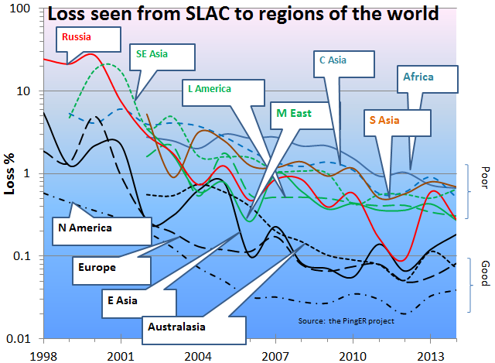

Figure 4: Packet Loss measured for various regions from SLAC till Dec 2014

It is seen that losses are lowest (best) for North America, East Asia, Europe and Oceania. They are highest (worst) for Central Asia and Africa. The improvement from year to year is roughly exponential with a factor of ~ 30 improvement in 10 years. The 2013 uptick in losses for the Russian hosts is interesting. Similar degraded performance in 2013 is also seen below in the jitter and throughputs (see Figure 8, Figure 9, Figure 10, and Figure 12). The effect appears to be prevalent in 11 of the 12 measured hosts. The exception is the host at the Ekaterinoburg Ural Branch Russian Academy of Sciences. The main contributors to the uptick are the hosts around Moscow such as Moscow State University, IHEP and ITEP. More information on the degredation in performance to Russia seen from SLAC can be found in the Russia 2013 case study[[33]](#footnote-33).

### Yearly minimum RTT

In general for wide area paths the minimum RTT depends mainly on the length of the path between the two hosts. If the path uses a GEOS link then the round trip path for the radio signal is ~450-500ms[[34]](#footnote-34). As can be seen for minimum RTT from SLAC to countries of the world in Figure 5, there is a clear minimum RTT threshold between 400 and 500ms between terrestrial paths and paths with GEOS links. It is also clear that most of the remaining countries monitored that still use GEOS links are in Africa. Looking at the differences in 2008 and 2013 it is seen that most of the African countries (e.g. Burundi, Democratic Republic of the Congo, Kenya, Madagascar, Malawi, Rwanda, Uganda and Zimbabwe) that were using GEOS satellites for communication have moved to terrestrial links. Of the remaining five African countries still using GEOS: Guinea, Liberia, and Sierra Leone have all had internal strife and most recently Ebola to contend with; Chad is extremely isolated and the United Nations' Human Development Index[[35]](#footnote-35) ranks Chad as the seventh poorest country. The laying of undersea fibre optic cables around Africa (in part to enable communication for the 2008 soccer World cup in South Africa) and their subsequent use to provide drop off to countries along the route have made a dramatic impact in RTT loss and related performance metrics..

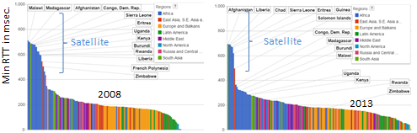

Figure 5: Minimum RTTs measured from SLAC to world countries, in Dec 2008 and Dec 2013. Different regions have different colors.

If one looks at maps of the minimum RTTs from SLAC to the world in 2008 and 2013 in Figure 6, one can see the countries that have moved away (moved from red to another color) from using GEOS links. One can see Greenland and Central Asia now use terrestrial links.

The installation of fibre cables from Europe and from the Middle East to East African countries driven by the 2010 soccer world cup in South Africa dramatically reduced round trip delays. The Democratic Republic of the Congo was finally connected to low-cost, high-quality international bandwidth through the WACS submarine fibre optic cable in 2013[[36]](#footnote-36). Also a fibre connection to the South East Democratic Republic of the Congo from Zambia was completed in Nov 2012[[37]](#footnote-37).

The African countries, that we can measure, that still have minimum RTTs > 500msec are: Chad, Guinea, Eritrea, Liberia and Sierra Leone. Try as we might we cannot find hosts that respond and that we trust as being in the Central African Republic, Congo Republic, Equatorial Guinea, South Sudan, or Western Sahara.

* Republic of Congo is building a fibre infrastructure around the capital Brazzaville, and will connect to Pointe Noire on the coast where the submarine fibre optic cable lands[[38]](#footnote-38)
* It is expected that Equatorial Guinea, Gambia, Guinea, Liberia, Mauritania, Sao Tome and Principe, and Sierra Leone and will get their first submarine connections via the ACE project in 2013.[[39]](#footnote-39) The cable will also connect via terrestrial fibre networks in the landlocked countries of Mali and Niger. The first phase of the 17,000 km-long fiber optic cable was put in service on December 15, 2012. Sierra Leone is supported by a loan from the World Bank[[40]](#footnote-40), however they still appear to be using satellite links.

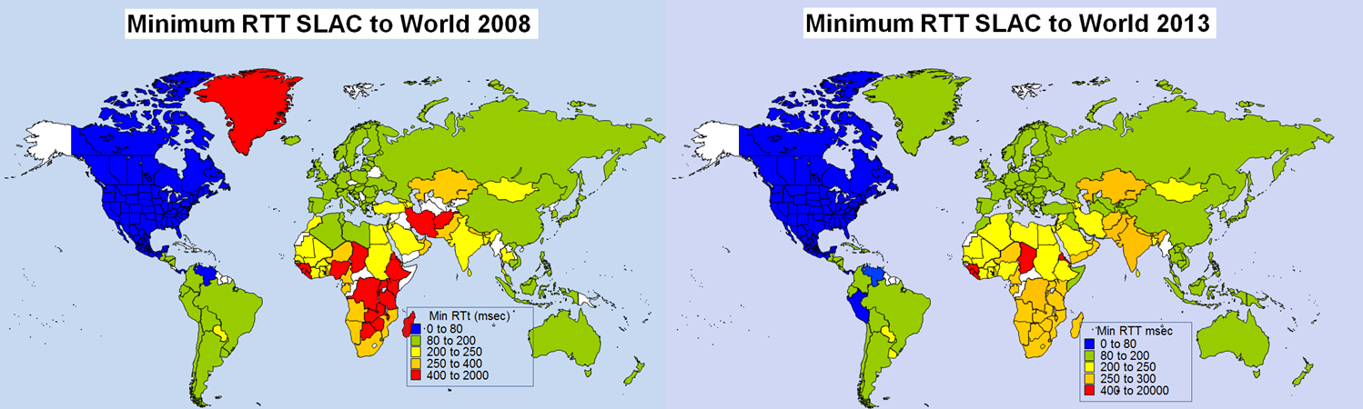

Figure 6: Maps of minimum RTTs from SLAC to the world in 2008 and 2013.

Looking at the minimum RTT as a function of time for many countries since 1998 seen in Figure 7, one can clearly see, by the precipitous drop in minimum RTT, when monitored hosts in various countries moved from GEOS satellite connections to terrestrial connections.

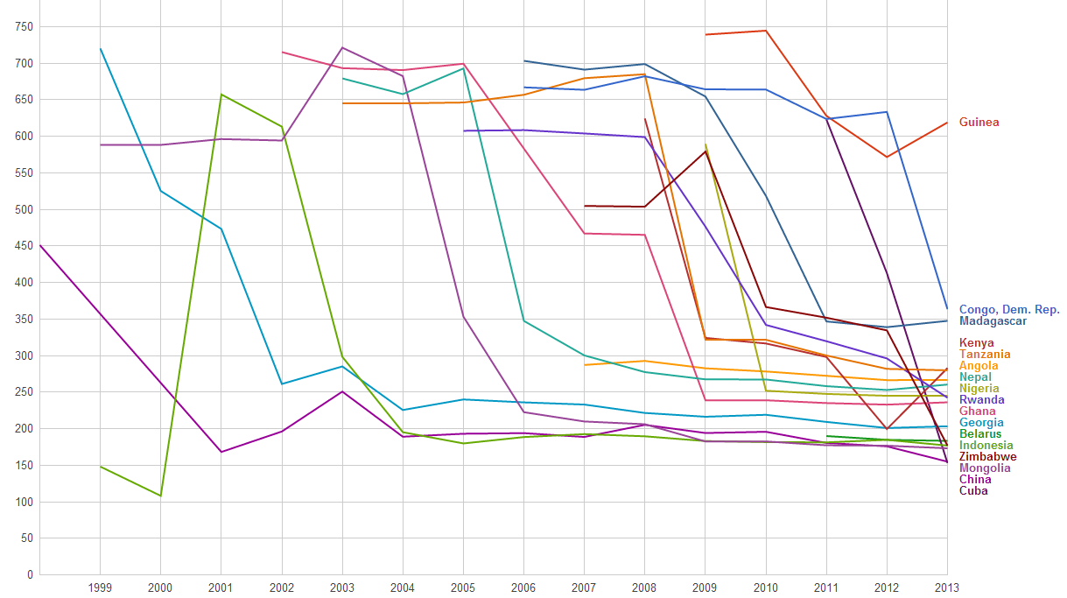

Figure 7: Time series of minimum RTT measured from SLAC to various countries since 1998

It can be seen that China shifted to a terrestrial link in 2001, Georgia in 2003, Indonesia and Belarus in 2004, Mongolia in 2006. Although Ghana received terrestrial connectivity in 2001, the nodes we were monitoring did not shift to a terrestrial connection until 2007. Rwanda, Kenya, Zimbabwe and Madagascar are some of the countries that started using terrestrial connections in 2010 due to the Soccer world cup in Africa. Cuba and Congo shifted to terrestrial link this year. RTT to Cuba first decreased to around 400ms in 2012 as the link in one direction switched to terrestrial and then reduced to 170ms in 2013 after completing the switch of both link directions to terrestrial26A.

It is interesting to compare the minimum RTT seen from SLAC to Africa with that from a site at the University of Ouagadougo, Burkina Faso in Western Africa. This is seen in Figure 8. Obviously the minimum RTTs from SLAC should be much larger given the distance to cross the US, the Atlantic to Europe and thence to Africa. More interesting is to see which countries Burkina Faso has reasonably direct connections to. It is seen for most of Africa the minimum RTTs are similar. This is since the connections from Burkina Faso are not direct but go via Europe. There are more direct connections from Burkina Faso to the Ivory Coast, Mauritania, Morocco, and Senegal as well as within Burkina Faso. The West and Central African Research and Education Network[[41]](#footnote-41) (WACREN) is bringing together the countries of West Africa and fostering direction connections between the members.

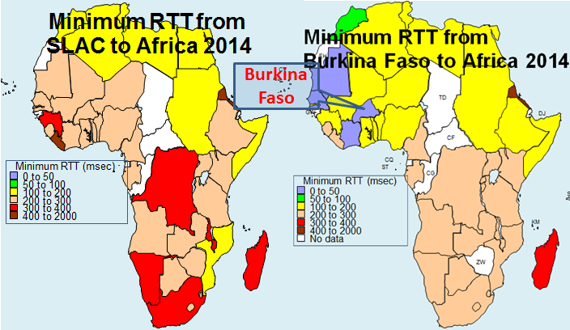

Figure 8: Minimum RTTs measured to African countries from SLAC and the University of Ouadouga in Burkina Faso

### Yearly Jitter trends

The short term variability or "jitter" of the response time is very important for real-time applications such as telephony, gaming, streaming media, haptic surgery. Jitter is a symptom that there is congestion, or not enough bandwidth to handle the traffic. The jitter specifies the length of the VoIP codec de-jitter buffer required to prevent over- or under-flow. An objective could be to specify that say 95% of packet delay variations should be within the interval [-30msec, +30msec].The links we measure generally have high performance backbones, so the main cause of jitter is the congestion at the edges. Thus the metric tends to be distance independent. There are several ways of measuring jitter[[42]](#footnote-42)B, for this report we shall report on the Inter Packet Delay Variability (IPDV). Figure 9 shows the jitter seen from SLAC to regions of the world.

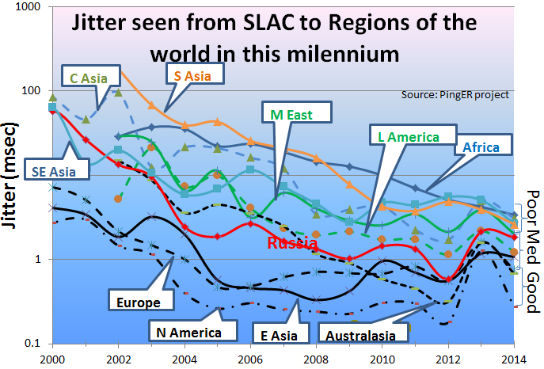

Figure 9: Jitter from SLAC to regions of the world until Dec 2014.

It is seen that the improvement to lower values of jitter is roughly exponential for regions with poor jitter, while for the good regions the improvements with time since 2006 appear to have leveled out. Also as for the losses the developed regions N. America, Australasia, E. Asia and Europe have the lowest jitter. Africa, Central Asia, S.E. Asia and S. Asia have the highest jitter.

### Yearly Throughput Trends

To combine the effects of loss and RTT we use the Mathis formula to calculate the TCP throughput. We have also reduced the effect[[43]](#footnote-43) of the *1/RTT* in the Mathis formula for derived throughput by normalizing the throughputs using:

*norm\_throughput = throughput \* min\_RTT(remote region) / min\_rtt(monitoring\_region)*,  
where: *throughput ~ 1460\*8 bits/(RTT\*sqrt(loss))*

The results are shown in Figure 10 showing data averaged into yearly intervals.

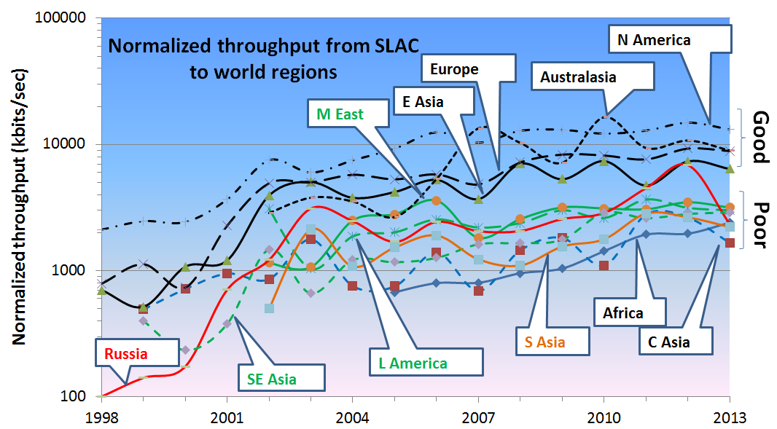

Figure 10: Yearly averaged normalized derived TCP throughputs from the SLAC to various regions of the world until Dec 2013.

The improved performance for Russia in 2001 is an artifact of measuring a single host (the Institute of High Energy Physics in Moscow) with high losses in 1999-2000 and adding a second host (Institute of High Energy Physics in Novosibirsk) with low losses in 2001. Parts of Latin America moved from satellite to fibre in 2000, and E. Asia in 1999. Also note the impact of moving the ESnet routing from E. Asia (in particular Japanese academic and research networks) to the US via New York in 2001 to a more direct route via the West Coast of the US. Also note that there is almost a 10 times difference in throughput between Africa and N. America, Europe and Oceania. Africa is the worst off region and had the slowest rate of improvement until 2008.

To make the overall changes stand out more clearly, Figure 11 shows just exponential trendline fits to monthly averages of the derived throughput on a log-linear scale (exponentials show up as straight lines). We have excluded N. America due to the distortion produced by the high value of 1/RTT, since the measurements are made from SLAC in N. America. These trendlines are useful to see in general how a particular region is doing against others and over a period of time, against its past. For guidance, the top yellow line shows what a 20% improvement per year would look like; this corresponds to roughly a factor of 10 in twelve years.

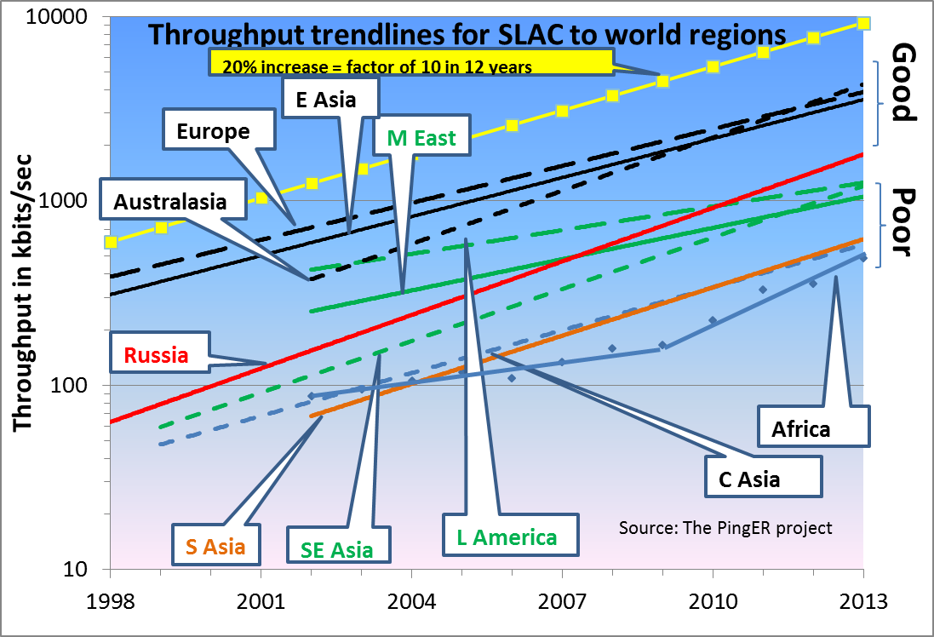

Figure 11: Derived Throughput kbits/sec from SLAC to the World (since the throughputs in this graph are not normalized we have not shown N. America) until Dec 2013. The yellow line is to help show the rate of change. If one extrapolates Europe’s performance backwards to February 1992, it intercepts Africa’s performance today.

The slow increase for Europe in Figure 11 is partially an artifact of the difficulty of accurately measuring loss with a relatively small number of pings (14,400 pings/month at 10 pings/30 minute interval, i.e. a loss of one packet ~ 1/10,000 loss rate). We looked at using a method[[44]](#footnote-44) that allows for zero packet loss, however it requires one to know the maximum congestion window size. Unfortunately this varies from host to host and can easily be changed, so we did not pursue it.

Looking at the data points one can see:

* East Asia and Oceania are catching Europe;
* Russia is 6 years behind Europe and catching up;
* Latin America and the Middle East are 7 years behind and falling further behind;
* S. E. Asia is also 7 years behind but is catching up;
* S. Asia and Central Asia are 11 years behind and keeping up;
* Africa is 14 years behind Europe, however see Figure 12 where it is seen:
  + In 2008-2009 Africa was 12-14 years behind Europe and even worse was falling further behind such that in 2030 it would have been 60 times worse off or almost 25 years behind. Prior to 2008 the rate of improvement was a factor of 2 in 7 years
  + Since 2008 the improvement is a factor of 3 in 5years and at the current rate it could catch up with Europe by around 2040.
  + This remarkable improvement is largely a reflection of the impact of the multiple terrestrial links installed since 2008[[45]](#footnote-45), initially driven by the soccer world cup.
  + However, there is some evidence that the rate of catch up has fallen off inn 2013 and 2014.

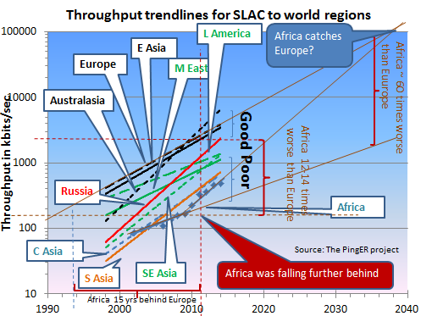

Figure 12: Extrapolations on the throughput data.

### View from Europe

To assist in developing a less N. American view of the Digital Divide; we added many more hosts in developing countries to the list of hosts monitored from CERN in Geneva Switzerland. We now have data going back for eight years that enables us to make some statements about performance as seen from Europe. Figure 13 shows the normalized throughput data from CERN to the rest of the world.

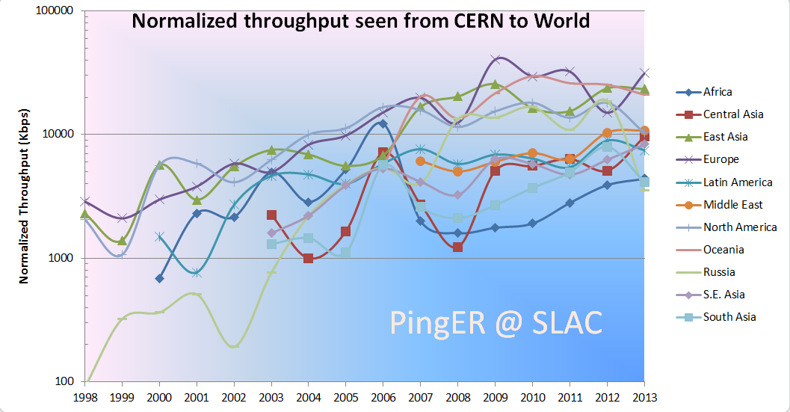

Figure 13: Normalized throughputs to various regions as seen from CERN until Dec 2013.

As can be seen by comparing Figure 10 and Figure 13 the general performance changes seen from CERN are very similar to those seen from SLAC.

### Variability of performance between and within regions

The throughput results, so far presented in this report, have been measured from North American sites and to a lesser extent from Europe. This is since there is more data for a longer period available for the North American and European monitoring hosts. Table 3 shows more details of all the measured throughputs seen between monitoring and remote/monitored hosts in the major regions of the world. Each column is for all monitoring hosts in a given region, each row is for all monitored hosts in a given region. The cells are colored according to the median throughput quality for the monitoring region/monitored region pair. White is for derived throughputs > 10,000 kbits/s (good), green for <= 10,000 kbits/s and >5,000kbits/s (acceptable), yellow for <= 5,000kbits/s and > 1,000 kbits/s (poor), pink for <= 1000kbits/s (very poor) and > 100kbits/s red for <= 100kbits/s and > 1 kbits/s (bad), and grey for no measurements. The Monitoring countries are identified by the Internet two-character Top Level Domain (TLD). Just for the record CA=Canada, US=NET=GOV=United States, CH=Switzerland, DE=Denmark, UK=United Kingdom, AU=Australia, CN=China, HK=Hong Kong, KR=South Korea, TW=Taiwan, BO=Bolivia, MX=Mexico, IN=India, LK=SriLanka, PK=Pakistan, SU=Russia, DZ=Algeria, ZA=South Africa and BF=Burkina Faso. E. Asia includes China, Japan, South Korea, Taiwan; S. Asia is the Indian sub-continent; S.E. Asia includes Indonesia, Malaysia, Singapore, Thailand and Vietnam.

Table 3: Derived throughputs in kbits/s from monitoring hosts to monitored hosts by region of the world for November 2013. The columns are for the monitoring hosts, the rows are for the remote (monitored hosts)



As expected it can be seen that for most TLDs (represented in columns) the best possible throughput values represented by the outlined boxes, usually exist within a region. For example for regions with better Internet connectivity, such as Europe, higher throughput is seen from European monitoring sites (CH, DE, IT and UK) to TLDs that lie within Europe. However, if the regions are close enough in terms of connectivity, throughput values are relatively higher. For example performance is better between closely located regions such as: the Balkans and European countries; Russia and E. Asia (the Russian monitoring site is in Novosibirsk. This shows that network performance is not completely dependent on geographic proximity, but rather on how close the regions are on the map of Internet connectivity and performance. Also take for example Burkina Faso (BF) in Western Africa: higher throughput values are evident between Africa and the TLDs DE, IT, and CH rather than between BF and African sites. This serves to illustrate the poor intra-regional connectivity between some parts of Africa.

This table also shows that throughput values show large variability within regions (e.g. a factor of ten or more between Burkina Faso and Egypt or South Africa). To provide further insight into the variability in performance for various regions of the world seen from SLAC, Figure 14 shows various statistical measures of the losses and derived throughputs. The regions are sorted by the median of the measurement type displayed. Note the throughput graph uses a log y-scale to enable one to see the regions with poor throughput.

It is apparent that the Interquartile range (IQR)[[46]](#footnote-46) can span one or more orders of magnitude. The most uniform region (in terms of IQRfor both derived throughput and loss) is Central Asia, probably since most of the paths use a GEOS link. The most diverse are Europe and East Asia. For Europe, Belarus stands out with poor performance. For East Asia, China stands out with relatively lower performance in terms of derived throughput.

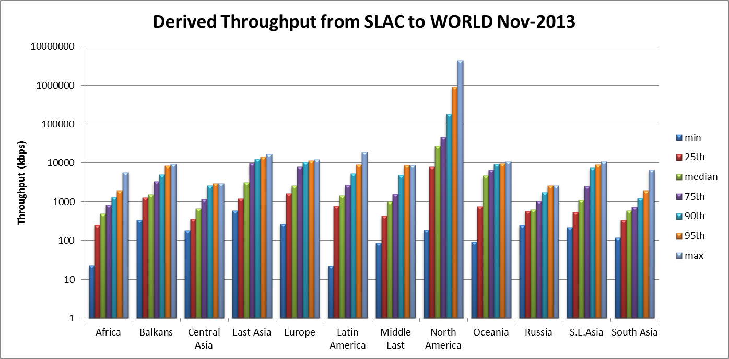

Figure 14: maximum, 95, 90, 75 percentile, median, 25 percentile and minimum derived throughputs of various regions measured from SLAC for Nov 2013 and ordered by median throughput.

A further example of the variability within a region is to look at S.E Asia as seen in Figure 15.

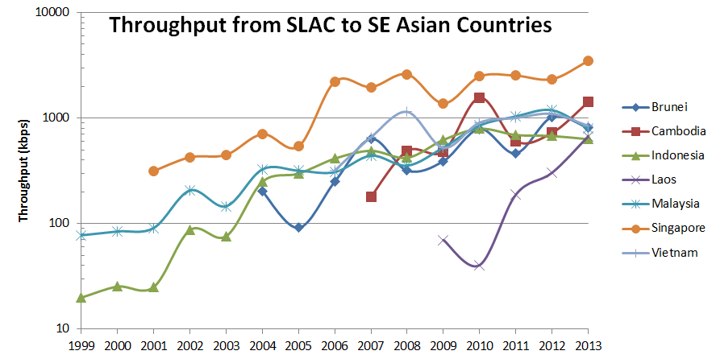

Figure 15: Derived throughput from SLAC to S.E. Asia countries until Dec 2013.

It is seen that Singapore (SG) has roughly four times better performance than the next S.E. Asian country Malaysia (MY). It is also seen that the performance to Singapore is almost a factor of ten better than that to Laos (LA). In fact Singapore’s performance approaches that of E. Asian countries.

### Yearly Mean Opinion Score (MOS) trends

The MOS is used by the telecom industry to categorize the quality of phone calls. The MOS can be related to the loss, RTT and jitter of the circuit[[47]](#footnote-47). With the emergence of Voice over IP (VoIP), it has become increasingly important to know what values of MOS are available on the Internet. A value of 5 is a perfect call; a value of 1 is no ability to communicate. The maximum MOS for VoIP is about 4.4. Typical values for usable VoIP are 4.2 to 3.5. Values below result in increasing frustration and inability to communicate. Figure 16 shows MOS values from SLAC to regions of the world.

It is seen that VoIP should work well from SLAC to most regions, and be usable to Central and South Asia[[48]](#footnote-48). It is not usable for most of Africa, however with the increased deployment of terrestrial links replacing GEOS links, it is improving

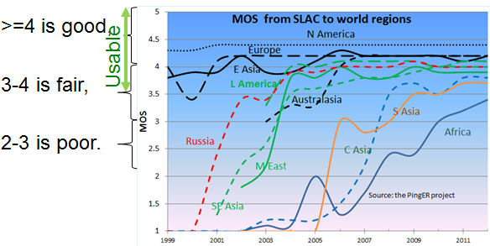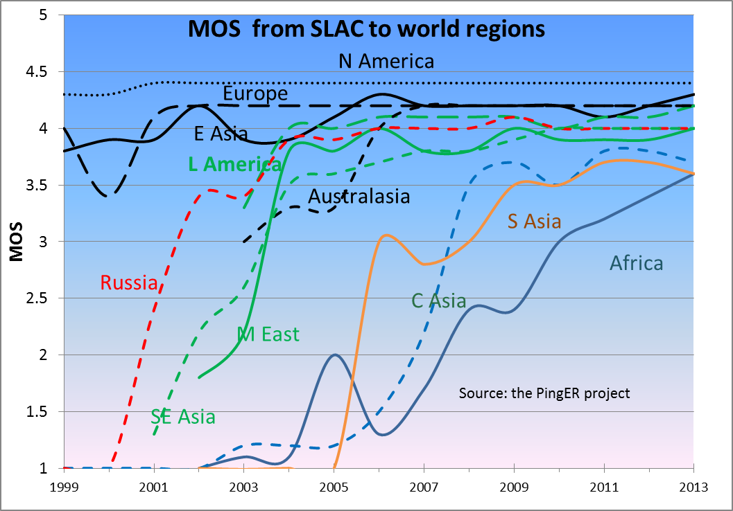

Figure 16: Mean Opinion Scores derived from PingER measurements from SLAC to regions of the world until Dec 2013.

### Directivity

Knowing the locations of the monitor and remote host we can calculate the great circle distance between them (D). The velocity of light in fibre (or electric pulses in copper cable) is v ~ (2/3)\*c = 200,000 km/sec (where c is the velocity of light in vacuum ~ 300,000km/sec) and the round\_trip\_distance = 2 \* D or D = (v / 2) \* round\_trip\_time (to\_travel\_distance\_D). To take account of the fact that the route between the monitor and target may not be a great circle route and there may be some other delays due for example to network equipment, we introduce the Directivity factor. Directivity = 1 for a great circle route and negligible network device delays. For the round\_trip\_time we use the minimum RTT (min\_RTT) measured by PingER to minimize the effects of network queuing etc. Then:

*D [km] = Directivity \* min\_RTT [msec] \* 100 [km/sec]*

and

*Directivity = D / (min\_RTT \* 100).*

Since Directivity <=1, if we derive a value > 1 this indicates the coordinates (longitude and longitude) of either (or both) the monitor or remote are incorrect, which is a valuable diagnostic. Large values of Directivity indicate the route is pretty direct, smaller values indicate it is less direct. Figure 17 shows the Directivity measured from SLAC to world regions.

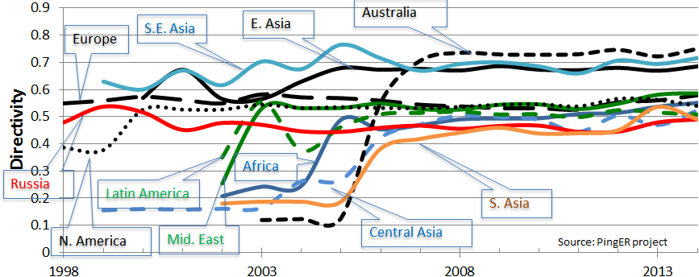

Figure 17: Directivity measured from SLAC to regions of the world until Dec 2014.

It is seen that more recently, as more remote hosts are monitored and routes are stabilizing Directivity is stabilizing. The rise in Directivity for Africa in 2004 is due to monitored hosts on the West coast of Africa taking advantage of the SAT-3[[49]](#footnote-49) fibre optic cable to move off GEOS links. The reason for the high Directivity values for E. Asia, S.E. Asia, and Australasia is since the routes from SLAC go fairly directly across the Pacific. The smaller Directivity routes to Europe, M. East, Africa and Latin America must first pass from California on the West coast of the U.S. through N. America. The Russian and C. Asian connections also are indirect since they have to cross Europe. S. Asia connections typically cross the Pacific to Japan and then South-south-west to Singapore and then North-west to S. Asia.

The Directivity between the monitoring host countries and the regions of the world are seen in Table 4.

Table 4: Directivity from monitors in countries to regions of the world for Nov 2013.



The table reveals some interesting low Directivity connections:

* The low values between China (CN – IHEP in Beijing) and E. Asia are typically via Hong Kong, ie. ~ 3500km rather than a direct route of 1300km for say Beijing to Tokyo.
  + Routes between India (IN) to Pakistan (PK) go via Singapore (adding about 4700km to the direct route of 21000km from Islamabad to Mumbai) and to Afghanistan via GEOS links.
* The routes between Jordan (JO) and: Israel, Iran and Turkey go via Europe
* Routes from Bolivia (BO) to Brazil (BR) go via Miami

## Comparisons with Economic and Development Indicators

The United Nations Development Program (UNDP), the International Telecommunication Union (ITU) and various other task forces are independent expert bodies which aim to provide policy advice, based on various economic factors, to governments, funding sources, and international organization for the purpose of bridging the Digital Divide. See the table below for details.

In reality, it is difficult to classify countries according to their development. The main challenges lie in determining what factors to consider, how to measure them, how useful and pervasive they are, how well defined they are, and whether they are uniformly measured for every country. Various organizations such as the ITU, UNDP, the Central Intelligence Agency (CIA), World Bank etc. have come up with Indices based on measured items such as life expectancy, GDP, literacy, phone lines, Internet penetration etc. Although many of the above challenges are not insurmountable they can require a lot of cost and time. Thus, many of these measurements are outdated and may not depict the current state of the country.

One of the most important factors determining the economic development of a country in today’s information age is its Internet connectivity. Thus we may expect moderate to strong correlations between the economy and development of a country with its Internet performance measurement. The significance of using PingER’s Internet measurements to characterize a country’s development is due to the fact that PingER’s data is current (up-to date within a day or so compared to say the most recent Information and Communications Technology (ICT) Development Index[[50]](#footnote-50) (IDI) data from the ITU that was published in 2012 and was measured in 2011) and covers countries of the world. Also PingER’s data is very objective not relying on statistics reported by governments with possibly vested interests. From the many indices available[[51]](#footnote-51), we chose the IDI since it is one of the most current, it is clearly related to Internet connectivity, and covers many of the countries covered by PingER. A bubble plot of throughput vs. the IDI access sub-index[[52]](#footnote-52) with the bubble sizes being proportional to population is shown in Figure 18.

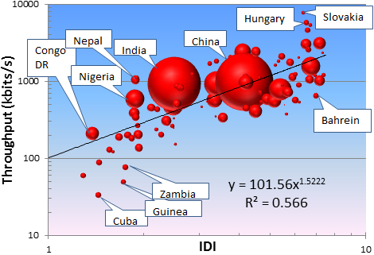

Figure 18: Pinger Derived Throughput vs. the ICT Development index. The bubble size is proportional to the country's population.

The black line is a trend line fit to a power series with the parameters shown. It is seen that there is a fairly strong correlation (R2=0.566 or R=0.75) between the IDI and PingER derived throughput.

## PingER Case Studies & Projects

### Bangladesh[[53]](#footnote-53)

##### In the Fall of 2014 we met with Prof. Javed Khan of Kent State at an Internet2 meeting and discussed deploying PingER in Bangladesh. The goal was to add more PingER monitoring and reverse traceroute/ping servers in Bangladesh. Following the meeting, we made a case study of PingER’s view of networking for Bangladesh to assist Javed in making the case to Bangladeshi universities.

During 2014, PingER monitored four hosts in Bangladesh, one of which is a monitor host at Daffodil International University in Shukrabad on the outskirts of the capital Dhaka. In summary the findings are:

* Connections between Pakistan and the two representative hosts (Beacons) in Bangladesh are very indirect going via Europe.
* The 4 Bangladesh hosts monitored from SLAC are not exhibiting diunral changes or jitter that would be indicative of congestion.
* In general the Internet performance from Bangladesh to other regions of the world, is similar to Pakistan's.
* One of the 4 sites (Brac University) in Bangladesh monitored from SLAC is not responding.
* VoIP should work acceptably well between Daffodil International University and most sites in Europe, Middle East, N. America, Russia ans S. E. Asia.
* It appears Bangladesh switched over from using geo stationary satellite connections to terrestrial connection to the US in 2005-2006.

### Afghanistan[[54]](#footnote-54)

We updated an earlier case study to illustrate the move from GEOS links to terrestrial links for 2 of the 3 hosts PingER monitors in Pakistan. The minimum RTTs measured from SLAC to Afghanistan for these three hosts are shown in Figure 19. It is seen that in late 2013 and 2014 [www.multinet.af](http://www.multinet.af) and mail.neds.af moved to terrestrial links while [www.mod.gov.af](http://www.mod.gov.af) continues to use a GEOS link. The route from SLAC appears to jump from the Bay Area to Frankfurt, then to Karachi and thence to Afghanistan.

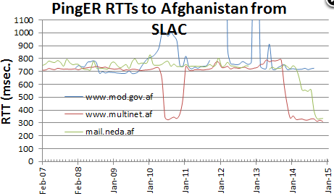

Figure 19: RTTs measured from SLAC to Afghanistan hosts.

### Cuba switch from Satellite to Terrestrial link[[55]](#footnote-55)

A 1,600-kilometer (994-mile) cable between Venezuela and Cuba, estimated to cost $70 million, was actually completed in February 2011 and was due to come into operation in July 2011. It was switched on in January 2013. The impact on one of the Cuban hosts monitored from SLAC is seen in Figure 20. The cutover process can be seen in the right hand image in the figure. Typically the cutover is made in one direction and tested, then the other direction is cut over. It is seen that they had to back-out one of the directions at some stage.

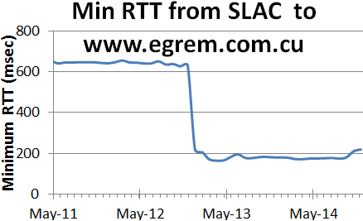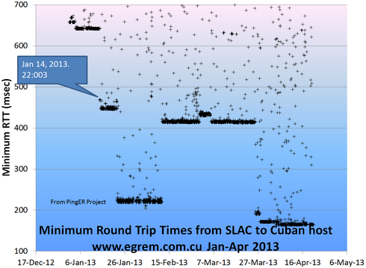

Figure 20: On the left - Minimum RTT seen from SLAC to www.egrem.com.cu in Cuba; on the right the

minimum RTTs from SLAC showing the steps in the conversion.

A second host ([www.uclv.edu.cu](http://www.uclv.edu.cu)) monitored from SLAC completed its cut-over towards the end of September. It is seen that the performance (RTTs) also dramatically improved at the start of the cutover.

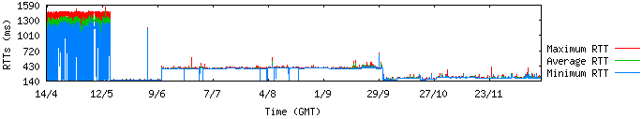

Figure 21: Ping RTT's measured from SLAC toCuban host.

### AAG Cable cut off Hong Kong Sep 15, 2014[[56]](#footnote-56)

Looking at the route of the cable that was cut, it might be expected this would impact PingER measurements from the US:

* To Thailand
* To Brunei, though there are two other cables connecting Brunei, so the impact may be limited;
* To Central E. coast Sumatra, though there is another cable connecting to central E coast Sumatra;
* To South Vietnam, though there is another cable connecting to South Vietnam.
* To Northern Phillipines.

However there was little evidence in any of the PingER metrics of noticeable impact, apart from one host in Thailand where the jitter increased by a factor of 3. This was presumably since there are a lot of other cables serving countries in the region.

### Malaysia[[57]](#footnote-57)

As part of extending the PingER collaboration to Malaysia, the first Malaysian PingER Measurement Agent (MA) installation was carried out by the Faculty of Computer Science & Information Technology (FCSIT), UNIMAS www.unimas.my/ in Kuching (East Malaysia) during December, 2012. In January, 2013, Universiti Teknologi Malaysia (UTM) in Johor Bahru http://www.utm.my/ and Universiti Malaya (UM) in Kuala Lumpur www.um.edu.my/ in West Malaysia conducted the installation of the PingER MA and Reverse Traceroute Server. Later, Universiti Utara Malaysia (UUM) in Sintok www.uum.edu.my/, also installed the PingER and traceroute servers in August 2014. In addition to the above monitoring sites we monitored 25 hosts in 12 of the 14 Malaysian states, plus 130 hosts in 10 S. E. Asian countries. To assist in spreading the word we also gave three workshops in Malaysia. We learnt about the configuration of the Malaysian NREN MYREN by discussions with the people of MYREN. We now have measurements from SLAC to Malaysia dating back to 1999 and measurements from within Malaysia dating back to December 2012.

Some early results of the analysis of the measurements from SLAC are reported in a Case Study[[58]](#footnote-58). They indicate that the route from SLAC to UM is badly congested leading to high losses (1-10%) and low derived throughput to UM. We have identified the congested router as being a MYREN router at the UM site and reported it to MYREN. Another observation was dramatic reduction in congestion after traffic shaping was introduced on the UNIMAS border in November 2012. We also noted the impact of upgrading MAYREN connectivity to TEIN3 from a capacity of 155 Mbps to a data capacity of 622Mbps on June 2014.

### Duplicate ping responses[[59]](#footnote-59)

Pinging some hosts causes multiple responses for a ping echo request. This is reported by the Linux ping command but not by OSX or Windows.

*Duplicate packets should never occur when pinging a unicast address, and seem to be caused by inappropriate link-level retransmissions. Duplicates may occur in many situations and are rarely (if ever) a good sign, although the presence of low levels of duplicates may not always be cause for alarm. Duplicates are expected when pinging a broadcast or multicast address, since they are not really duplicates but replies from different hosts to the same request[[60]](#footnote-60).*

We mined the PingER data to look for duplicate pings going back to 2005. Of the 500-800 hosts monitored by PingER from SLAC, typically each year there are around 50 hosts exhibiting duplicate ping responses. Of the one to three million samples/year less than 0.4% exhibit duplicate pings. The biggest exhibitor is [www.cern.ch](http://www.cern.ch) contributing to over 40% of the total duplicate pings.

We do not currently understand why the CERN host should respond with duplicate pings. It has been reported to CERN who believe it may be due to Load Balancing.

### Porting PingER to a Raspberry Pi[[61]](#footnote-61)

This is a follow on to the ePingER project where we setup PingER on an Ubuntu based embedded hosts and donated two such hosts to universities in Zambia. In the current case the goal is to enable the deployment of PingER hosts in remote places such as Bario in the Kelabit Highlands of Borneo. The requirements are low power requirement so we can use solar power, reliability so manual intervention is not needed, and low cost so there can be two devices deployed for redundancy.

The project is led by Johari Abdullah of UNIMAS, and the Raspberry Pi is now configured and installed at the data center at UNIMAS.

### Big Data/Analysis

Following Renan Souza’s visit last year and his work on providing Linked Open Data[[62]](#footnote-62) access to PingER data[[63]](#footnote-63), Renan returned to UERJ in Rio de Janeiro and working with Maria Luiza Campos put together a proposal[[64]](#footnote-64) to continue the work.

To enable access to the PinGER data we made it available by anonymous FTP[[65]](#footnote-65) and working with UFRJ, provided analysis of the volumes of data by year and metric[[66]](#footnote-66).

This data was also made available to Ibrahim Abaker of UM for his project proposal[[67]](#footnote-67) for a novel data storage model for PingER project using key-value store and MapReduce[[68]](#footnote-68) strategy for SPARQL[[69]](#footnote-69).

### Visual Traceroute (VTrace)[[70]](#footnote-70)

Visual Traceroute is a new feature developed that enables visualization of the traceroute on a map. Currently it can provide a visual traceroute from 29 landmarks (2 in USA and 1 per each of 27 countries).:

It works by first finding the traceroute to the target using the traceroute server[[71]](#footnote-71) installed at the landmark node and then geolocating each of the intermediate hop routers using TULIP.

We use TULIP's[[72]](#footnote-72) dynamic ping-based geolocation as compared to say database methods such as used by MaxMind[[73]](#footnote-73), since often router locations in the database tend to be given as at the corporate HQ that owns the routers (e.g. ESnet routers may supposedly be located in Berkeley). Besides locating the routers, VTrace also:

* gives an estimate of the accuracy of the predicted location
* provides estimates of the distance for each hop
* provides results from other location tools.(e.g. Maxmind based)

An example of VTRace for a route from SLAC to CERN is shown in Figure 22. Two traceroute paths are shown on the google map. One (shown in red) is drawn using TULIP and the other (shown in blue) is drawn using MaxMind (an IP host location database). The hops are shown as appropriate numbered markers, the error in the estimated location is shown as a red circle.

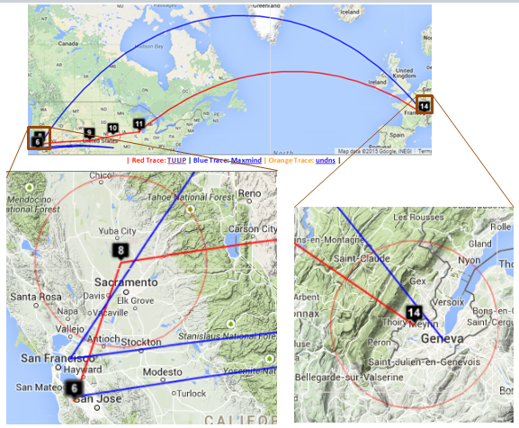

Figure 22: Visual traceroute from SLAC to NUST in Islamabad, Pakistan

As seen in Figure 23, VTrace also shows the tabular traceroute together with the Autonomous System Number (ASN), if known, the router's location coordinates and distance between hops. Clicking on the IP address will take you to the TULIP geolocation utility. Clicking on the ASN will provide information on the ASN.

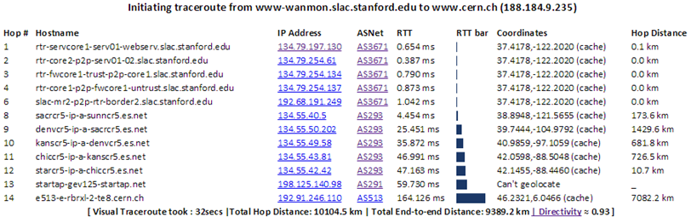

Figure 23: Traceroute displayed by VTrace.

**High Performance Network Monitoring**

***New and Ongoing Monitoring and Diagnostic Efforts in HEP***

PingER is an excellent system for monitoring the general health and capability of the existing networks used worldwide in HEP. However, we need additional end-to-end tools to provide high—performancde sites with the capability to quantify their network connectivity along specific paths in the network, quickly isolate and diagnose network issues and inform developing tools and applications that need network information to be optimize their tasks. These are needed both to ascertain the siter's current network capability as well as to identify limitations which may be impeding the user’s ultimate (expected) network performance. The perfSONAR project has grown to fill this need and we will show later how it is being leveraged to address the needs of the worldwide LHC community.

Most HEP users are not "network wizards" and don't wish to become one. In fact as pointed out by Mathis, the gap in throughput between what a network wizard and a typical user can achieve was growing significantly from the late 1980’s to the late 1990’s.

Within the last 15 years, because of improvements in default OS TCP stack settings, new protocols, hardware, firmware and software, this gap has decreased but still remains in 2014. Because of HEP's critical dependence upon networks to enable their global collaborations and grid computing environments, it is extremely important that more end-user focused tools be developed to support these physicists and continue to decrease the gap between what an expert can achieve and what a typical user can get “out of the box”.

Efforts continue in the HEP community to develop and deploy a network measurement and diagnostic infrastructure which includes end hosts as test points along end-to-end paths in the network. This is critical for isolating problems, identifying bottlenecks and understanding infrastructure limitations that may be impacting HEP’s ability to fully utilize their existing networks. The history of the effort was documented in last year’s report and we won’t repeat it here, instead highlighting updates during the last year in the following sections.

**perfSONAR for HEP**

High-energy physics grid sites rely upon the network to provide access to their computing and storage. The network provides the basis for users to access those resources and for virtual organizations to organize the sharing and use of their member's resources. When there are problems in the network, it can significantly degrade or even disable users and VOs ability to do their science.

Networking problems can be difficult to identify and isolate for numerous reasons:

* Network paths typically span multiple administrative domains with no single entity having complete access to the end-to-end infrastructure components
* Applications that work well on a Local Area Network (LAN) may behave significantly differently when run on a Wide Area Network (WAN) due to the impact of latency on the network communication involved
* End-host or LAN issues may be the actual source of problems and differentiating HOST vs LAN vs WAN problems can be difficult without sufficient expertise
* Problems that actually exist on a host or in the LAN may not be "visible" in local use and only show up when the application is used in the WAN. The tendency is to believe the WAN is the problem even though it many cases it isn't
* Real WAN problems are hard to localize and it is not practical or effective to contact every entity managing a portion of the network path on which you see a problem.

For high-performance, data intensive sites, PingER is insufficient to address these issues. Our goal is to help users, VOs and site administrators better understand their network infrastructure and enable them to more effectively find problems and isolate their root cause. To do this WLCG is mandating its Tier-0/Tier-1/Tier-2 sites deploy [perfSONAR Toolkit](http://docs.perfsonar.net/" \l "installation" \t "_top) instances in their infrastructure. A brief overview of the recent history behind this follows.

In June of 2012, the Open Science Grid (OSG) began a new effort in networking to enable OSG to become the networking information provider for its constituents. A primary goal was to work with the perfSONAR developers and the various Virtual Organizations (VOs) supported by OSG to enable pervasive network monitoring, regularly collecting network measurements, visualizing them and making them available for users and higher level services.

At nearly the same time (fall of 2012) the Worldwide LHC Computing Grid (WLCG) formed a deployment task force to guide the deployment and configuration of the perfSONAR Toolkit at all WLCG Tier-1 and Tier-2 sites worldwide. This decision was made in great part based upon both the success in using perfSONAR in the US and within the LHCOPN as well as the increasing need to better integrate networks within our HEP global cyberinfrastructure. This deployment task-force finished its work in spring 2014, having gotten 220 perfSONAR toolkits fully deployed (with 6 additional deployment’s “planned”) by May 30, 2014. WLCG then created a follow-on working group (the WLCG Network and Transfer Metrics Working Group[[74]](#footnote-74)) to maintain the perfSONAR deployments as well as to ensure all needed metrics from the network and transfer tools were being captured and made available to WLCG. This working group has actively supported new sites to install and configure perfSONAR, as well as documenting installation/upgrade procedures and coordinating and maintaining the systems already deployed. The working group tracks status (updated daily) at <http://grid-monitoring.cern.ch/perfsonar_coverage.txt>

### Using and Managing perfSONAR

The perfSONAR systems in WLCG (and OSG) are intended to serve a number of purposes. First we intend these systems to run regularly scheduled tests with other WLCG sites to track network behavior, verify proper network operation and find any problems as early as possible. There are three types of tests that are run: 1) traceroute (to monitor the network path between sites), 2) latency (to monitor one-way latency AND packet loss along the path) and 3) bandwidth (to provide a measure of available bandwidth between sites). The frequency of tests, the testing partners and the test parameters all need to be adjusted depending upon which set of sites are involved. WLCG has chosen to organize testing by Tier-1 cloud meshes, sometimes VO specific. For example, we have a USATLAS mesh (comprising the USATLAS Tier-1 and Tier-2 sites) as well as a USCMS mesh (comprising the USCMS Tier-1 and Tier-2 sites) but in the UK we have a single UK mesh (happens to be mostly ATLAS). There will be more on the meshes and how they are organized below. Another purpose for the perfSONAR instances is to provide a site “beacon” that can respond to on-demand tests. The perfSONAR developers have provided command line tools to run bandwidth or latency tests as required (if a problem is suspected). In addition the toolkit instances have some additional on-demand tests that try to identify common problems along a network path. Though not updated recently, NPAD and NDT are still useful to allow users to run a quick diagnostic via a web browser to the perfSONAR instances of their choice.

One of the challenges for a large scale deployment of perfSONAR is managing the tests amongst the participating sites. When USATLAS began deploying perfSONAR in 2008, all configuration for each site was controlled by “emails” to the perfSONAR administrators. Every change (addition or deletion) required every administrator to update their configuration. The perfSONAR developers provided a solution with the so called “mesh-configuration”. The perfSONAR toolkit was updated to provide a mesh agent that could get its configuration from URL. A web server could provide the JSON configuration for a whole mesh and changes could be made centrally. The perfSONAR administrators just needed to configure their agent to read from the specified URL for each mesh they participate in.

In 2014, OSG improved upon this system by providing a secured GUI in MyOSG (see Figure 24) that could construct meshes based upon the perfSONAR registration information required by OSG and WLCG. All perfSONAR instances in OSG are required to be registered in OIM while all such instances in WLCG (not in OSG) are required to be registered in GOCDB. This allows OSG to centrally gather all needed information to create meshes for use by perfSONAR instances all over the world. Once created the meshes automatically update as registration information is updated.

One further interesting capability was enabled by OSG because of their mesh-management system: since OSG knows which perfSONAR hosts are participating in which meshes it is possible to have each perfSONAR instance configure a single URL (even if they participate in multiple meshes). We call this new URL the “auto-mesh” URL and is identical for all perfSONAR hosts except for the last part, which is the perfSONAR host’s fully qualified domain name, e.g., [https://myosg.grid.iu.edu/pfmesh/mine/hostname/<FQDN](https://myosg.grid.iu.edu/pfmesh/mine/hostname/%3cFQDN)>. This is very powerful in that now perfSONAR admins no longer need to update their configuration if meshes are added or changed.

Using the mesh management system from OSG, we can now easily manage how, where and when tests are run. We need to walk a careful line of testing only enough to meet our needs. We have a tension between those who would like better test coverage vs those concerned about using available bandwidth to test.

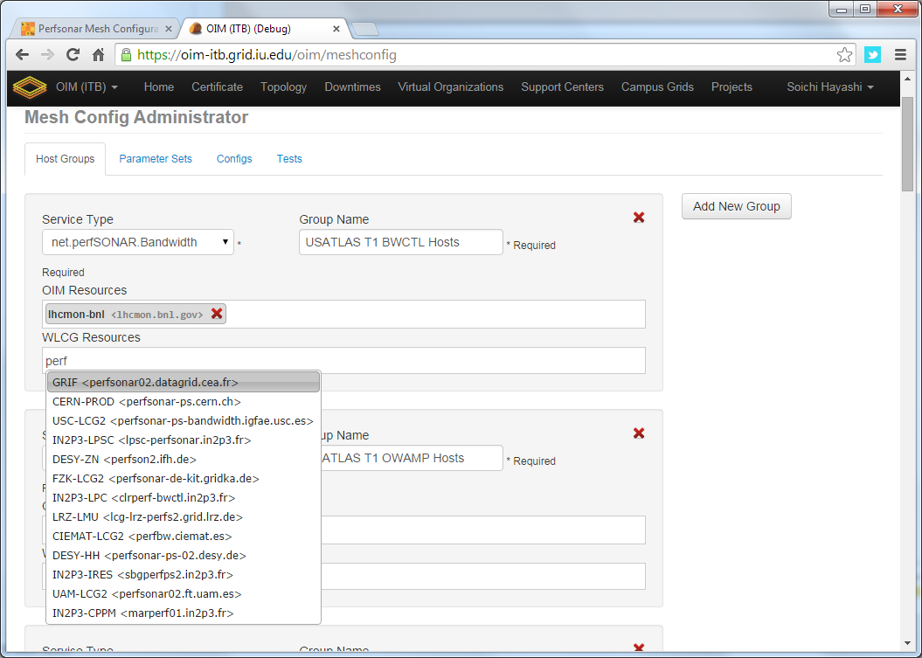

Figure 24: Example of OSG's mesh-management tool interface

The latency test we have configured are managed by OWAMP and measures one-way delays between the latency node and its test partner at another site. We send 10Hz of small UDP packets to each test partner continuously (600 packets/minute). Since absolute time accuracy is critical for this test, part of a latency node configuration includes setting up a reliable time service (ntpd) configuration to ensure the node keeps accurate time. From this measurement we get the one-way delay to the partner site as well as information on any packet losses for each 1 minute interval (how many of the 600 packets were lost?). It is the packet loss measurement that is very sensitive to problems along the network path.

The second type of test measures throughput using Iperf. Within a Tier-1 cloud mesh we schedule a 30 second throughput test each direction (source to destination and destination to source) every 6 hours. In addition EACH end schedules it (both ways) so we end up with two 30 second tests each direction each 6 hours. We additionally are trying to sample ALL network paths but at a much lower cadence. To do this we have setup a WLCG-wide mesh which tries to run a 30 second throughput test each direction, once per week. Until we can determine the impact of this, we have limited the WLCG mesh to be the largest 50 sites (according to their published disk storage numbers).

The last type of test is a critical one: traceroute. The traceroute test tracks the network path between the host and any destination and is run every 20 minutes to EACH destination which is being tested. If the route changes, we record the new route in the perfSONAR measurement archive. This is required to understand the topology we are measuring and can alert us to routing changes that may be correlated with observed network problems.

Details about how to setup and configure perfSONAR for OSG/WLCG are maintained at <https://twiki.opensciencegrid.org/bin/view/Documentation/DeployperfSONAR>

### Network Datastore

OSG and WLCG are working closely together on perfSONAR for high-energy physics (and others). OSG, as a member of WLCG, has agreed to become the control hub for the global perfSONAR deployment and has developed a Network Datastore, based upon the Esmond datastore in perfSONAR v3.4, to host all the perfSONAR metrics. Figure 24 provides an architecture diagram of the OSG network datastore, showing the use of a back-end Cassandra database easily scaled by adding additional instances. This datastore is intended to become the source of network metrics for OSG and WLCG and is planned to go into production in early winter 2015.

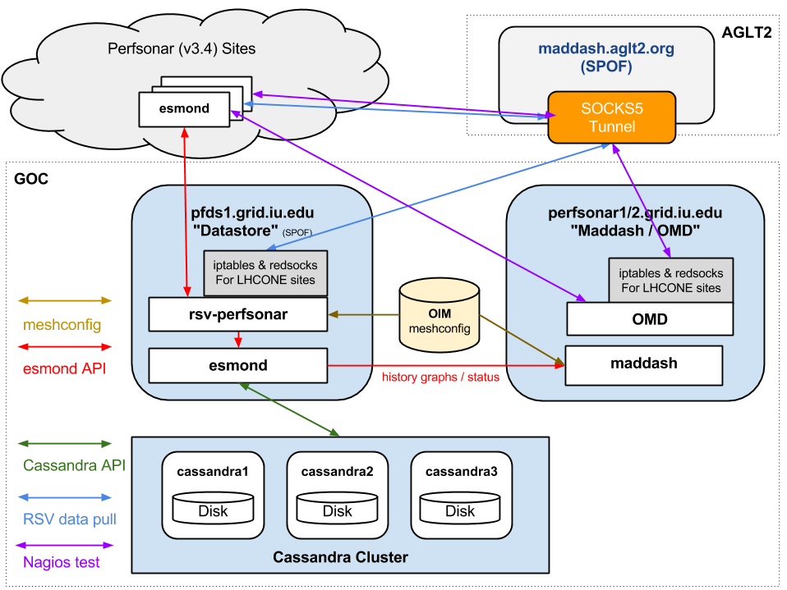

Figure 25 The OSG network datastore architecture used to gather, organize and archive network metrics from the global OSG and WLCG perfSONAR deployment and make those measurements available for visualization or higher-level services.

**perfSONAR Metric Visualization**

While perfSONAR provides a convenient way to gather standardized network metrics via deploying a toolkit instance, it can still be cumbersome to try to gather, check and interpret this data. As USATLAS began deploying perfSONAR instances we realized that a critical missing component was a means of centrally monitoring and displaying the information we were collecting. ESnet had some initial efforts in this direction by creating [Nagios](http://www.nagios.org/) “plugins” that could query individual perfSONAR instances and check to see if the data returned was within bounds.

Originally we started a project to provide a visualization and management dashboard, call the Modular Dashboard project. However the developer left BNL (where the project was hosted) in 2013 and we replaced it with MaDDash, a project created and supported by ESnet. We now use MaDDash to monitor all our WLCG and OSG metrics. The prototype instance can be seen at <http://maddash.aglt2.org/maddash-webui/> (and in Figure 26). Colors indicate whether the metrics tracked are OK (green), WARNING (yellow), CRITICAL (red) or UNAVAILABLE (orange). MaDDash also supports “drilling-down” by clicking on the cell which will take the user to an interface with historical data, graphs and details of the test results.

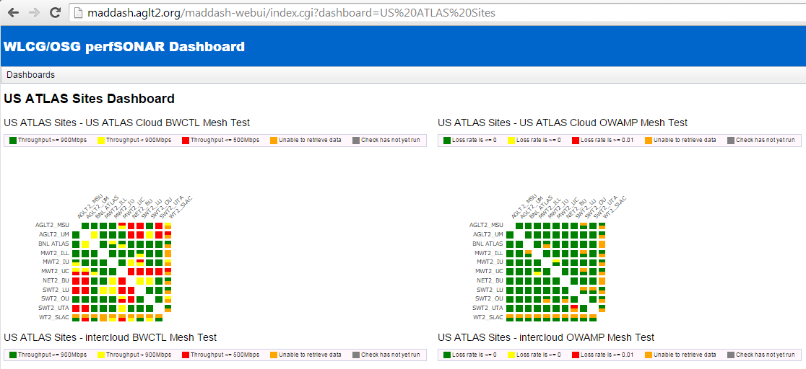

Figure 26: Example of MaDDash dashboard in prototype instance at AGLT2 showing the USATLAS meshes for bandwidth and latency.

OSG hosts the production instance at <https://perfsonar2.grid.iu.edu/maddash-webui/>

**Infrastructure and Service Monitoring**

In addition to metric visualization, the global perfSONAR deployment has another challenge. We need to be able to quickly find problems in the measurement infrastructure itself. While perfSONAR has evolved to be more robust over time, there are still cases where it has problems and fails to gather the needed metrics. To address this we have created a simple-to-deploy infrastructure monitoring system based upon OMD (Open Monitoring Distribution; <http://omdistro.org/> ) which is a single RPM install of Nagios and many integrated applications. This has allowed us to quickly find infrastructure issues and better support end-sites when they have problems. We have created service checks for all perfSONAR services (by host type) as well as checks on registration information like admin name and email, latitude and longitude and program version. See Figure 27 for a view of OMD summarizing the WLCG perfSONAR host status.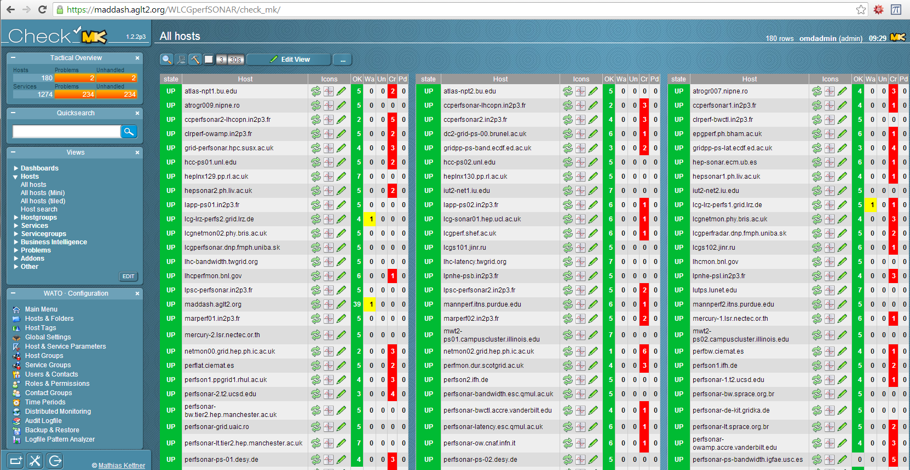

Figure 27: OMD Check\_MK screenshot showing some of the monitored perfSONAR hosts in WLCG.

OSG hosts the production version@ <https://perfsonar2.grid.iu.edu/WLCGperfSONAR/check_mk>

**Complementary End-to-End Monitoring**

The WLCG network and transfer metrics working group is trying to identify additional metrics related to ongoing data-transfers that can also provide insight into both the networks WLCG uses and well as the end-to-end data transfers continually underway. Both ATLAS and CMS rely upon FTS (and now FTS3) to handle transfers of files between sites and the transfer details (file size, source, destination, time, transfer rate) are tracked centrally. In addition the LHC experiments are also using the xrootd protocol to provide WAN access to data files directly, rather than copying the files first. To check the xrootd behavior regular xrootd file transfers are regularly scheduled between various sites and the results are stored in a central database at CERN.

The combination of file transfer metrics end-to-end along with the set of network metrics provided by perfSONAR will allow us to quickly differentiate between end-site issues and network issues.

**Summary: Progress in HEP Network Monitoring for 2014**

As noted above, efforts to ensure commonality in both monitoring and provisioning of networks have seen a significant increase in activity in HEP during 2014. Originally, the [GLIF](http://www.glif.is/)[[75]](#footnote-75) and [DICE](http://www.geant2.net/server/show/conWebDoc.1308)[[76]](#footnote-76) communities were both working toward implementing “managed” network services and the corresponding monitoring that will be needed to support their efforts. During 2014 there were a number of new or expanded initiatives within global HEP:

* The WLCG community completed deploying perfSONAR-PS toolkits at sites to provide needed network visibility for users, site-admins and eventually higher-level services.
* The Open Science Grid (OSG) focused on provisioning network monitoring within OSG to become the definitive source of networking information for OSG sites as part of their year-2 planning for networking.
* Previous ATLAS-initiated perfSONAR-PS deployments within national regions in the US, Italy and Canada, were augmented by new national deployments in France, Germany, Spain, Taiwan, Russia and the UK and now include all four LHC experiments.
* The Worldwide LHC Computing Grid (WLCG) continued work on network issues via the networking committee chaired by Michael Ernst.
* The WLCG perfSONAR-PS deployment taskforce, chaired by Simone Campana and Shawn McKee, focused on deploying perfSONAR at all WLCG Tier-2s worldwide and integrating their registration and measurements within the WLCG monitoring framework. Non-compliant sites are being ticketed as of December 2013. The goal is to have a single infrastructure providing network monitoring for WLCG as opposed to potentially many disparate systems per experiment or region.

To summarize, 2013 has seen a convergence to a standard network monitoring infrastructure based upon perfSONAR. The goal is to have a single system to provide network related metrics for HEP. This is feasible because HEP’s use of the network is qualitatively the same between HEP collaborations. It is desirable because network providers and users don’t want to have multiple “network measurement infrastructures” making redundant (and possibly interfering) measurements nor do they wish to have to develop, deploy and support many such instances when one will do.

***Related HEP Network Resear****ch*

There has been a significant amount of research around managed networks for HEP that we should note. There are efforts funded by the National Science Foundation ([UltraLight](http://www.ultralight.org/)[[77]](#footnote-77) (finished Aug 2009), PLaNetS) and Department of Energy ([Terapaths](http://www.atlasgrid.bnl.gov/terapaths/)[[78]](#footnote-78) (finished Dec 2009), [LambdaStation](http://www.lambdastation.org)[[79]](#footnote-79) (finished 2009), [OSCARS](http://www.es.net/oscars/index.html)[[80]](#footnote-80), and the associated follow-on projects StorNet, VNODs and [ESCPS](https://plone3.fnal.gov/P0/ESCPS/)[[81]](#footnote-81) projects) which are strongly based in HEP. These projects are not primarily focused upon monitoring but all have aspects of their efforts that do provide network information applications. Some of the existing monitoring discussed in previous sections either came out of these efforts or is being further developed by them.

In summer 2010 a new NSF MRI project was funded called [DYNES](http://www.internet2.edu/ion/dynes.html)[[82]](#footnote-82). The DYNES collaboration (Internet2, Caltech, Michigan and Vanderbilt) intends to create a virtual distributed instrument capable of creating dynamic virtual circuits on-demand between the participating member sites. The LHC community and its data access and transport requirements are the primary “users” targeted by this new infrastructure. Funding was provided to initially deploy DYNES at 40 institutions and 14 regional networks within the United States. DYNES leverages prior work related to virtual circuit construction, QoS and perfSONAR to enable the required capabilities. Instrument deployment began in spring 2011. The DYNES project was completed in July 2013 but work is continuing on a best effort basis to improve the ability of DYNES sites to utilize end-to-end circuits.

During 2012, with the LHC Long Shutdown 1 (LS1) approaching in 2013 through the spring of 2015, many people realized we have an opportunity to better integrate networking within our various LHC computing and software infrastructure. Two specific proposals targeting this area were funded in 2012 and have been active in 2013:

* Advanced Network Services for Experiments (ANSE), NSF funded (Caltech, Michigan, Vanderbilt and U Texas Arlington)
* Next Generation Workload Management and Analysis System for Big Data, PANDA integration with networking, DOE ASCR funded (BNL, U Texas Arlington)

ANSE is focusing on the integration of advanced network services into the software stacks of ATLAS and CMS with a goal of transparently integrating new networking capabilities to increase the overall efficiency and effectiveness of their globally distributed computing and storage resources. The ATLAS PANDA proposal has a similar focus and is trying to update the PANDA infrastructure with network “awareness” and the ability to interact with network services to prioritize and manage its workload.

## Comparison with HEP Needs

Previous studies of HEP needs, for example the TAN Report (<http://gate.hep.anl.gov/lprice/TAN/Report/TAN-report-final.doc>) have focused on communications between developed regions such as Europe and North America.  In such reports packet loss less than 1%, vital for unimpeded interactive log-in, is assumed and attention is focused on bandwidth needs and the impact of low, but non-zero, packet loss on the ability to exploit high-bandwidth links.  The PingER results show clearly that much of the world suffers packet loss impeding even very basic participation in HEP experiments and points to the need for urgent action.

The PingER throughput predictions based on the Mathis formula assume that throughput is mainly limited by packet loss.  The 20% per year growth curve in Figure 10 is somewhat lower than the 79% per year growth in future needs that can be inferred from the tables in the TAN Report. True throughput measurements have not been in place for long enough to measure a growth trend.  Nevertheless, the throughput measurements, and the trends in predicted throughput, indicate that current attention to HEP needs between developed regions could result in needs being met.  In contrast, the measurements indicate that the throughput to less developed regions is likely to continue to be well below that needed for full participation in future experiments.

## Other Scientific Research Interests in Africa

In addition to HEP interests there are considerable other scientific interests in the performance of networking to developing regions in particular Africa. For example:

* There is the Square Kilometer Array[[83]](#footnote-83) with cores in Sub-Saharan Africa and Australia costing €1.5 billion, with construction starting 2016, and initial observations 2019. The network traffic requirements are equivalent to ten times the Internet traffic today.
* Aug 30, 2012: CERN donated 220 computer servers from CERN to the [Kwame Nkrumah University of Science and Technology](http://www.knust.edu.gh/) in Ghana[[84]](#footnote-84).
* Strategic plan for a synchrotron light source in southern Africa[[85]](#footnote-85) championed by SLAC’s own Herman Winick
* Drugs from rain-forest, environment studies, geo-physics
* Six HEP International Conferences in Madagascar[[86]](#footnote-86)

*More funding and better Internet connectivity access are helping [Africa]. The number of scientific papers produced by Africans has tripled in the past decade, to over 55,400 in 2013 according to Reed Elsevier. That still only accounts for 2.4% of the world’s total but is quite a jump. The quality is rising too.* From Economist August 9th, 2014.

# Recommendations

There is interest from ICFA, ICTP, IHY and others to extend the monitoring further to countries with no formal HEP programs, but where there are needs to understand the Internet connectivity performance in order to aid the development of science. Africa is a region with many such countries. The idea is to provide performance within developing regions, between developing regions and between developing regions and developed regions.

We should strive for >=2 remote sites monitored in each major Developing Country. All results should continue to be made available publicly via the web, and publicized to the HEP community and others. Typically HEP leads other sciences in its needs and developing an understanding and solutions. The outreach from HEP to other sciences is to be encouraged. The results should continue to be publicized widely.

We need assistance from ICFA and others to find sites to monitor and contacts in the developing and the rest of the world, especially where we have <= 1 site/country. A current list of countries with active nodes can be found at <http://www-iepm.slac.stanford.edu/pinger/sites-per-country.html>.

# Future Support

Although not a recommendation, it would be disingenuous to finish without noting the funding support challenges. SLAC, and SEECS-NUST are the leaders in the PingER project. The funding for the PingER effort came from the DoE MICS office since 1997, however it terminated at the end of the September 2003, since it was being funded as research and the development is no longer regarded as a research project.

From 2004 onwards, development was continued with funding from the Pakistani Higher Education Commission (HEC) and the US State Department. Further funding for this research collaboration -- between SLAC and NUST -- was acquired from HEC for four years i.e. 2008-2011. This funding is primarily used for human resource development i.e. providing opportunities for graduating students to work at SLAC and participate in the research and development activities. The development consists of extending and enhancing the project, fixing known non-critical bugs, improving visualization, automating reports generated by hand today, finding new country site contacts, adding route histories and visualization, automate alarms, updating the web site for better navigation, adding more Developing Country monitoring sites/countries, and improve code portability.

The daily management, operation and supervising/leading the development was continued with discretionary funding from the SLAC and FNAL HEP programs. The management and operation includes maintaining data collection and archiving, explaining needs, identifying and reopening broken connections, identifying and opening firewall blocks, finding replacement hosts, making limited special analysis and case studies, preparing and making presentations, responding to questions. The equipment performing this is currently in place at SLAC and NUST.

Management, operation and supervision require central funding at a level of about 15% of a Full Time Equivalent (FTE) person, plus travel. This has been provided by discretionary funding from the HEP budgets of SLAC. The 2008 cuts in the US science budget, the impact on the Department of Energy, HEP and SLAC have meant that SLAC no longer has discretionary funding and thus no longer officially supports the Digital Divide activities.

In addition the funding from HEC ran out in 2012, so there have been no NUST students at SLAC since April 2012. In addition the funding for travel to Nigeria and Malaysia has been partially funded out of the SLAC PI’s own pocket and the time has been taken out of his vacation time. Without funding, for the operational side, the future of PingER and reports such as this one is unclear, and the level of effort sustained in previous years will not be possible.

Since April 2012, the PingER program with Pakistan continued at a reduced level with fortnightly Skype meetings. There was a visit to SLAC in September, by the Director General of SEECS (Dr. Arshad Ali) and the Rector of NUST. As a result of this we hope for limited funding from NUST to support a NUST student at SLAC for a year starting in 2013.

In 2012, we also completed a Memorandum of Understanding (MoU) between SLAC and the University of Malaysia in Sarawak (UNIMAS). As part of this we are working with UNIMAS and NUST to submit a proposal for limited funding to extend the PingER network in Malaysia.

Many agencies/organizations have expressed interest (e.g DoE, ESnet, NSF, ICFA, ICTP, IDRC, UNESCO, IHY) in this work but none have so far stepped up to funding the management and operation.

# Acknowledgements

We gratefully acknowledge the following: the assistance from NUST SEECS in improving the PingER toolkit and management has been critical to keeping the project running, with respect to this we particularly acknowledge the support of their leader Arshad Ali; and the students and lecturers who have assisted including recently: Umar Kalim, Anjum Navid, Raja Asad Khan of NUST SEECS who helped in updating some of the graphs, the case studies on Africa and Pakistan and implementation of PingER tools such as TULIP. Mike Jensen provided much useful information on the status of networking in Africa[[87]](#footnote-87). Alberto Santoro of UERJ provided very useful information on Latin America. Sergio Novaes of UNESP and Julio Ibarra of Florida International University provided useful contacts in Latin America. We received much encouragement from Marco Zennaro and Enrique Canessa of ICTP and from the ICFA/SCIC in particular from Harvey Newman the chairman. We must also not forget the help and support from the administrators of the PingER monitoring sites worldwide as well as all the perfSONAR site managers and the WLCG working group members.

.

# Appendices

## Appendix A: PingER Presentations etc. in 2014.

### Publications etc.

* Near Real-Time IP Geolocation: Experiences with Worldwide Latency Measurement Infrastructures, R. Khan, R. Cottrell, U. Kalim, SLAC-PUB-15944, submitted to IMC14.

### Talks

* PingER: Malaysia Initiative[[88]](#footnote-88), Johari Abdullar, Presented at MYREN InternetWorks Research SIG presented Research Seminar on Internet Performance Measurement and Monitoring, Nov 26, 2014.
* Project PingER: Background and Future[[89]](#footnote-89). Anjum Naveed, Presented at MYREN Research Seminar Nov 26, 2014
* Mobility[[90]](#footnote-90), lecture prepared by Les Cottrell for the School on Space Weather, Koudougou University, Burkina Faso, November 15, 2014.
* Network Problem diagnosis for non-networkers[[91]](#footnote-91), lecture prepared by Les Cottrell for the School on Space Weather, Koudougou University, Burkina Faso, November 15, 2014.
* The Internet: where did it come from, what are the challenges[[92]](#footnote-92), lecture prepared by Les Cottrell for the School on Space Weather, Koudougou University, Burkina Faso, November 15, 2014.
* Africa and the Internet[[93]](#footnote-93), talk prepared by Les Cottrell fort the School on Space Weather, Koudougou University, Burkina Faso, November 15, 2014.
* Linked Open Data Publication Strategies: Application in Networking Performance Measurement Data[[94]](#footnote-94), Renan Souza, Les Cottrell, Bebo White, Maria Campos, Marta Mattoso, poster presented at the BigDataScience - Stanford conference, CA, USA May 27-31, 2014.
* PingER Project[[95]](#footnote-95), presentation to Dave MacFarlane, associate Lab Director for PPA, SLAC, March 2014
* Monitoring the World's Networks[[96]](#footnote-96), Les Cottrell et. al., presented by Prof Harvey Newman at the ICFA meeting CERN February 2014.

## Appendix C: PingER Project History in 2014

There is a complete history of the PingER project this millennium[[97]](#footnote-97). Here we only report on 2014

We extended the collaboration with the University of Malaysia in Sarawak (UNIMAS), the University of Malaya (UM) in Kuala Lumpur and Universiti Tehcnologi Malaysia (UTM) in Johor Bahru to add Universiti Utara in Northern mainland Malaysia and the Malaysia Research and Education Network (MYREN) Internet Service Provider. We held 18 Skype meetings with NUST, UM, UTM and UNIMAS.

In November we held a half day workshop on PingER[[98]](#footnote-98) in Kuala Lumpur.

We prepared 9 hours of lectures on Internet and cell phone communications for a two week School on Space Weather at the University of Koudouga[[99]](#footnote-99) in Burkina Faso in November 2014. Unfortunately due to civil disturbance that burned down the parliament, deposed the old government and president and resuled in interim military rule, the school was postponed.

We more than doubled the number of hosts monitored in Malaysia and S. E. Asia, and added extra monitoring hosts in Pakistan and Malaysia

Raja Asad from NUST developed a Visual Traceroute web application that uses the TULIP ping based geolocation technique for locating routers along the route.

Submitted paper on dynamic ping delay based Geolocation to ACM/IEEE, Started development of geolocation Visual traceroute.

## Appendix D: ICFA/SCIC Network Monitoring Working Group

The formation of this working group was requested at the [ICFA/SCIC meeting at CERN in March 2002[[100]](#footnote-100)](http://www.slac.stanford.edu/grp/scs/trip/cottrell-icfa-mar02.html). The mission is to: *Provide a quantitative/technical view of inter-regional network performance to enable understanding the current situation and making recommendations for improved inter-regional connectivity.*

The lead person for the monitoring working group was identified as Les Cottrell. The lead person was requested to gather a team of people to assist in preparing the report and to prepare the current ICFA report for the end of 2002. The team membership used to consist of:

Table 7: Members of the ICFA/SCIC Network Monitoring team

|  |  |  |  |
| --- | --- | --- | --- |
| *Les Cottrell\** | SLAC | US | [cottrell@slac.stanford.edu](mailto:cottrell@slac.stanford.edu) |
| Richard Hughes-Jones | University of Manchester | UK and DANTE | Richard Hughes-Jones (Richard.Hughes-Jones@dante.net) |
| Sergei Berezhnev | RUHEP, Moscow State.Univ. | Russia | sfb@radio-msu.net |
| Sergio F. Novaes | FNAL | S. America | novaes@fnal.gov |
| Fukuko Yuasa | KEK | Japan and E. Asia | fukuko.yuasa@kek.jp |
| Shawn McKee\* | Michigan | I2 HEP Net Mon WG, USATLAS | [smckee@umich.edu](mailto:smckee@umich.edu) |

\*Still active.

### Goals of the Working Group

* Obtain as uniform picture as possible of the present performance of the connectivity used by the ICFA community
* Prepare reports on the performance of HEP connectivity, including, where possible, the identification of any key bottlenecks or problem areas

1. See <http://www.google.com/loon/> [↑](#footnote-ref-1)
2. See <http://motherboard.vice.com/read/google-will-beam-gigabit-internet-from-solar-powered-drones> [↑](#footnote-ref-2)
3. See http://www.nytimes.com/2015/01/22/business/google-hopes-to-take-the-web-directly-to-billions-lacking-access.html?\_r=1 [↑](#footnote-ref-3)
4. Since North America officially includes Mexico, the Encyclopedia Britannica recommendation is to use the terminology Anglo America (US + Canada). However, in this document North America is taken to mean the U.S. and Canada. [↑](#footnote-ref-4)
5. See http://www.internetworldstats.com/stats1.htm [↑](#footnote-ref-5)
6. Internet World Statistics available at <http://www.internetworldstats.com/stats1.htm> [↑](#footnote-ref-6)
7. A host is considered unreachable when none of the pings sent to it there is no response to any of the pings sent to it. [↑](#footnote-ref-7)
8. MonALISA, see http:// monalisa.caltech.edu [↑](#footnote-ref-8)
9. Pathload, see <http://www.cc.gatech.edu/fac/Constantinos.Dovrolis/bw-est/pathload.html> [↑](#footnote-ref-9)
10. What is perfSONAR available at http://www.perfsonar.net/ [↑](#footnote-ref-10)
11. Iperf home page is available at http://dast.nlanr.net/Projects/Iperf/ [↑](#footnote-ref-11)
12. Iperf3 at ESnet is available at http://software.es.net/iperf/ [↑](#footnote-ref-12)
13. "The GridFTP Protocol Protocol and Software". Available http://www.globus.org/datagrid/gridftp.html and also see <http://en.wikipedia.org/wiki/GridFTP> [↑](#footnote-ref-13)
14. See <https://confluence.slac.stanford.edu/download/attachments/135446386/PingER%20Malaysia%20Case%20Study%202014%20v2.2.docx> [↑](#footnote-ref-14)
15. See <https://confluence.slac.stanford.edu/display/IEPM/Bangladesh+case+study+November+2014> [↑](#footnote-ref-15)
16. See [hhttp://www.w3.org/RDF/](http://www.w3.org/TR/rdf-sparql-protocol/) [↑](#footnote-ref-16)
17. See <http://hadoop.apache.org/> [↑](#footnote-ref-17)
18. See <https://confluence.slac.stanford.edu/pages/viewpage.action?pageId=160007381> [↑](#footnote-ref-18)
19. ICFA/SCIC Monitoring Working Group’s Annual Reports, see <http://www.slac.stanford.edu/xorg/icfa/scic-netmon/#annual> [↑](#footnote-ref-19)
20. "PingER". Available <http://www-iepm.slac.stanford.edu/pinger/>; W. Matthews and R. L. Cottrell, "The PingER Project: Active Internet Performance Monitoring for the HEP Community", IEEE Communications Magazine Vol. 38 No. 5 pp 130-136, May 2002. [↑](#footnote-ref-20)
21. R. L. Cottrell, "Tutorial on Internet Monitoring & PingER at SLAC". See <http://www.slac.stanford.edu/comp/net/wan-mon/tutorial.html> [↑](#footnote-ref-21)
22. In special cases, there is an option to reduce the network impact to ~ 10bits/s per monitor-remote host pair. [↑](#footnote-ref-22)
23. PERFormance Service Oriented Network monitoring Architecture , see <http://www.perfsonar.net/> [↑](#footnote-ref-23)
24. WLCG/OSG perfSONAR details: <https://twiki.opensciencegrid.org/bin/view/Documentation/DeployperfSONAR> [↑](#footnote-ref-24)
25. See <http://en.wikipedia.org/wiki/List_of_countries_by_past_and_future_population> [↑](#footnote-ref-25)
26. "Requirements for WAN Hosts being Monitored", Les Cottrell and Tom Glanzman. Available at  <http://www.slac.stanford.edu/comp/net/wan-req.html> [↑](#footnote-ref-26)
27. "United Nations Population Division World Population Prospects Population database". Available <http://esa.un.org/unpp/definition.html> [↑](#footnote-ref-27)
28. The difference in the number of active remote sites in Figure 3 and the ~780 reported in the Deployment section is the difference in the number of sites with active hosts in the last 30 days (lower number) and the number active at some time in the last year, plus Figure 3 is for nodes monitored from all monitors worldwide while 780 is the number of different hosts monitored by all PingER monitoring sites. [↑](#footnote-ref-28)
29. R. L. Cottrell, "Tutorial on Internet Monitoring & PingER at SLAC". Available http://www.slac.stanford.edu/comp/net/wan-mon/tutorial.html [↑](#footnote-ref-29)
30. M. Mathis, J. Semke, J. Mahdavi, T. Ott, ["The Macroscopic Behavior of the TCP Congestion Avoidance Algorithm"](http://www.psc.edu/networking/papers/model_ccr97.ps),*Computer Communication Review*, volume 27, number 3, pp. 67-82, July 1997 [↑](#footnote-ref-30)
31. Throughput vs. Packet Loss, R. Les Cottrell, see http://www.slac.stanford.edu/comp/net/wan-mon/thru-vs-loss.html [↑](#footnote-ref-31)
32. The Internet at the Speed of Light, A. Singla et. al, see <http://web.engr.illinois.edu/~pbg/papers/singla14cspeed.pdf> [↑](#footnote-ref-32)
33. Russia 2013, see <https://confluence.slac.stanford.edu/display/IEPM/Russia+2013> [↑](#footnote-ref-33)
34. Geosynchronous satellite, see <http://en.wikipedia.org/wiki/Geosynchronous_satellite> [↑](#footnote-ref-34)
35. See <http://en.wikipedia.org/wiki/Human_Development_Index> [↑](#footnote-ref-35)
36. Democratic Republic of Congo - Telecoms, Mobile and Broadband, see <http://www.budde.com.au/Research/Democratic-Republic-of-Congo-Telecoms-Mobile-and-Broadband.html#sthash.baG5mnoD.dpuf> [↑](#footnote-ref-36)
37. Liquid Telecom lays fibre to the DRC and connects DRC mobile operator to Southerne Africa rRegional Fibre Nteowrk and to WACS. See <http://www.liquidtelecom.com/blog/liquid-telecom-lays-fibre-to-the-drc-and-connects-drc-mobile-operator-to-southern-african-regional-fibre-network-and-to-wacs> [↑](#footnote-ref-37)
38. Republic of Congo Ready to Surf the High Speed Internet, see <http://www.afriqueavenir.org/en/2011/07/28/republic-of-the-congo-ready-to-surf-with-high-speed-internet/> [↑](#footnote-ref-38)
39. ACE Cable System, see  [http://en.wikipedia.org/wiki/ACE\_(cable\_system) /](http://manypossibilities.net/african-undersea-cables/) [↑](#footnote-ref-39)
40. World Bank Supports Submarine Communications Cable and Helps Unlock High-Speed Opportunities, see <http://web.worldbank.org/WBSITE/EXTERNAL/TOPICS/EXTINFORMATIONANDCOMMUNICATIONANDTECHNOLOGIES/EXTEDEVELOPMENT/0,,contentMDK:23017590~menuPK:559467~pagePK:64020865~piPK:149114~theSitePK:559460,00.html> [↑](#footnote-ref-40)
41. See <http://wacren.net/> [↑](#footnote-ref-41)
42. 26A Case Study on Cuba, see <https://confluence.slac.stanford.edu/display/IEPM/Cuba+-+Switch+from+Satellite+to+terrestrial+link>

    B Tutorial on Internet Monitoring and PingER at SLAC, see <http://www.slac.stanford.edu/comp/net/wan-mon/tutorial.html#variable> [↑](#footnote-ref-42)
43. A notable effect on derived throughput is that for measurements made from say a N. American site, such as SLAC, to other N. American sites, 1/RTT is large and so throughputs are artificially enhanced compared to measurements to more distant regions with longer RTTs. [↑](#footnote-ref-43)
44. “[Modeling TCP throughput: A simple model and its empirical validation](http://conferences.sigcomm.org/sigcomm/1998/tp/paper25.pdf)” by J. Padhye, V. Firoiu, D. Townsley and J. Kurose, in *Proc. SIGCOMM Symp. Communications Architectures and Protocols* Aug. 1998, pp. 304-314. [↑](#footnote-ref-44)
45. African Undersea Cables, see <http://manypossibilities.net/african-undersea-cables/> [↑](#footnote-ref-45)
46. Interquartile Range, see <http://en.wikipedia.org/wiki/Interquartile_range> [↑](#footnote-ref-46)
47. Calculating the MOS, see <http://www.slac.stanford.edu/comp/net/wan-mon/tutorial.html#mos> [↑](#footnote-ref-47)
48. The PingER team is successfully holding weekly meetings using VoIP calls using Skype between SLAC in California, NUST in Islamabad, Pakistan and three universities in Malaysia. The quality is pretty good. The main problem is loss of connectivity due to power outages in Pakistan. [↑](#footnote-ref-48)
49. See <http://en.wikipedia.org/wiki/SAT-3/WASC> [↑](#footnote-ref-49)
50. Measuring the Information Society, from the ITU , see <http://www.itu.int/ITU-D/ict/publications/idi/2011/> [↑](#footnote-ref-50)
51. Table 4 “ICFA SCIC Network Monitoring Report, 2012”. see <http://www.slac.stanford.edu/xorg/icfa/icfa-net-paper-jan12/report-jan12.docx> [↑](#footnote-ref-51)
52. The IDI access sub-index measures ICT infrastructure and readiness. It includes: fixed-telephone subscriptions per 100 inhabitants, mobile-cellular telephone subscriptions per 100 inhabitants, international Internet bandwidth per Internet user, percentage of households with a computer and percentage of households with Internet access at home [↑](#footnote-ref-52)
53. See <https://confluence.slac.stanford.edu/display/IEPM/Bangladesh+case+study+November+2014> [↑](#footnote-ref-53)
54. See <https://confluence.slac.stanford.edu/display/IEPM/Afghanistan+Case+Study> [↑](#footnote-ref-54)
55. See <https://confluence.slac.stanford.edu/display/IEPM/Cuba+-+Switch+from+Satellite+to+terrestrial+link> [↑](#footnote-ref-55)
56. See <https://confluence.slac.stanford.edu/display/IEPM/AAG+Cable+cut+off+Hong+Kong+Sep+15%2C+2014> [↑](#footnote-ref-56)
57. See <https://confluence.slac.stanford.edu/download/attachments/2818462/PingER+Malaysia+Case+Study+2014>, Saqib Ali and R. Les Cottrell, Jan 2014. [↑](#footnote-ref-57)
58. See https://confluence.slac.stanford.edu/pages/viewpageattachments.action?pageId=2818462&highlight=PingER+Malaysia+Case+Study+2014.docx [↑](#footnote-ref-58)
59. See <https://confluence.slac.stanford.edu/display/IEPM/Duplicate+packets> [↑](#footnote-ref-59)
60. See <http://www.gsp.com/cgi-bin/man.cgi?section=8&topic=ping#4> [↑](#footnote-ref-60)
61. See <https://confluence.slac.stanford.edu/display/IEPM/ePingER+project+Malaysia> [↑](#footnote-ref-61)
62. See <http://en.wikipedia.org/wiki/Linked_data> [↑](#footnote-ref-62)
63. See <https://confluence.slac.stanford.edu/download/attachments/123309267/poster-final.pdf> and <https://confluence.slac.stanford.edu/display/IEPM/PingER+Linked+Open+Data+%28PingERLOD%29+overview> [↑](#footnote-ref-63)
64. See <https://confluence.slac.stanford.edu/download/attachments/184724016/RelatProjetoMuitiLodPinger-English.doc> [↑](#footnote-ref-64)
65. See <https://confluence.slac.stanford.edu/display/IEPM/Archiving+PingER+data+by+tar+for+retrieval+by+anonymous+ftp> [↑](#footnote-ref-65)
66. See <https://confluence.slac.stanford.edu/display/IEPM/Volume+of+PingER+data+Sep+2014> [↑](#footnote-ref-66)
67. See <http://en.wikipedia.org/wiki/Linked_data> [↑](#footnote-ref-67)
68. See <http://en.wikipedia.org/wiki/MapReduce> [↑](#footnote-ref-68)
69. See <http://en.wikipedia.org/wiki/SPARQL> [↑](#footnote-ref-69)
70. See <https://confluence.slac.stanford.edu/pages/viewpage.action?pageId=160007381> [↑](#footnote-ref-70)
71. See <http://www.slac.stanford.edu/comp/net/wan-mon/traceroute-srv.html> [↑](#footnote-ref-71)
72. See <http://www-wanmon.slac.stanford.edu/cgi-wrap/reflex.cgi> [↑](#footnote-ref-72)
73. See <https://www.maxmind.com/en/home> [↑](#footnote-ref-73)
74. Working group wiki at https://twiki.cern.ch/twiki/bin/view/LCG/NetworkTransferMetrics [↑](#footnote-ref-74)
75. “Global Lambda Integrated Facility”, see <http://www.glif.is/> [↑](#footnote-ref-75)
76. “DANTE-Internet2-CANARIE-ESnet collaboration, see <http://www.geant2.net/server/show/conWebDoc.1308> [↑](#footnote-ref-76)
77. “An Ultrascale Information System for Data Intensive Research”, see <http://www.ultralight.org/web-site/ultralight/html/index.html> [↑](#footnote-ref-77)
78. “Terapaths”, <https://www.racf.bnl.gov/terapaths/> [↑](#footnote-ref-78)
79. “Lambda Station”, see <http://www.lambdastation.org/> [↑](#footnote-ref-79)
80. “ESnet On-demand Secure Circuits and Advance Reservation System”, ESnet, see <http://www.es.net/oscars/index.html> [↑](#footnote-ref-80)
81. “End Site Control Plane Surface”, see <https://plone3.fnal.gov/P0/ESCPS> [↑](#footnote-ref-81)
82. “Development of Dynamic Network System”, Internet2, see <http://www.internet2.edu/ion/dynes.html> [↑](#footnote-ref-82)
83. See http://en.wikipedia.org/wiki/Square\_Kilometre\_Array [↑](#footnote-ref-83)
84. See http://euroafrica-ict.org/2012/08/30/cern-to-deliver-220-computers-servers-to-ghana [↑](#footnote-ref-84)
85. See http://vector.nsbp.org/2012/02/04/synchrotron-science-on-the-move-in-south-africa/ [↑](#footnote-ref-85)
86. See http://www.globaleventslist.elsevier.com/events/2014/01/6th-high-energy-physics-international-conference-hep-mad-13/ [↑](#footnote-ref-86)
87. Mike Jensen, ["Connectivity Mapping in Africa"](http://www.ictp.trieste.it/~ejds/seminars2002/Mike_Jensen/jensen-full.ppt), presentation at the ICTP Round Table on Developing Country Access to On-Line Scientific Publishing: Sustainable Alternatives at ITCP, Trieste, October 2002. Available http://www.ictp.trieste.it/~ejds/seminars2002/Mike\_Jensen/jensen-full.ppt [↑](#footnote-ref-87)
88. <https://confluence.slac.stanford.edu/download/attachments/123309267/PingER%20Malaysia%20Initiative.pptx> [↑](#footnote-ref-88)
89. <https://confluence.slac.stanford.edu/download/attachments/123309267/MyREN%202014.pdf> [↑](#footnote-ref-89)
90. <https://confluence.slac.stanford.edu/download/attachments/123309267/bf-mobility.pptx> [↑](#footnote-ref-90)
91. <https://confluence.slac.stanford.edu/download/attachments/123309267/bf-diagnosis.pptx> [↑](#footnote-ref-91)
92. <https://confluence.slac.stanford.edu/download/attachments/123309267/bf-internet-story.pptx> [↑](#footnote-ref-92)
93. <https://confluence.slac.stanford.edu/download/attachments/123309267/bf-africa.pptx> [↑](#footnote-ref-93)
94. <https://confluence.slac.stanford.edu/download/attachments/123309267/poster-final.pdf> [↑](#footnote-ref-94)
95. <https://confluence.slac.stanford.edu/download/attachments/17164/dm_presentation.pptx> [↑](#footnote-ref-95)
96. <http://www.slac.stanford.edu/xorg/icfa/icfa-net-paper-jan14/ICFASCICPresentation_MonitoringGroupSlides20140205.pptx> [↑](#footnote-ref-96)
97. History of PingER this Milenium, see <https://confluence.slac.stanford.edu/display/IEPM/History+of+growth+in+PingER+hosts+this+milenium> [↑](#footnote-ref-97)
98. See <https://confluence.slac.stanford.edu/download/attachments/123309267/MYREN%20Seminar%202014.pdf> [↑](#footnote-ref-98)
99. See <https://confluence.slac.stanford.edu/download/attachments/123309267/FLYERenglish%20V02mai2014.pdf> [↑](#footnote-ref-99)
100. "ICFA/SCIC meeting at CERN in March 2002". Available <http://www.slac.stanford.edu/grp/scs/trip/cottrell-icfa-mar02.html> [↑](#footnote-ref-100)