Pak-US JOINT

PROJECT PROPOSAL

- Please provide the required information briefly. Condensed statements are preferred. However, the boxes in Section 3 may be expanded as necessary. The maximum limit of the project document is 10 pages.
- Please attach one-page curricula vitae of all the participating scientists.

Project title

Measurement and Analysis for the Global Grid and
Internet end-to-end Performance (MAGGIE)

Duration  3 Years | Starting date  January 01, 2007

PAKISTAN SIDE |  |  |  | US SIDE
Principal Investigator  Prof. Dr. Arshad Ali  NUST Institution of Information Technology |  |  |  | Principal Investigator (Lead):  Dr. Les Cottrell  Stanford University/SLAC
Date |  | Signature |  | Date |  | Signature
Address  166A, Street 9 Chaklala Scheme III  Rawalpindi Pakistan 46000 |  |  |  | Address  Stanford University/Stanford Linear Accelerator Center  2575 Sand Hill Road, MS 96  Menlo Park, CA 94025
Telephone  92-51-9280433 | Fax  92-51-9280782 |  | E-mail  arshad.ali@niit.edu.pk | Telephone  650/  926-2523 | Fax  650/  926-3329 |  | E-mail  cottrell@slac.stanford.edu
Head of Institution/Vice-Chancellor/Rector  Lt. General (R) Syed Shujaat Hussain, Rector,  National University of Sciences and Technology  Tamiz-Ud-Din Road, PO BOX 297  Rawalpindi, Pakistan  Email: rector@nust.edu.pk  Phone: +92-51-9271575, +92-51-9271576  FAX : +92-51-9271577 |  |  |  | Head of Institution/Vice-Chancellor/Rector  c/o Meredith O’Connor,  Managing Senior Contract and Grants Officer  Stanford University  Office of Sponsored Research  320 Panama Street  Stanford, CA 94305  e-mail: meredith.oconnor@stanford.edu

2. Project Summary
Title of the Project:
Measurement and Analysis for the Global Grid and Internet end-to-end Performance (MAGGIE)
Pak Side  Co-Director Prof. Dr. Arshad Ali  Institution: NUST Institution of Information Technology | U. S. Side  Co-Director Dr. Johnathan Dorfan  Institution: Stanford University/Stanford Linear Accelerator Center (SLAC)
Fortunately in recent years, Pakistan has realized that application oriented research is of primal importance with reference to the development of highly skilled human resource. The NUST Institute of Information Technology has been playing its part for more than two and a half years by maturing a collaborative research initiative with SLAC, USA, under the umbrella of a research project - MAGGIE. MAGGIE’s objective is to develop highly skilled human resource by conducting applied research in the area of network monitoring and end-to-end network performance measurement. Consequently the MAGGIE endeavor involves students and professionals from both sides working on various development and research issues related to network monitoring.
A highly recommended area of application for this research is to build a “measurement infrastructure” for PERN, in which a collection of measurement hosts cooperatively measure the properties of PERN backbone paths and End-to-End (E2E) performance between the collaborating universities. This proposal aims at providing the maximum benefit to the PERN members by leveraging our expertise and extensive contacts with other measurement communities. With expected growth in bandwidths PERN will also be able to benefit from some of the more advanced tools being developed by SLAC and its collaborators. This project will position PERN/NTC to better monitor and understand the network performance. It will also enable improving the overall state of the network and better position it for expected growth in the years to come. Furthermore the system developed may be used for commercial ventures such as the measurement of Pakistan’s National Backbone, maintained by PTCL.
The motivation behind the project is the need for better and more integrated Network Performance Measurement and Monitoring, to support the inter-connection of increasing amounts of computing, storage and networking power in the scientific research community. Its purpose is to integrate numerous network and application performance monitoring tools into a scalable and secure infrastructure providing: measurements, analysis and access to data. Most of the monitoring tools being developed, derive their data from the PingER [1] or the IEPM-BW [2] projects.

By virtue of this proposal we propose to develop a ubiquitous monitoring infrastructure that would not only provide the measurements seen in multiple monitoring projects but also provide the novel addition of allowing us to co-ordinate and integrate tools in a co-operative framework.
As part of this proposal we aim to contribute to the research and development of the following projects to achieve the aims stated above:
- Development of a stable, accurate and scalable tool for Geographical location of IP addresses around the world using the technique of triangulation using Ping Round Trip Times (RTTs). This tool will provide the ability: to locate suspicious hosts; to supplement or verify the information in whois, DNS and PingER databases; to identify hosts with proxies; and to determine what content to deliver to a host.
- To contribute to the research and development of an application for the Topological Analysis and Visualization of Network Performance. The aim is the production of software packages that will facilitate the identification of network performance by providing scheduled monitoring, event detection, visualization and diagnosis.
- The development of a software package for forecasting values of network performance with reasonable confidence so that realistic expectations can be set. This project will also contribute to Network Anomaly Detection and Identification.
- The development of a portable client for the PingER project which can be used on hand-held devices as well as desktops. This client should provide visualization of the PingER architecture as well as graphing capabilities between various monitoring and monitored nodes.
3. Project Description
3(a) Background and Rationale
NIIT has been working with Stanford Linear Accelerator (SLAC) for the last few years. The NIIT-SLAC Collaboration has produced some high-quality research work in the areas of Network Monitoring and Forecasting including many peer reviewed papers and invited presentations. This has resulted in the development of several tools and analysis techniques, applied particularly to the massive amount of data collected by the PingER and IEPM-BW projects.
PingER (Ping End-to-end Reporting) is the name given to the Internet End-to-end Performance Measurement (IEPM) project to monitor end-to-end performance of Internet links, developed by the IEPM group at SLAC. The PingER project uses the ICMP echo (ping) mechanism to collect information between various end-to-end network links around the world. With data going back to January 1995, over 29 monitoring sites in 15 countries around the world and over 712 remote nodes at 562 sites in 111 countries forming over 2300 monitoring site- remote site pairs, PingER is arguably the most extensive (in time and space) internet monitoring effort in history. The countries monitored by PingER contain almost 90% of the total population in the world and over 99% of the world’s Internet connected population. PingER provides insight into a multitude of network activity such as the Response Time, the Packet Loss percentages, the variability of the response time both short term and longer, and the lack of reachability (no response for a succession of pings).
The IEPM_BW project is complementary to the PingER project and focuses less on widespread coverage and low intrusiveness, and more on high performance networks interconnecting major High Energy Physics (HEP) sites such as those involved in the BaBar and Large Hadron Collider (LHC) experiments, as well as major Grid sites. It makes regularly scheduled direct measurements of network available bandwidth and achievable throughput as well as route topologies. The probes used can be fairly network intrusive and so are not suited to measure the Digital Divide or without careful consideration of the impact on others.
The major focus of the proposed project will be the integration of these tools and techniques to create a comprehensive network monitoring infrastructure, as well as enhancing the existing capabilities of these tools for better visualization and easier analysis of the gathered data.
One of the areas in which the project can contribute effectively is monitoring of the PERN project. PERN is planned to function as the network infrastructure basis for a Grid environment for the Pakistani Research community, whose nodes are expected to be utilized by the worldwide HEP community. This will potentially provide access to computing resources (e.g. Grid nodes and storage) at up to 56 universities and institutes in Pakistan. PERN can be used as a test-bed for early deployment of the monitoring techniques and network applications developed as part of the MAGGIE project.
3(b) Problem Statement
To efficiently manage any network one needs to be able to measure it. This includes measuring and understanding current and long-term performance, identifying and reporting problems both E2E and within the network itself, and providing forecasts of both long and near term performance. Without such information the manager lacks planning information, the user and network administrator do not know what to expect, problems are reported by the users and the network administrator can only react, locations and sizes of bottlenecks and their behavior are unknown, and users and applications are unable to dynamically optimize their network usage. This project will provide for:
- Measuring the connectivity of and the network performance between nodes throughout the world, and making the results available in visual format.
- Performing analysis over the gathered data in order to identify the network problems and anomalies, provide trouble-shooting information, and information for planning and setting expectations

3(c) Prior Experience / Capability
Dr. Les Cottrell has worked on network monitoring for over 15 years. He was the PI for the project that successfully installed the first dedicated Internet connection to mainland China. He is the leader of the SLAC led IEPM-BW and PingER projects. He has also focused on utilizing high-speed networks and was a leading member of teams that twice captured the Internet2 Land speed record and captured the SC200x bandwidth challenge for three years in succession. As the leader of the SLAC production network services group, he is also well aware of production network needs. Further as a physicist working at a major HEP and Photon Source site (SLAC) he has valuable contacts to scientists with needs for powerful networking
Prof. Dr. Arshad has been supervising projects in the domain of Network Performance Monitoring for the last three years. Most of these projects are carried out in collaboration with SLAC USA, CERN Geneva, Caltech USA and Comtec Japan. His work mainly comprises of the development of tools for monitoring of end hosts and intervening network segments. MAGGIE-NS (Measurement and Analysis for the Global Grid and Internet E2E Performance) is a collaborative effort between SLAC, USA and NIIT to integrate numerous network and application performance monitoring tools into a scalable and secure infrastructure providing measurements, provide analysis and access to data. He holds the unique distinction of creating active research culture and initiating international research collaborations. Over the last year, the SLAC/NIIT team has been actively working on forecasting, anomaly detection, applying Principal Component Analysis (PCA) to network measurements, and improving PingER and IEPM-BW management, analysis and visualization. The currently ongoing project MAGGIE seeks to combine these different monitoring tools into a single infrastructure.
Over the last two and a half years there has been a close collaboration between the SLAC and NIIT teams with fortnightly phone meetings and several visits of key personnel in both directions. In addition there have been many meetings involving NIIT, NTC, PERN and SLAC to define and pursue this proposal and ensure it meets real needs (see the attached letters of support). Over the last year, the SLAC/NIIT team has been actively working on forecasting [3], anomaly detection [4], applying PCA to network measurements, event diagnosis, and improving PingER and IEPM-BW management, analysis and visualization.
3(d) Scope & Objectives
One of the primary aims of the project is to develop a lightweight yet comprehensive monitoring infrastructure for high speed networks (such as PERN) by enhancing, integrating and configuring the existing toolkits to fit the bandwidth environment of Pakistan and develop new tools. It aims at collecting network data by deployment of the IEPM-BW and PingER infrastructures together with their tools and other tools that we will integrate into the infrastructures. From these we will provide forecasts; identify and diagnose bottlenecks and performance issues present in the network by making use of the various tools. This project also aims to develop new forecasting tools to identify network anomalies. By using active as well as passive monitoring of the network, we aim to validate the E2E measurements, detect backbone anomalies and bottleneck locations, and characterize site traffic.
The monitoring information will be of value to network managers and users for problem identification and trouble-shooting, planning and setting expectations (e.g. for setting and verifying service level agreements) for the network. It will also assist in understanding and ameliorating the impact of the network on network based applications such as bulk-data transport, collaborative meetings, video conferencing, streaming video etc. In the later stages of the proposal, as the forecasting becomes a reliable service, we will work with Grid middleware and applications developers to enable applications to directly use the forecasts (by means of web services) to steer the application for example for replica selection.
Figure 1: Sites and connectivity for MAGGIE project
The deployment of such a monitoring infrastructure in a developing region such as Pakistan will also enable a better understanding of the digital divide both within Pakistan, between Pakistan and other developing regions such as Latin America, Africa, and Russia and between Pakistan and developed regions.
3(e) Methods
The conceptual framework of the proposal is based on the existing PingER and IEPM-BW projects developed at SLAC. Figure 1 shows a map of Pakistan with links between sites to be monitored. The PingER monitoring is based on the ubiquitous Internet ping facility. It includes 3 components (see Figure 2):
- The Remote Hosts/Sites: These hosts will typically be located at universities or institutes and performance to them is measured from the PERN monitoring hosts. No software needs to be installed on the remote hosts, they simply need to respond to pings. There may be multiple remote hosts at a single remote site.
- The Monitoring Hosts: The PingER monitoring tools are installed and configured on a host at each monitoring site. The installation can be done by the monitoring site personnel or centrally by PingER central administrators. The ping data collected is made available to the archive hosts via the HyperText Transport Protocol (HTTP) (i.e. there is a Web server to provide the data on demand via the Web). There are PingER tools to enable a monitoring site to be able to provide short term analysis and reports on the data it has in its local cache. Long term analyses are performed at the Analysis host(s). The load on the monitoring hosts is light and they are typically shared with other functions.
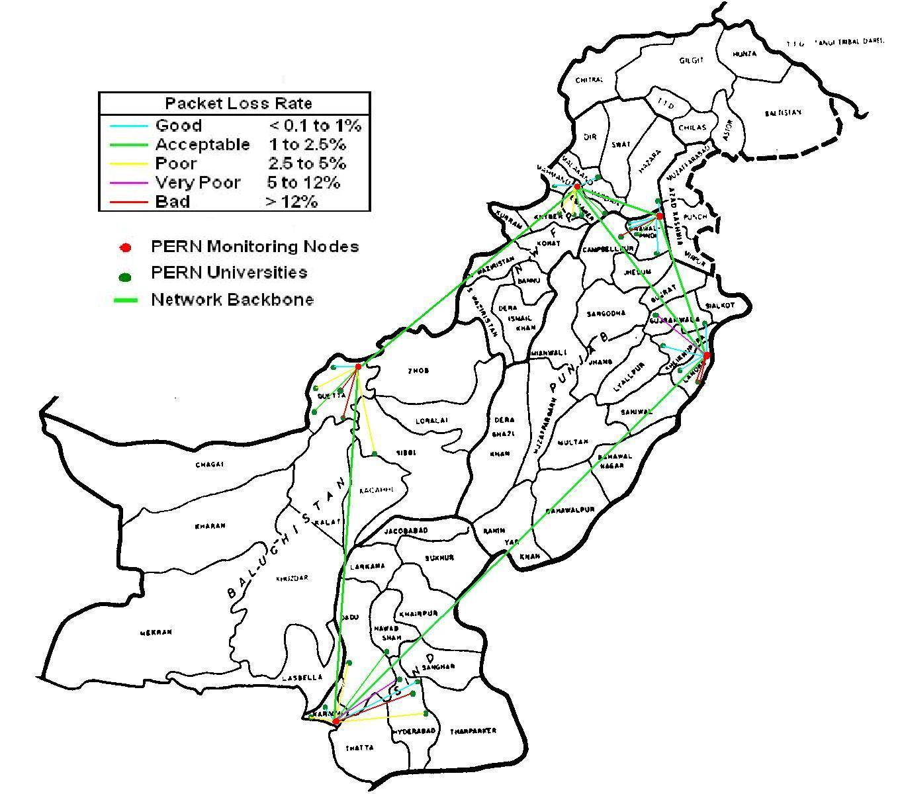
- 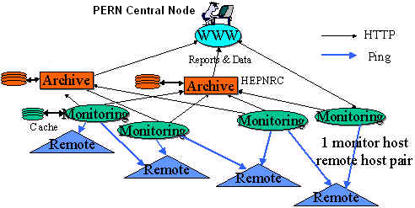Archiving & Analysis Host(s): There must be at least one each of these for each PingER project. The archive and analysis hosts maybe located at a single site, the two functions may be performed on a single host or they may be separated, different analyses may be performed on different hosts. The archive host will gather the information, by using HTTP, from the monitor hosts at regular intervals, and archive it. The archive host will provide the archived data to the analysis host(s). The analysis host provides web access to different reports obtained by analyzing the data gathered and provides tables and graphical plots of more extensive metrics going back over a longer period. Initially SLAC will provide the archive and analysis host/site for PERN. Depending on needs and expertise in Pakistan/PERN we will also evaluate and if necessary assist in setting up an archive and/or an analysis site in Pakistan.
Figure 2: Logical/conceptual architecture of PingER component of MAGGIE
Figure 1: Sites and connectivity for MAGGIE project
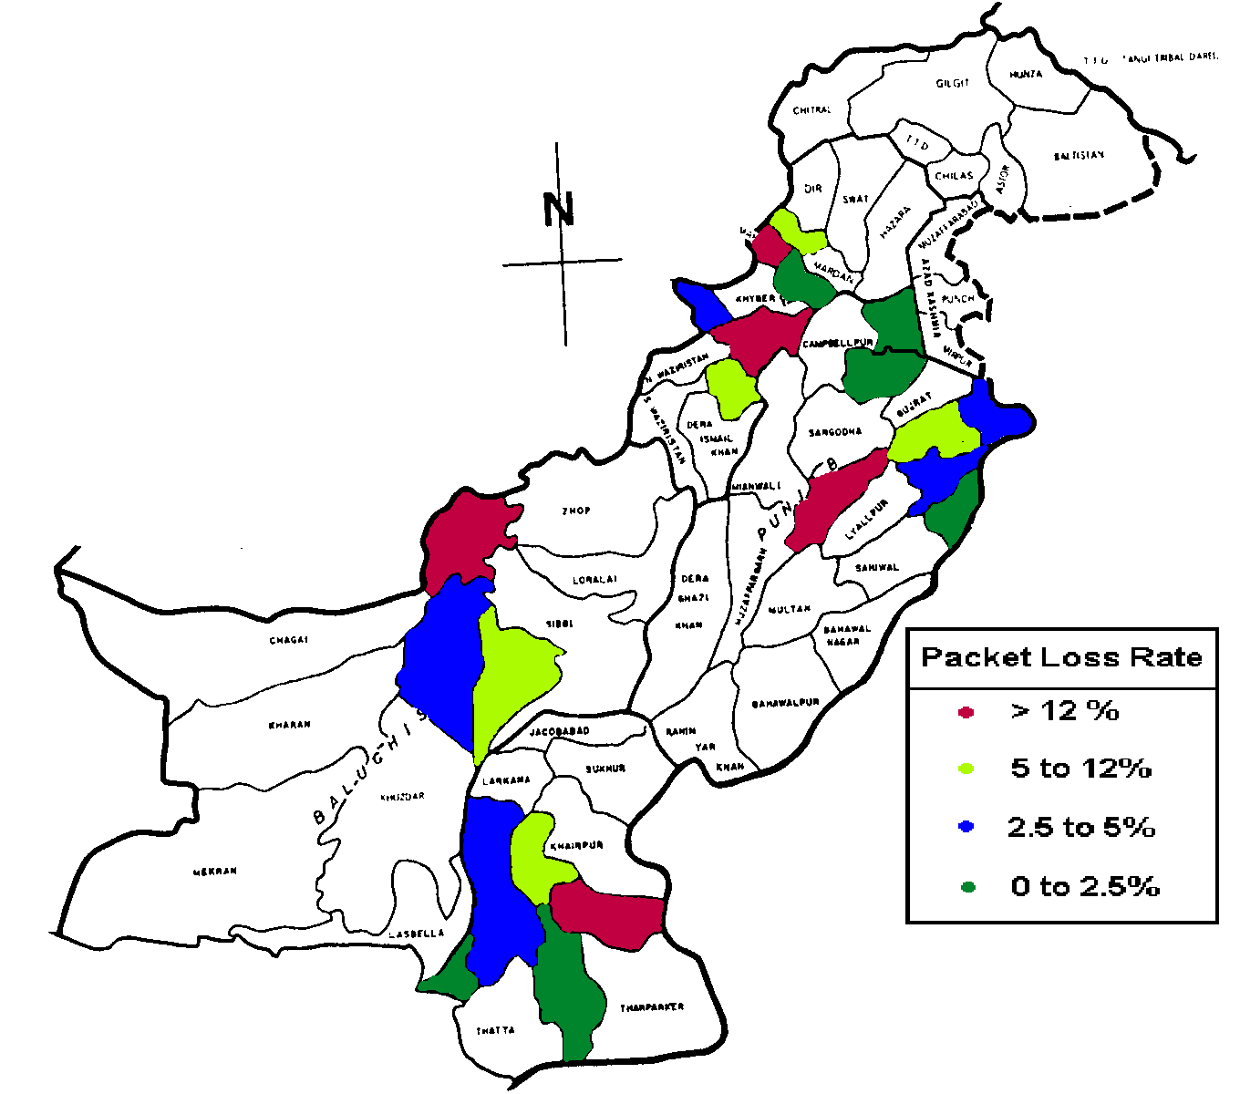
As part of the current proposal we will develop improved PingER management tools to reduce the manual work required and make the project more operationally sustainable. This will include simplifying new installations, quickly identifying and reporting hosts that are not responding, identifying bad data such as impossible values, identifying suspicious data such as similar paths reporting very different performance, checking the self-consistency of the database, providing tools to validate the location of a host using RTT measures from multiple sites to provide triangulation. We will also develop and introduce new visualization tools (see Figure 3 for an example) to automatically provide executive level reports of long-term performance improvements between regions, and provide mouse sensitive maps with drill down to further details.
Figure 3: Example of possible visualization of PingER results
IEPM-BW monitor sites are currently deployed at SLAC, CERN, FNAL, Caltech, Taiwan and BNL. They each monitor paths to sites of interest to the monitoring site. About 40 sites are monitored in about 12 countries. The speeds of the paths vary from 500kbits/s to 1Gbits/s. Currently IEPM-BW provides support for regular measurements using ping, traceroute, ABwE [5], and iperf [6], pathchirp [7], thrulay [8], pipechar [9], and bbftp [10],. As part of this project we will add support for pathneck and GridFTP [11]. The data is archived and analyzed at the monitoring host. The reports are accessed and displayed via the web. The toolkits provide for easy installation of the tools at both remote and monitoring hosts. Typically the remote hosts are undedicated and share other services. The monitoring hosts are typically dedicated to IEPM-BW.
As part of the proposal for IEPM-BW we also plan to evaluate forecasting and anomaly detection and provide better management. The forecasting will be based on work at SLAC and NIIT to use the Plateau algorithm [15] and the Holt-Winters [12] triple-exponential moving average and the Mark Burgess two-dimensional forecasting [13] techniques. We will also evaluate using PCA, the Kolmogorov-Smirnov [14], neural networks and ARMA/ARIMA [] techniques for anomaly detection. Where suitable these methods will also be developed and integrated as part of the current proposal.
In addition to using active E2E monitoring tools to gather data, we also plan to collaborate with NTC/PERN (see letter of support from NTC) to gather NTC backbone and border router interface utilization, capacity and error data using SNMP/MIBs. This will build on the work being pursued in the Internet2/ESnet/Géant PerfSONAR project. As part of the current proposal we will develop techniques to analyze and visualize this data, to provide forecasts, detect anomalies and locate and quantify bottlenecks. We will also evaluate utilizing Netflow [16] at PERN border routers to characterize border traffic for PERN sites, and to compare and complement the E2E measurements.
Briefly, this project will have a significant measurement component that will enhance and leverage existing network connectivity/performance measurement tools, bottleneck detection tools, forecasting and anomaly detection tools, and utilization monitoring services. The PingER and IEPM-BW toolkits will be deployed on hosts at PERN monitoring sites such as Islamabad-Region, Lahore-Region, Peshawar-Region and Karachi-Region. These measurement hosts will run active E2E light-weight measurement tools, including ping, traceroute, pathchirp and pathload, and more heavy weight tools such as, thrulay, iperf, and bbftp at regular intervals. The light-weight, more frequent measurements, will be used to assist in interpolating the less frequent, more heavy-weight measurement. The type of data collected by these measurements tools include round-trip-time, jitter, loss, routing information, capacity and available bandwidth, achievable throughput and file transfer rates. All the data assembled as part of the MAGGIE project will be served in the format used by the Global Grid Forum (GGF) Network Monitoring Working Group (NMWG) [17].
From the results obtained from the above architecture and procedures we will be able to identify which universities in Pakistan have poor to bad connectivity to the PERN Sites. For example, we will be able to identify which PERN sites experience good (<1% packet loss) or acceptable (< 2.5% packet loss) versus those that experience very poor to bad (>5% packet loss) and poor (> 2.5 % packet loss) connectivity (Figure 3). This information can be provided to the HEC management to assist in deciding where to focus PERN’s efforts to provide better connectivity to the universities. Using MAGGIE PingER results we can recommend ISDN/DSL/Cable Internet Service providers (ISP) that have better loss, RTT, jitter, reliability etc. for people wishing to connect to PERN from their homes/organizations. IEPM-BW information could also be utilized in scheduling for data intensive applications/middleware that need to make decision on jobs scheduling or moving/accessing data.
3(f) International Cooperation
This project will be an active collaboration involving, in Pakistan, engineers and scientists at PERN and NTC, students, researchers and teachers at NIIT together with researchers, and engineers at SLAC in California USA. The PERN and NTC experts will provide: access to network information including router utilization, guidance and follow up to problem reports, specifications for and feedback on network performance reports, collocation space and support for equipment. The NIIT students under guidance from SLAC and NIIT staff will develop, integrate, install, document and support network measurement, analysis and presentation tools, plus infrastructure management tools.
This project will also build upon, leverage and contribute to the worldwide PingER collaboration including major contributors from SLAC/California, FNAL/Chicago, ICTP/Trieste, and the UK, plus monitoring sites and contacts in over 30 countries. It will also build on the US DoE funded SLAC, BNL,/New York FNAL, U Michigan Terapaths project to provide measurements for QoS path selection. We also expect to collaborate closely with the Internet2, the U.S. Energy Science Network (ESnet) and the Pan-European Geant network PerfSONAR project to make core backbone router utilization measurements available by web services.

This MAGGIE collaboration will enable the Pakistani graduate students to work and gain valuable experience at SLAC and bring back their knowledge and expertise to benefit Pakistan/PERN network activities.
3(g) Relevance
The MAGGIE proposed project addresses the outlined objectives 1 and 3 as follows:
- It will provide opportunities for the NIIT faculty to visit the high quality research environment at SLAC and acquire the latest trends in Network and related technologies, and to take courses at Stanford University. This would enable the faculty members to gain valuable experience and promote the research culture in their classrooms, sowing the seeds of a long-term improvement in their teaching methods
- It will provide an opportunity for the Graduate and PhD Students to carry out their research work in a world class research center, thus enabling them to work with the best in the industry. This way, not only will they contribute to the development of new technologies but also share the experience and will be in a position to contribute positively to the Pakistani society and economy.
- It will enhance the capabilities of PERN to function as a network with over 56 universities throughout the country. The MAGGIE team feels that just connecting the universities is not sufficient; planning maintenance and continual improvement of service levels is also equally important, as is the ability to pro-actively respond to problems. With the team’s rich expertise in Network Monitoring and Measurement of the digital divide, the analyzed data would be highly valuable to the decision makers in the Pakistani government.
It will help understand the magnitude and nature of problems that Service Providers like NTC have in their network and enable them to provide better QoS level to their customers, thus improving the industry standards in Pakistan.
3(h) Results Statement
As a result of the first phase we will have a measurement infrastructure which will be able to provide persistent long term and yet near real-time measurement of E2E performance on the major network paths in PERN and paths accessed through PERN for example to international locations. The measurements and results will be archived, analyzed, visualized and presented via the web. The management of PingER will be much improved enabling reduced manual intervention, better quality control, higher quality data, and new visualization tools to provide executive level graphs, and mouse sensitive maps.
By the end of the second phase we will have an extended version of monitoring infrastructure which will be able to monitor high performance network paths involved in International Grid projects. The enhanced monitoring toolkit and infrastructure will focus on E2E network measurements to provide estimates of available bandwidth, achievable throughput, routing histories together with effective visualization tools. This will generate reports in the form of tabular and graphical time series, histograms and scatter plots. It will also provide computer readable reports, it will have automated tools to analyze performance data to identify performance anomalies and report them to network administrators.
As a third phase outcome we will have a toolkit to: provide appropriate access to core router interface information; analyze the router information and identify, forecast, and predict the location and magnitude of bottlenecks in the monitored network paths; detect and report anomalous network behavior using PCA techniques. We will also provide documentation and training to assist in technology transfer and reports identifying problem areas to serve as a guide for improvements.
3(i) Additional Benefits
The information provided by MAGGIE will enable the viewer (user, network administrator etc.) quickly to see long term-trends, compare the performance of various regions within Pakistan (Punjab, NWFP, Sindh and Balochistan), spot problems such as sudden unexpected changes in performance (anomalies), and provide higher level decision making information to the NTC and the HEC. Since the data archiving, analysis and visualization tools will be shared with the worldwide PingER project, this will also enable rapid comparison of how PERN is performing compared to other Academic and Research networks in developing and developed regions. A good comparison would be with the networks of partner countries in the Asia Pacific Advanced Network (APAN). The automated tools will be developed which will identify performance anomalies and report them to network administrators who can then take effective measures to improve performance. This work will enable an automated capability in PERN to improve quality of service to work around network bottlenecks. As NUST (National University of Sciences and Technology) and Quaid-e-Azam universities are already involved in Computer Grid Network collaboration with the CERN Large Hadron Collider (LHC) so this information could also be utilized in scheduling for data intensive applications which making decision of jobs scheduling or moving/accessing data.
References
- W. Matthews, R. L. Cottrell, “The PingER project: active Internet performance monitoring for the HENP community”, IEEE Communication Magazine, vol 38, issue 5 pp130-136, May 2000
- R. L. Cottrell, C. Logg, I-H Mei, “Experiences and Results from a New High-Performance Network and Application Monitoring Toolkit”, Proceedings of the Passive and Active Monitoring Workshop, 2003
- R. L. Cottrell, “Forecasting Network Performance”, presented at the Grid Performance Workshop, Edinburgh, June 22-24, 2005, available at http://www.slac.stanford.edu/grp/scs/net/talk05/predict-edinburgh-jun05.
- R. L. Cottrell, “End-to-end Anomalous Event Detection in Production Networks”, presented at the ESnet Site Coordinators meeting, Salt Lake City, Feb 2005, available at http://www.slac.stanford.edu/grp/scs/net/talk05/escc-feb05.ppt
- J. Navratil, R. L. Cottrell, “ABwE: A Practical Approach to Bandwidth Estimation”, Passive and Active Measurements 2003.
- A. Tirumala, F. Qin, J. Dugan, J. Ferguson, K. Gibbs, “iperf”, unpublished, available at http://dast.nlanr.net/Projects/Iperf/
- V. Ribeiro, R. Riedi, R. Baraniuk, J. Navratil, and L. Cottrell. “pathChirp: Efficient Available Bandwidth Estimation for Network Paths.” Passive and Active Measurement Workshop 2003
- S. Shalunov, “thrulay, network capacity tester”, unpublished, available at http://www.internet2.edu/~shalunov/thrulay/
- Jin Guojong, “Network Characterization Service (NCS)”, Proceedings of the 10th IEEE International Symposium on High Performance Distributed Computing (HPDC-10'01), page 289, 2001, also LBNL report 47982, see http://www.dsd.lbl.gov/OldProjects/NCS/
- “Bbftp: large file transfer softwarel” unpublished, see http://doc.in2p3.fr/bbftp/
- B. Allcock, J. Bresnahan, R. Kettimuthu, M. Link, C. Dumitrescu, I. Raicu, I. Foster, “The Globus Striped GridFTP Framework and Server”, Submitted to the 2005 High Performance Distributed Computing Conference (HPDC 14).
- Brutlag J.D., “Aberrant Behaviour Detection in Time Series for Network Monitoring”, Proceedings of LISA 2000, New Orleans, LA, USA, December 2000.
- Mark Burgess, “Two dimensional time-series for anomaly detection and regulation in adaptive systems”, Proceedings of 13th IFIP/IEEE International Workshop on Distributed System, operations and management (DSOM 2002). "Management Technologies for E-Commerce and E-Business Applications" Springer 2002.
- P. Brockwell and R. Davis, “Introduction to Time Series and Forecasting”, Springer New York 1996.
- Logg C, Cottrell R. L. and Navratil J., “Experiences in Traceroute and Available Bandwidth Change Analysis”, SIGGCOMM’04 Workshops, Aug 30 & Sep 3, 2004, Portland OR, USA
- Cisco netflow. http://www.cisco.com/warp/public/732/ Tech/Netflow
- B. Lowekamp, B. Tierney. R. L. Cottrell, R. Hughes-Jones, T Kielmann, M Swany, “A Hierarchy of Network Performance Characteristics for Grid Applications and Services” GGF document GFD-R-P.034, 24 May 2004. Also SLAC-PUB-10537.

3(j) Financial Support (in equivalent US $) (For First year, 2007)

 | Year 2007
Items requested | Pakistan Share |  | USA Share
Items requested | Requested | Approved | Requested | Approved
Equipment (Attach Performa invoice)
- 10 x Workstations @ US$ 1500/- each | $15,000
Intel Core Duo, Min 1 GB RAM, 80 GB HDD
- 3 x Server @ US$ 5500/- | $16,500
Dual Intel® Xeon, Min 2 GB RAM, 200 GB HDD
- 1 x Layer 3 Managed Switch @ US$ 3500/- | $3,500
Consumables
Stationary | As required
Literature Documents / Books | As required
Services (Attach Performa invoice)
High Speed Internet Services | $5,000
Travel
4 persons visit US (Tickets by Pakistan, Stay in US be be funded by US contribution) with 6 months/visit @ US$ 100 per day | $2000*4 = $8000 |  | $3000*4*6= $72,000
4 persons visit US (Tickets by Pakistan, Stay in US be be funded by US contribution) with 2 weeks/visit @ US$ 100 per day | $2000*4 = $8000 |  | $1400*4= $5,600
Do we need travel for say 1-2 SLAC people to visit Pak for 2 weeks each/year
Support personnel
Monthly Salary for 6 full-time research assistants @ Rs. 25,000/- per month ($417/month) | $2,502
Stipend for 6 part-time research assistants @ Rs. 10,000/month ($167/month) | $1,002
Miscellaneous
Support software | $4,500
Contingency | $1,000
ANNUAL TOTAL US $ | 65,004 |  | 77,600
GRAND TOTAL |  |  | 142,604

 | Year 2008
Items requested | Pakistan Share |  | USA Share
Items requested | Requested | Approved | Requested | Approved
Equipment (Attach Performa invoice)
Consumables
Stationary | As required
Literature Documents / Books | As required
Services (Attach Performa invoice)
High Speed Internet Services | $5,000
Travel
4 persons visit US with 6 months/visit @ US$ 100 per day | (($2000*4) + ($3000*4*6))/2 = $40,000 |  | (($2000*4) + ($3000*4*6))/2 = $40,000
4 persons visit US with 2 weeks/visit @ US$ 100 per day | (($2000*4) + ($1400*4))/2 = $6,800 |  | (($2000*4) + ($1400*4))/2 = $6,800
Support personnel
Monthly Salary for 6 full-time research assitants @ Rs. 25,000/- per month ($417/month) | $1,251 |  | $1,251
Stipend for 6 part-time research assistants @ Rs. 10,000/month ($167/month) | $501 |  | $501
Miscellaneous
Contingency | $500 |  | $500
ANNUAL TOTAL US $ | 54,052 |  | 49,052
GRAND TOTAL |  |  | 103,104

Items requested | Year 2009
Items requested | Pakistan Share |  | USA Share
Equipment (Attach Performa invoice) | Requested | Approved | Requested | Approved
Consumables
Stationary
Literature Documents / Books | As required
 | As required
Services (Attach Performa invoice)
High Speed Internet Services
 | $5,000
Travel
4 persons visit US with 6 months/visit @ US$ 100 per day | (($2000*4) + ($3000*4*6))/2 = $40,000 |  | (($2000*4) + ($3000*4*6))/2 = $40,000
4 persons visit US with 2 weeks/visit @ US$ 100 per day | (($2000*4) + ($1400*4))/2 = $6,800 |  | (($2000*4) + ($1400*4))/2 = $6,800
Support personnel
Monthly Salary for 6 full-time research assistants @ Rs. 25,000/- per month ($417/month)
Stipend for 6 part-time research assistants @ Rs. 10,000/month ($167/month) | $1,251 |  | $1,251
 | $501 |  | $501
Miscellaneous
Contingency
 | $500 |  | $500
ANNUAL TOTAL US $
GRAND TOTAL | 54,052 |  | 49,052
 |  |  | 103,104

US$ 142,604 (Year 1) + US$ 103,104 (Year 2) + US$ 103,104 (Year 3) = US$ 348,812

3(k) Executive Matters / Budget Requirements

i. Time table (Please indicate each major step in project evolution referring to the time schedule)
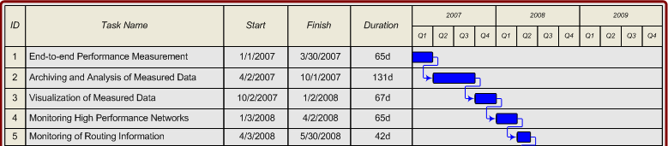
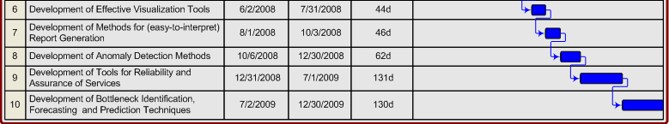
ii. Request justification (Please give detailed justification for each item requested)
Pak Side
Equipment:
In the second year of the project we will deploy the IEPM servers at PERN (Pakistan) and NIIT (Pakistan). These servers will cost around $3000 each.
Support Personnel:
Four graduate students from NIIT who will be visiting SLAC will be funded $1800 per month for one year. Every student from NIIT visiting SLAC will take a summer course at Stanford University which will cost $2000 each.
Inflations Applied:
Graduate students stipend, travel (domestic or foreign) and tuition fee are escalated by 3.5% per year.
US Side
Support Personnel:
One junior researcher, Jerrod Williams, employee of Stanford Linear Accelerator Center (SLAC) will be funded from this project for 1/3 of his Full Time Equivalent (FTE) for the first year and ¼ of his FTE for the next two years, with an escalation of 3.5% for each subsequent year of the proposal.
Miscellaneous Expenses:
The Stanford University fringe benefit rate of 30.5% for regular staff has been applied to the salary cost.
SLAC indirect costs are applied at 37% to salaries (including fringe) and Travel. All costs are escalated at 3.5% for the second and third year.
SLAC will also provide, at no cost to the current proposal/project, funding to meet the costs of supervision and leadership by Dr. Les Cottrell. We estimate the value of this funding at about $35,000 over the duration of the project.
SLAC will provide phone costs for fortnightly 90 minute meetings. We estimate the value of this to be about $6000 over the duration of the project.
SLAC is a department of Stanford University, under a Management and Operating contract with the US Department of Energy. All SLAC expenditures under this grant are incurred under the costs principles governing SLAC as outlined in the DOE/SLAC contract.
iii. Travel details (Please indicate number, during, timing and justification for the visit proposed for each side)
Pak Side:
The domestic travel money will be utilized by the Principle Investigators (PI) or graduate students to attend a conference each year to present results, meet with peers in the measurement and network community and install software/test-beds in different monitoring sites of PERN. The international travel money of $2000/each/year will be used by 4 graduate students to visit SLAC for one year. Under this travel funding two faculty members from NIIT will visit SLAC for collaborative meetings or give presentations in international conferences.
US Side:
The domestic travel money will be utilized by the Principle Investigator (PI) to attend a conference each year to present results, and meet with peers in measurement and network. Two researchers from SLAC will use travel money to visit NIIT/Pakistan for co-supervision of graduate students, give lectures/presentations and meet with PERN staff for future contributions.
iv. Additional notes (Please provide additional appropriate information, if any)

Brief CV for Dr. Roger Leslie Anderton Cottrell
Dr. R. Les. Cottrell received his BSc (Hons) in 1962 and his PhD in Nuclear Physics in 1967 from Manchester University, England. He then joined the Stanford Linear Accelerator Center (SLAC) as a research physicist in High Energy Physics, focusing on real-time data-acquisition and analysis in the Nobel 1990 prize winning group that discovered the quark. In 1972/3 he spent a year’s leave of absence as a visiting scientist at CERN in Geneva, Switzerland. In 1979/50 he spent another year’s leave of absence this time as a visiting scientist at the IBM UK Laboratories at Hursley, England. While at IBM he developed a dynamic graphical cursor that was granted United States Patent 4,688,181.
On returning from IBM UK, in 1980, he became the manager of SLAC’s computer networking. In 1982 he became the Assistant Director of SLAC’s Computer Services (SCS). From 1995-1997 he was the Acting Director of SCS. He is currently the Assistant Director of SCS and leads SLAC’s computer networking, telecommunications, and remote collaboration support groups. He is also SLAC’s representative on the ESnet Site Coordinating Committee (ESCC), the chairman of the International Committee on Future Accelerators (ICFA) Standing Committee on Inter-regional Connectivity (SCIC) Network Monitoring Working Group. He has served on many advisory groups such as for the Superconducting Super Collider (SSC), the American Institute of Physics, IHEP/Beijing, Internet2, and FNAL, as well as technical committees such as chairing the ESCC Network Monitoring Working Group, and being a member of the Global Grid Foundation’s Network Monitoring Working Group. He is also the PI of the DoE funded Internet End-to-end Performance Monitoring (IEPM) project which has attracted funding of almost $2M since 1997.
He was the leader of the effort that in 1994 established the first permanent Internet connection to mainland China. He was co-PI of teams that won the Internet2 Land Speed record twice, an achievement listed in the Guinness Book of Records (2004). He was a co-leader of teams from Caltech and SLAC and other institutes that won the prestigious SuperComputing Bandwidth Challenge three years in succession.

Brief CV for Prof. Dr. Arshad Ali
Prof. Dr Arshad Ali is a senior IT professional and academicians. He completed his PhD studies in 1992 from University of Pittsburgh, USA in the Design, Simulation and Fabrication of Optical Waveguides for Optical Computers. He has over 26 national and international publications to his credit. Dr Arshad has been awarded Pakistan Academy of Sciences and COMSTECH gold medal for IT research. Currently he is working as Dean, NUST Institute of Information Technology (NIIT), Rawalpindi.

Dr Arshad enjoys good rapport with IT industry which helped in establishment of CISCO Local Academy program, attracted donation of state of the art computer Lab from INTEL, USA and a teradata Lab from NCR Pakistan for NUST Institute of IT (NIIT).

Dr Arshad initiated research collaboration with Center for European Nuclear Research (CERN), Switzerland and earned the Associate Institute status of CMS-CERN for National University of Sciences & Technology (NUST). Dr Harvey Newman from CALTECH USA (29 faculty members include Nobel Laureates) has committed 40,000/= US dollars per year grant to strengthen this research collaboration initiative. The research collaboration with Stanford University (SLAC Project), USA has also helped in attracting 100,000/= US dollars funding from US State department.

Dr Arshad formed a joint consortium with University of the West of England UK, Beijing Institute of Technology China, University of Savoie France and NUST Pakistan which attracted 400,000/= Euro research funding from European Union. He is actively pursuing research in Distributed computing and Grid Technologies in collaboration with University of Melbourne Australia and University of Portsmouth UK. Prof. Dr Arshad is also contributing in launching of open source resource center in collaboration with Pakistan Software Export Board, Comtec (Communication Technologies) Japan and NUST, Pakistan.

