Pak-US JOINT

PROJECT PROPOSAL

- Please provide the required information briefly. Condensed statements are preferred. However, the boxes in Section 3 may be expanded as necessary. The maximum limit of the project document is 10 pages.
- Please attach one-page curricula vitae of all the participating scientists.

Project title

Measurement and Analysis for the Global-grid and PERN’s
Internet end-to-end Performance (MAGPIE)

Duration  3 Years | Starting date  January 01, 2007

PAKISTAN SIDE |  |  |  | US SIDE
Principal Investigator  Prof. Dr. Arshad Ali  NUST Institution of Information Technology |  |  |  | Principal Investigator (Lead):  Dr. Les Cottrell  Stanford University/SLAC
Date |  | Signature |  | Date |  | Signature
Address  166A, Street 9 Chaklala Scheme III  Rawalpindi Pakistan 46000 |  |  |  | Address  Stanford University/Stanford Linear Accelerator Center  2575 Sand Hill Road, MS 96  Menlo Park, CA 94025
Telephone  92-51-9280433 | Fax  92-51-9280782 |  | E-mail  arshad.ali@niit.edu.pk | Telephone  650/  926-2523 | Fax  650/  926-3329 |  | E-mail  cottrell@slac.stanford.edu
Head of Institution/Vice-Chancellor/Rector  Lt. General (R) Syed Shujaat Hussain, Rector,  National University of Sciences and Technology  Tamiz-Ud-Din Road, PO BOX 297  Rawalpindi, Pakistan  Email: rector@nust.edu.pk  Phone: +92-51-9271575, +92-51-9271576  FAX : +92-51-9271577 |  |  |  | Head of Institution/Vice-Chancellor/Rector  c/o Meredith O’Connor,  Managing Senior Contract and Grants Officer  Stanford University  Office of Sponsored Research  320 Panama Street  Stanford, CA 94305  e-mail: meredith.oconnor@stanford.edu

2. Project Summary
Title of the Project:
Measurement and Analysis for the Global-grid and PERN’s Internet End-to-end performance (MAGPIE)
Pak Side  Co-Director Prof. Dr. Arshad Ali  Institution: NUST Institution of Information Technology | U. S. Side  Co-Director Dr. Johnathan Dorfan  Institution: Stanford University/Stanford Linear Accelerator Center (SLAC)
Fortunately in recent years, Pakistan has realized that application oriented research is of primal importance with reference to the development of highly skilled human resource. The NUST Institute of Information Technology has been playing its part for more than two and a half years by maturing a collaborative research initiative with SLAC, USA. MAGPIE’s objective is to develop highly skilled human resource by conducting applied research in network monitoring and end-to-end network performance measurement. Consequently the MAGPIE endeavor involves students and professionals from both sides working on various development and research issues related to network monitoring.

A highly recommended area of application for this research is to build a “measurement infrastructure” for PERN, in which a collection of measurement hosts cooperatively measure the properties of PERN backbone paths and End-to-End (E2E) performance between the collaborating universities. This proposal aims at providing the maximum benefit to the PERN members by leveraging our expertise and extensive contacts with other measurement communities. With expected growth in bandwidths PERN will also be able to benefit from some of the more advanced tools being developed by SLAC and its collaborators. This project will position PERN/NTC to better monitor and understand the network performance. It will also enable improving the overall state of the network and better position it for expected growth in the years to come. Furthermore the system developed may be used for commercial ventures such as the measurement of Pakistan’s National Backbone, maintained by PTCL.
The motivation behind the project is the need for better and more integrated Network Performance Measurement and Monitoring, to support the inter-connection of increasing amounts of computing, storage and networking power in the scientific research community. Its purpose is to integrate numerous network and application performance monitoring tools into a scalable and secure infrastructure providing: measurements, analysis and access to data. Most of the monitoring tools being developed, derive their data from the PingER [1] or the IEPM-BW [2] projects.
By virtue of this proposal we propose to develop a ubiquitous monitoring infrastructure that would not only provide the measurements seen in multiple monitoring projects but also provide the novel addition of allowing us to co-ordinate and integrate tools in a co-operative framework.
The outcome of this project will aid the development and management of the Pakistani computer networks thus enabling advanced technologies such as voice and teleconferencing over IP, and large scale data analysis techniques for science applications. Furthermore, the proposed close collaboration between NIIT and SLAC will expose Pakistani students to world-class research to better understand and contrast the evolution and growth of different networks worldwide.
The
interdisciplinary composition of this proposal encompasses the following: computer networking, software engineering, statistical analysis, high energy physics/science and sociology.

3. Project Description
3(a) Background and Rationale
The influence of the Internet over the past two decades is unquestionable in the ability to provide unfathomable opportunities for both the education and business communities around the world. As technology progresses, we have been witnessing a segregation in the growth of network performance between 1st world and 3rd world countries [26]. Bridging the gap of this ‘digital divide’ is important to provide both economic and educational opportunities to the less developed countries. However, in order to close this gap, we first must understand and quantify it.
NIIT has been working with the Stanford Linear Accelerator (SLAC) for the last two and a half years. The NIIT-SLAC Collaboration has produced high-quality research work in the areas of Network Monitoring and Forecasting including many peer reviewed papers and invited presentations. This has resulted in the development of several tools and analysis techniques, applied particularly to the massive amount of data collected by the PingER and IEPM-BW projects.
PingER (Ping End-to-end Reporting) is the name given to the project for monitoring end-to-end performance of Internet links, developed by the Internet End-to-end Performance Measurement (IEPM) group at SLAC. The PingER project uses the ICMP echo (ping) mechanism to collect information between various end-to-end network links around the world. It utilizes ~ 100 bits/s of network traffic per monitor host – remote host pair, and thus inserts very little extra network traffic. It is thus highly suitable for measuring poorly performing links such as those often encountered for developing regions. With data going back to January 1995, over 29 monitoring sites in 15 countries around the world and over 712 remote nodes at 562 sites in 111 countries forming over 2300 pairs, PingER is arguably the most extensive (in time and space) internet monitoring effort in history. The countries monitored by PingER contain almost 90% of the total population in the world and over 99% of the world’s Internet connected population. PingER provides insight into a multitude of network activity such as the Response Time, the Packet Loss percentages, the variability of the response time both short term and longer, and the lack of reachability (no response for a succession of pings). It has aided research to understand the evolution and development of the Internet in the last 13 years.
The IEPM-BW project is complementary to the PingER project and focuses less on widespread coverage and low intrusiveness, and more on high performance and future networks interconnecting major High Energy Physics (HEP) sites such as those involved in the BaBar [31] and Large Hadron Collider [30] (LHC) experiments, as well as major Grid sites. It makes regularly scheduled direct measurements of network available bandwidth and achievable throughput as well as route topologies. The probes used can be fairly network intrusive and so are not suited to measure the Digital Divide or without careful consideration of the impact on others, however, they do provide very accurate representation of network performance for network users.
The major focus of the current proposal will be the integration of these tools and techniques to create a comprehensive network monitoring infrastructure, as well as enhancing the existing capabilities of these tools for better visualization, to provide more in-depth and accessible analysis of the gathered data, and to provide increased coverage and higher quality data.
One of the areas in which the project can contribute effectively is monitoring of the Pakistan Education & Research Network (PERN) project. PERN is planned to function as the network infrastructure basis for a worldwide compute and storage environment for the Pakistani Research community, whose nodes are expected to be utilized by the worldwide HEP community using Grid Technologies [18]. This will potentially provide access to computing resources (e.g. Grid nodes and storage) at up to 56 universities and institutes throughout Pakistan and aid in the advancement of scientific projects such as the LHC in Pakistan. PERN can be used as a test-bed for early deployment of the monitoring techniques and network applications developed as part of the MAGPIE project.

3(b) Problem Statement
To efficiently manage any network one needs to be able to measure it. This includes measuring and understanding current and long-term performance, identifying and reporting problems both end-to-end (E2E) and within the network itself, and providing forecasts of both long and near term performance. Without such information the manager lacks planning information, the users and network administrators do not know what to expect; problems are reported by the users and the network administrators spend all their time fire-fighting; locations and sizes of bottlenecks and their behavior are unknown; and users and applications are unable to dynamically optimize their network usage. This project will provide for:
- Measuring the connectivity of and the network performance between nodes throughout the world, and making the results available in presentable and useable format both on the web and in leading journals.
- Performing analysis on the vast volumes of already gathered network data from the PingER and IEPM-BW projects in order to identify the network problems and anomalies, provide trouble-shooting information, and information for planning and setting expectations.
3(c) Prior Experience / Capability
Dr. Les Cottrell has worked on network monitoring for over 15 years. He was the PI for the project that successfully installed the first dedicated Internet connection to mainland China. He is the leader of the SLAC led IEPM-BW and PingER projects. He has also focused on utilizing high-speed networks and was a leading member of teams that twice captured the Internet2 Land speed record and captured the SuperComputing bandwidth challenge for three years in succession. As the leader of the SLAC production network services group, he is also well aware of production network needs. Further as a physicist working at a major HEP and Photon Source site (SLAC) he has valuable contacts to scientists with needs for both reliable and powerful networking
Prof. Dr. Arshad has been supervising projects in the domain of Network Performance Monitoring for the last three years. Most of these projects are carried out in collaboration with SLAC USA, CERN Geneva, Caltech USA and Comtec Japan. His work mainly comprises of the development of tools for monitoring of end hosts and intervening network segments. He is the Pakistani PI of the MAGGIE (Measurement and Analysis for the Global Grid and Internet E2E Performance) collaborative effort between SLAC, USA and NIIT to integrate numerous network and application performance monitoring tools into a scalable and secure infrastructure providing means to perform measurements, and to provide analysis and access to data. He holds the unique distinction of creating active research culture and initiating international research collaborations. Over the last year, the SLAC/NIIT team has been actively working on forecasting, anomaly detection, applying Principal Component Analysis (PCA) to network measurements, and improving PingER and IEPM-BW management, analysis and visualization. The currently ongoing project MAGGIE seeks to combine these different monitoring tools into a single infrastructure.
Over the last two and a half years there has been a close collaboration between the SLAC and NIIT teams with fortnightly phone meetings and several visits of key personnel in both directions. In addition there have been many meetings involving NIIT, NTC, PERN and SLAC to define and pursue this proposal and ensure it meets real needs (see the attached letters of support). Over the last year, the SLAC/NIIT team has been actively working on forecasting [3], anomaly detection [4], event diagnosis, and improving PingER and IEPM-BW management, analysis and visualization.
3(d) Scope & Objectives
One of the primary aims of the project is to develop a lightweight yet comprehensive monitoring infrastructure for high speed networks (such as PERN) by enhancing, integrating and configuring the existing toolkits, and developing, enhancing and/or deploying new measurement tools customized to better suit the evolving bandwidth environment of Pakistan. It aims at collecting network data by deployment of the IEPM-BW and PingER infrastructures together with their tools and other tools that we will integrate into the infrastructures. From these we will provide trends and forecasts; identify and diagnose bottlenecks and performance issues present in the network by making use of the various tools. This project also aims to develop new forecasting tools to identify network anomalies. By both actively inserting well known traffic into the network, and by passively watching network traffic, we aim to validate the E2E measurements, detect backbone anomalies and bottleneck locations, and characterize site traffic.
The monitoring information will be of value to network managers and users for problem identification and trouble-shooting, planning and setting expectations (e.g. for setting and verifying Service Level Agreements) for the network. It will also assist in understanding and reducing the impact of the network on applications such as bulk-data transport, collaborative meetings, video conferencing, streaming video etc. In the later stages of the proposal, as the forecasting becomes a reliable service, we will work with Grid middleware and applications developers to enable applications to directly use the forecasts (by means of web services [19]) to steer an application for example for replica selection.
The deployment of such a monitoring infrastructure in a developing region such as Pakistan will also enable a better understanding of the digital divide both within Pakistan; between Pakistan and other developing regions such as Latin America, Africa, and Russia; and between Pakistan and developed regions. As a consequence of this understanding, it is hoped that the information will allow planners and investment into the most effective infrastructure upgrades to support the information age. It will also leverage the wealth of talent available in Pakistan to contribute towards world-class leading research in the field of network monitoring and optimization.
Our secondary, but equally important, objective is to nurture and train select NIIT graduate students to contribute to research and development of computer networks to benefit the Pakistani research and education community. Such training is critical to developing countries such as Pakistan. Homi Bhabba the famous Indian nuclear physicist put it well when he said: “What the developed countries have and the underdeveloped lack is modern science and an economy based on modern technology. The problem of developing the underdeveloped countries is, therefore, the problem of establishing modern science in them and transferring their economy to one based on modern science and technology”. More close to the current proposal, scientists cannot compete as equal partners unless they have connectivity to share data, results, and ideas. Distance education needs good communication for access to libraries, journals, educational materials, video, other teachers and researchers.
As an offshoot of this goal, students will spend time at SLAC, which is highly regarded as one of the foremost research facilities in the world; work with world class researchers; and have access to high performance computing and networking facilities not currently available in Pakistan. The training on advanced technologies and high speed networks such as ESnet and Internet2’s Abilene will facilitate growth and deployment of networks such as PERN2.
3(e) Methods
Figure 1: Sites and Connectivity for Maggie Project
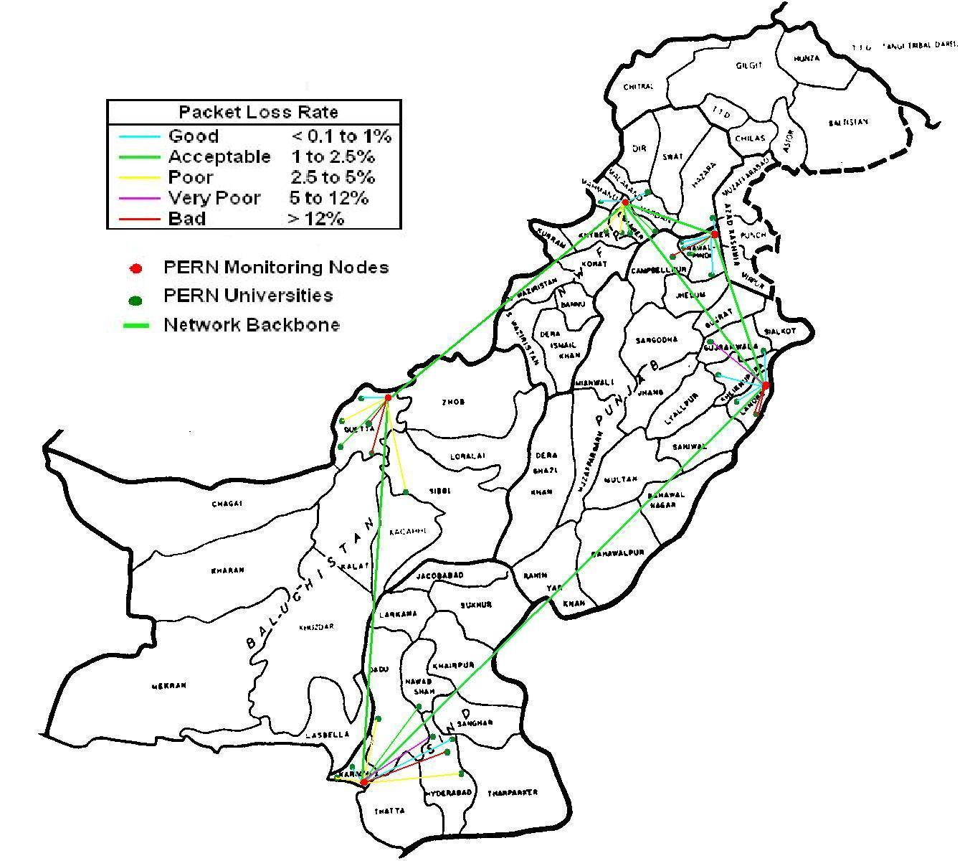
The conceptual framework of the proposal is based on the existing PingER and IEPM-BW projects developed at SLAC. Figure 1 shows a map of Pakistan with links between sites to be monitored. The PingER monitoring is based on the ubiquitous Internet ping [20] facility. It includes 3 components (see Figure 2):
- The Remote Hosts/Sites: These hosts will typically be located at universities or institutes and performance to them is measured from the PERN monitoring hosts. No software needs to be installed on the remote hosts, they need only to respond to pings. There may be multiple remote hosts at a single remote site.
- The Monitoring Hosts: The PingER monitoring tools are installed and configured on a host at each monitoring site. The installation can be done by the monitoring site personnel or centrally by PingER central administrators. The ping data collected is made available to the archive hosts via the HyperText Transport Protocol (HTTP) (i.e. there is a Web server to provide the data on demand via the Web). There are PingER tools to enable a monitoring site to be able to provide short term analysis and reports on the data it has in its local cache. Long term analyses are performed at the Analysis host(s). The load on the monitoring hosts is light and they are typically shared with other functions.
- Archiving & Analysis Host(s): There must be at least one each of these for each PingER project. The archive and analysis hosts maybe located at a single site, the two functions may be performed on a single host or they may be separated, different analyses may be performed on different hosts. The archive host will gather the information, by using HTTP, from the monitor hosts at regular intervals, and archive it. The archive host will provide the archived data to the analysis host(s). The analysis host provides web access to different reports obtained by analyzing the data gathered and provides tables and graphical plots of more extensive metrics going back over a longer period. Initially SLAC will provide the archive and analysis host/site for PERN. Depending on needs and expertise in Pakistan/PERN we will also evaluate and if necessary assist in setting up an archive and/or an analysis site in Pakistan.
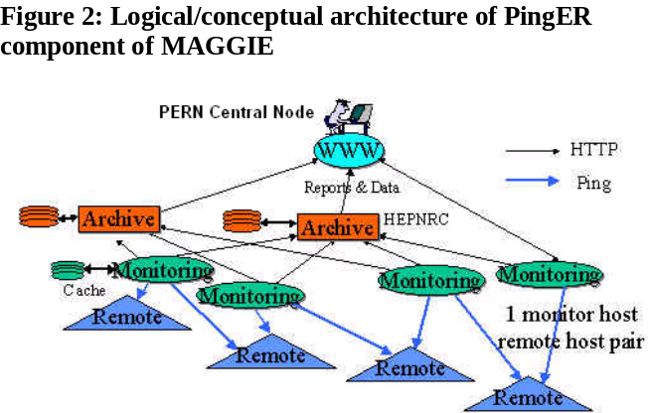
As part of this proposal we will develop improved PingER management to reduce the manual work required and make the project more operationally sustainable. This will include simplifying new installations, and providing better quality management. Quality management will be aided by automating the identification and reporting of hosts that are not responding; identifying bad data such as impossible values; identifying suspicious data such as similar paths reporting very different performance; checking the self-consistency of the database; and providing tools to validate the location of a host using RTT measures from multiple sites to provide triangulation to cross-validate results.
Figure 3: Example of possible visualization of PingER results
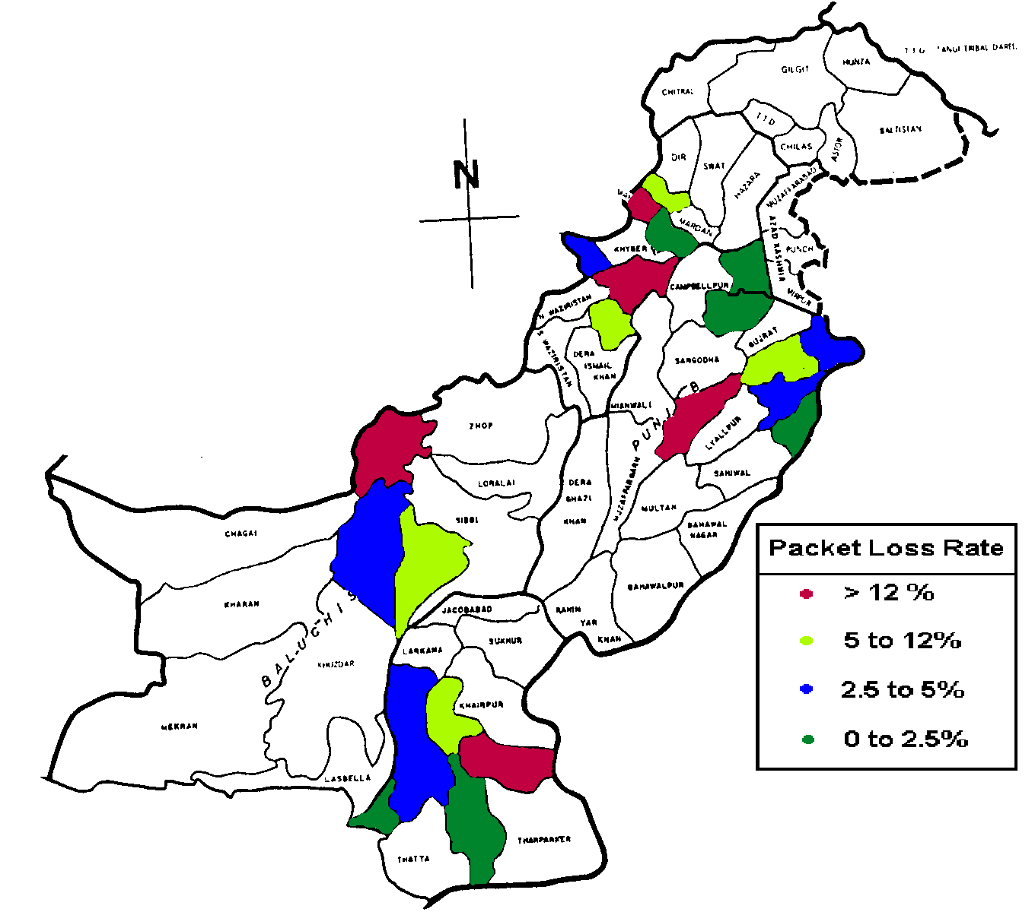
To extend the reach of the PingER measurements we will evaluate alternate non-ping based methods to enable measurements for hosts that block pings. This blocking is increasingly prevalent, often driven by security concerns, especially in developing regions. For example for the most popular (as determined by Google) university web sites in African countries bordering the Mediterranean, ~50% block pings. The security concerns typically have to do with Denial of Service attacks that utilize intense ping traffic concentrated on a target host. PingER traffic, as stated above, has been optimized to be very light and unobtrusive, so where feasible, we will also work with contacts at blocked sites to enable our traffic.
We will also develop and introduce new visualization tools (see Figure 3 for an example) to provide easily accessible methods to browse the vast amounts of data. As part of this, we will provide automatic generation of data for long-term performance improvements between regions which will be beneficial for high level reports for politicians, funding agencies (e.g. World Health Organization, World Bank, etc.) and other decision makers. As part of this, the core systems will be redesigned for efficiency and a more modular plug-in approach
IEPM-BW monitor sites are currently deployed at SLAC, CERN, FNAL, Caltech, Taiwan and BNL. They each monitor paths to sites of interest to the monitoring site. About 40 sites are monitored in about 12 countries. The speeds of the paths vary from 500kbits/s to 1Gbits/s. Currently IEPM-BW provides support for regular measurements using ping, traceroute [21], ABwE [5], and iperf [6], pathchirp [7], thrulay [8], pathload [9], and bbftp [10]. The data is archived and analyzed at the monitoring host. The reports are accessed and displayed via the web. Typically the remote hosts are undedicated and share other services. The monitoring hosts are typically dedicated to IEPM-BW. As part of this project we will add support for pathneck [22] and GridFTP [11] as we have identified them to be useful for characterizing real user network performance experiences. The toolkits will be extended to make them more modular, to provide easier (re-)installation at both remote and monitoring hosts, and provide improved management facilities. Due to the transparent nature of the Internet design it is often difficult to make sense of network paths. We will therefore also develop improved tools to enable easier visualization and analysis of Internet topologies.
As part of this proposal, we also plan to evaluate new forecasting and anomaly detection techniques and develop techniques for anomaly diagnosis. The forecasting will be based on work at SLAC and NIIT to use the Plateau algorithm [15] and the Holt-Winters [12] triple-exponential moving average and the Mark Burgess two-dimensional forecasting [13] techniques. We will also evaluate using Principal Component Analysis (PCA) [34], the Kolmogorov-Smirnov [14], neural networks and ARMA/ARIMA [25] techniques for anomaly detection. For diagnosis we will access our own data and data from multiple sources such as the Internet2/ESnet/Géant PerfSONAR project [27], host data from tools such as Ganglia and Nagios, on demand measurement tools such as NDT [28], data (and visualization techniques) from MonALISA [29]. We are already working with many of these projects and are actively sharing network performance data and analysis techniques. Where suitable these methods will also be developed and integrated into the new toolkits as part of the current proposal.
All the data assembled as part of the MAGPIE project will be served in the format used by the Global Grid Forum (GGF) Network Monitoring Working Group (NMWG) [17]. This will provide standardized web access to the data using standard XML schemas so that network performance consumers can query the extensive databases.
In addition to using active E2E monitoring tools to gather data, we also plan to collaborate with NTC/PERN (see letter of support from NTC) to gather NTC backbone and border router interface utilization, capacity and error data using SNMP/MIBs []. Such data is becoming increasingly important as link speeds increase and many E2E active measurement tools run into problems with timing, intrusivenss etc. Our work will build on the work being pursued in the Internet2 piPES and PerfSONAR projects. We will also evaluate utilizing Netflow [16] at PERN border routers to characterize border traffic for PERN sites, and to compare and complement the E2E measurements.
Briefly, this project will have a significant measurement component that will enhance and leverage existing network connectivity/performance measurement tools, bottleneck detection tools, forecasting and anomaly detection tools, and utilization monitoring services. The PingER and IEPM-BW toolkits will be deployed on hosts at PERN monitoring sites such as Islamabad-Region, Lahore-Region, Peshawar-Region and Karachi-Region. These measurement hosts will run active E2E light-weight measurement tools and more heavy weight tools at carefully optimized regular intervals. The light-weight, more frequent measurements, will be used to assist in interpolating the less frequent, more heavy-weight measurement. The type of data collected by these measurements tools include round-trip-time, jitter, loss, routing information, capacity and available bandwidth, achievable throughput and file transfer rates.
From the results obtained from the above architecture and procedures we will be able to identify which universities in Pakistan have poor to bad connectivity to the PERN Sites. For example, we will be able to identify which PERN sites experience good (<1% packet loss) or acceptable (< 2.5% packet loss) versus those that experience very poor to bad (>5% packet loss) and poor (> 2.5 % packet loss) connectivity (Figure 3). This information can be provided to the HEC management to assist in deciding where to focus PERN’s efforts to provide better connectivity to the universities. Using MAGPIE PingER results we can recommend ISDN/DSL/Cable Internet Service providers (ISP) that have better loss, RTT, jitter, reliability etc. for people wishing to connect to PERN from their homes/organizations. IEPM-BW information could also be utilized in scheduling for data intensive applications/middleware that need to make decision on jobs scheduling or moving/accessing data such as that required in large scale science applications.
3(f) International Cooperation
This project will be an active collaboration involving, in Pakistan, engineers and scientists at PERN and NTC, students, researchers and teachers at NIIT together with researchers, and engineers at SLAC in California USA. The PERN and NTC experts will provide: access to network information including router utilization, guidance and follow up to problem reports, specifications for and feedback on network performance reports, collocation space and support for equipment. The NIIT students under guidance from SLAC and NIIT staff will develop, integrate, install, document and support network measurement, analysis and presentation tools, plus infrastructure management tools.
This project will also build upon, leverage and contribute to the worldwide PingER collaboration including major contributors from SLAC/California, FNAL/Chicago, ICTP/Trieste, and the UK, plus monitoring sites and contacts in over 30 countries. It will also build on the US DoE funded SLAC, BNL/New York, FNAL/Chicago, U Michigan Terapaths project [24]. SLAC are close collaborators with the Internet2, the U.S. Energy Science Network (ESnet) and the Pan-European Geant network - we wish to extend our research to encompass this proposals efforts. For example, the widely accepted PerfSONAR project provides a common framework from which the back-end systems will facilitate the analysis and presentation methods outlined in this proposal.
A large part of funding for this proposal is to provide select Pakistani graduate students to work and gain valuable experience at SLAC and bring back their knowledge and expertise to benefit Pakistan/PERN network activities. At the same time, network efficiency and availability should increase as SLAC’s expertise in network monitoring and problem isolation is passed onto the Pakistani collaborators.
3(g) Relevance
The MAGPIE proposed project addresses the funding program’s objectives 1 and 3 as follows:
- It will provide opportunities for the NIIT faculty to visit the high quality research environment at SLAC and acquire the latest trends in Network and related technologies. This would enable the faculty members to gain valuable experience and promote the research culture in their classrooms, sowing the seeds of a long-term improvement in their teaching methods
- It will provide an opportunity for the graduate and PhD students to carry out their research work in a world class research center, thus enabling them to work with the best in the industry. It will also enable the students to take courses at Stanford University. This way, not only will they contribute to the development of new technologies but also share the experience and will be in a position to contribute positively to the Pakistani society and economy. Over the last two and a half years, SLAC has a proven track record in supervising and training Pakistani NIIT students to be productive and acquire knowledge that is both beneficial to all parties.
- It will enhance the capabilities of PERN to function as a network with over 56 universities throughout the country. The collaborators of this proposal believe that just connecting the universities is not sufficient; planning maintenance and continual improvement of service levels is also equally important, as is the ability to pro-actively respond to problems. With the team’s rich expertise in Network Monitoring and Measurement of the digital divide, the analyzed data would be highly valuable to the decision makers in the Pakistani government.
It will help understand the magnitude and nature of problems that Service Providers like NTC have in their network and enable them to provide better service level to their customers, thus improving the industry standards in Pakistan.
3(h) Results Statement
In order to meet the goals of the project to provide a network measurement system for the PERN network, hosts will first be identified at important sites around Pakistan whereby current versions of PingER will be installed to provide a measurement infrastructure which will be able to provide persistent long term and yet near real-time measurement of E2E performance on the major network paths in PERN and paths accessed through PERN for example to international locations. The measurements and results will be archived, analyzed, visualized and presented via the web. The management of PingER will be much improved enabling reduced manual intervention, better quality control, higher quality data, and new visualization tools to provide executive level graphs, and mouse sensitive maps.
Once PingER is widely deployed throughout the PERN network, we will start installation and deployment of IEPM-BW to monitor high performance network paths involved in International Grid projects. The enhanced monitoring toolkit and infrastructure will focus on E2E network measurements to provide estimates of available bandwidth, achievable throughput, routing histories together with effective visualization tools. This will generate reports in the form of tabular and graphical time series, histograms and scatter plots. It will also provide computer readable reports, it will have automated tools to analyze performance data to identify performance anomalies and report them to network administrators.
To meet the research issues of network analysis and presentation, the extension of anomaly detection methods, and network event diagnosis techniques, select Pakistani students will be offered the opportunity to work at SLAC. It is important for the students to work closely with their American supervisors to provide them with invaluable experience of working at world-class leading research facilities and also to ensure that the standard of their work is suitable for deployment. The projects are classified under Measurement and Storage, Data Analysis and Presentation and Problem Isolation and Alerting. They aim to help extend the architectural, analysis methods and suite features of PingER and IEPM-BW respectively and will provide an extensive range of tools from which in-depth network monitoring will be available.
An in-depth overview of the expected research projects is presented in Section 3(k). It is expected that the research effort will lead directly into production quality work that will be fed back into the deployed monitoring infrastructure mentioned above.
We will also provide documentation and training to assist in technology transfer and reports identifying problem areas to serve as a guide for improvements.

3(i) Additional Benefits
The information provided by MAGPIE will enable the viewer (user, network administrator etc.) to quickly to see long term-trends, compare the performance of various regions within Pakistan (Punjab, NWFP, Sindh and Balochistan), spot problems such as sudden unexpected changes in performance (anomalies), and provide higher level decision making information to the NTC and the HEC. Since the data archiving, analysis and visualization tools will be shared with the worldwide PingER project, this will also enable rapid comparison of how PERN is performing compared to other Academic and Research networks in developing and developed regions. A good comparison would be with the networks of partner countries in the Asia Pacific Advanced Network (APAN). The automated tools will be developed which will identify performance anomalies and report them to network administrators who can then take effective measures to improve performance. This work will enable an automated capability in PERN to improve quality of service to work around network bottlenecks.
Pakistan has proposed to host an LHC tier-2 computer site. NUST (National University of Sciences and Technology) and Quaid-e-Azam universities in Pakistan and SLAC in the US are already heavily involved in Network research for the CERN Large Hadron Collider (LHC) and Grid related technologies. This close collaboration with the LHC will ensure that the results of the current proposal will be applied to monitoring and improving the performance of the LHC networks for Pakistan.
References
- W. Matthews, R. L. Cottrell, “The PingER project: active Internet performance monitoring for the HENP community”, IEEE Communication Magazine, vol 38, issue 5 pp130-136, May 2000
- R. L. Cottrell, C. Logg, I-H Mei, “Experiences and Results from a New High-Performance Network and Application Monitoring Toolkit”, Proceedings of the Passive and Active Monitoring Workshop, 2003
- R. L. Cottrell, “Forecasting Network Performance”, presented at the Grid Performance Workshop, Edinburgh, June 22-24, 2005, available at http://www.slac.stanford.edu/grp/scs/net/talk05/predict-edinburgh-jun05.
- R. L. Cottrell, “End-to-end Anomalous Event Detection in Production Networks”, presented at the ESnet Site Coordinators meeting, Salt Lake City, Feb 2005, available at http://www.slac.stanford.edu/grp/scs/net/talk05/escc-feb05.ppt
- J. Navratil, R. L. Cottrell, “ABwE: A Practical Approach to Bandwidth Estimation”, Passive and Active Measurements 2003.
- A. Tirumala, F. Qin, J. Dugan, J. Ferguson, K. Gibbs, “iperf”, unpublished, available at http://dast.nlanr.net/Projects/Iperf/
- V. Ribeiro, R. Riedi, R. Baraniuk, J. Navratil, and L. Cottrell. “pathChirp: Efficient Available Bandwidth Estimation for Network Paths.” Passive and Active Measurement Workshop 2003
- S. Shalunov, “thrulay, network capacity tester”, unpublished, available at http://www.internet2.edu/~shalunov/thrulay/
- M. Jain, C. Dovrolis, “Pathload: A measurement tool for end-to-end available bandwidth”, in Proceedings of Passive and Active Measurements (PAM) Workshop, March 2002.
- “Bbftp: large file transfer software” unpublished, see http://doc.in2p3.fr/bbftp/
- B. Allcock, J. Bresnahan, R. Kettimuthu, M. Link, C. Dumitrescu, I. Raicu, I. Foster, “The Globus Striped GridFTP Framework and Server”, Submitted to the 2005 High Performance Distributed Computing Conference (HPDC 14).
- Brutlag J.D., “Aberrant Behaviour Detection in Time Series for Network Monitoring”, Proceedings of LISA 2000, New Orleans, LA, USA, December 2000.
- Mark Burgess, “Two dimensional time-series for anomaly detection and regulation in adaptive systems”, Proceedings of 13th IFIP/IEEE International Workshop on Distributed System, operations and management (DSOM 2002). "Management Technologies for E-Commerce and E-Business Applications" Springer 2002.
- P. Brockwell and R. Davis, “Introduction to Time Series and Forecasting”, Springer New York 1996.
- Logg C, Cottrell R. L. and Navratil J., “Experiences in Traceroute and Available Bandwidth Change Analysis”, SIGGCOMM’04 Workshops, Aug 30 & Sep 3, 2004, Portland OR, USA
- Cisco netflow. http://www.cisco.com/warp/public/732/ Tech/Netflow
- B. Lowekamp, B. Tierney. R. L. Cottrell, R. Hughes-Jones, T Kielmann, M Swany, “A Hierarchy of Network Performance Characteristics for Grid Applications and Services” GGF document GFD-R-P.034, 24 May 2004. Also SLAC-PUB-10537.
- I. Foster, ‘The Anatomy of the Grid: Enabling Scalable Virtual Organizations’, Springer 2001
- W3C Web Services Activity, http://www.w3.org/2002/ws/
- J. Postel, ‘Internet Control Message Protocol - DARPA Internet Program Protocol Specification’, IETF RFC 792, 1981
- Traceroute: www.traceroute.org
- Ningning Hu, Li Erran Li, Zhuoqing Morley Mao, Peter Steenkiste, Jia Wang, ‘Locating Internet Bottlenecks: Algorithms, Measurements, and Implications’, SIGCOMM 2004
- Hanemann, A., Boote, J. W., Boyd, E. L., Durand, J., Kudarimoti, L., Lapacz, R., Swany, D. M., Zurawski, J., Trocha, S., "PerfSONAR: A Service Oriented Architecture for Multi–Domain Network Monitoring", In "Proceedings of the Third International Conference on Service Oriented Computing", Springer Verlag, LNCS 3826, pp. 241–254, ACM Sigsoft and Sigweb, Amsterdam, The Netherlands, December, 2005.
- Bruce Gibbard, ‘Terapaths: MPLS based Data Sharing Infrastructure for Peta Scale LHC Computing’, DOE/MICS/SciDAC Network Research Program, August 24, 2004.
- D. Gujarati, “Basic Econometrics, 4th Edition”, published by McGraw Hill, 2004.
- R. L. Cottrell, A. Rehmatullah “January 2006 Report of the ICFA-SCIC Network Monitoring Working Group”, available at http://www.slac.stanford.edu/xorg/icfa/icfa-net-paper-jan06/
- Andreas Hanemann, Jeff W. Boote, Eric L. Boyd, Jérôme Durand, Loukik Kudarimoti, Roman Łapacz, D. Martin Swany, Szymon Trocha, Jason Zurawski “PerfSONAR: A Service-Oriented Rchitecture for Multi-Domain Network Monitoring”, ICSOC 2005: Third International Conference, Amsterdam Dec . 2005
- R. Carlson “Network Diagnostic Tool”, available at http://e2epi.internet2.edu/ndt/
- I. Legrand., H. Newman, P. Galvez, E. Voicu, C. Cirstoiu "MonaLISA: A Distributed Monitoring Service Architecture", Computing for High Energy Physics, La Jolla, California, 2003
- “LHC – The Large Hadron Collider”, available at http://lhc.web.cern.ch/lhc/
- “BaBar Public Information and Visitor Pages” available at http://www.slac.stanford.edu/BFROOT/
- “Whois” available http://en.wikipedia.org/wiki/Whois
- “Domain name system”, available http://en.wikipedia.org/wiki/Domain_name_system
- Pearson, K. “On Lines and Planes of Closest Fit to Systems of Points in Space”, Philosophical Magazine 2 (6): 559–572, 1901

3(j) Financial Support (in equivalent US $)
 | Year 2007 |  |  |  | Year 2008 |  |  |  | Year 2009
Items requested | Pakistan Share |  | USA Share |  | Pakistan Share |  | USA Share |  | Pakistan Share |  | USA Share
Items requested | Requested | Approved | Requested | Approved | Requested | Approved | Requested | Approved | Requested | Approved | Requested | Approved
Equipment
To be provided from existing resources
Consumables
Literature Documents / Books / Stationary (To be provided from existing resources)
Services
High Speed Internet Services (Provide from existing resources)
Travel
By PAK: 3 grad students visit US, (12 mo. stay in US) air tickets by Pakistan. PAK = 3 * $2,000 | $6,000 |  |  |  | $6,210 |  |  |  | $6,427
By PAK: 2 persons (NIIT faculty) visit US (Air paid and stay in US to be funded by Pakistan funding) with 2 weeks/visit @ $150 per day. 2*($2000+14*$150) for collaboration meetings at SLAC. | $8,200 |  |  |  | $8,487 |  |  |  | $8,784
By US: 2 persons (SLAC PI, researcher) visit Pakistan (Air paid by US, stay funded by Pakistan, with 2 weeks/visit @ $200/day. PAK share: = 2*( $200 * 14). US share: = 2*2000. | $5,600 |  | $4,000 |  | $5,796 |  | $4,140 |  | $5,999 |  | $4,285
Conference travel & per diem:  By PAK: 2 people (NIIT faculty) = 2*($3,000 (intl conf) + $1,000 (domestic PAK conf)).  By US: US = 2*($3000 intl conf +$2000 domestic US conf) | $8,000 |  | $10,000 |  | $8,280 |  | $10,350 |  | $8,570 |  | $10,712
Support Personnel
3 grad students/yr stay 12 mo in US, fund jointly 60:40 Pak:US (US includes 30.5% fringe benefits) | $54,000 |  | $46,980 |  | $55,890 |  | $48,624 |  | $57,846 |  | $50,326
Tuition. $3000 per student/yr | $9,000 |  |  |  | $9,315 |  |  |  | $9,641
Miscellaneous
PAK Contingency (3%) | $2,724 |  |  |  | $2,819 |  |  |  | $2,918
US Indirect Costs (15%) |  |  | $9,147 |  |  |  | $9,467 |  |  |  | $9,798
ANNUAL TOTAL US $ | $93,524 |  | $70,127 |  | $96,797 |  | $72,581 |  | $100,185 |  | $75,122
GRAND TOTAL | $163,651 |  |  |  | $169,379 |  |  |  | $175,307

3(k) Executive Matters / Budget Requirements

i. Time table (Please indicate each major step in project evolution referring to the time schedule)
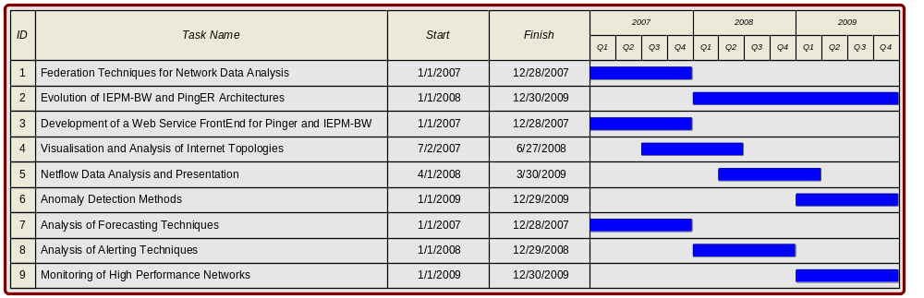
Description
Measurement and Storage: The primary focus would be to evaluate new network monitoring tools
and to extend the functionality of the PingER and IEPM-BW suites. Technologies will include relational databases, object oriented programming and service orientated architectures. Research and integration of other network monitoring systems will also be of importance. Following are the tasks planned under this
  - Federation Techniques for Network Data Analysis: The sharing of network performance data is vital in understanding the network as a whole. Projects such as perfSONAR and Internet2 piPES
provide in-depth router performance statistics, the understanding and correlation of which is of great value. Similarly Monalisa provides advanced aggregation and presentation techniques. Here the work will focus on developing such technologies in accordance to the work of IEPM to aid the effective sharing and analysis of the data.
  - Evolution of IEPM-BW and PingER Architectures: An important part in being able to provide network performance data lies in the ability for the IEPM-BW and PingER architectures to efficiently and accurately produce network performance data. However, as with all designs, the architectures need to be expanded upon to provide additional features, core systems redesign for efficiency and a modular component layout. Here the aim would be to evolve the architectures of IEPM-BW and PingER as per the change in requirements.
  - Monitoring of High Performance Networks: As PERN2 will be 10Gbps, there will be new challenges in understanding the effects of increased capacity on existing measurement tools and techniques. This task will evaluate and report on such issues and aid the selection of new measurement tools and techniques for future monitoring needs.

Data Analysis and Presentation: Using the vast amounts of network monitoring data already available, here the roles would be the mining and analysis of network performance trends and developing innovative and useful forms of data visualization. Examples include the developing web sites to accommodate and present such information with special attention to the unification and inter-machine communication of network data using XML. Technologies will include Perl/Python CGI, Application Servers and Service Orientated Architectures.
  - Development of a Web Service Front-End for Pinger and IEPM-BW: The intercommunication of network data is essential to provide access to network performance information. An essential part of this project will be to develop and implement standard XML schemas from which network performance consumers can query our extensive databases.
  - Visualization and Analysis of Internet Topologies: Due to the transparent nature of Internet design, it is often difficult to make sense of network path data. This project will focus on creating visual aids from which network performance data can be 'browsed' in a logical and consistent manner.
  - Netflow Data Analysis and Presentation: Passive monitoring will become important in the future as network speeds increase - as the action of active network testing more and more difficult. Netflow is a standardized information format from which real network traffic information from routers can be processed and analyzed. This project will investigate into the creating and presenting Netflow data with emphasis on comparison between active and passive measurement techniques.
Problem Isolation and Alerting: Using advanced mathematical techniques and algorithms, efforts would be made to isolate performance problems at both the network and compute levels. Techniques such as Holt-Winters will be used to automatically detect issues in the network and alert relevant parties of such trouble.
  - Anomaly Detection Methods & Analysis of Alerting Techniques: Some basic functionality is already in place to provide alerts within the IEPM-BW framework when performance changes occur. This project will both provide a more generic method to the automated analysis of network performance data, and also investigate and implement advanced algorithms for such analysis and reporting.
  - Analysis of Forecasting Techniques: The prediction of network performance will greatly aid large scale data replication applications. However, such techniques are currently not very well understood. This project will investigate and report upon techniques to provide reliable forecasts of network performance based upon past performance.
ii. Request justification (Please give detailed justification for each item requested)
Pak Side
Support Personnel:
Nine graduate students from NIIT who will be visiting SLAC for one year each, will be funded from the Pakistan side at $1500 per month.
Every student from NIIT visiting SLAC will take a summer course at Stanford University which will cost $3000 each.
Inflations Applied:
Graduate students stipend, travel (domestic or foreign) and tuition fee are escalated by 3.5% per year.
US Side
Support Personnel:
The nine graduate students who will be visiting SLAC for one year each, will be funded from the SLAC side at $1000 per month, escalated at 3.5% for years two and three.
Miscellaneous Expenses:
The Stanford University fringe benefit rate of 30.5% for regular staff has been applied to the salary cost.
SLAC indirect costs will be applied at 15%, following the proposal instructions, to labor costs (salaries including fringe) and Travel, although SLAC’s normal indirect rate is 39%.
Dr. Les Cottrell, head of the Network Computing group, will direct the project at SLAC (5% effort/no cost to the project). Other researchers (35% FTE/no cost to the project) will provide coordination, guidance, training and quality control and integration.
SLAC is a department of Stanford University, under a Management and Operating contract with the US Department of Energy. All SLAC expenditures under this grant are incurred under the costs principles governing SLAC as outlined in the DOE/SLAC contract.
iii. Travel details (Please indicate number, during, timing and justification for the visit proposed for each side)
Pak Side:
The domestic travel money per year will be utilized by the Principle Investigators (PI) or graduate students to attend a conference each year in Pakistan to present results, meet with peers in the measurement and network community and install software/test-beds in different monitoring sites of PERN ($2,000). The international travel money of $2000/each/year will be used by three graduate students to visit SLAC for one year, each year (i.e. a total of 9 students over the three years for this proposal, $6,000 per year). Also under this travel funding, two faculty members from NIIT will visit SLAC for collaborative meetings ($6,800 per year) and attend and give presentations at international conferences ($6,000 per year).
US Side:
The domestic travel money will be utilized by the Principle Investigator (PI) or senior researchers to attend two conferences each year ($4,000) to present results, and meet with peers in measurement and network and share needs and information. The timing of the chosen conferences will depend on when new information is available and relevant conferences are scheduled. Typically there will be a Spring and Fall meeting.
The Foreign travel money will be used in two ways. One to cover the costs of travel and per diem for the PI and senior researcher to attend conferences ($6,000 per year) to present MAGPIE results, to interact with interested parties, to make contacts for extended monitoring and needs. The second way will be for the PI and a researcher from SLAC to visit NIIT/Pakistan for co-supervision of graduate students, give lectures/presentations and meet with PERN and NTC staff for future contributions ($4,000). They will also meet with government ministers to present findings and make recommendations. These visits to Pakistan will typically be made between January and March of each year.
Travel costs have been escalated by 3.5% for years two and three.

iv. Additional notes (Please provide additional appropriate information, if any)

Brief CV for Dr. Roger Leslie Anderton Cottrell
Dr. R. Les. Cottrell received his BSc (Hons) in 1962 and his PhD in Nuclear Physics in 1967 from Manchester University, England. He then joined the Stanford Linear Accelerator Center (SLAC) as a research physicist in High Energy Physics, focusing on real-time data-acquisition and analysis in the Nobel 1990 prize winning group that discovered the quark. In 1972/3 he spent a year’s leave of absence as a visiting scientist at CERN in Geneva, Switzerland. In 1979/50 he spent another year’s leave of absence this time as a visiting scientist at the IBM UK Laboratories at Hursley, England. While at IBM he developed a dynamic graphical cursor that was granted United States Patent 4,688,181.
On returning from IBM UK, in 1980, he became the manager of SLAC’s computer networking. In 1982 he became the Assistant Director of SLAC’s Computer Services (SCS). From 1995-1997 he was the Acting Director of SCS. He is currently the Assistant Director of SCS and leads SLAC’s computer networking, telecommunications, and remote collaboration support groups. He is also SLAC’s representative on the ESnet Site Coordinating Committee (ESCC), the chairman of the International Committee on Future Accelerators (ICFA) Standing Committee on Inter-regional Connectivity (SCIC) Network Monitoring Working Group. He has served on many advisory groups such as for the Superconducting Super Collider (SSC), the American Institute of Physics, IHEP/Beijing, Internet2, and FNAL, as well as technical committees such as chairing the ESCC Network Monitoring Working Group, and being a member of the Global Grid Foundation’s Network Monitoring Working Group. He is also the PI of the DoE funded Internet End-to-end Performance Monitoring (IEPM) project which has attracted funding of almost $2M since 1997.
He was the leader of the effort that in 1994 established the first permanent Internet connection to mainland China. He was co-PI of teams that won the Internet2 Land Speed record twice, an achievement listed in the Guinness Book of Records (2004). He was a co-leader of teams from Caltech and SLAC and other institutes that won the prestigious SuperComputing Bandwidth Challenge three years in succession.

Brief CV for Prof. Dr. Arshad Ali
Prof. Dr Arshad Ali is a senior IT professional and academicians. He completed his PhD studies in 1992 from University of Pittsburgh, USA in the Design, Simulation and Fabrication of Optical Waveguides for Optical Computers. He has over 26 national and international publications to his credit. Dr Arshad has been awarded Pakistan Academy of Sciences and COMSTECH gold medal for IT research. Currently he is working as Dean, NUST Institute of Information Technology (NIIT), Rawalpindi.

Dr Arshad enjoys good rapport with IT industry which helped in establishment of CISCO Local Academy program, attracted donation of state of the art computer Lab from INTEL, USA and a teradata Lab from NCR Pakistan for NUST Institute of IT (NIIT).

Dr Arshad initiated research collaboration with Center for European Nuclear Research (CERN), Switzerland and earned the Associate Institute status of CMS-CERN for National University of Sciences & Technology (NUST). Dr Harvey Newman from CALTECH USA (29 faculty members include Nobel Laureates) has committed 40,000/= US dollars per year grant to strengthen this research collaboration initiative. The research collaboration with Stanford University (SLAC Project), USA has also helped in attracting 100,000/= US dollars funding from US State department.

Dr Arshad formed a joint consortium with University of the West of England UK, Beijing Institute of Technology China, University of Savoie France and NUST Pakistan which attracted 400,000/= Euro research funding from European Union. He is actively pursuing research in Distributed computing and Grid Technologies in collaboration with University of Melbourne Australia and University of Portsmouth UK. Prof. Dr Arshad is also contributing in launching of open source resource center in collaboration with Pakistan Software Export Board, Comtec (Communication Technologies) Japan and NUST, Pakistan.

Statements of Support

From: Dr. S. Sohail H. Naqvi [mailto:snaqvi@hec.gov.pk]
Sent: Friday, July 14, 2006 1:25 PM
To: 'Cottrell, Les'
Cc: arshad.ali@niit.edu.pk; 'Dr. Altaf Ali G. Shaikh'
Subject: RE: Pakistan-US Science & Technology Cooperative Program

Dear Dr Cottrell

This is to acknowledge receipt of your letter which I have also forwarded to Dr. Atta who is travelling in UK at the moment. I am delighted that your interaction with NIIT is growing and we certainly do look forward to your continued interest and support of HEC research initiatives along with our project to improve PERN

regards

Dr. S. Sohail H. Naqvi
Executive Director
Higher Education Commission
Sector H9
Islamabad
Tel: +92 51 444 8369
Email: snaqvi@hec.gov.pk
Website: www.hec.gov.pk

This can be reduced to ~ 10 bits/sec. for critical links.

