ANNUAL PROGRESS REPORT 2007
NUST INSTITUTE OF INFORMATION TECHNOLOGY
NATIONAL UNIVERSITY OF SCIENCES AND TECHNOLOGY

Measurement and Analysis of the Global Grid and Internet End-to-End Performance-NIIT SLAC
(MAGGIE-NS)

A collaborative research effort
BY

Stanford Linear Accelerator Center/Stanford University





NUST INSTITUTE OF INFORMATION TECHNOLOGY/NATIONAL UNIVERSITY OF SCIENCES AND TECHNOLOGY





sUBMITTED BY
pROF. dR. aRSHAD aLI

sUBMITTED TO
hIGHER EDUCATION COMMISSION, PAKISTAN.

dATED: 16TH jULY, 2007

Table of contents
Executive Summary 5
1. Terms of reference for the project 7
1.1. Project Summary 7
1.2. Project Introduction 8
1.3. Planned Project Objectives and Scope 8
2. Project Progress 10
2.1. Summary of Project Activities 10
2.1. Network Monitoring 12
2.2. The PingER Project 12
2.2.1. Pinger Management 12
2.2.2. Pinger Visualization 13
2.2.3. IEPM-BW 14
2.2.4. Importance of IEPM data 14
2.3. Major Projects Addressed by MAGGIE-NS 16
2.3.1. ViPER 16
2.3.2. Trilateration Utility for Locating IP hosts (TULIP) 19
2.3.3. Multi-route Event Detection Using PCA 22
2.3.4. End to End Event Diagnosis 22
2.3.5. SmokePing-PingER Integration 25
2.3.6. Network Weather Forecasting 31
2.3.7. Toplogical Analysis and Network Performance Visualization 41
2.3.8. PingER Executive Plots 42
2.3.9. Traceroute Change Analysis (TCA) 44
2.3.10. Other Projects 46
2.4. Case Studies 46
2.4.1 Pakistan Internal and International Connectivity 46
2.4.2. NUST Institute of Information Technology, Pakistan 46
2.5. Spin off Benefits 48
2.6. Papers and Technical Reports 48
2007 48
2006 49
2005 49
3.2. Talks 49
2007 49
2006 49
2005 50
3. Conclusion 51
3.1. Conclusions 51
3.2. Future Directions 51
4. References 53

Table of Figures

Figure 1 Screen shot showing the deployment of PingER monitoring (Blue) and remote (Red) hosts. When used interactively this map allows one to move the mouse over the host to find the name of the host 13
Figure 2 Example of pathchirp results, for minimum, average and maximum available bandwidth (thru) from iepm-bw.slac.stanford.edu to iepm-be.bnl.gov 14
Figure 3 Example of the ping average RTT between NIIT and monitored sites in Pakistan. 15
Figure 4 Multi stream iperf minimum (flow) achievable TCP throughput, maximum throughput and average throughput from iepm-bw.slac.stanford.edu to iepm-bw.cacr.caltech.edu 15
Figure 5 Iperf (single-stream achievable TCP throughput) measurement from iepm-bw.slac.stanford.edu to iepm-bw.cacr.caltech.edu 16
Figure 6 Measured achievable throughput as tlaytcp, together with rttmin, rttmax and rttavg from iepm-bw.slac.stanford.edu to iepm-bw.cern.ch 16
Figure 7 Snapshot of the PingER node deployment as shown by ViPER 17
Figure 8 ViPER interface implemented using the Google maps API 18
Figure 9 3-Dimensional representation of the PingER node deployment 18
Figure 10 Visualization presented by TULIP 19
Figure 11Statistics of the node being monitored and relevant landmarks 21
Figure 12 Event Diagnosis summary page, each row represents an analyzed event whose details can be seen by clicking on its link 23
Figure 13 Detailed results of an analyzed event 24
Figure 14 E-mail sent automatically after an event’s analysis 25
Figure 15 Visualization Enhancements made to SmokePing 28
Figure 16 Further Visualization Enhancements 29
Figure 17 Round Trip Delay Variation 30
Figure 18 Packet Success 30
Figure 19 Smokeping performance graphs showing PingER data 31
Figure 20 HW forecasts of ABwE data from SLAC to Indiana. The blue dots are the measurements, the blue line shows the smoothed measurements to help guide the eye. The magenta line shows the HW forecast and the black lines show the expected variation 32
Figure 21 Snapshot of data processing module for data extraction 34
Figure 22 Snapshot of data processing module for regularization process 34
Figure 23 Snapshot of forecasting module for parameter selection 35
Figure 24 Snapshot of forecasting module for plotting selected parameter 35
Figure 25 Snapshot of forecasting module for correlogram at levels 36
Figure 26 Snapshot of forecasting module for correlogram at 1st difference 36
Figure 27 Snapshot of forecasting module for order estimation 37
Figure 28 Snapshot of forecasting module for forecast and its plot 37
Figure 29 Plot of data used for forecasting 38
Figure 30 Forecasting results of HW and ARMA/ARIMA techniques 38
Figure 31 Snapshot of diagnostic check module for residuals plot 39
Figure 32 Snapshot of correlogram of residuals 40
Figure 33 Snapshot of Portmanteau test performed on residuals 40
Figure 34 WAN/LAN Topology Discovery 41
Figure 35 Bandwidth Measurements for the observed Topology 42
Figure 36 Loss quality as seen from SLAC – an example of PingER Executive Plots 43
Figure 37 Time series plot with route changes indicated 44
Figure 38 Screen shot of part of a traceroute summary web page with summary table 45
Figure 39 Median packet loss from 3 hosts in Rawalpindi to Pakistani sites 47

Executive Summary

The growth in Distributed and Network Systems provokes the challenge of developing a lightweight and reliable monitoring infrastructure, appropriate for bandwidth constrained environments such as Pakistan. MAGGIE-NS steps up to the task of developing and deploying solutions related to Network Monitoring, Network Troubleshooting, Capacity Planning and Auditing, Grid Scheduling and Evaluation of experimental networking components. MAGGIE-NS primarily aims at deploying a suitable monitoring infrastructure at NIIT and hosts in other developing countries, which is robust enough to be comparable to other monitoring infrastructures around the world, yet lightweight enough to generate minimal traffic on the already congested links. In order to solve these problems, the MAGGIE-NS project has made extensive improvements, and extended the deployment and use of two major network monitoring infrastructures developed by the SLAC Internet End-to-end Performance Monitoring (IEPM) team: PingER and IEPM-BW. As a consequence several network monitoring, event detection, diagnosis and analysis software tools have been developed and have been made available in the public domain (http://maggie.niit.edu.pk).
Since the deployment of a PingER monitoring host in Pakistan, several developments have been made as a consequence of collaboration with NIIT. These range from enhancement in the coverage of PingER by including further monitoring hosts in Pakistan (at PERN, COMSATS and Quaid-i-Azam Universtiy’s National Computing Center (NCP)) South Korea, Japan, etc., improvements in visualization of the software providing global network monitoring information provided by PingER and analysis of data, integration of PingER with network monitoring tools/infrastructures such as SmokePing and AMP to development of software for real-time monitoring of network performance using PingER.
IEPM-BW was developed/deployed to provide active End-to-End (E2E) application and network measurements to assist with detailed diagnostics about the network, gathering parameters like link bandwidth (available and utilized) and routing information etc. The MAGGIE-NS project facilitated the installation of IEPM-BW at NIIT; making NIIT the first IEPM-BW node outside Europe and North America. IEPM-BW and PingER together help in understanding the routing and congestion problems in the country’s network.
In this report, the various independent student projects are also discussed which have contributed in identifying network anomalies and either support or make use of data provided by IEPM-BW and PingER.
TULIP (IP Locator Using Triangulation) is a project to generate pings from various landmark sites around the world to an unknown target IP location, in order to correctly determine the geographical location of that particular IP, by estimating the Great Circle Distances (GCDs) derived from minimum Round Trip Time (RTT) measurements.
Network Weather Forecasting is used to predict the behavior of the network by extrapolating various parameters. It enables the network administrators and stakeholders to visualize the expected behavior of the network based on its history. Implementation of various forecasting and anomaly detection algorithms has been carried out to detect significant, persistent anomalous events in real E2E Internet Performance measurements. Besides active probing, methods for passive monitoring and anomaly detection are also being investigated in order to ensure addition of minimal traffic on the internet. Progress has been made on detecting network anomalies using Principal Component Analysis and algorithms of Auto Regression and Moving Averages. The results of this analysis are very encouraging especially given its ability to simultaneously look at multiple paths and multiple metrics.
Internet connectivity for Pakistan has significantly improved since the inception of MAGGIE-NS. However, the consumers still face network congestions due to last mile effects. As a consequence of the case-studies conducted under MAGGIE-NS, we were able to pin-point the reasons for network congestion and provided significant feedback to Internet Service Providers such as Micronet Broadband/Nayatel inc which was highly appreciated. Later suitable counter measures were taken to deal with bottleneck issues to the maximum extent possible. These steps also provided an opportunity to study the overall network infrastructure of Pakistan in general, and NIIT in particular. We also identified and reported that the overall quality of service experienced by Pakistani universities is poor. This analysis has been shared with and appreciated by the Higher Education Commission (HEC), as well as Pakistan Education and Research Network (PERN).
The MAGGIE-NS project opened the doors for the research community at SLAC to identify and understand the issues in the network infrastructure of Pakistan. However, the contributions are much beyond the bits and bytes. The culture of research that has been established at NIIT, with SLAC playing its due part, has been phenomenal in the overall growth of the institution. The cross visits by the researchers at SLAC and students and faculty at NIIT has proved extraordinary in enhancing the vision and expertise of these individuals. These experiences will have a very beneficial impact on understanding and improving the performance of Pakistani networks, proving understanding for support people and researchers, help sparking an Information and Communication Technology (ICT) revolution in the country, and benefit Pakistani society by leveling the connectivity playing field and improving access to knowledge.
MAGGIE-NS project has resulted in publication of five research papers, three reports and nineteen talks and presentations ranging from Network Problems to the quantification of the digital divide. It is hoped that the extension of MAGGIE-NS and a more focused proposal on the network infrastructure for PERN, called MAGPIE (Measurement and Analysis for the Global-grid and PERN’s Internet end-to-end Performance) will be funded so that the promising work initiated can be fully utilized for the benefit of Pakistan as well as the United States of America.

1. Terms of reference for the project

1.1. Project Summary
- Project title: Measurement and Analysis of the Global Grid and Internet End-to-End Performance-NIIT SLAC (MAGGIE-NS).
- Duration: 3 years.
- Starting date: September 2004.
- Field of Investigation: Internet Communications; Network Performance Measurement and Analysis.
- Project website: http://maggie.niit.edu.pk
- Principal Investigators:
Dr. Roger L. A. Cottrell
Assistant Director
SLAC Computing Services
Stanford Linear Accelerator Center (SLAC),
USA
cottrell@slac.stanford.edu

Prof. Dr. Arshad Ali
Director General
NUST Institute of Information Technology (NIIT),
Pakistan
arshad.ali@niit.edu.pk

- Personnel involved
NIIT | SLAC
- Mr. Umar Kalim  - Dr. Waqar Mehmood*  - Mr. Ejaz Ahmed*  - Mr. Azher Amin*  - Mr. Ahsan Chaudry*  - Mr. Adnan Iqbal+  - Mr. Aziz Allaudin*+  - Mr. Fawad Nazir*+  - Mr. Qasim Bilal  - Mr. Ahmad Hassan  - Mr. Faran Javed  - Ms. Fareena Saqib*  - Ms. Asma Shamshad*  - Mr. Fahad Ahmed  - Mr. Nauman Shah  - Mr. Raja Asher*  - Mr. Waqar Ali*  - Ms. Rabail Javed* | - Dr. Yee Ting Lee  - Ms. Connie Logg  - Mr. Asif Khan+  - Mr. Shahryar Khan+  - Mr. Akbar Mehdi+  - Mr. Jerrod Williams+
* Alumni
+ NIIT graduate students working (or have worked) at SLAC as Research Assistants

1.2. Project Introduction
Scientific research has greater computing and networking power than ever before, but it is recognized in the scientific community that the increases in power also bring with them major challenges. The deployment of Grid technologies and a production quality Grid Service requires detailed information on network performance. It is widely believed that what is needed is to develop a ubiquitous monitoring infrastructure that would not only provide access to the measurements seen in multiple monitoring projects but also provide the novel addition of allowing us to co-ordinate and integrate tools in a co-operative framework. Such a requirement is particularly needed in Pakistan since it has initiated and is collaborating in a number of Grid computing projects such as the National University of Sciences and Technology (NUST [1]) and Quaid-e-Azam University [2] involvement in the CERN Large Hadron Collider (LHC) Computing Grid (LCG) collaboration [3]. In addition, proposals have been submitted to develop an e-education and distance learning environment in Pakistan. Looking at the growth in the Grid Technologies, MAGGIE-NS proposed to integrate numerous network and application performance monitoring tools into a scalable infrastructure providing measurements, analysis and access to data. This enables us to gather useful data from different network monitoring and measurement tools in a closer to real-time manner for analysis. This data gathering could be utilized to address the above mentioned Grid needs as well as to: quickly see long term-trends; compare the performance of different world regions; spot problems such as sudden, significant, unexpected changes in performance (anomalies); set expectations (for example do Pakistan Research and Education sites have adequate network infrastructure to participate in LHC Computing Grid activities); and provide higher level decision making information for upper level management.

1.3. Planned Project Objectives and Scope
The major objectives of the MAGGIE-NS project were to propose and deploy solutions related to Network Monitoring, Network Troubleshooting, Capacity Planning and Auditing, Grid Scheduling and Evaluation of experimental networking components.
The objective of network troubleshooting is to quickly detect and report troubles and to provide information as to the magnitude of the trouble, when and where it occurred and details to assist in diagnosis, isolation and by-pass. This requires continuous monitoring, archiving and analysis of the data to determine normal behavior and to identify and locate anomalies in time and space.
Network monitoring data is necessary for capacity planning, so that resources are readily available when needed, and in order to prevent bottlenecks. Monitoring data is also needed to set realistic performance expectations and to define measurable service level agreements that can be agreed upon by the providers and users. Once the service level agreements are in place, monitoring is required to audit and ensure that the service level agreements are being met.
Nodes in Grid Computing are spread across the globe and scheduling the jobs on different Grid nodes requires comprehensive monitored data; for instance in order to provide optimal network access to data repositories and other resources, decision making based on the network monitoring data. The purpose of the project was to provide the data in a format which could be accessed by the Grid Services and used for decision making in scheduling the Grid related jobs.
Evaluation of networking components is an important factor of network reliability and performance. So the network monitoring data being collected could be used for evaluation of: new protocols for very high-speed and low-speed networks, new network interface card (NIC) features, large maximum transfer units (MTUs), optimal configuration parameters (such as window sizes and number of parallel streams) etc.

2. Project Progress

2.1. Summary of Project Activities
 | ACTIVITY | START DATE/ DURATION | STATUS/REMARKS
1 | Ping End-to-End Reporting (PingER) | October 2004 /3 years | Planned objectives achieved. Improvements in the deployment procedures made. Coverage increased. Further enhancements in progress.
2 | Internet End-to-End Performance Measurement (IEPM) | October 2004 / 3 years | Planned objectives achieved. Further enhancements in progress.
3 | TULIP: Trilateration Utility for Locating IP hosts | December 2004 / 3 years | Planned objectives achieved. 2 prototypes released and deployed at NIIT and SLAC. Evaluation of effectiveness in progress. Production quality software under development.
4 | Topological Analysis and Network Performance Visualization | March 2005 / 1 year | Planned objectives achieved. Production quality software released and deployed at NIIT.
5 | Anomaly Detection Using Principal Component Analysis | January 2005 / 1 year | Planned objectives achieved. Production quality software released and deployed at SLAC.
6 | PingER Visualization | October 2005 / 8 months | Planned objectives achieved. Production quality software released and deployed at SLAC.
7 | Evaluation of Techniques to Detect Significant Network Performance Problems using End-to-End Active Network Measurement | January 2005 / 1 year | Planned objectives achieved. Techniques developed are being utilized in other projects.
8 | NWF: Network Weather Forecasting (using Holts-Winter) | March 2005 / 8 months | Planned objectives achieved. Techniques developed were using for further research in the project NWF using ARMA and ARIMA.
9 | Traceanal: Trace route analysis | March 2005 / 8 months | Most of the planned objectives were achieved. However production quality software has not been released due to lack of human resource.
10 | End to End Event Diagnosis | January 2005 / 1 year | Planned objectives achieved. Production quality software released and deployed at SLAC.
11 | AMP PingER Integration | March 2006 / 1 year | Most of the planned objectives were achieved. However production quality software has not been released due to termination of the AMP project by NLANR.
12 | ViPER: Visualization for PingER | March 2006 / 8 months | Planned objectives achieved. Prototypes released. Production quality software released and deployed at NIIT and SLAC.
13 | NWF: Network Weather Forecasting (using ARMA/ARIMA) | March 2006 / 11 months | Planned objectives achieved. Prototypes released. Production quality software released and deployed at NIIT.
14 | Federation: SmokePing, PingER Integration | March 2006 / 11 months | Planned objectives achieved. Prototypes released. Production quality software released, integrated with PingER and deployed at SLAC.
15 | PingER Executive Plots | March 2006 / 6 months | Planned objectives achieved. Production quality software released and deployed at NIIT and SLAC.
16 | PingER Management | March 2006 / 6 months | Planned objectives achieved. Production quality software released integrated and deployed at NIIT and SLAC.
17 | IEPM Visualization | March 2007 / 1 year | In progress
18 | Topology Service for PerfSONAR | March 2007 / 1 year | Preliminary results available. Project in progress.
19 | DataGrid WAN Monitoring Infrastructure (DWMI) Terapaths Monitoring Project | March 2007 / 1 year | Preliminary results available. Project in progress.

2.1. Network Monitoring
Current Grid applications typically are able to use a much smaller percentage of available network bandwidth than expected. Whereas the application developers often blame the network as a problem for poor application performance, network engineers typically point to host issues or poor application design. Network monitoring services are necessary to identify and resolve the network issues and verify whether the network is in fact the source of the problem. Discovering and fixing Grid application configuration and performance problems is a challenging task. Problems can manifest themselves in many shapes and forms; making it difficult even for the experienced network engineers and application developers to understand the extent of such problems.
The MAGGIE-NS project has made extensive improvements, and extended the deployment and use of two major network monitoring infrastructures to assist in tackling the above challenges, The infrastructures are PingER and IEPM-BW.

2.2. The PingER Project

As part of MAGGIE-NS, PingER [4] was installed as a monitoring host in Pakistan (at NIIT), India, South Africa, Brazil, Bolivia, South Korea, Japan, Taiwan, and China. In addition the coverage of remote sites monitored was extended by about 20% to 673 and the countries monitored by about 10% to 125. The aim was to improve the overall understanding of the network performance within and from Digital Divide regions and in particular, Pakistan.
Since PingER measurements [5] add very little network traffic (< 100bits/s on average per monitor-remote host pair) it can be very effectively used for monitoring low-performance links such as those available to, within and between developing countries and regions such as Pakistan, India, Russia, Latin America, and Africa where the network infrastructure is less advanced. With the installation of PingER monitoring sites in Pakistan, India, Brazil, Russia and South Africa, the PingER/MAGGIE-NS project has made significant advances on quantifying the Digital Divide in terms of Internet performance [6]. The addition of about a dozen monitored remote sites in Pakistan has also enabled a more detailed study of the connectivity within Pakistan.

2.2.1. Pinger Management
Since its inception, the size of the PingER project has grown to where it now monitors hosts in over 130 countries from about 40 monitoring hosts in 14 countries. With the growth in the number of monitoring as well as monitored (remote) nodes, it was perceived that automated mechanisms need to be developed for managing this project. The following modules for PingER management project have been developed at NIIT/SLAC as part of the MAGGIE-NS project:
- Creation of filters to indicate the monitoring sites whose data is not available
- Creation of filters to indicate the monitored sites that are not available and categorize them according to their response status, how long not accessible etc.
- Identification of misplaced hosts, for example:
  - a host that physically moves to a new location (e.g. a host of a company that is bought up keeps its name but moves to a new site, or a host for a show that moves from site to site)
  - a host name that is replicated at multiple sites for better access (e.g. an Internet root name server, yahoo.com)
  - a server in one country’s top level domain but it is actually is a proxy in another country (e.g. many African web servers have proxies in N. America or Europe).
- Automated report generation tool to generate daily, monthly, yearly reports regarding problems in monitored data.
- Detect sudden, significant, persistent, anomalous changes in the behavior (including breaks in reachability) of the network.
- Identifying discrepancies (e.g. impossible values) in measured data and in the host configuration databases (e.g.; at the time of registration of the monitored hosts, the data entered might be incorrect and incomplete).

2.2.2. Pinger Visualization
To assist in visualizing and accessing PingER data, the MAGGIE-NS project has improved the storage of configuration data by converting to an Oracle database and adding several new fields of information per host. This in turn has enabled us to develop mouse sensitive maps that graphically illustrate the deployment of PingER.
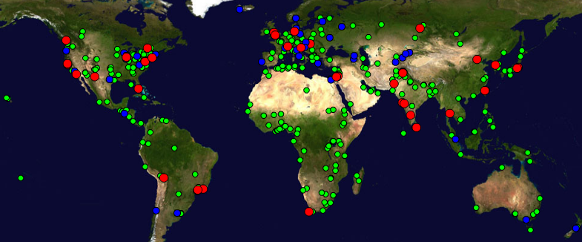
Figure 1 Screen shot showing the deployment of PingER monitoring (Red), remote (Green) and beacon (Blue) hosts. Beacons hosta are special remote hosts that are mopnitored from most monitoring hosts When used interactively this map allows one to move the mouse over the host to find the name of the host
MAGGIE-NS has developed several scripts to assist in the creation of executive level figures showing aggregations of performance by regions, correlations vs. populations etc. Prior to developing these scripts, creating such figures was very labor intensive. The MAGGIE-NS project has also been involved with Integration of PingER with the existing network monitoring software and visualizations and also plans on integrating the display of the PingER data with MonALISA [7] to enable more close to real-time display of the data by a monitoring node. This will be a significant improvement over the current simple tabular display functionality for real time information.

2.2.3. IEPM-BW
The primary task of the IEPM-BW [8] project was to develop/deploy a simple and robust, ssh based active End-to-End (E2E) application and network measurement and management infrastructure. The IEPM project that was funded by the DOE/MICS base program has the goal of providing Internet E2E active performance monitoring for planning, setting expectations, problem identification trouble-shooting, and networking research. The MAGGIE-NS team has deployed IEPM-BW at BNL, CERN, FNAL, Caltech, FZK, SLAC, TWAREN, NIIT and NCP. The first six are aimed at the High Energy Physics (HEP) CERN/LHC, FNAL/CDF/D0, Caltech/LHC/CMS, FZK/BaBar/LHC and the SLAC/BaBar/LHC/ATLAS experiments. The NIIT and NCP installations are important not only for understanding the connectivity of NIIT and NCP and Pakistan with the rest of the world. TWAREN is a National Research and Engineering Network (NREN) in Tawian.

2.2.4. Importance of IEPM data
PathChirp: As part of the MAGGIE-NS project, IEPM-BW has been extended to support PathChirp [9]. This is a packet pair dispersion technique for measuring available bandwidth. Due to its improved accuracy [10] compared to ABwE [11], focus is now on PathChirp to dynamically estimate the available bandwidth along an E2E network path from several monitoring sites to other remote sites.
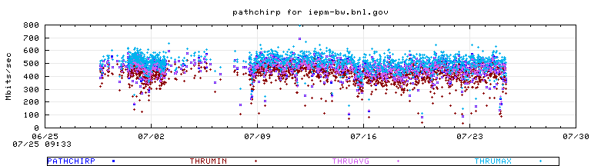
Figure 2 Example of pathchirp results, for minimum, average and maximum available bandwidth (thru) from iepm-bw.slac.stanford.edu to iepm-be.bnl.gov
Traceroute: Traceroute provides a hop by hop list of the routers along the path and the RTT to each router. Visualization of traceroute is described in section to follow.

Ping: The main information provided by ping is the reachability, packet loss and RTT. RTT information is obtained in IEPM-BW using Ping measurements. Jitter can also be obtained from the RTT measurements. An example of ping RTT time series is shown in Figure 3. The measurements are made at regular 10 minute intervals. Looking at the average RTT results seen in Fig.3, there is a lot of variability even for a single site (NIIT), typically ranging from 150-400ms for the NIIT NTC/PERN host and 80-180ms for the NIIT Micronet host, and the data points for each remote host track one another closely. This indicates a common point of congestion. The NTC host results are fairly flat for each remote host, thus indicating little congestion. One can also see that the performance to the NIIT NTC/PERN connected host from NTC and from NIIT via Micronet is more variable and poorer than for the other Pakistani sites. This would appear to indicate that the congestion is located close to or at the NIIT site.

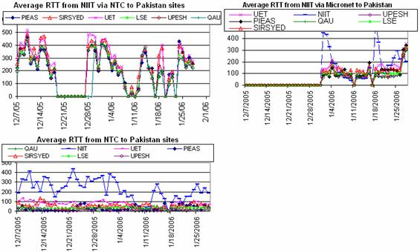
Figure 3 Example of the ping average RTT between NIIT and monitored sites in Pakistan.
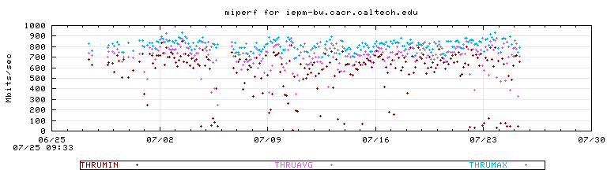
Figure 4 Multi stream iperf minimum (flow) achievable TCP throughput, maximum throughput and average throughput from iepm-bw.slac.stanford.edu to iepm-bw.cacr.caltech.edu
Iperf: Iperf [12] is a tool that used to measure TCP achievable throughput. It allows the tuning of various parameters such as window size and number of parallel streams. In IEPM-BW iperf with a single stream and with multiple streams (miperf) are run to measure TCP achievable throughput.
Thrulay TCP: As part of the MAGGIE-NS project IEPM-BW has been extended to support thrulay [13] TCP achievable throughput and RTT measurement tool. It is used to measure the capacity of a network by sending a bulk TCP stream over the path. Thrulay can report the TCP achievable throughput and RTT at intervals (e.g. 1 second) during its measurement duration. It is also more robust and easier to manage than iperf.

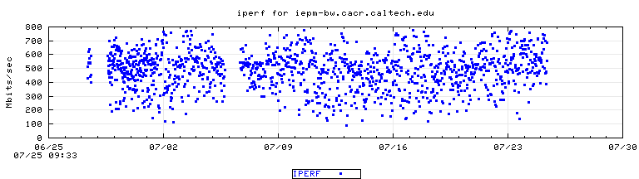
Figure 5 Iperf (single-stream achievable TCP throughput) measurement from iepm-bw.slac.stanford.edu to iepm-bw.cacr.caltech.edu
In Figure 6, the measurement durations were 15 seconds and the rttmin etc. are the minimum, average and maximum of the 15 one second intervals at which RTT was reported. It shows the achievable throughput from SLAC to CERN.
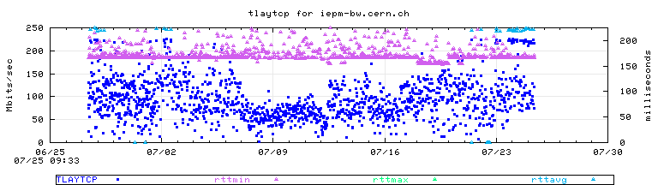
Figure 6 Measured achievable throughput as tlaytcp, together with rttmin, rttmax and rttavg from iepm-bw.slac.stanford.edu to iepm-bw.cern.ch

2.3. Major Projects Addressed by MAGGIE-NS

2.3.1. ViPER
ViPER [14] (Visualization for PingER) is an interactive Java application developed by the MAGGIE-NS team. The purpose is to visually present the location and meta-information for all the PingER nodes on the world map, show links and their performance between PingER Monitoring and Remote nodes and provide visual representation of all the data monitored by PingER.

2.3.1.1 Project Objectives
- Provide a global view of all the PingER monitoring, remote and beacon nodes
- Display detailed information about each node
- Provide statistics about total number of monitoring, remote and beacon nodes
- Graphically show links between monitoring nodes and remote hosts
- Save all the analysis information
- Draw graphs of various network parameters such as RTT, Packet loss etc
- Calculating physical distance between nodes
- Show plots of multiple metrics
- Give information about PingER down sites
- Development of PDA (Handheld) Client
- Color links according to TCP throughput

2.3.1.2. Project Description
Visualization of PingER (Viper) is an innovative Java-based interactive visualization application for the PingER Internet monitoring project. This presents the user with a zoomable and panable 2D or 3D map of the world, with the PingER monitoring and remote sites identified. The application is being ported to handheld computers.
With the wide deployment of PingER (over 600 sites in over 125 countries) ViPER provides an extremely valuable, eye-catching, overview of PingER's deployment and the performance between various regions of the world.
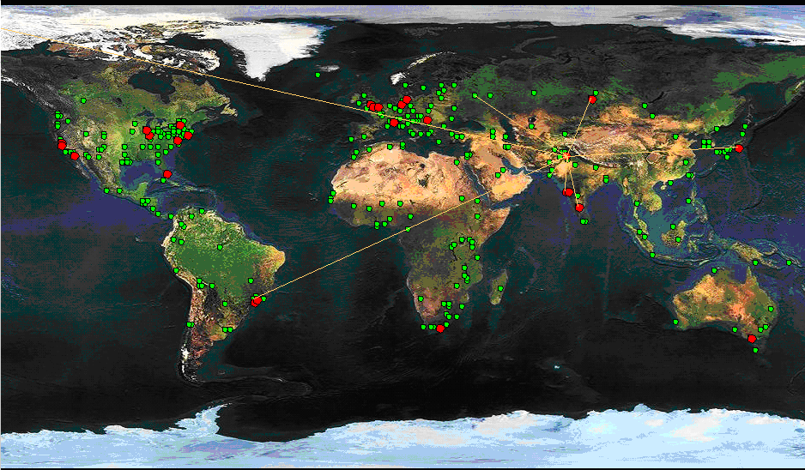
Figure 7 Snapshot of the PingER node deployment as shown by ViPER showing links from NIIT to various other sites.
Since PingER is focusing on mapping the Digital Divide, it desperately needs simple to use, graphically engaging tools such as ViPER to grab the attention of executives and senior management at funding agencies, and NGOs. ViPER also is valuable to the management of PingER since it quickly identifies PingER database errors (e.g. hosts with incorrect latitude/longitude) enabling better quality control.
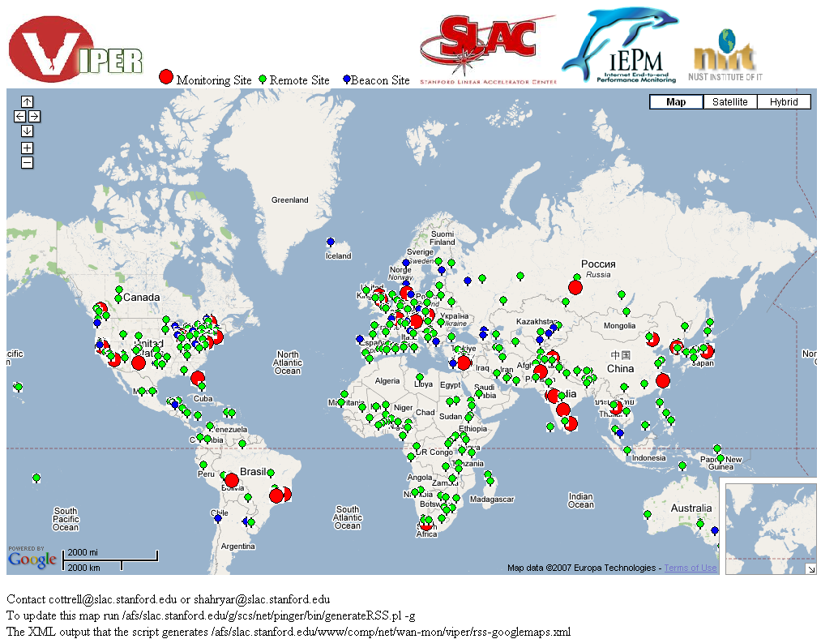
Figure 8 ViPER interface implemented using the Google maps API
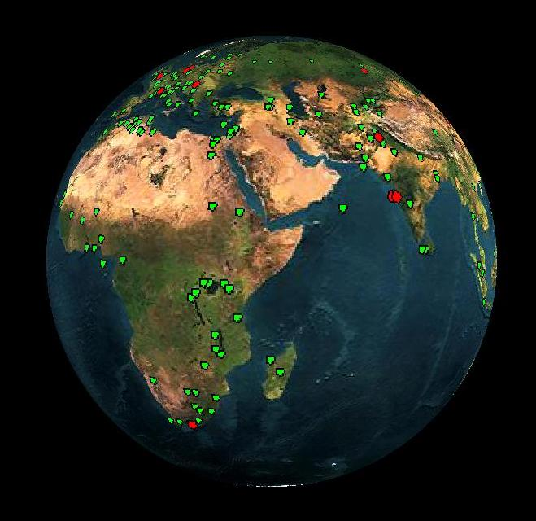
The same was implemented using the all-famous Google maps API as shown in Figure 8.
This project was also customized for the PDA clients. It was one demand of network engineers to get the holistic picture of network.

Figure 9 3-Dimensional representation of the PingER node deployment

2.3.2. Trilateration Utility for Locating IP hosts (TULIP)
With the extensive growth in the coverage of PingER arises the great difficulty of keeping track of the changes in the physical locations of the monitored sites. This might lead to mis-leading conclusions. To assist in automated location verification of PingER hosts, MAGGIE-NS has launched a task to build a platform agnostic, open-source tool (c.f. Traceware from Digital Island or Edgescape from Akamai) called TULIP [17] to give the latitude and longitude for a given IP address or name especially for hosts in developing countries. This tool may later be used for other applications such as content selection based on location, determining where inappropriate usage is originating, mapping traceroute topologies. This tool will then be used to identify hosts whose located position is in conflict with the PingER or other databases’ (e.g. Geo IP Tools or Hostip.info) latitudes and longitudes by comparing the minimum RTT with that predicted from distance between the monitor and remote sites. Anomalies will be reported so the PingER database can be corrected using values from the locator tool and/or new hosts can be chosen to be monitored.
The location of an IP address can be determined using the minimum RTT measured from multiple “landmark” sites at known locations, and triangulating the results to obtain an approximate location. The basic tool will be a script that takes RTT measurements from landmarks to a selected target host (typically at an unknown location) specified by the user and figures out the latitudes and longitudes of the target host.
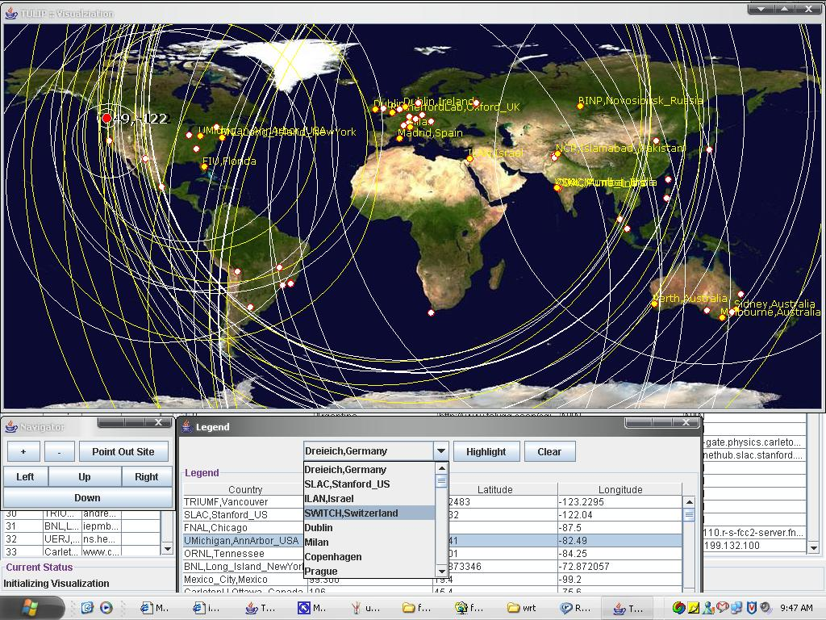
Figure 10 Visualization presented by TULIP
TULIP is a project to implement this triangulation technique. TULIP requests the landmark sites to make RTT measurements to the target host, collects these measurements, analyzes the data, presents the results and on demand can make traceroutes to the remote host from selected landmark sites to enable the user to see the paths. It is under development and will also utilize the historical min-RTT PingER data in order to verify the locations of hosts/sites recorded in the PingER configuration database, and to optimize the choices of parameters used by TULIP.
For landmarks we will: use existing LookingGlass [33] sites (that allow on demand ping measurements); add ping web agents to PingER monitoring sites and are working with the authors of [15] to utilize their landmark sites.
While implementing such a technique there are several factors that have to be taken into account:
- Bandwidth: Links can have capacity bandwidths that differ by many orders of magnitude (e.g. 1 Mbits/s versus 10Gbits/s). For a 1 Mbits/s link the time to clock a 100byte packet onto the link is about 0.8msec. This is roughly the delay time for light to propagate through a 100 mile (~161km) fiber (or roughly [16] 100km per msec of RTT, n.b. RTT ~ delay * 2). Thus, calculating a single conversion factor (alpha) from RTT to distance that works for all links for all distances is a non-trivial issue and may lead to considerable inaccuracies..
- Queuing delay can have major effects on the RTT measurement. Queuing delays are critically affected by cross-traffic. Increased cross-traffic is likely to increase queuing and thus RTTs. Hence the minimum RTT of multiple measurements is used with the assumption that the minimum possible RTT is for packets that see no queuing. However if the queuing persists for the duration of the measurement then the minimum RTT will include a queuing component and not accurately reflect the distance.
- Routing policy: The path a packet takes over the network may change dependent on link/router availability and routing policies. Extra hops in the path will add extra router and clocking delays, different hops will have different delays, and different links will have different capacities and distances. All of this will change the minimum RTT when a route changes. Further the peering may be such that the route between a landmark and a selected host is not direct. For example: the route from two landmarks in San Jose and Palo Alto to SLAC (< 20 miles away) went via New York; traffic from Rawalpindi, Pakistan to Pune, India goes via the U.S. Further hosts at multiple sites may respond to a single name (e.g. Yahoo, Akamai, route-name servers).
- Bottleneck bandwidth is the available bandwidth of the link in the path that at the measurement moment has the lowest available bandwidth. This may be the link with the lowest static capacity or it may be a heavily loaded link with the currently minimum available bandwidth (~ link capacity – link utilization). The link utilization changes as a function of time so the bottleneck magnitude may vary and its location may move from link to link.
- Misconfiguration of network devices such as routers and switches can cause unexpected delays. First of all misconfigurations can cause a router or link to fail. Secondly the alternative route may be poorly chosen (e.g. have much lower capacity or much longer delays).
- Traffic conditions may vary enormously as a function of time. For example, on Monday mornings typically there is a surge in traffic as people come to work; also there is usually much more traffic during peak work hours compared to weekends and nights. Such increased traffic often leads to congestion, increased queuing and thus increases in RTT.
Links in Canada, USA, Europe, Japan are generally of high capacity e.g. 100Mbits/s or 1 Gbits/s end host Network interfaces, 1 or 10Gbits/s backbone links and >= 100Mbits/s border router links. Also the routes tend to be well defined with optimum backup paths. Thus the distances derived from the minimum RTT values in those regions are generally accurate.
However, many developing regions/countries such as Pakistan do not yet have a similar infrastructure. For example some paths between sites in Pakistan have been observed by the MAGGIE-NS project to go via Europe or E. Asia. Furthermore, as mentioned above, the assumption that 1ms of RTT for a distance of 100km on the fiber may not work well for short paths with slow links or where the peering leads to indirect routing.
Even for well developed infrastructures, the actual RTT is usually much larger (e.g. a factor of two) than that given by 100km = 1 ms, since between nodes the path is often not a straight line (often following roads, railways and other rights of way), and the nodes themselves are not usually on a great circle route. Further there are delays in the routers themselves. A more realistic starting value is therefore for the conversion factor (alpha) to be closer to 50 km = 1 ms. One of the goals of this project is to optimize alpha to optimize the agreement of RTT distance estimations versus the GCDs between the sites and to understand whether multiple values are needed for alpha.
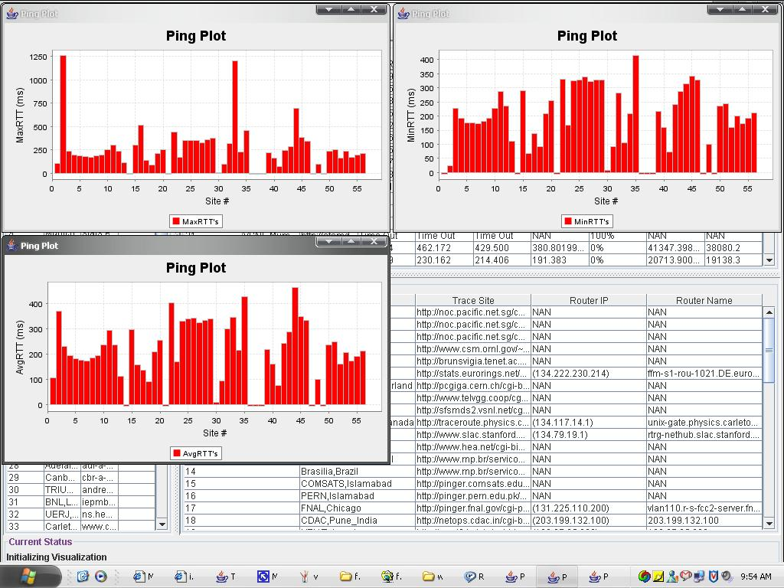
Figure 11Statistics of the node being monitored and relevant landmarks

2.3.3. Multi-route Event Detection Using PCA
Anomalous event detection in computer networks is becoming increasingly important. Several approaches exist for event detection problems. The majority of them have restricted themselves to single route and single metric analysis. Here our aim is to apply Principal Component Analysis to address the problem of anomalous event detection for single route as well as multiple routes. The scheme is to be applied on different data sets. Most notable is ABwE measurements from SLAC to different parts of world. Other data sets include data from other tools like IPerf, Pathchirp end Ping etc. Data sets from Fermi lab and other iepm-bw sites is also to be analysed. The tasks which are performed during analysis include pre-processing of data (Trimming, Normalization and Regularization), PCA analysis (Application of PCA and event detection) and study of results

2.3.3.1 Methodology
Principal Component Analysis is used in several applications. Its basic functionality is dimensionality reduction. Following steps have been applied to use PCA.
- Data set: The data should be a time series consisting of number of parameters. We have applied this scheme to a data set ranging from three parameters to eight different parameters.
- Adjust mean: Mean for every parameter in the series is calculated and subtracted from every value. Result is a data set which is the mean adjusted or zero mean data set.
- Covariance Matrix: Covariance of every parameter is calculated with reference to every other parameter. Then results are arranged in the form of matrix. This is a square matrix.
- Eigen Vectors & Eigen Values: Next step is to calculate Eigen vectors and Eigen values. Each Eigen vector represents a principal component.
- Feature Vectors: Feature vectors are constructed by removing Eigen vector (s) which are less important. It is done by first sorting all Eigen vectors and then by removing least important one.
- Abnormal Subspace Calculation: Multiplication of Feature Vectors with its transpose generated a square matrix. To get abnormal subspace this matrix is subtracted from identity matrix. Now resultant matrix is multiplied by original data set. Magnitudes of every vector in this matrix is calculated and output is passed through an event detector which alerts any value that is away from normal more than a specific threshold.
Note: The procedure is little different for multi-route analysis. Multi-route analysis also involves regularization of data and an extra step of combining different data sets into one data set.

2.3.3.2 Output and Analysis Details
Two different data sets are used to analyze above mentioned technique. Details of data sets, results and analysis are publicly available [18].

2.3.4. End to End Event Diagnosis
Event Diagnosis is the next step after Event Detection. The IEPM group has established a large infrastruture for network performance measurment all over the world. This infrasture provides near real time network performance related data. The IEPM group has developed analysis techniques and tools that detect a drop in performance. The Event Diagnosis project is aimed at finding out the cause of a performance drop. So it is a sub-system under IEPM-BW being developed over Event Detection. Current work is being carried out by a team of researchers at SLAC but given the nature and evident benefits of project it is expected to expand quickly.

2.3.4.1 Methodology
The IEPM infrastructure consists of Monitoring Nodes and Monitored Nodes. For Event Diagnosis puposes we add another term Central Node. Below is a small description of each type of node.
Monitoring Node: A node that runs tools for network measurement, collects data, stores data, analyzes data for Event Detection and generates alert on the basis of analysis result. Currently we have six such nodes.
Monitored Node: A node that is measured by a Monitoring Node. Each Monitoring Node has its own set of Monitored Nodes. Currently we have about 40 monitored nodes all over the world.
Central Node: A node that runs Event Diagnosis analysis. There is only one such node for the time being (SLAC)
All the implementation is in the form of perl scripts or cgi/perl scripts. Some scripts reside on monitoring nodes and some on central node. There is no script currently on any monitored node.
Code on Monitoring Nodes: Every monitoring node has three cgi scripts.
nodeid_host.cgi: if script is called with option n, should be provided with node id. if script is called with option h, should be provide ipv4 host alias. In either case it returns all records from which one can deduce node id or ipv4 host alias.
alert_rec.cgi: if called with out any option, returns all valuable alerts present on monitoring node other wise returns only the alerts which fulfill the criteria
tracert_analysis.cgi: script should be provided with trace route destination and time period. It returns if there was a route change between this period or not.
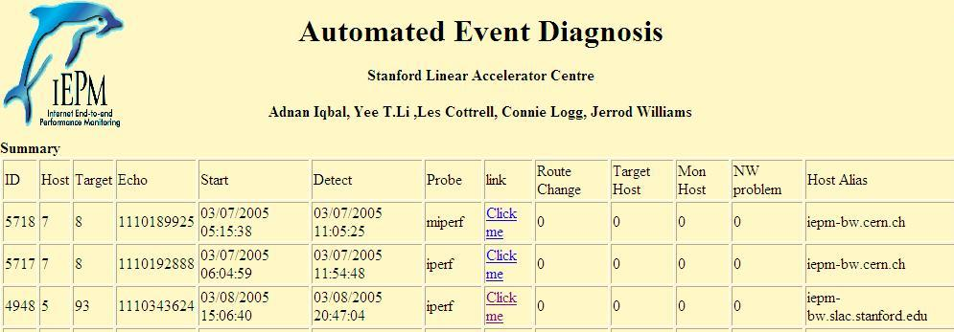
Figure 12 Event Diagnosis summary page, each row represents an analyzed event whose details can be seen by clicking on its link
Code on Central Node: Central Node has following scripts.
datatracker.pl: has the basic functionality to get data from all monitoring nodes. To use the script, it should be imported in the script and its APIs should be used. It currently provides following APIs:
- controller.pl: Performs all analysis on data obtained using APIs of datatracker.pl. Generates output in the form of web page. Also updates database with newly analyzed results
- get_asn.pl: package used to get autonomous system information by providing host name or ip address.
- analyze-all.pl: A wrapper over controller.pl, which analyzes all the alerts available in all the monitoring nodes
- op_main.pl: updates summary web page with latest results in database
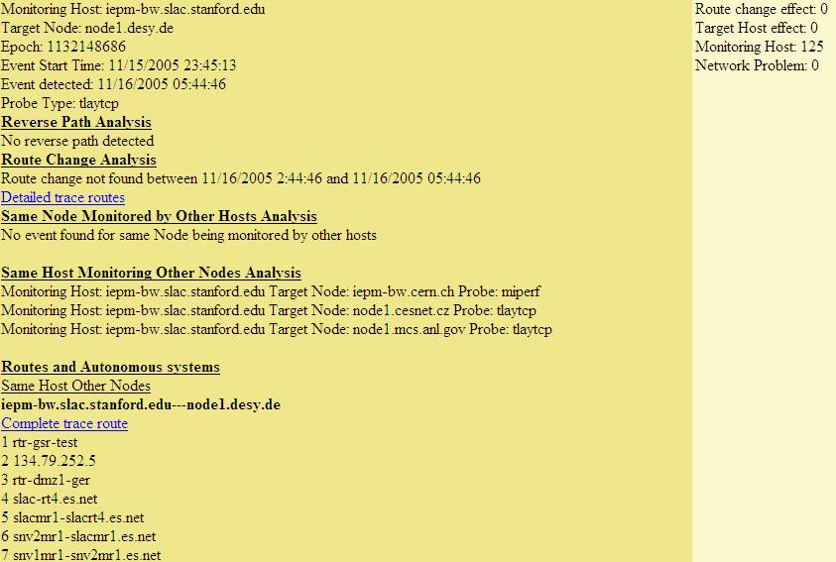
Figure 13 Detailed results of an analyzed event

2.3.4.2 Output and Analysis Details
The process is completely automatic. All events detected using Event Detection mechanism is analyzed for their probable cause. After the analysis results are e-mailed to relevant people, stored in database and published on web. These results include outcome and as well material for further manual analysis. Results since 2005 are available publicly [19].
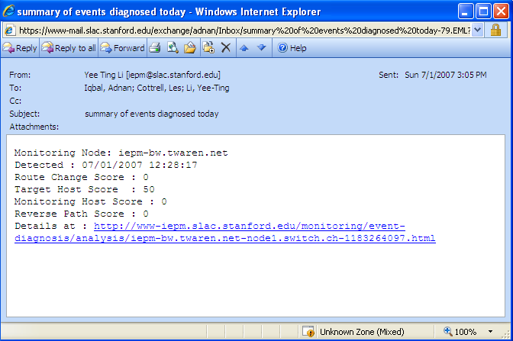
Figure 14 E-mail sent automatically after an event’s analysis

2.3.5. SmokePing-PingER Integration
The goals of MAGGIE-NS is to build a federation of measurement infrastructures so that latency measurements (historical and recent) can be shared, best practices among several measurement infrastructures can be adopted, the need for sites to deploy multiple infrastructures to gain all the available benefits be reduced and different analysis and visualization techniques be applied to yield more ubiquitous coverage and new insights. This project “Federation-SmokePing, PingER Integration” serves the main ‘MAGGIE Project’ and deals with the integration of two network latency measurement tools namely SmokePing and PingER.

2.3.5.1. Project Objectives
- Study and evaluate SmokePing and PingER to understand how they work, and their pros and cons.
- Extend the capability of SmokePing to utilize parameters/metrics not currently supported such as ping unreachability, jitter, derived TCP throughput, etc.
- Provide the ability to select and visualize these new metrics. Feed the modifications to SmokePing back into the development base.
- Modify PingER to enable it to utilize the SmokePing time series visualization tool.
- Evaluate and provide the ability to feed SmokePing data to the PingER analysis/visualization toolkit, so we can use the PingER aggregation techniques to characterize performance by regions, or affinity groups.
The work that has been done with respect to each objective and the results yielded are as follows:

2.3.5.2. Project Outcomes
        - Results Obtained from Objective- Working of SmokePing and PingER and the Pros and Cons of Each
Benefits of PingER over SmokePing
 | PingER | SmokePing
Parameters Measured | Measures thirteen parameters | Measure eight parameters
Data Visualization | Has an elaborate textual and graphical output | Smoke Ping only provides with graphical results
Data Analysis | Provides analysis for multiple locations using aggregation techniques to characterize performance by regions, or affinity groups | Provides analysis for installation location and each remote site separately
Data Storage | PingER provides detailed analysis on historical data dating back to more than 11 years | SmokePing data is not kept in a centralized manner
Development And Improvement | PingER is being constantly improved through a focused team | There is no official team to upgrade it. Never the less it has a active archive team of developers and users constantly removing problems and improving the software
Error Reporting | PingER has error reporting module | Does not have error reporting module
Data Maintenance | Data keeps on getting appended at the end of the flat files | Once the room in the database finishes, every new data entry causes an overwrite on an existing database entry in a round robin fashion

Benefits of SmokePing over PingER
 | SmokePing | PingER
Uptime Visualization | Uptime is depicted using colors displayed at the background of SmokePing graphs | No specific visualization support for “down” or unreachable hosts. Reports unreachability, also missing measurements indicate a host is unreachable.
Alarms | Generates alarms if performance goes below a certain point | Does not need nor generate any alarms
Data Resolution | Stores data in consolidated form after specified time. By default after twelve data sets are filled in the Round Robin Archive, they are combined to form one single data set in another Round Robin Archive. After hundred and forty-four data sets are filled, they are accumulated to form a data set in the third Round Robin Archive of the Round Robin Database. | Keeps data dating back to 11 plus years on high resolution, therefore it has high data storage requirements ~0.6 MB/pair/month
Smart Alarms | Offers plug able alarm modules called 'matchers' which are small Perl modules which examine the past latency measurements and decide if an alarm should be triggered after applying whatever operations necessary to come to a conclusive answer | Does not need nor provide alarms
Probes | Offers plug able modules to write application level probes | Does not work with application level probes

The objective “Working of SmokePing and PingER and the Pros and Cons of Each Tool” reveals the follow main facts:
- SmokePing shows network performance with the help of data collected and displayed at near real time. PingER on the other hand currently visualizes data of a day prior to date, at the analysis sites.
- SmokePing uses less disk memory for the same step interval as PingER by consolidating the data as time passes. This happens by default to the data beyond last three hours.
- PingER has the ability to show output based on hourly, daily, monthly, last 60 days and last 120 days, monthly and yearly aggregations.
- Using PingER one can characterize performance based on affinity groups and regions. SmokePing only shows data for one link from source to destination in which the source is always the site where SmokePing is deployed.
- PingER shows thirteen parameters where as SmokePing shows eight. Never the less SmokePing shows at a glance output of the network performance, with important network latency parameters such as packet loss,and RTT together in one graph and with Smoke depicting the RTT delay variation.
- SmokePing generates ‘smart’ alarms based on patterns that the administrator of the software specifies. It also mails the admin if the performance goes significantly low. PingER does not generate alarms nor mails and does not need to do so either as its data is not near real time but of a day prior to date.
- SmokePing shows uptime for dynamic hosts by displaying colors at the background of the graphs. This tells the amount of time a dynamic host was able to keep its IP address. PingER does not display this feature however it does make sure that it is monitoring the correct host using a script that runs automatically on a daily bases. PingER also measures unreachability (as a metric) if all pings of a set are lost, and missing data will indicate if the host is down or unreachable.
- Both the tools are being constantly improved.

Both SmokePing and PingER have their pros and cons. Depending upon what factors one wants to optimize one can choose between the two. For an in-depth and detailed analysis, and to characterize performance based on affinity groups and regions, a large (13) number of network latency parameters, PingER is the correct choice. If one wants at a glance near real time visualization of network performance, smart alarms, application level probes, with few important latency parameters, with monitoring possibility of only links between the installation system and the targets sites, SmokePing is a better choice.
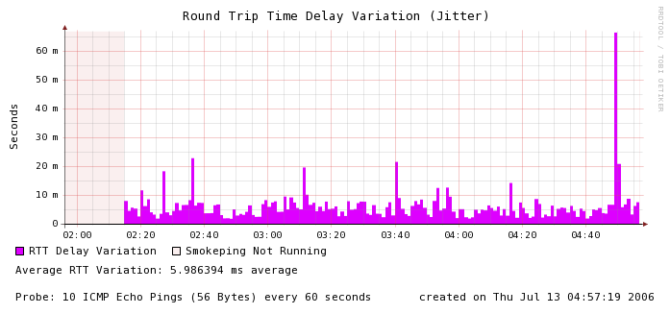
Figure 15 Visualization Enhancements made to SmokePing
        - Results Obtained from Objective- Enhancement of SmokePing Network Latency Parameters
The results of the objective “Enhancement of SmokePing Network Latency Parameters” are that SmokePing functionality has been enhanced with the following 11 parameters:
- RTT Overall Average: The total average RTT for all the ping data in the time interval displayed by the graph.
- RTT Maximum Average: The maximum average RTT that any probe ever reached during the time period displayed by the graph.
- RTT Current Average: The average RTT for the last probe received.
- Derived TCP Throughput: This is the bounded TCP throughput in Kilobits per second for the link between the monitoring host and the remote host.
- Average Packet Success: This is the percentage average success of the ping packets. These are the ones that out of the total packets sent came back.
- Maximum Packet Success: This is the percentage maximum success of the ping packets. These are the ones that out of the total packets sent for any probe during the time range of graph, came back.
- Current Packet Success: This is the percentage current success of the ping packets. These are the ones that out of the total packets sent for the last probe came back.
- RTT Delay Variation Graph: This graph displays the RTT variation for a given range of time. It is the difference between the maximum and minimum ping RTT for a probe.
- Average RTT Delay Variation: The overall average RTT variation for the RTT Delay Variation Graph.
- Packet Success Graph: This graph displays the packet success percentage against the axis time.
- The Minimum Packet Loss: This is the minimum packet loss that occurred for any probe in the range of the graph.
More parameters of PingER still need to be integrated into SmokePing. We are looking into the possibility of the integrating all latency measurement parameters as “plug-ins”.
        - SmokePing Enhanced Mode Visualization
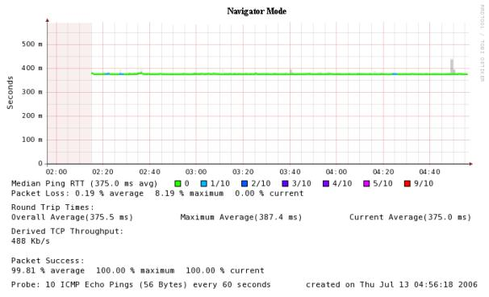
Figure 16 Further Visualization Enhancements

        - Results Obtained from Objective- Data Conversion from PingER Format to SmokePing Format and its Visualization
It is possible to convert PingER data into SmokePing format. The data is converted as a cron job on a daily basis. The data is maintained for the past 90 days. Converted data is visualized using RRDTool and developing graph codes.
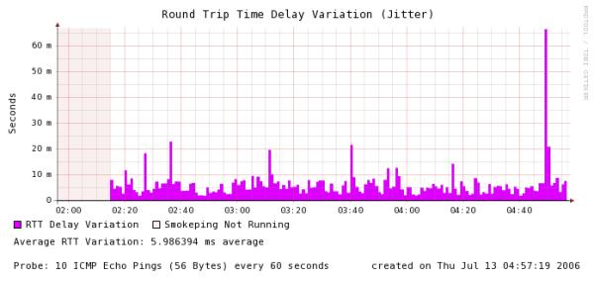
Figure 17 Round Trip Delay Variation
The converted data is displayed in the form of SmokePing Graphs to a user when he visits the “Selection Web page” and clicks on the desired monitoring host, remote host, packet size, pings per probe combination. The user can also plot the converted data by specifying any start and end date and/or time within the past 90 days.
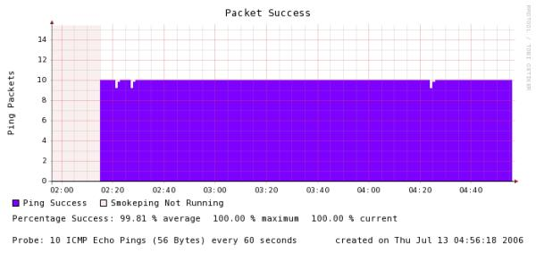
Figure 18 Packet Success
The user now is be able to plot the graphs by clicking on the corresponding monitoring site link present at the website of PingER ( http://www.slac.stanford.edu/cgi-wrap/pingtable.pl )
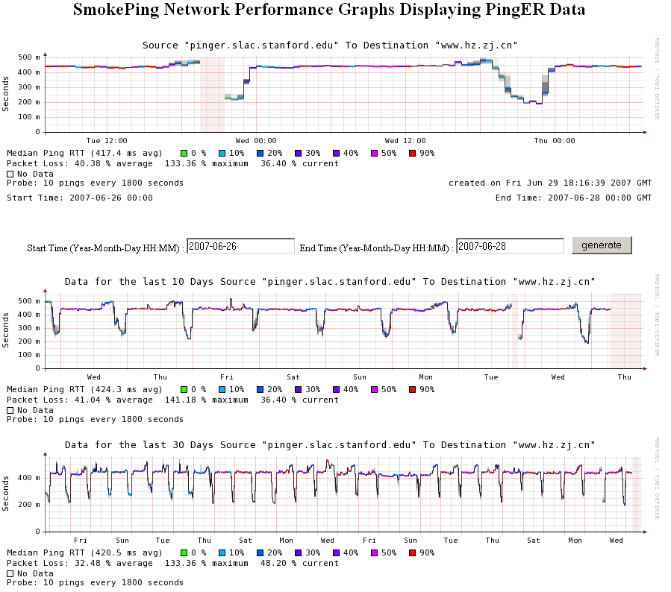
Figure 19 Smokeping performance graphs showing PingER data
The above graph shows a congested link in China ((www.hz.zj.cn) monitored from SLAC. The first graph shows the data for the last two days. It can be changed by selecting the start and end date in the fields and generating a new graph. The second graph shows data for the last 10 days and the third graph shows the data for the last 30 days. You can clearly see the day night effect here and huge losses.

2.3.6. Network Weather Forecasting
Network forecasting is a technique to forecast the behavior of the network by “extrapolating” various network measurements e.g. Available Bandwidth, Throughput, Round Trip Time etc. Forecasting enables the system administrators, network analysts and scientists with data intensive needs, to visualize the expected behavior of the network based on the historical behavior of the network. It also enables middleware, such as Grid based data replica selection, to determine the optimal places to get data from, based on forecasts for the near future. Given forecasts, results of the deviations of the forecast, (the expectation) from the observed behavior and anomalies can be obtained.
Anomalies are any significantly abnormal and unusual behavior in the network. They can arise in any network irrespective of their geographical limits and boundaries. Network anomaly detection is the detection of abnormal traffic conditions on a monitored network. Using the potentially overwhelming amount of monitoring data to track down problems is itself a problem. New tools are needed so that users and engineers can quickly spot anomalous behavior or conditions that affect E2E performance. These tools must provide predictive and alerting functionality, with easy drill-down capabilities. Some noteworthy rationales for sudden cropping up of this anomalous behavior in the network are router outages, configuration changes, flash crowd and abuse.
MAGGIE-NS has implemented and compared the use of several different algorithms to detect significant, persistent anomalous events in real E2E Internet performance measurements [20]. The algorithms include the Plateau Algorithm (PA) [21], the Kolmogorov-Smirnov (KS) [22] technique and the use of Principal Components Analysis (PCA) [23] for detecting anomalies. These techniques assume there are negligible seasonal effects in the data (or that the seasonal effects have been removed), To allow for seasonal effects, the Holt-Winters (HW) [24] and Burgess Techniques [25] have also been implemented and compared for making forecasts.
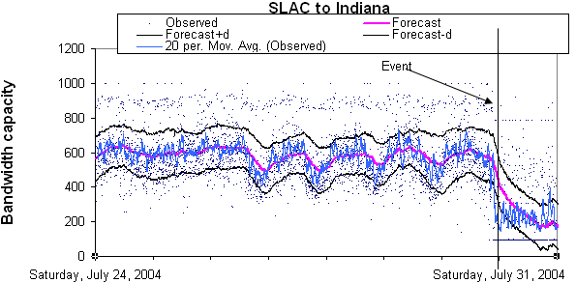
Figure 20 HW forecasts of ABwE data from SLAC to Indiana. The blue dots are the measurements, the blue line shows the smoothed measurements to help guide the eye. The magenta line shows the HW forecast and the black lines show the expected variation
The measurements are based on active probes running on 40 production network paths with bottlenecks varying from 0.5Mbits/s to 1000Mbit/s. To enable comparisons between the various techniques a canonical set of data for 30 sites for 100 days was prepared and studied and anomalous events of interest were identified and categorized. Moreover, the false positives were also identified and missed events for the various methods were categorized. For well behaved data (no missed measurements and no very large outliers) with small seasonal changes most algorithms identify similar events. However, for data with large seasonal changes (e.g. diurnal or weekly), PA or KS can detect false positives especially at the end of a weekend. The algorithms were compared for robustness with respect to false positives and missed events, especially when there were large seasonal effects in the data. The applicability of the algorithms in terms of their intuitiveness, their speed of execution as implemented, and areas of applicability were also studied. Figure 20 shows an example of applying HW to ABwE data measured from SLAC to Indiana. It is seen that the HW forecast tracks the seasonal (diurnal) changes and we can detect the anomalous event at the beginning of Saturday July 31st. This technique is aimed to providing forecasts up to a week in advance and automatically detect anomalies with few misses and few false positives.

2.3.6.1 Active and Passive Measurements
Besides using regular active measurements for forecasting, passive measurements for user data transfers are being investigated. This would add data for more paths, does not add extra network traffic, is related to real applications, needs, and collaborators, and does not require the measurement team to get accounts, passwords or certificates for the remote sites. To make the passive measurements, Netflow [26] records from the border router at SLAC are used. These records are anonymized and filtered to select large (> 100Kbytes), long (> 8 seconds) data transfers from selected applications (ports for iperf, thrulay, bbcp, bbftp, GridFTP, scp etc.) between SLAC and about 30 major collaborator sites. The flow throughputs are calculated from the recorded start and stop times and the number of bytes transferred.
At first, the passive flow information with that from corresponding active measurements was compared. Typically the agreement was good. The time stamps of the measurements agreed to within 30 seconds and the throughputs to within 3%. In both cases the reasons for the discrepancies are understood.
The distributions of the passive throughputs were reviewed and it was observed that peaks at well-known bottleneck capacity limits (e.g. T1, T3, and Fast Ethernet). Peaks are also observed at corresponding to a combination of RTT and the default TCP window size limiting the throughput. This suggests that there is room for improvement in achievable throughput by optimizing the maximum TCP window sizes.
By aggregating the flows by remote site and folding the data from four week periods onto a single week, 15 remote sites, each with > 1440 flows, i.e. on average a flow each 30 minutes were found. Active monitoring of only 3 of these 15 sites is being done. This would allow adding an extra 12 sites with sufficient data to make forecasts even if there are seasonal effects. About 10% of the sites have significant seasonal changes and for the remaining 90%, less frequent data is needed to make forecasts. Next steps include evaluating the variance of the passive throughput measurements by site and by application.
This project has also investigated techniques using the time series approach Auto Regressive Moving Average and Auto Regressive Integrated Moving Average (ARMA/ARIMA to forecast network performance for distribution of task and data. Experimental results have been obtained through employment of ARMA/ARIMA techniques, as they can be used both with stationary and non-stationary data, in order to determine the trends and seasonal changes in the data and come out with optimum forecasting of data. Cross traffic bandwidth time series and their corresponding extreme event processes were analyzed using statistical models in order to study the annual parameter trend, evolution and variability. The performance monitoring in Computational Grid settings is widely recognized to be an essential capability. In this context description has been made regarding a general Grid performance prediction architecture which employs econometric time-series modeling techniques, as well as implementation of the ARMA/ARIMA approach. The correctness of the proposed methodology has been verified through several experiments performed on selected network parameters.
There are several possible reasons for fitting ARMA models to data. Modeling can contribute to understanding the physical system by revealing something about the physical process that builds persistence into the series. ARMA models can also be used to predict behavior of a time series from past values alone. Such a prediction can be used as a baseline to evaluate possible importance and impact of other variables on the system.
In this context a forecasting tool was developed using ARMA/ARIMA technique. The snapshots of the tool developed under this project, for the forecasting have been presented in Figures 21-28 to show how it works and what are the steps of forecasting. Values of coefficients, standard deviation, t-values and significance for various variables under different orders (p,q) have been computed.
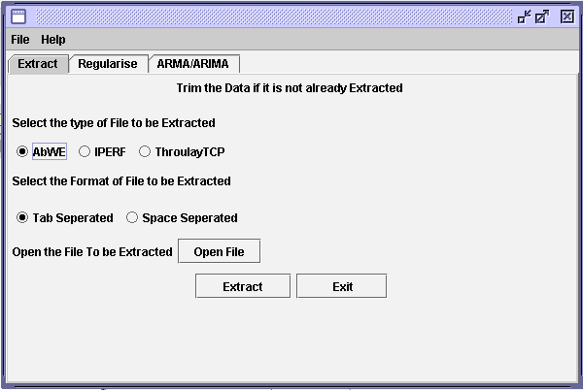
Figure 21 Snapshot of data processing module for data extraction
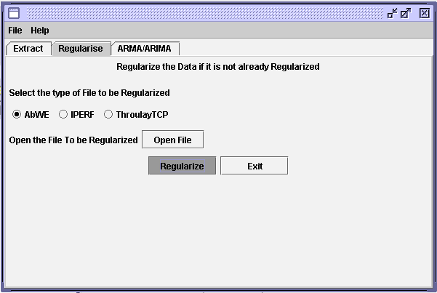
Figure 22 Snapshot of data processing module for regularization process
The data from active monitoring tool were used as an input to the developed tool for forecasting. The methodology adopted for this project, extracts the required parameters from the input file and a new file is created by the trim operation for the requisite parameters like available bandwidth, throughput, etc.
The snapshots of forecast order, forecast chart, and residuals have also been shown, followed by 1000 computed values of residuals.
Data bins of equal interval of 10 min were generated to carry out the regularization operation on the active network data. The missing data were interpolated at the same time by employing the moving average technique.
In data tab, the parameter and file are selected by the forecasting module. This results a file is generated, which contains date, time and value of the selected parameter.
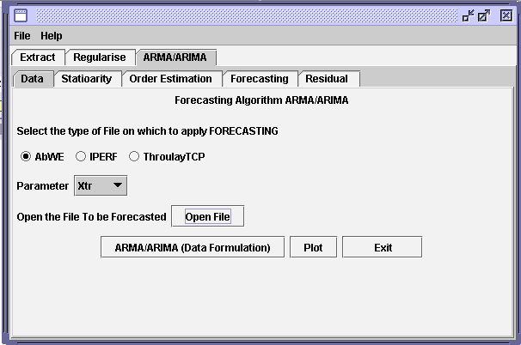
Figure 23 Snapshot of forecasting module for parameter selection
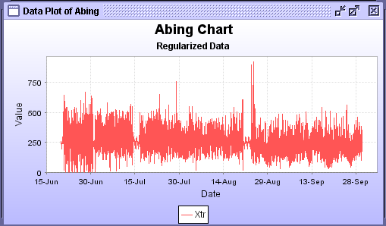
Figure 24 Snapshot of forecasting module for plotting selected parameter
In stationary, the trends need to be removed from the data. For this, the forecasting module was used to integrate the processed data. This caused the removal of autocorrelation as it can be seen in case of 1st difference.
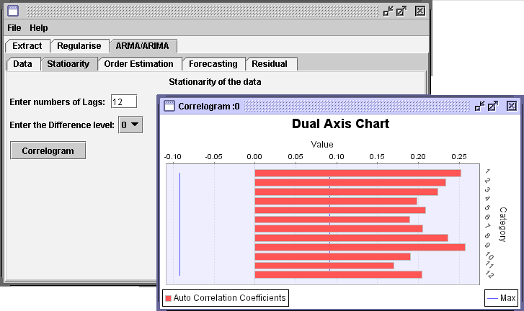
Figure 25 Snapshot of forecasting module for correlogram at levels
The significance of different combination of orders was computed by employing the forecasting module for order estimation. In order estimation, possible orders are estimated and different tests are applied for determining the significance of the orders.

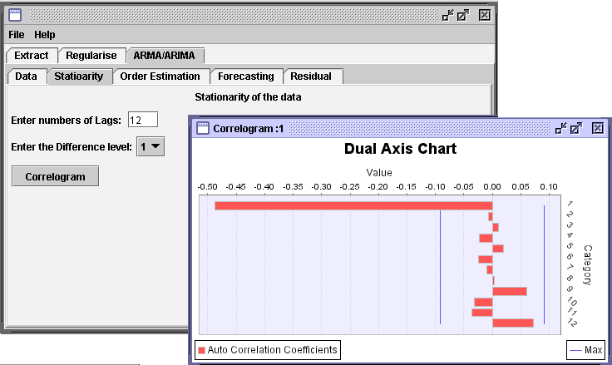
Figure 26 Snapshot of forecasting module for correlogram at 1st difference

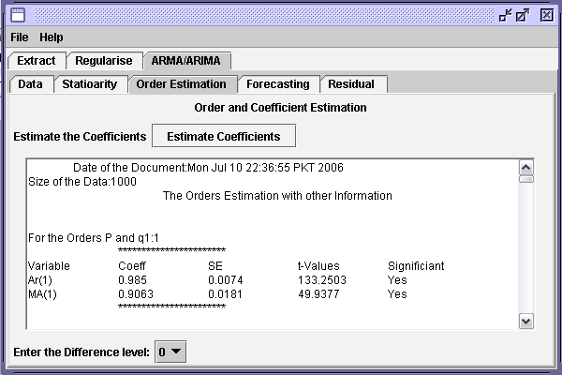
Figure 27 Snapshot of forecasting module for order estimation

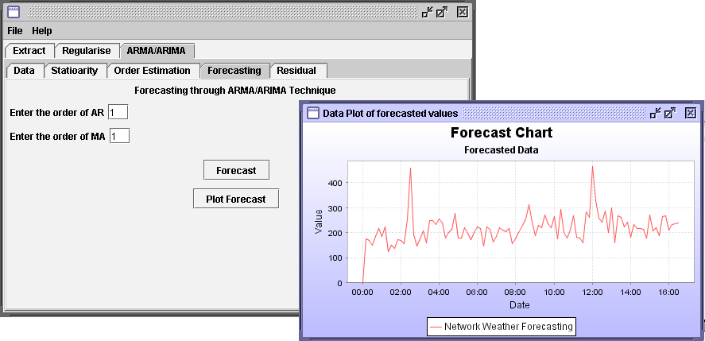
Figure 28 Snapshot of forecasting module for forecast and its plot

2.3.6.2 Comparison of ARMA/ARIMA with Holts Winter and EWMA
2.3.6.2.1 Forecasting with Holts Winter (HW)
Holts-Winter caters for trends and seasonality in the data. There are three basic equations of HW that cater for trend, seasonal effect and the overall smoothing in the data. The results of the three smoothing equations are combined into one to give the overall forecasts. These forecasted values are compared with the actual values when they occur and then the percentage change is calculated. The percentage change refers to the percent difference between the forecasted minus the actual values with respect to the original values. The percentage difference is used to calculate the average percentage difference which tells the overall accuracy of the forecasts.

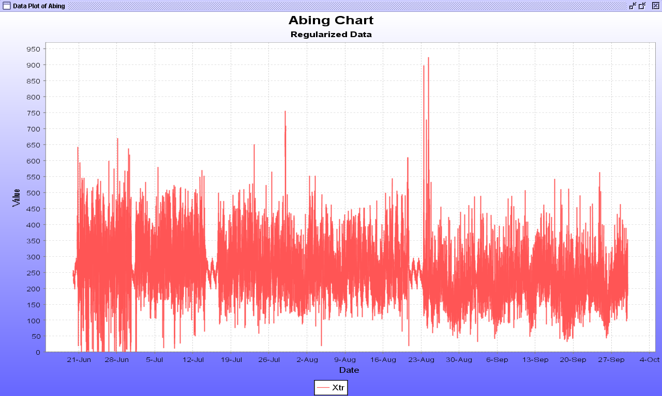
Figure 29 Plot of data used for forecasting

2.3.6.2.2 Case Study
Forecasting was performed by employing HW and ARMA/ARIMA approaches on same data set (Appendix-C). The data on which forcasting was carried out is of Abing and the parameter is cross traffic (xtr).
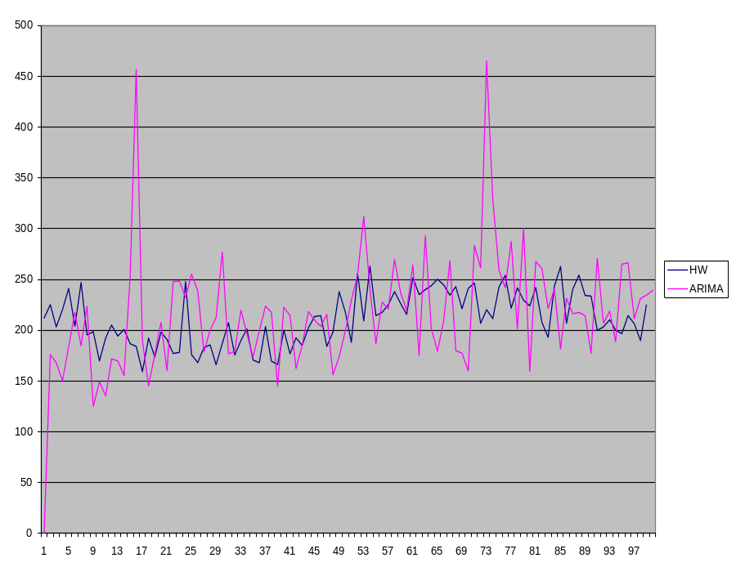
Figure 30 Forecasting results of HW and ARMA/ARIMA techniques

The results of the two techniques/forecasters have been compared (Figure 5.5) and can clearly be seen that in ARMA/ARIMA approach the trends and seasonal effects have been preserved whereas in Holts Winter approach these effects are not very visible.
2.3.6.2.3 Inferences
From the above comparison of forecast results, it is obvious that ARMA/ARIMA better conserves the trends and seasonal effects in the data. Therefore, the use ARMA/ARIMA approach should be preferred rather than Holts Winter in case of network weather forecasting. The tool developed for this project fits the data reasonably well.

2.3.6.3 Diagnostic Checks
Diagnostic checks were made by employing the diagnostic check module developed for the project. Residual plots and correlogram are presented in Figures 31-32, while the snapshot of the Portmanteau test performed on residuals is shown in Figure 33.
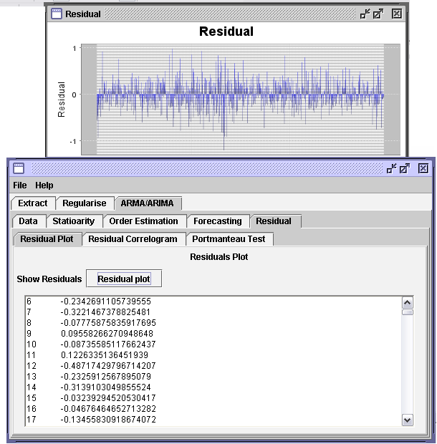
Figure 31 Snapshot of diagnostic check module for residuals plot
Having forecast data and the results shown, and tests performed on them for diagnosis, values of the 1000 computed residuals are given below.
The correlogram of residuals generated by the forecaster is shown in Figure 4.11. The results clearly show that there is no correlation between the residuals and hence prove that forecast is valid.
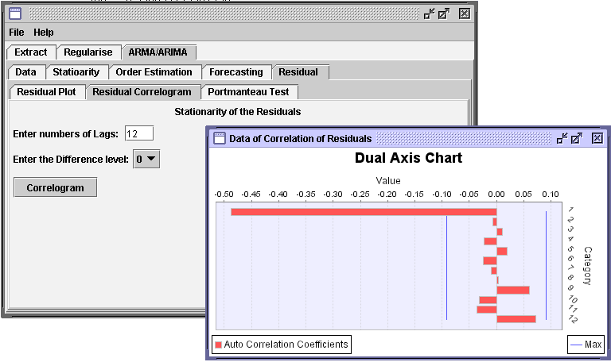
Figure 32 Snapshot of correlogram of residuals

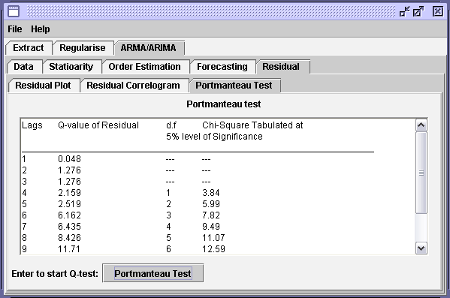
Figure 33 Snapshot of Portmanteau test performed on residuals

2.3.6.4. Conclusion
The basic requirement of Network Weather Forecasting has been achieved by resorting to two prong efforts.
Firstly the technique of ARMA/ARIMA was followed and secondly an Algorithm was developed, both of which converged in dynamic Network data forecasting.
The methodology adopted was:
- Available data on the subject was gathered and processed to be used as an input to the forecasting module.
- After studying ARMA/ARIMA and ascertaining its suitability, algorithm was developed.
- Based on the adopted approach and developed algorithm, experiments on forecasting were conducted employing the duly processed data.
- The results obtained through different experiments were computed, compared and characteristics were plotted to come out with a fair idea of the final accomplishment.
- Analysis of the results, their comparisons and other details were carried out before preparation of the report.
- Analysis of the forecasting results produced by ARMA/ARIMA reveal that:
  - The developed methodology is in order, appropriate and acceptable tool for the network weather forecasting as the model fits the data reasonably well sine no trend was found in residuals.
  - The forecasting on network data, performed by the developed tool was satisfactory as confirmed by the Portmanteau test performed for the purpose.
  - In ARMA/ARIMA approach, the trends and seasonal effects are preserved whereas in Holts Winter approach these effects are not very visible

2.3.7. Toplogical Analysis and Network Performance Visualization
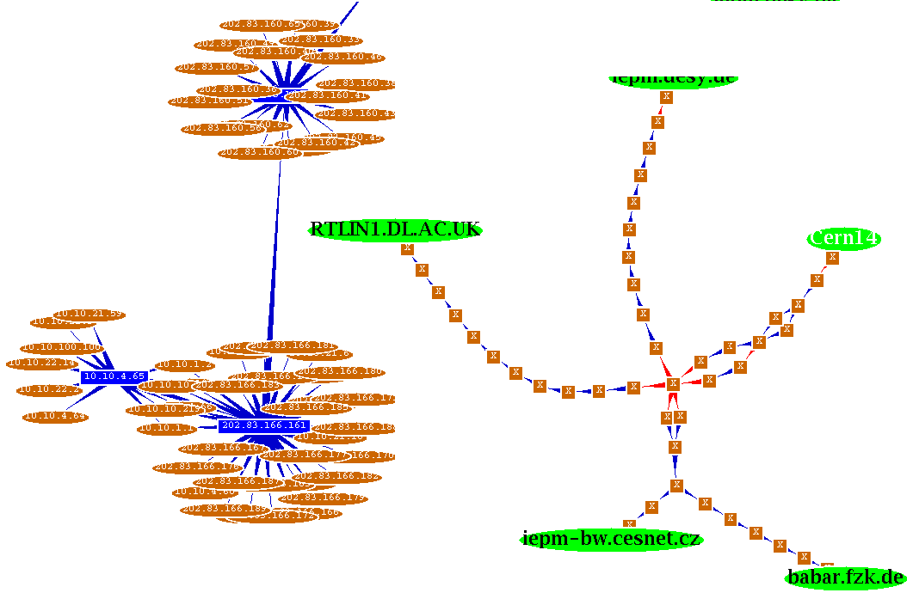
Figure 34 WAN/LAN Topology Discovery
The project is to contribute to production of software packages that will facilitate the identification of network performance scheduling , monitoring, event detection and visualization. In particular, PathNeck (an opensource tool developed jointly by AT&T and CMU) has been identified as a useful network monitoring tool that has been implemented to obtain information from. It combines traceroute information with throughput information from packet train deductions.
The software is used for network (WAN/LAN) topology discovery as shown in the figure below.
The software also provides statistical analysis for the observed topology as shown in the following figure.
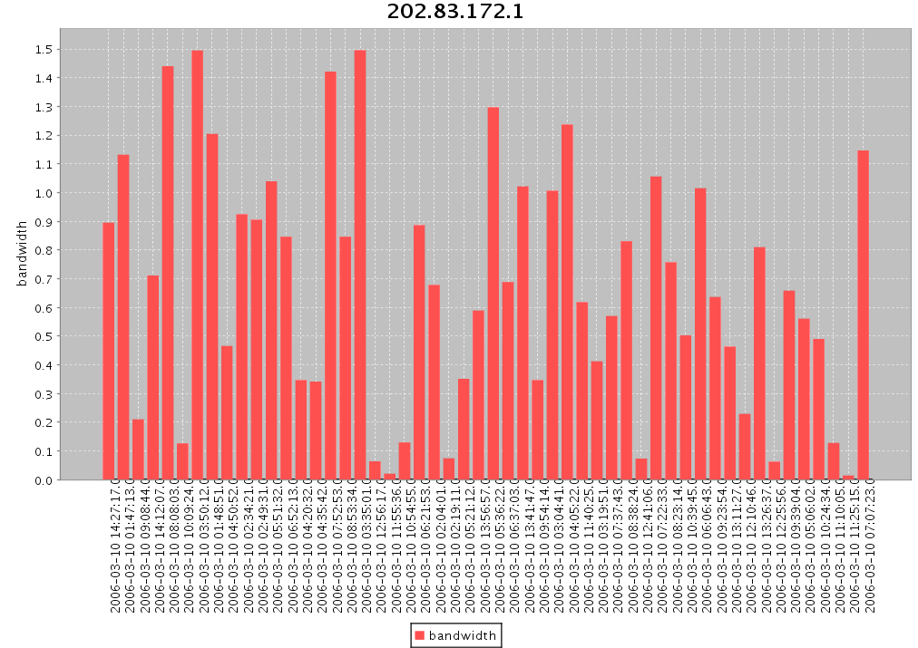
Figure 35 Bandwidth Measurements for the observed Topology

2.3.8. PingER Executive Plots
The aim of this project is to create long-term summary plots of PingER historical data. These plots may be bar charts, line charts or trend line charts of PingER data overtime

2.3.8.1. Motivation
The PingER project has been gathering historical data for various countries/regions for over 7 years. There was a need to design a software which could provide summary plots of this data. These plots need to be dynamic and adjustable in order to enable the user to analyze the data as he desires. In addition the software must be extendable to include new capabilities and functionalities as required.

2.3.8.2. Project Description
The current software has been programmed in Java using the JFreeCharts library. It has a variety of capabilities to enable the user to perform analysis to his liking. Firstly it can create various types of graphs of PingER historical data including Bar Charts, Line Charts and Trendline Charts.
- Bar Charts are average values of PingER historical data for a particular region.
- Line Charts simply graph the raw data in terms of simple line charts.
- Trendline Charts are exponential regression plots of the raw data. They attempt to map the data onto an equation of the form y = a * e ^bx. This is a useful tool for analysis the overall historical trends in the data.
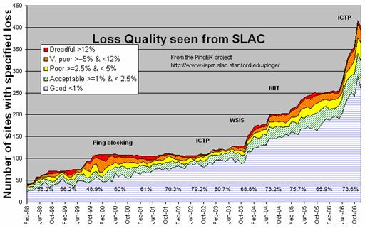
Figure 36 Loss quality as seen from SLAC – an example of PingER Executive Plots
Included with the ability to draw these charts are various other features to aid the user in his analysis. Some important ones are:
- Adding and removing regions/countries from the charts at runtime
- Zooming in and out of the line/trendline charts for better analysis.
- Displaying the parameters for the trendlines such as the coefficients of the equation and goodness of fit.
- Ability to change the pattern of the lines in order to include the graphs in printed reports and papers.
- Tool tips with the lines/trendlines giving information about the data points.
- Ability to change the various features (such as title/ background color) of the charts.
- Ability to save the charts as PNG images.

2.3.9. Traceroute Change Analysis (TCA)
Route change analysis is critically important for network monitoring and troubleshooting. A route change can be a major reason for fluctuations in round trip times, achievable and available bandwidth, file transfer throughput etc. However, an important point to consider is that not all route changes cause throughput changes. An example of a throughput change correlated with route changes, can be seen in Figure below.
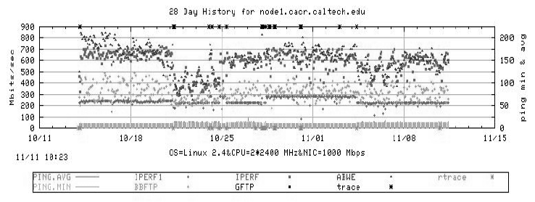
Figure 37 Time series plot with route changes indicated
In Figure 37, the asterisks along the top axis indicate forward path traceroute changes. The asterisks along the bottom axis indicate reverse route changes. Note the correspondence between throughput change on 10/21/05 and the forward route change.
As part of MAGGIE-NS, a new tool traceanal [27] has been implemented which is used to detect and visualize the route changes, and publish the results of route analysis through a web link [28].
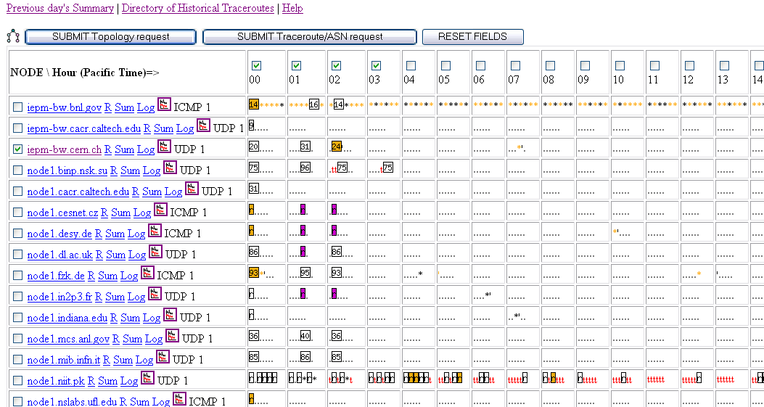
Figure 38 Screen shot of part of a traceroute summary web page with summary table
The web accessible route daily summary page (Figure 38) is created and updated throughout the day. At the top of the page, there are links to “Yesterday’s Summary”, today’s “Reverse Traceroute Summary”, and the directory containing the historical traceroute summaries. Under those links is the traceroute summary table which provides “at a glance” visualization of traceroute change patterns. This facilitates the observation of synchronized route changes for multiple hosts in the cases that a common sub route changes for some of them.
To facilitate further investigation of changes, there are highlighted links in this table that allow one to: view all the traceroutes for a selected remote host (as a color coded web table accessible by clicking on the node name); access text suitable for attaching to trouble reports (Sum); review the log files (Log*); review the route numbers (“R”) seen for a given host together with when last seen; view the available bandwidth time-series for the last 48 hours; to select times and remote hosts for which one wishes to view topology maps, or provide information on the Autonomous Systems (AS) along the routes. In Figure 38, for hours “01” and “14”, it can be seen that there were multiple route changes to node1.niit.edu.pk seen from SLAC. Each entry (there can be multiple for each box representing an hour) provides a dot to denote that the route has not changed from the previous measurement. If the route has changed, the new route number is displayed. The first measurement for each day is displayed with its route number. This very compact format enables one to visually identify if several routes changed at similar times, (i.e. route numbers appear in one or two columns for multiple hosts (rows)), and whether the changes occur at multiple times and/or revert back to the original routes.

2.3.10. Other Projects
Apart from the projects stated above, details of other sub-projects are available at the project website: http://maggie.niit.edu.pk and https://confluence.slac.stanford.edu/display/IEPM/.

2.4. Case Studies

2.4.1 Pakistan Internal and International Connectivity
Given the Pakistan interest of the MAGGIE-NS collaboration and the need to be able to set expectations for future Pakistan research and education Grid activities, the MAGGIE-NS team also embarked on a more general study of Pakistan’s internal and international connectivity. Very interesting results were observed including comparison of the performance of two main ISPs i.e. NTC and Micronet Broadband. This case study provides a lot of information about the congestion in the Pakistan’s networks. As a result of this analysis, the NTC staff was provided with solid evidence of their quality of service. The issues raised are now being investigated by NTC. This can be very helpful especially with NTC being the backbone of PERN.

2.4.2. NUST Institute of Information Technology, Pakistan
With NIIT being an important collaborator with SLAC, Caltech and CERN, we prepared a case study with 3 PingER monitoring sites in Pakistan to provide an overview and a measure of the issues at NIIT in particular and Pakistan in general.
The Pakistan Education and Research Network (PERN) “is a nationwide educational intranet connecting premiere educational and research institutions of the country. PERN focuses on collaborative research, knowledge sharing, resource sharing, and distance learning by connecting people through the use of Intranet and Internet resources”.
PERN uses the services of NTC (National Telecommunication Corporation), which is the national telecommunication carrier for all official/government services in Pakistan, for the provision of infrastructure and bandwidth to the universities in Pakistan. The PingER project worked with NTC install a PingER monitoring site at NTC headquarters in Islamabad, to monitor the performance of various universities connected to PERN. This data was compared with that from two PingER monitoring hosts at NIIT. One of the hosts uses NTC/PERN to provide external connectivity at 1-1.5Mbits/s, the second uses Micronet, a commercial network with a 512kbits/s connection to NIIT. We analyzed the data to compare the results from the three monitoring hosts to a common set of sites in Pakistan, for seven weeks, from 7th Dec 2005 thru 28th Jan 06. All the sites were connected to PERN/NTC and information about them is provided in the table below.
 | Remote Node | University Location | Service Provider | Traffic Enters the Country Via | End host location
1 | PK.QAU.EDU.N1 | Islamabad | NTC | Karachi | Rawalpindi
2 | PK.LSE.EDU.N1 | Lahore | NTC | Karachi | Lahore
3 | PK.NIIT.EDU.N1 | Rawalpindi | NTC | Karachi | Rawalpindi
4 | PK.PIEAS.EDU.N1 | Islamabad | NTC | Karachi | Rawalpindi
5 | PK.SIRSYED.SSUET.N1 | Karachi | NTC | Karachi | Karachi
6 | PK.UET.EDU.N1 | Lahore | NTC | Karachi | Lahore
7 | PK.UPESH.EDU.N1 | Peshawar | NTC | Karachi | Rawalpindi

The minimum RTT from NTC is about 5ms versus about 10-12 ms from NIIT via NTC/PERN. Presumably the extra ~5 ms is a last mile effect. From NIIT via Micronet the minimum RTT is closer to 60ms. This may be partially due to slower backbone links (it takes longer to clock the packets onto the network links) and different routes or more appropriately due to last mile affects. Unfortunately we are currently unable to make traceroute measurements from the NTC host.
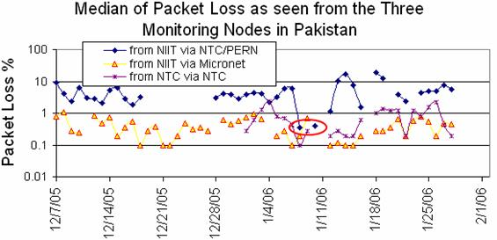
Figure 39 Median packet loss from 3 hosts in Rawalpindi to Pakistani sites
The loss results shown in Fig.19 indicate that NTC has a low loss network with the packet loss percentage being less than 1% from the NTC monitoring host to the Pakistan university sites. The NIIT Micronet link though having less bandwidth and a higher minimum RTT is found to have roughly a factor five lower packet loss (1-2%) than the NIIT NTC/PERN link (5-10%). This is believed to be since the NTC/PERN link is used by default for all NIIT’s traffic with Micronet being reserved for a few select projects/faculty. The drop in loss during the Eids holidays (red circle), for the NTC/PERN link when students typically are not present, confirms this. The missing NIIT measurements around Eids (red ellipse) are due to a power outage at NIIT.
We also prepared a case study [29] on the internet outage in Pakistan during the month of July-05 [pak-fibre] which disconnected the only submarine fibre link (SEAMEW3) for the whole nation of 150 Million for almost a fortnight. Officials of the Internet Service Provider Association of Pakistan (ISPAK) said “the entire country was facing an Internet blackout after a problem occurred at the end of the only Internet backbone provider – PTCL”. The backup satellite links were inadequate to handle the country’s internet traffic. As a result many sites had no international Internet access at all and the few lucky ones (priority was given to call centers) experienced high packet loss and unacceptable performance. There have been several such extended fibre outage incidents (March, June-July, September) in the last year.

2.4.3. South Asia
We also conducted a thorough case study on the South Asian region which yielded significant results.
As shown in Figure 1, the sites from which monitoring is conducted are shown in red, sites which are monitored by all monitoring hosts (these are referred to as beacon sites and also include monitor sites) are shown in blue, and other monitored remote sites are shown in green. From SLAC, PingER monitors about 460 sites, CERN used to monitor about 132 sites, however after re-installing in December 2006) they now only monitor beacon sites (56). ICTP Trieste monitors 105 sites but only has data going back to September 2006. map which defines how we assign countries to regions.
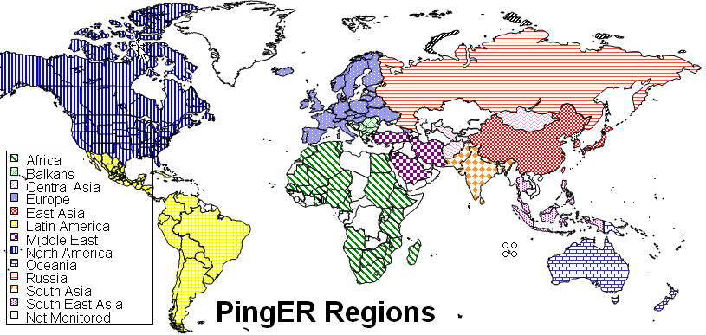
Figure 40 Map defining the way PingER regions are assigned
Figure 41 shows the countries we consider as part of S. Asia. The map shown in the center (figure 41) shows the monitoring and remote hosts (host monitored) in S. Asia. In India we have four PingER monitoring sites: CDAC sites in Pune and Mumbai, VSNL in Mumbai and ERnet in Bangalore. In Pakistan we have five working monitoring sites: two at NIIT/NUST Rawalpindi (one on the Pakistan Educational and Research Network (PERN), the other on a Micronet DSL link), one at the National Center for Physics (NCP) at the Quaid-e-Azam university (QAU) Islamabad, one at COMSATS university Islamabad and one at PERN itself. In addition we have 3 remote (monitored) sites in Afghanistan, 3 in Bangladesh, 2 in Bhutan, 9 in India, 2 in the Maldives, 3 in Nepal, 16 in Pakistan and 6 in Sri Lanka. The map shown at the right (figure 41) shows the location of the sites.
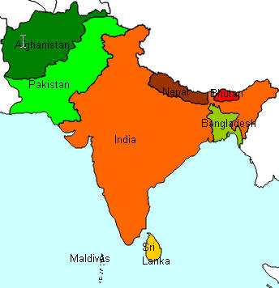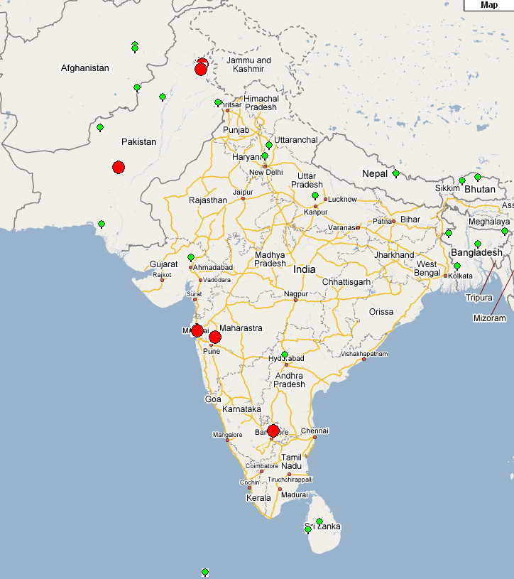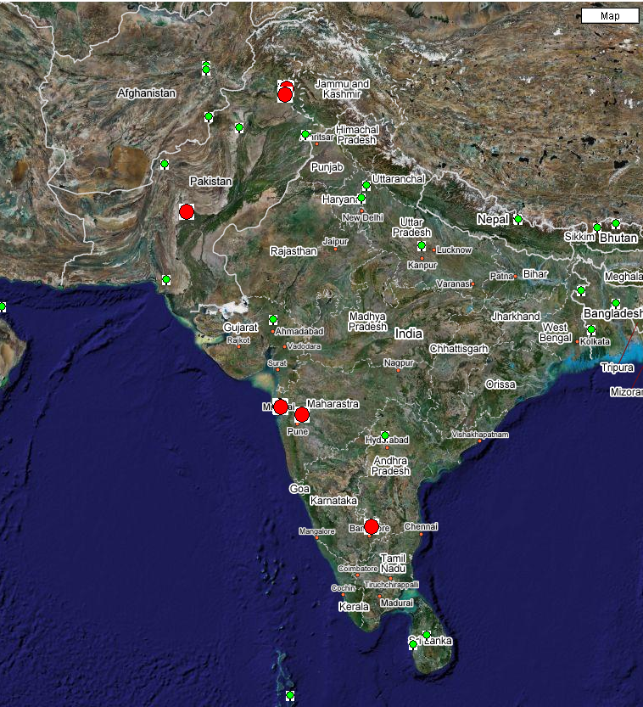
Figure 41 South Asian Countries, Monitoring and Remote hosts and Location of the sites

2.3.4.1 South Asia as compared to the rest of the world regions
Before we compare S. Asia to the rest of the world it is useful to look at a World Map of Internet Users. This shows that for most the developed world (US and Canada, W. Europe, Japan, Taiwan, S. Korea) typically 40% or more of the people have Internet connectivity while for S. Asia it is less than 5%, i.e. typically a factor of 10 less.
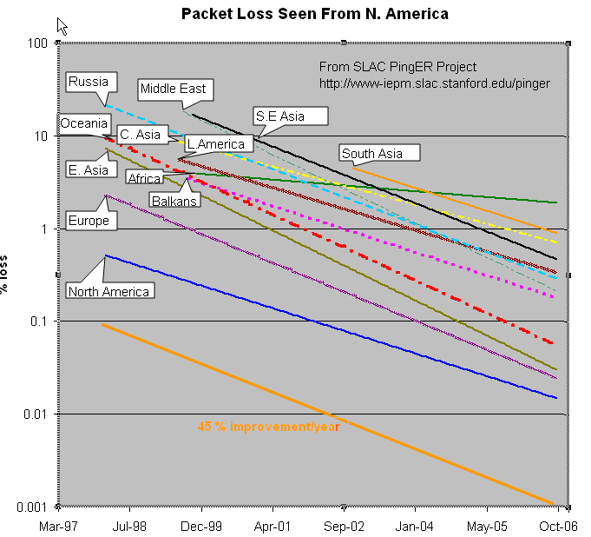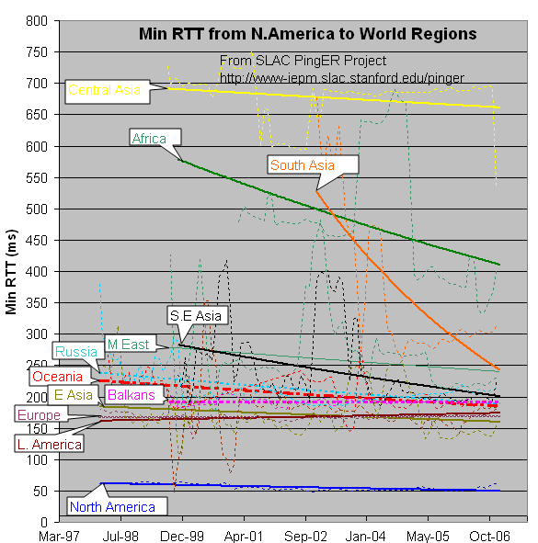
Figure 42 Packet Loss, Min RTT from N.America to World Regions

The figure 42 shows the packet loss to various regions of the world as seen from N. America. Since losses are fairly distance independent no attempt has been made to normalize the data. It is seen that the world divides up into two major super-regions: N. America, Europe, E. Asia and Oceania with losses below 0.1%, and Latin America, C. Asia, Russia, S.E. Asia, S. Asia and Africa with losses > 0.1% and as high as a few per-cent. All countries are improving exponentially, but Africa is falling further behind most regions.
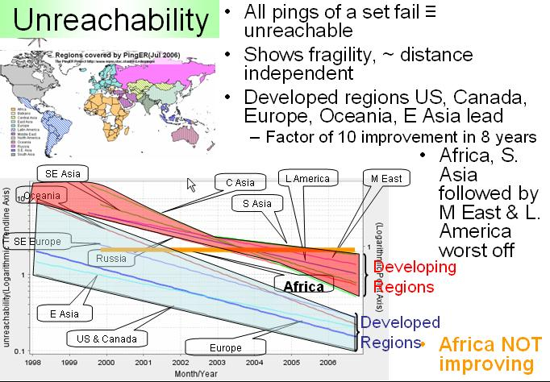
Figure 43 Unreachability
Figure 42 also shows the drop in the Minimum RTT from 2002-2006. The large step for S. Asia in 2003 was due to the change over from satellite to fibre. As the result of gradual shift from Satellite to fiber. Central Asia (also Afghanistan) has hardly moved in its minimum RTT since it continues to use geostationary satellites.
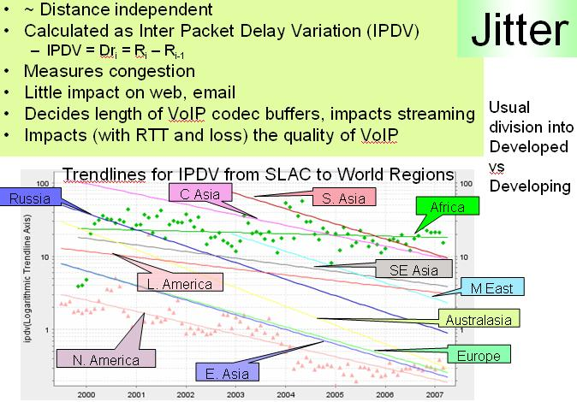
Figure 44 Jitter
Figure 43 shows the unreachability of world regions seen from the US. A host is deemed unreachable if all pings of a set fail to respond. It shows the fragility of the links and is mainly distance independent (the reasons for fragility are usually in the last mile, the end site or host). Again the developed regions, US and Canada, E. Asia, and Oceania have the lowest unreachability (< 0.3%) while the other regions have unreachability from 0.7% to 2%, and again Africa is not improving, with S. Asia having the second worst unreachability.

Figure 44 shows the jitter or variability of world regions seen from the US. The jitter is defined as the Inter Quartile Range (IQR) of the Inter Packet Delay Variability (IPDV i = RTT i - RTT i-1). The Jitter is relatively distance independent; it measures congestion, and has little impact on the Web and email. It decides the length of VoIP codec buffers and impacts streaming. We see the usual division into developed versus developing regions.

2.3.4.2. Min RTT and Packet Loss of South Asian Countries
The minimum RTTs (seen in the figure below from CERN/Geneva Switzerland) are acceptable for India and Pakistan. For Afghanistan they are large (dreadful or over 500ms) since the connections are via geostationary satellite(s). The routing (see above) for Sri Lanka, Bangladesh, Nepal and Bhutan is non-optimal so the RTTs are poor or very poor.
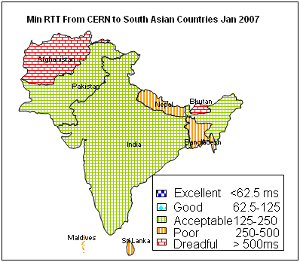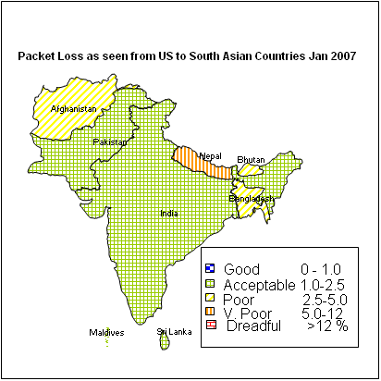
Figure 45 Min RTT and packet loss
The second figure shows packet losses. These are more distance independent than RTTs. Once again it is seen that India, Pakistan, Sri lanka and the Maldives have acceptable losses (< 2.5%). while Afghanistan, Bangladesh, Bhutan, and Nepal have poor to very poor losses.

2.3.4.3. Throughput time series for S. Asia from SLAC
Figure 46 shows the time series of the daily averaged derived TCP throughputs (in kbits/s) to S. Asia from SLAC. It can be seen that there are large fluctuations. These fluctuations are a characteristic of congested lines (typically the last mile). At weekends when people are not at work, there is less congestion and better throughput. It is also seen that the countries divide into two. India, Pakistan, Sri Lanka and the Maldives have better throughput 400-1200 kbits/s compared to Nepal, Bangladesh, Bhutan and Afghanistan with between 75 and 400 kbits/s.
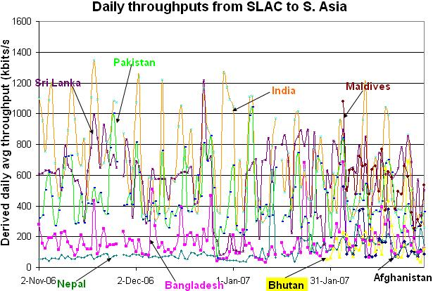
Figure 46 Daily throughputs from SLAC to S.Asia

2.3.4.4. South Asian Internet Usage Statistics
It can be seen that India has the largest population, but the growth in Internet users from 2000-2007 is maximum for Pakistan (8861%). India has the maximum Internet users about 40 million, which is only (3.65 %) of the population. Pakistan has about 12 million Internet users with a population penetration of 7.23 %.

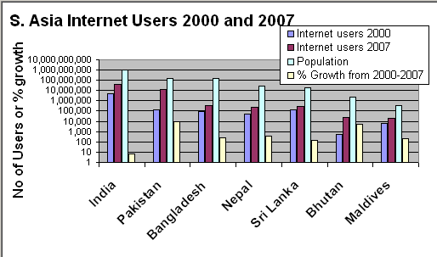
Figure 47 Internet USage - The y-scale is Logarithmic. India has ~3000 times the population of the Maldives

2.3.4.5 Comparison with Development Indices
The size of the Internet infrastructure is a good indication of a country's progress to information based economy. However measuring the number of users is not easy in developing countries because many people share accounts, use corporate and academic networks, or visit the rapidly growing number of cyber cafés, telecentres and business services. Furthermore, the number of users does not take into account the extent of use, from those who just write a couple of emails a week, to people who spend many hours a day on the net browsing, transacting, streaming, or downloading. New measures of Internet activity are needed to take these factors into account. Most of the Internet traffic in a developing country is international (75-90%). We measure international Internet performance which is an interesting (good?) indicator. To see how well this correlates with "development" indices we scatter plot the Mathis derived throughput from PingER against various development indices. If it correlates well then we may be able to make much quicker snap-shots of a country's/regions performance without subjective biases.
There are many "development" indices today:
- UNDP Human Development Index (2006, 177 countries)
- UNDP Technology Achievement Index (2001, 72 countries)
- ITU Digital Access Index (2003) and the Digital Opportunity Index (2006), both 180 countries
- World Economic Forum's Network Readiness Index (2004, 2005, 2006-2007: 122 countries)
- Harvard University Network Readiness Index (2002, 75 countries)
Typically these indices use some combination of GDP/capita, knowledge (e.g. tertiary education enrollment), life expectancy, network (hosts/capita, access, policy, usage, affordability, users/capita); technology (patents, royalties, exports, phones/capita)
In the scatter plots below of the derived throughputs vs. the "development" index, the US, Canada and Mexico are typically excluded since the distance from the measuring point (the US) RTT is small so the derived throughput from the Mathis formula will be artificially high. Hosts in well connected countries such as Finland, Sweden, Japan also have their losses poorly measureed since only 14,400 packets are sent to a host in a month, so measuring losses of < .01% is inaccurate.

2.3.4.5.1. Comparison of TCP Throughput with UNDP Human Development Index
The UNDP Human Development Index (HDI) is composed of 3 factors defining the development of a country. They are:
- A Long and healthy life, as measured by expectancy at birth.
- Knowledge, as measured by the adult literacy rate (with 2/3 weight) and the combined primary, secondary and tertiary gross enrolment ratios (with 1/3 weight).
- A decent standard of living, as measured by GDP per capita.
On the scatter plot the S. Asian countries are indicated by orange diamonds.
The figure below shows a scatter plot of the HDI versus the PingER Derived Throughput for July 2006. Each point is colored according to the country's region. A logarithmic fit is also shown. Logarithmic is probably appropriate since Internet performance is increasing exponentially in time and the differences between the countries can be related to number of years they are behind the developing countries, while human development is more linear. Since the PingER Derived TCP Throughput is linearly proportional to RTT, countries close to the U.S. (i.e. the U.S., Canada and Central America) may be expected to have elevated throughputs compared to their HDI. We thus do not plot or use these countries in the correlation fit between HDI and throughput. It is seen that there is a strong correlation (R2 > 0.6) between the HDI and throughput. As expected countries in Africa generally occupy the lower values in x and y, and European countries together with Australia, New Zealand, Korea and Japan occupy the higher values of x and y.
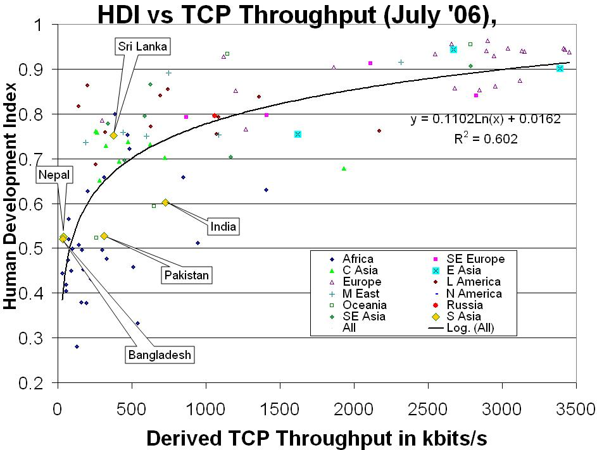
Figure 48 HDI vs TCP Throughput

2.3.4.5.2. Comparison of TCP Throughput with Technology Access Index
In 2001 the United Nations Development Programme (UNDP) introduced the Technology Achievement Index (TAI) with 72 countries to reflect a country's capacity to participate in the technological innovations of the network age. The TAI aims to capture how well a country is creating and diffusing technology and building a human skill base. It includes the following dimensions: Creation of technology (e.g. patents, royalty receipts); diffusion of recent innovations (Internet hosts/capita, high & medium tech exports as share of all exports); Diffusion of old innovations (log phones/capita, log of electric consumption/capita); Human skills (mean years of schooling, gross enrollment in tertiary level in science, math & engineering). the Figure below shows December 2003's derived throughput measured from the U.S. vs. the TAI. The correlation is seen to be positive and medium to good.
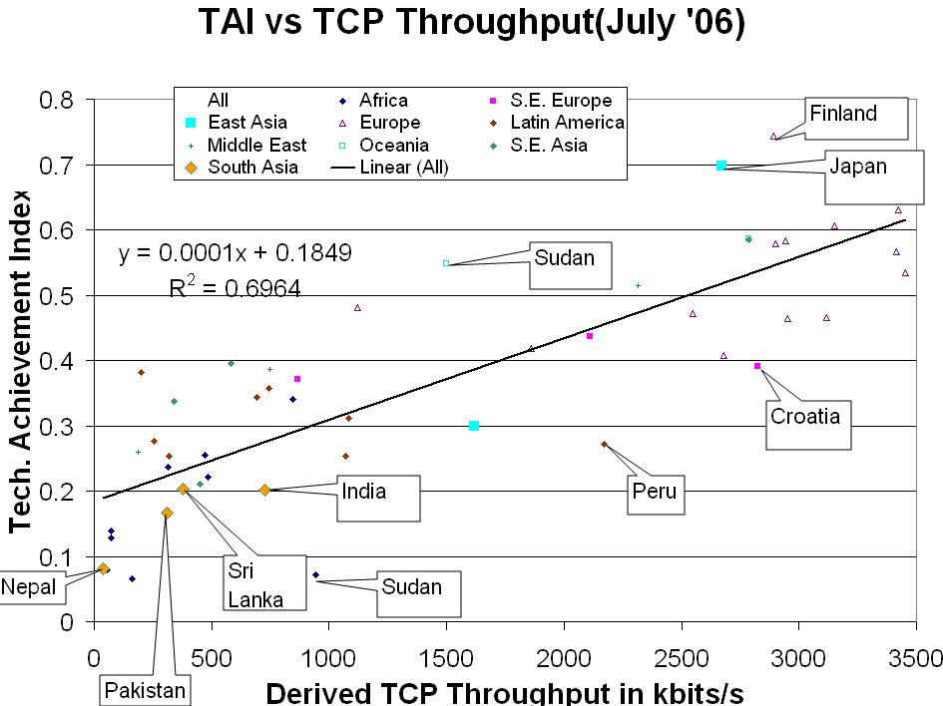
Figure 49 TAI vs TCP Throughput

2.3.4.5.3. Comparison of TCP Throughput with Digital Access Index
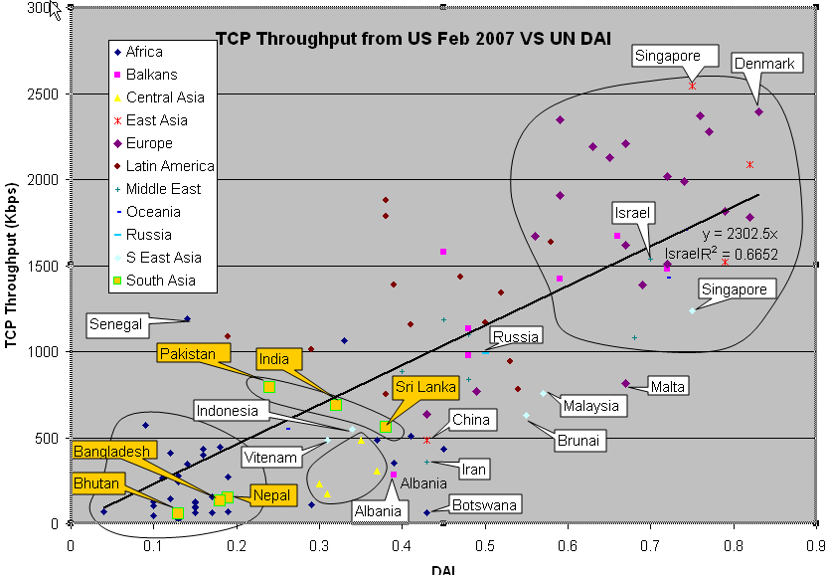
Figure 50 TCP Throughput vs UNDAI
"In 2003, the ITU's Market, Economics and Finance Unit launched the Digital Access Index (DAI), a new index, which measures the overall ability of individuals in a country to access and use new ICTs. The DAI is built around four fundamental vectors that impact a country's ability to access ICTs: infrastructure, affordability, knowledge and quality and actual usage of ICTs. The DAI has been calculated for ~180 economies where European countries were among the highest ranked. The DAI allows countries to see how they compare to peers and their relative strengths and weaknesses. The DAI also provides a transparent and globally measurable way of tracking progress towards improving access to ICTs." from http://www.itu.int/ITU-D/ict/dai/. In 2005 the ITU launched the Digital Opportunity Index(DOI) The DoI evaluates the opportunity, infrastructure and utilization of Information and Communication Technologies (ICTs) for 180 economies worldwide. The Index monitors the mobile communications that promise to bridge the digital divide in many parts of the world, as well as more recent technologies such as broadband and mobile Internet access. The figure 51 shows the DOI coverage and values worldwide.

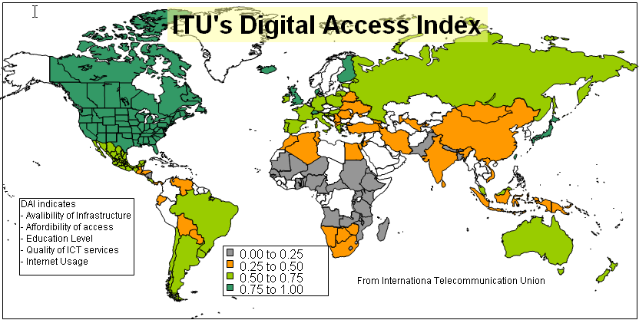
Figure 51 ITU Digital Access Index
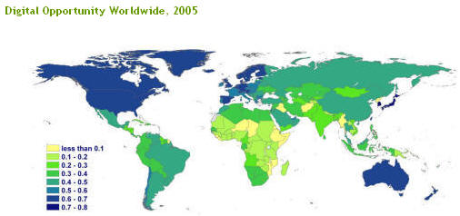
Figure 52 Digital Opportunity Worldwide

Most of the European countries lie above 1500 Kb/s throughput and greater than 0.6 DAI. With the exceptions being Malta, Belarus and Ukraine. Balkans is catching up with Europe with the exception being Albania which is way down.
Most of the East Asian countries lie in the same region of the scatter plot with the exception of China. Middle East and Russia are right in the middle. Two Middle Eastern countries Israel and Cyprus lie in the top cluster with Europe. The other exception in the Middle East is Iran which is way down.
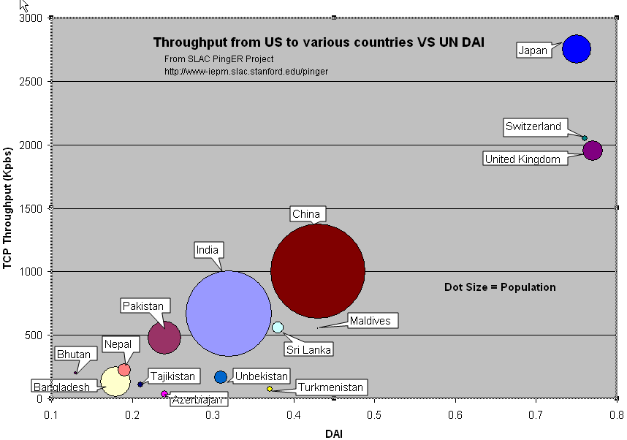
Figure 53 Throughput from US to various VS UN DAI
South East Asia can be divided into three categories with Singapore in the top, Malaysia and Brunei in the middle and Vietnam and Indonesia at the bottom. South Asia forms two clusters one is Pakistan, India and Sri Lanka which are reasonably good and the others Nepal, Bhutan etc which lies in the same category as Africa.
Africa and Central Asia mostly lies at the bottom.

2.3.4.5.4. Comparison of TCP Throughput with the Network Readiness Index (NRI) 2006-2007
The Network Readiness Index (NRI) comes from the "The Global Information Technology Report 2006-2007" of the World Economic Forum. NRI measures the degree of preparation of a nation or community to participate in and benefit from ICT developments. The NRI is composed of three component indexes which assess:
- environment for ICT offered by a country or community
- readiness of the community's key stakeholders (individuals, business and governments)
- usage of ICT among these stakeholders.
A map of the NRI for the 122 countries of the 2006-2007 NRI are shown in the map below.
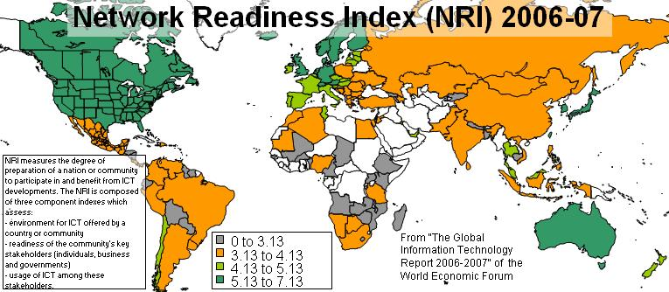
Figure 54 Network Readiness Index (NRI) 2006-2007
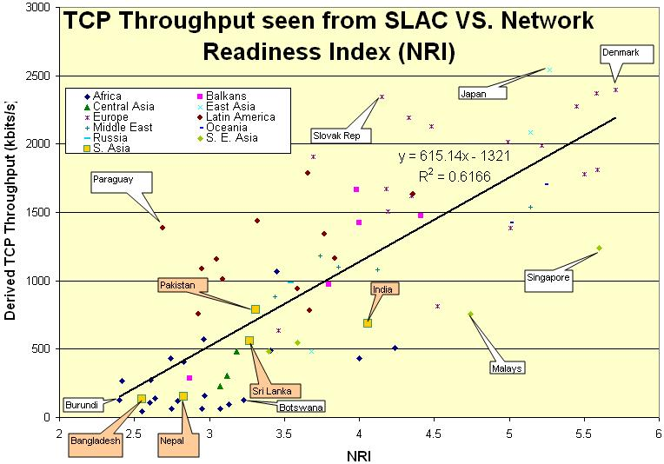
Figure 55 TCP Throughput seen from SLAC vs Network Readiness Index (NRI)
It is seen that the developed countries US, Canada, N. Europe, Japan, Korea, Australia, Taiwan have a high NRI (> 5.13, dark green) NRI, followed by S. & E. Europe, New Zealand, Chile, Malaysia, Tunisia, Qatar (NRI > 4.13, light green). The worst off countries (< 3.13, grey) of the countries reported on (countries not reported are in white) are mainly land-locked countries.
There is a strong correlation (R²>0.6) between the TCP throughput and NRI. Africa is mostly at the bottom with NRI less than 3.3 and TCP throughput mostly less than 1000 Kb/sec. Europe and East Asia are mostly at the top. In South Asia (large orange squares) though India has the largest NRI it is between Pakistan and Sri Lanka in its TCP throughput.

2.5. Spin off Benefits
The MAGGIE-NS Project also provided a great opportunity to the research community at SLAC, to identify and understand the issues in the network infrastructure in Pakistan. Regardless of the technical advancements achieved through the project, MAGGIE-NS stands out as a harbinger in raising the standard of research in Pakistan. An institute launched in April 1999 with a vision to “usher in an Information Culture and Technology Revolution in the Country”, NIIT has progressed by leaps and bounds, evident by the quick absorption and high standing of the first graduate batch (BIT-I) in the local market. However, it is the “Research Culture” and the growing number of “International Collaborations” that has raised NIIT to one of the best Technology institutes in the country. The NIIT-SLAC Collaboration has certainly played an important role in setting standards for other research groups in the institute.
The NIIT faculty gained many benefits working with the research community at SLAC. Not only did they get a chance to update themselves about the global research in networks and network monitoring, but the two week visit and constructive critique of the course contents by Dr. Les Cottrell proved to be valuable for the institute. The NIIT faculty got know-how about the latest trends in technology as well the variety of teaching methods followed at Stanford University. This was re-enforced by the visit of Prof. Dr. Arshad Ali to SLAC where he met with senior SLAC and Stanford faculty as well as senior people in successful (Sun and Cisco) and start-up technical industries. Issues discussed included distance learning techniques, training techniques, fostering of technology transfer and entrepreneurship, peace and conflict resolution. Moreover, the Network and System administrators at NIIT were able to see the networking and security policies in place at SLAC, giving them a broader vision of the improvements required in the internal infrastructure at NIIT.
MAGGIE-NS combined the guidance of Dr. Cottrell’s broad networking knowledge and the direction of Dr. Ali’s vision to transform a group of hardworking and motivated students into dynamic researchers, capable of initiating a revolution, not only in the IT sector in Pakistan, but also other aspects of the society. MAGGIE-NS contributed to the institute by providing the students with an opportunity to spend a year at SLAC and work in a high class research environment, study at a high class university, and interact with high class people, to transform them into high class individuals. In addition, two groups of graduate and undergraduate students located in Pakistan at NIIT have had the benefit of co-supervision by Dr. Cottrell. These experiences will definitely go a long way in impacting the Pakistani society and sparking an ICT revolution in the country.

2.6. Papers and Technical Reports

2007
- ICFA SCIC 2007 Report edited by R. L. Cottrell.
- Quantifying and Mapping the Digital Divide from and Internet Point of View, R. L. Cottrell, S. Khan, S. A. Mehdi, U. Kalim, A. Ali in proceedings of AACC 2007.
- Scientific Overview of Internet Connectivity and Grid Infrastructure in South Asian countries, S. Khan, R. L. Cottrell, U. Kalim, A. Ali in proceedings of CHEP 2007.

2006
- Evaluation of Techniques to Detect Significant Network Performance Problems using End-to-end Active Network Measurements, R. L. Cottrell, M. Chhaparia, F. Haro, F. Nazir, M. Sandford, NOMS 2006, April 2006
- Quantifying the Digital Divide: A Scientific Overview of the Connectivity of South Asian and African Countries, A. Rehmatullah, R. L. Cottrell, J. Williams, A. Ali, CHEP06.
- January 2006 Report of the ICFA-SCIC Monitoring Working Group, edited by Les Cottrell for the ICFA SCIC Monitoring Working Group.

2005
- 2005 Annual Project Report for MAGGIE-NS, R. Les. Cottrell. A. Ali, September 2005.

3.2. Talks

2007
- Quantifying the Need for Improved Network Performance for S. Asia, Les Cottrell, Shahryar Khan, I2 Planning Meeting: Enhancing Research & Education Connectivity to and within S. Asia, Arlington VA, US April 26, 2007
- Quantitative Measurement of the Digital Divide, Les Cottrell, Shahryar Khan, presented at the April APS meeting, Jacksonville Florida April 15, 2007
- MAGGIE NIIT-SLAC On Going projects, presented by Adnan Iqbal
- Next Generation Network Monitoring, by Les Cottrell
- PingER project, perfSONAR, proposal of NIIT, SLAC and PERN for HEC, presented by Les Cottrell to Anwar Anjad head of PERN, Pakistan, Martch 16, 2007
- Visualilzing the Digital Divide from an Internet View and Some Challenges, prepared by Les Cottrell, Umar Kalim, Shahryar Khan and Akbar Mehdi for the COMSATS University, Islamabd, Pakistan
- Stanford University, SLAC, NIIT, The Digital Divide and Projects, given by Les Cottrell to the NIIT undergradates March 15, 2007.
- Next Generation Network Monitoring for Pakistan, A Proposal, presented by Les Cottrell and Arshad Ali to Prof. Dr. Atta-ur-Rehman, chairman of the Higher Education Commission, Pakistan
- The Digital Divide, by Les Cottrell, Shahryar Khan & Akbar Mehdi at the Quaid-e-Azam University Islamabad, Pakistan, March 2007
- Stanford University, SLAC and NIIT, by Les Cottrell at the NIIT Convocation dinnet March 9, 2007

2006
- Quantifying the Digital Divide from an Internet Point of View, R. Les Cottrell, Aziz Rehmatullah, Jerrod williams and Akbar Mehdi, Presented at the Reuters Digital Vision Program Stanford October 17, 2006.
- Internet Monitoring and Results for the Digital Divide, R. Les Cottrell, Aziz Rehmatullah, Jerrod williams and Akbar Mehdi, presented at the "International ICFA Workshop on Grid Cativities within Large Scale International Collaborations", Sinaia, Romania October 13-18, 2006.
- Quantifying the Digital Divide from an Internet Point of View, R. Les Cottrell, Aziz Rehmatullah, Jerrod williams and Akbar Mehdi, presented at ICTP "Optimization Technologies for Low-Bandwidth Networks" workshop Trieste October 2006.
- PingER: An Effort to Quantify the Digital Divide, presented by Aziz Rehmatullah, May 2006.
- Stanford University, SLAC, NIIT, the Digital Divide and Bandwidth Challenge, Presented by Les Cottrell to the NUST/NIIT Faculty, Islamabad, Feb 2006.

2005
- Higher Education and Research in Pakistan presentation to SLAC Computer Services by Prof. Dr. Arshad Ali, NUST, Rawalpindi, Pakistan, April 15, 2005
- Internet Monitoring lecture given by Les Cottrell at NIIT, Rawalpindi, Pakistan, March 2005.
- Stanford University, SLAC, NIIT and the Digital Divide dinner talk given by Les Cottrell at NUST convocation, Rawalpindi, Pakistan, March 2005.
- Quantifying the Digital Divide, prepared by Les Cottrell for the Internet2/World Bank meeting, Feb 7 2005.

3. Conclusion

3.1. Conclusions
The outcome of MAGGIE-NS has been very promising considering the progress and pace of development of PingER and IEPM-BW. The students and researchers at NIIT have contributed a significant amount of time and effort and have taken the lead to help establishing a research culture at NIIT. As a consequence, a host of network monitoring and performance analysis software were developed ranging from performance measurement, data analysis, event diagnosis and detection software to a variety of tools such as Topological Analysis and Network Performance Visualization, PingER Executive Plots, PingER Management and Visualization software and others which are publicly available via the project website [34].
These developments have significantly benefited NIIT and Pakistan by providing ample opportunity to all the participants to develop highly skilled human resource, trained in sophisticated network performance monitoring, analysis and diagnosis and develop state of the art software for network performance measurement and analysis.
As an outcome of this project the team has been able to publish five research papers in internationally renowned conferences, three technical reports, six thesis and nineteen talks. Also, five undergraduate students designed and implemented their final year projects as part of research and development. Two of these have continued to work with us as research associates where as two have moved on to join well-reputed commercial organizations (namely NCR and Mobilink) in the capacity of analysists and network engineers, where as one has moved on to setup his own business in providing analysis of user access to network services (such as web-server contents).
The contribution from NIIT has revolved around development and analysis tasks of extending and improving the monitoring infrastructures of PingER and IEPM as well as miscellaneous but relevant network analysis software. The on-going visit of dynamic individuals to and from SLAC has certainly increased the pace as well as the nature of these contributions, with significant enhancements in the on-going projects. This has provided NIIT’s students and staff with training in best-practices and state of the art technology. Consequently, the problems in the overall network of Pakistan are being analyzed with a much greater amount of depth with an aim to replicate these findings to other developing countries.
The US partner (SLAC) has on occasions provided financial support to students who were required to extend their stay at SLAC due to development requirements. This speaks volume of the level of confidence that both sides have in each other as well as the strength of the collaboration.
Most importantly, MAGGIE-NS has provided NIIT and Pakistan with a platform to develop the skill-set required to make herself self-sufficient regarding its technical needs.

3.2. Future Directions
The next proposal to USAID/US-State Department focuses on not only on extending the MAGGIE-NS work but also to develop a comprehensive next-generation monitoring infrastructure for the Pakistan Educational Research Network (PERN). In the near future for MAGGIE-NS, we plan to address:
- The promising study of passive measurements for forecasting still needs considerable work identify how well/consistently it works for various applications.
- A detailed case study covering various aspects of the Pakistan network performance is being carried out. Classification on the basis of cities, universities, ISPs etc would be made to help identify the most reliable, fast, efficient link the country. Congestion level would be found at various levels i.e. the end host for instance NIIT, ISP, for instance NTC or the core gateway router of the country, for instance the PIE (Pakistan Internet Exchange) [30]. This would help in identifying the exact locations of the bottlenecks, which would in turn help optimize the country’s network with much less than projected cost.
- We plan to apply the perfSONAR framework to PERN, this will involve amending and or creating new services, from the existing perfSONAR services, which are tailored towards the specific requirements of the Pakistani research network. This framework shall ultimately:
- Be easily extensible to new types of measurement and analysis tools. Tool developers will be able to focus on how the tool operates, not on how to deploy the tool widely enough for it to become useful.
- Scale to global size. Multi-national science communities will be able to focus on science, not just run networks.
- Contain flexible policy for sharing across administrative domains. Local domains will retain control over the policies that define how specific resources can be accessed and what data will be shared with whom according to uniform, organization-agreed-upon policies, not ad hoc decisions based on personal relationships.
- Use common data exchange formats. The OGF Error: Reference source not found NM-WG Error: Reference source not found schemata will be used to ensure that different tools and archives can exchange data effectively.
- Use common discovery mechanisms. Users will be able to find measurements points and archival data to assist in troubleshooting an application’s behavior.
- Use generic service components for tracking resource utilization and user authorization to acquire those resources for performance testing.
- Piggyback on existing federated trust authentication infrastructures
- We shall also develop new and innovative presentation, reporting, network problem detection and alerting techniques based upon the perfSONAR framework using the experience gained from previous projects and make them production quality for use on PERN2.
- Equally importantly, we shall foster the partnership between NIIT/Pakistan and the SLAC/U.S. to improve the quality and relevance of Pakistani higher education in science and technical fields.

4. References

- National University of Sciences and Technology (NUST). http://www.nust.edu.pk
- Quaid-e-Azam University (QAU). http://www.qau.edu.pk
- Large Hadron Collider (LHC) Computing Grid Collaboration (LCG). http://lcg.web.cern.ch/LCG/
- The PingER Project: Active Internet Performance Monitoring for the HENP Community, Warren Mathews and Les Cottrell, Stanford Linear Accelerator Center, IEEE Communications Magazine, May 2000
- http://www.slac.stanford.edu/comp/net/wan-mon/tutorial.html#ping
- Quantifying the Digital Divide from Within and Without presented by Les Cottrell at the International ICFA Workshop on HEP Networking, Grid and Digital Divide Issues for Global e-Science, Daegu, Korea, May 23-27, 2005
- MonALISA: A Distributed Monitoring Service Architecture; H.B. Newman, I.C. Legrand, P.Galvez, R. Voicu, C. Cirstoiu; CHEP 2003, La Jola, California, March 2003
- http://www-iepm.slac.stanford.edu/bw/
- pathChirp: Efficient Available Bandwidth Estimation for Network Paths; Vinay J. Ribeiro et al; ;PAM 2003, San Diego Super Computer Center, University of California, San Diego
- Comparison of Public End-to-end Bandwidth Estimation Tools on High-Speed Links, A. Shriram, M. Murray, Y. Hyun, N. Brownlee, A. Broido, M. Fomenkov, k. claffy, PAM 2005
- ABwE :A Practical Approach to Available Bandwidth Estimation; Jiri Navratil and R. Les. Cottrell Stanford Linear Accelerator Center (SLAC); PAM 2003
- http://dast.nlanr.net/Projects/Iperf/
- thrulay, network capacity tester, S. Shalunov, available at http://www.internet2.edu/~shalunov/thrulay
- http://www.slac.stanford.edu/comp/net/wan-mon/viper/
- Constraint-based Geolocation of Internet Hosts; B. Gueye, A Ziviani, M. Crovella, S Fdida, ACM Internet Measurement Conference 2004
- Scale-free behavior of the Internet global performance; Roberto Percacci_ and Alessandro Vespignani European Physical Journal B 32 411-414 (2003)
- TULIP - http://www.slac.stanford.edu/comp/net/wan-mon/tulip/
- http://confluence.slac.stanford.edu/display/IEPM/Multi-route+Event+Detection+Using+PCA
- http://www-iepm.slac.stanford.edu/monitoring/event-diagnosis/analysis/summary.html
- Cause and Effect of Anomalous Events on QoS Parameters; Márcio de Freitas Minicz and Alessandro Anzaloni; 2nd International Workshop on Inter-Domain Performance and Simulation (IPS 2004) 22-23 March 2004, Budapest, Hungary. http://w3.tmit.bme.hu/ips2004/papers/ips2004_028.pdf
- Automated Event Detection for Active Measurement Systems; A. J. McGregor and H-W. Braun, Passive and Active Measurements 2001. Available at http://byerley.cs.waikato.ac.nz/~tonym/papers/event.pdf
- http://www.physics.csbsju.edu/stats/KS-test.html
- “Diagnosing Network-Wide Traffic Anomalies”; Lakhina A, Crovella M, Diot C; Sigcomm 2004
- http://www-iepm.slac.stanford.edu/monitoring/forecast/hw.html
- Principle components and importance ranking of distributed anomalies; Kyrre Begnum and Mark Burgess; Machine Learning Journal, 58, 217-230, (2005)
- http://www.cisco.com/warp/public/732/Tech/nmp/netflow/index.shtml
- Experiences in Traceroute and Available Bandwidth Change Analysis, presented by Connie Logg, Les Cottrell, and Jiri Navratil at the Sigcomm2004 Net Trouble Shooting Workshop Portland Oregon Sept 3, 2004. Also SLAC-PUB-10518
- http://www.slac.stanford.edu/comp/net/iepm-bw.slac.stanford.edu/tracesummaries/today.html
- http://www.slac.stanford.edu/grp/scs/net/case/pakjul05/
- www.pie.net.pk
- “Open Grid Forum”, available at http://www.ogf.org/.
- “Network Monitoring Working Group”, available at http://nmwg.internet2.edu/.
- http://www.nanog.org/lookingglass.html
- http://maggie.niit.edu.pk

The route number is simply an index assigned to a unique route between two hosts.

