Abstract—We describe and compare the use of several different algorithms that we have implemented to detect persistent anomalous events in real end-to-end Internet performance measurements. The measurements are based on active probes running on 40 production network paths with bottlenecks varying from 0.5Mbits/s to 1000Mbit/s. For well behaved data (no missed measurements and no very large outliers) with small seasonal changes most algorithms identify similar events. We compare the algorithms’ robustness with respect to false positives and missed events especially when there are large seasonal effects in the data. We also discuss the applicability of the algorithms in terms of their intuitiveness, their speed of execution as implemented, and areas of applicability.
Anomalous Event Detection for Internet End-to-end Performance Measurements
R. Les Cottrell, Connie Logg, Mahesh Chhaparia (SLAC), Maxim Grigoriev (Fermilab), Felipe Haro (PUC), Fawad Nazir (NIIT), Mark Sandford (Loughborough University)

Index Terms—anomalous event detection, forecasting, network monitoring, network performance, performance analysis, persistent anomalies, trouble shooting, Kolmogorov-Smirnov, Holt-Winters, Principal Component Analysis, plateau algorithm.

INTRODUCTION
Management of wide area networking from an end user/administrator point of view is increasingly hard as the complexity of the paths, the diversity of the performance, and the dependency on the network increases. Several monitoring infrastructures have been built [1], [2], [3], [4], [5], [6], [7] to assist by addressing the measurement, archiving, analysis, and presentation aspects of end-to-end performance monitoring. Each of these infrastructures consists of tens to hundreds of monitoring hosts. Each of these monitoring hosts, can make measurements of multiple metrics e.g. delays (both Round Trip Time (RTT) and one way delay), loss, jitter, TCP achievable throughput, available bandwidth, and applications performance (e.g. file transfers or web requests) to hundreds of monitored (remote) hosts. Typically for every pair of hosts (monitor and remote host) there will be a time series plot for each metric, amounting to hundreds to thousands of plots that need to be reviewed to look for anomalous changes in performance. The network administrator can, at best, review some of these reports reactively upon being presented with a problem by a user. We need to enable the network administrator to be pro-active and spot the problem before the user. This in turn requires automating reliable (few false positives and most events detected) detection of persistent (lasts for at least a few hours), anomalous (unusual and significant) changes (events) in performance and reporting them in an efficient way to the network administrator.
Most current commercial products rely on a comparison with a user configured static threshold value and often require access to SNMP MIB information from network devices that the end-user does not have permission to view. Our intent is to dynamically derive the threshold from the end-user accessible data so that it automatically tracks the network’s performance.
In this paper we report on three open source approaches to automatically detect persistent anomalies in end-to-end network performance metrics using active end-to-end network performance measurements from an instantiation of the IEPM-BW [2] measurement infrastructure. The requirements are to detect decreases in performance that are sufficiently large and persist for sufficient time that, upon notification, the local network administrator is able to review the change and report the problem to the up stream provider’s Network Operations Center.
The rest of the paper is organized as follows. Section II describes how the measurements were made, section III describes the analysis used to extract anomalous events, section IV describes the results, section V describes work in progress that will be reported in the final paper, and section VI presents the conclusions.

Measurements
We use measurements from the ABwE [8] lightweight bandwidth estimation tool that uses the packet pair dispersion technique and from the more intense iperf [9] achievable bandwidth estimation tool. We are also applying the techniques to bbftp [10], and GridFTP [11] measurements made at 90 to 120 minute intervals [12], though the results from this are not reported here. ABwE was chosen since it quickly (< 1 second) provides both RTT and rough dynamic bandwidth estimates, that are important to many applications such as bulk data transfer, while it imposes a light network load. Twenty packet pairs are used per direction for each measurement. The frequency of the measurements used for the current work is one to three minute intervals. For each interval, three metrics are measured: dynamic bottleneck capacity (Cap) by analyzing the minimum packet pair separation; Cross Traffic (Xtr) by analyzing the packet pair dispersion; and the Available Bandwidth (Abw) = Cap – Xtr. ABwE also simultaneously provides Cap, Xtr and Abw measurements for the reverse direction.
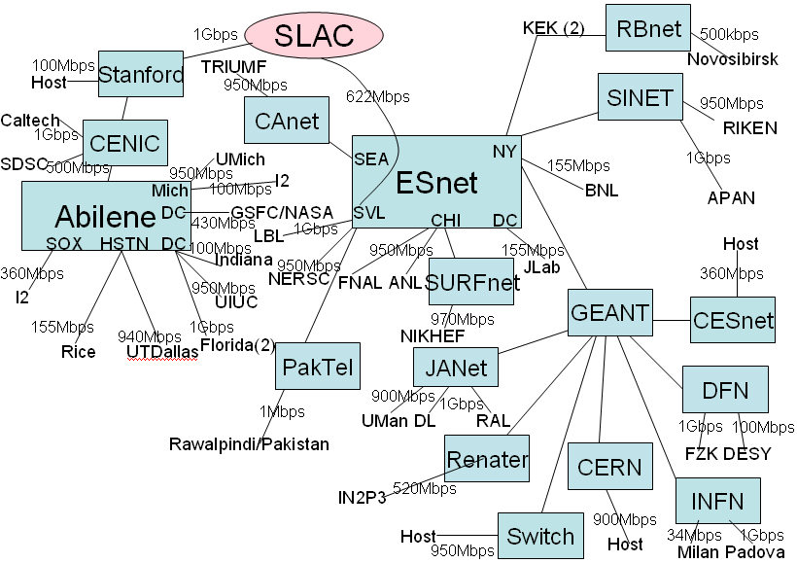
Figure 1: Topology of the remote hosts measured from SLAC
The Abw measurements are probably of most interest to a user, however they are more sensitive to cross-traffic over which we have little control. Changes in Cap on the other hand are more likely to reflect route changes or operator errors etc. and thus may be easier to address. Cap estimates are thus generally preferred for our work. Since only 20 packet pairs are used for each bandwidth estimate, the statistical variability of the estimates is quite high. Estimates can thus vary dramatically from minute to minute and have large outliers. Therefore, ABwE also provides smoothed data using an Exponential Weighted Moving Average (EWMA).
The measurements are made to about 40 hosts in 13 countries, the static bottlenecks vary from 0.5Mbits/s to 1000Mbits/s, the paths traverse about 50 Autonomous Systems (ASs) and over 15 major Internet Service Providers (ISPs). The topology of the remote hosts is seen in Fig. 1. The main ISPs that the paths cross are identified as shaded boxes. For Abilene and ESnet the major Points of Presence (PoPs) are also identified. The remote host sites are also noted, as well as the capacity bottlenecks (Cap) for the paths. Five of the remote hosts (identified in Fig. 1 by “I2” and “host”) are at ISP PoPs, the remainder are at end user sites.
The measurements also suffer from gaps in the observations due to problems with the measurement host, the paths and/or the remote (measured host).
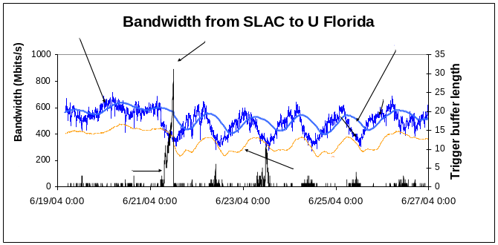
Figure 2 : ABwE bandwidth estimates from SLAC to U. Florida with a history buffer duration (λ) of 10 hours.

Analysis

Plateau Algorithm
The “Plateau” bandwidth change detection algorithm is described in [13]. It is a modification of the algorithm described in [14] that was used to detect step changes in a time series set of measurements of Round Trip Times (RTT). Here we use it to analyze both the Abw and Cap measurements. Currently, missing measurements (e.g. because there is no functioning path between the monitor and monitoring host) are ignored compressing time so the gap is covered over.
The plateau algorithm basically divides the measurements into two buffers: a history buffer (h) for base-lining, or into a trigger buffer (t), when a measurement meets a specific requirement. The specific requirement is that the current measurement is less than β (we use bold face to indicate user settable parameters) standard deviations (o_{h}) below the current mean of the history buffer m_{h}. If the measurement is placed in h then the oldest entry is removed from t. The buffers have maximum lengths of λ (history) and τ (trigger). Given a requested buffer duration, the number of items in a buffer (length) is calculated using the median time separation of the data points. When τ is reached the mean of the trigger buffer m_{t} is compared with m_{h} and if the relative difference Δ = (m_{h} – m_{t}) / m_{h} is greater than the threshold δ then an event is deemed to have occurred.
Sensible values of β are between 2 and 3 [15], we used β = 2. Το minimize the effects of diurnal changes we used λ = 1 day. Longer values flatten the time series behavior of m_{h}, shorter values result in the sinusoidal-wave like curve of m_{h} being out of synchronization with the diurnal changes (see for example Fig. 2 where m_{h} = 10 hours and is seen to trail the EWMA(Abw) by several hours). Note that missing data points can also cause loss of synchronization. Since we were only interested in long term changes we used τ = 3 hours. We currently use δ = 33%. Larger values of δ are likely to miss more real events; lower values are likely to lead to more false positives.

Kolmogorov-Smirnov (KS)
The KS test [16] is the best known of several distribution free techniques for testing for general differences between distributions. The technique makes no assumption about the underlying distribution of the measurements. It compares the observed and expected Cumulative Distribution Functions (CDF) for M data points before (expected) and after (observed) each measurement being evaluated. The KS test is calculated taking the vertical difference between the two CDFs as a test statistic. M in the current work was chosen to be 100 (5 hours for measurements separated by 3 minutes) as a reasonable compromise between the accuracy obtained (sufficient points for the distributions), the time to wait for a response and the analysis time. If response time is deemed less important it may well be worth using a larger value of M as this will provide a larger sample for each distribution. For previous work [20] with less frequent measurements, we chose M to be 24 hours worth of data to minimize the diurnal effects as discussed earlier in the current paper (although one still gets false positives associated with weekends, public holidays etc.)

Holt-Winters (HW) Algorithm
The Holt-Winters (HW) [16], [18] algorithm uses a triple EWMA approximation to characterize the time series behavior as a superposition of three components: a baseline, a linear trend and a seasonal effect (e.g. diurnal changes). We developed two implementations of the HW technique and also used the RRD implementation [17] to compare our results against, and to understand the technique. We will focus our discussion on the implementation developed at SLAC (that is based on the formulation in [18]) since it has the most flexibility for our needs.
HW is critically dependent on having regularly spaced data with no missing points, so the first step is to bin the data into regularly spaced time bins and use similar data to interpolate for bins with no data. For bins with no data in the first week we use data from following weeks for the same day and time bin. For the following weeks we use the previous week’s interpolated data. For our data with bin widths of 3 minutes we found that having about five to seven weeks of data enabled us to successfully interpolate the data and fill in missing bins. Once we have the first week’s interpolated data, new data can be quickly merged onto the existing interpolated data without having to go back through all the data.
Due to the noisiness of the data, we also set the maximum forecast = maximum of all observed values.
We used two methods to choose the initial HW parameters.
- We chose the initial HW parameters using the guidelines in [17]. 99% of the contribution for the baseline EWMA came from measurements made in the last 24 hours; 99% of the seasonal EWMA contribution came from the last week.; 50% of the trend EWMA contribution came from last 24 hours.
- For each path, we minimized the sum of the squares of the residuals (R² = Σr_{i}^{2,} where r_{i} = y_{i} – f_{i}, the sum is over all interpolated data, y_{i} is the interpolated observation at time i and f_{i} is the forecast at the same time) as a function of the HW parameters. This method always resulted in the trend parameter being set to very close to 0 (< 0.00001), which though it may be the optimum for forecasting may not be the optimum for detecting events.
Besides raising alerts if there is missing data, several methods were used to raise anomalous event conditions:
- The residual (r_{i}) at each point was examined to see if it was a trigger, i.e. outside the standard deviation of the forecast for the last 100 points. If 70% of the points in a window of 3 hours were triggers then an event was generated.
- The residual was compared to the EWMA of the absolute deviation [17]. If over 82% of the residuals were outside twice the EWMA of the absolute deviation in the last 84 minutes then an event was generated.
- With a moving window we calculated X² = (1/N) R²
- We applied the plateau algorithm to the residuals.

D. Mark Burgess (MB) Technique
The Mark Burgess (MB) technique introduces a two dimensional time approach [21] to classify a periodic, adaptive threshold for service level anomaly detection. An iterative algorithm is applied to history analysis on this periodic time to provide a smooth roll-off in the significance of the data with time. This method was originally designed to detect anomalous behavior on a single host, with the aim of using the information for self-regulation, by initiating a counter response. An anomaly is indicated by a code indicating the state of the given statistic, as compared to an average of equivalent earlier times. Table 3 gives some examples of the codes.
Code | High | Normal | Low | Meaning
-56 | High | anomaly; more than 3 standard deviations from the expected value
-55 | Normal
-54 | Low
-46 | High | dev2; more than 2 standard deviations from the expected value
-45 | Normal
-44 | Low
-36 | High | dev1; more than 1 standard deviation from the expected value
-35 | Normal | dev1; more than 1 standard deviation from the expected value
-34 | Low | dev1; more than 1 standard deviation from the expected value
Table 1: Some MB Error Codes

Results
To provide a canonical set of measurements to evaluate and compare the detection methods against we used Cap measurements from SLAC to 30 remote hosts for ~100 days from June through September 2004.
To first characterize the events seen in the canonical data, we used the Plateau algorithm, since it is the most intuitive of the algorithms and allows direct variation of parameters representing the size and duration of an event. We set δ to 0 (i.e. we detect all events that fill the trigger buffer) and the other user parameters set as described above. About 25 of the 40 paths manifested one or more events in this period. We carefully reviewed each of these events and created a library of interesting events. We observe three general types of events that trigger our Plateau algorithm.
- Step down changes in bandwidth (“step”)
- Diurnal changes (“diurnal”)
- Changes caused by actions causing congestion, e.g. a regularly scheduled cron job, or network bandwidth test (“host”), flash crowds etc.
Three paths out of 30 (Caltech, NIIT and U. Florida) exhibited marked diurnal changes that triggered “diurnal” plateau events, especially following a weekend. To study the diurnal behavior more carefully we binned the bandwidth data by hour of day and calculated the percentiles to identify the daily bandwidth patterns. An example is shown in Fig. 3 where there is a quick decrease in bandwidth when people arrive to work (20:00-23:00 PDT = 08:00 – 11:00 Pakistan time). This in turn causes an abnormally high number of events to be detected by the plateau and KS algorithms during these hours (see Fig. 4). Usually these changes are not as sudden as the typical step change which may also help in separating the two types. For our purposes, these “diurnal” events are false positives that need to be eliminated.
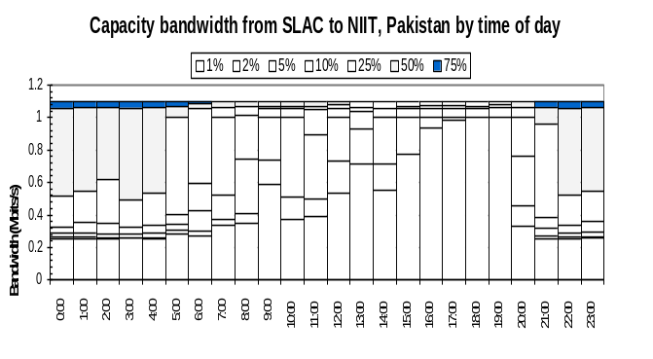 Figure 3: Percentiles of capacity bandwidth seen on the SLAC-NIIT path as a function of time of day
One host (ANL) exhibited regular “host” type events that were tracked down to a cron job running on the host that used (via NFS) the network heavily. This host was eliminated from further analysis. Events for a given host typically have a small range for Δ (standard deviation (Δ) / mean (Δ) ~ 0.11± 0.1) indicating that the backup routes or diurnal behavior is consistent. This manifests itself in a multi-modal Distribution Function for Δ.

By careful examination of ~ 120 plateau candidate events detected with δ = 0 (and ignoring whether the events are diurnal) we classify all candidates as to whether they are events we are interested in or not (i.e. exhibit sharp drop in bandwidth (e.g. 90% of change occurs in < 220 mins), persist for a long term (>> 3 hours) and are large enough (e.g. δ > 10%)). With δ = 10% and restricting the duration of 90% of the trigger buffer to 220 minutes, we miss 8% of the events and see 16% false positives. Increasing δ to 33% we get 32% misses and 2% false positives. In this case 15% of the events are caused by diurnal changes.
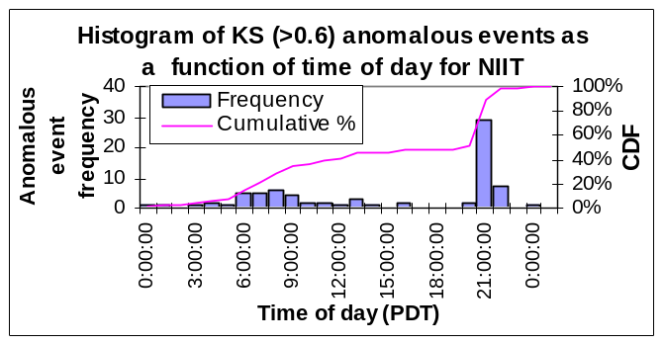
Figure 4: Distribution of events as a function of time of day for the SLAC-NIIT path.
We then also applied KS and HW algorithms to the canonical data. Fig. 5 shows a visualization of the plateau, KS and HW algorithms applied to capacity bandwidth observations with step changes in performance from SLAC to BINP. As expected all three algorithms detect marked changes. KS detects both increases and decreases in the data (but does not identify the sign) and thus detects roughly twice as many events (229:116) as the plateau algorithm which is currently tuned for negative changes only. Detecting both steps is valuable since, for example, it enables determining the duration of a change and/or taking some action when the original performance is restored. KS also provides the most accurate time estimate for when the event occurred which is important when correlating the event with other time-dependent information.
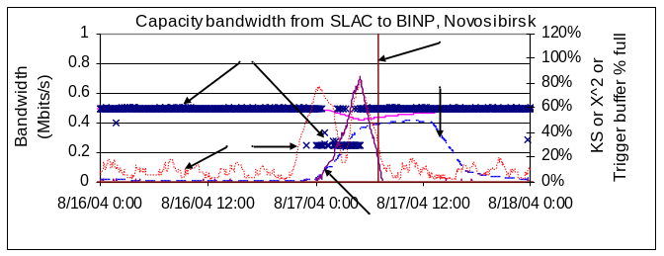
Figure 5: Plateau, KS and HW algorithms applied to an observed step down and back up performance change

In Fig. 5 the KS statistic (dotted) is seen to reach a value of about 0.72, on both the step up and down. The plateau algorithm’s trigger buffer (solid line) only reaches ~ 80% full (since the step down’s duration is too short, in this case ~ 4 hours) so no event is triggered. The HW Χ² (dashed line) triggers an event after the performance has recovered.
Increasing the threshold value (K) of the KS coefficient that defines an event reduces the false positives at the cost of increasing the missed events as seen in Fig.6. Currently we are using a value of K = 0.7 to trigger an event. Most (69%) of the false positives come from four paths. Minimizing R² to estimate the initial HW parameters results in a fairly wide range of values of the local smoothing parameter (a = 0.0001 to 0.95, median = 0.0024 ± 0.12) and the seasonal parameter (b = 0.0023 to 0.999, median = 0.22 ± 0.2). About 50% of the paths have 0.0008 < a < 0.02 and 0.18 < b < 0.4. There is very week correlation between a and b or R² and a or b., which is suggestive that there may not be suitable single set of parameters for all paths.
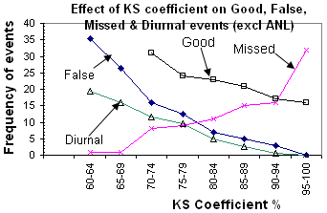
Figure 6: Cumulative step down event types as function of KS coefficient
Using HW with the 70% of triggers in 2.5 hours method to detect events, plus bunching together events separated by < 3 hours, successfully removed the diurnal events for Caltech, NIIT and U. Florida. It also succeeded in eliminating the effects of the ANL cron jobs that ran at regular times each morning. However, there appear to be similar effects that do not occur at regular intervals that make the ANL data problematic. A similar effect giving rise to false positives was seen with the SDSC path. In this case there was a step down of about 10% (65Mbits/s) lasting for 3-4 hours starting around 1am each day for about one week.
With the above HW event detection method, three paths (SOX, NASA and CESnet) with very small deviations in the observations, had small changes in bandwidth that resulted in events with very small changes in bandwidth.
Eliminating the ANL and SDSC paths, and demanding a bandwidth change of at least 5% for an event, HW detected 23 true events, with 1 false positive and 6 missed events. Four of the misses were during the first week of data, when the HW algorithm performs poorly due to not having good initial estimates. A further miss was since the change happened slowly (it took over a day to get from the initial value to the new stepped down value). The final miss was for a step down in performance that only lasted four hours. Thus, with the caveat that HW cannot forecast events (and thus eliminate) caused by applications running at irregular times and causing congestion, the HW technique works well for our data. To understand such events better more measurements are needed on hosts and network equipment to isolate the cause.
Figs. 7 and 8 show the effects of applying the KS and MB techniques to the same iperf data (from SLAC to Caltech March 6 – March 13, 2005). In Fig. 5, to try and remove some of the noisiness in the data and to make the plot more comprehensible, the data has been smoothed by taking a moving average over ??? adjacent points. It is seen in Fig. 4 that the KS coefficient (solid line) identifies the obvious long term step down and step up (both identified by circles) in the data on March 9, 2005 and March 11, 2005 respectively. In Fig. 8 on the other hand, the MB code (the lines) oscillates wildly as it tries to track the individual spikes in the noisy data.
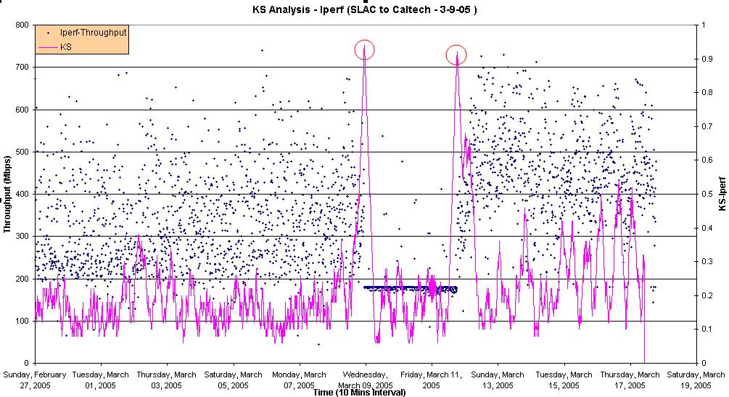
Figure 7 : KS on Iperf data from SLAC to Caltech

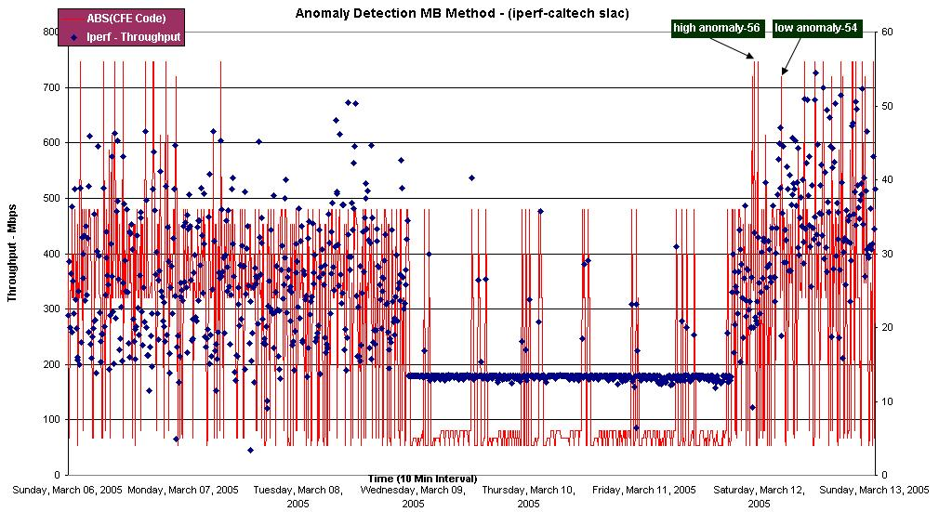
Figure 8 : MB on Iperf Data SLAC to Caltech

Conclusions
For measurements with limited diurnal (or other seasonal) changes all three algorithms work well.
The plateau algorithm is easily understood by people with a non-statistical background and has easy to interpret user settable parameters.
The KS algorithm is the most statistically formal of the three algorithms. It has only two parameters: the number of data points (M) used to evaluate the distribution functions; and the threshold (K) of the KS coefficient above which an event is assumed to have occurred. It provides both positive and negative step indications and also provides the best estimates of when a step occurs.
The MB technique is mainly aimed at providing real time anomaly detection and thus is not suited to finding long-term persistent anomalous changes.
For the HW techniques it is critical to provide complete data at regular time intervals. Also one needs a few weeks worth of data to get a reasonable estimate of the seasonal variations. Estimating the parameters using the minimization techniques appears to work well in most cases. The HW technique explicitly incorporates seasonal changes and so works better than the plateau and KS methods on paths with significant diurnal changes. The basic Holt-Winters algorithm is a forecasting technique, and so may also be used for providing forecast information to applications such as Grid middleware.
Both the plateau and HW algorithms are implemented on Linux systems as Perl scripts and so should be relatively easy to port. Currently no attempt has been made to optimize the speed of execution. For 43K data points on a dual Xeon 3GHz cpu host, it takes about 15 seconds to interpolate the data, 30-40 seconds to minimize R² to find the optimum HW parameters, and about 2 minutes for the HW analysis and reporting. The plateau algorithm has mainly been used for exploring the data and thus has many extra tests and reporting which result in it taking about six times as long. The KS algorithm is implemented in C and takes about 1 minute with M = 100. The execution time of KS, however, is very dependent on M. For example, increasing M from 100 to 400 increases the analysis time by a factor of 14.
We are looking at using wavelet decomposition to eliminate outliers and white noise seen in real data.
The subspace PCA analysis has been reported [19] to work well when applied to measurements from core routers. It is unclear how well it will work on less correlated end-to-end active Internet performance measurements. It has the advantage of being able to simultaneously look at measurements of multiple metrics (e.g. RTT, iperf throughput, Cap, Xtr, reverse and forward performance measures such as provided by ABwE, and/or hosts/system performance measures) and paths simultaneously. On the other hand it is less intelligible to someone without a statistical background. We have implemented this algorithm and are currently applying it to the ABwE data.
A second, filter process may be applied once potential events have been identified using one of the above techniques. A filter may serve two purposes. Firstly unwanted events, or false positives may be removed and not reported. Secondly, events that are noteworthy may be classified to aid in further diagnostic processes. A neural network has been used as such a filter process in [20]. We are also looking at at using neural networks to interpolate between infrequent, heavyweight measurements such as iperf by using more frequent lightweight measurements such as ABwE or RTT etc.
Once we have a robust, reliable anomalous event detection technique that works with the ABwE data, we will extend it to other measurements including GridFTP and observations of host/system performance measures. We also plan to use the current work to generate alerts. These will be filtered relevant information gathered from network devices, analyzed and reported to network administrators.
Besides detecting anomalous alerts, we plan to make the forecasts available for Grid middleware such as a replication managers.
Acknowledgment
We gratefully acknowledge Jerrod Williams and the administrators at the remote hosts for their work in setting up the hosts and keeping the measurements running. We also thank Mark Crovella, Jerry Friedman, and Waqar Mahmood for useful discussions on the subspace PCA technique, and Alf Wachsman for help with the RRD version of HW and assistance with the CFETool version of MB.
References
- McGregor A, Braun H-W, and Brown J, “The NLANR network analysis infrastructure”, IEEE Communications Magazine, May 2000
- Cottrell R. L, Logg C, and Mei I-H, “Experiences and Results from a New High Performance Network and Application Monitoring Toolkit”, PAM 2003.
- Matthews W. and R. L. Cottrell, “The PingER Project: Active Internet Performance Monitoring for the HENP Community”, IEEE Communications Magazine, May 2000.
- “National Internet Measurement Infrastructure”, available at http://www.ncne.nlanr.net/nimi/
- “E2E piPES”, available at http://e2epi.internet2.edu/pipes/
- “RIPE NCC Test Traffic Measurements”, available at http://www.ripe.net/ttm/
- “MonALISA: Monitoring Agents using a Large Integrated Services Architecture” available at http://monalisa.caltech.edu/
- Navratil J and Cottrell R. L, “ABwE: A practical Approach to Available Bandwidth Estimation”, PAM 2003 also SLAC-PUB-9622.
- “Iperf the TCP/UDP Bandwidth Measurement Tool”, available http://dast.nlanr.net/Projects/Iperf/
- “BBFTP Large Files Transfer Protocols”, available at http://doc.in2p3.fr/bbftp/
- “Globus Grid FTP Protocol and Software”, available at http://www.globus.org/datagrid/gridftp.html
- Grigoriev M, Cottrell R. L. and Logg C., “Wide Area Network Monitoring System for HEP Experiments at FNAL”, Computing in High Energy Physics, Interlaken Switzerland, Sep 2004.
- Logg C, Cottrell R. L. and Navratil J., “Experiences in Traceroute and Available Bandwidth Change Analysis”, SIGGCOMM’04 Workshops, Aug 30 & Sep 3, 2004, Portland OR, USA
- McGregor A.J. and Braun H-W, ”Automated Event Detection for Active Measurement Systems”, Proceedings of PAM2001, Amsterdam, Netherlands, April 2001
- A. Ward, P. Glynn and K. Richardson, “Internet service performance failure detection” Performance Evaluation Review, 26:38-43, 1998
- Brockwell P. and Davis R, “Introduction to Time Series and Forecasting”, Springer New York, 1996
- Brutlag J.D., “Aberrant Behaviour Detection in Time Series for Network Monitoring”, Proceedings of LISA 2000, New Orleans, LA, USA, December 2000.
- NIST e-handbook of statistics, http://www.itl.nist.gov/div898/handbook.
- Lakhina A, Crovella M, Diot C, “Diagnosing Network-Wide Traffic Anomalies”, Sigcomm 2004.
- Sandford, J.M., Parish, D.J. and Phillips, I.W., ''Neural approach to detecting communication network events'' , IEE Proc. Communications, 1495 , October 2002, pp 257-264, ISSN 1350-2425.
- Mark Burgess, Two dimensional time-series for anomaly detection and regulation in adaptive systems, Proceedings of 13th IFIP/IEEE International Workshop on Distributed System, operations and management (DSOM 2002). "Management Technologies for E-Commerce and E-Business Applications" Springer 2002.
- Comparison between Two Dimensional time-series & KS technique for Anomalous Variations in End-to-End Internet Traffic : http://www-iepm.slac.stanford.edu/monitoring/forecast/ksvsmb/ksvsmb.htm

 Manuscript received May 8, 2004. This work was supported in part by the Director, Office of Science, Office of Advanced Scientific Computing Research, Mathematical and Computational Sciences Division under the U.S. Department of Energy. The Stanford Linear Accelerator Center (SLAC) is operated by Stanford University for the U.S. Department of Energy under contract DE-AC02-76SF00515. The Fermi National Accelerator Laboratory (Fermilab) is operated by Universities Research Association, Inc. for the U.S. Department of Energy under contract DE-AC02-76CH03000. R. Les. Cottrell, Connie Logg and Mahesh Chhaparia are with SLAC, 2575 Sand Hill Road, Menlo Park, CA 94025, USA (+1-650-926-2523, fax 1+650-926-2523, email: {cottrell, cal,maheshc}@slac.stanford.edu) Maxim Grigoriev is with the Fermilab, Batavia, IL 60510, USA (email: maxim@fnal.gov). Felipe Haro is with Pontificia Universidad Catolica de Chile, Vicuna Mackenna, Santiago, Chile (email: felipeharo@gmail.com). Fawad Nazir is with the NUST Institute of Information Technology, Rawalpindi, Pakistan (email : fawad.nazir@niit.esu.pk). Mark Sandford is with the Department of Electronic Engineering, Loughborough University, Leics, LE11 3TU, UK (email: J.M.Sandford@lboro.ac.uk).
For our purposes we roughly defined an anomalous event as having a relatively quick (≤ 3hours) step down in performance, where the magnitude of the step was over 10%, and the reduction in performance lasted for over 4 hours.
Less than 10% of these candidate events were associated with noticeable traceroute changes.
Others may have very different criteria, in particular the duration of the change or the magnitude of the drop. With the exception of the plateau algorithm, the duration and magnitude filters need to be applied as a separate step.
The time estimates for plateau and HW could be improved, for example for the plateau algorithm by identifying the time of the change when the event occurred as the time at which the trigger buffer reached say 10% full.

