Abstract—We describe and compare the use of three different algorithms that we have implemented to detect persistent anomalous events in real end-to-end Internet performance measurements. The measurements are based on active probes running on 40 production network paths with bottlenecks varying from 0.5Mbits/s to 1000Mbit/s. For well behaved data (no missed measurements and no very large outliers) with small seasonal changes the algorithms identify similar events. We compare the algorithms’ robustness with respect to false positives and missed events especially when there are large seasonal effects in the data. We also discuss the applicability of the algorithms in terms of their intuitiveness, their speed of execution as implemented, and areas of applicability.
Experiences in developing and using three methods for anomalous event detection for Internet End-to-end performance measurements
R. Les Cottrell, Connie Logg (SLAC), Maxim Grigoriev (Fermilab), Azam Bukhar, Waqar Mahmood (NIIT), Mark Sandford (Loughborough University)

Index Terms—anomalous event detection, network monitoring, network performance, performance analysis, persistent anomalies, trouble shooting, Kolmogorov-Smirnov, Holt-Winters, Principal Component Analysis, plateau algorithm.

INTRODUCTION
Management of wide area networking from an end user/administrator point of view is increasingly hard as the complexity of the paths, the diversity of the performance, and the dependency on the network increase. Several monitoring infrastructures have been built [1], [2], [3], [4], [5], [6], [7] to assist by addressing the measurement, archiving, analysis, and presentation aspects of end-to-end performance monitoring. Each of these infrastructures consists of tens to hundreds of monitoring hosts. Each of these monitoring hosts, can make measurements of multiple metrics e.g. delays (both Round Trip Time (RTT) and one way delay), loss, jitter, TCP achievable throughput, available bandwidth, and applications performance (e.g. file transfers or web requests) to hundreds of monitored (remote) hosts. Typically for every pair of hosts (monitor and remote host) there will be a time series plot for each metric, amounting to hundreds to thousands of plots that need to be reviewed to look for anomalous changes in performance. The network administrator can, at best, review some of these reports reactively upon being presented with a problem by a user. We need to enable the network administrator to be pro-active and spot the problem before the user. This in turn requires automating reliable (few false positives and most events detected) detection of persistent (lasts for at lease a few hours), anomalous (unusual and significant) changes (events) in performance and reporting them in an efficient way to the network administrator.
In this paper we currently report on three open source approaches to automatically detect persistent anomalies in end-to-end network performance metrics using active end-to-end network performance measurements from an instantiation of the IEPM-BW [2] measurement infrastructure. The requirements are to detect decreases in performance that are sufficiently large and persist for sufficient time that, upon notification, the local network administrator is able to review the change and report the problem to the up stream provider’s Network Operations Center.
The rest of the paper is organized as follows. Section II describes how the measurements were made, section III describes the analysis used to extract anomalous events, section IV describes the results, section V describes work in progress that will be reported in the final paper, and section VI presents the conclusions.

Measurements
We use measurements from the ABwE [8] lightweight bandwidth estimation tool that uses the packet pair dispersion technique. We are also applying the techniques to iperf [9] bbftp [10], and GridFTP [11] measurements made at 90 to 120 minute intervals [12], though the results from this are not reported here. ABwE was chosen since it quickly (< 1 second) provides both RTT and rough dynamic bandwidth estimates, that are important to many applications such as bulk data transfer, while it imposes a light network load. Twenty packet pairs are used per direction for each measurement. The frequency of the measurements used for the current work is one to three minute intervals. For each interval, three metrics are measured: dynamic bottleneck capacity (Cap) by analyzing the minimum packet pair separation; Cross Traffic (Xtr) by analyzing the packet pair dispersion; and the Available Bandwidth (Abw) = Cap – Xtr. ABwE also simultaneously provides Cap, Xtr and Abw measurements for the reverse direction.
The Abw measurements are probably of most interest to a user, however they are more sensitive to cross-traffic over which we have little control. Changes in Cap on the other hand are more likely to reflect route changes or operator errors etc. and thus may be easier to address. Cap estimates are thus generally preferred for our work. Since only 20 packet pairs are used for each bandwidth estimate, the statistical variability of the estimates is quite high. Estimates can thus vary dramatically from minute to minute and have large outliers. Therefore, ABwE also provides smoothed data using an Exponential Weighted Moving Average (EWMA) Error: Reference source not found.
The measurements are made to about 40 hosts in 13 countries, the static bottlenecks vary from 0.5Mbits/s to 1000Mbits/s, the paths traverse about 50 Autonomous Systems (ASs) and over 15 major Internet Service Providers (ISPs). The topology of the remote hosts is seen in Fig. 1. The main ISPs that the paths cross are identified as shaded boxes. For Abilene and ESnet the major Points of Presence (PoPs) are also identified. The remote host sites are also noted, as well as the capacity bottlenecks (Cap) for the paths. Five of the remote hosts (identified in Fig. 1 by “I2” and “host”) are at ISP PoPs, the remainder are at end user sites.
The measurements also suffer from gaps in the observations due to problems with the measurement host, the paths and/or the remote (measured host).

Analysis

Plateau Algorithm
The “Plateau” bandwidth change detection algorithm is described in [13]. It is a modification of the algorithm described in [14] that was used to detect step changes in a time series set of measurements of Round Trip Times (RTT). Here we use it to analyze both the Abw and Cap measurements. Currently, missing measurements (e.g. because there is no functioning path between the monitor and monitoring host) are ignored compressing time so the gap is covered over.
The plateau algorithm basically divides the measurements into two buffers: a history buffer (h) for base-lining, or into a trigger buffer (t), when a measurement meets a specific requirement. The specific requirement is that the current measurement is less than β standard deviations (o_{h}) below the current mean of the history buffer m_{h}. If the measurement is placed in h then the oldest entry is removed from t. The buffers have maximum lengths of λ (history) and τ (trigger). Given a requested buffer duration, the number of items in a buffer (length) is calculated using the median time separation of the data points. When τ is reached the mean of the trigger buffer m_{t} is compared with m_{h} and if the relative difference Δ = (m_{h} – m_{t}) / m_{h} is greater than the threshold δ then an event is deemed to have occurred.
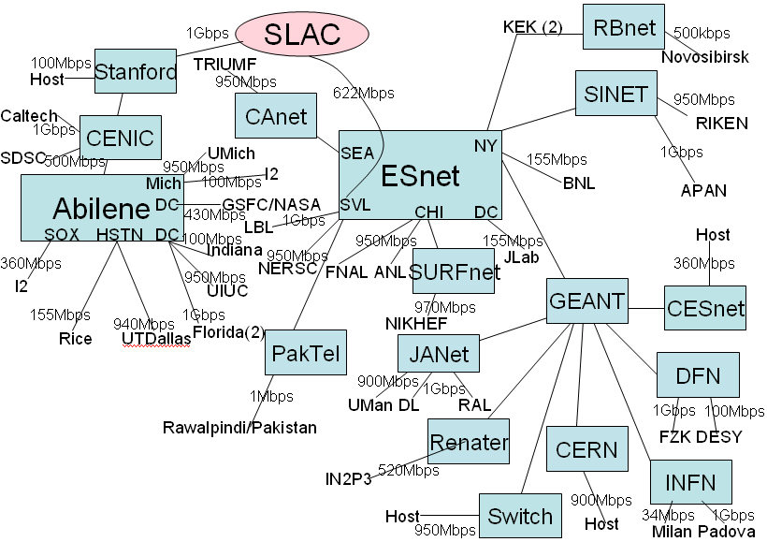Figure 1: Topology of the remote hosts measured from SLAC
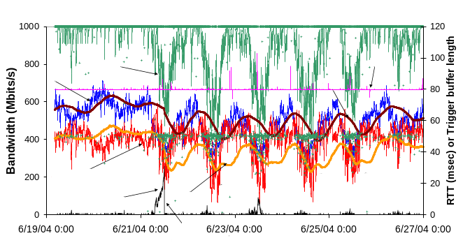Figure 2: ABwE bandwidth estimates from SLAC to U Florida with a history buffer duration (λ) of 10 hours.
Sensible values of β are between 2 and 3 [15][15], we used β = 2. Το minimize the effects of diurnal changes we used λ = 1 day. Longer values flatten the time series behavior of m_{h}, shorter values result in the sinusoidal-wave like curve of m_{h} being out of synchronization with the diurnal changes (see for example Fig. 2 where m_{h} = 10 hours and is seen to trail the EWMA(Abw) by several hours). Since we were only interested in long term changes we used τ = 3 hours. We currently use δ = 33%. Larger values of δ are likely to miss more real events, lower values are likely to lead to more false positives.

Kolmogorov-Smirnov (KS)
The KS test [16] is the best known of several distribution free techniques for testing for general differences between distributions. The technique makes no assumption about the underlying distribution of the measurements. It compares the observed and expected Cumulative Distribution Functions (CDF) for M data points before (expected) and after (observed) each measurement being evaluated. The KS test is calculated taking the vertical difference between the two CDFs as a test statistic. M in the current work was chosen to be 100 (5 hours for measurements separated by 3 minutes) as a reasonable compromise between the accuracy obtained (sufficient points for the distributions) and the time to wait for a response. If response time is deemed less important it may well be worth using a larger value of M as this will provide a larger sample for each distribution. For previous work [20] with less frequent measurements, we chose M to be 24 hours worth of data to minimize the diurnal effects as discussed earlier in the current paper (although one still gets false positives at weekends, public holidays etc.).

Holt-Winters (HW) Algorithm
The Holt-Winters (H-W) [16], [18] algorithm uses a triple EWMA approximation to characterize the time series behavior as a superposition of three components: a baseline, a linear trend and a seasonal effect (e.g. diurnal changes). We combined the HW algorithm with the Χ² error estimation method. The Χ² criterion is applied to every measurement from the moving window of the last N_{time-window} measurements. The initial set of HW parameters is chosen according to [15] with 95% of the contribution for the baseline EWMA coming from measurements made in the last ten hours, 95% of the contribution for the trend EWMA coming from measurements made in the last week, and 95% of the seasonal EWMA contributions coming from measurements from the prevous week. In the case of missing (lost) measurements the same forecasting technique is used to fill in gaps.
To raise an anomalous event condition: the system checks for the lost measurements and reports them; then for every new measurement the set of forecasted values for N_{total} – N_{time-window} is built and for each measurement from N_{time-window} the Χ² estimate is calculated. An anomalous event is generated if the Χ² sum for the whole window (N_{time-window} – 1 degrees of freedom) lies outside of a 5% confidence interval. If there are N_{time-window} – 1 consecutive anomalous events (exact number defines the total sensitivity), then the system generates an alert and sends a message to the local network administrator, notifying her/him about a significant and consistent drop in the network performance.

Results
To provide a canonical set of measurements to evaluate and compare the detection methods against we used Cap measurements from SLAC to 40 remote hosts for ~100 days from June through September 2004.
To first characterize the events seen in the canonical data, we used the Plateau algorithm, since it is the most intuitive of the algorithms and allows direct variation of parameters representing the size and duration of an event. We set δ to 0 (i.e. we detect all events that fill the trigger buffer) and the other user parameters set as described above. About 25 of the 40 paths manifested one or more events in this period. We carefully reviewed each of these events and created a library of interesting events. We observe three general types of events that trigger our plateau algorithm.
- Step down changes in bandwidth (“step”)
- Diurnal changes (“diurnal”)
- Changes caused by actions causing congestion, e.g. a regularly scheduled cron job, or network bandwidth test (“host”), flash crowds etc.
Two paths out of 40 (BINP and UFlorida) exhibited marked diurnal changes that triggered “diurnal” events. To study he diurnal behavior more carefully we binned the bandwidth data by hour of day and calculated the percentiles to identify the daily bandwidth patterns. An example is shown in Fig. 3 where there is a quick increase in bandwidth when people arrive to work (20:00-23:00 PDT = 08:00 – 11:00 Pakistan time). This in turn causes an abnormally high number of events to be detected by the plateau and KS algorithms during these hours (see Fig. 4). Usually these changes are not as sudden as the typical step change which may also help in separating the two types. For our purposes, these “diurnal” events are false positives that need to be eliminated.
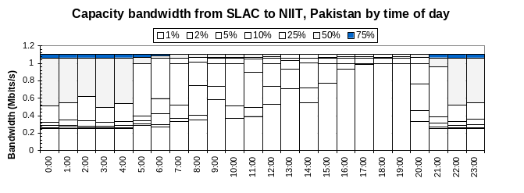 Figure 3: Percentiles of capacity bandwidth seen on the SLAC-NIIT path as a function of time of day
One host (ANL) exhibited regular “host” type events that were tracked down to a cron job running on the host that used (via NFS) the network heavily. This host was eliminated from further analysis. Events for a given host typically have a small range for Δ (standard deviation (Δ) / mean (Δ) ~ 0.11± 0.1) indicating that the backup routes or diurnal behavior is consistent. This manifests itself in a multi-modal Distribution Function for Δ.
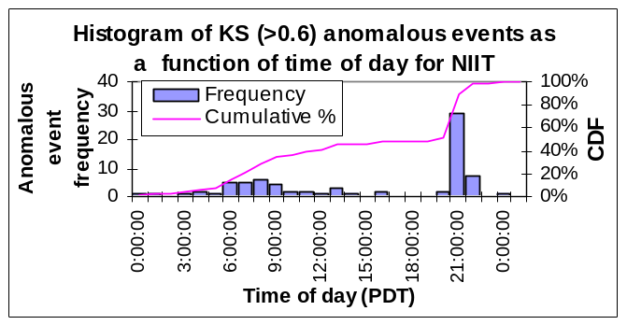
Figure 4: Distribution of events as a function of time of day for the SLAC-NIIT path.
By careful examination of ~ 120 plateau candidate events detected with δ = 0 (and ignoring whether the events are diurnal) we classify all candidates as to whether they are events we are interested in or not (i.e. exhibit sharp drop in bandwidth, persist for a long term (>> 3 hours) and are large enough). With δ = 10% and restricting the duration of 90% of the trigger buffer to 220 minutes, we miss 8% of the events and see 16% false positives. Increasing δ to 33% we get 32% misses and 2% false positives. In this case 15% of the events are caused by diurnal changes.
We then also applied KS and HW algorithms to the canonical data. Fig. 5 shows a visualization of the plateau, KS and HW algorithms applied to capacity bandwidth observations with step changes in performance from SLAC to BINP. As expected all three algorithms detect marked changes. KS detects both increases and decreases in the data (but does not identify the sign) and thus detects roughly twice as many events (229:116) as the plateau algorithm which is currently tuned for negative changes only. Detecting both steps is valuable since, for example, it enables determining the duration of a change and/or taking some action when the original performance is restored. KS also provides the most accurate time estimate for when the event occurred which is important when correlating the event with other time-dependent information.
In Fig. 5 the KS statistic (dotted) is seen to reach a value of about 0.72, on both the step up and down. The plateau algorithm’s trigger buffer (solid line) only reaches ~ 80% full (since the step change is too short, in this case ~ 4 hours) so no event is triggered. The HW Χ² (dashed line) triggers an event after the performance has recovered.
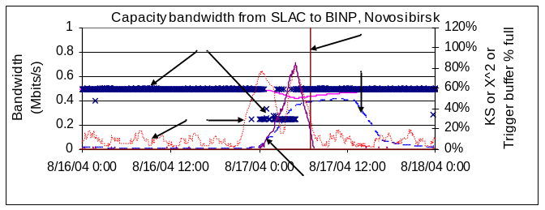
Figure 5: Plateau, KS and HW algorithms applied to an observed step down and back up performance change
Increasing the value of the KS statistic that defines an event reduces the false positives at the cost of increasing the missed events as seen in Fig. 7. Currently we are using a value of 0.7 to trigger an event.
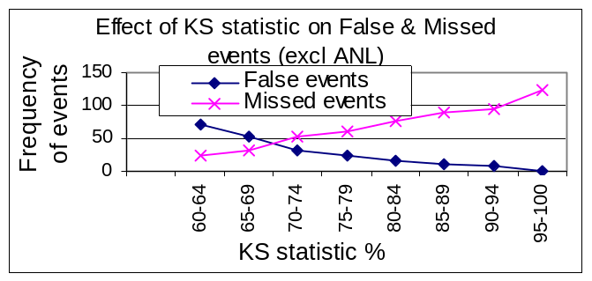

Conclusions
For measurements with limited diurnal (or other seasonal) changes all three algorithms work well.
The plateau algorithm is easily understood by people with a non-statistical background and has easy to interpret user settable parameters.
The KS algorithm is the most statistically formal of the three algorithms. It has only two parameters: the number of data points (M) used to evaluate the distribution functions; and the threshold of the KS statistic above which an event is assumed to have occurred. It provides both positive and negative step indications and also provides the best estimates of when a step occurs. In the current implementation (in C) it is by far (factor of ten) the fastest method so it could be used as an initial filter followed by further filters such as evaluation of the magnitude and duration of a change for example.
The HW technique explicitly incorporates seasonal changes and so should work better on paths with significant diurnal changes. It is sensitive to the choice of the forecasting parameters and the size of the moving time window. We found that choosing optimal initial parameters was difficult and requires careful study of their effects on the smoothing. Additional study is needed to simplify this by minimizing the difference in the measurements and the forecast as a function of the parameters for a representative set of paths.
The use of interpolated data to fill in holes of missing measurements simplified choosing the right window lengths to minimize diurnal effects for the HW algorithm.
Both the plateau and HW algorithms are implemented on Linux systems as Perl scripts and so should be relatively easy to port. Currently no attempt has been made to optimize the speed of execution. Our implementation of HW takes about 7 minutes on a ~ 1GHz Intel Xeon host to analyze about 43K Cap measurements while plateau takes about twice as long. The KS algorithm is implemented in C and runs about ten times as fast.
We are looking at using wavelet decomposition to eliminate outliers and white noise seen in real data.
The subspace PCA analysis has been reported [19] to work well when applied to measurements from core routers. It is unclear how well it will work on less correlated end-to-end active Internet performance measurements. It has the advantage of being able to simultaneously look at measurements of multiple metrics (e.g. RTT, iperf throughput, Cap, Xtr, reverse and forward performance measures such as provided by ABwE, and/or hosts/system performance measures) and paths simultaneously. On the other hand it is less intelligible to someone without a statistical background. We have implemented this algorithm and are currently applying it to the ABwE data.
A second, filter process may be applied once potential events have been identified using one of the above techniques. A filter may serve two purposes. Firstly unwanted events, or false positives may be removed and not reported. Secondly, events that are noteworthy may be classified to aid in further diagnostic processes. A neural network has been used as such a filter process in [20][20].
Once we have a robust, reliable anomalous event detection technique that works with the ABwE data, we will extend it to other measurements including iperf and observations of host/system performance measures. We also plan to use the current work to generate alerts. These will be filtered relevant information gathered from network devices, analyzed and reported to network administrators.
Acknowledgment
We gratefully acknowledge Jerrod Williams and the administrators at the remote hosts for their work in setting up the hosts and keeping the measurements running. We also thank Mark Crovella and Jerry Friedman for useful discussions on the subspace PCA technique.
References
- McGregor A, Braun H-W, and Brown J, “The NLANR network analysis infrastructure”, IEEE Communications Magazine, May 2000
- Cottrell R. L, Logg C, and Mei I-H, “Experiences and Results from a New High Performance Network and Application Monitoring Toolkit”, PAM 2003.
- Matthews W. and R. L. Cottrell, “The PingER Project: Active Internet Performance Monitoring for the HENP Community”, IEEE Communications Magazine, May 2000.
- “National Internet Measurement Infrastructure”, available at http://www.ncne.nlanr.net/nimi/
- “E2E piPES”, available at http://e2epi.internet2.edu/pipes/
- “RIPE NCC Test Traffic Measurements”, available at http://www.ripe.net/ttm/
- “MonALISA: Monitoring Agents using a Large Integrated Services Architecture” available at http://monalisa.caltech.edu/
- Navratil J and Cottrell R. L, “ABwE: A practical Approach to Available Bandwidth Estimation”, PAM 2003 also SLAC-PUB-9622.
- “Iperf the TCP/UDP Bandwidth Measurement Tool”, available http://dast.nlanr.net/Projects/Iperf/
- “BBFTP Large Files Transfer Protocols”, available at http://doc.in2p3.fr/bbftp/
- “Globus Grid FTP Protocol and Software”, available at http://www.globus.org/datagrid/gridftp.html
- Grigoriev M, Cottrell R. L. and Logg C., “Wide Area Network Monitoring System for HEP Experiments at FNAL”, Computing in High Energy Physics, Interlaken Switzerland, Sep 2004.
- Logg C, Cottrell R. L. and Navratil J., “Experiences in Traceroute and Available Bandwidth Change Analysis”, SIGGCOMM’04 Workshops, Aug 30 & Sep 3, 2004, Portland OR, USA
- McGregor A.J. and Braun H-W, ”Automated Event Detection for Active Measurement Systems”, Proceedings of PAM2001, Amsterdam, Netherlands, April 2001
- A. Ward, P. Glynn and K. Richardson, “Internet service performance failure detection” Performance Evaluation Review, 26:38-43, 1998
- Brockwell P. and Davis R, “Introduction to Time Series and Forecasting”, Springer New York, 1996
- Brutlag J.D., “Aberrant Behaviour Detection in Time Series for Network Monitoring”, Proceedings of LISA 2000, New Orleans, LA, USA, December 2000.
- NIST e-handbook of statistics, http://www.itl.nist.gov/div898/handbook.
- Lakhina A, Crovella M, Diot C, “Diagnosing Network-Wide Traffic Anomalies”, Sigcomm 2004.
- Sandford, J.M., Parish, D.J. and Phillips, I.W., ''Neural approach to detecting communication network events'' , IEE Proc. Communications, 1495 , October 2002, pp 257-264, ISSN 1350-2425.

 Manuscript received December 31, 2--4. This work was supported in part by the Director, Office of Science, Office of Advanced Scientific Computing Research, Mathematical and Computational Sciences Division under the U.S. Department of Energy. The Stanford Linear Accelerator Center (SLAC) is operated by Stanford University for the U.S. Department of Energy under contract DE-AC02-76SF00515. The Fermi National Accelerator Laboratory (Fermilab) is operated by Universities Research Association, Inc. for the U.S. Department of Energy under contract DE-AC02-76CH03000. R. Les. Cottrell and Connie Logg are with SLAC, 2575 Sand Hill Road, Menlo Park, CA 94025, USA (+1-650-926-2523, fax 1+650-926-2523, email: {cottrell, cal}@slac.stanford.edu) Maxim Grigoriev is with the Fermilab, Batavia, IL 60510, USA (email: maxim@fnal.gov). Azam Bukhari and Waqar Mahood are with the NUST Institute of Information Technology, Rawalpindi, Pakistan (email :azam.bukhari@gmail.com, drwaqar@niit.edu.pk). Mark Sandford is with the Department of Electronic Engineering, Loughborough University, Leics, LE11 3TU, UK (email: J.M.Sandford@lboro.ac.uk).
Less than 10% of these candidate events were associated with noticeable traceroute changes.
Others may have very different criteria, in particular the duration of the change or the magnitude of the drop. With the exception of the plateau algorithm, the duration and magnitude filters need to be applied as a separate step.

