International Committee for Future Accelerators (ICFA)
Standing Committee on Inter-Regional Connectivity (SCIC)
Chairperson: Professor Harvey Newman, Caltech

ICFA SCIC Network Monitoring Report

Prepared by the ICFA SCIC Monitoring Working Group
On behalf of the Working Group:
Les Cottrell cottrell@slac.stanford.edu



January 2006 Report of the ICFA-SCIC Monitoring Working Group
Edited by R. Les Cottrell and Aziz Rehmatullah on behalf of the ICFA-SCIC Monitoring WG
Created January 18, 2006. Last Update January 28, 2006
ICFA-SCIC Home Page | Monitoring WG Home Page
This report is available from http://www.slac.stanford.edu/xorg/icfa/icfa-net-paper-jan06/
Contents:
Executive Overview | Introduction | Goals | Methodology | PingER Results | IEPM Results | Comparison with HEP Needs | New Monitoring and Diagnostic Efforts in HEP | Comparisons with Economic Indicators | Accomplishments since Last Report | Recommendations | Appendix: Countries in PingER Database | References

Executive Overview
Internet performance is improving each year with packet losses typically improving by 40-50% per year and losses by 25%-45% per year, and for some regions such as S. E. Europe, even more. Geosynchronous satellite connections are still important to countries with poor telecommunications infrastructure. However, the number of countries with fiber connectivity has and continues to increase and in most cases, satellite links are used as backup or redundant links. In general for HEP countries satellite links are being replaced with land-line links with improved performance (in particular for RTT).
Links between the more developed regions including Anglo America, Japan and Europe are much better than elsewhere (5 - 10 times more throughput achievable). Regions such as S.E. Europe, Central Asia and Russia are catching up with the more developed regions (at the present rate of progress they should catch up by the end of the decade). However, China, the Middle East, Latin America and Africa are several years behind in performance compared to the more developed regions, and do not appear to be catching up. Even worse, S. Asia and Africa appear to be falling further behind. In general, throughput measured from within a region is much higher than when measured from outside.
For modern HENP collaborations and Grids there is an increasing need for high-performance monitoring to set expectations, provide planning and trouble-shooting information, and to provide steering for applications.
Africa and South Asia are two regions where the internet has seen phenomenal growth, especially in terms of usage. However, it appears that network capacity is not keeping up with demand in these regions. In fact many sites in Africa and India appear to have throughputs less that that of a well connected (cable, DSL or ISDN) home in Europe or Anglo America. Further the end-to-end networking is often very fragile both due to last mile effects and poor infrastructure (e.g. power) at the end sites, and also due to lack of adequate network backup routes.
There is a positive correlation between the various economic and development indices. Besides being useful in their own right these indices are an excellent way to illustrate anomalies and for pointing out measurement/analysis problems. The large variations between sites within a given country illustrate the need for careful checking of the results and the need for multiple sites/country to identify anomalies.
To quantify and help bridge the Digital Divide, enable world-wide collaborations, and reach-out to scientists world-wide, it is imperative to continue and extend the monitoring coverage to all countries with HENP programs and significant scientific enterprises. This in turn will require help from ICFA to identify sites to monitor and contacts for those sites, plus identifying sources of on-going funding support to continue and extend the monitoring.

Introduction
The formation of this working group was requested at the ICFA/SCIC meeting at CERN in March 2002 [icfa-mar02]. The mission is to: Provide a quantitative/technical view of inter-regional network performance to enable understanding the current situation and making recommendations for improved inter-regional connectivity.
The lead person for the monitoring working group was identified as Les Cottrell. The lead person was requested to gather a team of people to assist in preparing the report and to prepare the current ICFA report for the end of 2002. The team membership consists of:
Table 1: Members of the ICFA/SCIC Network Monitoring team
Les Cottrell | SLAC | US | cottrell@slac.stanford.edu
Richard Hughes-Jones | University of Manchester | UK | rich@a3.ph.man.ac.uk
Sergei Berezhnev | RUHEP, Moscow State.Univ. | Russia | sfb@radio-msu.net
Sergio F. Novaes | FNAL | S. America | novaes@fnal.gov
Fukuko Yuasa | KEK | Japan and E. Asia | Fukuko.Yuasa@kek.jp
Sylvain Ravot | Caltech | CMS | Sylvain.Ravot@cern.ch
Daniel Davids | CERN | CERN, Europe, LHC | Daniel.Davids@cern.ch
Shawn McKee | Michigan | I2 HENP Net Mon WG | smckee@umich.edu

Goals of the Working Group
- Obtain as uniform picture as possible of the present performance of the connectivity used by the ICFA community
- Prepare reports on the performance of HEP connectivity, including, where possible, the identification of any key bottlenecks or problem areas.
This report may be regarded as a follow on to the May 1998 Report of the ICFA-NTF Monitoring Working Group [icfa-98], the January 2003 Report of the ICFA-SCIC Monitoring Working Group [icfa-03] the January 2004 Report of the ICFA-SCIC Monitoring Working Group [icfa-04] and the January 2005 Report of the ICFA-SCIC Monitoring Working Group [icfa-05]. The current report updates the January 2005 report, but is complete in its own right in that it includes the tutorial information from the January 2003 report.

Methodology
There are two complementary types of Internet monitoring reported on in this report.
- In the first we use PingER [pinger] which uses the ubiquitous "ping" utility available standard on most modern hosts. Details of the PingER methodology can be found in the May 1998 Report of the ICFA-NTF Monitoring Working Group [icfa-98] and [ejds-pinger]. PingER provides low intrusiveness (~ 100bits/s per host pair monitored¹) Round Trip Time (RTT), loss, reachability (if a host does not respond to a set of 21 pings it is presumed to be non-reachable). The low intrusiveness enables the method to be very effective for measuring regions and hosts with poor connectivity. Since the ping server is pre-installed on all remote hosts of interest, minimal support is needed for the remote host (no software to install, no account needed etc.)
- The second method (IEPM-BW [iepm]) is for measuring high network and application throughput between hosts with excellent connections. Examples of such hosts are to be found at HENP accelerator sites and tier 1 and 2 sites, major Grid sites, and major academic and research sites in Anglo America², Japan and Europe. The method can be quite intrusive (for each remote host being monitored from a monitoring host, it can utilize hundreds of Mbits/s for ten seconds to a minute each hour). It also requires more support from the remote host. In particular either various services must be installed and run by the local administrator or an account is required, software (servers) must be installed, disk space, compute cycles etc. are consumed, and there are security issues. The method provides expectations of throughput achievable at the network and application levels, as well as information on how to achieve it, and trouble-shooting information.

PingER Results
The PingER data and results extend back to the start of 1995. They thus provide a valuable history of Internet performance. PingER has 34 monitoring nodes in 14 regions, that monitor 1037 remote nodes at over 750 sites in around 124 countries (see PingER Deployment [pinger-deploy]). These countries contain over 90% of the world's population (see Table 2) and over 99% of the online users of the Internet. Most of the hosts monitored are at educational or research sites. We try and get at least 2 hosts per country to help identify and avoid anomalies at a single host, although we are making efforts to increase the number of monitoring hosts to as many as we can. The requirements for the remote host can be found in [host-req]. Fig. 1 below shows the locations of the monitoring and remote (monitored sites).
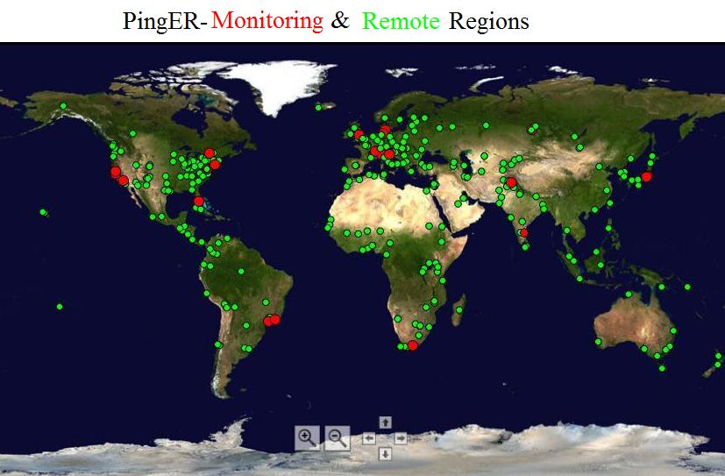
Figure 1: Locations of PingER monitoring and remote sites as of Jan 2006.
There are around thirty seven hundred monitoring/monitored-remote-host pairs, so it is important to provide aggregation of data by hosts from a variety of "affinity groups". PingER provides aggregation by affinity groups such as HENP experiment collaborator sites, Top Level Domain (TLD), Internet Service Provider (ISP), or by world region etc. The world regions, as defined for PingER, and countries monitored are shown below in Fig. 2. The regions are chosen starting from the U.N. definitions [un]. We modify the region definitions to take into account which countries have HENP interests and to try and ensure the countries in a region have similar performance.
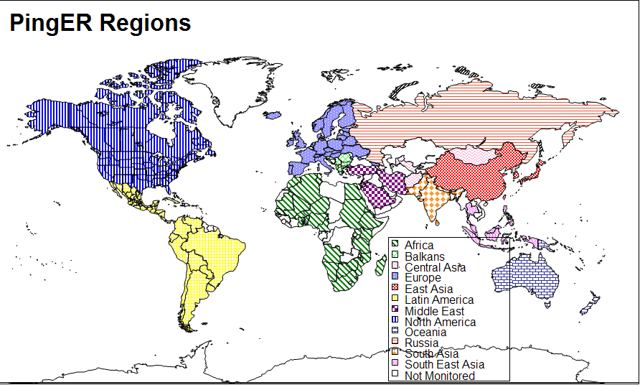Figure 2: Major regions of the world for PingER aggregation by regions

More details on the regions are provided in Table 2 that highlights the number of countries monitored in each of these regions, and the distribution of population in these regions.
Table 2: Countries and populations by region
Regions | # of Countries | %age of World Population | %age of Monitored Population
Africa | 31 | 11.5 | 12.8
Balkans | 9 | 1.0 | 1.1
Central Asia | 4 | 1.0 | 1.1
Europe | 25 | 7.9 | 8.8
Latin America | 18 | 8.2 | 9.1
North America | 2 | 5.1 | 5.7
East Asia | 4 | 23.2 | 25.9
South East Asia | 6 | 6.2 | 6.9
South Asia | 5 | 22.5 | 25.0
Middle East | 5 | 2.8 | 3.1
Oceania | 5 | 0.5 | 0.5
Russia | 1 | 2.2 | 2.5

To assist in interpreting the results in terms of their impact on well-known applications, we categorize the losses into quality ranges. These are shown below in Table 3.
Table 3: Quality ranges used for loss
 | Excellent | Good | Acceptable | Poor | Very Poor | Bad
Loss | <0.1% | >=0.1% & &  < 1% | > =1%  & < 2.5% | >= 2.5%  & < 5% | >= 5%  & < 12% | >= 12%
More on the effects of packet loss and RTT can be found in the Tutorial on Internet Monitoring & PingER at SLAC [tutorial], briefly:
- At losses of 4-6% or more video-conferencing becomes irritating and non-native language speakers become unable to communicate. The occurrence of long delays of 4 seconds (such as may be caused by timeouts in recovering from packet loss) or more at a frequency of 4-5% or more is also irritating for interactive activities such as telnet and X windows. Conventional wisdom among TCP researchers holds that a loss rate of 5% has a significant adverse effect on TCP performance, because it will greatly limit the size of the congestion window and hence the transfer rate, while 3% is often substantially less serious, Vern Paxson. A random loss of 2.5% will result in Voice Over Internet Protocols (VOIP) becoming slightly annoying every 30 seconds or so. A more realistic burst loss pattern will result in VOIP distortion going from not annoying to slightly annoying when the loss goes from 0 to 1%. Since TCP throughput for the standard (Reno based) TCP stack goes as 1/(sqrt(loss) [mathis]) (see M. Mathis, J. Semke, J. Mahdavi, T. Ott, "The Macroscopic Behavior of the TCP Congestion Avoidance Algorithm",Computer Communication Review, volume 27, number 3, pp. 67-82, July 1997), it is important to keep losses low for achieving high throughput.
- For RTTs, studies in the late 1970s and early 1980s showed that one needs < 400ms for high productivity interactive use. VOIP requires a RTT of < 250ms or it is hard for the listener to know when to speak.
It must be understood that these quality designations apply to normal Internet use. For high performance, and thus access to data samples and effective partnership in distributed data analysis, much lower packet loss rates may be required.

Loss
Of the two metrics loss & RTT, loss is more critical since a loss of a packet will typically cause timeouts that can last for several seconds, moreover, RTT increases with increase in distance between any two nodes and also, with the increase in the number of hops. For instance RTT between a node at SLAC and somewhere in Europe is expected to be around 160ms.
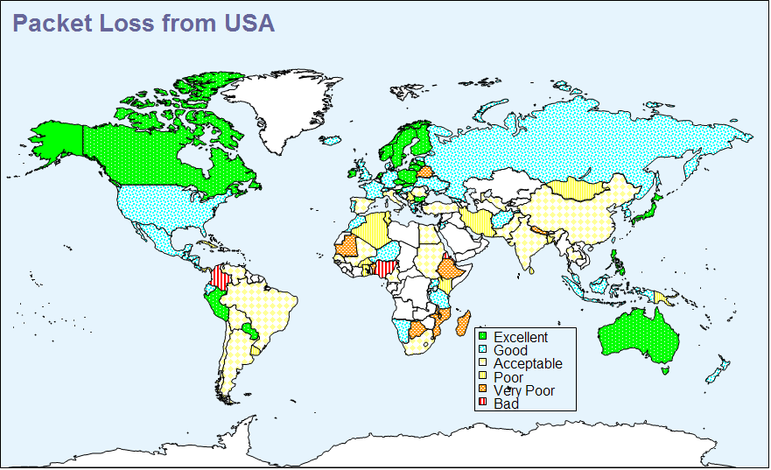
Figure 3: December 2005 packet loss snapshot seen from USA sites to the world.
Fig. 3 shows a snapshot of the losses for December 05. We observe that very few countries have bad connectivity. Most of N. America, Europe, Oceania and Russia have excellent or good performance, meaning that the average packet loss is less than 1%.
Another way of looking at the losses is to see how many hosts fall in the various loss quality categories defined above as a function of time. An example of such a plot is seen in Fig 4.
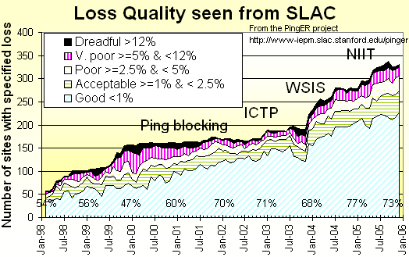
Figure 4: Number of hosts measured from SLAC for each quality category from February 1998 through December 2005.
It can be seen that recently most sites fall in the good quality category. The numbers at the bottom indicate the percentage of total sites that see good or better packet loss at the start of the year. Also the number of sites with good quality has increased from about 55% to about 75% in the 9 years displayed. The plot also shows the increase in the total number of sites monitored from SLAC over the years. The improvements are particularly encouraging since most of the new sites are added in developing regions.
Towards the end of 2001 the number started dropping as sites blocked pings due to security concerns. The rate of blocking was such that out of 214 host that were pingable in July 2003, 33 (~15%) were no longer pingable in December 2003.
The increases in monitored sites towards the end of 2002 and early 2003 was due to help from the Abdus Salam Institute of Theoretical Physics (ICTP). The ICTP held a Round Table meeting on Developing Country Access to On-Line Scientific Publishing: Sustainable Alternatives [ictp] in Trieste in November 2002 that included a Proposal for Real time monitoring in Africa [africa-rtmon]. Following the meeting a formal declaration was made on RECOMMDENDATIONS OF the Round Table held in Trieste to help bridge the digital divide [icfa-rec]. The PingER project is collaborating with the ICTP to develop a monitoring project aimed at better understanding and quantifying the Digital Divide. On December 4th the ICTP electronic Journal Distribution Service (eJDS) sent an email entitled Internet Monitoring of Universities and Research Centers in Developing Countries [ejds-email] to their collaborators informing them of the launch of the monitoring project and requesting participation. By January 14th 2003, with the help of ICTP, we added about 23 hosts in about 17 countries including: Bangladesh, Brazil, China, Columbia, Ghana, Guatemala, India (Hyderabad and Kerala), Indonesia, Iran, Jordan, Korea, Mexico, Moldova, Nigeria, Pakistan, Slovakia and the Ukraine.
The increase towards the end of 2003 was spurred by preparations for the second Open Round Table on Developing Countries Access to Scientific Knowledge: Quantifying the Digital Divide 23-24 November Trieste, Italy and the WSIS conference and associated activities in Geneva December 2003.
The increases in 2004 were due to adding new sites especially in Africa, S. America, Russia and several outlying islands. See Fig. 1 and section “Accomplishments since last report”.
In 2005, the Pakistan Ministry Of Science and Technology (MOST) and the US State Department funded SLAC and the National University of Sciences and Technology’s (NUST) Institute of Informtaion Technology (NIIT) to collaborate on a project to improve and extend PingER. As part of this project and the increased interest from Internet2 in “Hard to Reach Network Places” many new sites in the South Asia and Africa were added to the need to increase the coverage in these regions and also to replace sites that were blocking pings. For instance we can find no sites in Angola that are pingable in Dec 2005. Also as part of this project we started to integrate PingER with the NLANR/AMP project and as a result a number of the AMP nodes were added as PingER remote hosts in the developing regions. With help of Tenet (http://www.tenet.ac.za), we successfully set up a monitoring node in South Africa, which would be a great help in viewing the Digital Divide from within the Divide. With the help of NIIT (www.niit.edu.pk), a monitoring node was set up at NIIT and in Nov’ 05 another one at NTC (National Telecommunication Corporation www.ntc.net.pk), which is the service provider for the PERN (Pakistan Educational and Research Network www.pern.edu.pk ). Although it is too early to provide any long terms predictions, but more than almost two months of data gathered indicate certain interesting results which would be discussed later in a little more detail.
Fig. 5 below shows the long term trends for the various regions as seen from Anglo America.
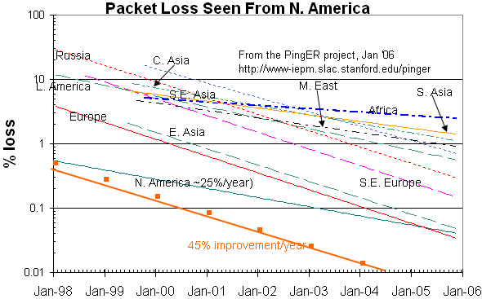
Figure 5: Packets loss trends from Anglo America to various regions of the world.
The following general observations can be made for the losses:
- For most regions the improvement in losses is typically between 25% and 45% per year.
- The better rgions are achieving better than 1% packet for most of their sites seen from SLAC.
- At the same time, the ratio between the excellent and dreadful nodes is decreasing, especially considering that a lot of nodes in Africa and South Asia have been added over the last year. More nodes, especially those in South Asia have acceptable level of performance.
Fig. 6 shows the world's connected population fractions obtained by dividing countries up by loss quality seen from the US, and adding the connected populations for the countries (we obtained the population/country figures from "How many Online" [nua]) for a given loss quality to get a fraction compared to the total world's connected population.
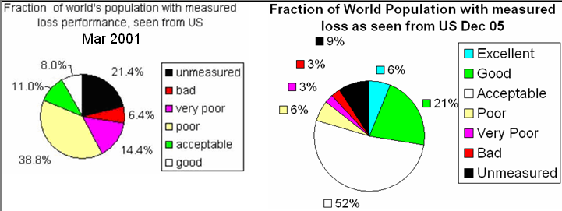
Figure 6: Fraction of the world's connected population in countries with measured loss performance in 2001 and Dec 2005
It can be seen that in 2001, <20% of the population lived in countries with acceptable or better packet loss. By December 2005 this had risen to 79%. The coverage of PingER has also increased from about 70 countries at the start of 2003 to over 120 in December 2005. This in turn reduced the fraction of the connected population for which PingER has no measurements. The results are even more encouraging when one bears in mind that the newer countries being added typically are from regions that have traditionally poorer connectivity.
It is interesting to compare the packet losses seen by various regions with those seen by residential DSL customers in the San Francisco Bay Area. This is shown in Fig. 7 below.
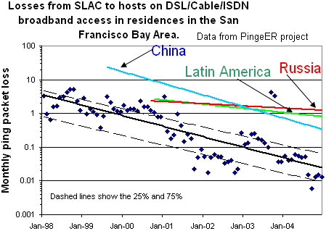
Figure 7: Losses from SLAC to various world regions compared with that for residential customers in the San Francisco Bay Area.

RTTs
There are limits to the minimum RTT due to the speed of light in fibers or electricity in copper. Typically today, the minimum RTTs for terrestrial circuits are about 2 * distance / (0.6 * (0.6 * c)), where c is the velocity of light, the factor of 2 accounts for the round-trip, 0.6*c is roughly the speed of light in fiber and the extra 0.6 allows roughly for the delays in network equipment such as routers. For geostationary satellites links the minima are between 500 and 600ms. For U.S. cross country links (e.g. from SLAC to BNL) the typical minimum RTT (i.e. a packet sees no queuing delays) is about 70 msec.
Fig. 8 below shows the trends of the min-RTT measured from ESnet sites in Anglo America to the various regions of the world. The straight lines are exponential fits to the data (straight lines on a log-linear plot), and the wiggly lines are moving averages for the last 6 months.
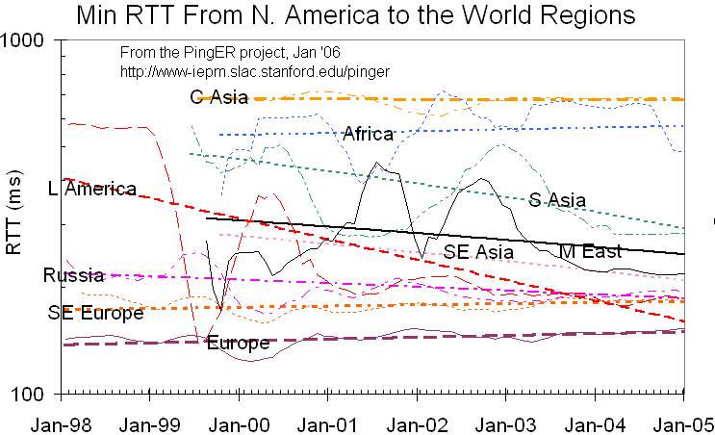
Figure 8: Minimum RTT measured from ESnet sites in the US to sites in regions of the world

As is seen by comparing the exponential fits with the moving averages, the trends here are less clear. Europe and the Balkans and to a lesser extent Russia have been pretty stable since upgrading the links from say 45 to 155, 622 or 2400 or 10,000 Mbps implying that link speeds have a small effect on the minimum RTT, the main effect being the distance. Central Asia on the other hand has been stuck with geo-stationary satellites and so little change is seen for it. The minimum RTT for Africa is partly increasing since we are extending the monitoring to reach more distant countries and more countries with satellite links. South Asia has been gradually upgrading the links within and outside the countries. Also, as is evident from the year 2000 minimum RTT map in Fig 9 below, India and Pakistan have moved from satellite to fiber optics, resulting in a decline in the minimum RTT values. Latin America took a huge step down in RTT at the end of 1999 going from mainly satellite (>500ms) to 200ms (i.e. mainly landlines). S.E. Asia looks like a gradual improvement.
Fig. 9 shows the RTT from the U.S. to the world in January 2000 and December 2005. It also indicates which countries of the world contain sites that were monitored (in the Jan 2000 map countries in green are not monitored, in the Dec 2005 apart from the US unmonitored countries are left white).
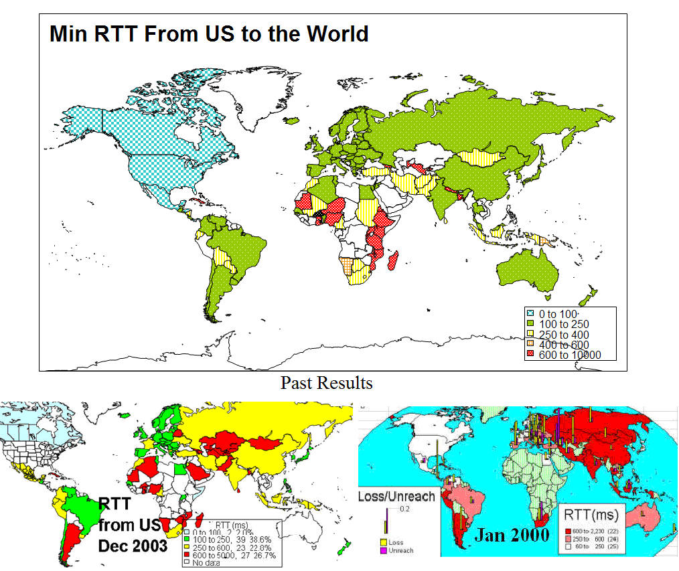
Figure 9: December 05 comparison of Minimum RTT with 2003 and 2000 results

It is seen that the number of countries with satellite links (> 600ms RTT or dark red) has decreased markedly in the 6 years shown. Today satellite links are used in places where it is hard or unprofitable to pull terrestrial-lines (typically fibers) to. Barring a few countries in Central and Eastern Africa, Bangladesh and Nepal most of the countries being monitored by PingER now have optical fiber connectivity. The Eastern Africa Submarine Cable System (EASSy [EASSy]) Project has been established to develop and implement a submarine cable system to provide fibre optic telecommunications facilities to the Eastern coast of Africa. The partners include Botswana, Burundi, Djibouti, Ethiopia, Kenya, Madagascar, Mozambique, Rwanda, Somalia, South Africa, Sudan, Zanzibar, Tanzania and Uganda so this could make a big improvement for this area. This cable will also link Northern and Southern African international gateways to the system.
Two interesting examples stand out in this data: Niger and Mali. Both countries have minimum RTTs greater than 600ms, indicating that both these links are satellite. However as seen in Fig. 3, the link loss quality from the US to the sites monitored in these countries is fairly good, with packet loss around 1%. This is much better than most of the South Asia, where the quality of the links are barely acceptable.

Throughput
We also combine the loss and RTT measurements using throughput = 1460Bytes[Max Transmission Unit]/(RTT * sqrt(loss)) from [mathis]. The results are shown in Fig. 10. The orange line shows a ~40% improvement/year or about a factor of 10 in < 7 years.
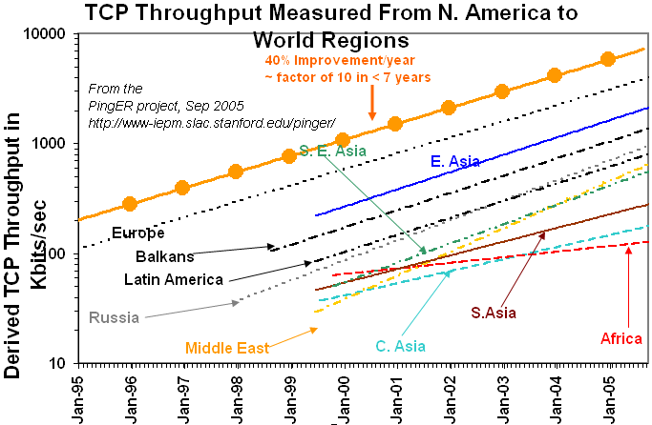
Figure 10: Derived throughput as a function of time seen from ESnet sites to various regions of the world. The numbers in parentheses are the number of monitoring/remote host pairs contributing to the data. The lines are exponential fits to the data.
The data for several of the developing countries only extends back for only about five years so some care must be taken in interpreting the long term trends. With this caveat, it can be seen that the performances to regions such Russia are catching up to the more developed countries. Latin America and S. E. Asia appear to be keeping up, while India, Africa and Central Asia appear to be falling further behind. At the same time it is seen Central Asia, Russia and Latin America are 5 to 6 years behind Europe, while Africa, Central Asia, the Middle East and South Asia are 7 years behind and behind with throughputs 10-40 times lower than those for Europe. In fact sites in Africa and S. Asia appear to have throughputs less than that of a well connected (cable, DSL or ISDN) home in Europe or Anglo America. For more on Africa see Connectivity Mapping in Africa [ictp-jensen], African Internet Connectivity [africa] and Internet Performance to Africa [ejds-africa]).

View from Europe
To assist is developing a less N. American view of the Digital Divide; we added many more hosts in developing countries to the list of hosts monitored from CERN in Geneva Switzerland. We now have data going back for almost four and a half years that enables us to make some statements about performance as seen from Europe. Fig. 11 shows the data from CERN as of September 2005. The lines are exponential fits to the data.
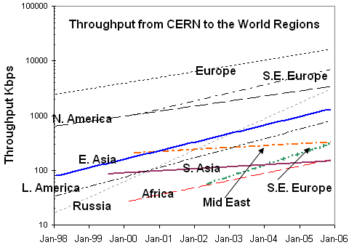
Figure 11: Derived throughputs to various regions as seen from CERN
The slow increase for N. America is partially an artifact of the difficulty of accurately measuring loss with a relatively small number of pings (14,400 pings/month at 10 pings/30 minute interval, i.e. a loss of one packet ~ 1/10,000 loss rate). The very slow increase in throughput for the Middle East, is an artifact caused by initially only monitoring hosts in 2 Middle East countries (Israel and Egypt) with one (Israel) having markedly better performance (factor of 20) than anywhere else in the Middle East. As we added hosts in more Middle East Countries (starting in July 2003), the median dropped dramatically as Israel had less effect. We have added several hosts to the Mid-East based on hosts being successfully monitored from SLAC. Apart from the special case of the Middle East mentioned above, the trends are similar to those seen from ESnet/US: the improvements are between 50% and 100% per year; Russia and S. E. Europe (Balkans) and to a lesser extent Latin America are catching up with Europe; the Middle East and S. Asia are falling behind. There is insufficient data at the moment to indicate how far the various regions are behind N. America or how long it will take to catch up

Variability of performance between and within regions
The throughput results, so far presented in this report, have been measured from Anglo America or to a lesser extent from Europe. This is partially since there is more data for a longer period available for the Anglo America monitoring hosts. Table 4 shows the throughputs seen between monitoring and remote/monitored hosts in the major regions of the world. Each column is for monitoring hosts in a given region, each row is for monitored hosts in a given region. The cells are colored according to the median quality for the monitoring region/monitored region pair. White is for derived throughputs > 5000 Kbits/s (good), blue for <= 5000 Kbits/s & >1000Kbits/s (acceptable), yellow for <= 100Kbits/s and > 500 Kbits/s, and magenta for <= 500Kbits/s (very poor to bad). The table is column ordered by decreasing median performance. The rows are sorted by region. The Monitoring countries are identified by the Internet two character Top Level Domain (TLD). Just for the record CH=Switzerland, DE=Denmark, HU=Hungary, CA=Canada, RU=Russia, JP=Japan, BR=Brazil, IN=India, PK=Pakistan and ZA=South Africa. S. Asia is the Indian sub-continent; S.E. Asia is composed of measurements to Indonesia, Malaysia, Singapore, Thailand and Vietnam.
Table 4: Derived throughputs in kbits/s from monitoring hosts to monitored hosts by region of the world for December 2005
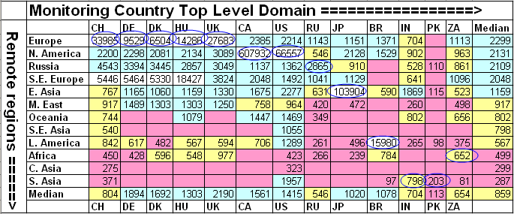
As expected it can be seen that within regions (the circled cells) performance is generally better than between regions. Also performance is better between closely located regions such as Europe and S. E. Europe, Russia and Europe, Russia and S.E. Europe.
To provide further insight into the variability in performance for various regions of the world seen from SLAC Fig. 12 shows various statistical measures of the losses and derived throughputs. The regions are sorted by the median of the measurement type displayed. Note the throughput graph uses a log y-scale to enable one to see the regions with poor throughput. The countries comprising a region can be seen in Fig. 2.
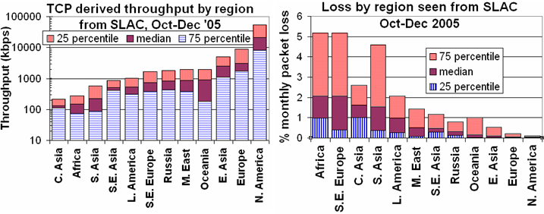
Figure 12: 25 percentile, median and 75 percentile derived throughputs and losses for various regions measured from SLAC for Oct-Dec '05
The difference in throughput for N. America and Europe is an artifact of the measurements being made from N. America (SLAC) which has a much shorter RTT (roughly between a factor of 2 and 20 times or for the average sites close to 3 to 4) to N. American than to European sites. Since the derived throughput goes as 1/RTT this favors N. America by about a factor of 3 to 4 times. The most uniform region (in terms of Inter-Quartile-Range/median for both derived throughput and loss) is Central Asia, probably since all the paths use a geo-stationary satellite. The most diverse are N. America and Europe. For Europe, Belorussia stands out with poor performance.
Africa and South Asia, Comparison between Min and Avg. RTTs
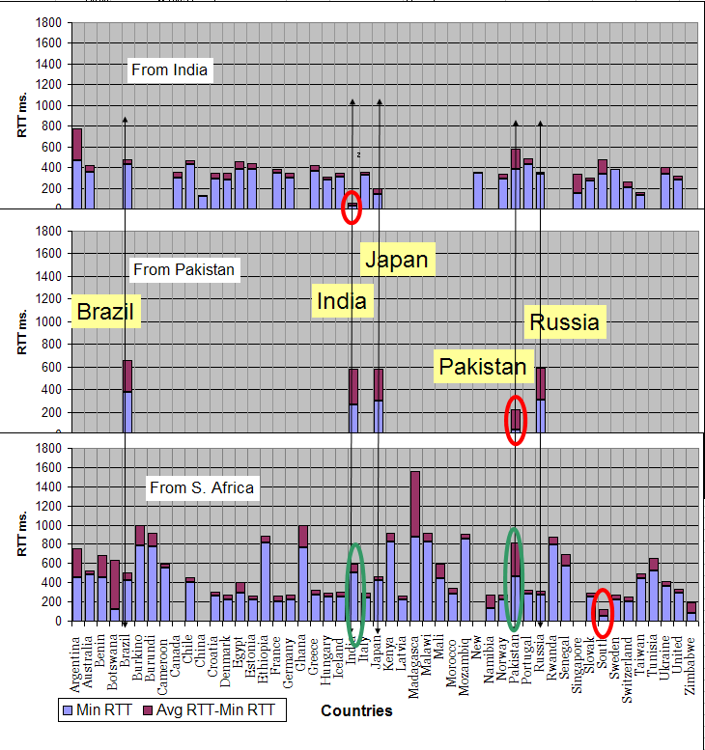
Figure 13: Congestion seen from Africa, India and Pakistan to the different countries; Measurements for Oct-Dec 2005 of min-RTT and average RTT from India, Pakistan and S. Africa to various countries; Countries with monitored hosts common to all monitoring countries are shown in yellow.

The main influence on the min-RTT (blue bar) should be the physical distance between the monitor and the monitored site. Min-RTTs of over 600ms usually indicate that a geo-stationary satellite link is in use. The shortest min RTTs (the red ellipses) are expected to be between hosts that are in the same country (e.g. an Indian host monitoring another Indian host). The difference in the min-RTT and avg-RTT (the red bars) is an indication of queuing delays or congestion.

It is seen that all sites monitored from Pakistan have significant congestion (> 150 ms.) This may suggest that the monitor host sites (there are 2 in Pakistan) have poor connectivity. However looking at the measurements from S. Africa all 10 monitored sites in Pakistan apparently have high congestion.

Even though Botswana is adjacent to S. Africa (and thus has low min-RTT), it is seen that the path is heavily congested (over 400ms.). Other countries with heavy congestion seen from S. Africa are Argentina, Madagascar, Ghana and Burkina Faso.

In general India appears to be better of congestion-wise than Pakistan. This can also be seen by comparing India with Pakistan as seen from S. Africa (green ellipses).
View from Africa
Being behind the rest of the world, we feel that Africa deserves a special study. In August 05, with assistance from TENET, we deployed a monitoring node in South Africa to get a view of Africa from within Africa. This node now monitors sites in 25 African countries that between them contain about 83% of the African population. Although the elapsed time has been too short to provide any long term trends, we have gathered some results and derived the routing to the countries in Africa.
First we looked at the traceroutes to these remote sites in African countries from South Africa. We summarize our results in Fig 13.

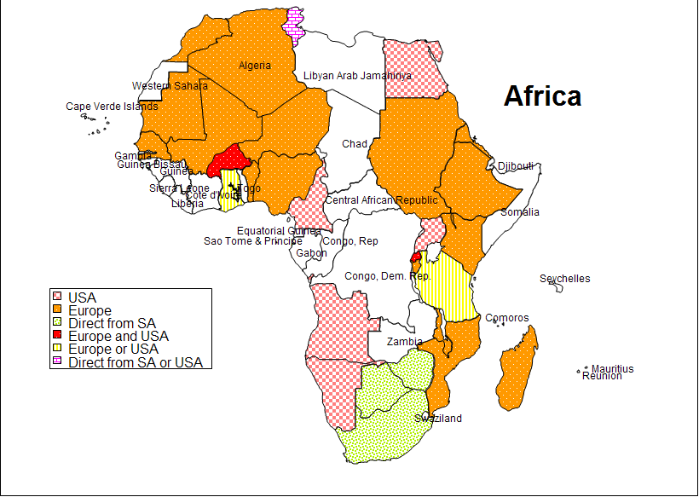
Figure 14: Routing to various countries in Africa. This data is typically based on 2 or 3 nodes per country

The data is typically based on 2 or 3 nodes per country. The initial analysis shows that the various countries in Africa have fairly diverse routing that is seldom very direct. A majority of the traffic going from South Africa to these countries goes via Europe or North America. Only Botswana and Zimbabwe have direct routing from South Africa. To Burkina Faso, the traffic first goes to Europe from South Africa, then USA and finally in to the country.
Fig. 15 shows the losses from South Africa to world regions (left hand graph) and as a table the losses from South Africa to African countries. The numbers in parentheses in the graph legend are the number of sites monitored in that region. The table is sorted by median loss. The cell colors indicate the losses, white (good) <=1%, green (acceptable) = 1-2.5%, yellow (poor) = 2.5-5% and magenta (very poor or worse) > 5%. There are no measurements for the red cells. The right hand column labeled # indicates the number of sites measured for that country. The fact that many countries are only represented by a single site means that care must be used in interpreting the results.
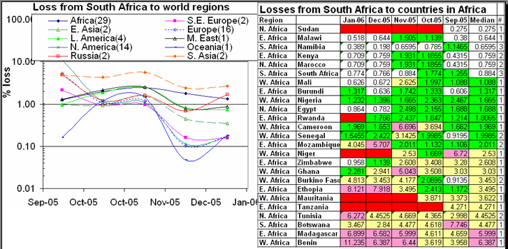
Figure 15: Losses from South Africa to regions of the world (left hand graph) and to Africa countries (right hand table).
Looking at the losses from Africa to world regions it can bee seen to vary widely from region to region. It is also apparent that the connectivity from S. Africa to developed regions is better than the connectivity within Africa. This is not surprising since many Africa countries connect via Europe and N. America. Within Africa again the losses are very variable. Since there are only measurements for one month (and to one site) the high ranking for Sudan may be an anomaly. The next ranking countries are Malawi, Namibia, Kenya and South Africa that are all reasonably close to the monitoring site (near Cape Town). Marocco has connectivity to Europe via GEANT. The bottom five countries in terms of losses are Benin, Madagascar, Botswana, Tanzania and Tunisia. The Madagascar, Botswana and Tanzania are relatively close to the monitoring site. Further one might expect Tunisia, with its proximity to the Mediterranean and Europe and the SEA-MEW cable, to have good connectivity. Further study on this is in order.

Case Study on NIIT, Pakistan

With NIIT being an important collaborator with SLAC, Caltech and CERN, we prepared a small case study with 3 PingER monitoring sites in Pakistan to provide a brief overview and a measure of the issues at NIIT in particular and Pakistan in general.

Overview:

In 2005, we have done quite a bit in trying to understand the network issues in Pakistan. The efforts are a part of the US State Department funded MAGGIE-NS (Measurement and Analysis of Global Grid and Internet End-to-end – NIIT SLAC) project. SLAC collaborator in this project is NIIT (NUST Institute of Information Technology), or the IT Wing of National University of Sciences and Technology (NUST). NUST, being a premier university in Pakistan, is an important member of PERN (Pakistan Education and Research Network). PERN “is a nationwide educational intranet connecting premiere educational and research institutions of the country. PERN focuses on collaborative research, knowledge sharing, resource sharing, and distance learning by connecting people through the use of Intranet and Internet resources”.

PERN uses the services of NTC (National Telecommunication Corporation) for the provision of infrastructure and bandwidth to the universities in Pakistan. NTC, which is the national telecommunication carrier for all official/government services in Pakistan, installed and deployed a PingER monitoring site at their headquarters in Islamabad, in order to monitor the performance of various universities connected to PERN. The results, going back almost seven weeks, have shown some interesting results.

Before we provide the results graphically, it is imperative to consider the following:

- Data from 7th Dec 2005 onwards to 28th Jan 06 was taken
- Only the remote nodes common to all the monitoring sites were taken, incidentally, all the nodes were in Pakistan and part of PERN.

 | Remote Node | Location | Service Provider | Traffic Enters the Country Via | Terminates at | Via PERN or NO
1 | PK.QAU.EDU.N1 | Islamabad | NTC | Karachi | Rawalpindi | PERN
2 | PK.LSE.EDU.N1 | Lahore | NTC | Karachi | Lahore | PERN
3 | PK.NIIT.EDU.N1 | Islamabad | NTC | Karachi | Rawalpindi | PERN
4 | PK.PIEAS.EDU.N1 | Islamabad | NTC | Karachi | Rawalpindi | PERN
5 | PK.SIRSYED.SSUET.N1 | Karachi | NTC | Karachi | Karachi | PERN
6 | PK.UET.EDU.N1 | Lahore | NTC | Karachi | Lahore | PERN
7 | PK.UPESH.EDU.N1 | Peshawar | NTC | Karachi | Rawalpindi | PERN

- The three monitoring sites are at NIIT using NTC, NIIT using Micronet (operational Jan 1 2006) and NTC headquarters in Islamabad.

Packet Loss:

The loss results show that NTC, the actual service provider has a good quality network with the packet loss percentage being less than 1% most of the times. Interestingly, the Micronet link which has been found to be a more reliable service provider (based on NIIT’s experience and past results) also maintains a fairly low loss ratio, whereas the NIIT experiences a network of fairly low quality, indicating that the network is congested most of the times.

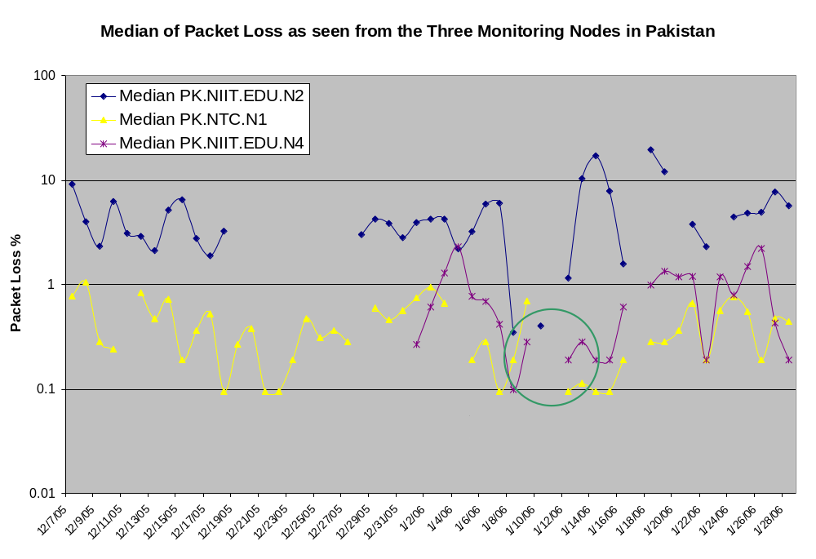

Minimum RTT

The minimum RTT results, though not very surprising show that the network within the country needs a lot of improvement. NTC has a good infrastructure and the minimum RTT to the PERN connected institutes is fairly good. Adding another hop, the minimum RTT from NIIT being slightly higher is also understandable. However, the minimum RTT from Micronet link suggests that the traffic, even if going to the same city adds around 45-50 ms to the RTT value as the service provider changes. This should be investigated and improved by the concerned people in Pakistan. The spike at the end of Micronet’s plot points out to an internet outage.
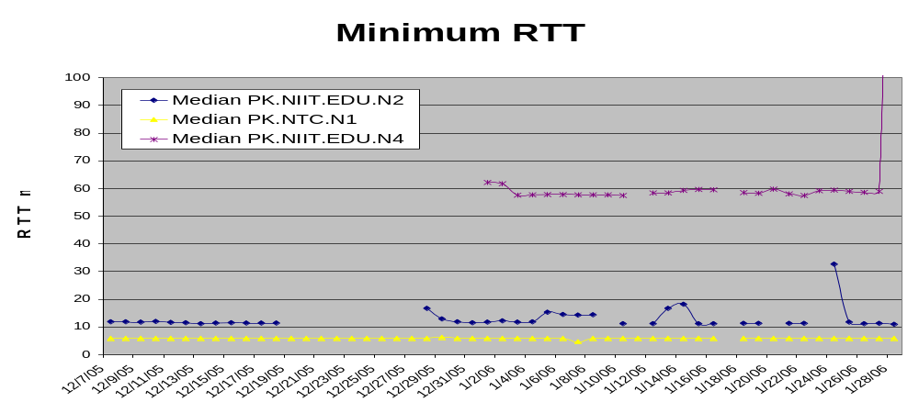
Congestion from NIIT:

The graph below may be very discouraging, but it is encouraging to know that the usage of Internet at universities is increasing. As the difference between average and minimum RTT points out, the NTC’s network is not very congested. The Micronet link at NIIT which is just a backup link to the main NTC’s link, is also lightly congested. However, the main NIIT link is very congested with average RTT values in the range of over 450ms at times to nodes in the same city, being served by the same ISP.

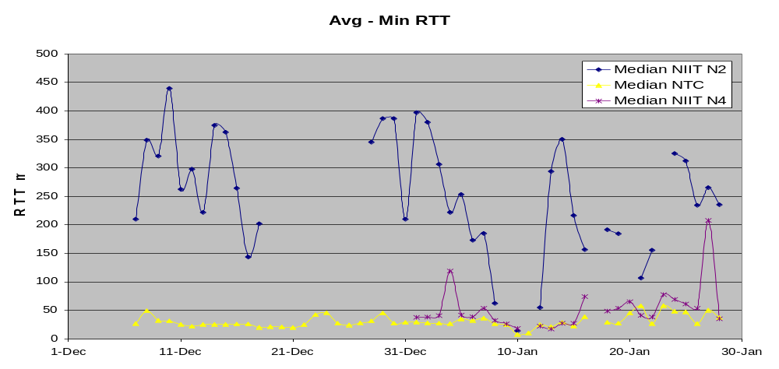

Throughput:
The throughput results also indicate that NIIT is not getting very good throughput from NTC or the network is too congested to allow better throughput. The throughput value from the Micronet link is acceptable, considering that bandwidth of the link is just 512 KBps. 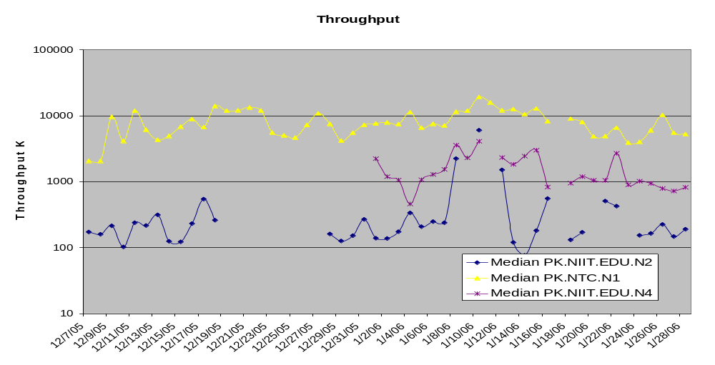

IEPM-BW Results
The PingER method of measuring throughput breaks down for high speed networks due to the different nature of packet loss for ping compared to TCP, and also since PingER only measures about 14,400 pings of a given size/month between a given monitoring host/monitored host pair. Thus if the link has a loss rate of better than 1/14400 the loss measurements will be inaccurate. For a 100Byte packet, this is equivalent to a Bit Error Rate (BER) of 1 in 10⁸, and leading networks are typically better than this today (Jan 2006). For example if the loss probability is < 1/14400 then we take the loss as being 0.5 packet to avoid a division by zero, so if the average RTT for ESnet is 50msec then the maximum throughput we can use PingER data to predict is ~ 1460Bytes*8bits/(0.050sec*sqrt(0.5/14400)) or ~ 40Mbits/s and for an RTT of 200ms this reduces to 10Mbits/s.
To address this challenge and to understand and provide monitoring of high performance throughput between major sites of interest to HEP and the Grid, we developed the IEPM-BW monitoring infrastructure and toolkit. There are about 5 major monitoring hosts and about 50 monitored hosts in 9 countries (CA, CH, CZ, FR, IT, JP, NL, UK, US). Both application (file copy and file transfer), TCP throughputs, available bandwidth, RTT, losses and traceroutes are measured.
These measurements indicate that throughputs of several hundreds of Mbits/s are regularly achievable on today's production academic and research networks, using common off the shelf hardware, standard network drivers, TCP stacks etc., standard packet sizes etc. Achieving these levels of throughput requires care in choosing the right configuration parameters. These include large TCP buffers and windows, multiple parallel streams, sufficiently powerful cpus (typically better than 1 GHz), fast enough interfaces and busses, and a fast enough link (> 100Mbits/s) to the Internet. In addition for file operations one needs well designed/configured disk and file sub-systems.
Though not strictly monitoring, there is currently much activity in understanding and improving the TCP stacks (e.g. [floyd], [low], [ravot]). In particular with high speed links (> 500Mbits/s) and long RTTs (e.g. trans-continental or trans-oceanic) today's standard TCP stacks respond poorly to congestion (back off too quickly and recover too slowly). To partially overcome this one can use multiple streams or in a few special cases large (>> 1500Bytes) packets. In addition new applications ([bbcp], [bbftp], [gridftp]) are being developed to allow use of larger windows and multiple streams as well as non TCP strategies ([tsnami], [udt]). Also there is work to understand how to improve the operating system configurations [os] to improve the throughput performance. As it becomes increasingly possible to utilize more of the available bandwidth, more attention will need to be paid to fairness and the impact on other users (see for example [coccetti] and [bullot]). Besides ensuring the fairness of TCP itself, we may need to deploy and use quality of service techniques such as QBSS [qbss] or TCP stacks that back-off prematurely hence enabling others to utilize the available bandwidth better [kuzmanovic]. These subjects will be covered in more detail in the companion ICFA-SCIC Advanced Technologies Report. We note here that monitoring infrastructures such as IEPM-BW can be effectively used to measure and compare the performance of TCP stacks, measurement tools, applications and sub-components such as disk and file systems and operating systems in a real world environment.

New Monitoring and Diagnostic Efforts in HEP
PingER and IEPM-BW are excellent systems for monitoring the general health and capability of the existing networks used worldwide in HEP. However, we need additional end-to-end tools to provide individuals with the capability to quantify their network connectivity along specific paths in the network and also easier to use top level navigation/drill-down tools. The former are needed to both ascertain the user's current network capability as well as to identify limitations which may be impeding the user’s ultimate (expected) network performance. The latter are needed to simplify finding the relevant data.
Most HEP users are not "network wizards" and don't wish to become one. In fact as pointed out by Mathis and illustrated in Fig. 16, the gap in throughput between what a network wizard and a typical user can achieve is growing.
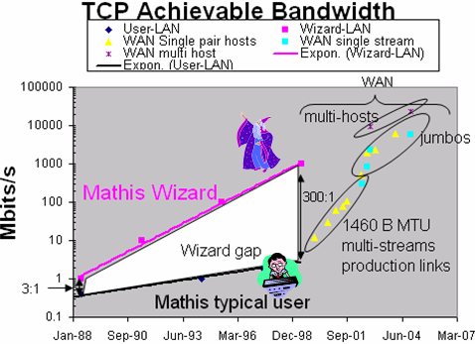
Figure 16: Bandwidth achievable by a network wizard and a typical user as a function of time. Also shown are some recent network throughput achievements in the HEP community.
Because of HEP's critical dependence upon networks to enable their global collaborations and grid computing environments, it is extremely important that more user specific tools be developed to support these physicists.
Efforts are underway in the HENP community, in conjunction with the Internet2 End-to-End (E2E) Performance Initiative [E2Epi], to develop and deploy a network measurement and diagnostic infrastructure which includes end hosts as test points along end-to-end paths in the network. The E2E piPEs project [PiPES], the NLANR/DAST Advisor project [Advisor] and the EMA (End-host Monitoring Agent) [EMA] are all working together to help develop an infrastructure capable of making on demand or scheduled measurements along specific network paths and storing test results and host details for future reference in a common data architecture. The information format will utilize the GGF NMWG [NMWG] schema to provide portability for the results. This information could be immediately used to identify common problems and provide solutions as well as to acquire a body of results useful for baselining various combinations of hardware, firmware and software to define expectations for end users.
A primary goal is to provide as "lightweight" a client component as possible to enable widespread deployment of such a system. The EMA Java Web Start client is one example of such a client, and another is the Network Diagnostic Tester (NDT) tool [NDT]. By using Java and Java Web Start, the most current testing client can be provided to end users as easily as opening a web page. The current version supports both Linux and Windows clients.
Details of how the data is collected, stored, discovered and queried are being worked out. A demonstration of a preliminary system is being shown at the Internet2 Joint-techs meeting in Hawaii on January 25th, 2004.
The goal of easier to use top level drill down navigation to the measurement data is being tackled by MonALISA [MonALISA] in collaboration with the IEPM project.
A long term goal is to merge Pinger and IEPM-BW results into a larger distributed database architecture for use by grid scheduling and network diagnostic systems. By combining general network health and performance measurement with specific end-to-end path measurements we can enable a much more robust, performant infrastructure to support HEP worldwide and help bridge the Digital Divide.

Comparison with HEP Needs
Recent studies of HEP needs, for example the TAN Report (http://gate.hep.anl.gov/lprice/TAN/Report/TAN-report-final.doc) have focused on communications between developed regions such as Europe and Anglo America. In such reports packet loss less than 1%, vital for unimpeded interactive log-in, is assumed and attention is focused on bandwidth needs and the impact of low, but non-zero, packet loss on the ability to exploit high-bandwidth links. The PingER results show clearly that much of the world suffers packet loss impeding even very basic participation in HEP experiments and points to the need for urgent action.
The PingER throughput predictions based on the Mathis formula assume that throughput is mainly limited by packet loss. The 40% per year growth curve in Fig. 10 is somewhat lower than the 79% per year growth in future needs that can be inferred from the tables in the TAN Report. True throughput measurements have not been in place for long enough to measure a growth trend. Nevertheless, the throughput measurements, and the trends in predicted throughput, indicate that current attention to HEP needs between developed regions could result in needs being met. In contrast, the measurements indicate that the throughput to less developed regions is likely to continue to be well below that needed for full participation in future experiments.

Comparisons with Economic and Development Indicators
Various economic indicators have been developed by the U.N. and the International Telecommunications Union (ITU). It is interesting to see how well the PingER performance indicators correlate with the economic indicators. The comparisons are particularly interesting in cases where the agreement is poor, and may point to some interesting anomalies or suspect data.
The Human Development Index (HDI) is a summary measure of human development (see http://hdr.undp.org/reports/global/2002/en/ ). It measures the average achievements in a country in three basic dimensions of human development:
- A long and healthy life, as measured by life expectancy at birth
- Knowledge, as measured by the adult literacy rate (with two-thirds weight) and the combined primary, secondary and tertiary gross enrolment ratio (with one-third weight)
- A decent standard of living, as measured by GDP per capita (PPP US$).
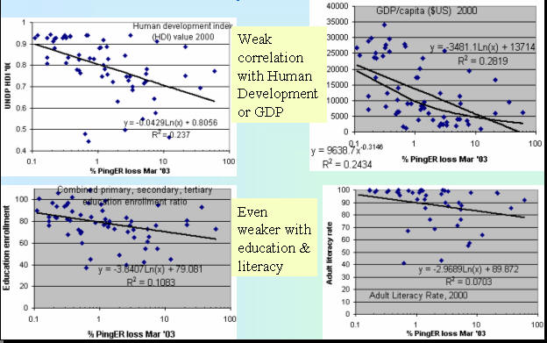
Figure 12: Comparisons of PingER losses seen from N. America to various countries versus various U.N. Development Programme (UNDP) indicators.
The Network Readiness Index (NRI) from the Center for International Development, Harvard University (see http://www.cid.harvard.edu/cr/pdf/gitrr2002_ch02.pdf ) is a major international assessment of countries’ capacity to exploit the opportunities offered by Information and Communications Technologies (ICTs), i.e. a community’s potential to participate in the Networked World of the future. The goal is to construct a network use component that measures the extent of current network connectivity, and an enabling factors component that measures a country’s capacity to exploit existing networks and create new ones. Network use is defined by 5 variables related to the quantity and quality of ICT use. Enabling factors are based on Network access, network policy, networked society and the networked economy.
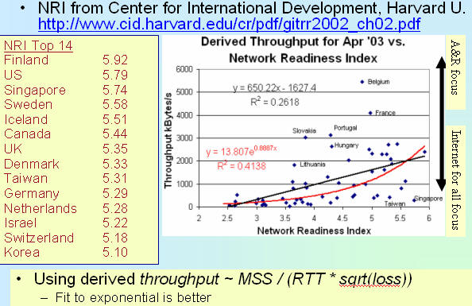
Figure 17: PingER throughputs measured from N. America vs. the Network Readiness Index.
Some of the outlying countries are identified by name. Countries at the bottom right of the right hand graph may be concentrating on Internet access for all, while countries in the upper right may be focusing on excellent academic & research networks.
The Digital Access Index (DAI) created by the ITU combines eight variables, covering five areas, to provide an overall country score. The areas are availability of infrastructure, affordability of access, educational level, quality of ICT services, and Internet usage. The results of the Index point to potential stumbling blocks in ICT adoption and can help countries identify their relative strengths and weaknesses.
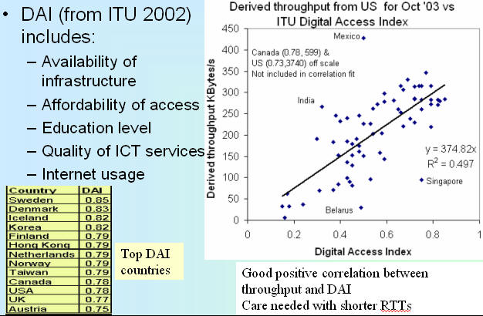
Figure 18: PingER derived throughput vs. the ITU Digital Access Index for PingER countries monitored from the U.S.
Since the PingER Derived Throughput is linearly proportional to RTT, countries close to the U.S. (i.e. the U.S., Canada and Mexico) may be expected to have elevated Derived Throughputs compared to their DAI. We thus do not use the U.S. and Canada in the correlation fit, and they are also off-scale in Figure 18. Mexico is included in the fit, however it is also seen to have an elevated Derived Throughput. Less easy to explain is India's elevated Derived Throughput. This maybe due to the fact that we monitor university and research sites which may have much better connectivity than India in general. Belarus on the other hand apparently has poorer Derived Throughput than would be expected from its DAI. This could be an anomaly for the one host currently monitored in Belarus and thus illustrates the need to monitor multiple sites in a developing country.
The United Nations Development Programme (UNDP) introduced the Technology Achievement Index (TAI) to reflects a country's capacity to participate in the technological innovations of the network age. The TAI aims to capture how well a country is creating and diffusing technology and building a human skill base. It includes the following dimensions: Creation of technology (e.g. patents, royalty receipts); diffusion of recent innovations (Internet hosts/capita, high & medium tech exports as share of all exports); Diffusion of old innovations (log phones/capita, log of electric consumption/capita); Human skills (mean years of schooling, gross enrollment in tertiary level in science, math & engineering). Fig. 19 shows December 2003's derived throughput measured from the U.S. vs. the TAI. The correlation is seen to be positive and medium to good. The US and Canada are excluded since the losses are not accurately measureable by PingER and the RTT is small. Hosts in well connected countries such as Finland, Sweden, Japan also have their losses poorly measured by PingER and since they have long RTTs the derived throughput is likely to be low using the Mathis formula and if no packets are lost then assuming a loss of 0.5 packets in the 14,400 sent to a host in a month.
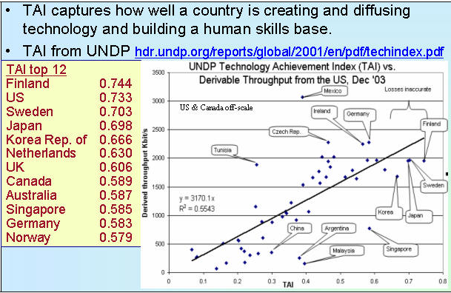
9ure 19: PingER derived throughputs vs. the UNDP Technology Achievement Index (TAI)

Accomplishments since last report
We have extended the measurements to cover more developing countries and to increase the number of hosts monitored in each developing country. We have carefully evaluated the routes and minimum ping RTTs to verify that hosts are where they are identified to be in our database. As a result we have worked with contact in relevant countries and sites to find alternatives, and about 20-30 hosts have been replaced by more appropriate hosts. In addition (see Table 5) we have added 14 new countries (AF, BJ, BU, CM, ET, GE, ML, PK, PA, PY, RW, SU, TH). At the same time we are no longer able to find hosts to monitor in 11 countries (AN, AU, BE, KY, MO, RE, SA,SC, SL, ES and VN). The unreachability of these sites has mainly been caused by ping blocking
The collaboration between SLAC and the NIIT in Rawalpindi Pakistan was funded by the Pakistan Ministry Of Science and Technology and the US Department of State for one year starting September 2004. The funding is for travel only. The collaboration is successfully working on designing, building and populating a new PingER configuration database to keep track of location (city, country, region, latitude/longitude), contacts, site name, affinity groups etc. This data is already being used to provide online maps such as Fig. 1. Work is also proceeding on automating the process of generating graphs of performance aggregated by region
We still spend much time working with contacts to unblock pings to their sites (for example ~15% of hosts pingable in July 2003 were no longer pingable in December 2003), to identify the locations of hosts and to find new hosts/sites to monitor. It is unclear how cost-effective this activity is. It can take many emails to explain the situation, sometimes requiring restarting when the problem is passed to a more technically knowledgeable person. Even then there are several unsuccessful cases where even after many months of emails and the best of intentions the pings remain blocked. One specific case was for all university sites in Vietnam were blocked for ping. We have been working with people in Palestine for about 6 months to get sites to monitor, however the fragile political situation is still delaying fruition.
Even finding knowledgeable contacts, explaining what is needed and following up to see if the recommended hosts are pingable, is quite labor intensive. To assist with this we have created a brochure for PingER describing its purposes, goals and requirements. More recently we have had more success by using Google to search for university web sites in specific TLDs. The downside is that this way we do not have any contacts with specific people with whom we can deal in case of problems.
Efforts for Better PingER Management:

With the increase in the monitoring data of PingER, we initiated efforts to develop supporting systems for better management and installation of PingER. In all, three major initiatives have been taken, which are summarized below:

TULIP- IP Locator Using Triangulation
With the growth in the coverage of PingER arises the great difficulty of keeping track of the changes in the physical locations of the monitored sites. This might lead to mis-leading conclusions, for instance our sole monitoring node in Sweden had a minimum RTT of 59ms from SLAC. This is not possible as a node deployed at the East Coast in USA has a minimum RTT value greater than 70 ms. Moreover, many nodes in the developing region often change their geographical locations for a variety of reasons. In order to detect and track changes in the physical locations of nodes, the PingER team launched a task to build a tool to give the latitude and longitude for a given IP address or URL. This tool will then be used to identify hosts whose located position is in conflict with the PingER database latitude and longitude by comparing the minimum RTT with that predicted from distance between the monitor and remote sites and making traceroute measurements to further vindicate the results. Anomalies will be reported so the PingER database can be corrected using values from the locator tool and/or new hosts can be chosen to be monitored.
The location of an IP address is being determined using by using the minimum RTT measured from multiple “landmark” sites at known locations, and triangulating the results to obtain an approximate location. The basic application, prototype deployed at http://www.slac.stanford.edu/comp/net/wan-mon/tulip/ is a java based jnlp application that takes RTT measurements from landmarks to a selected target host (typically at an unknown location) specified by the user and figures out the latitudes and longitudes of the target host. The application is under-development and its algorithm and the provision of landmark sites under constant improvement to make the process reasonably accurate.
TULIP (IP Locator Using Triangulation) will also utilize the historical min-RTT PingER data in order to verify the locations of hosts/sites recorded in the PingER configuration database, and to optimize the choices of parameters used by TULIP.
The PingER Management Initiative
Since its inception, the size of the PingER project has grown to where it is now monitoring hosts in over 120 countries from about 35 monitoring hosts in 14 countries. With growth in the number of monitoring as well as monitored (remote) nodes, it was perceived that automated mechanisms need to be developed for managing this project. The following modules for PingER management project are being developed or under testing:
- Creation of filters to indicate the monitoring sites whose data is not available
- Creation of filters to indicate the monitored sites that are not available and categorize them according to their response status.
- Identification of a host that physically moves to a new location (e.g. a named web server actually is a proxy that is not where it used to be), by calculating drastic changes in the minimum RTTs of the monitored hosts
- Automated report generation tool to generate daily, monthly, yearly reports regarding problems in monitored data.
- Detect sudden, significant (anomalous) changes in the behavior (including breaks in reachability) of the network.
- Identifying discrepancies (e.g. impossible values) in measured data and in the host configuration databases (e.g. at the time of registration of the monitored hosts, the data entered might be incorrect and incomplete).
PingER2: Easy Installation
Until last year, PingER had a complex installation procedure. An initial improved installation process was developed by students working under Warren Matthews at Georgia Tech. This was extended, and productized by two NIIT project students in order to integrate the improvements and make PingER easier to install for the monitoring sites. This upgrade was necessary, given the increase in the number of monitoring sites around the globe, and the lack of technical skills at the newer sites, especially in the developing regions. The new version is called PingER2, which possesses the same functionality as PingER, but is much easier to install. As a result, the new monitoring hosts in Africa and Pakistan have installed PingER2.

Publications/Presentations:
- Bringing the Internet to China Essay by Les Cottrell in Symmetry magazine volume 02, issue 09, November 05.
- PingER Brochure
- Report from ICFA Digital Divide WorkshopCommand: Daegu, Korea, May 23-27 05 presented by Les Cottrell at the Internet2 Fall Members meeting, Philadelphia Sept 21, 2005.
- Network Monitoring for SCIC prepared by Les Cottrell for the ICFA meeting September 2005.
- Network Monitoring Tools for High Performance Networks presented by Les Cottrell at the Internet Fall 2005 Members meeting, Philadelphia, Sep 19, 2005.
- Network Monitoring for ICFA/SCIC presented by Les Cottrell, at ICFA/SCIC meeting 8/24/05
- Monitoring 10Gbits/s and Beyond presented by Les Cottrell at the LHC tier0, tier1 meeting, CERN Jily 19 '05
- Forecasting Network Perfomance presented by Les Cottrell at the Grid Performance Workshop, Edinburgh June 2005.
- Diagnostic Steps presented by Les Cottrell at the Networking for Non-Networkers second Workshop in Edinburgh, June 2005
- Quantifying the Digital Divide from Within and Without presented by Les Cottrell at the International ICFA Workshop on HEP Networking, Grid and Digital Divide Issues for Global e-Science, Daegu, Korea, May 23-27, 2005.
- Internet Monitoring and Tools presented by Les Cottrell at the International ICFA Workshop on HEP Networking, Grid and Digital Divide Issues for Global e-Science, Daegu, Korea, May 23-27, 2005.
- Quantifying the Digital Divide from Within and Without presented by Les Cottrell at the Internet2 Members Meeting SIG on Hard to Reach Network Places, Washington, May 2005.
- Datagrid Wide Area Monitoring Infrastructure (DWMI) aka IEPM-BW presented by Connie Logg to the ESCC and the Joint Techs Performance Tools Workshop, February 2005.
- End-to-end Anomalous Event Detection in Production Networks, presented by Les Cottrell at the ESnet Site Coordinators metting, Salt Lake City, February 2005.
- Quantifying the Digital Divide, prepared by Les Cottrell for the Internet2/World Bank meeting, Feb 7 2005.

Recommendations
There is interest from ICFA, ICTP and others to extend the monitoring further to countries with no formal HEP programs, but where there are needs to understand the Internet connectivity performance in order to aid the development of science. Africa is a region with many such countries.
Extend the monitoring from within developing countries to provide performance within developing regions, between developing regions and from developing regions to developed regions..
We should ensure there are >=2 remote sites monitored in each Developing Country. All results should continue to be made available publicly via the web, and publicized to the HEP community and others. Typically HENP leads other sciences in its needs and developing an understanding and solutions. The outreach from HENP to other sciences is to be encouraged. The results should continue to be publicized widely.
We need assistance from ICFA and others to find sites to monitor and contacts in the following countries:
- Latin America: Columbia, Panama, Paraguay, Uruguay
- Vietnam*
- Belarus^{h} (need > 1), Moldova (have none)
- Africa: Algeria, Benin, Burundi, Cameroon, Ethiopia, Ghana, Mali, Madagascar, Mauritania, Niger, Somalia, Sudan, Zimbabwe (all need > 1 site/country), Libya, (have none)
- Afghanistan, Jordan (need > 1 site/country), Palestine, Saudi Arabia (have none)
Continue work on reducing the ongoing management and improving the quality of the data:
- simplify and where possible automate the procedures to analyze and create the summary statistical information (graphs and tables seen in the current report) at regular intervals;
- develop automated methods to discover non-responsive hosts, make extra tests to pin-point reasons for non-responsiveness, and report to administrator together with contact email addresses.
Although not a recommendation per se, it would be disingenous to finish without noting the following. SLAC & FNAL are the leaders in the PingER project. The funding for the PingER effort came from the DoE MICS office since 1997, however it terminated at the end of the September 2003, since it was being funded as research and the development is no longer regarded as a research project. To continue the effort at a minimum level (maintain data collection, explain needs, reopen connections, open firewall blocks, find replacement hosts, make limited special analyses, prepare & make presentations, respond to questions) would probably require central funding at a level of about 50% of a Full Time Equivalent (FTE) person, plus travel. To extend the and enhance the project, fix known non-critical bugs, improve visualization, automate reports generated by hand today, find new country site contacts, add route histories and visualization, automate alarms, update web site for better navigation, add more Developing Country monitoring sites/countries, improve code portability) interestingly is currently being addressed by the MAGGIE-NS project with NIIT in Pakistan funded for one year by the US Department of State and the Pakistani Ministry Of Science and Technology (MOST). Without funding, for the operational side, the future of PingER and reports such as this one is unclear, and the level of effort sustained in 2003 and 2004, and 2005 will not be possible in 2006. Many agencies/organizations have expressed interest (e.g DoE, ESnet, NSF, ICFA, ICTP, IDRC, UNESCO) in this work but none can (or are allowed to) fund it..

Appendix: Countries in PingER Database
Table 5 lists the 115 countries currently (January 1st 2005) in the PingER database. Such countries contain zero (the Vietnam hosts we used to monitor now block pings, and we are unable to find a host that does not block pings) or more sites that are being or have been monitored by PingER from SLAC. The number in the column to the right of the country name is the number of hosts monitored in that country. The number cell is colored red for zero hosts, yellow for one host for the country and green for 2 or more hosts for the country. The 37 countries marked in orange are developing countries for which we only monitor one site in the country.
Table 5: PingER countries monitored from SLAC with the number of sites/country. Countries in green were added in 2005. We are unable to find any monitorable sites any longer in countries with 0 sites.
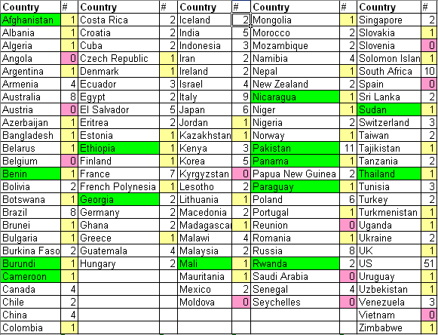

References
[Advisor] http://dast.nlanr.net/Projects/Advisor/
[africa] Mike Jensen, "African Internet Connectivity". Available http://www3.sn.apc.org/africa/afrmain.htm
[africa-rtm] Enrique Canessa, "Real time network monitoring in Africa - A proposal - (Quantifying the Digital; Divide)". Available http://www.ictp.trieste.it/~ejds/seminars2002/Enrique_Canessa/index.html
[bbcp] Andrew Hanushevsky, Artem Trunov, and Les Cottrell, "P2P Data Copy Program bbcp", CHEP01, Beijing 2002. Available at http://www.slac.stanford.edu/~abh/CHEP2001/p2p_bbcp.htm
[bbftp] "Bbftp". Available http://doc.in2p3.fr/bbftp/.
[bullot] "TCP Stacks Testbed", Hadrien Bullot and R. Les Cottrell. Avialble at http://www-iepm.slac.stanford.edu/bw/tcp-eval/
[coccetti] "TCP STacks on Production Links", Fabrizzio Coccetti and R. Les Cottrell. Available at http://www-iepm.slac.stanford.edu/monitoring/bulk/tcpstacks/
[E2Epi] http://e2epi.internet2.edu/
[eassy] The East African Submarine System http://eassy.org/
[ejds-email] Hilda Cerdeira and the eJDS Team, ICTP/TWAS Donation Programme, "Internet Monitoring of Universities and Research Centers in Developing Countries". Available http://www.slac.stanford.edu/xorg/icfa/icfa-net-paper-dec02/ejds-email.txt
[ejds-africa] "Internet Performance to Africa" R. Les Cottrell and Enrique Canessa, Developing Countries Access to Scientific Knowledge: Quantifying the Digital Divide, ICTP Trieste, October 2003; also SLAC-PUB-10188. Available http://www.ejds.org/meeting2003/ictp/papers/Cottrell-Canessa.pdf
[ejds-pinger] "PingER History and Methodology", R. Les Cottrell, Connie Logg and Jerrod Williams. Developing Countries Access to Scientific Knowledge: Quantifying the Digital Divide, ICTP Trieste, October 2003; also SLAC-PUB-10187. Available http://www.ejds.org/meeting2003/ictp/papers/Cottrell-Logg.pdf
[EMA] http://monalisa.cern.ch/EMA/
[floyd] S. Floyd, "HighSpeed TCP for Large Congestion Windows", Internet draft draft-floyd-tcp-highspeed-01.txt, work in progress, 2002. Available http://www.icir.org/floyd/hstcp.html
[gridftp] "The GridFTP Protocol Protocol and Software". Available http://www.globus.org/datagrid/gridftp.html
[host-req] "Requirements for WAN Hosts being Monitored", Les Cottrell and Tom Glanzman. Available at http://www.slac.stanford.edu/comp/net/wan-req.html
[icfa-98] "May 1998 Report of the ICFA NTF Monitoring Working Group". Available http://www.slac.stanford.edu/xorg/icfa/ntf/
[icfa-mar02] "ICFA/SCIC meeting at CERN in March 2002". Available http://www.slac.stanford.edu/grp/scs/trip/cottrell-icfa-mar02.html
[icfa-jan03] "January 2003 Report of the ICFA-SCIC Monitoring Working Group". Available http://www.slac.stanford.edu/xorg/icfa/icfa-net-paper-dec02/
[icfa-jan04] "January 2004 Report of the ICFA-SCIC Monitoring Working Group". Available http://www.slac.stanford.edu/xorg/icfa/icfa-net-paper-jan04/
[iepm] "Internet End-to-end Performance Monitoring - Bandwidth to the World Project". Available http://www-iepm.slac.stanford.edu/bw
[ictp] Developing Country Access to On-Line Scientific Publishing: Sustainable Alternatives, Round Table meeting held at ICTP Trieste, Oct 2002. Available http://www.ictp.trieste.it/~ejds/seminars2002/program.html
[ictp-jensen] Mike Jensen, "Connectivity Mapping in Africa", presentation at the ICTP Round Table on Developing Country Access to On-Line Scientific Publishing: Sustainable Alternatives at ITCP, Trieste, October 2002. Available http://www.ictp.trieste.it/~ejds/seminars2002/Mike_Jensen/jensen-full.ppt
[ictp-rec] RECOMMDENDATIONS OF the Round Table held in Trieste to help bridge the digital divide. Available http://www.ictp.trieste.it/ejournals/meeting2002/Recommen_Trieste.pdf
[kuzmanovic] "HSTCP-LP: A Protocol for Low-Priority Bulk Data Transfer in High-Speed High-RTT Networks", Alexander Kuzmanovic, Edward Knightly and R. Les Cottrell. Available at http://dsd.lbl.gov/DIDC/PFLDnet2004/papers/Kuzmanovic.pdf
[low] S. Low, "Duality model of TCP/AQM + Stabilized Vegas". Available http://netlab.caltech.edu/FAST/meetings/2002july/fast020702.ppt
[mathis] M. Mathis, J. Semke, J. Mahdavi, T. Ott, "The Macroscopic Behavior of the TCP Congestion Avoidance Algorithm",Computer Communication Review, volume 27, number 3, pp. 67-82, July 1997
[MonALISA] http://monalisa.cacr.caltech.edu/
[NDT] http://miranda.ctd.anl.gov:7123/
[NMWG] http://www-didc.lbl.gov/NMWG/
[nua] NUA Internet Surveys, "How many Online". Available http://www.nua.ie/surveys/how_many_online/
[os] "TCP Tuning Guide". Available http://www-didc.lbl.gov/TCP-tuning/
[pinger] "PingER". Available http://www-iepm.slac.stanford.edu/pinger/; W. Matthews and R. L. Cottrell, "The PingER Project: Active Internet Performance Monitoring for the HENP Community", IEEE Communications Magazine Vol. 38 No. 5 pp 130-136, May 2002.
[pinger-deploy] "PingER Deployment". Available http://www.slac.stanford.edu/comp/net/wan-mon/deploy.html
[PiPES] http://e2epi.internet2.edu/
[qbss] "SLAC QBSS Measurements". Available http://www-iepm.slac.stanford.edu/monitoring/qbss/measure.html
[ravot] J. P. Martin-Flatin and S. Ravot, "TCP Congestion Control in Fast Long-Distance Networks", Technical Report CALT-68-2398, California Institute of Technology, July 2002. Available http://netlab.caltech.edu/FAST/publications/caltech-tr-68-2398.pdf
[tsunami] "Tsunami". Available http://ncne.nlanr.net/training/techs/2002/0728/presentations/pptfiles/200207-wallace1.ppt
[tutorial] R. L. Cottrell, "Tutorial on Internet Monitoring & PingER at SLAC". Available http://www.slac.stanford.edu/comp/net/wan-mon/tutorial.html
[udt] Y Gu, R. L Grossman, “UDT: An Application Level Transport Protocol for Grid Computing”, submitted to the Second International Workshop on Protocols for Fast Long-Distance Networks.
[un] "United Nations Population Division World Population Prospects Population database". Available http://esa.un.org/unpp/definition.html

1. In special cases, there is an option to reduce the network impact to ~ 10bits/s per monitor-remote host pair.
2. Since North America officially includes Mexico, we follow the Encyclopedia Britannica recommendation and use the terminology Anglo America (US + Canada) and Latin America. Unfortunately many of the figures use the term N. America for what should be Anglo America.
h. These countries appear in the Particle Data Group diary and so would appear to have HENP programs.
*. These countries are no longer monitored, usually the host no longer exists, or pings are blocked.

