Magnet IOC Application
Software Specification Document

Introduction

Scope
The scope of this document shall cover the EPICS Magnet Power Supply Controls, which will can be run on three different processors:

Processor | Operating System
COM-X | RT Linux
MVME6800 | RTEMS
(Soft IOC) | Red Hat Linux

The COM-X is an embedded processor onboard the SLAC MCOR Slot-00 Controller, which shall be used for low current power supply. This board also contains an embedded event receiver (EVR) , which shall be used to provide pulse id and timestamp information, which may be used to correlated magnet field with the Beam Position Monitor data. The event trigger shall be used in the fast feedback system to set the field of a magnet at 120Hz. The SLAC MCOR controller is capable of controlling up to 16 magnets per crate, in addition to a single bulk power supply.

The MVME6800 is a processor with a PMC-EVR shall be used to control the Bi-Ra MCOR Slot-00 Controller. The event riggers shall be used in the fast VME IPAC DAC and ADCs will be used to control and monitor up to 16 magnets per MCOR crate. All Bulk Power supplies and Pulsed Supplies shalll be controlled and monitored from PLCs.

Intermediate Power Supplies shall be controlled over Ethernet by Ethernet Power Supply Controllers (EPSC).

Definitions

Acronym | Description
BiRa MCOR Controller | MCOR Controller purchased from BiRa Systems
SLAC MCOR Controller | MCOR Controller with, Ethernet CPU & FPGA onboard
FPGA | Programmable Gate Array program includes logic to control/monitor the ADCs, DACs(immediate setpoint as well as ramp modes), Bulk power supply, MCOR channels and interface to the CPU and timing.
EPSC | Ethernet Power Supply Controller

Subsystem Software Specification
This document describes the IOC application software interface for magnet power supply control EPICS driver and device support, along with other modifications in the $EPICS_IOC_TOP/Magnet IOC application.

Subsystem Test Plan
Hyperlink to IOC Test Plan (word doc)

Subsystem User Guide
Hyperlink to IOC User Guide (word doc)

User Documentation and Training
Documentation for the subsystem is listed above as project deliverables

Subsystem training for physicists and operators is provided.

Requirements

Use Cases

MCOR System Configuration
The MCOR system is used to power up to 16 low current magnets per MCOR crate.
Multiple MCOR Crates can be powered by a single bulk power supply (e.g 10kW). Each MCOR crate will have a slot-00 controller in the left most slot, with power modules that fill 16 slots to the right. The power modules can include +/-1, 2, 6, 9, 12 or 30Amps.

Although multiple MCOR crates can be powered by one bulk, only one SLAC MCOR controller shall control the bulk supply. This controller will be referred to as the master, and all other MCOR crate powered from the bulk will be referred to as slaves. All slaves will receive the status information from the bulk through an interconnect panel, where the bulk supply signals will be passed.

The available signals from a Bulk Power Supply depend upon the manufacture and model. However, table 1 below provides a list of the common signals available for all power supplies types currently in used for LCLS.

Bulk Power Supply Signals
Signal | Lambda | EMS | ESS
Voltage Output | x
Voltage Readback | x
Current Output Readback | x
Gound Current | x
PS On/Off Request | x
PS On/Off Status | x
Over Voltage | x
Under Voltage | x
Over Temperature Fault | x
Ground Current Fault | x
Fault Reset | x
Local Mode
Table 1: Bulk Power Supply Signals

The signals available to the MCOR Slot-00 controller are listed in table 2 below.

MCOR Slot-00 Controller
Signal | No Chans | SLAC | BiRa
Channel Voltage Output | 16 | x | x
Channel Voltage Readback | 16 | x | x
Channel Feedback Voltage Readback | 16 | x | x
Channel Summary Fault | 16 | x | x
Channel Local Mode | 16 | x
Bulk PS Local Mode | 1 | x
Bulk PS On/Off Request | 1 | x
Bulk PS On/Off Status | 1 | x
Bulk PS Current Set point | 1 | x
Bulks PS Gound Current Resistance | 1 | x
Bulk PS Under Voltage Fault | 1 | x
Reset Bus | 1 | x | x
Inhibit Bus (not used) | 1 | x | x
Table 2: MCOR Slot-00 Controller Signals

Fault Conditions
The MCOR Slot-00- Controller has a summary fault signal for each channel. This signal includes:
- Channel Power Module Fault
- Bulk power supply fault (summary of ground current, over current, under current and over temperature)
The SLAC MCOR Slot-00 Controller FPGA shall ramp all channels to zero if a channel fault condition has occurred or if the bulk power supply has been turned off, unless the MCOR channel has been set to local mode. A bit in the channel status register register shall indicates if the MCOR channel mode.

Please note that the bulk power supply requested setopnit will not be zeroed if a bulk summary fault has occurred, instead the bulk will be turned off, unless the bulk is set to a slave in the configuration status register.
Operating Modes
The MCOR channels and bulk power supply shall have a operational mode control and status. However the mode control will be read only. The control can only be set from the USB port. Upon power up, both the channel and bulk supply mode will be set to remote (0). When local mode has been set on the MCOR channel or bulk supply the configuration and set point requested registers are ignored and the status register ramping bit may not reflect the actual state.

Please note, that although many of the bulk power supplies do have an operational mode signal, it is not available to the MCOR Slot-00 Controller.

Ramp Timeout
A expected ramp dealy can be calculated based on the ramp rate set and the distance the voltages is changed. If the requested setpoint cannot be reached in the expected timeframe then the ramping status bit shall indicate a timeout has occurred and stop the attempt to reach the setpoint, if in closed loop or direct and fast feedback mode.

Functional Requirements
- Control Functions
  - Set reference point using closed loop control with ramping – trim
  - Set reference pont using open loop control - perturb
  - Standardization - stdz
- Mini-standardize while trimming to maintain standardization.
- Calibration - calb
- Degaussing - degaus
- Remote reset capability of faults - reset
- Remote on/off control of power supply – on/off
- Feedback field correction up to a maximum of 120Hz
Set a list of reference points (all 16-channels or a subset) in parallel. This will be useful for feedback.
- Monitor analog readbacks
- Reference current (IACT)
- Secondary current and compare to reference (IMON)
- Ripple current ( IRIPL)
- Fault Status
  - Interlock fault status
    - Water flow switch fault for water cooled magnets
    - Temperature faults for water cooled magnets
    - PPS permit fault for magnets with PPS safety requirements
- Bulk Power Supply
- Turn on/off bulk power supply
- Set power supply reference
- Set power supply maximum current output
- Set powers supply ground current limit
- Read power supply interlocks.
- Provide ground current fault status
- Provide power supply fault reset
- Provide power supply on/off status
- Provide current readback

Data and Performance Requirements
- Set the magnet field with 1000ppm for magnets powered by low current ps, and 100ppm for those powered by intermediate ps.
- The 120Hz feedback magnet corrector for LCLS are required to settle to within the physics requirement of 85% of the reference point.
- Alarm readbacks when not witin acceptable tolerances.
  - Report power supply and all interlock faults,
  - Comparision of feedback and reference readback for accuracy
  - Reference readback and setpoint
  - Power Supply tripped or powered off
- Restore reference values of MCOR channels and bulk power supply on reboot or power cycle of crate.

Functional or Performance limitations (list)
An opportunity to list what this subsystem should NOT be expected to do.

DETAILED DESIGN

System Architecture

Functional Description

Block Diagram (IOC based)

Interfaces

Hardware Interfaces

  - MCOR System
The MCOR system is a 16-channel, precision magnet driver, capable of providing bipolar output currents in the range from +/–1A to +/-30A at 45V. The figures below shows an MCOR crate at the top of the rack. The MCOR Slot-00 controller is located in the far left slot of the MCOR crate. The remaining slots (1-16) accommodate the individual power regulation modules. A single, unregulated bulk power supply provides the main DC power for the entire crate. Currently the MCORs can provide 1000 ppm regulation of the B-field. The MCOR System employs a modular architecture, so that any individual channel is serviceable without disturbing the operation of adjacent channels in the same crate. There are two type of controller used for the MCOR system, the Bira Slot-00 Controller and the SLAC Slot-00 controller.

A special feature of an MCOR power modules can be modified to reduce the full scale output range by changing the resistors on the PGM card, which is a piggyback module on a power module. For example, an MCOR12 power module can be modified to output of full scale 6 or 9Amps, which would be referred to as an MCOR6 and MCOR9 respecively. Although the output range has been modified, the readback remains 12Amps, which means that an MCOR6 when set to full scale of 6Amps would produce a readback of 12Amps. The table below provides a list of MCOR output and corresponding readback currents. This discrepancy between readback and output current must be handled by the software (ie. FPGA, database, etc.)

MCOR Full Range Current
Power Module | Max Readback Current | Max Output Current
MCOR6 | 12 | 6
MCOR9 | 12 | 9
MCOR12 | 12 | 12
MCOR1 | 2 | 1
MCOR1.5 | 2 | 1.5
MCOR2 | 2 | 2
MCOR30 | 30 | 30
Table 3

  - BiRa MCOR Slot-00 Controller
The BiRa MCOR Slot-00 Controller interfaces to the control system through connectors off the rear of the crate. Analog signals from the power regulation modules is provided from two Amp 36-Pin connectors J3 (DAC) and J4 (ADC) in the rear of the MCOR crate (see figure 2 top far right). A summary of power regulation module faults is provided through the J1 connector.
Figure 2: MCOR Crate (front view)
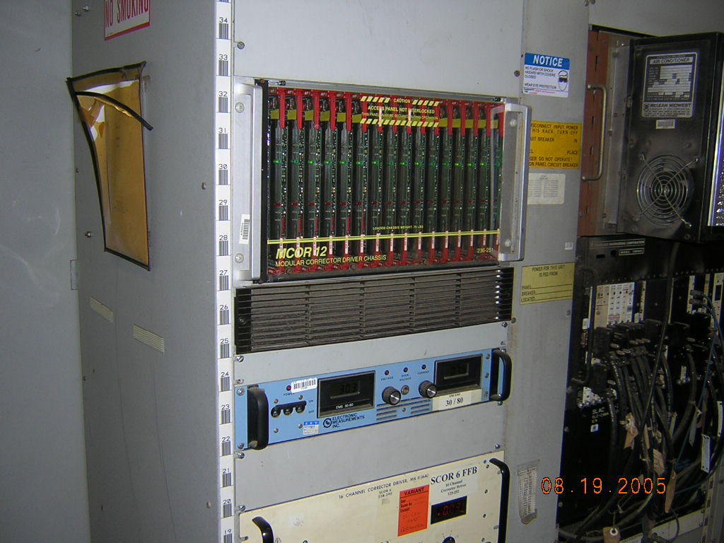
Figure 3: MCOR Crate (rear view)
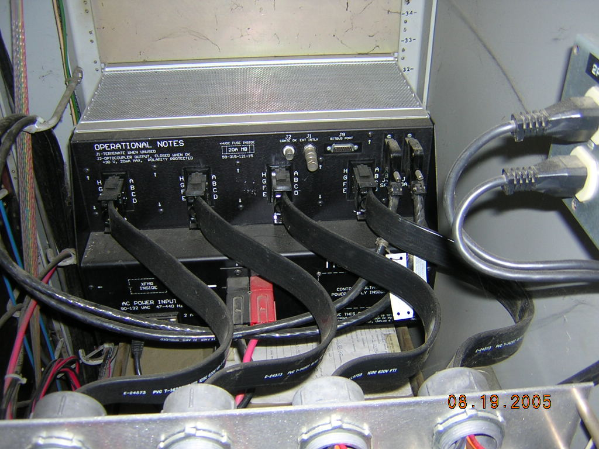

In the current magnet control system for LCLS, a BiRa MCOR Slot-00 Controller is used, and the analog signals are controlled and monitored from a VME IPAC 16-bit, 16-channel DAC and ADC modules that are connected to the Amp-36 pin connectors on the rear of the MCOR crate, J3(DAC) and J4(ADC).

An Allen-Brandley PLC is used in the current control system to provide the control and montor of the 10 kW bulk power supply used to power an MCOR systems in each accelerator sector.

Figure 7 is a block diagram of the MCOR System using the BiRa MCOR Slot-00 Controller and PLC to control the bulk power supply.

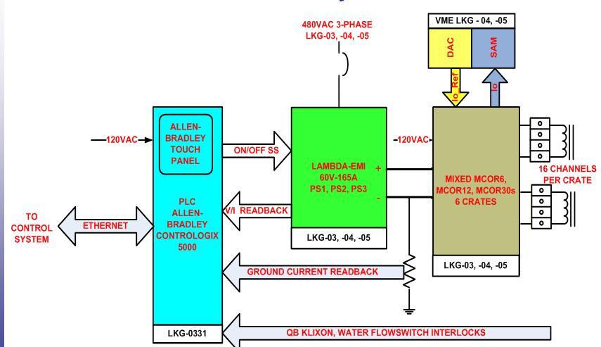

Figure 4: BiRa MCOR Controller System

  - SLAC MCOR Slot-00 Controller
The SLAC MCOR Slot-00 controller, shown in figure 5 below, incorporates all the functionality of the present VME and the Allen Bradley PLC system (see figure 4) on a single card along with the ability to a power modules at a rate of 10 to 120Hz for feedback. This new system shall also provide control and monitor functionality for the Bulk power supply along with ground readback, fault detection and interlock status, such as water flowswitch, thermal (klixon) and pps permits, which was a function performed by the PLC previously. In addition, 4 digital output signals and 8 digitial input signals will be available for use. The SLAC MCOR slot-00 controller will also provide diagnostic features.

The COM-X CPU hosts the magnet IOC application. The $EPICS_IOC_TOP/Magnet/ application will be modified to accommodate the new architecture. The main modifications will be in the EPICS driver/device support layer. The modifications will be discussed in this document.

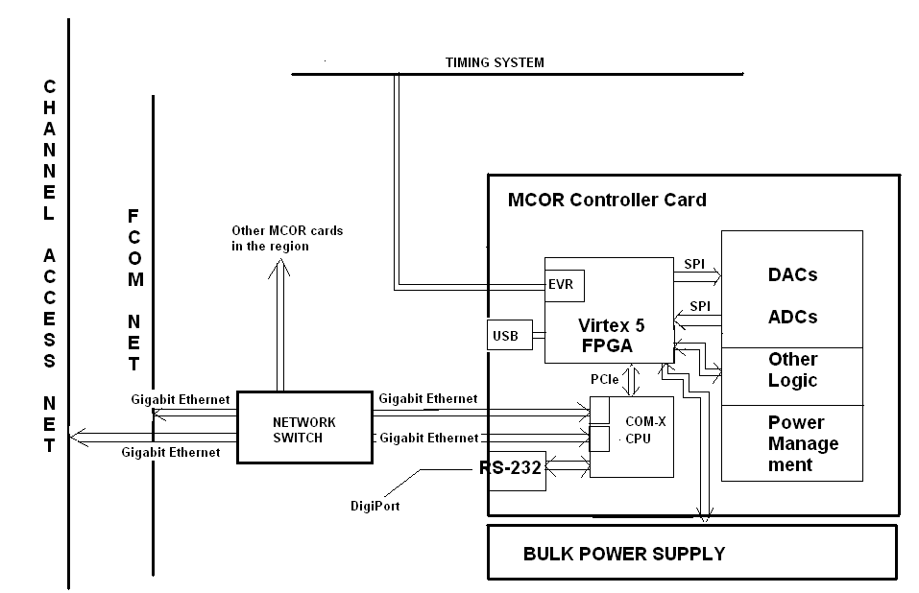
Figure 5: MCOR Slot-00 Controller Block Diagram

  - Ethernet Power Supply Controller (EPSC)
Ethernet Power Supply Controller, designed at SLAC, is used to control and monitor intermediate power supplies for magnets. The EPSCs have an Ethernet interface and the existing EPICS etherPSC driver and device suppport is used to communicate to this device.

  - Programmable Logic Controllers (PLC)
Programmable Logic Controllers, PLC’s are used to in the magnet controls of the MCOR system Bulk Power Supplies, Pulsed Magnet Power Supplies and as an interface to the PPS System. A variety of PLC manufacturers and models are used in the LCLS control system, Allen-Bradley and Beckhoff . The PLCs in use have an Ethernet interface and existing EPICS driver and device support is used to communicate with these devics. For the Allen-Bradley PLCs the etherIP EPICS support is used, while the asyn EPICS support is use for the Beckhoff communication.

  - Power Supplies with a Serial Interface
Some power supplies such as Lambda Genesys models provide do provide a serial interface, which could be connected to a nearby terminal server. However, we do not currently make use of this interface through the control system, although such an addition would be simple to add using the EPICS asyn driver and device support currently available.

  - Timing System
The timing system with pluse id stored as part of the EPICS time is available to the magnet through the even receiver hardware. The timing system is used by the plused magnets and by the fast feedback correctors in the LTU to set the field of the magnet.

External Interfaces

NFS

Channel Access (CA)
- etherPSC
- etherIp
- plcAdmin
- ModBus
- Asyn
- Slow Feedback
- Machine Protection (Machine Protection)
- Beam Containment System (BCS)
- Personnel Protection System (PPS)
- High Level Applications (HLA)
- LCLS Oracle Infrastructure

Feedback (FCOM)

Timing
  - VME PMC EVR-200
The magnet subsystem interfaces externally to the timing system using an EVR which for the new MCOR Slot-00 Controll the electronics is built-in, in contrast to the BiRa MCOR Slot-00 Controller which uses a PMC-EVR installed onto an MVME6100 module. Currently, the EVR is used for timestamp, which provides the beam pulse ID . For the fast correctors used by the Fast Feedback Subsystem, the EVR event module also interfaces to the Pattern Aware Unit (PAU) software in order to receive the timing pipeline.

  - Builtin PMC-EVR SLAC MCOR Controller
The Field Programmable Gate Array (FPGA) includes logic to control/monitor the ADCs, DACs (immediate setpoint as well as ramp modes), Bulk power supply, MCOR channels and interface to the CPU and timing.

  - Linux PMC-EVR

Functional Flow

Data Flow Diagram / (Timing, Feedback, etc…)

Timing

Feedback
There are two types of feedback control, fast and slow feedback. The fast feedback can operate at a maximum of 120Hz, and has time slot capability (pattern aware). All fast feedback requires special hardware, including ps controller, magnet, beam pipe and feedback network. The slow feedback runs at a maximum of 10Hz and does not requires special hardware. The feedback commands are setnt from the feedback controller IOC, for both fast and slow feedback. However, slow feedback are sent to the magent IOC over the channel access (CA) network, whereas the fast feedback request are sent via the dedicated fast feedback network FCOM.

In fast feedback mode, where feedback and the pattern aware capability has been enabled, the control of the magnet is performed by the fast feedback software, which

Operating Modes
There are two basic operating modes regarding magnet controls, normal and feedback.
Under the normal operating mode the magnet power supply control is performed by a user request from a EPICS EDM display. When a magnet is under feedback control, the magnet field is set by the feedback software running on the magnet ioc, based on data received over the FCOM network.

Feedback Operating Mode
Feedback magnet control has only one function available, pertub. Only correctors currently have feedback control. However, there are no software restrictions for feedback control, the only are the controller hardware, the physical magnet, and beam line.

Normal Operating Mode
Normal magnet control provides various functions, trim, perturb, standardize, calibrate, degauss, power on, power off and reset. The functions available to a magnet depends upon the magent configuration, power supply hardware, type of magnet and physics requirements.

Magnet Configurations
There are two types of magnet configuration, individual and strings. Individual magnet configuration consists of a single magnet powered by one or more power supplies connected in series.
BXS
power
supply

A string magnet configuration is a set of magnets connected in series and powered by one or more power supplies that are connected in series. For control purposes, one magnet I the string is choosen as the master. The remaining magnets in the string are considered slaves. The master posses all control and monitoring capability, and each slave uses the current readback from the master with the polynomial coefficients to converts the data to field. The criteria used to choose the master in string is as follows:
- Case 1: For strings where none of the magnets have trim coils, then the first magne in the string, which is based on z-position is the master.
- Case 2: For strings, where all but one has a trim coil, which is always the second magnet in the string, the second magnet is chosen as the master.
- Case 3: For strings, where all magnets have trim coils the second magnt in the sting is considered the master.

BX01
BX02
power
supply

Magnet Types
The types of magnets installed in LCLS are dipole, quadrupole, solenoid, horizontal and vertical correctors magnets. LCLS-II will also include sextupole magnets. The dipole and quadrupole magnets can have additional windings or coils, which are powered by a separate supply. These coils are referred to as bend trims or quad trims. Solenoid power supplies can have something called a bucking coil built into the magnet, which can also be powered separated.

Magnet  Type | Naming Convention Device Type
Dipole | BEND
Quadrupole | QUAD
Solenoid | SOLN
Horizontal Corrector | XCOR
Vertical Corrector | YCOR
Dipole Trim Coil | BTRM
Quadrupole Trim Coil | QTRM
Table 4

SNL Diagram and Description

Calibration
The calibration procedure measures magnet current as a function of the DAC, and calculates a linear fit, generating a new slope. This slope is then used to calculate the DAC counts from current when setting the supply.

The SLAC MCOR Slot-00 controller, due to the accuracy of the DAC and ADCs, in addition to the closed loope control functionality, will not require calibration. However, this will not prevent implementation of a software calibration procedure.

The EPSC uses pulse width modulation for setting the current of the power supply. An internal auto calibration procedure is run providing an accurate current setting. The status and time of the last calibration is provided through the EPSC interface.

Standardization
The standardization of a magnet allows for the magnetic fields dependence on the current through the coils to be set in a way that is reproducible. The standardization procedure cycles the magnet is ramped a number of times to it’s maximum and then minimum current range. At each limit a wait is done to allow for the eddie fields to settle before completing the cycle. At the end of a standardize, successful or failed, the magnet is trimmed to the desired B-field, the standardize OK is set to YES if successful and the standardize time updated. However, if the procedure fauiled the standardize OK is set to NO.

The ramp rate and settle times are defined by the magnet measurements team and should only be changed when authorized by the area physicists and the appropriate PRD update to reflect any such changes.

Trim
Closed loop method of setting the desired field of a magnet is referred to as a “Trim” operation. The trim procedure converts the desire B-field to current. The current is then ramped to this desired set point in one of two methods.

- The first method is called linear, where the desired current is set at the full ramp rate. A wait for the eddie currents to settle is done, afterwhich the actual current is readback to determine if the current is within tolerance. Power Supply controllers that use closed loop shall use the linear method. Note that the only difference between a trim and a perturb is that with a trim
- a mini-standardize will be performed, if standardized is enabled and the current is being set opposite to that of standardization. If a mini-standaridze is done, a wait before setting the final current is doen to wait for the eddie currents to settle.
- The current is set in closed loop rather than open loop mode.
- Settle time at the end of the trim is performed.

- The second method is called three-linear, where the desired current is set in three steps. The first stop the magnet is ramped to 90% of the desired current at the full ramp rate. The second step ramps to the remaining 9% of the desired current at 10% of the full ramp rate . Step three ramps the remainin 1% of the desired current at the 1% of the full ramp rate. Durning each step a wait for the eddie currents to settle is done, afterwhich the actual current is read to determine if the current set is within tolerance. Power Supply controllers that use open loop shal use the three-linear method.

If the magnet B-field requested is to move the current in the direction opposite to that of standardization then the magnet is first moved to the desired current plus 5% of the full current range, afterwhich the magnet is trimmed as usual to the desirec current.

The ramp rates and settle times are defined by the magnet measurements team and should only be changed when authorized by the area physicists and the appropriate PRD update to reflect any such changes.

Perturb
Open loop method of setting the desired field of a magnet is referred to as “Perturb” operation. The perturb procedure convts the desired B-field to current, the current is then ramped to the desired set point. users enteres the desired field and without reading the current position of the magnet the current or voltage output is calculated from field and the dac is set and the operation considered complete. A wait at the end of the perturb function is not performed before flaging the perturb operation complete.

Degauss
The degauss procedure can be specific to a particular magnets. In the case of LCLS, only one magnet BXHS magnet string is currently degaussed. After the degauss is performed, degauss OK and time is set, and the supply is turned off. See procedure provided by Scott Anderson.

Power On and Off
The intermediate and bulk power supplies have an on/off control. If the supply (LGPS) or magnet is defined in the databse as in-service and the device has digital on/off control available, then the request is honored. When as supply is turned off, the standardize OK is cleared.

Power on has two modes for reversible supplies, Power On Normal and Power On Reverse. Only the Ethernet Power Supply Controller currently is capable of controlling a reversing switch. The supply must be turned off to move between states, normal to reverse or revers to normal.

Out-Of-Service
When a magnet is set out of service the current is ramped to zero and the supply is turned off and the standardize OK flag is cleared if standardize is enabled.

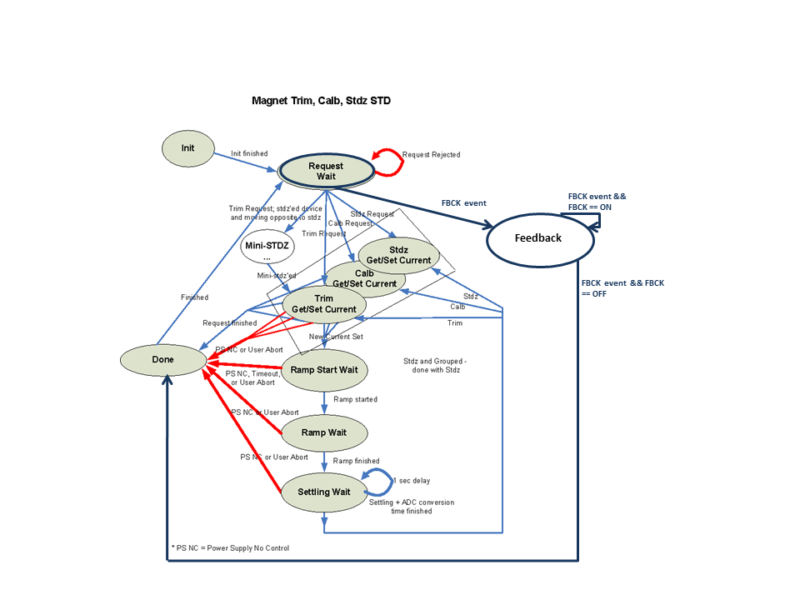
Figure 6 State Notation Diagram

EPICS Record Processing (Databases)
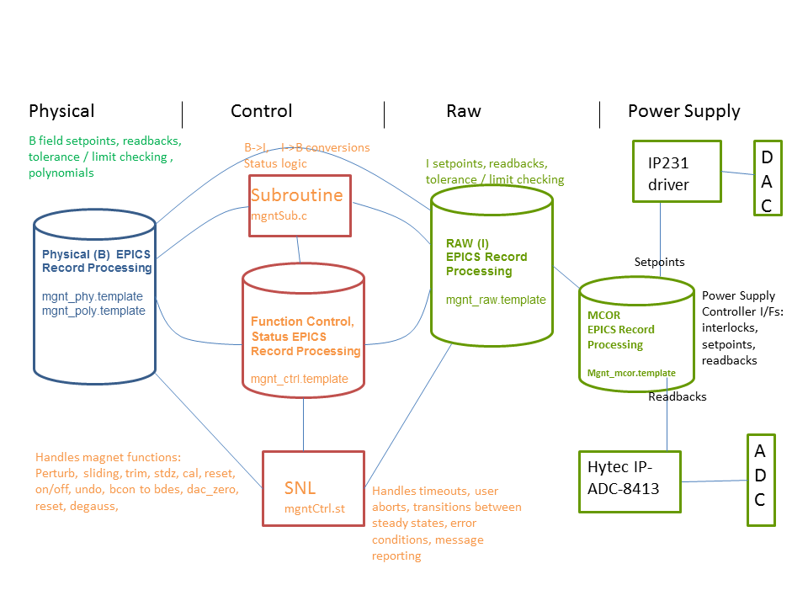
Figure 7 Record processing plus SNL (Sequence)

Subroutine Record Descriptions
Figure 7 Record processing plus SNL (Sequence). The diagram illustrates some of the major record processing functions included in the magnet IOC application. The “Control” record processing with associated SNL processing, is expanded in Figure 8 Normal Control Record Processing.

Refer to $EPICS_IOC_TOP/Magnet…../mgntApp/src/mgntSub.c

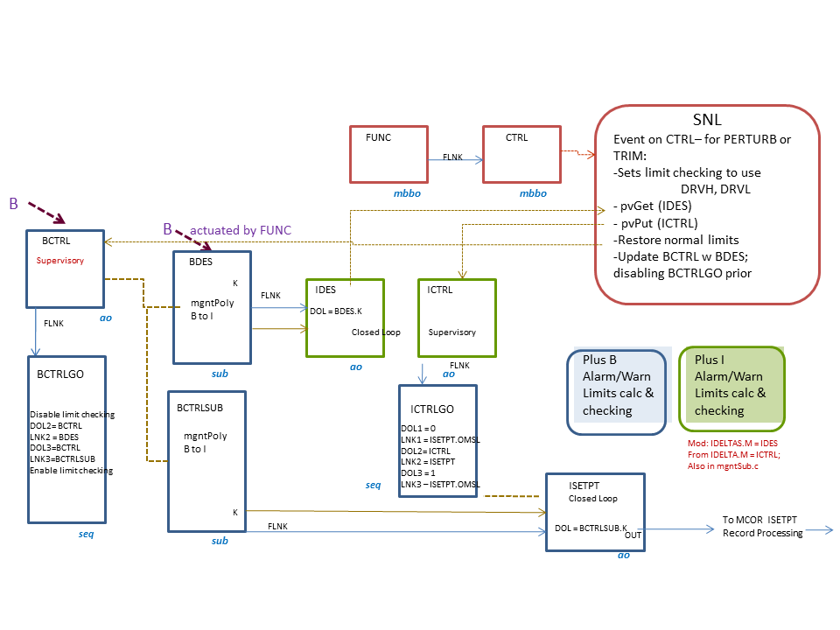
Figure 8 Normal Control Record Processing

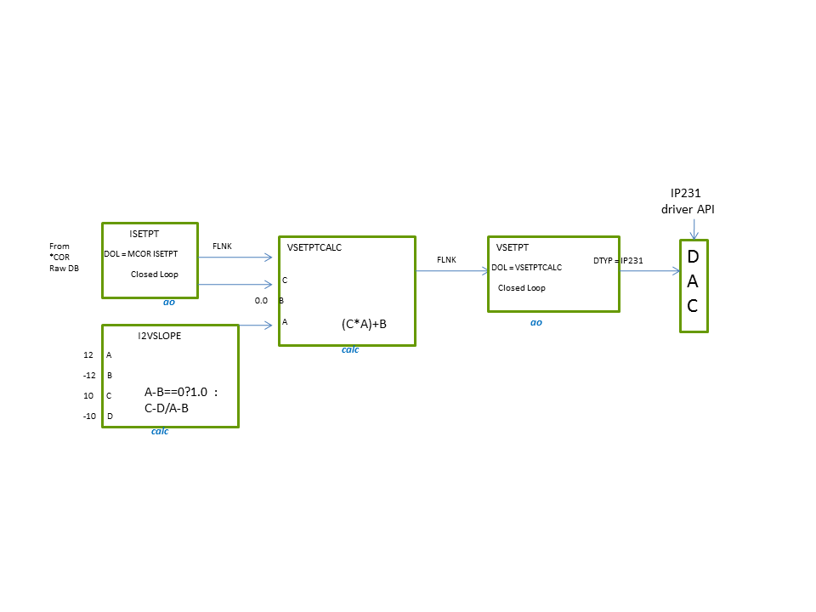
Figure 9: Raw Record Processing
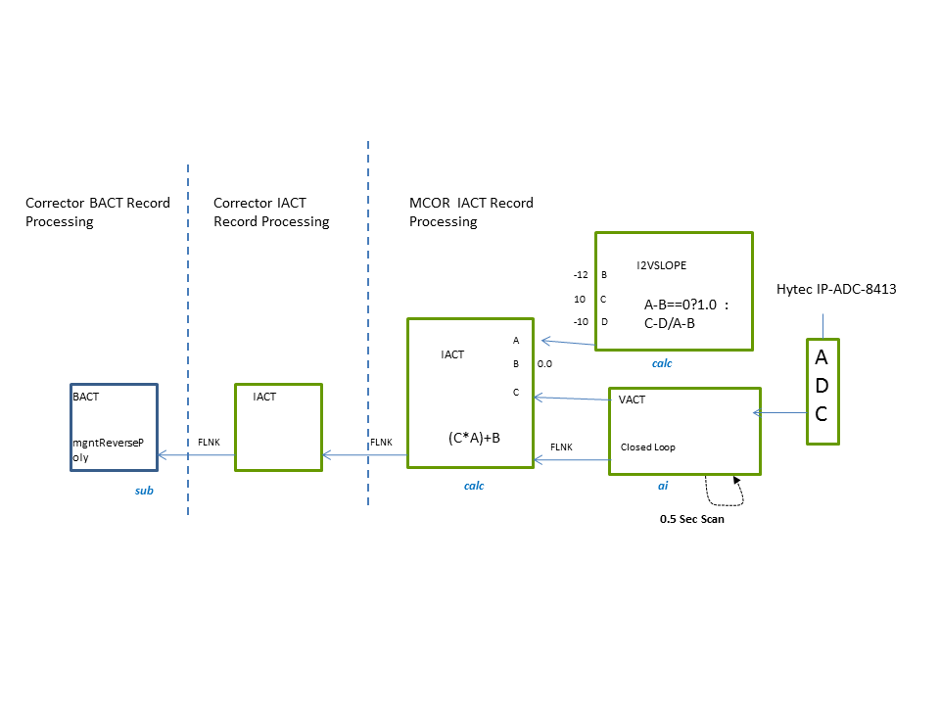
EPSC /SLAC MCOR
PS Controller
BACT
mgntReversePoly
IACT
FLNK
Figure 10: Bi Ra MCOR Readback Record Processing

IOC Modules
This section documents all software modules built into the subsystem. First, all software modules associated with particular hardware modules, such as drivers. Second, all other software modules are described, both common EPICS software modules from the $EPICS_MODULES_TOP, and custom modules developed only for this subsystem.

After installation refer to the LCLS Production IOC Configuration Report .

List all IOC node names that are part of this subsystem so that they can be entered into the LCLS Production IOC Configuration report APEX application.

Common
- Sequencer
- dbRestore
- iocAdmin

Ethernet Support

PLC
The EPICS modules required for PLC communications are the following:
- etherIP
- plcAdmin
- modBus

Analog Inputs
Bulk Power Supplies and Modulators
Record Type | ai
PV Name | PS:<area>:<instance>:<attr>
Attribute | Description | Bulk PS | Modulator
VACT | Voltage Reading | x | x
VINPRAW | Input Voltage |  | x
VOUT | Voltage Output Readback |  | x
IACT | Current Reading |  | x
IGND | Ground Current | x | x
IGNDTRIPPT | Ground Current Trip |  | x
Table 5: PLC EPCIS Analog Input PVs

Analog Outputs
The bulk power supply is currenty ramped to a preset voltage, output by the Allen-Bradley PLC when the supply is turned on. This voltage is physically limited by a knob on the front panel of the power supply. When the bulk power is turned off, either from the control system or locally from the PLC, the voltage is ramped to zero by the PLC. The VSETPT PV for the bulk voltage, is only used in the control system to compare the expected voltage setpoint to the readback voltage, so that a check to see if the bulk supply volate is within tolerance. It should be noted, that some of the modulators set the voltage output value, while others set the current of the supply.

Bulk Power Supplies and Modulators
Record Type | ao
PV Name | PS:<area>:<instance>:<attr>
Attribute | Description | Bulk PS | Modulator
VSETPT | Voltage Set point | x | x
ISETPT | Current Set pont |  | x
Table 6: PLC EPICS Analog Output PV

Digital Outputs
Bulk Power Supplies and Modulators
Record Type | bo
PV Name | PS:<area>:<instsance>:<attr>
Attribute | Description | Bulk PS | Modulator
STATESETPT | Power On/Off Request
RESET | Reset Interlock Faults (pulsed)
Table 7: PLC EPICS Digital Output PVs

Digital Inputs
Bulk Power Supplies and Modulators
Record Type | bi
PV Name | PS:<area>:<instance>:<attr>
Attribute | Description | Bulk PS | Modulator
MODE | Local/Remote Control Status | x | x
STATE | Power On/Off Status | x | x
VOVERSTATE | Over voltage fault status | x | x
VUNDERSTATE | Under voltage fault status | x | x
IGNDSTATE | Ground fault status | x | x
FLOWSWSTATE | Water Flow Switch Interlock Status | x | x
THERMSWSTATE | Termal Switch #1 Fault Status | x | x
THERMSW2STATE | Termal Switch #2 Fault Status | x | x
THERMSW3STATE | Termal Switch #3 Fault Status |  | x
MODSTATE | Modulator Ready Status |  | x
SYSREADY | System ready for turn on |  | x
CABLESTATE | Status of cable connection to ps |  | x
FAULT | HVPS Fault Status |  | x
HV_READY | HVPS Ready Status |  | x
PPS_STATE | PPS Permit Status |  | x
TRIGSTATE | Pulse Trigger Status |  | x
BUSYSTATE | System Busy Status |  | x
ESTOPSTATE | Emergency Stop Status |  | x
Table 8: PLC EPICS Digital Input PVs

Ethernet PS Controller
The etherPSC EPICs device and driver support is used to control and monitor the EPSC signals.

Analog Inputs
Intermediate Power Supplies
Record Type | ai
PV Name | PSC:<area>:<instance>:<attr>
Attribute | Description
IACT | Current Reading
IACTINP | Current Transductor Reading
IMON | Auxillary Current Transductor Reading
IGND | Ground Current
VACTSPARE | Spare Channel Voltage
IACTV2I | Transductor Voltage to Current Constant
IMONV2I | Auxilliary Transductor Voltage to Current Constant
IGNDV2I | Ground Current Voltage to Current Constant
IRIPL | Ripple Current
IDAC | DAC Current
PSV2V | PS Voltage to Voltage Constantr
PSVREF | PS Voltage Reference
PSVOUT | PS Output Voltage
CONTROLTEMP | PS Controller Temperature
Table 9: EPSC EPICS Analog Input PVs

Analog Outputs
Intermediate Power Supplies
Record Type | ao
PV Name | PSC:<area>:<instance>:<attr>
Attribute | Description
ISETPT | Current Setpoint
IRAMPRATE | Current Ramp Rate Setpoint
Table 10: EPSC EPISC Analog Output PVs

Digital Inputs
Intermediate Power Supplies
Record Type | bi
PV Name | PSC:<area>:<instance>:<attr>
Attribute | Description
RAMPSTATE | Current Ramp Status | IDLE | BUSY
STATE | PS on/off status | OFF | ON
READY | PS ready for Turn On | NOTREADY | READY
MAGNET 0STATUS | Interlock 0 Status | FAULT | OK
MAGNET1STATUS | Interlock 1 Status | FAULT | OK
MAGNET2STATUS | Interlock 2 Status | FAULT | OK
MAGNET3STATUS | Interlock 3 Status | FAULT | OK
IACTSTATUS | Transductor Interlock Status | FAULT | OK
IGNDSTATUS | Gound Current Fault | FAULT | OK
FAULTSTATUS | Fault Latch Status | FAULT | OK
PSSTATE | PS On/Off Readback Status | OFF | ON
PS0STATUS | PS 0 Status | FAULT | OK
PS1STATUS | PS 1 Status | FAULT | OK
PS2STATUS | PS 2 Status | FAULT | OK
PS3STATUS | PS 3 Status | FAULT | OK
IMONSTATUS | Auxillary Transductor Status | FAULT | OK
MODE | Controller Local Mode Status | LOCAL | REMOTE
CALBOK | Auto-Calibration Status | FAULT | OK
HWSTATUS | Hardware Status | FAULT | OK
Table 11: EPSC EPICS Digital Input PVs

Digital Outputs
Intermediate Power Supplies
Record Type | bo
PV Name | PSC:<area>:<instance>:<attr>
Attribute | Description
STATESETPT | Power On/Off Request | OFF | ON
RESET | Interlock Reset | Pulsed
Table 12: EPSC EPICS Digital Output PVs

Long Input
Intermediate Power Supplies
Record Type | longin
PV Name | PSC:<area>:<instance>:<attr>
Attribute | Description
COMMANDCNT | Bitbus Command Count
RESPONSE CNT | Butbus Response Count
RESETCODE | Last Reset Code
SELFTESTCODE | Last Self-test Ccode
STATECODE | Last Turn Off Code
CALBCODE | Last Calibration Code
DACSLOPECNT | DAC Gain Raw Data
DACOFFSETCNT | DAC Offset Raw Data
ADCGAINCNT | ADC Gain Raw Data
ADCOFFSETCNT | ADC Offset Raw Data
Table 13: EPSC EPICS Long Input PVs

String Input
Intermediate Power Supplies
Record Type | stringin
PV Name | PSC:<area>:<instance>:<attr>
Attribute | Description
CALBTOD | Calibration timestamp
INFOMSG | Informational Message
IPADDRESS | IP Address
Table 14: EPSC EPICS String Input PVs

Feedback
There are two methods of feedback control for magnets, which are categorized as slow feedback and fast feedback. The slow feedback control runs over the channel access (CA) network at 10Hz. Commands are sent from the fast feedback controller IOC to the magnet IOC, to perturb the field of a magnet.

The fast feedback control runs over the dedicated fast feedback (FCOM) network at a maximum rate of 120Hz. Command are received over FCOM from the feedback controller IOC to the magnet IOC. A thread on the magnet IOC takes care of this request by converting desired field to current, using PV information in the EPICS database and then finally converted to the appropriate units and output the the anlog output hardware.
For more detailed information on feedback please see refer to the following documents.

Magent Feedback Design Review
Patter Aware Unit Design Review

The EPICS modules required for fast feedback control of magnets over the FCOM network by the feedback controller are:
- pau
- fcom
- fcomUtil
- udpComm

The database templates provided by the pau module that are used by the magnet IOC applciation are:
- dbPau.template
- dbMux.template
In addition, the db file mgnt_mux.template, found in the magnet application must be included for all magnet devices, even those that do not used fast feedback.

Analog Input
Intermediate Power Supplies
Record Type | ai
PV Name | <prim>:<area>:<position>:<attr>
Example | PAU:LTU1:MG01:<attr>
Attribute | Description
FIDCNT | Fiducial Count
CBCNT | Callback Count
DLYISR | Interrupt Delay
DLYPULL | Pull Function Delay
DLYPUSH | Push Function Delay
SPNFID | Spin Time for Fidicual
SPNDIAG | Spin Time for Diagnostics
Example | XCOR:LTU1:548:<attr>
BCTRL:PULLCNT | User Pull Exec Counter
BCTRL:PUSHCNT | User Push Exec Counter
BCTRL:SPNPULL | Spin Time for User Push
BCTRL:SPNPUSH | Spin Time for User Push
BCTRL:GETFCOM_<0-F> | FCOM Data Reading 0-15
BCTRL:GETDATA_<0-F> | Static Data Reading 0-15
Table 15: Feedback EPICS Analog Input PVs

Analog Output
Intermediate Power Supplies
Record Type | ao
PV Name | <prim>:<area>:<position>:<attr>
Example | PAU:LTU1:MG01:<attr>
Attribute | Description
PIPEIDX | EVR Pipeline Index
DELAY | Timer Delay
Example | XCOR:LTU1:548:<attr>
BCTRL:OFFSET_0 | Offset for Data Slot 0
BCTRL:OFFSET_1 | Offset for Data Slot 1
BCTRL:OFFSET_2 | Offset for Data Slot 2
BCTRL:OFFSET_3 | Offset for Data Slot 3
BCTRL:SETDATA_<0-F> | Static Data Setting 0-15
Table 16: Feedback EPICS Analog Output Pvs

Binary Output
Intermediate Power Supplies
Record Type | bo
PV Name | <prim>:<area>:<position>:<attr>
Example | XCOR:LTU1:548:<attr>
Attribute | Description | Zero State | One State
FBCKFCOM | Mode | CA Mode | FCOM
PAU | PAU Configuration | NotConfigured | Configured
BCTRL:FBCK | Feedback Mode Requeest | OFF | ON
Example | PAU:LTU1:MG01
ACTPAU | Activate PAU | OFF | ON
ACTPULL | Activate Pull Function | OFF | ON
ACTPUSH | Activate Push Function | OFF | ON
ACTDIAG | Activate Diagnostics | OFF | ON
FBCK | Feedback Mode | OFF | ON
Table 17: Feedback EPICS Binary Output PVs

Long Outputs
Intermediate Power Supplies
Record Type | longout
PV Name | <prim>:<area>:<position>:<attr>
Example | PAU:LTU1:MG01:<attr>
Attribute | Description
BEAMCODE_0 | Beam Code 0
BEAMCODE_1 | Beam Code 1
BEAMCODE_2 | Beam Code 2
BEAMCODE_3 | Beam Code 3
BEAMCODE_4 | Beam Code 4
BEAMCODE_5 | Beam Code 5
BEAMCODE_6 | Beam Code 6
BEAMCODE_7 | Beam Code 7
BEAMCODE_8 | Beam Code 8
BEAMCODE_9 | Beam Code 0
BEAMCODE_A | Beam Code 10
BEAMCODE_B | Beam Code 11
BEAMCODE_C | Beam Code 12
BEAMCODE_D | Beam Code 13
BEAMCODE_E | Beam Code 14
BEAMCODE_F | Beam Code 15
TIMESLOT_<0-F> | Timeslot 0-15
INCL<0-F> | Inclusion Mask 0-15
EXCL<0-F> | Exclusion Mask 0-15
Table 18: Feedback EPICS Long Output PVs

String Output
Intermediate Power Supplies
Record Type | stringin
PV Name | <prim>:<area>:<position>:<attr>
Example | XCOR:LTU1:548:<attr>
Attribute | Description
MCORDEVNAME | MCOR PV Device Name
Table 19: Feedback String Input PVs
  - SLAC MCOR Slot-00 Controller Modifications Required:
Slow Feedback
No changes to software is required. May need to set direct mode closed loop when setting DAC., or simply set the ramp rate to 0 when in CA feedback mode. Direct mode ignores the ramp rate where as setting a ramp rate to 0 will require that it be set back to the appropriate ramp rate when in not in direct mode.

Fast Feedback
Modify functions in mgntPauUser.c , using #ifdefs based on processor.

- Modify structure pullUsrData_ts: add ifdefs around pcard element based on processor type, and include the appropriate structure, or make this a void pointer.
- Modify mgntPauUsrGetFieldsFromPVsInit : using ifdefs set the following strings to NULL for ip231: vsetpthopr_ca, vsetptlopr_ca, vsetptESLO_ca, vsetptEOFF_ca, i2vslope_ca, daccard_ca. Change logic to parse the pv <PSDEVNAME>:VSETPT.OUT to determine dac card and dac chan, such that “OUT@<card>:<chan>:DATA”
- Modify mgntPauUsrGetFieldsFromPVs: use ifdefs to get PV data based on hardware.
- Modify mgntPauUsrPull: Move mgntCalcItoV to function mgntsetDAC.
- Modify mgntsetDAC: using ifdefs to allow for setting the SLAC MCOR channel current (i.e. mcorWriteDirect) or the BiRa MCOR (i.e. ip231Write)
- Add function mcorWriteDirect: set the current for the specified channel using direct mode and open loop modes. In this mode the ramp rate is ignored. This function should provide the option of setting closed loop rather than open loop.

Asyn
<To be added later>

VME Support

The EPICS VME modules support required is:
- IPAC
- Hytec IP8413-ADC
- VSAM
- EVR

PMC-EVR 200
The magnet subsystem interfaces externally to the timing system usin a PMC-EVR 200, which is installed as a piggy back module on the MVME6100 processor board. Currently, the EVR is only used to timestamp the data with the beam pulse ID. For the fast correctors the EVR event module also interfaces to the Pattern Aware Unit (PAU) software in order to receive the timing pipeline.

Analog Inputs
The BiRa MCOR Controller provides 16 channel reference input signals. This data is read from an VME 16-bit, 16-channel ADC. The database defines a PV per channel, scanned every 0.5 second. The channel data is converted from ADC counts to voltage (+/-10V) is device support, which in subsequent PVs is converted to current and then to B-field, which the users and higher level applications require. The example below defines the PVs for a vertical corrector (YC21303) magnet in LINAC sector 21. The magnet is powered from MCOR crate crate 1, channel 7.

MCOR
Record Type | ai
Crate | 1-9 | Chan | 01-16, 00 is crate controller
PV Name | MCOR:<area>:<crate>:<chan>:<attribute>
Attribute | Description | Hytec IP-8413 |  | VSAM
VACT | Voltage | x |  | x
VRIPL | Ripple Voltage |  |  | x
VRANGE | Voltage Range |  |  | x
Figure 11:VME EPICS Analog Input PVs

Analog Outputs
To control and monitor the channels from the BiRa MCOR Controller, a 16-bit, 16-channel DAC IPAC module was selected, the Acromag IP231-16E. The database defines a PV per channel to set the voltage, which is processed on demand. The voltage is converted to DAC counts in the device support, where the DAC voltage range of +/-10V is converted to DAC counts in device support and output to the specified DAC channel.

MCOR
Record Type |  | ao
Crate | 1-9 | Chan |  | 01-16, 00 is crate controller
PV Name |  | MCOR:<area>:<crate><chan>:<attr>
Attribute |  | Description | IP231 |  | IP8413 | VSAM
VSETPT |  | Voltage Set Point | x
Table 20: VME EPICS Analog Output PVs

Binary Input
The analog input modules have some setup registers that can be read. The following are the different input available that require EPICS binary input device support

MCOR
Record Type |  | bi
Crate | 1-9 | Chan |  | 01-16, 00 is crate controller
PV Name |  | MCOR:<area>:<crate><chan>:<attr>
Attribute |  | Description | IP231 |  | IP8413 | VSAM
VRANGE |  | Voltage range |  |  | x
MODE |  | Module Operating Mode |  |  | x
SMODE |  | Module Scan Mode |  |  |  | x
DMODE |  | Module Data Mode |  |  |  | x
FORMAT |  | ADC Data Format |  |  | x
CALBSTATE |  | Calibration Values Used |  |  | x
CALBOK |  | Calibration OK |  |  |  | x
Table 21:VME EPICS Binary Input PVs

Binary Output
The analog input modules have some setup registers that can be read. The following are the different input available that require EPICS binary output device support

MCOR
Record Type |  | bo
Crate | 1-9 | Chan |  | 01-16, 00 is crate controller
PV Name |  | MCOR:<area>:<crate><chan>:<attr>
Attribute |  | Description | IP231 |  | IP8413 | VSAM
CALBSETPT |  | Calibration Values Request |  |  | x
SMODESETPT |  | Module Data Mode Setpoint |  |  |  | x
DMODESETPT |  | Module Scan Mode Setpoint |  |  |  | x
FORMATSETPT |  | Module Endianness |  |  |  | x
CALBSETPT |  | Calibration Values Request |  |  | x
RESET |  | Reset Module |  |  |  | x
DIAG |  | Hault Onboard Processor |  |  |  | x
Table 22: VME EPICS Binary Output PVs

Long Input
MCOR
Record Type |  | longin
Crate | 1-9 | Chan |  | 01-16, 00 is crate controller
PV Name |  | MCOR:<area>:<crate>00:<attr>
Attribute |  | Description | IP231 |  | IP8413 | VSAM
SERNO |  | Module Serial Number |  |  | x
MODEL |  | Module Model Number |  |  | x
REV |  | Module Revision |  |  | x
Table 23: VME EPICS Long Input PVs

Multi-Bit Binary Input

MCOR
Record Type |  | mbbi
Crate | 1-9 | Chan |  | 01-16, 00 is crate controller
PV Name |  | MCOR:<area>:<crate>00:<attr>
Attribute |  | Description | IP231 |  | IP8413 | VSAM
CALBTYPE |  | Calibration Type |  |  | x
CLKRATE |  | Internal Clock rate |  |  | x
INTVEC |  | Interrupt Vector |  |  | x
Table 24: VME EPICS Multi-Bit Binary Input PVs

SLAC MCOR Controller Support
The EPICS devBusMapped modules support will be used for the SLAC MCOR
The EPICS records supported needed shall be the ao,ai,bo,bi, longin, longout, mbbiDirect and waveform.

Analog Inputs
The SLAC MCOR Slot-00 Controller inputs will be polled or read on demand. The channel current and voltage readbacks are supplied in milliamps with the exception of the waveform data, which will be provided in ADC counts. The device support will convert from milliamps to amps or ADC counts to amps in the case of waveform data.

Since MCOR power modules can be modified to reduce the full scale output, the user must configure both the output and input full scale range during initializationso that the FPGA will know how to convert from ADC to milliamps and from milliamps to DAC counts. See table 3 for a list of MCOR output and corresponding readback currents. Please note that on boot, if the output and input full scale ranges have not been set the full range defaults to 0Amps. After the full range has been set the “configured” bit in the configuration regtister must be set.
To set the input full scale range the device support will need to set the specified memory location for that channel (offset from base chanNo*0x40) in the table below with the maximum range in milliamps. The input full scale range can be retrieved from the database PV field absolute value of DRVH. The FPGA will assume the full rnage is +/- the value set.

Note: blue text indicates set point.
MCOR Channel (ai)
Base | 0x00000000 | No. Chans |  | 16 | Bytes/Chan |  |  | 0x40 (64)
PV Name | MCOR:<area>:<crate>00:<attr> |  |  | Example |  | MCOR:LI21:100:<attr>
Offset | Description |  |  | PV Attribute
0x00 | Setpoint Requested |  |  | ISETPT
0x04 | Current setpoint (ramping) |  |  | ISETPTRBCK
0x08 | Monitor ADC Reading |  |  | IACT
0x0C | Monitor Average ADC Reading |  |  | IACT_AVE
0x10 | Monitor Ripple Measurement |  |  | IRIPL
0x14 | Feedback ADC Reading |  |  | IMON
0x18 | Feedback Average ADC Reading |  |  | IACT2_AVE
0x1C | Feedback Ripple Measurement |  |  | IRIPL2
0x20 | Full Scale Current Readback |  |  | ISETPT.DRVH (absolute value)
0x24 | Full Scale Readback Current |  |  | IACT.DRVH (absolute value)
0x28 | Ramp rate setpoint readback |  |  | IRAMPRATE
0x2C | Sample/Average |  |  | NSAMPLE
0x30 | Status Register |  |  | STAT
Bulk Power Supply (ai)
Base | 0x00000400 |  |  | Bytes |  |  | 1024
PV Name | PS:<area>:<instance>:<attr> |  |  | Example |  |  | PS:LI21:1:<attr>
Offset | Description |  |  | PV Attribute
0x00 | Bulk Voltage Requested |  |  | VSETPT
0x04 | Bulk Voltage Readback |  |  | VACT
0x08 | Bulk Current Readback |  |  | IACT
0x0C | Ground Fault Current |  |  | IGND
0x10 | Bulk Current Limit |  |  | IMAX.DRVH
0x14 | Bulk Full Scale Voltage |  |  | VACT.DRVH
0x18 | Bulk Full Scale Current |  |  | IACT.DRVH
0x1C | Ramp Rate Readback |  |  | IRAMPRATE
MCOR System Diagnostics (ai)
Base | 0x00000470 |  | Bytes
PV Name | MCOR:<area>:<crate>00:<attr> |  | Example |  |  | MCOR:LI21:100:<attr>
Offset | Description |  | PV Attribute
0x00 | 15V(In) |  | V15
0x04 | 12V(In) |  | V12
0x08 | 5V(In) |  | V5V
0x0C | 3.3V(In) |  | V3_3
0x10 | 3.3VCCIO |  | VCCIO3_3
0x14 | -15V(In) |  | V15MINUS
0x18 | 15V(In) Current |  | I_V15
0x1C | 12V(In) Current |  | I_V12
0x20 | 5V(In) Current |  | I_V5
0x24 | 3.3V(In) Current |  | I_V3_3
0x28 | 3.3VCCIO Current |  | I_VCCIO3_3
0x2C | 2.5V(In) Current |  | I_V2_5V
0x30 | 1.0V(In) Current |  | I_V1.0
0x34 | -15V(In) Current |  | I_V15MINUS
0x38 | Board Temperature |  | TEMP
Xilinx Temp and Voltage (ai)
Base | 0x00000490 |  | Bytes
PV Name | MCOR:<area>:<crate>00:<attr> |  | Example |  |  | MCOR:LI21:100:<attr>
Offset | Description |  | PV Attribute
0x00 | Current Temperature |  | TEMP
0x04 | Current V(Int) |  | VACT
0x08 | Current V(Aux) |  | VACT2
0x0C | Max Temp |  | MAXTEMP
0x10 | Max V(Int) |  | VMAX
0x14 | Max V(Aux) |  | VMAX2
0x18 | Min Temp |  | TEMPMIN
0x1C | Min V(In) |  | VMIN
0x20 | Min V(Aux) |  | VMIN2
Table 25: SLAC MCOR EPICS Analog Input PVs
26

Analog Output

MCOR Slot-00 Controller provides four (4) analog output signals for each channel and five (5) for the bulk.

  - Initialization
IOC initialization will require that the ramp rate and the full scale current and voltage be set for the bulk. In addition, all MCOR channel ramp rates, full scale setpont and readback currents and will need to be set as part of an MCOR crate configuration. Once the configuration has been completed for a channel or bulk supply, the “configured” bit in the configuration set/reset register should be set to “1”.

Note that the power on status for all MCOR channels is the following:
- full scale setpoint 0Amps/sec
- full scale readback 0Amps/sec
- ramp rate 0Amps
- ramp mode “normal”
- ramp rate 0Amps/sec

The bulk supply power on status is:
- full scale voltage 0Volts/sec
- full scale current 0Amps/sec
- ramp rate 0Amps/sec

Table 3 lists the full scale currents ranges based on the MCOR power module type. The bulk power supply current and voltage ranges are specific to the manufacturer and model and this information can be requested from the power conversion engineer.

MCOR Channel
Base | 0x00000000
Bytes | 0x40 (64) | No. Chans | 16
PV Name | MCOR:<area>:<crate><chan>:<attr> | Example | MCOR:LI21:100:<attr>
Offset | Description
0x00 | Setponut Requested | VSETPT
0x20 | Full Scale SetpointCurrent | ISETPT.DRVH (absolute value)
0x24 | Full Scale Readback Current | IACT.DRVH (absolute value)
0x28 | Ramp rate setpoint | IRAMPSETPT
Bulk Power Supply
Base | 0x00000400
PV Name | PS:<area>:<instance>:<attr> | Example | PS:LI21:1:<attr>
Offset | Description
0x00 | Full Scale Voltage Output | VSETPT
0x10 | Current Limit | IMAX
0x14 | Full Scale Voltage | VACT.DRVH (absolute value)
0x18 | Full Scale Current | IACT.DRVH (absolute value)
0x1C | Ramp Rate | IRAMPSETPT
Table 27: SLAC MCORAnalog Output Registers

  - Set Current or Voltage
Ramping
The reference current for an MCOR channel can be ramped to a requested current by setting the following:

- set ramp rate to a value greater than 0Amps/sec
- set ramp mode to “normal”
- set closed loop
- set fast feedback to “normal”
- set requested current

The reference current for a bulk supply master can be ramped to a requested voltage by setting the following:
- set ramp rate to a value greater than 0Volts/sec
- set requested voltage

Note that the reference current for a bulk supply slave cannot be ramped.

Since the bulk voltage is currently ramped by the Allen-Bradley PLC during a the turn on or off request, new logic will be added to the EPICS sequence, as part of the power supply TURN ON procedure for MCOR bulks to maintain this logic.

  - No Ramping with Correction
The reference current for an MCOR channel can be set directly with a correction based on checking the readback and tweeking to get closer to the desired set point. To do this set the following:
- set ramp mode “immediate”
- set open loop
- set fast feedback “normal.
- set requested current

  - No Ramping (fast feedback)
The reference current for an MCOR channel can be set directly without ramping by setting the following:

- set the ramp mode to “immediate”
- set open loop
- set fast feedback bit to “1”
- set requested current

  - Fault Conditions
If an MCOR channel has a summary fault, the FPGA will ramp the current at a maximum of 1Amp/sec, after which the requested setpoint will be set to 0. The closed loop mode and ramp modes will not be changed.
If an MCOR bulk is tripped the bulk supply will slam to zero, however to avoid the supply turning on after a reset has cleared any faults, the FPGA will set the configuration set/reset register for PS on/off to OFF (0). This will require the users to turn on the PS from the control system panel. This will maintin the current latching logic performed in the PLC.

  - Operating Modes
There are two operating modes for an MCOR channel and bulk power supply, local and remote. The loca mode is normally used either during commissioning or for a failure mode when the current can only be set locally. The operating mode can only be set from the USB port on the Slot-00 Controller, howevera the status can be read from the configuration status register. The default power on operating mode is remote.

If an MCOR channel is in local mode the ramp rate, requsted current and configuration set/reset register are all iginored. All readback registers read the current, as long as the MCOR channel have been configured properly. The configuration status register ramping bit may not reflect the actual ramping status..

If the bulk powers supply is in local mode the ramp rate, voltage requested and the configuration set/reset register will be ignored. The configuration status resgister may not reflect the actual ramping status.

  - Control Type
The MCOR is a distributed low current powers supply system, where a single bulk (10KW) can provide power to numerous MCOR crates. Since only one MCOR crate will be allowed to control the bulk, but all MCOR crates will be reading these input status and analog signlas from the bulk, a configuration register bit is provided to indicate if an MCOR crate is a master, and allowed to control the bulk, or a slave and has only read access to the bulk control registers.

Multibit-Binary Direct Inputs
MCOR Channel (mbbiDirect)
Base | 0x00000440 | Access | Read Only
PV Name | MCOR:<area>:<crate>00:<attr> | Example | MCOR:LTU1:200:FAULT
Offset | 0x00
Bit | Description | Zero | One
0 | Chan 0 Power Module Fault | OK | FAULT
1 | Chan 1 Power Module Fault | OK | FAULT
2 | Chan 2 Power Module Fault | OK | FAULT
3 | Chan 3 Power Module Fault | OK | FAULT
4 | Chan 4 Power Module Fault | OK | FAULT
5 | Chan 5 Power Module Fault | OK | FAULT
6 | Chan 6 Power Module Fault | OK | FAULT
7 | Chan 7 Power Module Fault | OK | FAULT
8 | Chan 8 Power Module Fault | OK | FAULT
9 | Chan 9 Power Module Fault | OK | FAULT
10 | Chan 10 Power Module Fault | OK | FAULT
11 | Chan 11 Power Module Fault | OK | FAULT
12 | Chan 12 Power Module Fault | OK | FAULT
13 | Chan 13 Power Module Fault | OK | FAULT
14 | Chan 14 Power Module Fault | OK | FAULT
15 | Chan 15 Power Module Fault | OK | FAULT
PV Name | MCOR:<area>:<crate>00:<attr> | Example | MCOR:LTU1:200:LATCHED_FAULT
Offset | 0x04
Bit | Description | Zero | One
0 | Chan 0 Power Module Latched Fault | OK | FAULT
1 | Chan 1 Power Module Latched Fault | OK | FAULT
2 | Chan 2 Power Module Latched Fault | OK | FAULT
3 | Chan 3 Power Module Latched Fault | OK | FAULT
4 | Chan 4 Power Module Latched Fault | OK | FAULT
5 | Chan 5 Power Module Latched Fault | OK | FAULT
6 | Chan 6 Power Module Latched Fault | OK | FAULT
7 | Chan 7 Power Module Latched Fault | OK | FAULT
8 | Chan 8 Power Module Latched Fault | OK | FAULT
9 | Chan 9 Power Module Latched Fault | OK | FAULT
10 | Chan 10 Power Module Latched Fault | OK | FAULT
11 | Chan 11 Power Module Latched Fault | OK | FAULT
12 | Chan 12 Power Module Latched Fault | OK | FAULT
13 | Chan 13 Power Module Latched Fault | OK | FAULT
14 | Chan 14 Power Module Latched Fault | OK | FAULT
15 | Chan 15 Power Module Latched Fault | OK | FAULT
Table 28: SLAC MCORController EPICS mbbiDirect PVs

Multi-Bit Binary Outputs

To reset an MCOR fault, first you must clear the latched fault for that channel before pulsing (asserting/deasserting) the MCOR Reset, which resets all faults on the bus.

MCOR Channel (mbbiDirect)
Base | 0x00000440 | Access | Write Access
PV Name | MCOR:<area>:<crate><chan>:<attr> | Example | MCOR:LTU1:200:RESET
Offset | 0x08
Bit | Description
0 | Reset Chan 0 Power Module Latched Fault
1 | Reset Chan 1 Power Module Latched Fault
2 | Reset Chan 2 Power Module Latched Fault
3 | Reset Chan 3 Power Module Latched Fault
4 | Reset Chan 4 Power Module Latched Fault
5 | Reset Chan 5 Power Module Latched Fault
6 | Reset Chan 6 Power Module Latched Fault
7 | Reset Chan 7 Power Module Latched Fault
8 | Reset Chan 8 Power Module Latched Fault
9 | Reset Chan 9 Power Module Latched Fault
10 | Reset Chan 10 Power Module Latched Fault
11 | ResetChan 11 Power Module Latched Fault
12 | Reset Chan 12 Power Module Latched Fault
13 | Reset Chan 13 Power Module Latched Fault
14 | Reset Chan 14 Power Module Latched Fault
15 | Reset Chan 15 Power Module Latched Fault

Binary Inputs
MCOR Channel (bi)
Base | 0x00000000 |  | Access | Read Only
Bytes | 0x40 (64) |  | No. Chans | 16
PV Name |  |  | Example
Offset | 0x30
Bit | Description | Zero |  | One
0 | Summary Fault Status | OK |  | FAULT
1 | Ramping | Done |  | In Progress
2 | Standardize Direction | Rising (UP) |  | Falling (DOWN)
3 | Ramp Mode | Normal |  | Immediate
4 | Closed Loop | Open |  | Closed
5 | Fast Feedback | Normal |  | Fast Feedback
6 | Configured | No (power on) |  | Yes
7 | Operating Mode | Remote |  | Local
 | MCOR Bus (bi)
 | Bulk Power Supply (bi)
Base | 0x00000400 |  | Access | Read Only
PV Name |  |  | Example
Offset | 0x20
Bit | Description | Zero |  |  | One
0 | Ramping | Done |  |  | In Progress
1 | Bulk On Status | ON |  |  | OFF
2 | Bulk Reset | Not Asserted |  |  | Asserted
3 | Bulk On/Off Request | OFF |  |  | ON
4 | Operating Mode | Remote |  |  | Local
5 | Control Type | Slave |  |  | Master
Table 29: SLAC MCOR Controller EPICS Binary Input PVs

Binary Output
MCOR Channel (bo)
Base | 0x00000000 |  |  | Access | Read-Write
Bytes | 0x40 (64) |  |  | No. Chans | 16
PV Name |  |  |  | Example
Offset | 0x30
Bit | Description | Zero |  |  | One
0 | Summary Fault Status | OK |  |  | FAULT
1 | Ramping | Done |  |  | In Progress
2 | Standardize Direction | Rising (UP) |  |  | Falling (DOWN)
3 | Ramp Mode | Normal |  |  | Immediate
4 | Closed Loop | Open |  |  | Closed
5 | Fast Feedback | Normal |  |  | Fast Feedback
6 | Configured | No (power on) |  |  | Yes
7 | Ramp timeout | No |  |  | Yes
Base | 0x00000440 | Access |  |  | Read-Write
Offset | 0x0C
Bit | Description | Zero |  |  | One
1 | Reset All MCOR Faults | Reset Deassert |  |  | Reset Assert
Base | 0x00000440 | Access |  |  | Read-Write
Offset | 0x10
Bit | Description | Zero |  |  | One
1 | Reset All MCOR Faults | Clear Fault |  |  | Clear Fault
 | Bulk Power Supply (b0)
Base | 0x00000400 |  | Access |  | Read-Write
PV Name |  |  | Example
Offset | 0x20
Bit | Description |  | Zero |  |  | One
0 | Ramp Mode |  | Ramp |  |  | Immediate
1 | Bulk Reset |  | ON |  |  | OFF
2 | Operating Mode |  | Remote |  |  | Local
3 | Control Type |  | Slave |  |  | Master
Table 30: SLAC MCOR Controller EPICS Binary Output PVs

Long Output
MCOR Channel (longout)
Base | 0x00000000 | Access | Write Only
Bytes | 0x40 (64) | No. Chans | 16
PV Name |  | Example
Offset | Description | Min | Max
0x28 | Set Samples per Average | 0 | 5
Table 31: SLAC MCOR EPICS Long Output PVs
Sample/Average Register | Number of samples
0 | 1
1 | 2
2 | 4
3 | 8
4 | 16
5 | 32

Waveform
MCOR Channel (longout)
Base | 0x00000450 | Access | Read Only
Words | 64K | No. Chans | 1-16
PV Name |  | Example
Size | Description
2K | Monitor Channel 0 Waveform
.. | Monitor Channel 1 Waveform
.. | Monitor Channel 2 Waveform
.. | Monitor Channel 3 Waveform
.. | Monitor Channel 4 Waveform
.. | Monitor Channel 5 Waveform
.. | Monitor Channel 6 Waveform
.. | Monitor Channel 7 Waveform
.. | Monitor Channel 8 Waveform
.. | Monitor Channel 9 Waveform
.. | Monitor Channel 10 Waveform
.. | Monitor Channel 11 Waveform
.. | Monitor Channel 12 Waveform
.. | Monitor Channel 13 Waveform
.. | Monitor Channel 14 Waveform
.. | Monitor Channel 15 Waveform

EVR (Kuhkee)
The magnet subsystem interfaces externally to the timing system using an EVR, which is built onto the SLAC MCOR Slot-00 Controller. Currently, the EVR is used for timestamp, which provides the beam pulse ID . For the fast correctors the EVR event module also interfaces to the Pattern Aware Unit (PAU) software in order to receive the timing pipeline.

Linux Support

PMC-EVR

Custom Configuration

Custom Diagnostics

Alarms, Warnings, Status
Link to list of PVs as described in section Error! Reference source not found.IOC CA API above, that includes a column of isAlarmed.

Performance Expectations
List how the subsystem will meet the performance requirements
List performance limitations that may exist.

Building – describe layout
The Magnet database templates, libraries and source code are included in the Magnet IOC Application. The source is stored in the LCLS CVS repository at /afs/slac/g/lcls/cvs/epics/ioc/Magnet/Magnet_New.

Supporting Client Applications

Displays

The EPICS Display Manager (EDM) tool will be used to generate MCOR module diagnostic displays. Templates will utilize macros to specify MCOR Crate (1-n), channel (MCOR channel, 00-16, where 00 is the controller) number and bulk power supply device name, wherever possible to reduce maintenance.

The EDM display files are listed in Table 10.

Table 32: EDM Display List
Filename | Description | Macros
mgnt_emcor_diag.edl | Single mcor crate status, voltages and firmware version. In addition waveform data for the specified channel | PDEV  LOCA  C  CHAN
mgnt_emcor.edl | Single mcor crate channels and bulk power supply information The information shall include current and voltages set points and read backs as well as interlock and ground found data, and a reset button. | PDEV  LOCA  C

Macro definitions:
PDEV – Bulk power supply device
LOCA – area or sector location
C – MCOR crate number, which ranges from 1-9.
CHAN – MCOR channel number of interest (00-16, where 00 is the controller)

Standards
The displays will be placed in the Controls Department CVS repository: tools/edm/display/mgnt. The main EDM reference displays will be stored in the CVS repository tools/edm/display/<accelerator> directory.

Please note that buttons with a “…”, is the standard used to indicate that the button will take the user to another display and will not perform any control action such as database processing. This is a standard used by the LCLS Control System and followed here.

User Interface
All MCOR status and diagnostic displays will be accessible from the following displays:
- Network and IOC status displays
- Magnet graphical displays for each sector
- Magnet single units display from button labled “PS Controller Hardware…”
The users can get to all these displays from LCLSHOME, followed by selecting the tab for the sector of interest. For example, to view the LI21 MCOR Crate Display, the user would select the intersecting tab in column LI21 on LCLSHOME, and row labeled Network. Next, the users would select any magnet hard IOC display, and then the “MCOR Crate Status…” button.
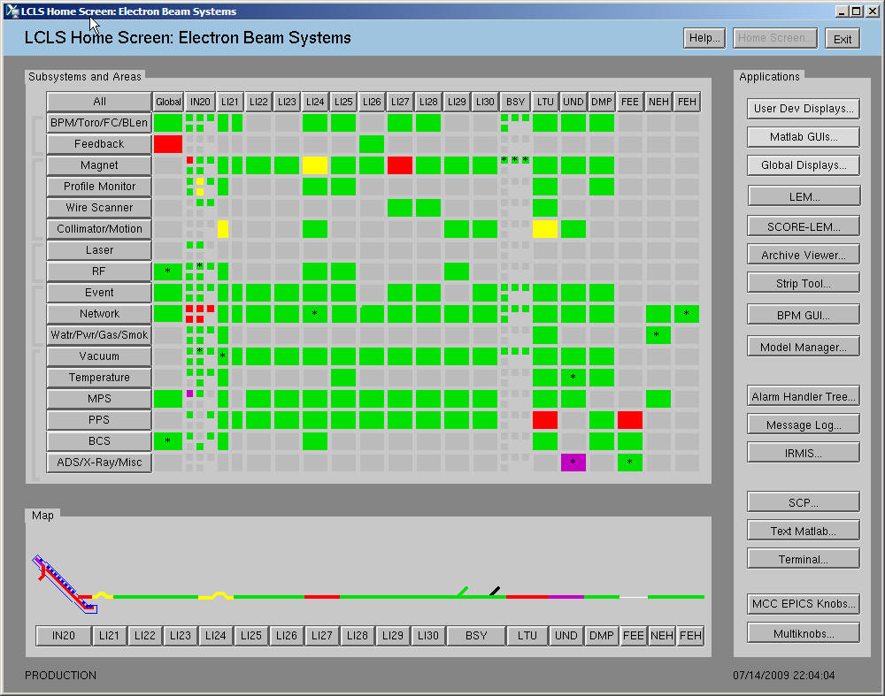
Click here for LI21 Magnet
Display
Click here for LI21 Network Displays

Figure 12: LCLSHOME

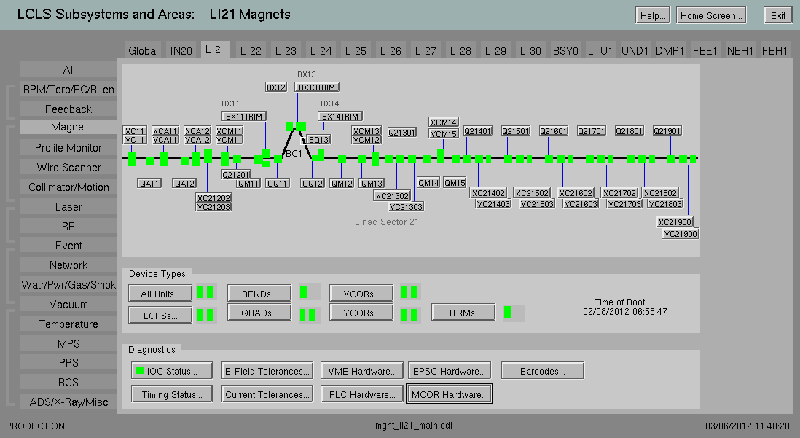
Click here for LI211 MCOR Displays

Figure 13: LI21 Magnet Display
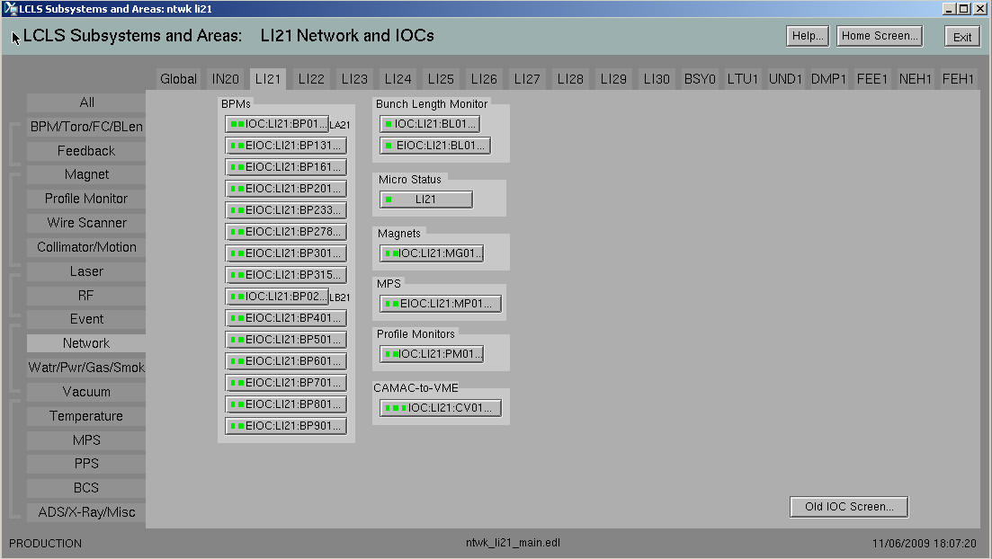
Click here for LI21 Magnet IOC
IOC
Figure 14: LI21 Network and IOC Display

At design review time, show mock-up EDM MCOR displays here

Configuration Tools

Channel Archiver

The MCOR Slot-00 Controller provides channel and bulk power supply data that will be archived. In addition, the Slot-00 Contoller Xilinks contains an on chip monitor, that allows access to board voltages and temperatures that will be archived as well. See tables 2 and 3 below for the list of archived PVs.
The ADEL field for the archived PVs will be set based on the hardware accuracy specified in the ??? Document..

After install use the LCLS and FACET Channel Archiver EPICS PV query application

MCOR Channels
Crate | 1-9 | Chan | 01-16, 00 is crate controller
PV Name |  | MCOR:<loca>:<crate><chan>:<attr>
Attribute |  | Description |  | Method  Scan/Monitor |  |  | Interval (secs)
IMAX |  | Maximum Current Range |  | M
ISETPT |  | Desired Current Setpoint |  | M
ISETPTRBCK |  | Current Setpoint Readback  (Setpoint during ramp, set internally) |  | S |  |  | 1
IRAMPSETPT |  | Current Ramp Rate Requested (Amps/sec) |  | M
IACT |  | Current Readback |  | S |  |  | 1
IACTAVE |  | Current Readback Average |  | S |  |  | 1
IMON |  | Feedback Readback |  | S |  |  | 1
IMONAVE |  | Feedback Readback Average |  | S |  |  | 1
IRIPL |  | Feedback Ripple Current Readback |  | S |  |  | 1
PSSTATE |  | MCOR Power Module State |  | S |  |  | 1
RAMPSTATE |  | Ramping Status (busy/done) |  | S |  |  | 1
IRAMPRATE |  | Ramping Rate (Amps/Sec) |  | S |  |  | 10
AUTOTRIM |  | Closed Loop TRIM Request |  | M
AUTOTRIMSTATE |  | Closed Loop Status |  | S |  |  | 10
FBCK |  | Feedback Requested |  | M
FBCKSTATE |  | Feedback Status |  | S |  |  | 10  0
SAMPLENUM |  | Number of Samples to Average Over  (i.e. 2, 4, 8, 16, 32, 64) |  | M
STATUS |  | Status Register |  | M
CTRL |  | Configuration Register |  | M
MCOR Slot-00 Controller
PV Name |  | MCOR:<loca >:<crate>00:<attr>
RESET |  | MCOR Power Module Reset  Resets all faults on backplane |  |  | M
V15 |  | Slot-00 Controller Board +15V (In) |  |  | S | 10
V12 |  | Slot-00 Controller Board +12V (In) |  |  | S | 10
V5 |  | Slot-00 Controller Board +5V (In) |  |  | S | 10
V3_3 |  | Slot-00 Controller Board +3.3V |  |  | S | 10
VCCIO |  | Slot-00 Controller Board +3.3VCC IO |  |  | S | 10
V15MINUS  MINUS |  | Slot-00Controller Board -15V (In) |  |  | S | 10
V12MINUS |  | Slot-00Controller Board -12V (In) |  |  | S | 10
V5MINUS |  | Slot-00Controller Board -5V (In) |  |  | S | 10
I_V15 |  | Slot-00Controller Current of V15V (In) |  |  | S | 10
I_V12 |  | Slot-00Controller Current of 12V (In) |  |  | S | 10
I_V5 |  | Slot-00Controller Current of 5V (In) |  |  | S | 10
I_V3_3 |  | Slot-00Controller Current of 3.3V (In) |  |  | S | 10
I_VCCIO |  | Slot-00Controller Current of VCCIO |  |  | S | 10
I_V2.5 |  | Slot-00Controller Current of 2.5V (In) |  |  | S | 10
I_V1 |  | Slot-00Controller Current of 1.0V (In) |  |  | S | 10
I_V15MINUS |  | Slot-00Controller Current of -15V (In) |  |  | S | 10
TEMPSTATE |  | Slot-00 Controller Board Temperature |  |  | S | 10
Table 33: MCOR Archived Data

BULK Power Supply
Crate | 1-9 | Chan | 01-16, 00 is crate controller
PV Name |  | <device>:<attr>
Attribute |  | Description |  | Method  Scan/Monitor | Interval (secs)
VSETPT |  | Desired Voltage |  | M
VRAMPRATE |  | Ramp Rate Setpoint (volts per second) |  | M
STATESETPT |  | PS On/Off Request |  | M
VMAX |  | Maximum output voltage measured since crate was powered on |  | M
IMAX |  | Maximum allowable current |  | M
RESET |  | Reset Power Supply (Asserted/Not Assserted) |  | M
RAMPSTATE |  | Ramp Status (busy/done) |  | S | 1
VACT |  | Voltage Readback |  | S | 10
IACT |  | Current Readback |  | S | 10
IGNDSTATE |  | Ground Current Fault |  | S | 10
STATE |  | PS On/Off Status |  | S | 1
STATUS |  | Status Register |  | M
CTRL |  | Configuration Register |  | M
Table 34: Bulk Power Supply Archived Data

Where the macro definitions are defined as:
- PDEV – Bulk Power Supply device name (e.g. PS:LI21:1)

Message Logging
The Channel Watcher will be used to log a change of state for signalsof interest. An example of a PV that will be logged is the bulk power supply power on status. A change of state in the EPICS database will generate a text string, which is sent to the Message Logger. In addition, messages will be logged from the sequence, when performing an requested action, such as turning on a power supply.

Facility | Severity |  | Text | Time
Channel Watcher | MAJOR |  | LGPS:LI21:2:STATE change to OFF |  | 23:00:50 2009-11-09
Figure 15: Logged Messge Example

PV Name | <device>:<attr>
Attribute | Description | From Where
STATE | Power Supply On/Off Status | Channel Watcher
IGNDSTATE | Gound Fault Status | Channel Watcher
IRAMPRATE | Ramp Setpoint | Channel Watcher
PSSTATE | MCOR Power Module Status | Channel Watcher
RAMPSTATE | Ramp Status | Channel Watcher
STATESETPT | Power Supply On/Off Request | Channel Watcher

Alarm Handler

A summary status PV for each magnet will be maintained by the magent IOC. The severity of this PV will be used by the Alarm IOC application to provide a summary status for each accelerator area by magnet type. The summary status for MCOR controlled magnets will include amoung other PVs, the following MCOR states shown in the table below.

The Alarm Handler GUI is organized by accelearator area followed by subsystem. The magnets subsystem will include a summary status for each magnet type in that area.

MCOR Channels
Crate | 1-9 | Chan | 01-16, 00 is crate controller
PV Name |  | MCOR:<loca>:<crate><chan>:<attr>
Attribute |  | Description |  | State
IGNDSTATE |  | Ground Current Status |  | FAULT  OK
PSSTATE |  | MCOR Power Module Status |  | FAULT  OK
STATE |  | Power Supply On Status |  | OFF  ON
Magnet Device
(
PV Name |  | <device >:<attr>
Attribute |  | Description
STATMSG |  | Magnet device status message, worst case

SCORE

Although SCORE is used by Magnet Power Supply Controls, restore configuration settings, no MCOR channel, bulk power supply information is needed by SCORE.

ORACLE Database Infrastructure
At design time list subsystem devices that must be included in RDB

After installation list search strings required to find devices in the Oracle APEX application.

How to add a Magnet Device

References

All Hardware and Software documentation for the MCOR upgrade project can be found at the following SharePoint location:
MCOR Functional Requirments
MCOR Hardware User’s Manual
Bira MCOR 30 Technical Manual
Bira MCOR 12 Technical Manual
Bira MCOR 12 Datasheet

Baseline documentation for the LCLS Controls can be found at:
IOC Runtime Infrastructure. (Ernest’s doc IOC Specification Document)
LCLS Development Environment
LCLS Network Block Diagram
LCLS Controls C coding standard
LCLS Naming Conventions

EPICS documentation can be found at:

EPICS R3.14 Channel Access Reference Manual.
EPICS Application Developer's Guide

Revision History
Revision | Date Released | Description of Change
R001
R000 | April 5, 2012 | Original Release

