

Diamond Light Source Ltd

Rutherford Appleton Laboratory

Chilton, Didcot

Oxfordshire OX11 0QX

United Kingdom

www.diamond.ac.uk

Service PC Operating Manual for SLS Digital Controller and ADC Cards

(Software Release 4.0)

Prepared by: J A Dobbing, Head of Power Supplies,

Diamond Light Source Ltd.
Contents
Page
1 Introduction 3
2 Getting Started 3
3 How to Turn the Test Unit On/Off and Change the Reference 3
4 How to Load and View a Waveform 3
5 How to Activate a Waveform 4
6 How to Set up the DAC Outputs and Virtual Oscilloscope 4
7 How to Modify the Controller Parameters 5
8 How to View the Digital Signals 6
9 How to View the Analogue Signals 6
10 Temporary Change of Digital Inputs. 7
11 Data logger Utility 7
12 Register Access 7
13 Fault Diagnostics 7
14 Device Commisioning 7
15 Related Documents 8

Diagram 1: VisualECS Displays 9
Diagram 2: Waveform Utilities Window 9
Diagram 3: Signal Processing Utility Window 10
Diagram 4: Data Logging Utility Window 10
Diagram 5: Feedback Loop Control Structure 11
Diagram 6: Block Diagram of ADC/DAC Card 12
Diagram 7: Block Diagram of DSP Card 13

Introduction
Local control of SLS controller cards is provided by a PC running VisualECS. Communication to the controller card is from the serial port of the PC to the ‘Service PC’ port on the controller card front panel.

The main screen of VisualECS (see Diagram 1) is divided into four areas:-
  - Top left, which gives the power supply status and on/off control.
  - Bottom, which displays user settable graphical information transmitted over the serial link from the power supply. This forms a virtual oscilloscope but with limited bandwidth due to the data link.
  - Top right, provided the interface to set up the two DAC output channels on the ADC card.
  - Centre, which provides an error log.

Getting Started
Once the serial link cable is installed and the control power to the cards switched ON, then VisualECS can be started on the PC. When started VisualECS reads the Device ID number and selects the correct graphical user interface.

Note: If the service link (RS232) is used for communication, it is necessary to prioritize this link. (Device → Prioritise Service-Link or icon)

How to Turn the Test Unit On/Off and Change the Reference
The control button to turn the Test Unit On/Off is in the top left area of the main screen. When the turn on sequence is initiated the unit goes through a calibration state ‘ADC_CAL’ before the main contactor is closed (Clunk sound) and the PS_ON state is achieved.

The reference is normally zero at first turn on. To set a reference value click on the reference value display area to get a dialogue box. Type a value (limits are + 3 by the Test Unit) and press ‘Enter’.

How to Load and View a Waveform
Waveforms can be generated using a Matlab command file (WFM_Gen.m) and view using another Matlab command file (Readwfm.m). These files need to be edited to define the waveform, input/output files etc. A 0xFFFFFFFF data value signals a Stop Flag (this makes it possible to partition a Waveform into different parts). If repetitive triggering is required the waveform must be terminated in two Stop Flags separated by a few data values. This feature in included by default in WVF_Gen.m.

Waveforms are stored in 32 bit floating point format, with a fixed sample interval settable in the range 60 μs to 100,000μs. The maximum file size is 64Kb. A selection of waveforms are stored in C:\Programme Files\VisualECS\waveforms.

To download a Waveform using the Waveform Utility (see Diagram 2) the following steps are required:-

Download a waveform from the PC using Tools → Waveform Utility→ Waveform Download. Then select the required waveform filename and position in which to store it (waveforms 1-11). Click Waveform Download to initiate the download and confirm.

To upload a Waveform from the Controller to the PC and view it, using the Waveform Utility the icons beside each waveform should be used:-

- Preview (only each 10th data value will be transferred from the Controller card to the PC).
- Uploaded (all data points will be transferred to the PC, which needs more time than preview).
- Clear Waveform (the Waveform is cleared from the screen).
- Saved As (the waveform is saved as the specified file in the PC).

How to Activate a Waveform
Waveforms can be triggered by an external optical trigger (TRI IN), repetitively triggered, triggered manually (one shot) or triggered over the EPICS serial link.

The operation of the controls at the top of the Waveform Utilities window are as follows:-

Select waveform loads the selected waveform into memory as the reference waveform.
Start/Stop Waveform enables/disables the waveform. Store Endvalue takes the last Waveform data point as new DC offset value.
Scale Factor allows the amplitude of the waveform to be scaled.
Step Size allows the sample interval to be varied in the range 60 to 100,000 μs.
Auto-trigger on/off allows repetitive triggering or manual single shot (the waveform must be terminated with a Stop Flag for repetitive triggering).
Partition Start/Stop triggers or stops the next partition of a waveform.
Next Stop Flag switches to next partition if the waveform is partitioned with stop flags.
Ramping on/off allows the last value to be used as the reference value once the waveform period is completed.

When the cursor is positioned over the waveform display area a zoom function can be activated by dragging a box over the desired area. Right click to zoom out.

A stop flag can be set by a 0xFFFFFFFF data value. This is created by the Matlab file (see section 4).

How to Set up the DAC Outputs and Virtual Oscilloscope
A wide range of signals can be selected from the menu for each of the two DAC channels and the virtual oscilloscope and the bottom of the main screen (see Diagram 1). The output signal offset and scaling can be adjusted to check ripple and resolution.

Internal signals can be process using the Signal Processing Utility. The commands are Tools → Signal Processing Utility. This provides a window (see Diagram 3) where two signals can be generated:-

a*Signal A + b*Signal B + c*Signal C = AOF_Output 1 or 2

Signals can also be filtered to give AOF_Output 3 and 4. These signals are available for either the DAC outputs or the virtual oscilloscope.

To activate this function a tick must be placed in the Add On Functions box in the top left corner of the window.

How to Modify the Controller Parameters
Changing the controller parameters can result in limits being set above a level at which the power circuit is damaged. Changes to parameters must therefore be performed only by competent and authorized staff.

The following operations are required:-
- Turn the power supply OFF.
- Go to the Power Supply → Change Device Parameter Set window. The active parameter set is displayed at the top of the screen.
- To display the current parameters click the corresponding modify parameters point.
- Edit table below or use the graphical representation of the controller to modify the control loop performance. When setting new parameters the ‘enter’ key must be used.
- Save the new parameters using the save as and OK in the dialogue box to restart the firmware. The power supply remains in a MODIFY_DATA state until the dialogue box is acknowledged.

The test unit’s original parameters are stored in a file: c:\Programme files\VisualECS\data\Profile_Diamond.bin. These can be restored using Device → Parameterisation Wizard and selecting this file.

The operation of the controller in the Analogue Devices SHARC DSP is as shown in Diagram 2. The reference signal input range is limited and low pass filtered. It rate of change is also limited. The measured current signal is similarly low pass filtered before being fed to the summing junction with the reference. For one and two quadrant controllers a variable gain is provided to compensate for non-linearity in the power circuit at low output. The resulting error signal is fed to a PI controller with anti-wind-up of the integrator.
The dc link voltage is high pass filtered to provide a signal that will compensate for the ripple on the link. This is combined with the PI controller signal before being fed to a low pass filter that filters the modulation signal and also limits its rate of change. This rate limit is required to protect the power circuit output filter.
The output of the controller is sent to the FPGA, where the pulse width modulation generation is performed.

How to View the Digital Signals
Signals → Digital Signals enables the state of the 16 digital input and 8 digital outputs to be monitored. The firmware allocation of these is as shown below:-

Name | Bit mask | Input
MAIN_RELAY | 0x1 | DIG-IN 0-0
AUXILIARY_RELAY | 0x2 | DIG-IN 0-1
TEMP_TRANSFORMER | 0x4 | DIG-IN 0-2
MASTER_SWITCH | 0x8 | DIG-IN 0-3
TEMP_RECTIFIER | 0x10 | DIG-IN 0-4
TEMP_CONVERTER | 0x20 | DIG-IN 0-5
CURRENT_TRANSDUCER | 0x40 | DIG-IN 0-6
POLARITY_SWITCH_POS | 0x80 | DIG-IN 1-0
POLARITY_SWITCH_NEG | 0x100 | DIG-IN 1-1
(not used) |  | DIG-IN 1-2
TEMP_POLARITY_SWITCH | 0x400 | DIG-IN 1-3
ENABLE_SIGNAL | 0x800 | DIG-IN 2-0
VENTILATOR | 0x1000 | DIG-IN 3-0
DOOR | 0x2000 | DIG-IN 4-0
WATER_LOAD | 0x4000 | DIG-IN 5-0
TEMP_LOAD | 0x8000 | DIG-IN 6-0
Name | Bit mask | Output
MAIN_RELAY_OUT | 0x1 | DIG-OUT 0-0
AUXILIARY_RELAY_OUT | 0x2 | DIG-OUT 0-1
(not used) |  | DIG-OUT 0-2
VENTILATOR_OUT | 0x8 | DIG-OUT 0-3
POLARITY_SWITCH_OUT | 0x10 | DIG-OUT 1-0
MAIN_RELAY_OUT_II | 0x20 | DIG-OUT 2-0
(not used) |  | DIG-OUT 3-0
TEST_OUT | 0x80 | DIG-OUT 4-0
USER_LED_OUT | 0x100

In the Test Unit only the output MAIN_RELAY_OUT and inputs MAIN_RELAY and ENABLE_SIGNAL are used. The latter is a link in the rear of the unit (11x2)

How to View the Analogue Signals
The ADC inputs can be viewed as numerical values using the command signals → ADC Card. A log file of these values can be created to enable the signals to be processed off line. This is created in c:\Programme Files\VisualECS\work\ADC_logfile.txt. A time vector is provided in addition to all eight input channels.

In the Test Unit analogue channels are allocated as shown below:-

Channel Number | Signal
P1 | Output Current
P2 | Output Current
P3 | Output Current
P4 | Output Current
UP1 | DC Link voltage +ve
UP2 | DC Link voltage -ve
UP3 | Output Voltage +ve
UP4 | Output Voltage –ve

Table 2: Analogue input signal allocation.

Temporary Change of Digital Inputs.
The command Tools → Temporary Change to Digital Inputs brings up the digital signals. These can temporarily be included or excluded from the firmware. After a firmware restart the old settings will be adopted.

Data logger Utility
The Command Tools → Data Logger Utility brings up the Data Logger Window (See Diagram 4). This enables 82k samples to be taken of two waveforms. The list of available waveforms is the same as for the virtual oscilloscope. Sampling is triggered manually. This utility only works in the Device ON state.

Register Access
The Command Tools → Register Access brings up the Register Access window this enables the numerical values in the registers to be viewed. The list of available registers is the same as for the virtual oscilloscope. Register values can also be set manually but may then be overridden by the software. This function only works in the Device ON state.

Fault Diagnostics
The Command Tools → Fault Diagnostics brings up the Fault Diagnostics window this enables the device fault history to be seen plus the communication error log.

Device Commisioning
The Command Device → Start Commissioning brings up a dialogue box. Commissioning runs the power supply at 50% nominal output for 180 seconds and measures the resistance of the load. If the load resistance subsequently changes by more than the “TOLERANCE_LOAD_RESISTANCE” parameter the power supply trips.

Related Documents
User Documentation Power Supply DSP Firmware
Developer Documentation Power Supply DSP Firmware
Documentation PSI-DSP Software Tools
System Design PSI-DSP HW
System Design PSI-DSP SW
Documentation VHDL Code PSI Power Supply Controller (PSC)
Test System for PS Controller Card
SPA 499 ADC Card Description and Operation
SPA 499 ADC Timing Diagram
SPA 499 ADC Card: Setup and Testing After Manufacture

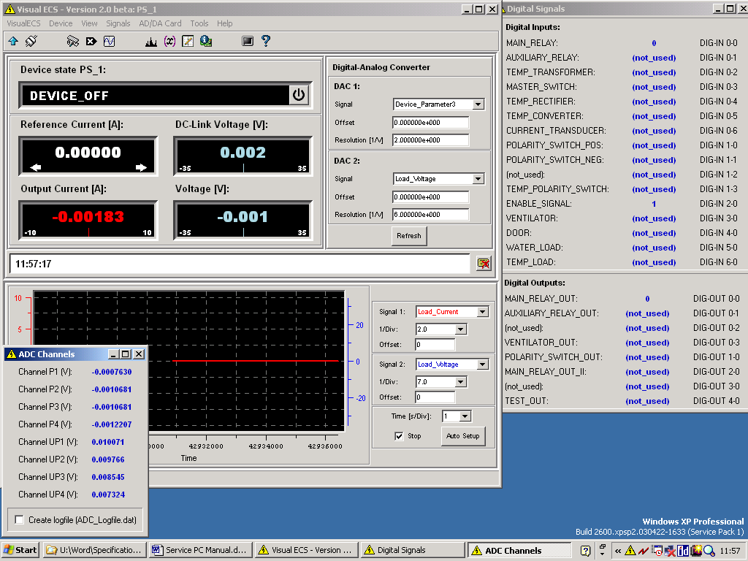
Diagram 1: VisualECS Main Displays Plus Digital and Analogue I/O

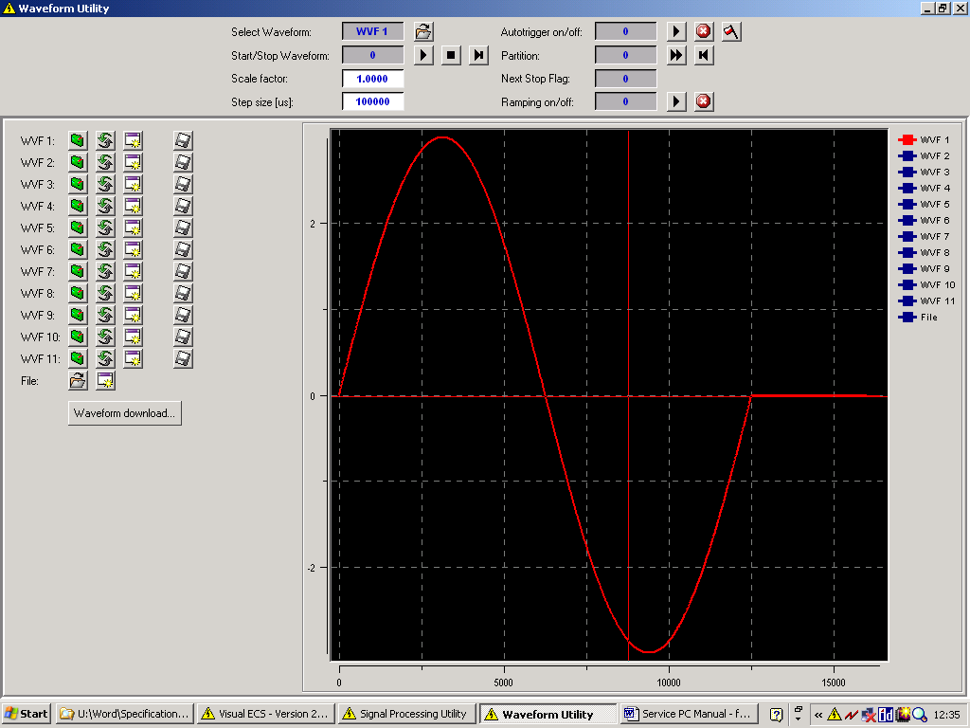
Diagram 2: Waveform Utility Window

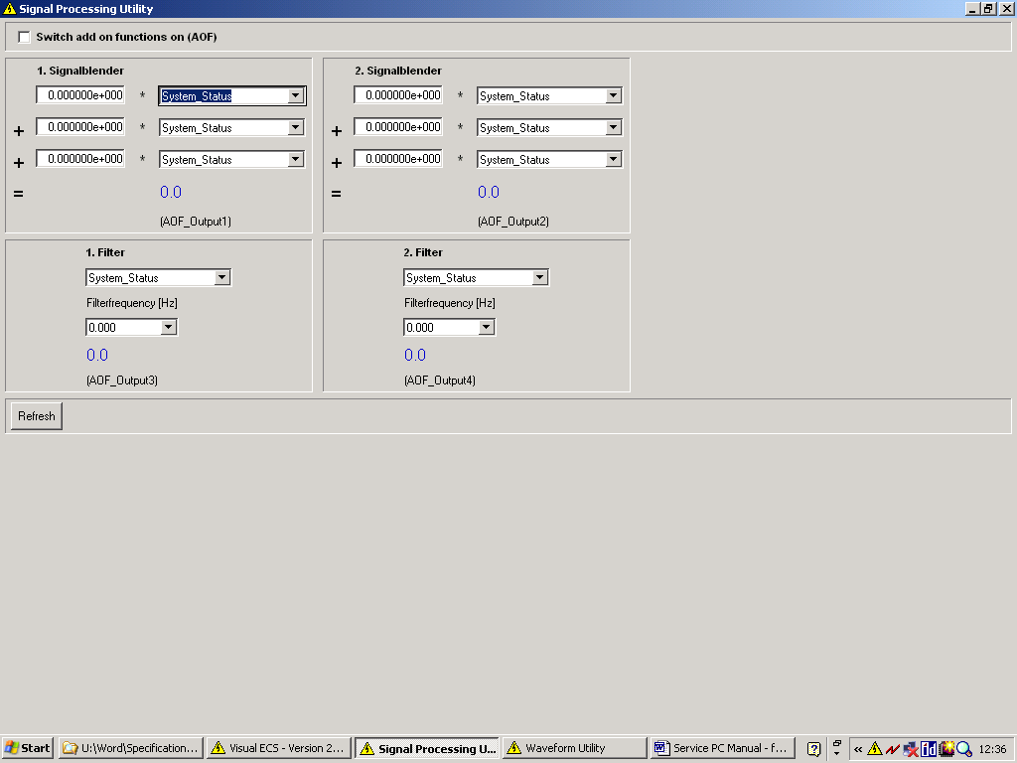
Diagram 3: Signal Processing Utility Window

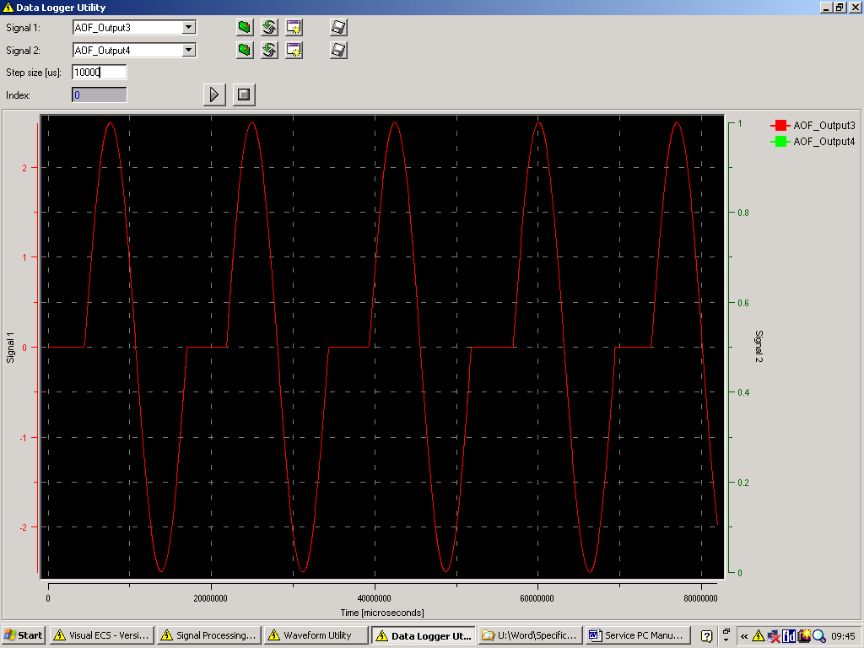
Diagram 4: Data Logger Utility Window
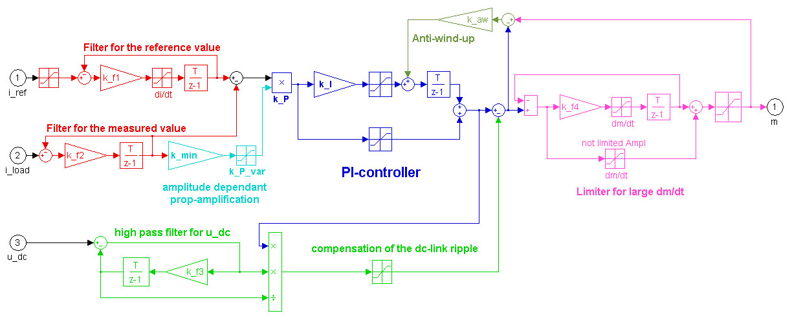

Diagram 5: Feedback Loop Control Structure

DSP
Controller
Card
FPGA

"SPEEDY"
P1
Distribute
Control
Signals
Crystal
2 channel
16 bit 100 kHz
Crystal
2 channel
16 bit 100 kHz
Analog Device
4 channel
16 bit 200 kHz
Analog Device
2 channel
14 bit 100 kHz
P2
P3
P4
UP1
UP2
UP3
UP4
DAC1
DAC2
SPARE
24 V
5 V
SPORT 0
ADC clock (200 kHz)
SoC
Backplane
Backplane
FPGA

"ADCON"
"ADMUX"
FPGA

"ADORA"
FPGA

"DACSYNC"
DC
DC
DC
Front
DC
Reference
voltage
source

Diagram 6: Block Diagram of ADC/DAC Card
5 V
BUS
Flags, IRQs, Reset
Service
PC
ADC/DAC
Card
Control
System
(EPICS)
other
DSP
Controller
Cards
Security
controller

(Watchdog)
24 V
SHARC
DSP
ADSP-21065L
SRAM
2 MBit
FLASH EPROM
8 MBit
EPROM
FPGA
CLOCK
60/30/20MHz
Control-IO serial link
RS 232
Power Converter
Feedback PWM
PWM signal
PWM synchronisation
SoC / SPARE / ADC clock (200 kHz)
SPORT 1 (serial port)
SPORT 0 (serial port)
Power
Monitor
Reset
PWM
generator
IO-
controller
Trigger /Reset /Interrupt
Backplane
D SUB 15
optic
FPGA
fast optical input for Trigger /Reset /Interrupt
DC
DC
Analog Sig.
JTAG
digital Input / Output
optic
Timer
Diagram 7: Block Diagram of DSP Card

