LCLS Engineering Specification Document # | 1.1-301 | RF | Revision | 0
RF Controls

D. Kotturi
(Author) | Signature(s) | Date

B. Dalesio
(System Manager) | Signature | Date

P. Krejcik
(System Physicist) | Signature | Date

Brief Summary:

Keywords: RF, High Powered RF, HPRF, Low Level RF, LLRF, control system, EPICS, VME, feedback, klystron

Key WBS#’s: 1.2.2.2, 1.3.2.2, 1.1.3.5.2

Introduction

Many components of the LCLS control system are global. RF is one example. (Global systems are specified in the ESD 1.1-303 LCLS Control System Requirements.- so what? this doesn’t exist - does it/will it contain anything about RF Controls?) The scope of this document is to describe the engineering specifications for the RF control system. The LCLS RF system consists of two parts: the High Powered RF (HPRF) and the Low Level RF (LLRF). Most of the controls for the HPRF (eg. the MKSUs) already exist in the Linac. So, the interfaces to the HPRF will be specified. The controls for the LLRF are new and will be specified here.

Scope

The LLRF controls system is a series of RF phase and amplitude local feedback loops. There are 9 instances of these local feedback loops: at the laser, at the gun, in L0-A, in L0-B, in L1-S, in L1-X, in the transverse cavity, in L2 and in L3. The latter two are listed here for completeness, but differ from the rest due to the large number of klystrons involved. Each of these local RF feedback loops will be globally controlled by the LCLS beam-based longitudinal fast feedback system, but this is outside the scope of the system described here.

Defining the requirements

The inputs to the RF phase and amplitude local feedback loops are the forward and reverse RF phase and amplitude relative to the klystron (4 inputs). The gun will have
2 additional inputs, to give 6 in total
.
The clock speed of the RF is 119 MHz.
(The fill time of the cavity is 850 ns)
There is a burst of 1000 samples at 119 MHz (8.4 ns) once every 120 Hz (8.3 ms). .
Each sample is a 2 byte integer
So the amount of data to digitize from the analog output of the Phase/Amplitude Detector (PAD) for all but gun is 4 channels*1ksample*2bytes/sample = 8 kB @ 120 Hz per local loop.
For the gun, it’s 6 channels*1ksample/channel*2bytes/sample = 12 kB @ 120 Hz

The total amount of data to be digitized is (8 kB*6 klystrons) + (12 kB for gun klystron) = 60 kB at 120 Hz (ignoring L2 and L3, for now)

Calibration must also be done, therefore doubling the load on the processor.

Design

During the last months of 2004 and January of 2005, we studied possible solutions for meeting the LLRF specifications. The results of this work were presented in Kotturi Low Level RF Controls Design. Since January, the design has evolved further due to closer study of existing COTS products and further discussions with vendors about new products under design.

Figures 1 and 2 show our current, preferred, viable options.
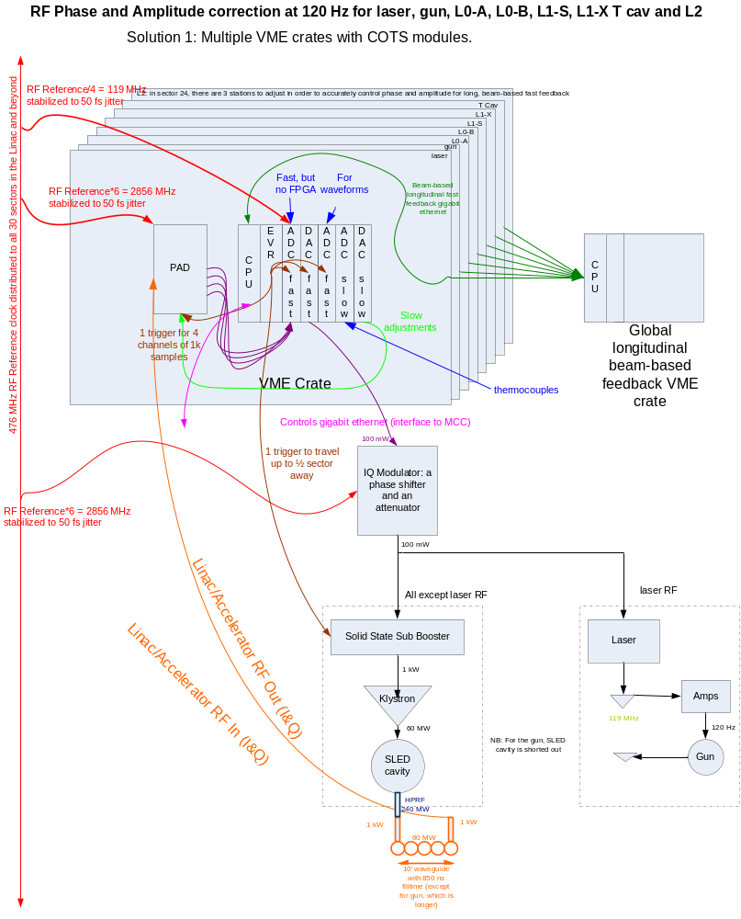
Figure 1

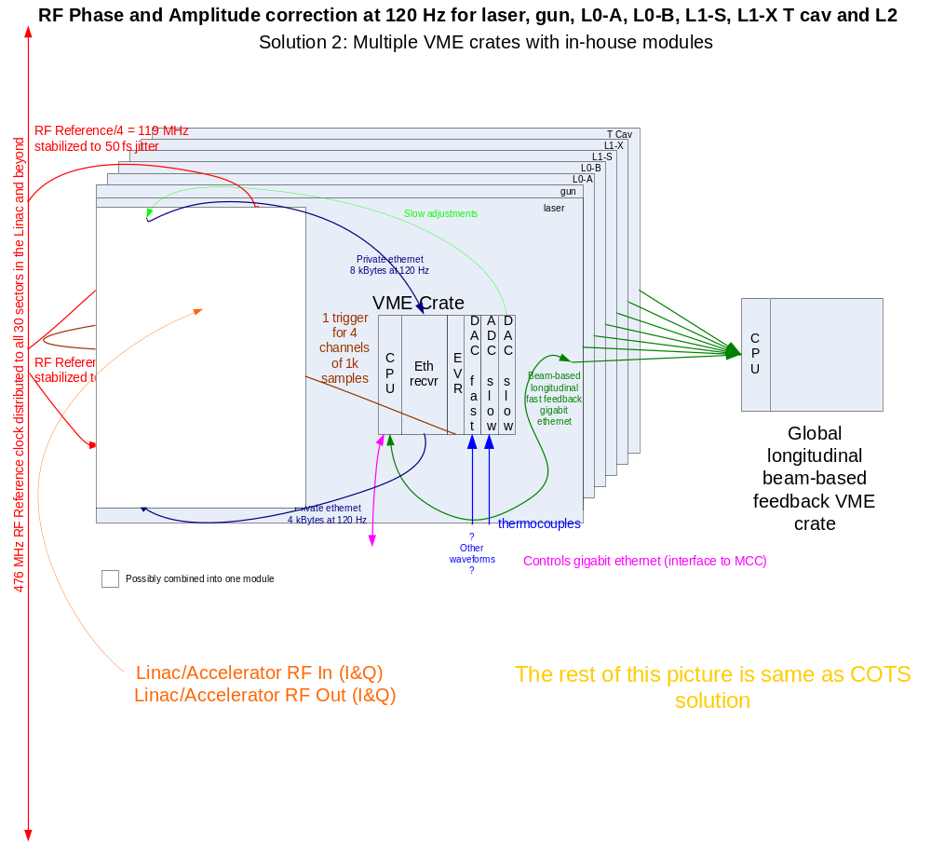
Figure 2

The solution shown in Figure 1 shows a COTS solution currently under evaluation.
At this time, there is no commercially available VME DAC that can meet our clock speed requirements. However, there are existing VXI and PCI solutions. We are asking the manufacturer to adapt their VXI/PCI product to VME.

The solution shown in Figure 2 shows a solution that could be developed in-house.

Signals for "Standard Klystron" Control System (R. Akre)

Below is a list of parameters taken from the existing SLC klystron support system and including LCLS requirements.

SLC Fast Time Plots - 10MHz BW 64 data points - 6.5uS

Fast Plots - require
SLED out PHAS & AMPL
Accelerator In PHAS & AMPL LCLS Required
Accelerator Out PHAS & AMPL LCLS Required
Klystron Forward Ampl
Klystron Reflected Ampl
Klystron Drive PHAS & AMPL LCLS Required
Klystron Reference Phase LCLS Required
Gold Phase - Calculated

Other Waveforms
Beam Volts LCLS Required
Beam Current
Perviance - Calculated

Triggers
Modulator Trigger Delay
RF Trigger Delay LCLS Required
Sub-booster Trigger delay LCLS Required
Sub-booster RF delay LCLS Required
Sample Trigger Delay LCLS Required

Analog Signals
Klystron Vacuum
Waveguide Vacuum
Klystron Focus Coil Current
Klystron Heater Power

Thermocouples 12 total
PAD LCLS Required
MKSU
SSSB LCLS Required
2X Klystron Windows
3X Accelerator LCLS Required
4X Waveguide LCLS Required

Power Supplies
PAD 3X LCLS Required
SSSB 2X LCLS Required
Control 4X LCLS Required

References
External Ground LCLS Required
Differential Ground LCLS Required
DACs LCLS Required
ADCs LCLS Required

Control Signals
DACs I&Q LCLS Required
2 Channels
119MHz 8.6uS = 1k Samples / channel
0.03 degrees resolution = 0.5mRadians = 1/2000 = 12 bit DAC
Noise Levels
Assume 12bit peak = 1V input : LSB = 250uV

MUX
* MAX4567 2xSPDT
MAX4564 1xSPDT

14 bit 119MHz DACs
AD AD9775 400MSPS Dual Chan 410mW Digikey
TI DAC2904 125MSPS Dual Chan 310mW Digikey
TI DAC5672 200MSPS Dual Chan 330mW
MAX5887 500MSPS Sing Chan 130mW

Klystrons Signals Monitored
Standard Linac Station

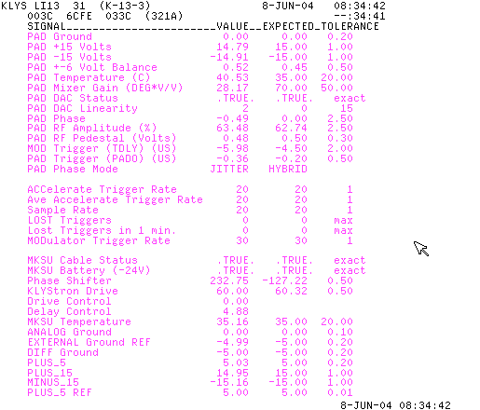

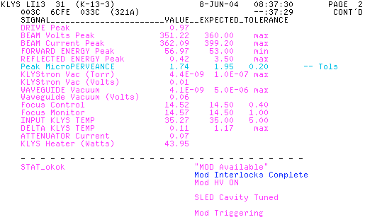

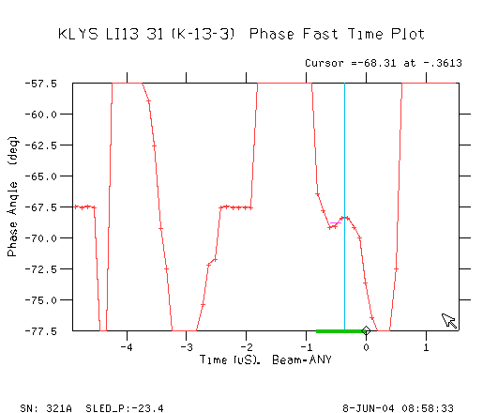

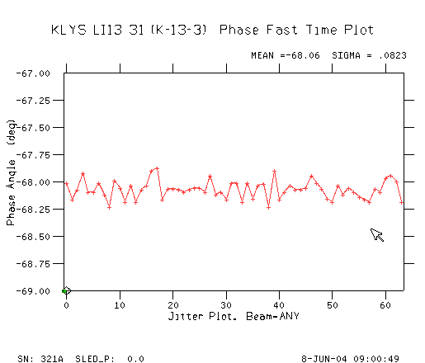
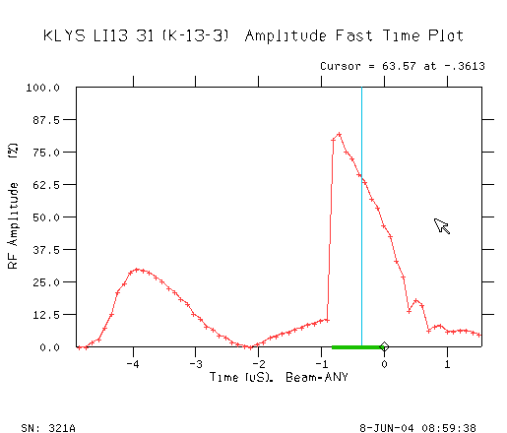

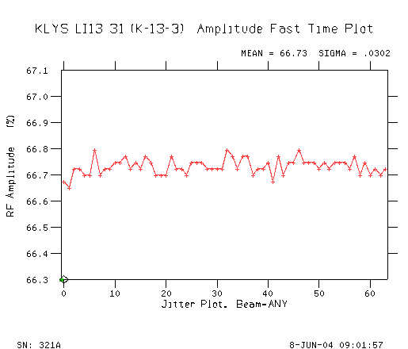
Control Signals for LCLS Injector and L1
 |  |  | From RF HUT
Sub-system | Signal Name | Cable Type | To Location |  | CHANNELS | I/O Device | Signal Type
Laser | RF Reference | 1/2" Heliax | Laser Room |  | 2 | 14Bit Fast Digitizer | Phas/Ampl CW
 | Laser Oscillator Out | 1/2" Heliax | Laser Room |  | 2 | 14Bit Fast Digitizer | Phas/Ampl CW
 | 120Hz Laser Pulse | 1/2" Heliax | Laser Room |  | 2 | 14Bit Fast Digitizer | Phas/Ampl picoSec
Gun | Cell 1 RF Monitor | 1/2" Heliax | Gun |  | 2 | 14Bit Fast Digitizer | Phas/Ampl 5uS 120Hz
 | Cell 2 RF Monitor | 1/2" Heliax | Gun |  | 2 | 14Bit Fast Digitizer | Phas/Ampl 5uS 120Hz
 | RF In FOR 1 | 1/2" Heliax | Gun |  | 2 | 14Bit Fast Digitizer | Phas/Ampl 5uS 120Hz
 | RF In REFL 1 | 1/2" Heliax | Gun |  | 2 | 14Bit Fast Digitizer | Phas/Ampl 5uS 120Hz
 | RF In FOR 2 | 1/2" Heliax | Gun |  | 2 | 14Bit Fast Digitizer | Phas/Ampl 5uS 120Hz
 | RF In REFL 2 | 1/2" Heliax | Gun |  | 2 | 14Bit Fast Digitizer | Phas/Ampl 5uS 120Hz
 | Circulator RF In FOR | 1/2" Heliax | Gun Area |  | 2 | 14Bit Fast Digitizer | Phas/Ampl 5uS 120Hz
 | Circulator RF In REFL | 1/2" Heliax | Gun Area |  | 2 | 14Bit Fast Digitizer | Phas/Ampl 5uS 120Hz
 | RF Control |  |  |  |  | 2 PAU Type outputs | 120Hz
 | Thermocouple 1 | TC wire | Gun Cell 1 | 1 |  | SAM | Slow Temp.
 | Thermocouple 2 | TC wire | Gun Cell 2 | 1 |  | SAM | Slow Temp.
 | Thermocouple 3 | TC wire | Circulator | 1 |  | SAM | Slow Temp.
 | Thermocouple 4 | TC wire | Spare | 1 |  | SAM | Slow Temp.
L0-1 | RF In FOR 1 | 1/2" Heliax | L0-1 |  | 2 | 14Bit Fast Digitizer | Phas/Ampl 5uS 120Hz
 | RF In REFL 1 | 1/2" Heliax | L0-1 |  | 2 | 14Bit Fast Digitizer | Phas/Ampl 5uS 120Hz
 | RF In FOR 2 | 1/2" Heliax | L0-1 |  | 2 | 14Bit Fast Digitizer | Phas/Ampl 5uS 120Hz
 | RF In REFL 2 | 1/2" Heliax | L0-1 |  | 2 | 14Bit Fast Digitizer | Phas/Ampl 5uS 120Hz
 | Sum RF In FOR | 1/2" Heliax | L0-1 |  | 2 | 14Bit Fast Digitizer | Phas/Ampl 5uS 120Hz
 | Sum RF In REFL | 1/2" Heliax | L0-1 |  | 2 | 14Bit Fast Digitizer | Phas/Ampl 5uS 120Hz
 | Load FOR | 1/2" Heliax | L0-1 |  | 2 | 14Bit Fast Digitizer | Phas/Ampl 5uS 120Hz
 | Load REFL | 1/2" Heliax | L0-1 |  | 2 | 14Bit Fast Digitizer | Phas/Ampl 5uS 120Hz
 | Control |  |  |  |  | 2 PAU Type outputs | 120Hz
 | Thermocouple 1 | TC wire | L0-1 Acc In | 1 |  | SAM | Slow Temp.
 | Thermocouple 2 | TC wire | L0-1 Acc Center | 1 |  | SAM | Slow Temp.
 | Thermocouple 3 | TC wire | L0-1 Acc Out | 1 |  | SAM | Slow Temp.
 | Thermocouple 4 | TC wire | Spare | 1 |  | SAM | Slow Temp.
L0-2 | RF In FOR | 1/2" Heliax | L0-2 |  | 2 | 14Bit Fast Digitizer | Phas/Ampl 5uS 120Hz
 | RF In REFL | 1/2" Heliax | L0-2 |  | 2 | 14Bit Fast Digitizer | Phas/Ampl 5uS 120Hz
 | Load FOR | 1/2" Heliax | L0-2 |  | 2 | 14Bit Fast Digitizer | Phas/Ampl 5uS 120Hz
 | Load REFL | 1/2" Heliax | L0-2 |  | 2 | 14Bit Fast Digitizer | Phas/Ampl 5uS 120Hz
 | Control |  |  |  |  | 2 PAU Type outputs | 120Hz
 | Thermocouple 1 | TC wire | L0-2 Acc In | 1 |  | SAM | Slow Temp.
 | Thermocouple 2 | TC wire | L0-2 Acc Center | 1 |  | SAM | Slow Temp.
 | Thermocouple 3 | TC wire | L0-2 Acc Out | 1 |  | SAM | Slow Temp.
 | Thermocouple 4 | TC wire | Spare | 1 |  | SAM | Slow Temp.
L0- Transverse | RF In FOR | 1/2" Heliax | L0- Transverse |  | 2 | 14Bit Fast Digitizer | Phas/Ampl 5uS 120Hz
 | RF In REFL | 1/2" Heliax | L0- Transverse |  | 2 | 14Bit Fast Digitizer | Phas/Ampl 5uS 120Hz
 | Load FOR | 1/2" Heliax | L0- Transverse |  | 2 | 14Bit Fast Digitizer | Phas/Ampl 5uS 120Hz
 | Load REFL | 1/2" Heliax | L0- Transverse |  | 2 | 14Bit Fast Digitizer | Phas/Ampl 5uS 120Hz
 | Control |  |  |  |  | 2 PAU Type outputs | 120Hz
 | Thermocouple 1 | TC wire | L0-Transverse Acc In | 1 |  | SAM | Slow Temp.
 | Thermocouple 2 | TC wire | L0-Transverse Acc Center | 1 |  | SAM | Slow Temp.
 | Thermocouple 3 | TC wire | L0-Transverse Acc Out | 1 |  | SAM | Slow Temp.
 | Thermocouple 4 | TC wire | Spare | 1 |  | SAM | Slow Temp.
L1-S | SLED Out FOR | 1/2" Heliax | 21-1 |  |  | Not used in EPICS
 | SLED Out REFL | 1/2" Heliax | 21-1 |  |  | Not used in EPICS
 | ACC A/B In FOR | 1/2" Heliax | 21-1 |  | 2 | 14Bit Fast Digitizer | Phas/Ampl 5uS 120Hz
 | ACC A/B In REFL | 1/2" Heliax | 21-1 |  | 2 | 14Bit Fast Digitizer | Phas/Ampl 5uS 120Hz
 | ACC C IN FOR | 1/2" Heliax | 21-1 |  | 2 | 14Bit Fast Digitizer | Phas/Ampl 5uS 120Hz
 | ACC C IN REFL | 1/2" Heliax | 21-1 |  | 2 | 14Bit Fast Digitizer | Phas/Ampl 5uS 120Hz
 | Load A/B FOR | 1/2" Heliax | 21-1 |  | 2 | 14Bit Fast Digitizer | Phas/Ampl 5uS 120Hz
 | Load A/B REFL | 1/2" Heliax | 21-1 |  | 2 | 14Bit Fast Digitizer | Phas/Ampl 5uS 120Hz
 | Load C FOR | 1/2" Heliax | 21-1 |  | 2 | 14Bit Fast Digitizer | Phas/Ampl 5uS 120Hz
 | Load C REFL | 1/2" Heliax | 21-1 |  | 2 | 14Bit Fast Digitizer | Phas/Ampl 5uS 120Hz
 | Control |  |  |  |  | 2 PAU Type outputs | 120Hz
 | Thermocouple 1 | TC wire | 21-1A In | 1 |  | SAM | Slow Temp.
 | Thermocouple 2 | TC wire | 21-1A Center | 1 |  | SAM | Slow Temp.
 | Thermocouple 3 | TC wire | 21-1A Out | 1 |  | SAM | Slow Temp.
 | Thermocouple 4 | TC wire | Spare | 1 |  | SAM | Slow Temp.
 | Thermocouple 5 | TC wire | 21-1B In | 1 |  | SAM | Slow Temp.
 | Thermocouple 6 | TC wire | 21-1B Center | 1 |  | SAM | Slow Temp.
 | Thermocouple 7 | TC wire | 21-1B Out | 1 |  | SAM | Slow Temp.
 | Thermocouple 8 | TC wire | Spare | 1 |  | SAM | Slow Temp.
 | Thermocouple 9 | TC wire | 21-1C In | 1 |  | SAM | Slow Temp.
 | Thermocouple 10 | TC wire | 21-1C Center | 1 |  | SAM | Slow Temp.
 | Thermocouple 11 | TC wire | 21-1C Out | 1 |  | SAM | Slow Temp.
 | Thermocouple 12 | TC wire | Spare | 1 |  | SAM | Slow Temp.
L1-X | KLY Out RF FOR | 3/8" Heliax | 21-2 |  | 2 | 14Bit Fast Digitizer | Phas/Ampl 2uS 120Hz
 | KLY Out RF REFL | 3/8" Heliax | 21-2 |  | 2 | 14Bit Fast Digitizer | Phas/Ampl 2uS 120Hz
 | ACC In FOR | 3/8" Heliax | 21-2 |  | 2 | 14Bit Fast Digitizer | Phas/Ampl 2uS 120Hz
 | ACC In REFL | 3/8" Heliax | 21-2 |  | 2 | 14Bit Fast Digitizer | Phas/Ampl 2uS 120Hz
 | Load FOR | 3/8" Heliax | 21-2 |  | 2 | 14Bit Fast Digitizer | Phas/Ampl 2uS 120Hz
 | Load REFL | 3/8" Heliax | 21-2 |  | 2 | 14Bit Fast Digitizer | Phas/Ampl 2uS 120Hz
 | Control |  |  |  |  | 2 PAU Type outputs | 120Hz
 | Thermocouple 1 | TC wire | Acc In 21-2 | 1 |  | SAM | Slow Temp.
 | Thermocouple 2 | TC wire | Acc Center 21-2 | 1 |  | SAM | Slow Temp.
 | Thermocouple 3 | TC wire | Acc Out 21-2 | 1 |  | SAM | Slow Temp.
 | Thermocouple 4 | TC wire | Spare | 1 |  | SAM | Slow Temp.
 | Thermocouple 5 | TC wire | Mode Converter 1 21-2 | 1 |  | SAM | Slow Temp.
 | Thermocouple 6 | TC wire | Mode Converter 2 21-2 | 1 |  | SAM | Slow Temp.
 | Thermocouple 7 | TC wire | Spare | 1 |  | SAM | Slow Temp.
 | Thermocouple 8 | TC wire | Spare | 1 |  | SAM | Slow Temp.
LLRF Distribution | LCLS OSC RF | 1/2" Heliax | RF HUT |  | 2 | 14Bit Fast Digitizer | Phas/Ampl CW
 | MDL RF | 1/2" Heliax | RF HUT |  | 2 | 14Bit Fast Digitizer | Phas/Ampl CW
 | Dist AMP 1 RF | 1/2" Heliax | RF HUT |  | 2 | 14Bit Fast Digitizer | Phas/Ampl CW
 | Dist AMP 2 RF | 1/2" Heliax | RF HUT |  | 2 | 14Bit Fast Digitizer | Phas/Ampl CW
 | LINAC REF RF | 1/2" Heliax | RF HUT |  | 2 | 14Bit Fast Digitizer | Phas/Ampl CW
 | F.O. REF RF | 1/2" Heliax | RF HUT |  | 2 | 14Bit Fast Digitizer | Phas/Ampl CW
 | Thermocouple 1 | TC wire | LCLS Oscillator RF HUT | 1 |  | SAM | Slow Temp.
 | Thermocouple 2 | TC wire | Dist. Amp 1 RF HUT | 1 |  | SAM | Slow Temp.
 | Thermocouple 3 | TC wire | Dist. Amp 2 RF HUT | 1 |  | SAM | Slow Temp.
 | Thermocouple 4 | TC wire | Rack 1 Temp RF HUT | 1 |  | SAM | Slow Temp.
 | Thermocouple 5 | TC wire | Rack 2 Temp RF HUT | 1 |  | SAM | Slow Temp.
 | Thermocouple 6 | TC wire | RF HUT Temp | 1 |  | SAM | Slow Temp.
 | Thermocouple 7 | TC wire | Linac S20 Tunnel Temp | 1 |  | SAM | Slow Temp.
 | Thermocouple 8 | TC wire | Linac S20 Tunnel 1 Temp | 1 |  | SAM | Slow Temp.
 | Thermocouple 9 | TC wire | Linac S21 Tunnel 2 Temp | 1 |  | SAM | Slow Temp.
 | Thermocouple 10 | TC wire | Injector Tunnel 1 Temp | 1 |  | SAM | Slow Temp.
 | Thermocouple 11 | TC wire | Injector Tunnel 2 Temp | 1 |  | SAM | Slow Temp.
 | Thermocouple 12 | TC wire | Injector Tunnel 3 Temp | 1 |  | SAM | Slow Temp.
 | Thermocouple 13 | TC wire | Laser Room Temp | 1 |  | SAM | Slow Temp.
 | Thermocouple 14 | TC wire | Laser Room Temp | 1 |  | SAM | Slow Temp.
 | Thermocouple 15 | TC wire | Phase Dist. 1 RF HUT | 1 |  | SAM | Slow Temp.
 | Thermocouple 16 | TC wire | Phase Dist. 2 RF HUT | 1 |  | SAM | Slow Temp.
LLRF Monitors | Thermocouple 1 | TC wire | Chassis Temp Monitor | 1 |  | SAM | Slow Temp.
 | Thermocouple 2 | TC wire | Chassis Temp Monitor | 1 |  | SAM | Slow Temp.
 | Thermocouple 3 | TC wire | Chassis Temp Monitor | 1 |  | SAM | Slow Temp.
 | Thermocouple 4 | TC wire | Chassis Temp Monitor | 1 |  | SAM | Slow Temp.
 | Thermocouple 5 | TC wire | Chassis Temp Monitor | 1 |  | SAM | Slow Temp.
 | Thermocouple 6 | TC wire | Chassis Temp Monitor | 1 |  | SAM | Slow Temp.
 | Thermocouple 7 | TC wire | Chassis Temp Monitor | 1 |  | SAM | Slow Temp.
 | Thermocouple 8 | TC wire | Chassis Temp Monitor | 1 |  | SAM | Slow Temp.
 | Thermocouple 9 | TC wire | Chassis Temp Monitor | 1 |  | SAM | Slow Temp.
 | Thermocouple 10 | TC wire | Chassis Temp Monitor | 1 |  | SAM | Slow Temp.
 | Thermocouple 11 | TC wire | Chassis Temp Monitor | 1 |  | SAM | Slow Temp.
 | Thermocouple 12 | TC wire | Chassis Temp Monitor | 1 |  | SAM | Slow Temp.
 | Thermocouple 13 | TC wire | Chassis Temp Monitor | 1 |  | SAM | Slow Temp.
 | Thermocouple 14 | TC wire | Chassis Temp Monitor | 1 |  | SAM | Slow Temp.
 | Thermocouple 15 | TC wire | Chassis Temp Monitor | 1 |  | SAM | Slow Temp.
 | Thermocouple 16 | TC wire | Chassis Temp Monitor | 1 |  | SAM | Slow Temp.
TOTALS | Thermocouples |  |  | 68 |  | SAM Channels
 | Phas/Ampl Monitor |  |  |  | 94 | 14Bit Fast Digitizer
 | Phas/Ampl Control |  |  |  | 12 | PAU type devices

