
“Technically Superior Products…
Right The First Time!”

2U & 4U Modified SRME Chassis
Proposal
Presented to:
Stanford Labs
5/22/07
Hybricon Proposal Number: 22844
Submitted by:

Mike Sikorski
Key Account Manager


Hybricon Corp. • 12 Willow Rd. • Ayer, MA 01432 • Phone: (978)772-5422 • Fax: (978)772-7570

Table of Contents
1. Purpose 5
2. Work Definition 5
2.1. Additional Requirements 6
2.2. Clarifications 6
3. Deliverables 7
3.1. Documentation 7
3.2. Products 8
4. Reviews 8
5. Program Schedule 8
6. Dependencies 8
7. Pricing 8
8. Quote Validity 9
9. Payment Terms 9
10. Hybricon Capabilities 10
10.1. Thermal / Airflow Modeling and Simulation 10
10.2. Signal Integrity 10
10.3. Manufacturing Capabilities 11
11. Corporate Profile 11

Revision History
Revision | Date | By | Description
⎯ | 5/22/07 | R. Pellecchia | Initial Release

Purpose
Stanford Labs has solicited a proposal to provide a 2U & 4U VME64x Chassis based on Stanford Labs’s requirements.

Work Definition
The following table defines the specifications / requirements Hybricon is being asked to follow during the design phase for the 2U & 4U Modified SRME Chassis.
Activity | Details
System Packaging
Chassis Design | Chassis:  - 2U – 3.50”H x ≅14.77”D x 17.72”W (for 19” Rackmount System)  - 4U – 7.00”H x ≅14.77”D x 17.52”W (for 19” Rackmount System)  - 80mm Rear Transition Area  - IEEE 1101.10 / 11 compliant  - Construction  - Extrusions: 6063-T6 Aluminum, precision grade with clear iridite plating  - (2U) Top & Bottom: 0.060” thick steel with black powder coat paint  - (4U) Top & Bottom: 0.090” thick aluminum with black powder coat paint  - Card Guides: Molded plastic, Noryl N190X Black, UL94-V0 (Red for CompactPCI system slot)  - Tapped strips: Carbon steel bar stock with zinc plating and supplementary chromate treatment  - ESD Ground Clip: Beryllium Copper, Alloy C17400, ½ HT, with Bright Tin plating / MIL-T-10727  - 10A AC Line: (1) power cord included, 100 – 240VAC Input, Fused rear line voltage inlet connector with RFI Line Filter  - Rear Power Switch  - Removable 45ppi air filter (air filter removed from rear)  - Removable fan tray
Card Cage:
- Card Cage uses Pac-2000 IEEE™ 1101.10 compliant components
- 6U x 160mm front card cage area
- Patented CoolSlot™ air deflecting card guides for improved air-flow

300W Pluggable Power Supply:
- The 2U enclosure will have (2) 300W supplies.
- The 4U enclosure will have (4) 300W supplies.
- The 300 Watts of power is broken down as follows:
  - + 3.3V @ 40.0A
  - + 5.0V @ 30.0A
  - +12.0V @ 5.0A
  - –12.0V @ 0.5A
- Operation range of 90 – 240VAC at a frequency of 47 – 63 Hz
- Holdup time of 16ms @ full load
- MTBF: >400,000 hours per Belcore 332 issue 6
25-50W Embedded Power Supply:
- This supply is located in the rear of the chassis and is designed to run the fans and the monitor board.
- This supply will always been on when AC power is applied to the chassis.

Backplane
Circuitry Design | Backplane:  - 2U Enclosure  - 4-slot VME64x backplane  - 4U Enclosure  - 8-slot VME64x backplane
Monitor Board:
- Monitor Board included in the chassis that provides;
  - Voltage monitoring (power good and 3.3, 5, 12 and -12)
  - Fan speeds and fan fail (board also controls the speed of the fans to reduce airborn noise when full speed is not needed)
  - (3) temperature monitors
  - Remote Turn on/off capability
  - Remote access via Ethernet or Serial (snmp capabilities built in)
  - And many other features
- Web Access , planned availability is the end of June and may not be in the qual units .
  - Basic web access is available – Users would be able to log into a web site. The web session would then open a “terminal Window” that would display data the same as using a program like hyper terminal.
  - Advanced web access is currently being developed.
- Machine to Machine communication, planned availability is the end of June and may not be in the qual units
  - The monitor board can configured to send a string of text when a “q” command is issue. This string of text provides information on the status of different feature sets on the board.
  - Three commands are currently available to send to the monitor board (Remote on/off and VME reset). This write command would be invoked by sending something like “"W" (0x57) + "C" (0x43) + COMMAND NUMBER”
Environmental
Industry Specifications | Safety Agencies:  - Designed to meet UL 1950; CSA 22.2 #234; TUV EN60950
Temperature:
- -5ºC – 45ºC (power supply de-rates at 2.5%/C after 45ºC (assuming a board temperature rise of 10ºC).
EMC:
- Designed to meet FCC Part 15, Subpart J, Class A; CISPR 22, Class A. Standard unit designed for EMI containment of frequencies up to 250 – 500 MHz.
Flammability Rating:
- UL94-V0

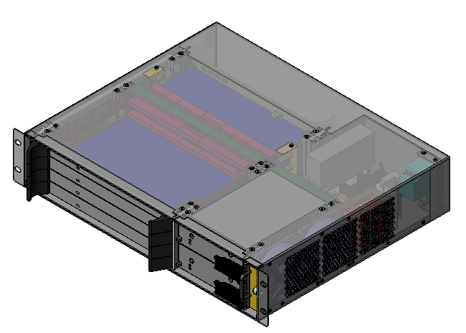
Concept
Pluggable Redundant 300W supplies
Removable Fan Tray
VME Cards (shown for reference)
Monitor Board
Rear Embedded Power supply
Rear Transition Cards
Removable Air filter
Airflow

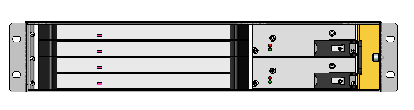
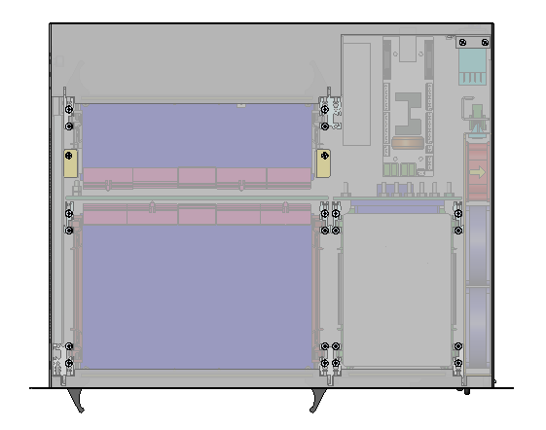
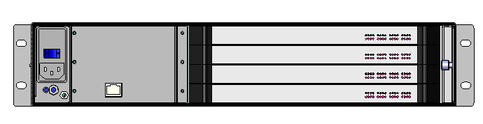
AC Input
Power Switch
Ground Stud
ESD Clip
Ethernet Port

Deliverables

Documentation
The documentation package provided to Stanford Labs will contain:
- Assembly drawing in electronic format (.pdf file)
- Interconnect diagram in electronic format (.pdf file)

Products
- Pre-Production quantity of one (2-4) units
- Production quantity of 20/65 units

Reviews
Informal design reviews and conference calls as required on a bi-weekly schedule (Hybricon will provide an “Open Items Report”).

Program Schedule
Delivery based on the requirements required is estimated as follows:
- Based on an initial PO on/or before May 25,2007
- (2) 2U and (2) 4U chassis ship for delivery on 6/26
- Stanford labs to evaluate and place production order on/or before 6/29
- (20) 2U and (65) 4U chassis ship 8/17 for delivery TBD (depending on shipping methods).

Pricing
The 2U & 4U Modified SRME Chassis price breaks are described in the pricing summary below. These prices are based on the anticipated volumes as discussed with Stanford Labs:

2U & 4U Modified SRME Chassis | Pricing
Part Number: 078-xxx (TBD at time of order placement)  2U Chassis  1-2 Unit  20+ Units  4U Chassis  1-2 Unit  65+ Units | Arrow quote to follow
NRE
Non-Recurring Engineering  Mechanical & Electrical Design of the system as detailed in the prior pages of this proposal. | $ 13,200.00
Note: Pricing for production quantities is based on lots of 20-85 chassis per shipment. Additionally, a Non-Cancellable/Non-Returnable (NCNR) Agreement signed by Stanford Labs is required and all units must be deliverable within 2 months of order placement. This is required in conjunction with receipt of purchase order.

Quote Validity
This quotation is valid for 60days from date of quotation. All pricing is subject to review beyond that date.

Payment Terms
Payments are due net 30
50% of NRE is payable upon acceptance of purchase order. Invoices will be submitted at the conclusion of each stage of the program and at the final meeting. Invoices are payable within 30 days. Other terms are addressed in Hybricon’s Standard Terms and Conditions incorporated herein by reference.
Hybricon considers the estimates provided in this proposal to be confidential and respectfully requests that Stanford Labs handle this material accordingly.
Thank you for the opportunity to submit this proposal. Hybricon appreciates the opportunity to work with Stanford Labs on this project and if you have any questions regarding this proposal, please contact your sales representative, Mike Sikorski, at Hybricon.

Hybricon Capabilities
Hybricon Corporation is a full service electronics packaging and engineering services provider that has been in business since 1976. We have a staff of people carefully recruited to provide:
- In depth theoretical based solutions and analyses
- Broad commercial manufacturing approaches
- Exceptional environment of innovation
- Understanding and executing complex customer requirements
- Providing successful transition of design to revenue in an expeditious manner
Hybricon is focused on providing high quality, custom electronic packaging solutions to fit your budget and time frames.

Thermal / Airflow Modeling and Simulation
- Thermal modeling and simulation can be used to predict system temperatures and air flow
- Advanced visualization capabilities provide insights into a system's performance
- Temperature profiles
- Air flow profiles
- Animations
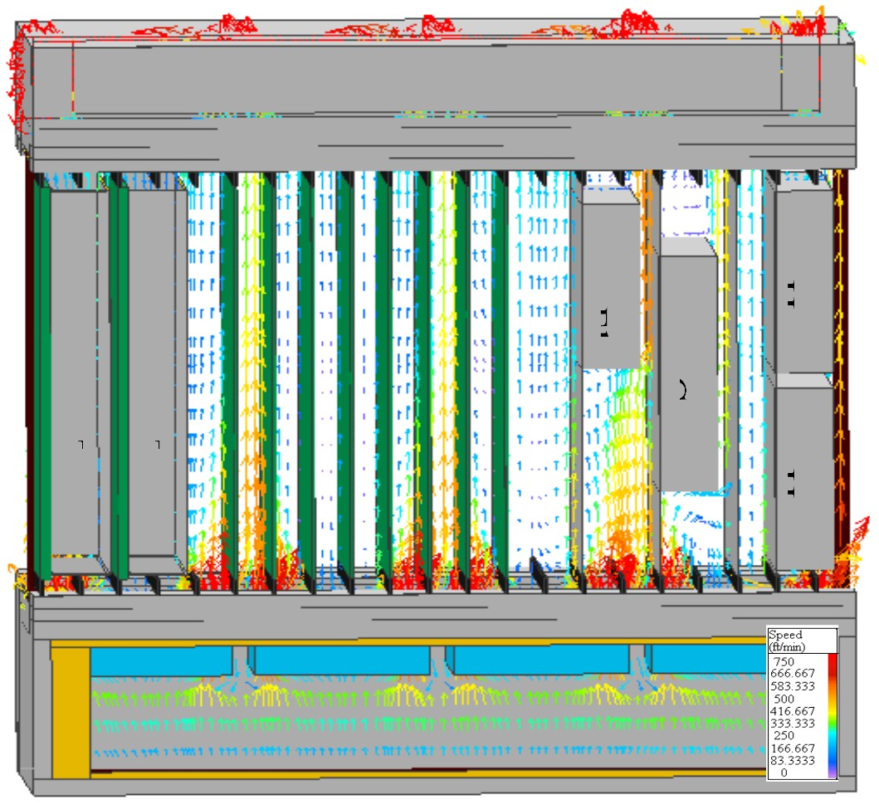

Signal Integrity
Hybricon has over a decade of experience in high performance backplane design and simulation, having performed Signal Integrity analysis and design of numerous custom switch fabric backplane designs. In addition, Hybricon has performed Signal Integrity Studies for VITA 2.1, PICMG 2.13, PICMG 2.16, and PICMG 2.17. Hybricon has performed these studies for many custom applications for data rates up to 3.125 GBPS using LVDS and PECL transceiver technologies. Our personnel have experience in performing full 3D modeling and simulation of interconnects at frequencies up to 20 GHz.
- HSPICE Simulation Post Processing tools provide simulated measurements for high performance backplanes
- Simulated Eye-diagrams allow evaluation of the channel's net ability to transmit data
- Simulated TDR and TDT are also available
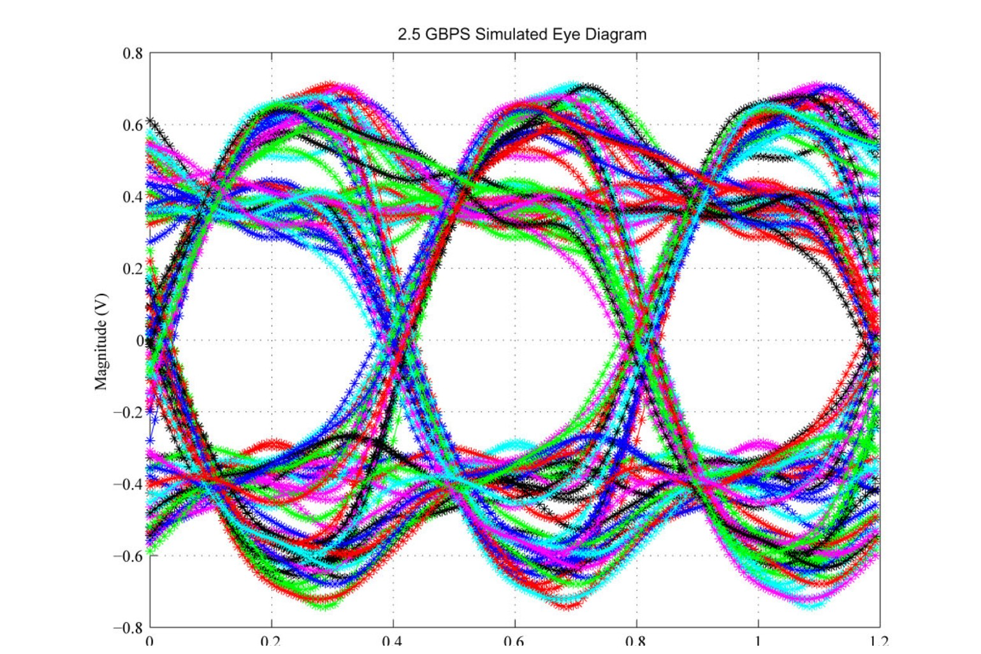
Simulated Eye Diagram for a 2.5 GBPS Differential Pair Link USING 2mm connectors

Manufacturing Capabilities
Hybricon Corporation offers a complete turnkey manufacturing environment, with full ERP/MRP systems, giving our customers the ability to migrate from prototype quantities to production with out the need for change. By using work-cell manufacturing techniques and lean manufacturing, we can modify our production flow to satisfy both different product mixes as well as quantities changes. Full integration can also be provided, including OS and disk drives. In-house capabilities include:
- ESD Controlled manufacturing floor
- Full cable assembly (AC & DC)
- Automated pinning equipment
- MEP-12T SEMI-AUTO Backplane press
- Full bed-of-nails board testing
- Dedicated workcells for production builds
- High speed 3D milling centers

Corporate Profile
Market Focus: Interconnect and Packaging Products and Engineering Services for Standard and Proprietary Bus Structures.
Plant: Main Plant - 25,500 sq. feet (15,000 sq. ft. manufacturing)
Future expansion at this location: 75,000 to 100,000 sq. ft.
Officers: The officers of the company are as follows:
C. Michael Hayward Chief Executive Officer
Paul R. Freve President
James F. Williams Vice President Operations
John Kosiba Vice President Finance
Robert C. Sullivan Vice President and Corp. Director of Technology
James B. Doyle Vice President of Sales

HYBRICON CORP. - Standard Terms and Conditions for Sale of Goods and Services.
HYBRICON CORPORATION (hereinafter referred to as "SELLER") and "BUYER" whose name and address appears on the attached Quotation, or Purchase and Sale of Goods and Services Contract, hereby agree to be bound by the terms and conditions for sale of goods specified herein or on attachments specifically incorporated herein by reference. These terms and conditions apply in whole or as amended by any attachments duly signed as agreed and accepted by BUYER and SELLER. If terms or conditions other than those included herein become a matter of disagreement or conflict then these terms and conditions specified herein shall prevail.
1. AMOUNT AND TYPE OF GOODS. SELLER agrees to sell and BUYER agrees to buy the quantity and type of goods which are described herein or which comply with written specifications agreed and accepted by BUYER and SELLER. (Hereinafter referred to as “Goods/Services”) as documented in this contract, BUYER’S Purchase Order, SELLER’S Proposal and /or Quotation and other attachments signed by BUYER and SELLER.

2. ACCEPTANCE OF ORDER AND EXPIRY DATE. Orders are accepted only upon and subject to SELLER’S Terms and Conditions for Sale of Goods and Services, as printed herein, ("Terms") and SELLER’S Proposal and/or Quotation. Unless expressly accepted in writing, any qualification or modification of Terms by BUYER in any written or printed document or otherwise shall be inapplicable. Unless previously withdrawn, SELLER’S Quotation expires 30 days after the date thereof. No binding contract shall be created by the acceptance on the part of BUYER, of a quotation or offer made by SELLER until notice of the acceptance of the order shall have been given by SELLER.

3. PRICE AND PAYMENT. The price of the goods shall be as specified upon the Hybricon quotation, and attached purchase order from BUYER and written sales acceptance order from SELLER. (hereafter collectively referred to as S.O.) Any deviation on the S.O from the Hybricon quoted specifications initially requested by BUYER may result in price adjustments. If, prior to delivery by SELLER of the Goods, the cost to SELLER of any component to be incorporated in the GOODS (the cost of the component to include and brokers’ or finders’ fees or other costs associated with acquiring the component) (hereafter collectively referred to as “the component cost”), is increased from the prevailing market price of such component at the time this contract is entered into, the BUYER agrees that the price of the GOODS shall be increased by the amount of 110% of the additional component cost incurred by SELLER in order to acquire such component for incorporation into the GOODS. In the event that more than one shipment of GOODS is made pursuant to this contract, the provisions of the preceding sentence shall apply separately to each shipment. Payment shall be net cash, in U.S. currency, thirty (30) days from date of invoice unless otherwise provided for in writing by Hybricon. SELLER may impose a 1&1/2% per month late charge (compounded) after 30 days. Minimum order amount as established by SELLER is applicable.

4. TAXES AND TARIFFS. Prices are exclusive of all federal, state and local excise, sales use and similar taxes, if any. Customers purchasing for resale must furnish, where applicable, a resale certificate that bears the BUYER’S resale permit number. BUYER must pay any taxes as well as any tariffs or customs duty as applicable.

5. DELIVERY. The delivery of the Goods shall be made, in a single lot or in multiple lots, as specified in S.O. and shall be made on or before the date specified herein, or within a reasonable time thereafter. The delivery schedule hereof can be extended by the SELLER as specified in paragraph 19 hereof or failure of BUYER to pay past due invoices. All installments shall be separately invoiced and paid as billed without regard to future deliveries. Failure to pay for any installment when due shall excuse SELLER from making further deliveries. Delay in delivery of any installment shall not relieve BUYER of its obligation to accept remaining installments. All claims for delay shall be deemed waived unless presented to SELLER in writing within ten (10) days after delivery of each shipment. The Goods shall be delivered to the place described in S.O.

6. BUYER REVISIONS. Any revisions (including delivery dates) to this order require written notice from BUYER which must be accepted in writing by SELLER. Any such revisions by BUYER may be subject to appropriate charges.

7. Engineering Charges. Engineering charges represent the cost of taking SELLER’S existing technology (proprietary) and product database and adapting these to meet customer special needs. All resulting product designs and technology is exclusively the property of SELLER and cannot be disclosed to or manufactured by other third parties without expressed agreement of SELLER, who retains exclusive ownership of all contributing technology, data, intellectual property rights, database and other property and information (here after referred to as "Intellectual Property"), except for information and or hardware provided by SELLER or other third party. Engineering charges are billable upon customer approval of the design (if required) and release of the design to Manufacturing.

8. PATENTS AND COPYRIGHTS
Hybricon Corporation will defend or settle at its expense and indemnify and hold harmless BUYER in any action brought against BUYER alleging that the Hybricon Corporation Products , or any of their parts manufactured by Hybricon Corporation, infringe a United States patent or copyright, provided that BUYER promptly notifies Hybricon Corporation in writing of such action, provides Hybricon Corporation with all reasonable assistance, at Hybricon Corporation's expense, for the defense or settlement of such action, and grants to Hybricon Corporation sole authority and control for the defense or settlement of such action.
If a final adjudication enjoins BUYER from using the Products, Hybricon Corporation will, at Hybricon Corporation's option and expense, either procure for BUYER the right to continue using such Products, or part, or replace or modify such Products, or part so that it becomes noninfringing, or remove such Products, or part and refund to BUYER the purchase price, or license fee if applicable, and transportation costs.
Hybricon Corporation shall not have any liability to BUYER if the alleged infringement is based on the use of such Products, or part with products not manufactured by Hybricon Corporation, which products infringe any patent or copyright, or Hybricon Corporation's compliance with BUYER’S designs, specifications or instructions.
The foregoing states Hybricon Corporation's entire liability for patent or copyright infringement by such Products, or part.

9. PRODUCTS SPECIFICATIONS
Hybricon Corporation reserves the right to make changes in the specifications of Products, provided the changes do not diminish the performance of the Products as confirmed by Hybricon Corporation's Order Acknowledgment.

10. LIMITATIONS OF LIABILITY
IN NO EVENT SHALL HYBRICON CORPORATION BE LIABLE FOR ANY INDIRECT, INCIDENTAL, SPECIAL OR CONSEQUENTIAL DAMAGES, EVEN IF NOTICE HAS BEEN GIVEN OF THE POSSIBILITY OF SUCH DAMAGES.

11. SHIPPING. Goods are sold F.O.B. factory with title passage upon SELLER delivery to a common carrier... Shipping, unless otherwise specified by BUYER, will be the least expensive transportation as determined by SELLER. The price shall be paid by BUYER upon tender of delivery. It is expressly agreed that BUYER shall not be entitled to the paid documents of title until such time as the draft drawn against the same has been paid in full.

12 DEFAULT OF PAYMENT. In the event that the BUYER defaults in paying any sum due under any contract as and when it becomes due or should BUYER be in breach in any respect of the contract entered into, SELLER shall have the right with or without notice at the discretion of SELLER, to either suspend all further deliveries until the default be made good, or to terminate any contract then subsisting so far as any further goods remain to be delivered without prejudice to any cancellation charges or other claim or right the SELLER might otherwise make or exercise.
In the event that BUYER fails to perform any of the terms and conditions set forth herein and SELLER seeks to enforce BUYER’S obligations hereunder, BUYER shall be responsible for all of SELLER’S costs and expenses, including attorneys fees incurred by SELLER, in addition to all other liabilities imposed by this contract.

13. SHIPMENT UNDER RESERVATION. It is agreed that SELLER will maintain title and the right of possession in the Goods sold until such time as payment therefore, including shipping, taxes, duties and any other applicable charges, is made by BUYER.

14. PACKAGING. SELLER will determine the type of container and arrange for suitable packaging for domestic transport. Special packaging may be requested by BUYER and may result in additional charges to BUYER, provided BUYER’S request is in writing and delivered to SELLER.

15. RISK OF LOSS. Risk of loss of the Goods shall pass to BUYER on delivery by SELLER to a common carrier. Unless expressly requested by
BUYER, and at BUYER’S expense, no additional insurance will be purchased
by SELLER and BUYER will be responsible for loss or damage to product during shipment if option for insurance is waived.

16. WARRANTIES. The goods sold hereunder, when installed and operated in accordance with the specifications provided by BUYER to SELLER are warranted to be free from defects in workmanship and materials for a period of one (1) year (or as may be extended for specific products as set forth in writing by SELLER) from the date of shipment , provided BUYER shall give notice in writing to SELLER, stating in what respects the product has failed to fulfill this express warranty. (Failure to give notice within such period shall be a waiver of this warranty and any assistance rendered thereafter shall not extend to revive it.) The SELLER shall be allowed a reasonable time after receipt of such notice to remedy the defect, if any, and the BUYER agrees to render friendly assistance. If the product cannot be made to fulfill the warranty and the BUYER promptly returns it to the SELLER at its place of business, the SELLER will either furnish another product with the same warranty, or at its option refund the amount paid, which shall constitute a settlement in full of all claims of every nature, the SELLER’S liability being expressly limited to replacing the product. The warranty shall become void if the product is damaged due to the mishandling of the product by anyone other than the SELLER, or if any attempts are made by any party other than the SELLER to repair said product. The warranties provided herein, the obligations and liabilities of SELLER hereunder and the rights and remedies of BUYER hereunder are exclusive . THE WARRANTIES PROVIDED HEREIN ARE IN LIEU OF ALL OTHER WARRANTIES, EXPRESS OR IMPLIED, INCLUDING ANY IMPLIED WARRANTIES OF MERCHANTABILITY AND FITNESS FOR A PARTICULAR PURPOSE.
17 RETURN POLICY - INCORRECT MATERIAL. Upon determination that SELLER has shipped incorrect material and upon receipt of notice in writing from BUYER a Returned Material Authorization ("RMA") will be issued which authorizes the return of the material for replacement or credit and SELLER shall assume responsibility for reasonable inbound and outbound transportation charges, within the continental United States, incurred in the transaction. It is BUYER’S obligation to ascertain the correctness of the material before any attempt is made to install it. SELLER will not accept return of, nor issue an RMA or credit for, any Goods which bear any appearance of having been installed, totally or in part, nor will transportation expenses be allowed.

18 DEFECTIVE MATERIAL. It shall be BUYER’S responsibility to inspect and notify SELLER if, when received, there is a non-conformance to specification and/or workmanship standards within thirty (30) days after receipt. If the Goods fail during the warranty period, BUYER must notify SELLER within 30 days after termination of the warranty period. If initial information requested from BUYER to SELLER indicates that the Goods may be defective due to manufacturing deficiencies, an RMA will be issued. SELLER reserves the right to perform any tests it deems necessary, on site or on SELLER’S premises to determine if the defect is due to manufacturing deficiencies. Any returned Goods will be subject to the following: A) If tests show that the Goods are defective due to manufacturing deficiencies, credit will be issued and the Goods will be repaired or replaced at SELLER’S option; B) If tests determine that the defect is the result of damage inflicted by others or faulty installment, no credit will be issued and BUYER will be invoiced for all expenses incurred in testing and shipping of the Goods. If BUYER wishes to have the Goods repaired, BUYER will issue a Purchase Order for the charges quoted by SELLER.

19. CANCELLATION BY BUYER. BUYER may cancel or suspend an order only with SELLER’S written consent and agreement to terms which will indemnify SELLER against any expense incurred. When an order calling for scheduled delivery is placed with SELLER for a period of three months or more, SELLER will manufacture and/or procure goods in quantities equal to the requirements called for over three month periods. In the event of cancellation or postponement of scheduled orders, SELLER reserves the right to invoice for the difference in selling price applicable to the quantity taken up to the time of cancellation or postponement or the expiration of the contracted schedule period compared with the price for the quantities actually released by BUYER for shipment.
Cancellation:
Days before Scheduled Shipment Charge
60 days or under Full price and will be delivered as ordered.
Over 60 days Direct costs incurred plus applicable burdens.
Postponement:
Days before Scheduled Shipment Conditions *
30 days or under (catalog products) No postponement.
60 days or under (non-catalog products) No postponement
Over 30 days (catalog products) Up to 90 days postponement.
Over 60 days (non-catalog products) If over 90 days, 20% surcharge payable with written notice of postponement.
* If canceled after postponement, additional cancellation charges apply from date of original scheduled delivery.

20. INDEMNITY. BUYER shall indemnify the SELLER in respect of all damage or injury occurring to any personal property and against any actions and expenses in the connection for which SELLER may become liable in respect of the Goods sold if the damage or injury is caused by negligence of BUYER or his servants or agents.

21. TERMINATION. If BUYER violates, or is officially charged with a violation of any law, regulation or ordinance which may govern the sale, handling or disposition of any of the Goods or if BUYER becomes insolvent, or makes any assignment for the benefit of creditors, or is adjudged bankrupt, or if a receiver or trustee of BUYER’S property is appointed SELLER may, at its sole discretion, terminate this contract and may refuse to make any further deliveries. BUYER shall be responsible for charges as set forth in paragraph 12.

22. BUYER’S REMEDIES. In the event of breach or repudiation of this contract by SELLER, BUYER’S right to damages shall be limited to the difference between the contract and the market price of the Goods and BUYER shall not have the right to "cover" and fix damages by contracting for substitute Goods. Further, SELLER shall not be liable, under any circumstances, for the cost of processing, lost profits, injury to goodwill or any incidental or consequential damages as those terms are defined in the Uniform Commercial Code.

23. EXCLUSIVE AGREEMENT. This contract constitutes the entire contract and exclusively determines the rights and obligations of the parties hereto, any prior course of dealing, custom or usage of the trade or course of performance notwithstanding, and may not be modified except by a writing signed by SELLER.

24. NON-ASSIGNABILITY. This contract shall not be assignable and
delegable by either party hereto without the written consent of the other.

25. FORCE MAJEURE. SELLER shall not be responsible for delays in delivery or any failure to deliver due to causes beyond SELLER’S control including, but not limited to, acts of God, war mobilization, civil commotion, riots, embargoes, domestic or foreign governmental regulations or orders, fires, floods, strikes, lockouts and other labor difficulties, or shortages of or inability to obtain shipping space or transportation or loss of material in transit.

26. EXPORT. Delivery of Goods to BUYER shall be subject to all required licenses, permits, decrees, statutes, rules and regulations of the government of the United States and agencies thereof and of any applicable foreign government. BUYER warrants that it will not export Goods either directly or indirectly in violation of applicable export laws and regulations and agrees to indemnify and hold harmless SELLER for any breach of this section.

27.CHOICE OF LAW. This contract, and all of the rights and obligations of the parties hereto, shall be governed by the Uniform Commercial Code as enacted and in force in the Commonwealth of Massachusetts on the date of this contract. The failure of either party to exercise any right or remedy provided for herein shall not be deemed a waiver of that right or any other rights or remedies available hereunder.

