Migrating Oracle Application Server from RHEL-4 to RHEL-5

RHEL-4 Server – mccas1
RHEL-5 Server - mccas2

Hostnames and IP Addresses –
Name: mccas1.slac.stanford.edu
Address: 134.79.151.35

Name: mccas2.slac.stanford.edu
Address: 134.79.151.37

seal.slac.stanford.edu is an alias pointing to Oracle Application Server.
Before migration it was pointing to mccas1. After migration it started pointing to mccas2 like following –

seal.slac.stanford.edu canonical name = mccas2.slac.stanford.edu.
Name: mccas2.slac.stanford.edu
Address: 134.79.151.37

Migration Steps -

1)Build RHEL-5 Server as hostname mccas2.
2)Install Oracle App. Server on mccas2. This is done by SCCS (Arash).
3)Prepare the list of all Applications running on Oracle Application
Server and respective support personnel.
Personnel and Apps list –
Judith – IRMIS
Greg – AidaWeb
Elie – Apex
4)Install the applications on the RHEL-5 Server mccas2. This is done
by the folks who are responsible for the respective applications.
5)Test the application on mccas2.
6)Schedule 1 hour outage. Open a ticket with SCCS for pointing the
alias seal to the new server during the outage window.
7)During outage bring down the current prod server. Coordinate with
sccs and ensure that they have done the changes for the alias seal.
Confirm by issuing “nslookup seal” command from Windows as well as
Unix machines.

Preparing RHEL-5 Server mccas2 –
4 disk configuration and the separation of OS from applications.

# hostname
mccas2

# df -h
Filesystem Size Used Avail Use% Mounted on
/dev/sda1 19G 5.8G 13G 33% /
/dev/sda8 22G 173M 21G 1% /scratch
/dev/sda7 965M 52M 864M 6% /scswork
/dev/sda6 1.9G 1.2G 703M 62% /usr/vice/cache
/dev/sda3 7.6G 557M 6.7G 8% /var
/dev/sda2 7.6G 146M 7.1G 2% /tmp
tmpfs 6.0G 0 6.0G 0% /dev/shm
AFS 8.6G 0 8.6G 0% /afs
/dev/sdc1 68G 2.9G 62G 5% /opt/oracle
[root@mccas2 ~]# fdisk -l

Disk /dev/sda: 73.4 GB, 73407820800 bytes
255 heads, 63 sectors/track, 8924 cylinders
Units = cylinders of 16065 * 512 = 8225280 bytes

Device Boot Start End Blocks Id System
/dev/sda1 * 1 2550 20482843+ 83 Linux
/dev/sda2 2551 3570 8193150 83 Linux
/dev/sda3 3571 4590 8193150 83 Linux
/dev/sda4 4591 8924 34812855 5 Extended
/dev/sda5 4591 5610 8193118+ 82 Linux swap / Solaris
/dev/sda6 5611 5865 2048256 83 Linux
/dev/sda7 5866 5992 1020096 83 Linux
/dev/sda8 5993 8924 23551258+ 83 Linux

Disk /dev/sdb: 73.4 GB, 73407820800 bytes
255 heads, 63 sectors/track, 8924 cylinders
Units = cylinders of 16065 * 512 = 8225280 bytes

Device Boot Start End Blocks Id System
/dev/sdb1 * 1 2550 20482843+ 83 Linux
/dev/sdb2 2551 3570 8193150 83 Linux
/dev/sdb3 3571 4590 8193150 83 Linux
/dev/sdb4 4591 8924 34812855 5 Extended
/dev/sdb5 4591 5610 8193118+ 82 Linux swap / Solaris
/dev/sdb6 5611 5865 2048256 83 Linux
/dev/sdb7 5866 5992 1020096 83 Linux
/dev/sdb8 5993 8924 23551258+ 83 Linux

Disk /dev/sdc: 73.4 GB, 73407820800 bytes
255 heads, 63 sectors/track, 8924 cylinders
Units = cylinders of 16065 * 512 = 8225280 bytes

Device Boot Start End Blocks Id System
/dev/sdc1 1 8924 71681998+ 83 Linux

Disk /dev/sdd: 73.4 GB, 73407820800 bytes
255 heads, 63 sectors/track, 8924 cylinders
Units = cylinders of 16065 * 512 = 8225280 bytes

Device Boot Start End Blocks Id System
/dev/sdd1 1 8924 71681998+ 83 Linux

Deploying the Apps on RHEL-5 Server before the migration –
SCCS/Arash created an "appadmin" user that can be used to deploy apps to the mccas2oc4j container. SCCS/Arash communicated the password to App Support folks for them to deploy the Application. URL to use to deploy application –
https://mccas2.slac.stanford.edu/em

Testing the Apps on RHEL-5 Server before the migration -

When the applications are tested on mccas2/RHEL-5 server before the migration we would get a warning/error about security certificate. That is expected. The security certificate is attached to alias seal. Ignore this warning before migration.
For example when accessing the following URL, you would get an warning - https://mccas2.slac.stanford.edu/apex/mccora2/f?p=400).

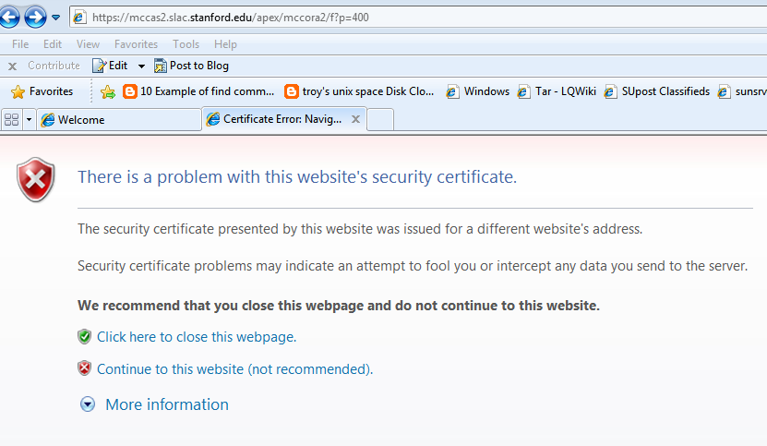

Creating a cron script to copy App Data from App Disk to Mirror App Disk –
Create a script to rsync data from the App Data Disk sdc1 to App Data Backup Disk sdd1.

$ cat app_disk_rsync
#!/bin/bash

PATH=/sbin:/bin:/usr/sbin:/usr/bin:$PATH
umount /dev/sdd1 2>/dev/null

/bin/mount /dev/sdd1 /mnt 2>/dev/null

if [ $? != 0 ]
then
echo "Backup failed for the application disk. Please check and correct." | /bin/mailx -s "Backup failed for the application diskon mccas2. Please check and correct." "Divekar@slac.stanford.edu, brobeck@slac.stanford.edu,jingchen@slac.stanford.edu"
exit 0
else
/usr/bin/rsync -avz /opt/oracle/ /mnt >/tmp/rsynclog
/bin/umount /dev/sdd1 2>/dev/null
fi

Put the app_disk_rsync script under cvs.
# Step # 1
bash
mkdir work-tools
cd work-tools
cvs co tools/script/linuxdd
cd tools/script/
cp /tmp/app_disk_rsync .
cvs add app_disk_rsync
cvs commit

# Step # 2
cd /afs/slac/g/lcls/
cvs update tools/script/app_disk_rsync

Add the cron job and confirm.
[root@mccas2 tmp]# crontab -l | grep app_disk_rsync
42 1 1,16 * * /afs/slac/g/lcls/tools/script/app_disk_rsync > /tmp/app_disk_rsync.log 2>&1

URLs for Applications on a working setup –
For OC4J/Java apps, they were deployed on mccas2 by the owners.

https://mccas1.slac.stanford.edu/aidaweb (Greg White)
Note from Judith -
https://seal.slac.stanford.edu/IRMISQueries/

Url to use to update/deploy the application: https://seal:1156

Apex application is supported by Elie.
https://mccas2.slac.stanford.edu/apex/
https://mccas2.slac.stanford.edu/apex/mccora2/f?p=400
Arash/SCCS created an "appadmin" user that can be used to deploy apps to the mccas2oc4j container. Arash/SCCS communicated the password to application owners so they can deploy the applications. Here's the url to use:

https://mccas2.slac.stanford.edu/em

Following two war files related to Aidaweb were found on mccas1 and Judith used one of them for deploying Aidaweb on mccas2.

/oracle/appserver/10.1.3.1/j2ee/mccas1oc4j/applications/aidaweb/aidaweb.war
/oracle/mcc/aidaweb.war

TEST PLAN in Cater -

Following test plan was submitted for cutover on Tuesday 02/28/2012 -

10:00 AM - mccas1 shutdown completely.
10:05 AM - DNS alias seal will start pointing to mccas2.
10:20 AM - DNS changes would get propagated in 15 minutes as per SCCS.
10:25 AM - mccas2 will be brought up.
10:30 AM - Arash will test/check the general functionality of Oracle Apps server running on mccas2.
10:35 AM - Elie, Judith and Bob will test the web links and apps for which they are responsible.

Back out plan -

Bring down mccas2.
DNS alias seal will start pointing to mccas1.
Bring up mccas1.
Arash will test/check the general functionality of Oracle Apps server running on mccas1.
Elie, Judith and Bob will test the web links and apps for which they are responsible.

After the cutover verification was done by Judith and Elie –
Elie tested the MACHINE_MODEL and SCORE Apex apps for both MCCQA and MCCO.
Judith tested IRMIS IOC Info jsp application.
Judith tested IOC Info, EPICS camdmp, and Archiver PV list APEX apps.

