General Information about NX and Neatx –
NX - NoMachine NX is an enterprise-class solution for secure remote access, hosted virtual desktop deployment
Neatx is an Open Source NX server, similar to the commercial NX server from NoMachine. If you're not familiar with NX, these links might help:
- NoMachine's “Getting Started With NX”
- NoMachine's “Introduction to NX technology”
- Wikipedia article on NX technology

What’s the use of these products for us –
From home we can remotely login and work on graphics intensive programs.

Our Environment –
We have one for testing/evaluation. On SCCS server we have installed NX Evaluation product. For accessing both NX server, you need to install NX Open source client on your PC/Laptop.

SCCS Provided NX Server - nxserv02.slac.stanford.edu

Procedure to download and install NX client on Windows –
Go to following URL -
http://www.nomachine.com/download-package.php?Prod_Id=3655
1 ) Download and install following in SEQUENCE – Install NX Client first and then install install the additional fonts below as given in the above web link.

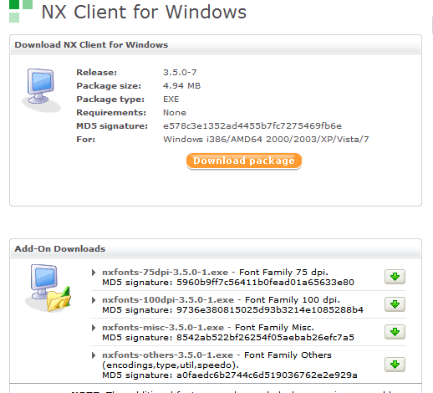

2) Click on NX client icon.

For using NX Server -
Provide server name as “nxserv02.slac.stanford.edu”.
Select Desktop options – Unix and GNOME.

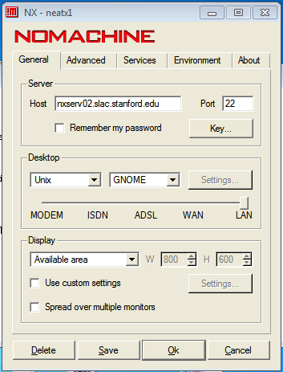

Select one of the following depending upon your home connectivity
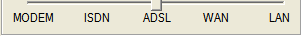
Issues and workarounds for NX Server nxserv02.slac.stanford.edu –
Issue - First time the user is able to login successfully using NXClient on nxserv02.slac.stanford.edu. When the person logs off and tries to connect again, he/she gets following error -
Server Configuration Error. Cannot login. Please contact your system administration.

Workaround –
Logon to mcclogin
cd .ssh
unlink authorized_keys2
cp ~/.ssh/.public/authorized_keys2 ~/.ssh/

Logoff and log to NX/nomachine again.
Miscellaneous Issues on NX/NeatX Server –
Issue – Slow server response.
Reason – NX/Neatx server’s primary responsibility is Fast Remote Access. User’s are expected to get connected to NX/Neatx server from home and ones connected they are expected to ssh/login to their respective server. At times NX/Neatx server becomes busy because users launch CPU intensive jobs on NX/Neatx server. Please avoid using NX/Neatx server for launching CPU intensive jobs.

Issue - Performance issue for a while now for both NeatX and NX. When you put the mouse over the "taskbar" it will pop up a balloon with more information about the task bar item and this animation is extremely slow (~min) to complete and stalls everything else.
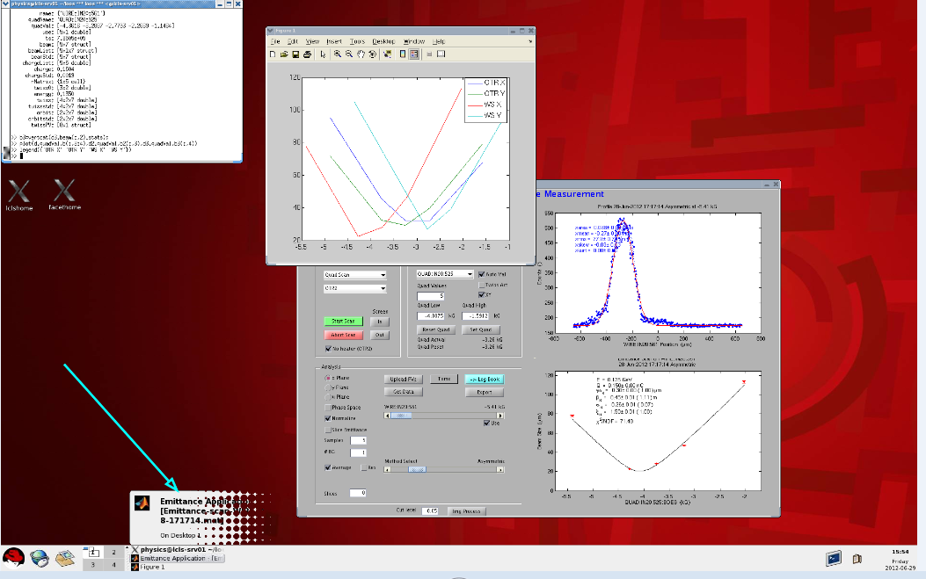

Fix –
1) Exit from NX Session
2) Click on NX Icon, and before you login do following

Press "Configure"

Chose tab "Advanced"

Check the box "Disable DirectDraw for screen rendering".
3) Now you enter your password and start the NX Session

