 | Document # | Date Effective
 | LAT-TD-00438-D3 | 12/26/02
 | Responsible Engineer(s) | Supersedes
 | Alex Moiseev | None
GLAST LAT Technical Document
GLAST LAT Technical Document | Subsystem/Office
GLAST LAT Technical Document | ACD Subsystem
Document Title
LAT ACD Light Collection/Optical Performance Tests

Gamma-ray Large Area Space Telescope

(GLAST)

Large Area Telescope (LAT)

Anticoincidence Detector (ACD)

Light Collection/Optical Performance Tests

TILE DESIGN TEST RESULTS
LIGHT BUDGET AND ABSOLUTE EFFICIENCY
Effect of broken fibers on the tile efficiency
EDGE EFFECT STUDY

Sealing of the gaps between ACD tiles – design,
simulations and tests
CHANGE HISTORY LOG

Revision | Effective Date | Description of Changes | DCN #
1 |  | Initial Release
2 | 12/31/01 | Added new sections
3 | 12/2602 | Added new sections

CONTENTS
1. PURPOSE………………………………………………………………3
2. SCOPE….………………………………………………………………3
3. DEFINITIONS…………………………………………………………3

4. APPLICABLE DOCUMENTS……..………….………………………4
5. TILE DESIGN TEST RESULTS…..………….……………………….4
6. LIGHT BUDGET AND ABSOLUTE EFFICIENCY …..………….….8
7. Effect of broken fibers on the tile efficiency..…….10
8. EDGE EFFECT STUDY……………….…………………...…………..…….13

9. Sealing of the gaps between ACD tiles – design,

simulations and tests.……………….………………..….14
10. CONCLUSIONS………………………………………………..…….17

1. PURPOSE
This document describes light collection and efficiency testing of the GLAST LAT ACD scintillator system.

2. SCOPE
Effectiveness of the light collection is essential to the operation of the GLAST LAT ACD. The tests describe methods to improve light collection and resulting measurements of absolute charged particle detection efficiency.

3. DEFINITIONS
ACD - AntiCoincidence Detector
GLAST – Gamma-ray Large Area Space Telescope
LAT – Large Area Telescope
MIP – Minimum Ionizing Particle (see definition below)
cm – centimeter
Cosmic Ray - Ionized atomic particles originating from space and ranging from a single proton up to an iron nucleus and beyond.
eV – Electron Volt
GeV – Giga Electron Volts. 10⁹ eV
MeV – Million Electron Volts, 10⁶ eV
Minimum Ionizing Particle – The mean signal from cosmic ray produced air shower muons at sea level normally incident on a scintillator tile. It corresponds to approximately 1.9 MeV per cm of scintillator.
ph – photons
PMT - photomultiplier tube
s, sec – seconds
TDA - Tile detector assembly (scintillator, waveshifting fibers, and photomultiplier tube)
WSF - waveshifting fibers

4. APPLICABLE DOCUMENTS
Documents that are relevant to the development of the ACD concept and its requirements include the following:
LAT-SS-00010, “GLAST LAT Performance Specification”, August 2000
LAT-SS-00047, “LAT Mechanical Performance Specification”
“GLAST Large Area Telescope Flight Investigation: An Astro-Particle Physics Partnership Exploring the High-Energy Universe”, proposal to NASA, P. Michelson, PI, November, 1999.

5. TILE DESIGN TEST RESULTS

Task: study different designs of the ACD scintillating tile for optimization of the light collection.

All scintillators tested are 1cm thick, readout by Hamamatsu R1635 photomultiplier tubes.

- Fiber spacing effect.
All tiles are BICRON, TYVEK wrapped, multiclad fibers

Fiber spacing | Light yield, relative units
2 cm | 15.9
1 cm | 18.1
0.5 cm | 22.0
0.25 cm | 20.2
Continuous | 23.3

Conclusion – 0.5 cm spacing or closer is optimal.

- Wrapping effect

Wrapping | Tile | Relative light yield
TYVEK | BICRON, 5mm fiber spacing, multiclad fibers | 22.0
TETRATEC | ---- “ “ ---- | 24.5
Polyester | ---- “ “ ---- | 20.0
TYVEK | ElJen scintillator, 10mm fiber spacing, single clad fibers | 15.3
TETRATEC | ---- “ “ ---- | 17.2

Conclusion – TETRATEC gives ~ 10% increase of the light yield

- Use of half of fibers (2 PMTs)

All tiles are BICRON, 5mm multiclad fiber spacing, wrapped in TETRATEC

Number of readout fibers | Relative light yield
All fibers | 24.5
Half fibers | 11.9

Conclusion: Use of 2 PMTs reduces the light for each PMT by 50%.

- Aluminization of the fiber ends

Fiber ends | Tile | Relative light yield
Razor Cut | TYVEK, ElJen scintillator, 1cm single clad fiber spacing | 14.1
Aluminized at GSFC | ---- “ “ ---- | 15.3
Razor Cut | TETRATEC, BICRON, 5 mm multiclad fiber spacing | 24.5
Mylar at the ends | ---- “ “ ---- | 21.1
Razor cut | TYVEK, 1 cm multiclad fiber spacing | 18.1
Aluminized in FNL | ---- “ “ ---- | 21.2

Conclusion – aluminization at GSFC gives 5-7% light increase. Aluminization at Fermilab improves the light yield by ~ 17%.

- Fiber cladding

All tiles are ElJen scintillator, 1cm fiber spacing, TYVEK wrapped

Fibers | Relative light yield
Single clad | 14.1
Multiclad | 17.8

Conclusion: multiple cladding is important, gives ~ 25% light increase

- Scintillator manufacturer

All tiles are 1cm multiclad fiber spacing, TYVEK wrapped

Scintillator | Relative light yield
BICRON | 18.1
ElJen1 | 17.8

Conclusion: Difference is within the measurement errors; scintillators perform similarly.

- Other different designs

Tile | Tested feature | Relative light yield
TETRATEC wrapped, BICRON | Light is transmitted to PMT by clear fibers viewing from the tile edge | 5.5
BICRON, TYVEK wrapped | Light is collected by WSF glued to both tile edges without spacing | 13.2
BICRON, TYVEC wrapped, 1cm multiclad fiber spacing | 2 fibers in one groove | 19.0 (to compare with 18.1 for one fiber)
BICRON, TYVEK wrapped, 1cm multiclad fiber spacing | Tile is made of 2 5mm thick tiles, fibers are glued between them in grooves cut in one tile | 11.0

Conclusion: none of these tests suggests any significant improvement.

Design conclusion. It was found that the largest light yield will be provided by the following tile design:
- 5 mm fiber spacing
- TETRATEC as a wrapping material
- Fiber ends are aluminized by the technology developed at Fermilab
- Multicladding wave-shifting fibers are used
- Scintillator manufacturer (Bicron or ElJen) does not matter much
This design provides 50%-60% light increase compared with that obtained for the beam test/balloon flight tile design

- LIGHT BUDGET AND ABSOLUTE EFFICIENCY

The absolute efficiency of a TDA (Tile detector assembly) has been measured, and the corresponding light yield was estimated. The measurements have been performed with relatively short fibers (only WSF) which collect the light from the tile and deliver it to the PMT. In the real design there will be up to 1.5 meter long fiber bundles to deliver the light from the most distant (in the middle of the top ACD surface) tiles to the PMT location. Two cases are considered in this memo – (1) the resulting efficiency if no clear fibers are used and light is delivered to PMT by only WSF (1.5 meters long, 40% light loss assuming the published absorption length), and (2) the use of fiber-to-fiber connectors and clear fibers to deliver the light to PMT (much more transparent fibers, the light loss is ~ 15% due to losses in the connector between the WSF and clear fibers).

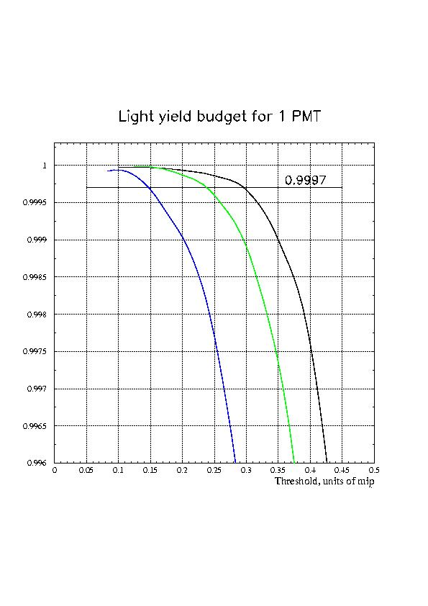
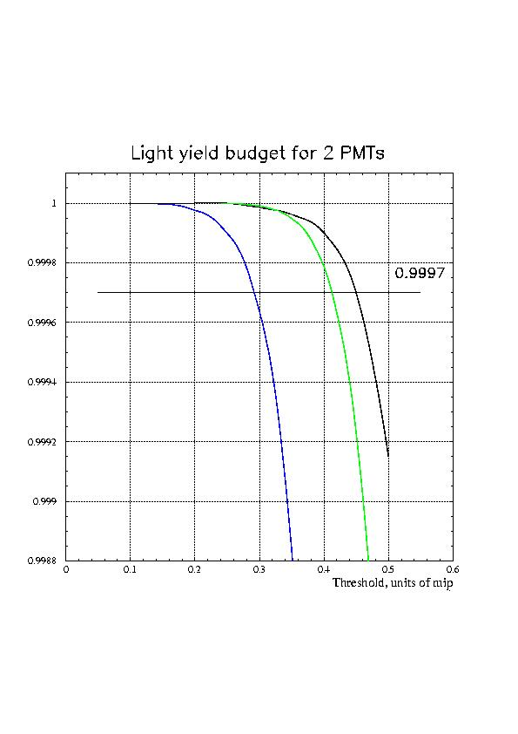
Fig.1. Light budget for 1 PMT.
Black line – measured efficiency (corresponds to 19 p.e.)
Green line – efficiency assuming 15% light loss (16 p.e.) in the fiber connector and clear fibers
Blue line – efficiency assuming 40% light loss (12 p.e.) in 1.5 meters WSF
Fig.2. Light budget for 2 PMTs.
Black line – measured efficiency
Green line – efficiency assuming 15% light loss
Blue line – efficiency assuming 40% light loss

Conclusions. The nominal ACD threshold is 0.3 of a MIP. Using this value as a reference, the efficiency of the ACD under different configurations can be obtained from the figures.

- Single Phototube operation - For those ACD tiles not located close to the base electronics, the losses in either the WSF or the clear fiber connector will push the nominal efficiency slightly below the 0.9997 goal. The implication is that the ACD system is not fully redundant. The default operating mode must be with both tubes operating. The loss of a single tube could result in performance degradation.

- Two Phototube operation. Even running both PMTs, the required efficiency may not be achieved with 0.3 MIP threshold if the light is transmitted only by WSF. Use of the clear fibers is strongly indicated. The efficiency could be increased by lowering the thresholds, but it will increase the self-veto caused by backsplash, and also will reduce signal-to-noise ratio.

7. Effect of broken fibers on the tile Efficiency

1. Task: study how missing fibers effect the efficiency of the tile

2. Experimental approach: measure the efficiency of the tile with all fibers on the place, and after that start cutting fibers and measure the efficiency. The traditional experimental setup is used (Fig. 3):
muon
Triggering tile S1 (5 by 5 cm)
Triggering tile S2 (5 by 5 cm)
Tested tile T ( 8cm by 24 cm)
Triggering tile S3 (8 cm by 24 cm)

Fig. 3 -- Test setup for efficiency measurements.

Events with energy depositions (pulse heights) in S1, S2, and S3 corresponding to mean MIP loss (plus-minus approximately 2 sigmas) were selected to determine the efficiency of tested tile T. Tiles T and S3 were the tiles made in 1997 for the beam test. These tiles have single-cladding fibers, TYVEK wrapping and are not the best made in our lab. I used this tile for the tested tile T because I had to cut fibers, so the tile is lost after the test.

3. Runs description (Fig. 4): Run 1 – all fibers are in place

Run 2 (1 missed fiber) Run 3 (3 missed fibers)
Area of S1 and S2
Tested tile T (muons pass here) Missed fibers

Run 4 (4 missed fibers) Run 5 (5 missed fibers)

Run 6 (7 missed fibers) Run 7 (8 missed fibers)

Fig. 4 -- Test configuration for missing fibers

4. MIP mean pulse height.

Run | MIP mean pulse height, channels | MIP mean pulse height, relative
1 | 369 | 1
2 | 374 | 1
3 | 367 | 0.98
4 | 316 | 0.85
5 | 275 | 0.74
6 | 274 | 0.73
7 | 244 | 0.65

5. Efficiency measurements
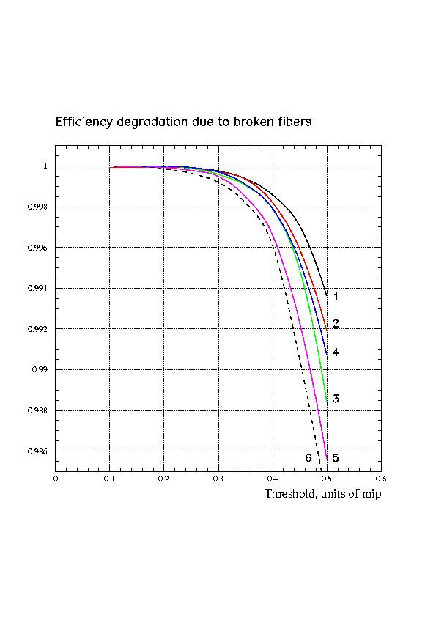
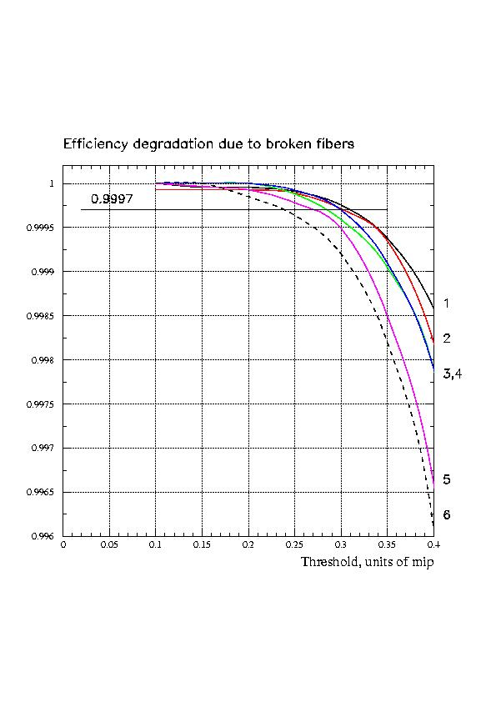
Fig. 5 and 6 -- For both figures: Line 1 (black) – run 1; line 2 (red) – run 3; line 3 (green) – run 4; line 4 (blue) – run 5; line 5 (pink) – run 6; and line 6 (black dashed) – run 7. Run 2 demonstrated the same, even slightly better (within the uncertainty), efficiency as that for run 1, that’s why run 2 is not shown.

5. Efficiency fitting by Poisson.

I fitted the best curve (for run 1) and the worst curve (run 7) by Poisson distributions with mean numbers (here number of photoelectrons) respectively 23 and 17. The fitting results are shown below (Fig. 7), where the black lines are the experimental, and the red ones are Poisson predictions for given number of p.e.

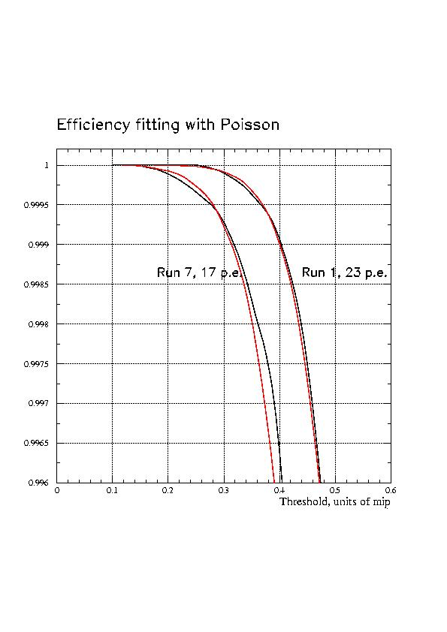

Fig. 7 -- Comparison of measured and calculated number of photoelectrons.

6. Conclusions.
The ratio between the light yield of run 7 (8 broken fibers, 3 of which are in the vicinity of the trajectory, 17 p.e.) and the tile with no broken fibers (run 1, 23 p.e.) is 0.65 from the MIP mean pulse height and 0.74 from the fitted number of p.e. I believe these numbers are consistent.
Assuming that there are 34 p.e. in total for the current tile design (see fitting in “Light budget assuming light loss in the fibers”, fig.2) there will be at least 22 remaining photoelectrons in the case of 8 broken fibers. This number of photoelectrons provides the required efficiency at a threshold ≥0.3 MIP. In the case of running one PMT, we cannot afford to have more than 1 missed fiber, because the light yield from 1 PMT already does not have margins (see the same document, fig.1)

I think that the minimal design requirements can be set as follows:

- To be qualified for the ACD assembly, the tile should have NO missing fibers
- For assembly into LAT, ACD can have tiles with maximum 2 missing fibers, with minimum of 2 good fibers between the broken ones. There should be not more than 3 tiles in total with broken fibers.
- ACD launch requirement – not more than 4 missing fibers in any tile, with minimum of 2 good fibers between any 2 broken ones. There should be not more than 3 tiles in total with broken fibers.

8. EDGE EFFECT STUDY

Possible non-uniformity of the light collection near the tile edges has been studied. The first approach was realized by John Krizmanic, who used radioactive source Ru¹⁰⁶ to activate the scintillation in the tile, and measured the light yield (PHA peak position) moving the collimated source across the tile. The results of the measured relative light yield (scaled to the light yield far from the edge) are given in Fig.8, lines 1 (solid circles data points). Since the tested tile (same tile as used in the efficiency test described above) had 2 PMTs viewing 2 WSF bundles, the measurements were done for both PMTs. The difference between them is that one bundle (PMT1) had a first wave-shifting fiber embedded in the tile closer to the tile edge (5mm), and the second bundle had the first fiber spaced by 5mm from the first one (PMT2). The same measurements were performed by using cosmic muons, and determining the position of muon intersection with the tile by a scintillating hodoscope made of 1mm square fibers (A.M.). The results are represented in the same Fig.8 by lines 2 (triangle data points).
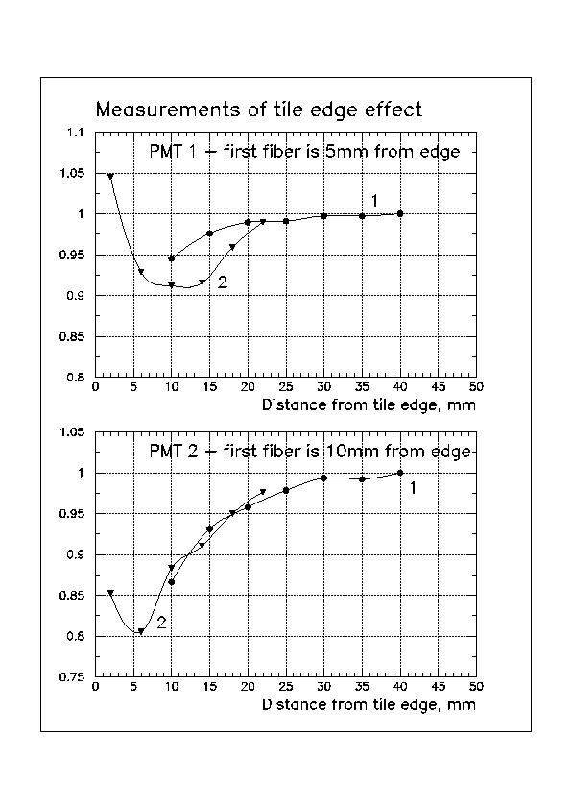

Fig.8. Measurements of edge effect. Lines 1 (solid circles) correspond to the use of Ru¹⁰⁶ (J.Krizmanic), and lines 2 (triangles) are for the test with cosmic muons (A.M.)

Finer spatial resolution allowed us to get the first measured point closer to the edge, where a light yield increase was observed. This can be due to short-attenuated UV photons, which effectively reflect from the tile edge and increase the light collection. That’s why this effect is higher for the PMT1 where the first WSF fiber is closer to the edge. The light yield drop at the distance 5-20mm from the edge, observed in both measurements, can be explained by more limited space for internal light reflection. The efficiency measurements for the sealing ribbon (next section) included this area of light yield decrease because the 5cm by 5cm triggering scintillators were used. The magnitude of this effect (20% percent of the light decrease at worst) and available light budget (more than 30 p.e. in average for the MIP) say that this effect is not very serious for the ACD performance. In flight ACD tiles the closest to the edge wave-shifting fibers will be placed closer (at least 2 mm), and possibly 2 fibers in one groove (from PMT1 and PMT2) to reduce this effect.

9. Sealing of the gaps between ACD tiles – design, simulations and tests

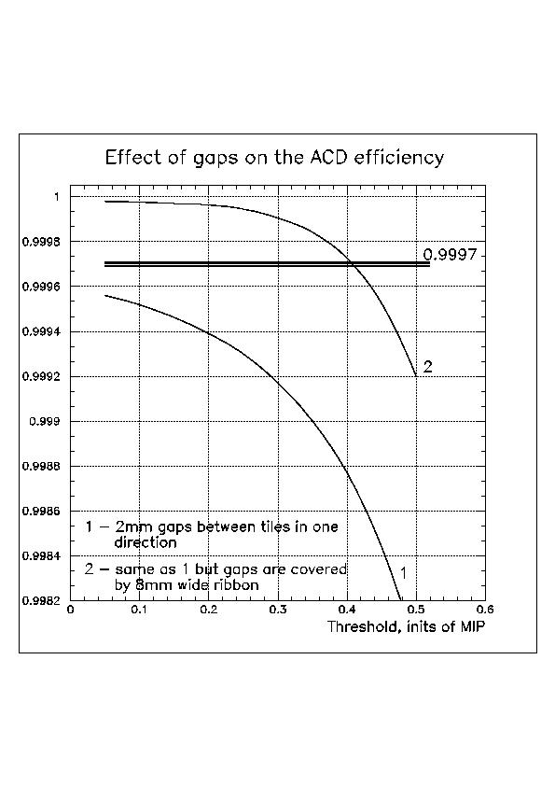
Introduction into the problem. Design of ACD assumes the presence of 2-3mm gaps between the tiles for the wrapping and tile thermal expansion. The effect of these gaps on the ACD efficiency of charged particle detection was studied and results are given in internal notes “ACD Transparency” (A.Moiseev, 05/03/01). It was found that 2mm gaps even in one direction (tiles are overlap in the other) immediately pushes the efficiency of ACD below the required level of 0.9997. One viable way, which was accepted for ACD, is to cover these gaps by pre-bent plastic scintillating ribbon (Fig.8). The simulated efficiency of ACD is shown in Fig.9. It is seen that the required efficiency of 0.9997 for the design with 2mm gaps cannot be achieved at any threshold (line 1). Sealing the gaps by a plastic scintillating ribbon, 2mm thick and 8mm wide, dramatically improves the situation. The mean light yield for the ribbon was assumed to be 5.5 p.e., and the threshold was set at ~0.3 MIP (2 p.e.). These results confirm the design solution to use ribbons to seal the gaps.
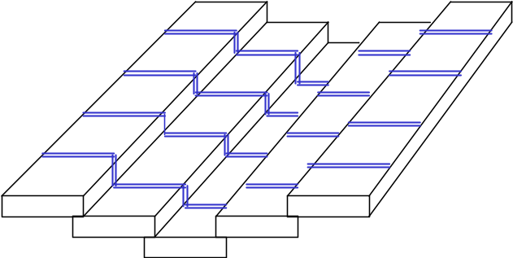
Fig.8. Scheme of the top surface of ACD. Sealing ribbons are shown by double line.
Fig.9. Simulated ACD efficiency

Ribbon production and the effect of cladding. We found that the desired solid ribbon cannot be made of the needed length (approximately 3 meters). One more complicating factor is that the ribbon should have cladding for better light propagation. That is why the ribbon was initially planned to be made of bonded together square scintillating fibers using the extensive experience of the group at Washington University at Saint Louis (W.R.Binns et al.) The design of the ribbon made of square clad scintillating fibers was simulated. It was found that the thickness of the cladding (4% of the fiber thickness) creates dead area sufficient to reduce the efficiency below the desirable level (Fig.10). The simulations were performed for the setup which later was tested with cosmic muons (Fig.11). The 2 mm gap between tested tiles (each is viewed by 2 PMTs) was covered by the ribbon.

S1
R
T1 T2
S2

Fig.11. Cross-section of the setup. T1 and T2 – tested tiles, R – sealing ribbon, S1 and S2 – triggering scintillators.

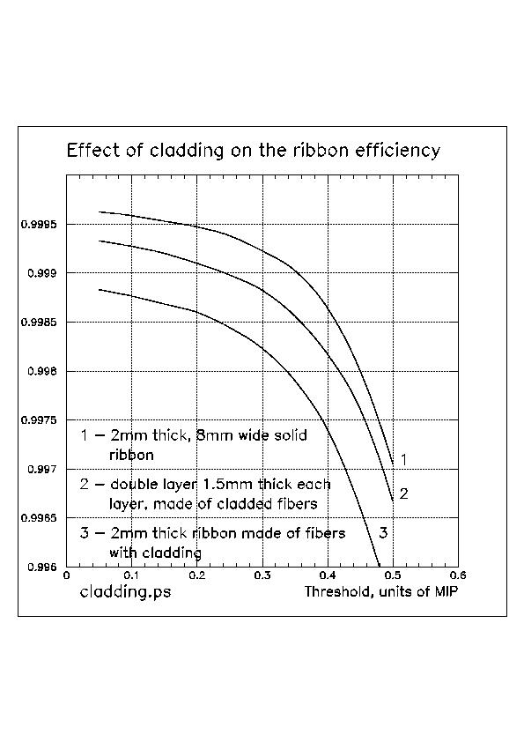s of the effect of cladding for the test setup

Fig.10. Simulations of the effect of cladding for the test setup

Curve 1 corresponds to the 2mm thick, 8mm wide solid ribbon, assuming 5.5 p.e. in average from the MIP and with the threshold at 1.5 p.e. (0.27 of MIP). Events were selected by triggering scintillators S1 and S2, 5cm by 5cm of the area each. Use of these triggering scintillators changes the ratio between the area where the efficiency is being measured and the area of the gap; therefore the obtained efficiency cannot be directly compared with that given in Fig.9 for the whole ACD. We should use line 1 (for the solid ribbon) as a reference, because it provides proper ACD hermeticity (Fig.9) and compare all other variants with it for the test setup. Line 3 corresponds to the case when we take into account that 2mm thick ribbon is made of separate, 2mm square fibers, each having 4% thick cladding. It is seen that the efficiency drops dramatically. The possibility to resolve this problem is to make the ribbon of 2 layers of fibers, with layers overlapping (Fig.12). Some space between the fibers was also added to account for the glue (obtained experimentally). The simulation results for this ribbon design are shown by line 2 in Fig.10, where the ribbon is made of 1.5mm square scintillating fibers, 6 in one layer, and 7 in the other.

Test Results. Fig. 13 shows the test results plotted along with simulations. The tests were performed for the double-layer ribbon described above (Fig.12), and test setup shown in Fig.11. Line 3 (solid ribbon) corresponds to the reference case with which the required ACD performance can be achieved (Fig.9). The test results are shown by lines 1 and 2 with the thresholds in the ribbon respectively 0.1 MIP and 0.2 MIP. Line 4 shows the simulations for the tested ribbon design, and threshold of 0.2 MIP (to be compared with experimental line 2 – acceptable agreement). The difference between line 2 (test) and 4 (simulations) can be explained by probably higher light output from the fibers (that is why the tested efficiency is higher at lower thresholds) and by some light yield decrease close to the tile edge (edge effect) which causes the faster efficiency drop at higher thresholds.
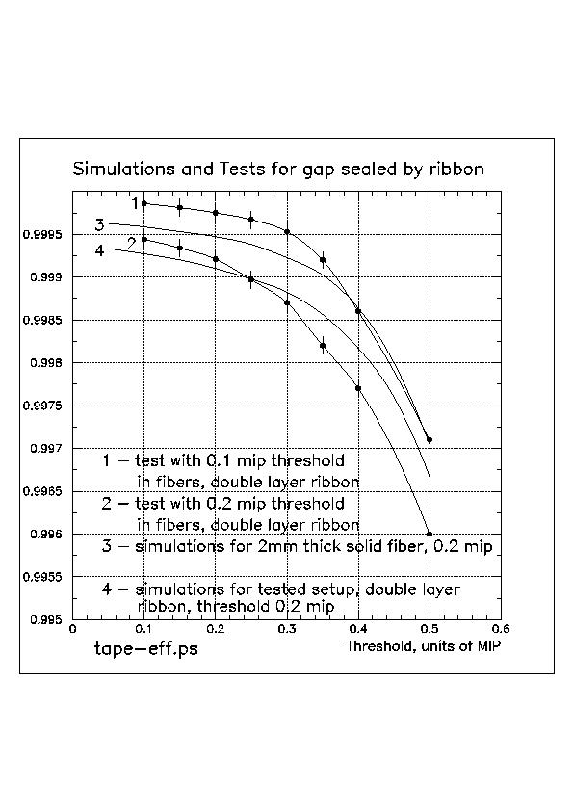

Fig.13. Test results, compared with simulations, for the proposed ribbon design

Fig.12 Structure of double-layer ribbon

Conclusion. Obtained results demonstrate that the ribbon made of square scintillating fibers, with 2 overlapping layers, will provide us the required level of ACD hermeticity. This statement comes from the comparison of experimental line 1 in Fig. 13 and simulated line 3, with which the required ACD efficiency can be achieved (line 2, Fig.9). This design has some margin because the fibers we tested (lines 1 and 2 in Fig.13) are not of the best quality (Paul Hink, private communication) and the light yield from them could be ~30% higher. The proposed design for the ribbon is to make them from 1.5mm clad scintillating fibers, 17 fibers in total (8 in one layer, and 9 in the other), to fit the photocathode of the Hamamatsu R-4443 PMT which will be used in GLAST ACD. The use of the inner 8.5mm photocathode diameter of the available 10mm diameter is assumed to secure the uniform photocathode sensitivity to all fibers. The best way of fiber bonding inside the ribbon will be determined later. The resulting ribbon sealing width will be slightly over 12mm.

10. conclusions

Principal results of this study show that the ACD can meet its required detection efficiency:

- Fiber spacing of 5 mm, Tetratec wrapping material, fiber end aluminization, and choice of multiclad fibers optimizes the light collection.

- Use of clear transmission fibers is needed to assure adequate light for long fiber bundles.

- Up to two broken fibers on up to three tiles can be tolerated without violating the efficiency requirement.

- Edge effects cause up to 20% lower light output in the worst conditions, a level that can be tolerated.

- A double-layer fiber ribbon is needed in order to seal the gaps between tiles.

Appendix A

On the ACD net efficiency for real geometry

The purpose of this note is to determine the efficiency of ACD in presence of gaps between tiles.

The “current” mechanical design (per Ken Segal) assumed 4.2 mm gaps between adjacent tiles and 2.6 mm vertical clearance between overlapping tiles (tiles overlap is 1 cm). This note considers only top entry events through the top ACD surface. The gaps between top and side tiles (on the upper ACD edges) can be neglected because the events sneaking through these gaps will create neither tracker nor calorimeter trigger.

The light yield from the tile was assumed to be 40 p.e. from the tile, which will work for the majority of the tiles (light loss in fiber-to-fiber connector and clear fibers are taken into account.) No tile edge effect was considered. The light yield from fiber ribbon was assumed to be 6 p.e. No attenuation in scintillating fibers was assumed.
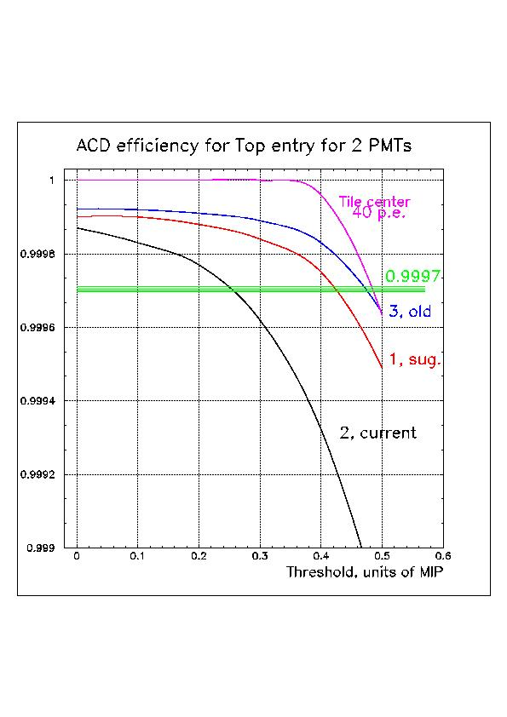

Fig.1. Two PMT’s running in OR. It is seen that “current” design is unacceptable (2, black), but the slight reduction of gaps between tiles, and slight increase of the tile size to secure 2 cm overlaps (tile becomes 1 cm bigger) give us reasonable ACD performance (“improved” line 1, red). Single tile (pink line) demonstrates better performance at lower thresholds – no leakage through gaps, but degrades faster at higher thresholds due to presence of off-angle events in the real isotropic flux used in simulations
Glast/ACD/Flight/Design/Gaps/eff_gaps_2.jpg
The ACD sides were not segmented because it does not affect the transparency of the top.

Configurations Used: lines on the plots (see more detail in the Table at the end of these notes):

1 ( red) – “improved” geometry (baseline as of Dec. 2002) for the instrument: 3 mm gaps between tiles, 2.6 mm vertical clearance between tiles, 2 cm overlap
2 ( black) – “current” geometry (per Ken): 4.2 mm gaps, 2.6 mm vertical clearance, 1 cm tile overlaps
3 ( blue) – my old geometry assumption: 2 mm gaps between tiles, 1 mm vertical clearance
Pink – calculated for NORMAL incidence mip’s through single tile

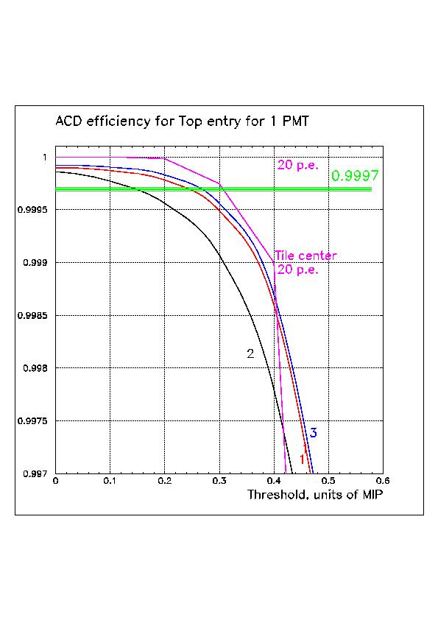

Fig.2. The results if we use only 1 PMT of 2.
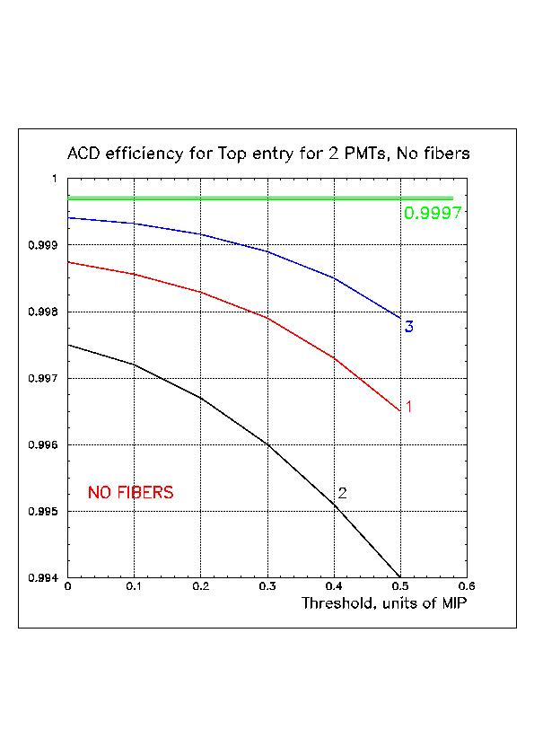

Fig.3. NO fibers are in use for 2 PMTs running in “OR” on the top ACD surface. No way even to approach the required efficiency without use of fiber ribbons.
ACD/Flight/Design/Gaps/eff_gaps_1.jpg

ACD/Flight/Design/Gaps/eff_gaps_1_nofiber.jpg

2. Design modification (line 4 in fig. 4 and 5)
- tile size increase by 1cm, which gives 2 cm tile overlap instead of 1cm
- reduced vertical clearance between fiber ribbon and tile from 3mm to 2 mm
- 3-layer fiber ribbon (4.5 mm thick in total), 24 fibers in total are in a ribbon. 9 p.e. mean light yield is assumed from normal incidence MIP
- Event is rejected if there were two adjacent tiles hit with signals above 0.15 MIP (line 5)

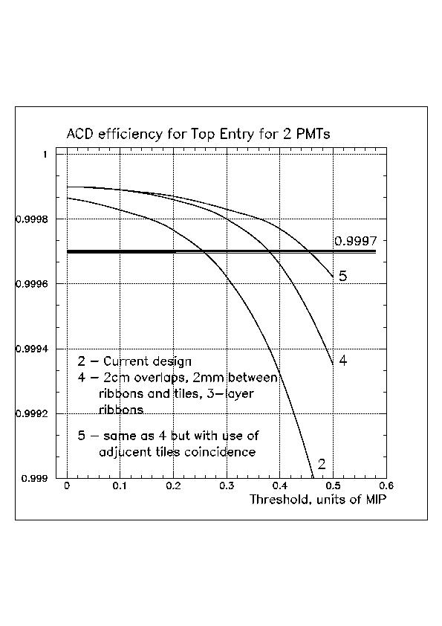

Fig.4. Two PMT running in OR for modified deign. Line 5 corresponds to the use of RCH idea of adjacent tiles coincidence
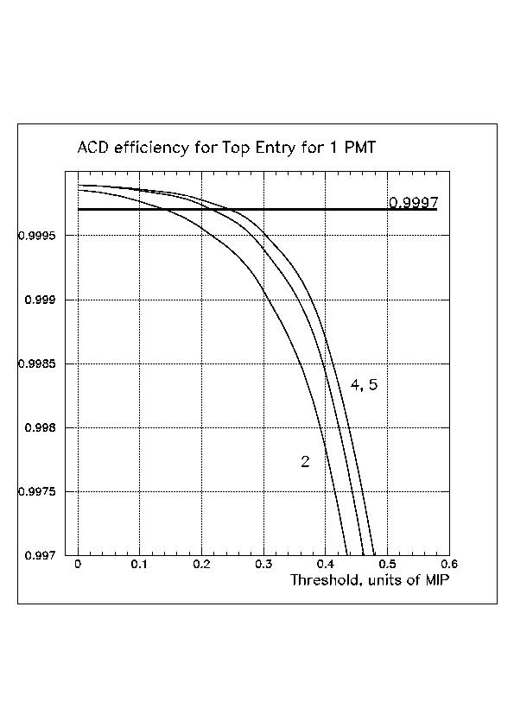

Fig.5 One PMT is in use. Lines numbering is the same as in fig.4

ACD/Flight/Design/Gaps/eff_gaps_21.jpg

ACD/Flight/Design/Gaps/eff_gaps_11.jpg
- Effect of failed FREE board. This effect was simulated for the isotropic flux through the top ACD surface. One FREE was assumed dead, so 6 tiles of 25 on the top the running with only one PMT running. The results are shown in fig.6.
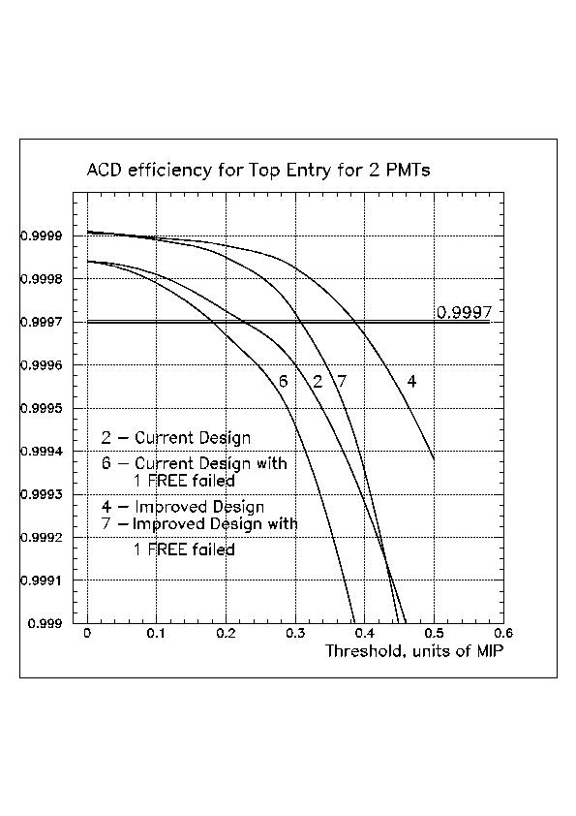

Fig.6. Effect of the failed FREE. “Current” design – all gaps, 1 cm tile overlap; Improved design – 2 cm tiles overlap and 3-layer ribbon

4. Effect of mounting holes in the tiles. There are 4 mounting holes, 3mm diameter each, in each tile. The lines shown in fig.6, changed to that on fig. 7 (for current design) and to that on fig. 7a (for improved design). Current design, as previously stated, assumes 4.2 gaps between tiles, 2.6mm vertical clearance between tiles, 1 cm tiles overlap, 2-layer ribbon with 6 p.e. light yield, 3mm vertical clearance between ribbons and tiles, 40 p.e. of the total light yield (per both PMTs together) for the tile. Improved design assumes 3-layer ribbon with 9 p.e. light yield, 2cm tiles overlap, and 2mm vertical clearance between ribbons and tiles
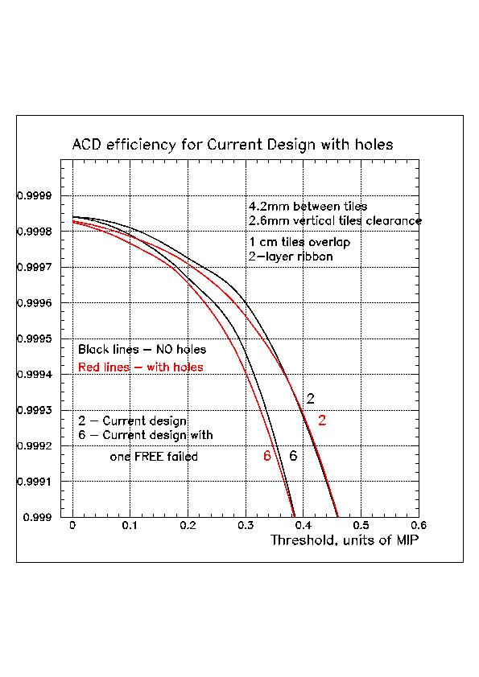

Fig. 7 – for the current design (see above) with mounting holes and failed FREE board

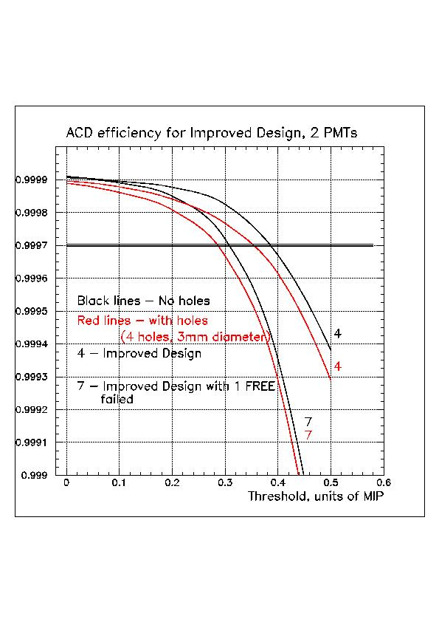

Fig. 7a – for the improved design, with the effect of mounting holes and failed FREE

ACD/Flight/Design/Gaps/eff_gaps_31.jpg

ACD/Flight/Design/Gaps/eff_gaps_3.jpg

5. Effect of the gap between tiles, Light Yield, and tiles overlap. The results of this analysis are respectively shown in figures 8-10. We can see the significant improvement with the increase of tiles overlap (fig.10), with the reduction of the gaps between tiles (fig. 8). Light yield has not very big effect for 2 PMTs running (fig. 9a), but much stronger effect if only one PMT will be running (fig. 9b).
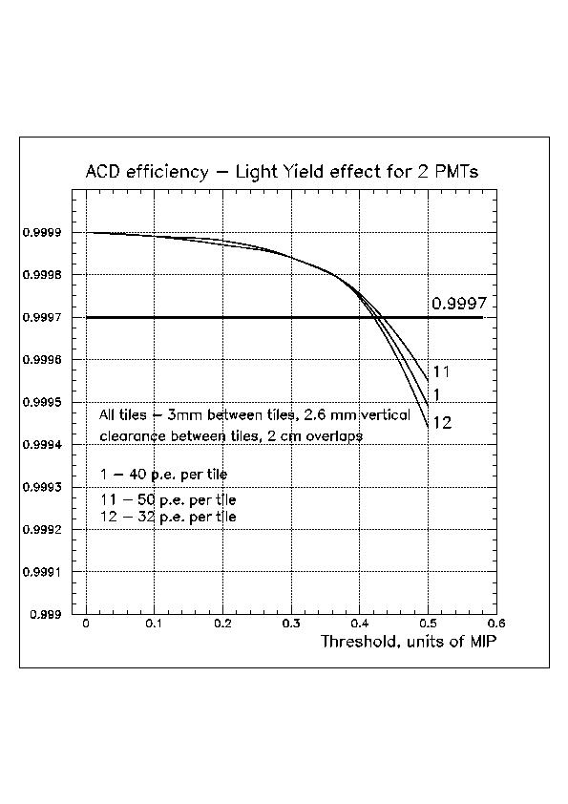

Fig. 9a – Effect of Light Yield for 2 PMT running
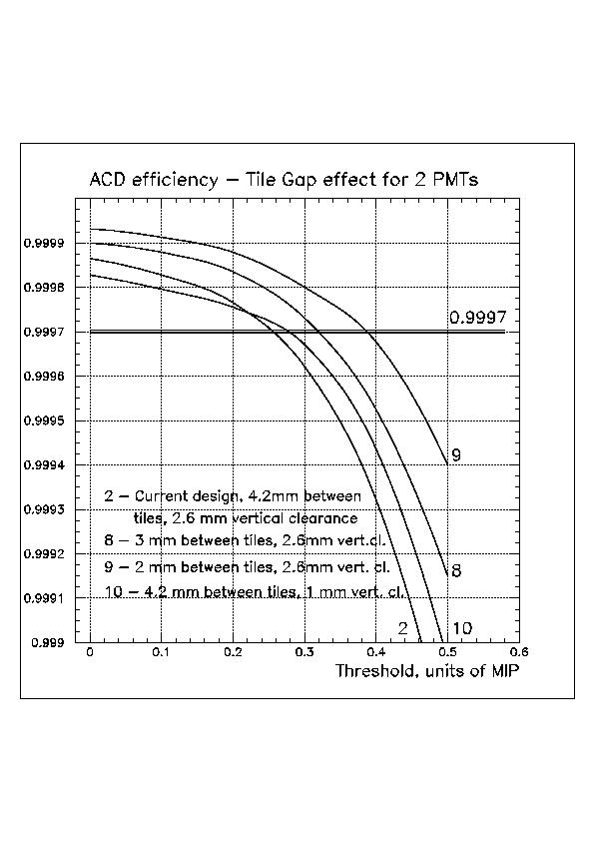

Fig. 8 –Effect of the gaps
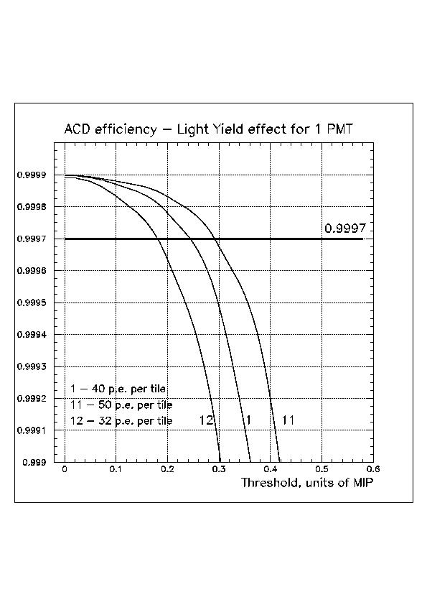

Fig. 9b Effect of Light Yield for one PMT running
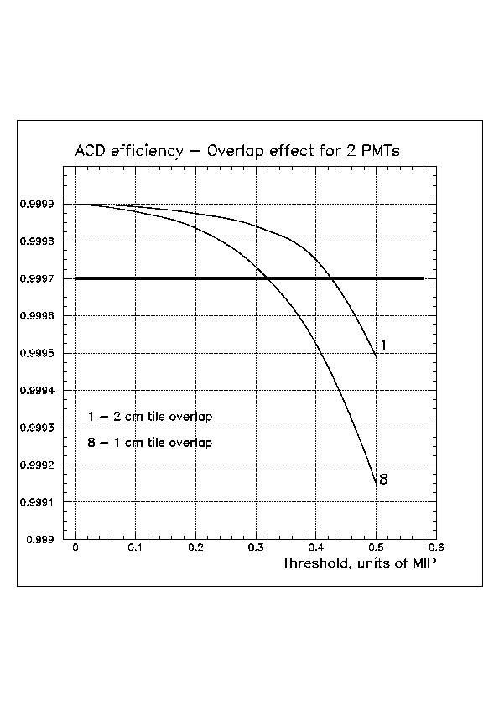

Fig. 10 – Effect of tiles overlap
ACD/Flight/Design/Gaps/eff_gaps_5.jpg
ACD/Flight/Design/Gaps/eff_gaps_4.jpg

ACD/Flight/Design/Gaps/eff_gaps_51.jpg

ACD/Flight/Design/Gaps/eff_gaps_6.jpg

6. Event leakage through the gaps at the corners (Case 2C in Ken Segal’s Summary). This gap was estimated to be 4.0 mm at max.
This gap was included in the simulations. During the first run it demonstrated large degradation in the efficiency, but more careful cross-check showed that it was due to the gaps at the top where the top edge tiles join with upper side tiles.
Conclusion from this: 5 mm gap between edge top tile and adjacent upper side tile is bad (at the sides where is no bending of the tiles). The actual geometry of the mutual position of the tracker sensitive area and the ACD should be carefully checked.

Simulation of the effect of gaps in the ACD edges surprisingly showed very modest efficiency degradation – see fig. 11a (two PMTs) and 11b (one PMT running). 4mm gaps were used at the ACD edges (per Ken). The sides did not have segmentation, only these gaps. The resulting lines (14 and 15) in these figures were obtained as a product of lines 4 and 15 (to obtain 16) and 4 and 13 to obtain 14.
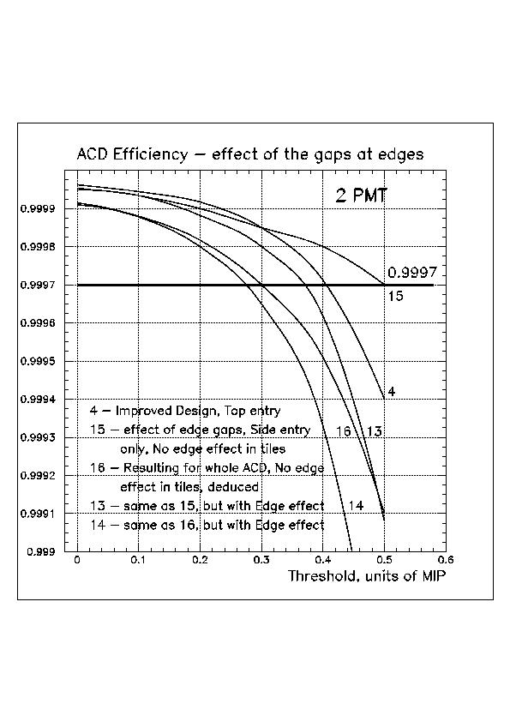

Fig.11a. Effect of gaps at ACD edges. 2 PMTs running
Line 4 – “improved” design, only uniform Top entry events;
15 – effect of edge gaps, only Sides entry, No edge effect in the tiles;
16 – Resulting for the whole ACD illuminated, No edge effect in tiles
13 – effect of edge gaps, Side entry, Edge effect in tiles included
14 – Resulting for whole ACD illuminated, edge effect in tiles included

Fig.11b. Effect of gaps at ACD edges with 1 PMT running in each tile. The line numbering is the same as in fig.11
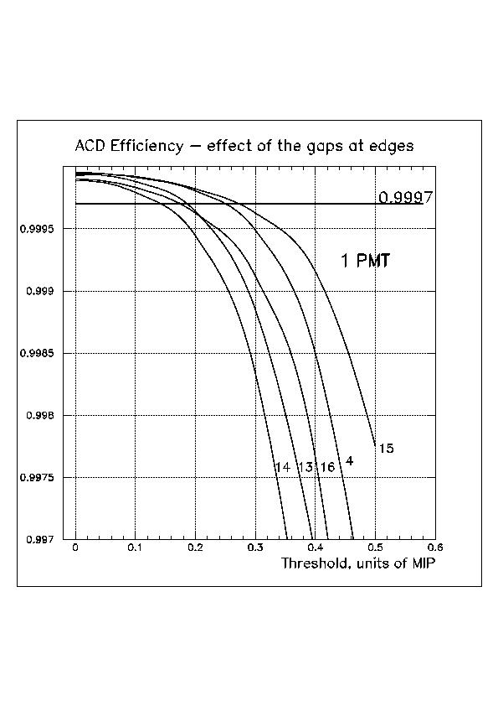

Fig.11b. Effect of gaps at ACD edges with 1 PMT running in each tile. The line numbering is the same as in fig.11a

ACD/Flight/Design/Gaps/eff_gaps_7.jpg

7. Images of the simulated geometry


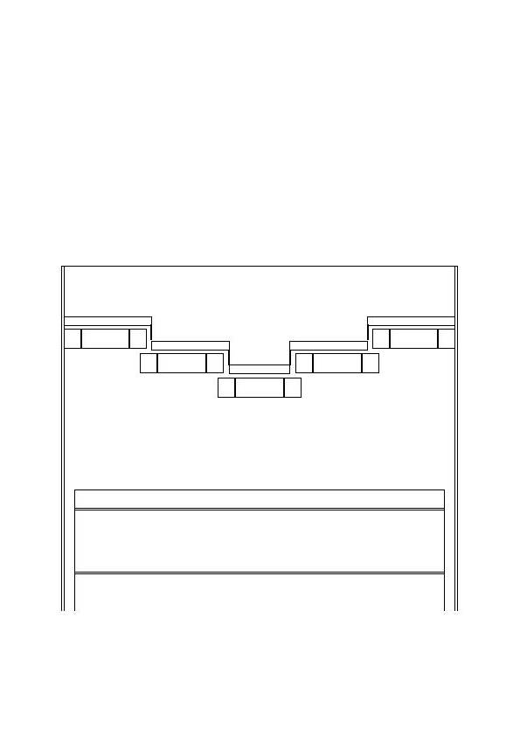

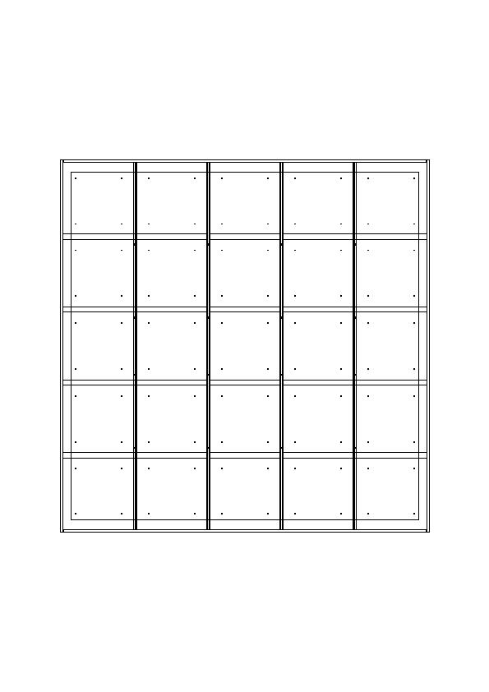
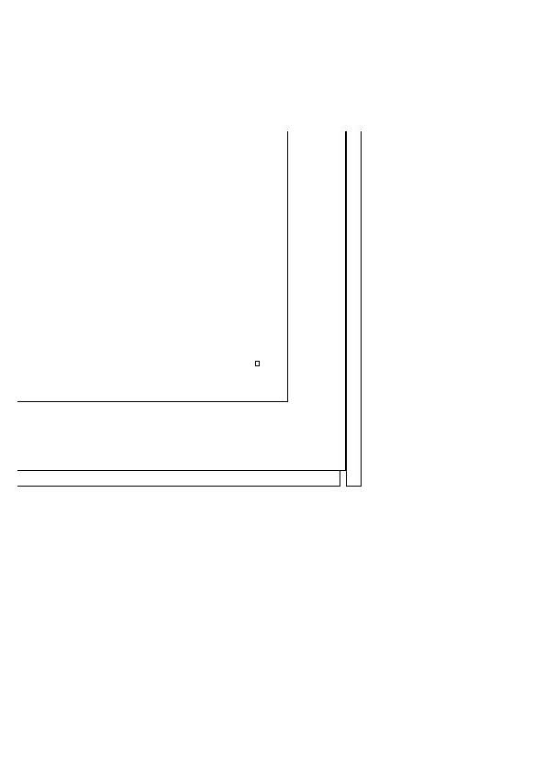
Fig 12a ACD Side View (in the direction of tile overlaps).

Fiber ribbon
Tile with holes
Fig 12b ACD Side View (magnified).
Top tiles overlap
Gaps between tiles covered by fiber
ribbon
Fig 12c ACD Top View
Border of the Tracker

Mounting hole in tile
Top tile border
Side tile

4 mm Corner gap
Fig 12d ACD Top view, corner, magnified.

Table. Description of the line numbering.
Line | Entry | Tile overlap, cm | Gap between tiles, mm | Vert. Clearance between tiles, mm | Vert. Clearance between tile and ribbon, mm | Mounting holes | Ribbon thickness, layers | Light Yield from tile | Failed FREE | Adjacent tile use
1 | Top | 2 | 3 | 2.6 | 3 | No | 2 | 40 | No | No
2 (Current) | Top | 1 | 4.2 | 2.6 | 3 | No/Yes | 2 | 40 | No | No
3 (Old) | Top | 1 | 2 | 1.0 | 3 | No | 2 | 40 | No | No
4 | Top | 2 | 4.2 | 2.6 | 2 | No/Yes | 3 | 40 | No | No
5 | Top | 2 | 4.2 | 2.6 | 2 | No | 3 | 40 | No | Yes
6 | Top | 1 | 4.2 | 2.6 | 3 | No/yes | 2 | 40 | Yes | No
7 | Top | 2 | 4.2 | 2.6 | 2 | No/yes | 3 | 40 | Yes | No
8 | Top | 1 | 3 | 2.6 | 3 | No | 2 | 40 | No | No
9 | Top | 1 | 2 | 2.6 | 3 | No | 2 | 40 | No | No
10 | Top | 1 | 4.2 | 1 | 3 | No | 2 | 40 | No | No
11 | Top | 2 | 3 | 2.6 | 3 | No | 2 | 50 | No | No
12 | Top | 2 | 3 | 2.6 | 3 | No | 2 | 32 | No | No
13 | Side | No segme | ntation, | 4 mm gap | at ACD edges. | Edge | effect in | side tiles | Included
15 | Side | -“- | -“- | -“- | -“- | -“- | -“- | -“- | Not inclu | ded
14 | Whole | Design 4 | + design | 13, deduced |  | Edge | effect in | side tiles | Included
16 | Whole | -“- | -“- | -“- |  | -“- | -“- | -“- | Not inclu | ded

