 | Research and Development of Power Distribution Schemes for the ATLAS Silicon Tracker Upgrade
ATLAS Document No: | Institute Document No. | Created: 27/11/2007 | Page: 1 of 2
 |  | Modified: 20/11/2007 | Rev. No.: 0.3

Research and Development of Power Distribution Schemes for the ATLAS Silicon Tracker Upgrade

Abstract

Background material for ATLAS Upgrade Preview on February 4, 2008

Dates
30/11/2007 Circulate information
04/12/2007 Reviewers phone meeting
12/12/2007 Present information at Valencia
04/02/2008 P(review)

Prepared by:  Design team | Checked by: | Approved by:
Distribution List

Input to review as requested by Mike Tyndel

A number of options for powering are under consideration for the silicon strip and pixel systems. The following information should be provided for the P(review)

- Requirements and Constraints to include
  - Specification of module power requirements
  - Control, monitoring and interlocks
  - Readout architecture
  - Grounding and shielding
  - External services (existing and any new requirements)

- Schemes under consideration. For each scheme provide schematic, hybrid layout, list of components to be developed, schedule for prototyping and risk analysis:
  - Independent/parallel powering
  - DC/DC powering
  - Serial powering

- Evaluation and interface to module/stave program
  - Radiation hardness – requirements & qualification
  - Testing with modules/staves (Pixels and Strips)

- Summary including global plan, decision process and resources

The following section is a living compilation of our background material.

“Requirements and constraints”

Strip module power requirements

These needs the input of ROIC power estimates and assumption on module features.
We have updated the tables 1 and 2 of our ATLAS power distribution R&D proposal

Table 1 gives an estimate of the power consumption and operation voltages of the future ATLAS silicon strip readout chip, the ABC-Next chip [6]. The estimates include the ABC-Next regulators for analog voltage, but not the shunt regulator or the power of the DC-DC conversion chip or any radiation effects on power consumption. For comparison the power consumption of the ABCD, the SCT readout chip, is given as well.

 | ABCD  0.8 μm | ABC-Next  0.25 μm | ABC-Next  0.13 μm | ABC-Next  0.13 μm SiGe
Vanalog [V] | 3.5 | 2.5 | 1.5 | 1.5
Vdigital [V] | 4 | 2.5 | 1.5 | 1.5
I analog [mA] | 74 | 40 | 40 | 34
I digital [mA] | 35 | 100 | 100 | 100
Analog power[mW] | 260 | 100 | 60 | 51
Digital power [mW] | 140 | 250 | 150 | 150
Total power [mW]/chip | 390 | 350 | 210 | 201
Total power [mW]/channel | 3 | 2.7 | 1.6 | 1.6
Table 1: Measured power consumption of the ABCD silicon strip chip. Estimate of power consumption of the ABC-Next chip. The CMOS version of the chip is optimized for short strips.

Strip module conceptual design is most advanced for the barrel inner region. This design is used to get some sample numbers. We assume that:
- Sensor area is 10 cm x 10 cm; strips are 2.5 cm long;
- A supermodule (SM) is made of ten sensors on either side;
- Each sensor is read out by one hybrid with 40 ABC_Next chips or by two hybrids with 20 ABC_Next chips each;
- The current and power consumption is as shown in table 1 above.

The barrel outer layers have not received much attention, but the channel density is less (for same sensor area) and thus power consumption is less and power distribution poses much less difficulties. The forward region has not yet been looked at in detail, but again channel density and number of channels per sensor does not exceed that of the barrel modules. At this stage of the R&D it is not known if 40 chips per hybrid can be powered reliably.

A summary of the electrical hybrid parameters for the silicon strip detector is compiled in Table 2. The table differs from the one in the R&D proposal since the module concept has evolved.

Short strips barrel | Typ. | Min. | Max. | Pixels barrel | Typ. | Min. | Max.
# of hybrids per barrel stave (top side) | 20 | 10 | 20 | # modules per barrel stave | 12?
# of ABC_Nexts/hybrid | 20 | 20 | 40 | # of FE/module | 4 | 1 | 10
Hybrid voltage | 1.5 V | 1.5 V | 2.5 V | Module voltage | 1.6 V | 1.5 V | 1.8 V
Channels/hybrid | 2560 | 2560 | 5120 | Channels/ 4 chips module | 82000 | 75000 | 90000
Hybrid power | ~4 W | ~4 W | ~14 W | Hybrid power | 7 W | 6 W | 9 W
Hybrid current | 2.8 A | 2.8 A | 5.6 A | Hybrid current | 4 A | 3 A | 5.5 A
Voltage across SM for SP | 30 V | 15 V | 50 V² | Voltage across stave for SP | 20 V | 18 V | 30 V
Total power per SM (both sides) | 160W | 160W | 280 W | Total power per barrel stave | 84 W?

Table 2: Illustration of hybrid electrical parameters for the silicon strip section of ATLAS SLHC inner tracker.
Assumptions: 1.6 mW/channel and 160 mA per 128 channel chip for the final chip; 2.7 mW/channel for 0.25 um chip. Typical, minimum and maximum values are given to indicate the expected variation depending on different choices of hybrid sizes. For ease of comparison the pixel module parameters of table 3 are shown as well.

Marc to contact Carlos/Nigel for input on forward strips

Pixel module power consumption

Power consumption estimates of the ATLAS pixel readout chips are given in Table 3. The current pixel chip is the FE-I3. The design of the FE-I4 chip for the pixel B-layer replacement has started. The FE-I5 chip could be an alternative to evolving FE-I4 chip for SLHC. Note that the size of a pixel cell will decrease by a factor of two for the inner layers (from 50 x 400 µm² to 50 x 200 µm² –B-layer upgrade: 50 x 250 µm²).

Pixels | FE-I3  0.25 µm | FE-I4  0.13 µm | FE-I4  0.13 µm | FE-I5 0.09 µm
 | present | inner | Outer
Chip area [cm²] | 0.778 | 2.8 | 2.8 | 2.8
Pixel length [um] | 400 | 250 | 250 | 200
Voltage digital [V] | 2.0 | 1.5 | 1.5 | 1.2
Voltage analog [V] | 1.6 | 1.5 | 1.5 | 1.2
I density digital [mA/cm²] | 100 | 140 | 110 | 180
I density analog [mA/cm²] | 141 | 140 | 130 | 140
Power density digital [mW/cm²] | 200 | 210 | 160 | 215
Power density analog [mW/cm²] | 226 | 210 | 200 | 170
Power density total [mW/cm²] | 426 | 420 | 350 | 385
Power total/pixel [μW] | ~85 | ~50 | ~45 | ~40
Table 3: Measured power consumption of the FE-I3 pixel readout chip. Estimate of power consumption of future iterations of FE-I chips for SLHC.

At present time, it is foreseen that the pixel module will consist of 4 Front-End chips belonging to a single module. Table 4 shows a few reference numbers for this module.

Pixels | Typ. | Min. | Max.
# modules per barrel stave | 12?
Number of FE/ module | 4 | 1 | 10
Module voltage | 1.6 V | 1.5 V | 1.8 V
Channels/ 4 chips module | 82000 | 75000 | 90000
Hybrid power | 7W | 6W | 9W
Hybrid current | 4 A | 3 A | 5.5 A
Voltage across stave for SP | 20 V | 18 V | 30 V
Total power per barrel stave | 84 W?

Table 4: Reference numbers for power consumption and hybrid current for a 4-chip pixel module. It should be noted that the actual size of the module and the chip to module ratio is still to be defined.

Control, monitoring and interlocks
Let’s think about what we want for DC-DC and SP. Provide a few plots.

What quantities (voltage, module current, temperature, other) should be controlled/monitored/”interlocked” at
Hybrid/module, supermodule end, rack power supply. Which resolution? Any complications?
How should SC be powered/grounded?

Marc

Input by DC-DC and SP teams, contact Didier and Susanne

Read-out architecture

Relation to read-out architecture through clock on/off. Power-up. MCC

Add more details. Who?

Grounding and shielding
The same principles as for the current trackers apply: protection of small signal path (strip/pixel ⬄ input transistor ⬄ analog ground ⬄ sensor return ⬄ sensor bias). Common ground reference in detector.
Floating power supplies for groups of modules (DC-DC parallel/independent or serial powering.)

Pick-up later. No work has been done.

External services

Satish
Work out a few sample regarding efficiency, number of conversion/regulator stages for DC-DC schemes.
a) reuse cables (R=4 -> 2 Ohms) b) same but with R=4 -> 1 Ohm c) don’t reuse.

Give the number of modules to be powered in series: 20

Start with number of cables for pixel and SCT; digital and analog
=> 1744 pixel + 4088 SCT = 6000 cables. If only digital power is needed than we could use 2x 6000 cables for 12000 modules. Give estimated number of modules for SLHC.

Look at cable ratings in terms of current and voltage, include TRT.

“Schemes under consideration”

Independent/parallel powering

This scheme is not under consideration. It does not work at SLHC. We can do very little to improve independent powering.

a) Reuse existing cables and tie them together to reduce cable resistance and cable losses from rack supply by a factor of 4 or more. This is parallel powering without DC-DC conversion, which is equivalent to independent powering. Parallel makes sure we have enough cables to power the increased number of modules, but are left with the material problem and very low efficiency.

b) Use only digital and create analog by regulators on the ROICs. This does not reduce total current and thus does not achieve very much by itself.

Serial powering

List of components

1) Constant current source

Commercial constant current sources are rare. So far power supplies in over-current protection were used to power serial powering systems at Bonn and RAL. While this worked well so far, it is not ideal. Work on a dedicated design at started at RAL. First specifications are given in the appendix.

2) LVDS buffers
Several designs, which differ in technology, are in progress. It is likely that a single design block could be used in the future for pixels and strips. See table 5. See schematics in Appendix.
Mitch and Bonn
3) Shunt regulator and shunt transistor

There are different architectures and designs. See figure 1 and table 6

Need to fill in features and estimated performance for strips: Mitch
Very short description of features, advantages and disadvantages of different architectures
 | Strips | Pixels
 | AC-coupled LVDS buffers | LVDS receiver / transmitter | AC-coupled buffers (a la FE-I3)
Process | 0.25μm CMOS TSMC (SMARP);  later 0.25μm CMOS IBM (MCC) | 0.13μm CMOS IBM | 0.25μm CMOS IBM
Next submission | Jan 2008 | Jan 2008 (UMC die 130 nm available) | Commercial device
Input voltage | 2.5 V | 1.2V -1.5 V | 3.3 V
Max. frequency | 160 MHz | 320 MHz | Tested at 40 MHz
Feed-back schematic
DC-balanced protocol | Not required, but likely and desirable in final implementation
Current | Adjustable? | 0.6 mA- 3 mA
# of channels
Die/block size
Design blocks other than LVDS buffer | DCS | DCS

Table 5: Overview of LVDS buffers. Schematics are shown in the Appendix

Figure 1: Sketch of alternative serial powering implementations in a two module configuration with three ROICs. (Top) A single shunt regulator and shunt transistor external to the ROICs. (Middle) Parallel shunt regulators and shunt transistors, one each in each ROIC. (Bottom) A single external shunt regulator combined with parallel shunt transistors, one in each ROIC.

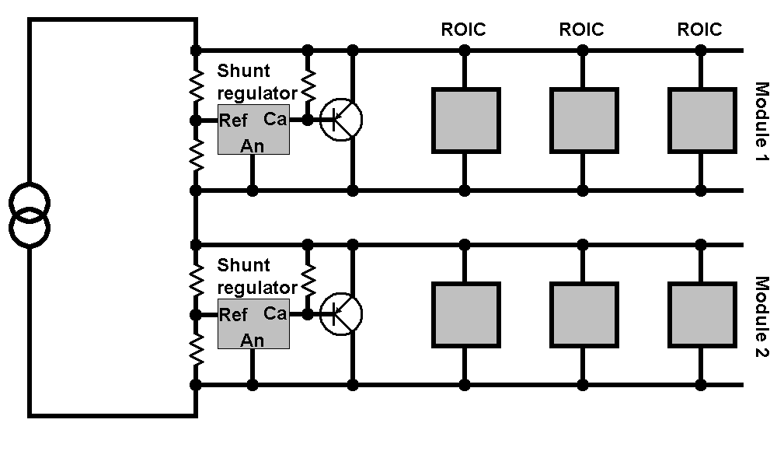

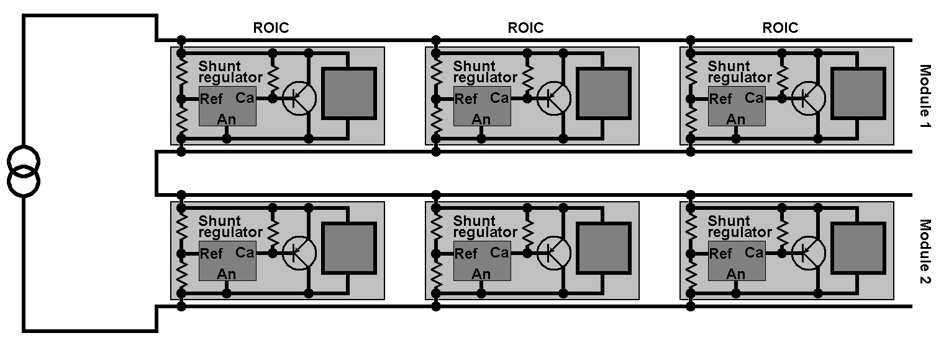

The fully integrated shunt regulator system (first used by the Bonn group for pixels) offers a number of advantages
- power dissipated in the shunt regulators is distributed uniformly across the hybrid,
- no very high current devices are required,
- single point of failure is eliminated, compared to solutions with one regulator per hybrid,
- the hybrid design can be fully scaleable with respect to power distribution.
The very fundamental problem to be addressed and solved in such a distributed system is related to matching of parameters of individual shunt regulators, when their outputs get connected in parallel on the hybrid. How this is done in the ABC_Next chip is described in detail Wladek’s document (see appendix)

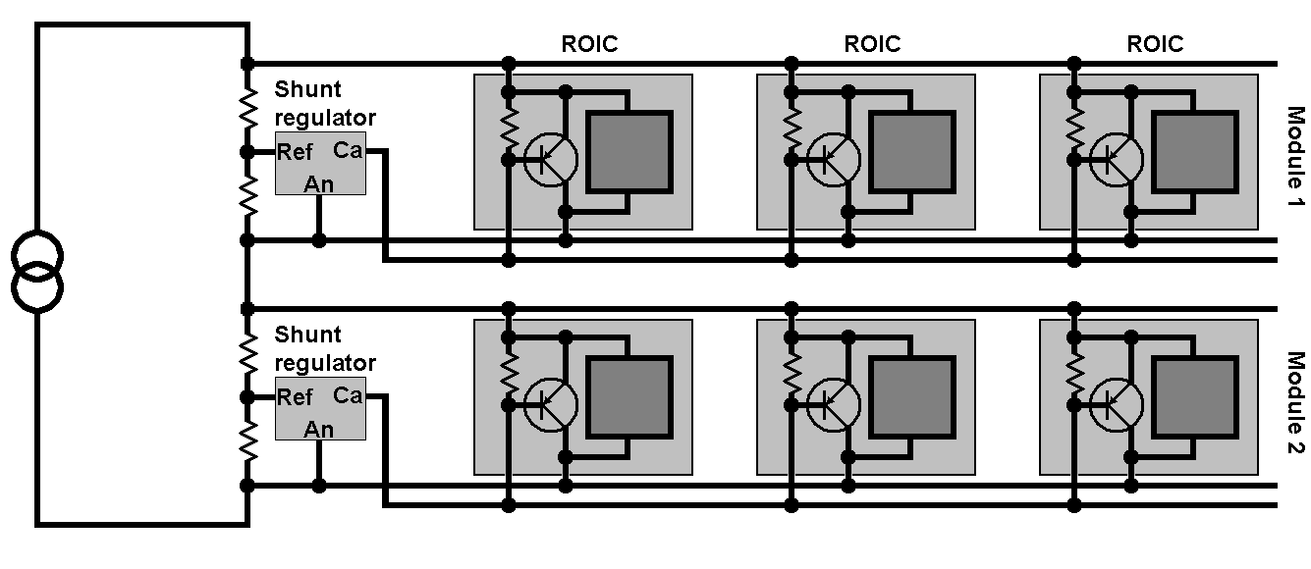

 | Strips commercial | Strips custom |  |  | Pixel
 | Used on 6 module stave  with ABCD | a) External SR and ST (SMARP) | b) Integrated SR and ST (ABC_Next) | c) External SR (SMARP) and integrated ST | Integrated SR and ST:  FE-I3 / FE-I4
Process | N/A | 0.25μm CMOS TSMC | 0.25μm CMOS IBM | 0.25μm CMOS  TSMC and IBM | 0.25μm CMOS IBM | 0.13μm  CMOS IBM
Next submission | N/A | Jan 2008 | Feb 2008 | Jan and Feb 2008 | Done | Jan 2008
Output voltage | 4 V | 1.5 V – 2.5 V | 2.5 V | 1.5 V – 2.5 V | 2/2.4/2.8V | 1.6 V
Output impedance | << 1 Ω at < 1 MHz  ~10 Ω at < 5 MHz  ~30 Ω at < 10 MHz |  | ~5 Ω at < 10 kHz  ~10 Ω at < 3 MHz | 0.1 Ω at <100kHz  0.5 Ω at < 10 Hz |  | 0.1 Ω at < 100 kHz  0.5 Ω at < 10 MHz
Maximum shunt current | ~2 A | ~1 A | n x 50 mA |  | ~200mA | ~1.5A
Protection features | None | ST current sensing | Power-up; parallel SR and ST |  | None | Controlled short; separate
Serial regulator for analog | Yes | Yes | Yes | Yes | Yes | Yes
Other |  | ADC; 2 linear regulators; register |  |  | Digital regulator can be used: this was shown not to be useful in SP case | 1 analog and 1 digital linear regulator

Schematics

Let’s discuss which level of detail is appropriate. It is important to provide initial transistor level schematics for devices that are soon going out for submission. This would require a talk to go with them at Valencia or the review itself.

Table 6: Parameters of custom serial powering prototypes.

Schedule for prototyping
See the tables

Risk analysis

Some risks have been identified and are listed below together with protection measures. This is followed by a more detailed discussion by Dave Lynn and Jim Kierstedt.

a) Broken connection e.g. connector/bond wire causing an open ⬄ protection due to reduced number of connections and robust engineering, limit number of modules in series (risk ratio is proportional to ~number of modules/4)
b) Thermal stress to shunt transistor in case of module failure/disconnection ⬄ distributed shunt transistors, over-current protection
c) Over-voltage (e.g. due to power-up) ⬄ protection diode
d) Other local features ⬄ circuitry to switch module out of constant current loop
e) Radiation-hardness is not expected to be a problem since the same process is taken for ROICs and serial powering circuitry, but special attention should be given to SEE and threshold shifts of feed-back FET.

In the serial power architecture the primary hazard appears to be an open in the current path from module to module. This may be due to:

1. Failure of shunt regulator(s) (or insufficient current during power-up) resulting in a high impedance path
2. Failure (fusing) of interconnect between modules

The symptom of such a failure is a quick rise in voltage across the malfunctioning module. To protect a complete stave (or supermodule) in real-time it is necessary to have an over-voltage activated protection device (or devices) located on the stave that shunts current to maintain the current path. An over-voltage protection device located tens of meters away at the current source power supply cannot react quickly enough to provide adequate protection due to tens of microseconds propagation delay.

Two possible ways of implementing real-time local over-voltage protection are:

1. Locate a single device at the stave end that shunts current away from all modules
2. Locate across each module a real-time over-voltage protection device.

Option 1 protects the modules that have not malfunctioned, but does not allow operation of the stave unless a slow controls bypass of the malfunctioning module can be implemented. Option 2 may prevent continued operation of the stave depending on the nature of the protection device. However, we feel it is desirable to also consider ways for slow control implemented module bypassing. This has the benefit of permitting disabling a module (and reducing thermal load) if:

1. The module itself develops noise that affects the performance of the other modules on the stave.
2. The over-voltage protection device, when activated, itself generates noise that affects the rest of the stave.

For real-time protection some of the following devices or combinations of devices are being investigated and would be used in parallel with the shunt regulator:

1. Zener diode
2. Thyristor
3. Transistor latch
4. Shunt regulator with higher V_{t} .

The slow controls protective bypass should have some of the following characteristics:

1. Require little additional circuitry and traces
2 Should not increase the probability of failure
3. Have good electrical isolation from the module circuitry
4. Have a low impedance when active such that all current will travel through the bypass and none through the Module

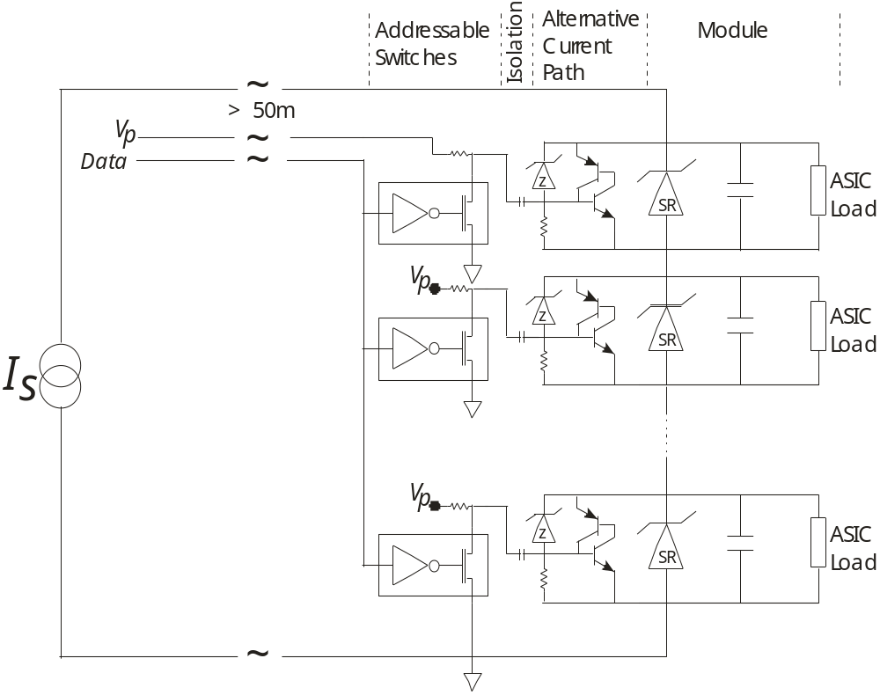
Figure 2: One real-time and slow controls protection architecture.

Figure 2 shows one possible protection architecture. The module in this figure is modeled as a shunt regulator (“SR” enclosed in a zener diode symbol), a parallel capacitance, and a load representing the readout ASICS (e.g. ABCD next). A pair of bipolar transistors forms a latch that activates when the adjacent small current zener diode (“z” enclosed in a zener diode symbol) turns on due to over-voltage. The latch is designed to handle large currents.

A slow control system also can activate the latch. The slow controls system as sketched is modeled on the Maxim Semiconductor 1-wire protocol. The 1-wire devices shown require only ground and a data-line that permits one to individually address each switch. An output open drain switch may be driven low or pulled high via an external pull-up resistor to an externally supplied voltage. We have successfully tested this mechanism using a discrete bipolar pair, a Maxim 1-wire latch, with a 5k pull-up resistor to 5 volts. Our tests at this stage are very preliminary.
In such a slow controls system the implication of a failure of the 1-wire (or 1-wire like) devices must be considered. As the latch in this case is edge triggered and capacitively coupled to the slow control, a failure of the 1-wire latch to respond, to short, or to fuse, results in the inability to bypass a module but does not result in the premature loss of a module or the module chain. The capability of the circuit to deal with an over voltage condition on a module will remain even if the 1-wire latch fails.

One possible problem with such a system is that the voltage drop across the latch may not be low enough to disable noisy ASICS. We are still investigating how low a drop we may achieve, but likely this will not be below one diode drop. It is not clear that this will be sufficient.

One interesting possibility that we wish to pursue involves the use of MEMS (Micro-Electromechanical Systems) switches. At the moment there are few commercial suppliers or parts available but this is likely to increase over the coming years.

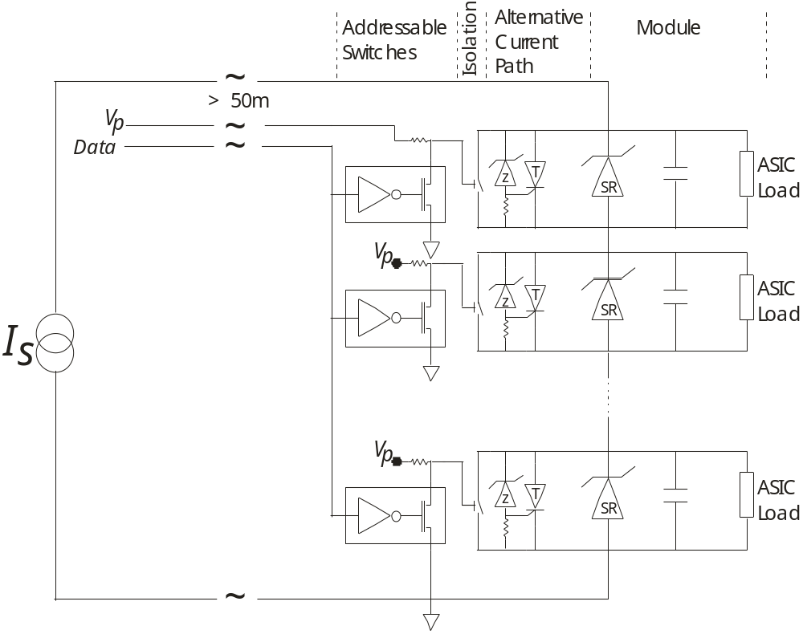
Figure 3: Another real-time and slow controls protection variant. This illustrates the use of a MEMS switch

Coupling

To allow for the differences in voltage levels between the various modules of the stave the slow control signal would have to be isolated from the latch of the module. Some of the techniques that can be used for this include the following

A. Capacitive Coupling
B. Inductive (e.g. nonmagnetic core transformer)
C. Optocoupler
D. MEMS

Testing on capacitive coupling has been started. Switching has been initiated in a transistor latch using a 1-wire setup from Maxim and a 220 pico Farad capacitor. Testing continues to characterize the actual pulse characteristics needed for latching and optimizing the design. This seems to be the most promising technique to date

Attempts to latch using an inductive method have so far been unsuccessful. First calculations imply that the required transformer will be too large to be practical.

A literature search on optocouplers indicates that the devices will not survive the radiation environment. Even rad tolerant devices used in space applications appear to fail at 1% or less of the anticipated neutron fluence.

As noted above MEMS switches are an interesting alternative. They are most probably radiation hard and are very reliable. The drawback is the activating the switch requires a higher than desirable voltage (about 100 Volts). This then requires a dedicated line for each module or a high voltage switch.

Hybrid layout (pixels and strips separately)

No detailed layout studies on SLHC strip hybrids have been attempted. This should start when floor planning of the ABC_Next and SMARP is more advanced. A natural place for local power supplies is at the edge of the hybrid, closer to the MCC and/or DCS chips.

It is important to understand the real-estate overhead due to local power supplies. For strips and commercial components, serial powering without protection features has been implemented in a six ABCD ceramic hybrid (LBNL, Carl Haber) as shown in Figure 4. This covers an area of ~270 mm².

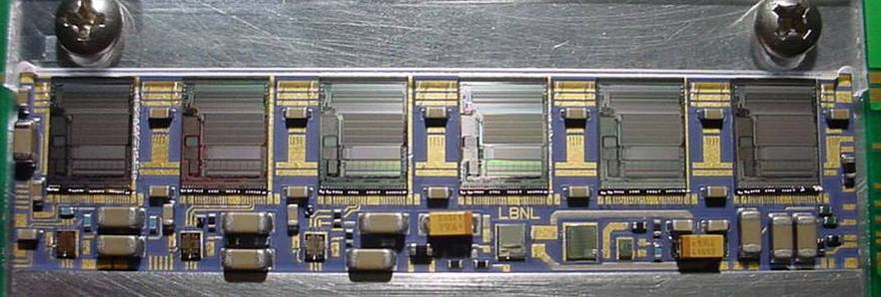
Data/clock/command Linear regulator ST SR
AC-coupling

Figure 4: Ceramic hybrid with six ABCDs and serial powering circuitry (LBNL).

We expect serial powering circuitry with custom electronics to consume less real estate by a factor of 2 to 3. This is because many of the passive components can be integrated into custom ASICs; the number dice will be reduced from 6 to 1 or 2 and the size of the AC coupling capacitors can be chosen to be 0402 rather than 1206 with reduced operation voltage of the ROIC.

(Closer to review in Feb. 2008 consider floor plan of ABC_Next and SMARP)

The module material increase due to serial powering circuitry should to first order correspond to the increase of hybrid area.

Bonn: similar estimate for pixels

DC-DC conversion
List of components

1) Switching chip/pulse width modulator

2) Air coil /capacitors
Add some detail on sizes and inductivity/sizes Federico/Maurice

3) Power supply
A standard commercial power supply should be fine for the next few years
 | Custom DC-DC |  | Commercial DC-DC
 | Switching caps | Buck converter | Buck converter
Process | Austria H35 | AMIS I3T80 | Enpirion’s outside Foundry
Next submission | TBD | March 2008
Output voltage | 0-3.3 V | 1.5 - 2.5 V | 0.8 -3.3 V
Output impedance
Gain | 4 | 6-10 | 4 to 10  (max. Vin ~12 V)
Maximum current | 1 A | 2 A | 6 A
Protection features | No input to output DC path | Left for future submissions | On chip: Over currnet, thermal
Efficiency | Depends on operation parameters |  | 75% - 90% Commercial devices
Radiation tolerance | OK to 10Mrad. More tests needed. No rad hard design rules used. | HV MOS: tested to 200 Mrad X- ray/8.6 E15 p/cm2 ⬄ fine.  Standard logic transistors: Some V_{thr} shifts for PMOS at 40 MRad (not critical) | Commercial device  >100 Mrads Co60  Load 4 amps@ 1.8 V
Other | No PWM. Output voltage controlled by input voltage |  | There are several devices built on the same process and should have similar rad tolerance
Table 7: Parameters of DC-DC converters

Schematics

Let’s discuss which level of detail is appropriate. It is important to provide initial transistor level schematics for devices that are soon going out for submission. This would require a talk to be go with them at Valencia or the review itself.

Schedule for prototyping
See table.

Risk analysis
DC-DC Converter Protection

In a DC-DC converter the primary failure mode which would threaten parts of the stave outside the local module would be a short in the MOSFET switches or in the load. This would be particularly unpleasant in a parallel powering system with DC-DC conversion.

Another mode of failure would be noise generated in the module and coupled to other modules in the stave. Below is suggested protection for each converter.

- There would be a fuse, potentially resettable, on the input of the DC-DC converter before the primary MOSFET switch. In the event of a short circuit in either the DC-DC converter or the load it would blow and isolate the module from the rest of the stave.
- There would be an over voltage protection circuit in parallel with the load. The over voltage circuit would consist of a low power zener diode in series with a resistor between the output voltage and the return would activate a high power thryristor crow bar. When activated the thryristor would hold the voltage down and cause the fuse on the input voltage to blow. This would isolate the module from the rest of the stave.
- Each DC-DC converter has a controller which senses the output of the converter and controls the switching of the MOSFETs. A disable input designed in the controller would turn off the DC-DC converter (stop the switching) and isolate the module from the rest of the stave. This could be activated by a “Slow Control” similar to that described in the shunt regulator above.

This is shown in Figure YY.

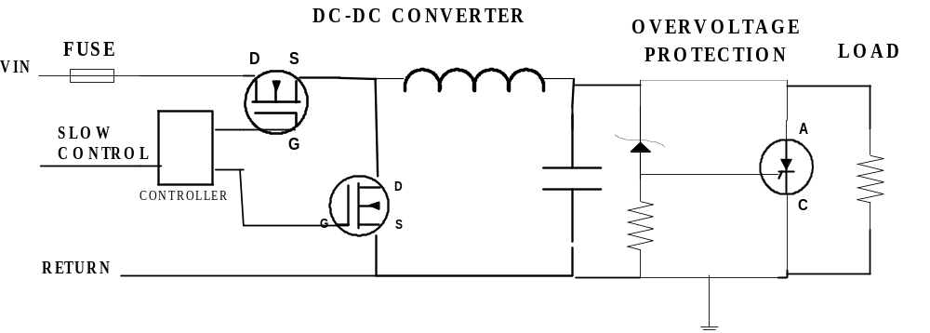
Figure YY: One possible type of over voltage and slow control protection on each DC-DC converter. The converter shown is a buck converter. The module is represented by the LOAD. The over voltage would respond on the order of a micro-second.

The same variants of slow control protection can be used here as in the shunt regulators. Unlike the shunt regulator since there is a common ground between control and each converter. Isolation (AC coupling) or the equivalent is not needed.

Hybrid layout (pixels and strips separately)

Estimate size of DC-DC circuitry Maurice, Satish, Federico
Show picture of BNL, Yale module (commercial converter), give size estimate for custom circuitry

“Evaluation and interface to module/stave program”

Radiation hardness – requirements and qualification
What do we need and want to test when. Which levels, type of irradiation. Can we organize combined radiation campaigns with FE-I4, ABC_Next. Procedures.

Testing with modules/staves (pixels and strips)

The following table lists significant builds with and without modules and future plans. We need to identify groups who provide, build or contribute (effort/cash) to expensive hardware.

Serial powering pixels (Bonn):
- Extensive work already done with FE-I3 and a 6-module serially powered stave

- Plan to test serially powered FE-I4 prototype (target date for prototype submission: end of January. This prototype will contain shunt regulator / linear regulators).
- Marc’s question: Plan to build stave?

Serial powering strips (LBL, RAL):
- Built two generations of serial powering PCBs to 6 SCT modules in series (RAL)
- Built mini-serial powering PCB to build 6-module stave (one at LBNL and one at RAL; ongoing)
- Built dedicated 6-chip hybrid with ABCDs and serial powering circuitry (LBNL; working) to build 30-module stave with serial powering (spring 2008)

- Plan to submit ABC_Next and SMARP (FNAL) in February 2008 (1. submission is funded, what about 2. submission if needed?)
- Plan to build short strip hybrid to test 3 SP architectures (needed by mid 2008). Need to identify group
- Plan to build serial powering test bed: stave with ABC_Next, short strips, 10 cm x 10 cm sensors, protection features (end 2008/2009). Need to identify group. Relation to mechanical prototyping unclear in case of diverging time scales.

DC –DC pixel/strips (BNL, CERN, LBL, Yale):
- Built DC-DC switching chip (received November 2011, Maurice: does it have a name?)
- Building module with first miniaturized commercial buck converter
- Plan to submit custom air-coil buck converter (Federico and co. by March 2008)

Other
- Built test-stand at CERN (Georges Blanchot) to characterize common-mode (as a function of frequency) of local power supplies (DC-DC converters or others)
- Building …
- Plan to build …

“Summary including global plan, decision process and resources”

The global plan and set of milestones have been focussed and extended to include a decision tree, but otherwise have not changed compared with the R&D proposal. There are three main phases each power distribution approach has to work through (not strictly in chronological order.)

  - Generic studies to identify basic features and challenges; rule out show stoppers and prove feasibility of a given approach.
Target date: mid 2008

  - Develop radiation-hard custom electronics (Shunt regulators; DC-DC converters; piezo transformers);
Build and test systems with large number of modules (with commercial or preliminary electronics).
Target date: mid to end 2008

  - Implementation of power distribution schemes with custom electronics on advanced supermodule prototypes
Advanced prototypes should used full size sensors; ABC_Next and FE_I4 readout chips and realistic hybrid designs with protection and slow-control features.

The aim is to build and characterize a full electrical and power distribution test bed for the two most promising approaches and to evaluate performance, pros and cons carefully.
Target date: end 200/beginning 2009

The implementation phase is crucial to establish supermodule electrical performance before production. Construction of realistic prototyping is expensive and cannot be afforded for all possible power distribution approaches in parallel. Some discrimination between alternatives is required. Show stoppers might be found during generic studies or custom electronics development and thus eliminate one R&D branch. If this is not the case, we suggest the following decision tree.

Design hybrid layout to test three SP architecture | Build hybrid with custom/miniaturized DC-DC converter for each approach (buck/switched-cap/piezo transformer)  If possible use similar hybrid layout
Build serial powering supermodule with ≥ 10 modules for serial powering  (this should be a thermal/mechanical model as well) | Build module for each DC-DC approach
 | Characterize and discriminate between DC-DC approaches
Characterize and discriminate between three architectures | Build DC-DC (parallel or independent) supermodule with ≥ 10 modules
At this stage two alternative test beds are available and performance in terms of output impedance/ripple; max. current; radiation-hardness; cable budget; risk; overall power efficiency; local inefficiency; material; costs; etc. is reasonably well understood
Discriminate between approaches

The decision tree considers that it is not prudent to rule out an approach, before it has reached a given maturity; a decision should be taken based on experimentally demonstrated features wherever possible. It would be desirably to reach an informed decision in 2009.

Open questions:
Who does what? When is discrimination between approaches needed; e.g. DC-DC independent/parallel
Needs discussion, but we should aim to make our own suggestion how to have an informed decision on relatively mature designs rather than having project pressure and lack of resources define a “random” one.

Resources
Let’s update the table below where needed.

Institution | Manpower | R&D Interest | Funding status
AGH Krakow | W. Dabrowki | ABC-Next design
Bonn | N. Wermes, M. Barbero,  M. Cristinziani, students | SP module development;  Opto-coupling on module | R&D is funded
BNL | D. Lynn, J. Kierstedt | DC-DC conversion inductor;  System failure and protection analysis; Radiation testing
CERN | F. Anghinolfi, J. Kaplon | ABC-Next design | Funded
LBNL | C. Haber | Serial powering strips
LBNL | M. Garcia-Sciveres, R. Ely, P. Denes, students | Switched capacitor DC-DC | US ATLAS funds received in FY07. More requested for FY08-FY11.
RAL | R. Holt, G. Villani, M. Weber, N. Partanen | Serial power strips | Funded until 2009
Yale | O. K. Baker, S. Dhawan, P. L. Tipton | DC-DC conversion inductor | US ATLAS funds received for FY08. More requested for FY09-FY11
Wuppertal | T. Flick, S. Kersten, P. Kind, P. Maettig, C. Zeitnitz | Slow control design | R&D is funded
Table 8: Parameters of custom serial powering prototypes.

Could we please try to fill in the following tables (otherwise the reviewers will have to do that) to indicate what is urgent (and important) and where effort is available? I think this will be useful and we are expected to do this. Fill in anything you care for or have an opinion on. I suggest

High/Medium/Low meaning:
Very urgent, urgent, less urgent or Significant effort devoted to it/some effort/little effort.

All
 | SP | DC-DC | SP effort | SP urgency | DC-DC effort | DC-DC urgency
ASIC design | Shunt regulators and transistors in ROIC | High-voltage radiation-hard process | H | H | H | H
ASIC design | SMARP: generic powering IC (> 2 A) | Capacitor switching chip | H | H | H | H
ASIC design | LVDS buffers (160-320 MHz) | Pulse width modulator | H | H | H | H
Feasibility study  and  performance  characterization | Module/supermodule prototype construction |  | M | M | M | M
Feasibility study  and  performance  characterization | Noise immunity/electrical performance |  | H | H
Feasibility study  and  performance  characterization | Output impedance
Feasibility study  and  performance  characterization | Compatible with multi-hybrid modules | Verification of magnetic field operation
Feasibility study  and  performance  characterization |  | Switching noise; layout and  shielding techniques
Feasibility study  and  performance  characterization |  | Magnet fringe field
System design | Serial powering architecture | IP or PP, multi-stage/single-stage
System design | Cable budget |  | M | L | L | L
System design | Overall efficiency
System design | Local power supply size, material budget, inefficiency
Protection and  redundancy  features;  reliability | Over-current and over-voltage protection
Protection and  redundancy  features;  reliability | Controlled short | Controlled open
Protection and  redundancy  features;  reliability | Power-up
Protection and  redundancy  features;  reliability | Aging of components
Protection and  redundancy  features;  reliability | Risk analysis
Slow-control | Specification and design of IC blocks
Slow-control | Powering scheme of SC blocks
Power supply | Constant current source | Power supply
Cables and  connectors | Resistance, current and voltage ratings, etc.
Cables and  connectors | Interface to existing services (if these will be reused)
Table 9: Parameters of custom serial powering prototypes.

Appendix

a) List of publications and other supporting material:

TWEPP proceedings of Satish Dhawan, Stefano Michelis, Giulio Villani, M. Weber,
Vertex proceedings of Maurice Garcia-Sciveres

b) Design of the distributed shunt regulator in the ABC-N (Wladek Dabrowski)

c) Constant current source specifications (G. Villani)

Schematics of circuitry close to submission.

This is the input voltage to the serial regulator for analog power.
This value can be obtained for the 0.25 μm CMOS version of the ABC-Next.
The given minimum value assumes 1.6 mW/channel, while the 14 W maximum is estimate using 2.7 mW/channel.

